Git Clone URL: <https://github.com/Chakrapani240286/IIHT_DOT_NET_Final_Certification.git>

**STEPS TO CREATE THE GIT ACCOUNT AND COMMIT:**

1. Login to Git: <https://github.com/>
2. Go to Your repositories

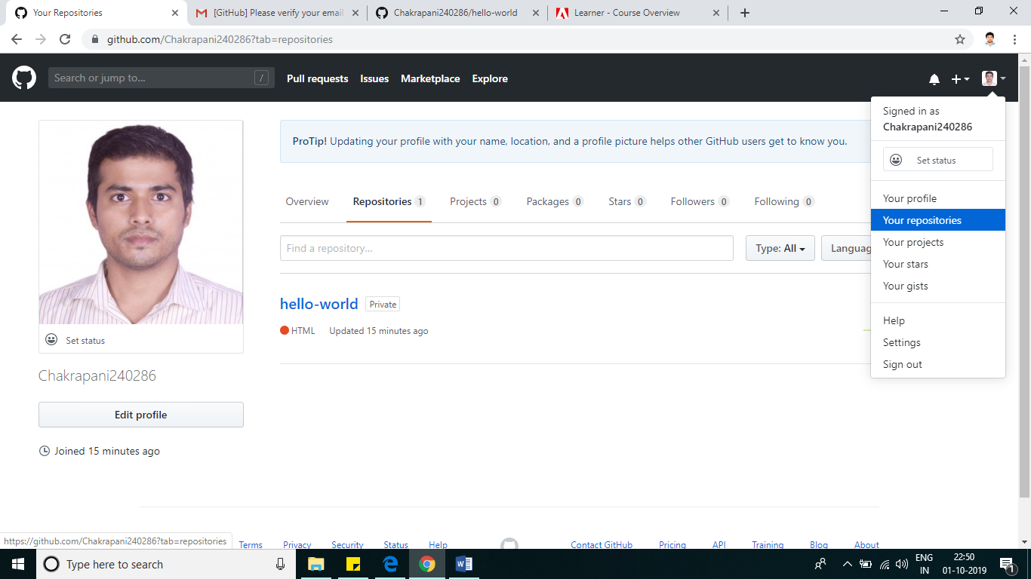

1. Click On  Button
2. Enter the detail and Create Repository

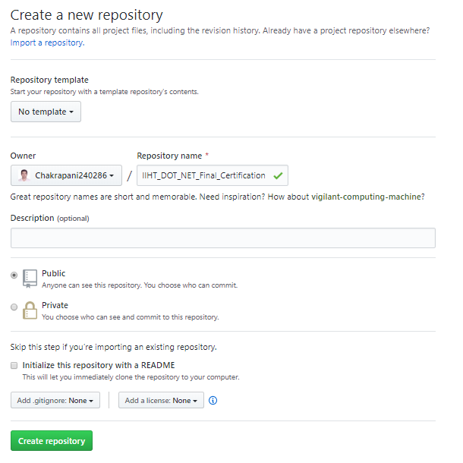

1. Repository Created

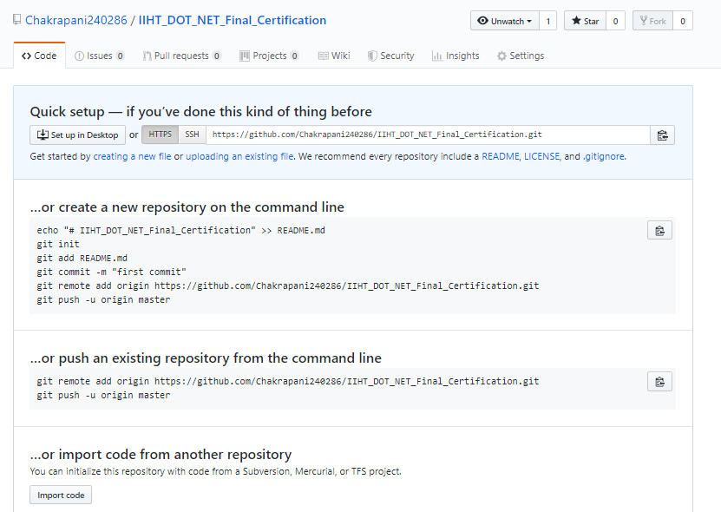

1. Go to any drive in your computer
2. Right click on folder 🡪 Git Clone…

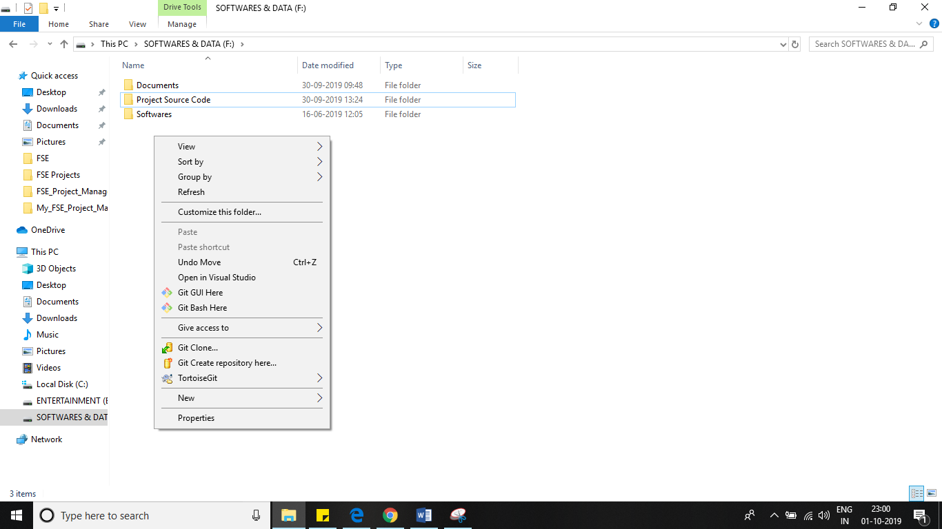

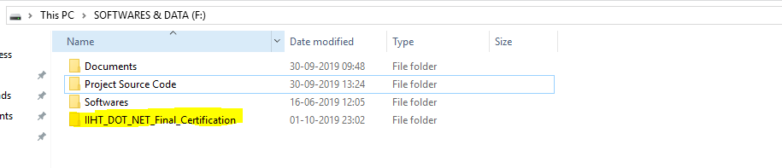

1. Open the folder and paste your source code in it
2. Once code files copied into the folder then right click on folder and Click Commit 🡪 Master

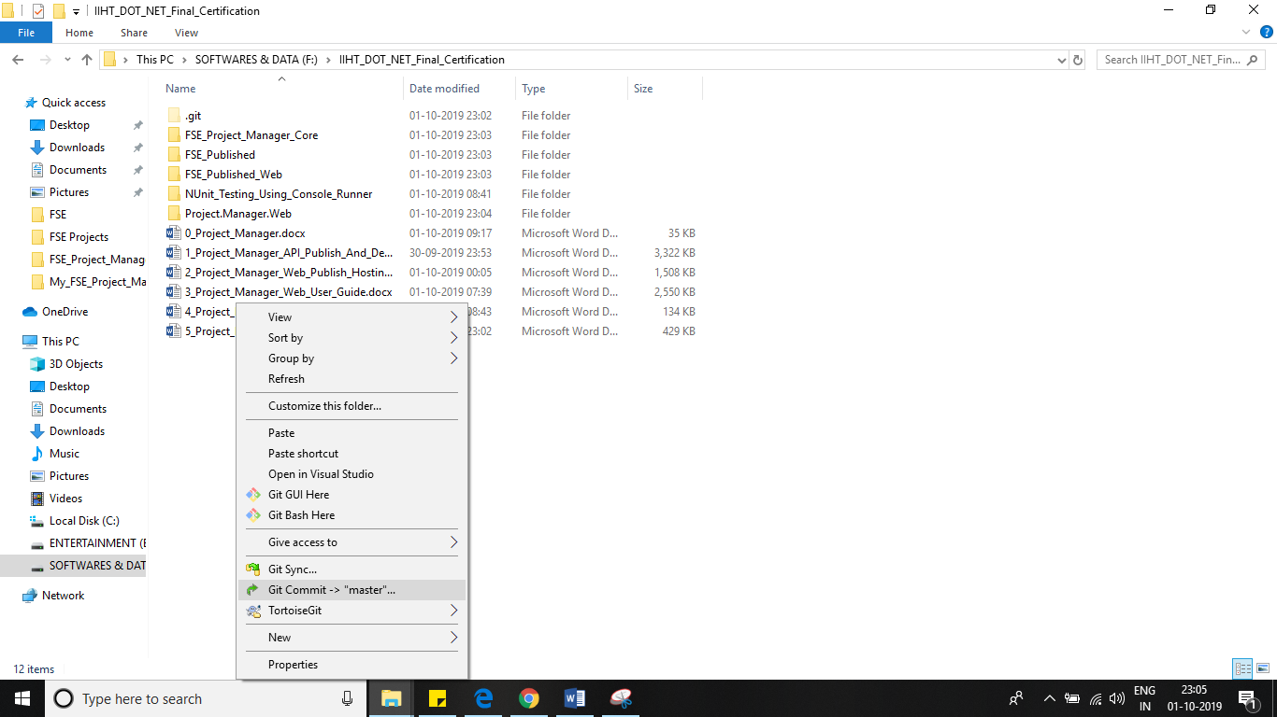

1. Check All Files and Select Al files, then right click and Add

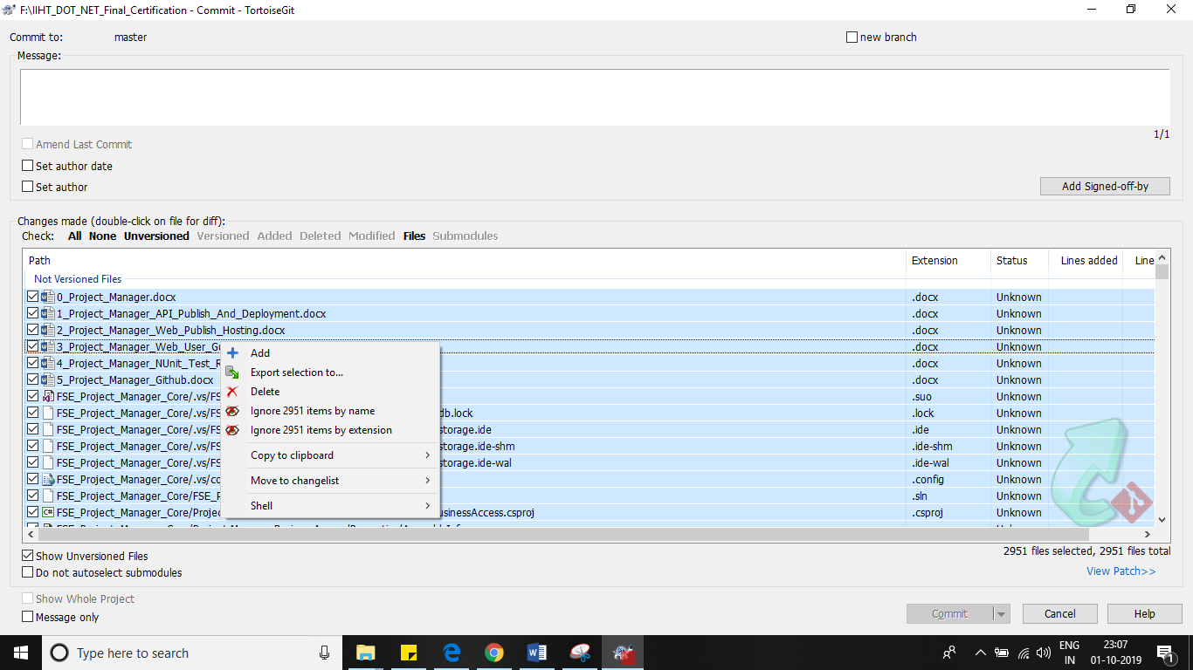

1. Once Added Successful, Then enter the comment and commit and push

