Bad Prompt: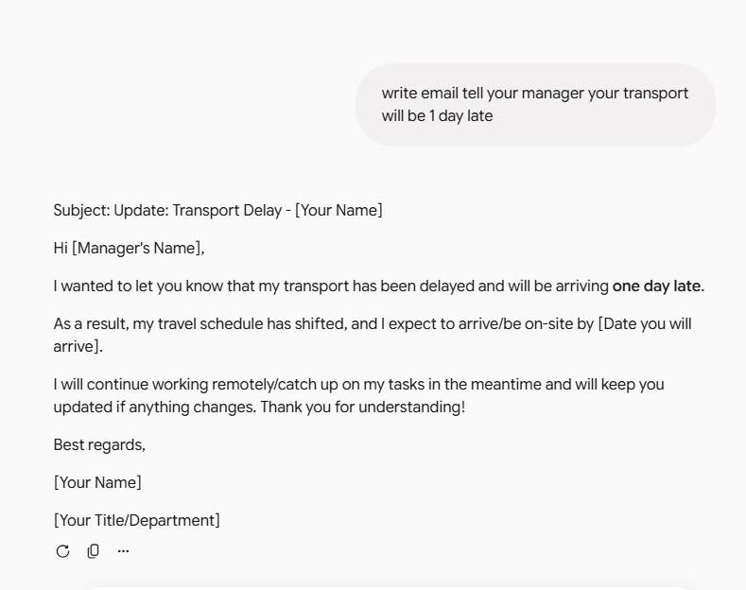
Good Prompt:
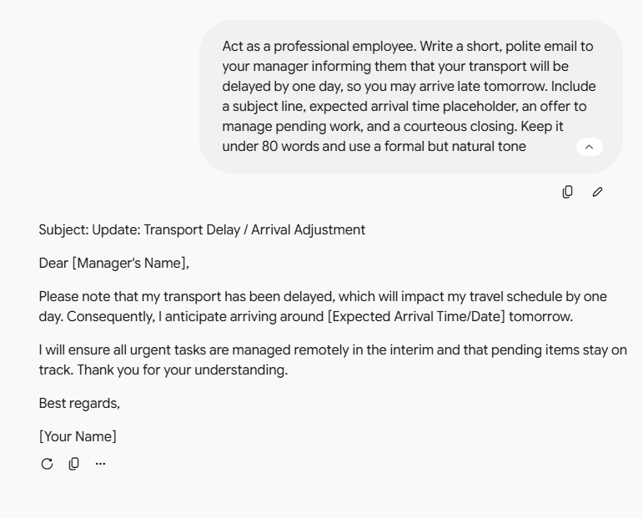
Bad Prompt :
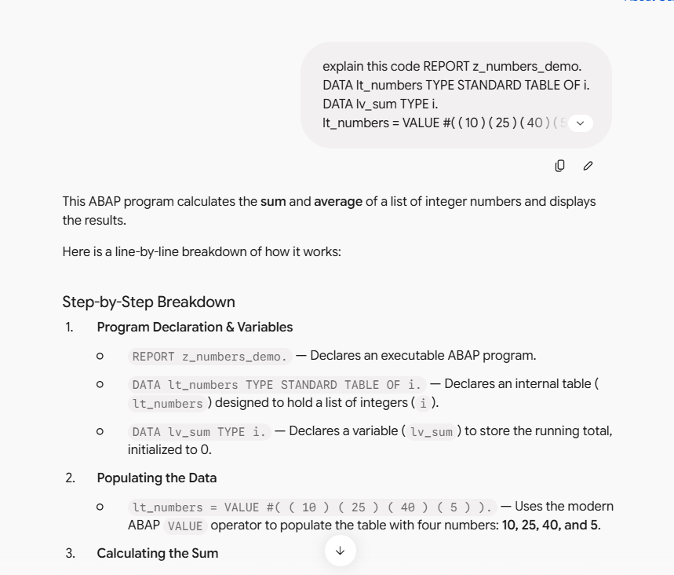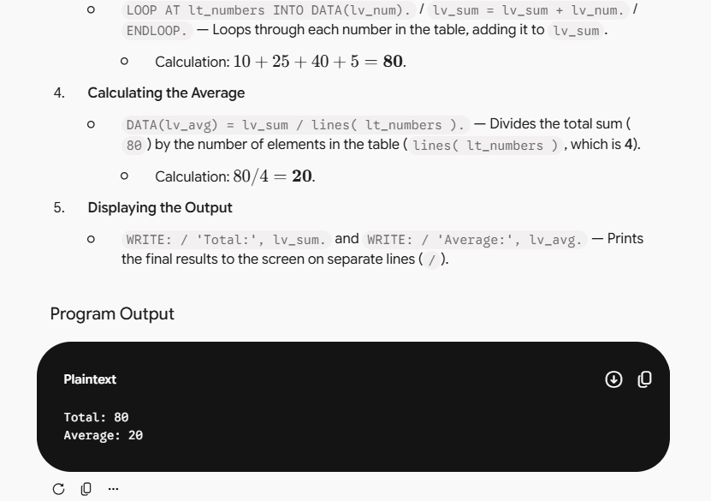

Good Prompt:
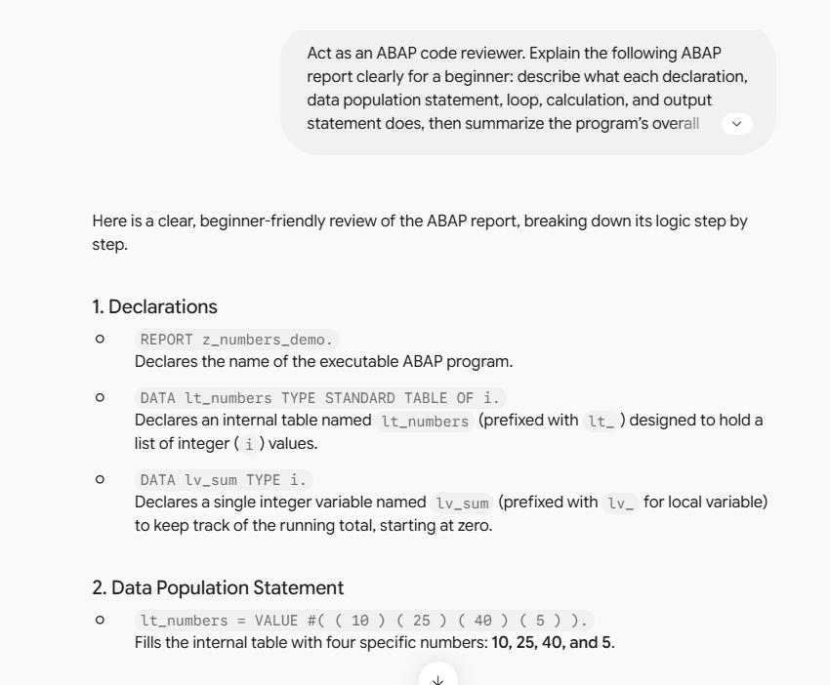
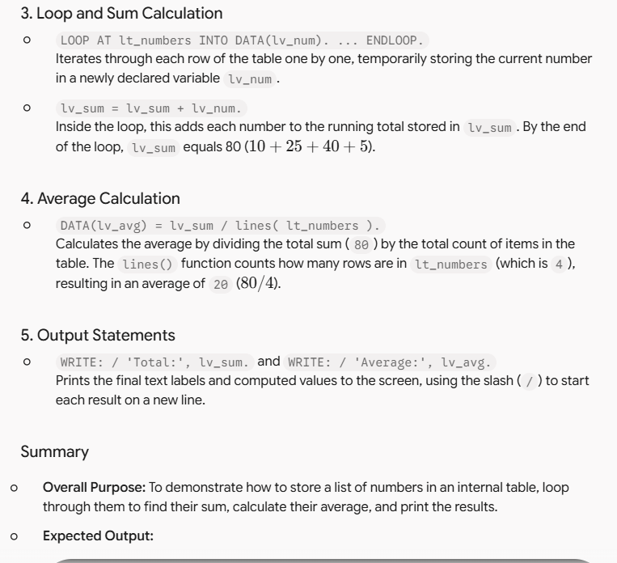

Bad Prompt:
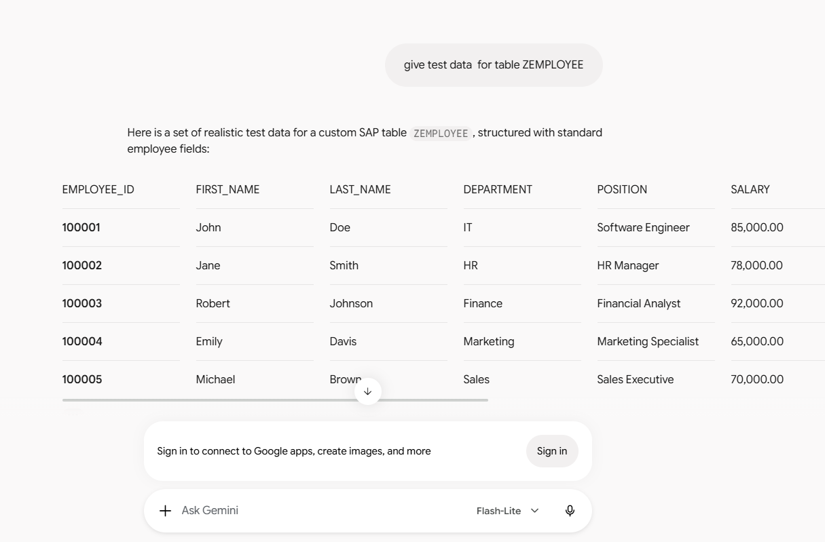
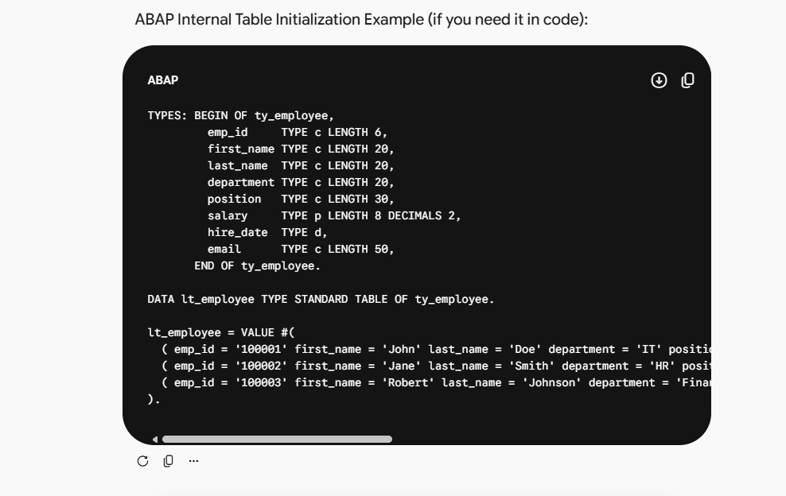

Good Prompt :
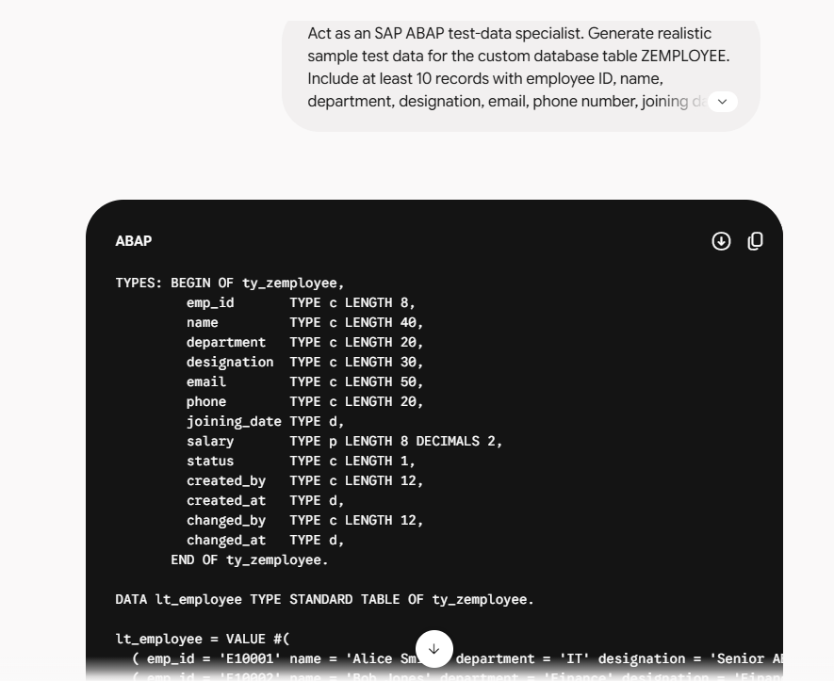

Bad Prompt:
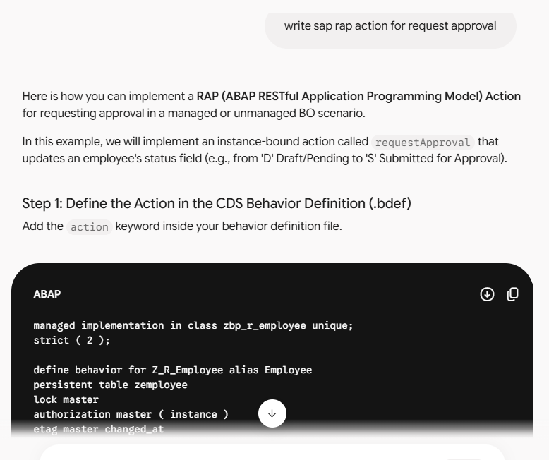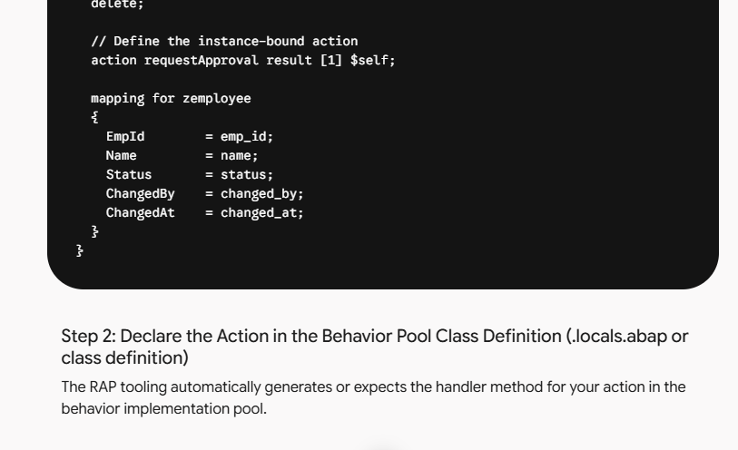
Good Prompt:
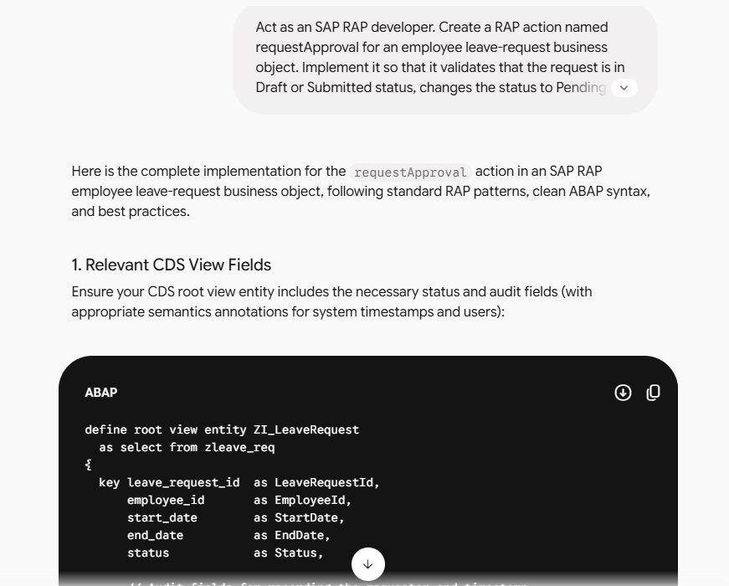
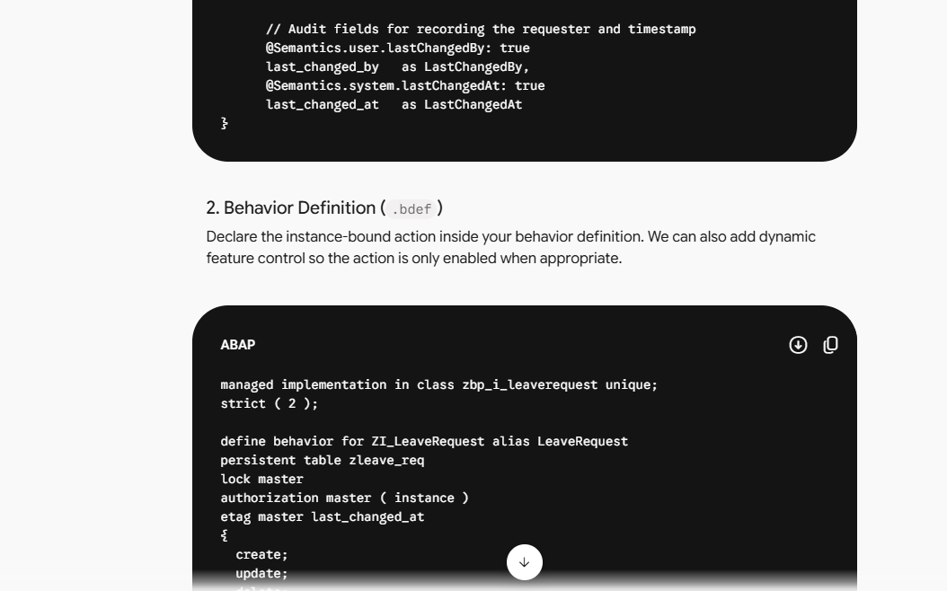
Bad prompt:
action vs internal action in rap
In SAP RAP (ABAP RESTful Application Programming Model), both standard actions (action) and internal actions (internal action) execute custom business logic beyond standard CRUD operations. However, they differ fundamentally in accessibility, exposure, and use cases.

Key Comparison
Feature | Standard Action (action) | Internal Action (internal action)
Accessibility | Public / External | Private / Internal-only
Trigger Source | OData clients, SAP Fiori UI buttons, external consumers, or internal code | Only from within the Business Object implementation (via EML)
Projection Layer | Must be explicitly exposed using use action | Cannot be exposed on the service projection layer
UI Representation | Can be mapped to UI buttons via Metadata Extensions (#FOR_ACTION) | Invisible to UI and OData consumers
Primary Use Case | User-driven tasks (e.g., Approve, Reject, Submit, Calculate Discount) | Reusable backend calculation routines or logic triggered automatically by determinations/actions (e.g., Recalculate Totals)

1. Standard Action (action)
A standard action is meant to be part of the contract between your Business Object and the outside world.
- Behavior Definition (BDEF):
ABAP
action submitForApproval result [1] $self;
- Projection & UI: Needs to be explicitly exposed in the behavior projection (use action submitForApproval;) and can be rendered as an interactive button on Fiori UI screens via metadata extensions.

2. Internal Action (internal action)
An internal action is designed strictly for modularizing internal business logic. It allows you to wrap complex processing steps into a reusable handler method without exposing them to external consumers or UI clients.
- Why use it instead of a Determination? Determinations execute automatically based on specific field changes. An internal action acts as a callable function (via Entity Manipulation Language - EML) that can be invoked programmatically from multiple places (e.g., across different actions, save sequences, or background routines).
SAP Community
- Behavior Definition (BDEF):
ABAP
internal action recalculateTotals;
- Projection & UI: You cannot use use action for an internal action in the projection BDEF. Attempting to expose it externally will trigger a syntax or compilation error.

How Internal Actions are Triggered (EML Example)
Because internal actions cannot be called from the UI, you invoke them programmatically inside your behavior implementation pool using RAP EML (MODIFY ENTITIES):
ABAP
MODIFY ENTITIES OF zi_sales_order IN LOCAL MODE
ENTITY SalesOrder
EXECUTE recalculateTotals
FROM CORRESPONDING #( keys )
FAILED DATA(lt_failed)
REPORTED DATA(lt_reported).

Good Prompt:
Welcome! Think of standard actions as public API methods, and internal actions as private helper routines within your Business Object.
- Standard Action (action)
  - Visibility & Purpose: Publicly exposed via OData for external consumers and UI interaction.
  - Use Case: User-driven tasks like Approve, Submit, or Close.
  - BDEF Example: action requestApproval result [1] $self; (Must be exposed in the projection layer via use action).
- Internal Action (internal action)
  - Visibility & Purpose: Private to the backend Business Object. Invisible to OData and UI clients.
  - Use Case: Reusable business logic triggered programmatically via Entity Manipulation Language (EML) from other actions or determinations.
  - BDEF Example: internal action recalculateTotals; (Cannot be exposed in projection).

When to Choose Which
- Choose a Standard Action when an end user needs an explicit button on the Fiori UI to trigger a specific business operation.
- Choose an Internal Action to modularize and share backend logic across multiple behavior methods safely, avoiding unnecessary public endpoints.

Bad prompts and missing blocks :
---------------------------------------------
1: write sap rap action for request approval
Act as an experienced SAP RAP developer. Create a complete RAP action named requestApproval for an employee leave-request business object. The action should validate that the leave request is in Draft or Submitted status, change valid requests to Pending Approval, store the requester and request timestamp, and return an appropriate success or error message. Provide the required behavior definition, behavior implementation class, and any CDS view fields needed. Use clean, modern ABAP syntax, include meaningful comments, follow SAP RAP best practices, and keep the solution focused only on the approval-request functionality.
Your original prompt named the required RAP action but did not define its business rules, so the result could be incomplete or inconsistent. The improved version adds an experienced SAP RAP developer role to ensure technically appropriate implementation. It gives context by specifying an employee leave-request business object and defines the task precisely: validation, status change, requester/timestamp capture, and messaging. It also sets the output format by requiring the behavior definition, implementation class, and CDS fields, while constraints such as clean modern ABAP, comments, best practices, and a focused scope make the expected solution clear and maintainable.
2: action vs internal action in rap
Act as an SAP RAP expert. Compare a standard action and an internal action in SAP RAP for an ABAP developer who is new to RAP. Explain their purpose, visibility, typical use cases, implementation approach, and when each should be used. Include one concise ABAP behavior-definition example for each action type, present the differences clearly, and keep the explanation under 300 words.
Your original prompt only asked for a comparison without specifying the audience, depth, or output style, which could lead to a generic or overly technical explanation. The improved version adds an SAP RAP expert role and establishes context by identifying the reader as an ABAP developer new to RAP. It turns the broad topic into a focused task by naming the exact comparison points: purpose, visibility, use cases, implementation, and usage guidance. The format is clarified through concise ABAP examples and a clear explanation, while the 300-word constraint keeps the response focused and easy to read.
3: give test data for table ZEMPLOYEE
Act as an SAP ABAP test-data specialist. Generate realistic sample test data for the custom database table ZEMPLOYEE. Include at least 10 unique employee records with fields such as employee ID, name, department, designation, email, phone number, joining date, salary, status, and standard audit fields. Provide the data in an ABAP VALUE #(...) format that can be used for insertion, ensure employee IDs and email addresses are unique, and include a realistic mix of active and inactive employees. Do not include explanations or additional commentary.
Your original prompt identified the target table but did not specify the number of records, required fields, data format, realism requirements, or whether the data should be insertion-ready. The improved version adds an SAP ABAP test-data specialist role to ensure technically valid output. It provides context by identifying ZEMPLOYEE as a custom SAP database table and defines a precise task: create at least 10 unique, realistic records. It also specifies the expected fields and output format using ABAP VALUE #(...), while constraints around uniqueness, active/inactive variety, and no explanations make the result directly usable for testing.
4: Act as an ABAP code reviewer and instructor. Explain the provided ABAP report to a beginner by describing the purpose of each declaration, the VALUE #(...) table population, the LOOP AT calculation, the average calculation, and the WRITE output statements. Then summarize what the program does overall and state its expected output. Use simple language, organize the explanation logically, and do not rewrite or optimize the code.
abap
REPORT z_numbers_demo.

DATA lt_numbers TYPE STANDARD TABLE OF i.

DATA lv_sum TYPE i.

lt_numbers = VALUE #( ( 10 ) ( 25 ) ( 40 ) ( 5 ) ).

LOOP AT lt_numbers INTO DATA(lv_num).

lv_sum = lv_sum + lv_num.

ENDLOOP.

DATA(lv_avg) = lv_sum / lines( lt_numbers ).

WRITE: / 'Total:', lv_sum.

WRITE: / 'Average:', lv_avg.
Your original prompt asked to explain code but did not identify the audience, desired depth, or whether the code should be rewritten. The improved version adds an ABAP code reviewer and instructor role to ensure a clear, technically accurate explanation. It provides context by stating that the reader is a beginner and defines the task precisely: explain each major part, summarize the program, and state the expected output. The output format is guided through logical organization and simple language, while the constraint not to rewrite or optimize the code keeps the response focused on explanation rather than code changes.
5: write email tell your manager your transport
will be 1 day late
Act as a professional employee. Write a short, polite email to your manager informing them that your transport will be delayed by one day, so you may arrive late tomorrow. Include a clear subject line, a placeholder for the expected arrival time, an offer to handle urgent work remotely if needed, and a professional closing. Keep the email under 80 words and use a formal but natural tone.
Your original prompt stated the situation but did not define the tone, recipient expectations, email structure, or length. The improved version adds a professional employee role to ensure an appropriate workplace voice. It provides context by identifying the recipient as your manager and the issue as a one-day transport delay affecting tomorrow’s arrival. The task is made specific by requiring a subject line, expected arrival placeholder, offer for remote support, and closing. Constraints such as keeping it under 80 words and maintaining a formal but natural tone ensure the email remains concise and professional.

