|  |  |  |
| --- | --- | --- |
| Academic year: 2024-25 Even | | |
| Sub name: C# and .Net Programming | Sub-code: B22EFS615 | Sem & Sec: VI & PE4 |
| Date: 18/03/2025 | | |
| Staff in-charge: Dr. Sohara Banu A R | | |

|  |  |  |  |
| --- | --- | --- | --- |
| **Q. No.** | **Questions** | **Blooms level** | **Course**  **Outcomes Mapped** |
| 1 | Create a Windows application in C# having two text boxes and three buttons named as factorial, prime, factorial series. When you click any button the resultant value will be displayed on the second textbox. | 3 | CO4 |
| 2 | Create a Windows application in C# for registration form and fill the details and when you click the submit button it display the details in the message box. | 3 | CO4 |

**Use of various instructional methods and pedagogical initiatives:**

In order to improve the quality of Teaching and Learning process,the following instructional methods and pedagogical initiatives are followed by the faculty in content delivery.

* Chalk and Talk
* Information and Communication Tools(ICT) (Presentation ,Videos,E-learning resources)
* Flipped classroom
* Different Learning approaches like Interactive Learning and Collaborative Learning(Group Discussion, Brainstorming sessions and Seminars).

**Chalk and Talk:**

The conventional and most effective instructional method is the chalk & board and the faculty exhaustively resort to this traditional method. The faculty use chalk and audio-visual aids in teaching,Students are also encouraged to interact during the lecture hour by getting the doubts clarified on the spot.

**Information and Communication Tools(ICT) (Presentation ,Videos,E-learning resources)**

For better understanding of the concepts,faculty members use ICT members, use ICT enabled teaching methods such as Presentations,Animated videos are extensively used to improve the teaching –learning process.

Note: P16 file to be referred

**Flipped classroom**

Flipped lectures are included in the teaching plan. Accordingly, the students are intimated a week before to prepare the topic. On the day of the presentation, students discuss the topic and faculty members ask probing questions.

In a flipped classroom, students watch or engage with instructional content outside of class, typically through videos or online resources, and then use class time for collaborative activities, discussions, and hands-on learning.

**Different Learning approaches like independent Learning, Interactive Learning and Collaborative Learning (Peer to Peer, Group Discussion, Brainstorming sessions and Seminars)**

Collaborative Learning: Faculty facilitate discussion an important concepts within the classroom to encourage combined learning. Departmental association are highly active in the institution.These association regularly organize seminars,discussions and competitions to encourage collaborative learning among the students.

Classroom quiz sessions: These help in creating interest by breaking monotony of regular classes while enhancing the learning experience.

**PEDAGOGICAL INITIATIVE: FLIPPED CLASSROOM**

**SUB: DESIGN AND ANALYSIS OF ALGORITHMS**

**STAFF NAME: Mrs. Thirumagal E**

Flipped Classroom is one of the most innovative methods of teaching that has evolved in the recent times.Gradually revolutionizing its age-old counter part,Flipped classroom is nothing but a blended strategy of teaching and learning.Its aim at enhancing the overall student engagement,thereby yielding more rewarding outcomes.

Flipped classroom is a systematic approach in teaching where in traditional classroom-based learning is inverted.This approach helps students in getting introduced to the study material beforehand.

As the students would have already learnt about the subject ,the actual classroom time can be used to explore the subject.Teachers can utilize classroom time to deepen subject understanding by way of group discussion and problem solving activities.

Flipped classroom is nothing but an inverted version of traditional learning.Students are made to acquire as much knowledge within a specified classroom context,followed by analyzing and evaluating the subject after the class.

Students are given specific instructions on the subject before the classroom time.As a result,the actual time can be used for practicing and application of concepts and ideas through interaction with peers and faculty.

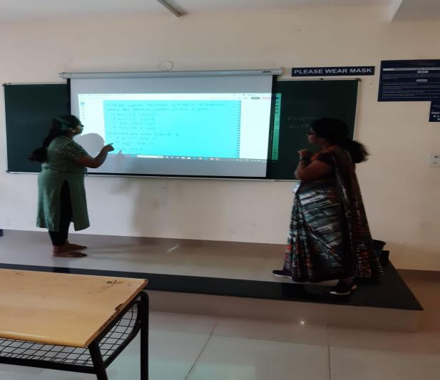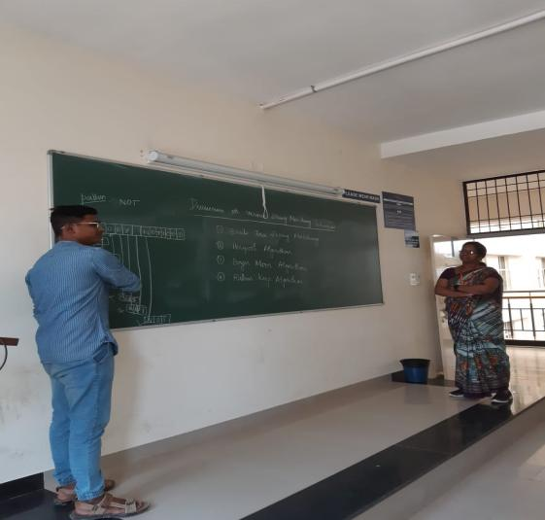

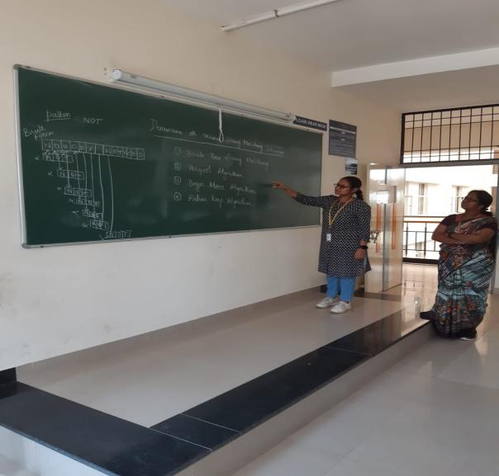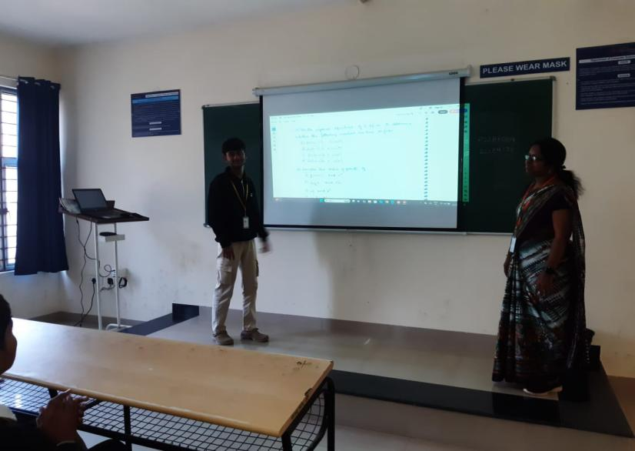

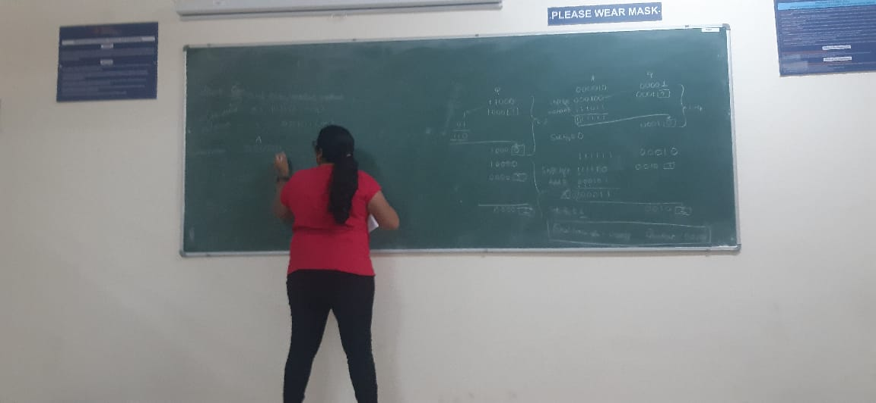

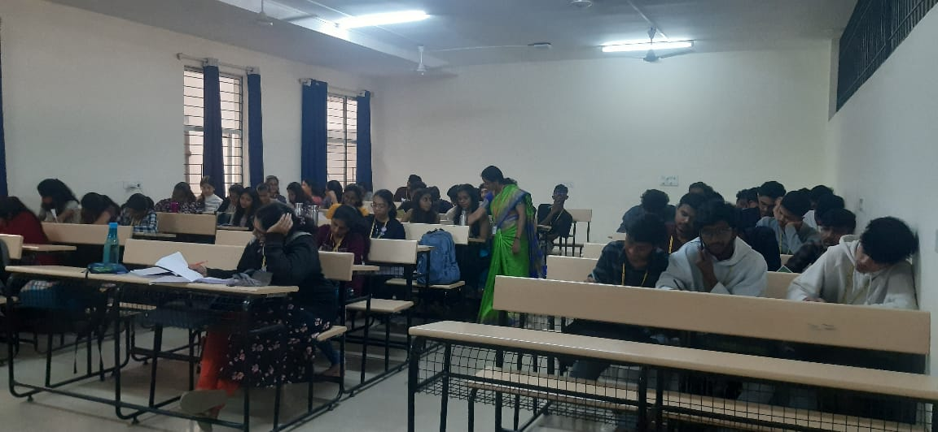

**Benefits for students:**

* • Lesser frustration with homework as students watch/listen to lectures at home and then solve problems.
* • When students have problems understanding a new concept,they can ge it cleared immediately through targeted answers.
* • Enough classroom to explore new concepts/subjects through collaboration and peer discussion
* • Become faster and easier for students to catch up with peer group on lectures missed out on

**PEDAGOGICAL INITIATIVE: COLLABORATIVE LEARNING**

**SUB: DESIGN AND ANALYSIS OF ALGORITHMS**

**STAFF NAME: Mrs. Thirumagal E**

Learning can take various forms depending on the approach used. Here are some key learning approaches and their characteristics:

* Interactive Learning : It involves active participation in the learning process rather than passive reception.

This can include:

Technology-based learning: Online quizzes, simulations, Hands-on activities: Lab experiments, role-playing, and case studies,Question-based learning: Socratic questioning and interactive discussions

**Benefits to students**

· Engages learners and enhances retention

· Encourages critical thinking and problem-solving

· Makes learning enjoyable and dynamic

* Collaborative Learning

Collaborative learning involves working with peers to achieve shared learning goals. It can take multiple forms:

a) Peer-to-Peer Learning

Learning directly from a peer through mentorship, tutoring, or study partnerships . Encourages knowledge exchange and clarification of concepts

b) Group Discussions

A structured conversation where participants share ideas on a particular topic. Helps develop communication and reasoning skills

c) Brainstorming Sessions

Generating creative ideas in a group setting.Encourages open-ended thinking and diverse perspectives

d) Seminars

Formal gatherings where learners present and discuss ideas on a topic. Often involves expert insights and Q&A sessions

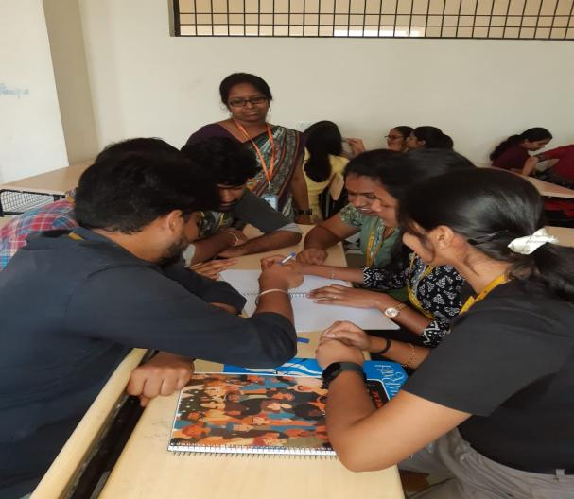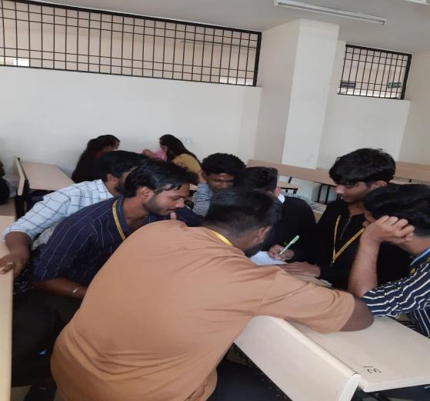

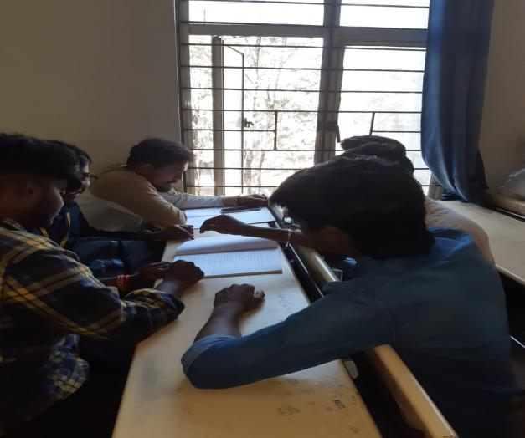

**Benefits of Collaborative Learning:**

* Enhances teamwork and communication skills
* Provides diverse viewpoints and solutions
* Encourages engagement and participation