Decentralized peer to peer Ride sharing System using Block Chain

Mr. Tenali Ravi Kumar 1
Assistant Professor (SG) Department of CSE
Saveetha Engineering college Chennai, Tamilnadu, India xxxxxxxxxxx@gmail.com
P. Guravaiah 2
Department of Computer Science and Engineering
Saveetha Engineering college Chennai, Tamilnadu, India pokalaguruvaiahroyal@gmail.com

N. Lokesh4
Department of Cyber Security Saveetha Engineering College Chennai, Tamilnadu, India loke40381@gmail.com
S. Lakshman Reddy 3
Department of Computer Science and Engineering
Saveetha Engineering college Chennai, Tamilnadu, India srikireddylaxman@gmail.com
Abstract— The majority of existing ride-sharing platforms, including popular ones like Uber and Lyft, are based on centralized systems in which an umbrella organization controls all the user, ride, and payment data. This use of a central system has a number of drawbacks like high fees for services, low transparency, risks to data privacy, and potential system crashes. In response to these drawbacks, this project proposes a decentralized ride-sharing system developed through blockchain technology. The system eliminates middlemen through direct “peer-to-peer (P2P) interactions” between drivers and riders, encouraging trust and fairness. It is based on a “private blockchain” that uses the “Proof of Authority (PoA)” consensus algorithm, which ensures secure and fast transaction verification with low computational overhead. The system facilitates login-free ride booking, “decentralized identity verification, and an escrow-based payment system with an integrated tamper-proof reputation system to guarantee reliability. By merging the immutability and transparency of blockchain with optimized P2P networking, the system ensures data integrity, fairness, and cost-effectiveness. In addition, it supports user autonomy through transparent and verifiable ride agreements, minimizing fraud and manipulation. “Decentralized in nature”, this solution provides a solid foundation for a scalable, secure, and community-driven ride-sharing ecosystem that can evolve with future innovations in mobility.
Keywords— Decentralized, Blockchain, Ride-Sharing, Peer-to-Peer, Proof of Authority, Smart Contract, Escrow, Reputation System, Token Payments.

INTRODUCTION
Ride-sharing is now an essential element of urban transport, offering convenience and economy. The majority of current platforms, though, rely upon centralized systems that tend to impose high fees, are not transparent, and are susceptible to service outages. “Blockchain-based decentralized ride-sharing systems” have been implemented to solve the aforementioned issues but often suffer from low transaction rates, high fees, and limited scalability. This project presents a peer-to-peer ride-sharing platform based on a private blockchain with “Proof of Authority” consensus, facilitating rapid, secure, and transparent ride transactions [1]. Login-free ride booking is one of its features, where riders and drivers can use the service without signing up. It provides an escrow-based payment system along with a reputation module to ensure fairness and trust for users. Through the marriage of blockchain with peer-to-peer networking, the platform provides a scalable, cost-effective, and user-friendly solution for “decentralized ride-sharing”.
The website provides a user-friendly interface for both drivers and riders, with simple booking and handling of rides. Security is also a point of emphasis with the protection of users' information and guaranteeing secure and reliable transactions. All rides and payments are stored in secure logs, which can be utilized in the future for audits or resolving disputes, and this offers accountability and transparency to all the parties involved.

PROBLEM DEFINITION
Ride-sharing services such as Uber, Ola, and Lyft have revolutionized city travel, providing ease and convenience. But they have numerous significant issues. These platforms are extremely centralized, allowing companies complete access to user and driver data. This can create privacy issues, as individuals' personal details, ride histories, and financial information can be monitored, used for focused promotions, or distributed to third parties without customers' complete knowledge. Security is also a problem. “Centralized models” are prone to data leaks, scams, and hacking, exposing sensitive data to potential risks [2]. Drivers tend to experience opaque fee policies and abrupt commission adjustments, while passengers face restrictive payment methods and ride availability. Transparency is also restricted. Customers cannot check on their own transactions, ratings, or ride history, and auditing past rides or payments is not easy. Having a central server introduces a single point of failure —When it crashes, they have no access. These issues strengthen the need for a decentralized, safe, and open ride-sharing platform that provides more control to riders and drivers, protects their information, ensures secure transactions, and maintains verifiable records for accountability.

EXISTING WORK
There have been various decentralized ride-sharing systems invented over the years to counter the disadvantages of centralized systems [3]. Arcade City was an initial effort that established a peer-to-peer network where riders and drivers could communicate directly without an intermediary. It focused on community governance and open-ended pricing but struggled to scale and be widely adopted. La'Zooz adopted a “blockchain-based” system so that the riders could be rewarded with tokens for joining the network. It promoted user interaction and openness but meant the transaction confirmation was delayed and expensive, making it less ideal for real-time booking of rides [4]. The DAV Network integrates self-driving cars with decentralized ride-sharing based on blockchain and smart contracts. While it provides trust and transparency, it is also slow and not scalable, which makes it impractical for regular use [5]. Overall, such platforms are plagued by slow transactions, high fees, limited scalability, and reliance on “public blockchains”. They tend to lack user-friendly interfaces and functionalities such as escrow payments or login-less access. These are problems calling for a private blockchain-powered answer that provides rapid, secure, and transparent ride transactions with peer-to-peer matching, reputation monitoring, and audit-compliant ride logs.

PROPOSED WORK
This project seeks to create a peer-to-peer ride-sharing service based on a private blockchain in order to eliminate the shortcomings of existing “centralized” solutions. By allowing riders and drivers to own their own data, the system improves privacy and security. Transactions are confirmed by a “Proof of Authority (PoA)” consensus algorithm, enabling rapid and efficient processing, thereby making the platform ideal for real-time booking of rides [6]. The system's core feature is login-free reservation, which enables users to take rides without accounts, making things easier for all. Payment occurs via an escrow mechanism, keeping money safe until the end of the ride. A reputation module also keeps ratings on the blockchain for riders and drivers, offering an open and tamper-proof means of ensuring trust. The system also holds ride logs ready for audit, where transaction and ride information is saved to be verified in the future or for resolving disputes. By using a lean blockchain infrastructure coupled with peer-to-peer matching of rides, this system provides a secure, open, and easy-to-use system. The system is also adaptable enough to accommodate future upgrades, including token-based transactions and off-chain storage of ride records [7]. “Furthermore, the proposed framework can be extended to integrate AI-based route optimization and dynamic pricing models, enhancing efficiency, reducing waiting times, and improving the overall user experience.”

LITERATURE SURVEY
Several studies have explored ride-sharing systems to improve convenience, safety, security and efficiency. “Trustworthy Decentralized Transportation Platform Using Blockchain Technology” by T. Nguyen and K. Kim (2020) introduces a blockchain-based transportation platform that minimizes intermediaries by enabling direct peer-to-peer interactions between customers and service providers. It ensures data immutability, fosters user trust, and supports verifiable reputation mechanisms for drivers and riders [8]. “Secure and Efficient Carpooling Using Ethereum Blockchain” by P. K. Sharma and J. Lee (2021) proposes an Ethereum-based smart contract system that automatically matches drivers and passengers while maintaining immutable trip logs to prevent fraud and enable transparent fare calculation with self-executing agreements [9]. “A Privacy-Preserving Ride-Sharing Framework Using Blockchain” by L. Wang and C. Xu (2021) focuses on preserving user anonymity using cryptographic anonymization and zero-knowledge proofs, ensuring data integrity and preventing unauthorized tracking [10]. “Decentralized Ride-Sharing Using Blockchain and Edge Computing” by H. Zhang and Y. Chen (2022) presents a hybrid model combining blockchain and edge computing to reduce ride-matching latency, improve route optimization, and enhance passenger safety [11]. “Blockchain for Ridesharing: A Systematic Literature Review” by E. B. Tirkolaee and M. A. Esfahani (2023) reviews blockchain-supported ride-sharing systems, comparing consensus algorithms like “Proof of Work” (PoW) and “Proof of Stake (PoS)” while discussing scalability, transaction costs, and user anonymity [12]. “A Secure and Decentralized Ride-Sharing System Using Blockchain and Smart Contracts” by A. Kumar and S. R. Singh (2023) introduces an Ethereum-based framework that automates trip requests, dynamic pricing, and payments to enhance transparency and eliminate manipulation by intermediaries [13]. Finally, “Blockchain Ethereum-Based Decentralized Secure Ride-Sharing Framework for Carpooling System” by J. Wessly and R. Durga (2024) presents BEDSRF, which utilizes “Role-Based Access Control (RBAC)” and “Elliptic Curve Cryptography (ECC)” to secure communication and authentication while improving trust, confidentiality, and transparency through tamper-proof trip records and decentralized identification [14]. “Blockchain Based Smart Mobility System for Urban Transport by M. S. Ali and F. Bao (2019) suggests a “blockchain-based smart mobility system for urban transport that accommodates shared vehicles”, optimal ride assignment, and traffic control. The design aims at enhancing sustainability, traceability, and accountability [15].
The Recent studies highlight a shift from centralized ride-sharing platforms to decentralized blockchain-based systems that enhance security, transparency, and trust. These frameworks use smart contracts and cryptographic methods to ensure fair, tamper-proof transactions without intermediaries. “Role-Based Access Control (RBAC)” and privacy-preserving mechanisms protect user data and enable secure authentication. Overall, blockchain-driven models promote reliable, efficient, and privacy-focused ride-sharing ecosystems. These systems also enable immutable ride and payment records, facilitating auditability and dispute.

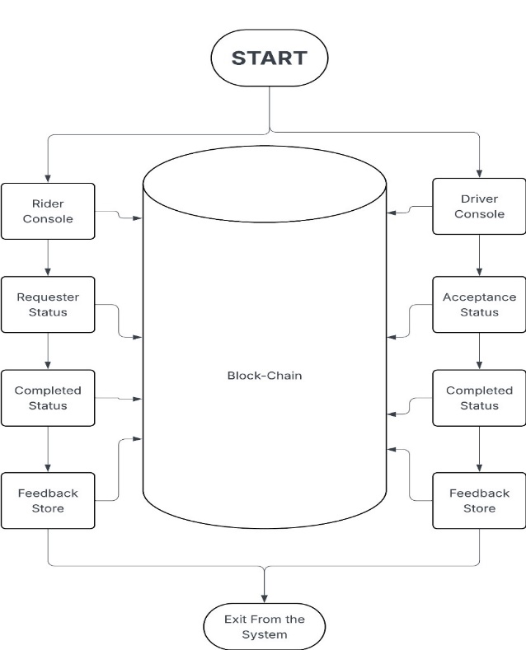
METHODOLOGY
Figure 1. System Architecture Diagram

Data Storing - Immutability and State Management:
Data is stored through a hybrid method that takes advantage of the immutability of a “blockchain” for history and the speed of an off-chain ledger for real-time reputation checks. All interactions, from a rider ordering a trip to both parties completing ratings—are recorded as transactions. Transactions are grouped into blocks and linked together, forming an immutable, auditable record as shown figure 1.
Most importantly, although the history of transactions resides forever on the chain, dynamic user reputation scores are stored in a distinct, high-performance dictionary, the “reputation_ledger”. This enables the platform to immediately look up a driver's or rider's score without computing the computationally intensive task of reading the complete block history. The crucial aspect is that such an off-chain state is not random; it can be changed only after a finished transaction is cryptographically verified and sealed into a new block by the mining algorithm. This guarantees the reputation state to be a verifiable derivative of the unalterable on-chain information.

Data Security: Verifiability Through Hashing and PoA:
Data protection is essentially secured through the cryptographic framework of the system. The integrity of each block is confirmed with the “SHA-256 algorithm for hashing”. The hash functions as the digital fingerprint of the block, a small, specific summary of all its data (transactions, timestamp, and proof). A block is connected to its antecedent by referencing the prior block's hash in the metadata of the block, forming the chain. What this implies is even the slightest change to one transaction in history would alter that block's hash, propagating a mismatch through all following blocks and rendering data tampering instantly evident and verifiable by any single node in the network.
For agreement, the platform uses a lightweight “Proof-of-Authority (PoA) protocol”. In this “proof-of-concept” research, the mining is governed by an appointed Authority Node (the server), which allows for instant block generation and transaction resolution. Although a production system would entail a whitelisted set of trusted validators, such a controlled environment will suffice for showing the fundamental functionality—ensuring that each transaction is processed, validated, and accounted for by a trusted source with no delay. Transaction integrity is also protected conceptually by a cryptographic signature field, which proves the origin of any state-altering action, so that only the rightful rider may request a ride and only the proper driver may accept one

Main Functionality: Trip State Machine and Dynamic Reputation:
The core logic of the platform relies on a multi-transactional approach to modeling a single ride, specifically engineered to feed the reputation system.
  - ESCROW_PENDING:
The trip life cycle begins in the “ESCROW_PENDING” state, which is the Rider's first request and an important conceptual commitment of funds. Upon making the request via the authorized endpoint, a transaction is immediately recorded to the “blockchain pool” as shown in figure 1. This purchase is the demonstration of intent, notionally tying the fair value into an escrow system; while money is not actually transferred in this simulation, the on-chain record indicates that the funds are being held in anticipation of the trip and verifies the Rider's intention. In this pre-ride state, the driver_id field is usually a generic placeholder, signifying the request is driver-independent and currently live on the network. This “transaction” effectively makes the ride opportunity available to all potential service providers, exposing it as a pending request for acceptance.
  - RIDE_ACCEPTED_IN_PROGRESS:
The journey advances “RIDE_ACCEPTED_IN_PROGRESS” state upon establishment of an agreement between parties, which indicates service provisioning has begun. This state change is activated upon receiving a Driver's acceptance of the outstanding request, creating a new transaction through the specific endpoint. Importantly, this step represents no update to the initial “ESCROW_PENDING record but creates an irreversible, auditable state modification on the ledger. The new transaction is necessary as it formally ties the particular Driver's ID to the trip and marks the status to “RIDE_ACCEPTED_IN_PROGRESS”, being the on-chain confirmation that the ride is allocated and in progress in shown in figure 1. The transaction keeps a clear chain to the original request through a conceptual or explicit pointer (for example, an “original_tx_id”), so the whole history remains traceable. The ride is in this state of activity until the last completion action is recorded.
  - ESCROW_RELEASED_COMPLETED:
The lifecycle of the escrow is finalized with the ESCROW_RELEASED_COMPLETED state, which is the terminal point of the ride, indicating both service completion and ultimate financial settlement. This state is triggered through the /ride/complete endpoint, creating the last and most important transaction in the series. Its importance is twofold: it is the on-chain indication that the escrow is released, and essentially, it requires the submission of both the rider_rating and driver_rating. This embedded information guarantees the consistency of the performance evaluation. Most importantly, the extraction of this transaction is the only event that triggers the Reputation System; once sealed, a specialized processing procedure identifies “ESCROW\RELEASED\COMPLETED” status and immediately applies the reputation logic. This architecture guarantees that all adjustments to user scores rely on nothing but confirmed, completed, and finalized service interactions, not any tentative previous state.
  - THE MULTI-TRANSACTION TRIP MODEL:
The decentralized ride-sharing network employs a multi-transactional state machine—a strong blockchain design—is used to replicate a single trip's life cycle, departing from mutable update-to-record-based methods and headed towards a verifiable chain of events. Every action in the life cycle of a trip spawns a new, chained transaction: the original ride request is recorded as “ESCROW_PENDING”, typically with a placeholder for the driver. When a driver accepts, the /ride/accept endpoint creates a follow-up transaction, moving into a locked “RIDE_ACCEPTED_IN_PROGRESS” state and unequivocally associating the driver_id with the trip. This chain is implicitly or explicitly connected through mechanisms such as the original_tx_id field. Lastly, closure of the trip through the /ride/complete endpoint generates the eponymous “ESCROW_RELEASED_COMPLETED” transaction, which is intended to require submission of both the rider_rating and driver_rating. By integrating these critical ratings into a final, immutable, and irrefutable transaction locked on the blockchain, the system ensures that downstream reputation update logic gets its data from the most secure and authentic source.
This last transaction is the only trigger for the Dynamic Reputation System. The calculate_reputation_impact function has the current score, the received rating (on a 1 to 5 scale), and the transaction fare to calculate the change. Ratings greater than the neutral 3.0 increase reputation, and those less than decrease it. A special aspect is fare-based scaling: more expensive fare transactions, representing more substantial involvement, are weighted a bit heavier (scaled by 1+fare/150) in the ultimate reputation score. This protects the validity of a user's score proportionally being linked to their most valuable and substantial service activity, with the score rigidly bounded between 1.0 and 5.0.

Cryptographic Hashing: The SHA-256 Algorithm:
The ledger's integrity is essentially guaranteed through the use of cryptographic hashing, applying industry-standard SHA-256 to produce an irreversible digital fingerprint for each block. This step is essential because it guarantees that once a block has been added to the ledger, its contents cannot be modified without being detected. The hash is a deterministic one-way function that accepts as input anything (the block data) and outputs as its result a string of fixed length (a 256-bit or a 64-character hex value). The digital cement that binds them all together is this hash function, making the ledger tamper-proof. The fundamental operation can be stated with the formula “HashBlock=SHA-256(Block Data)”. Prior to being fed into the SHA-256 algorithm, the Block Data goes through important preparation processes to guarantee determinism—i.e., that the same data will always produce the same hash. This includes translating the contents of the block into a normalized string format, carefully ordering all keys in the data so that simple reordering does not alter the hash, and then encoding resulting data into bytes. The computed hash is utilized strategically to play two fundamental roles: it creates Block Identity by creating a distinct identifier for the block in question, and it accomplishes Chain Linkage by being incorporated as the 'previous_hash' in the next block. This forms an uninterrupted chain of cryptography in which any alteration of a previous block would alter its hash, thus rendering the stored connection in the subsequent block invalid and rendering unauthorized data alteration computationally impractical to conduct, thereby forming the immutability of the ledger.

RESULTS
The implemented decentralized ride-sharing system successfully demonstrates the core functionalities of a transactional state machine and a verifiable ledger, confirming the viability of the blockchain-based methodology. The results validate that the system correctly processes and records the full lifecycle of a ride request, establishing the foundation for the transparent reputation system. 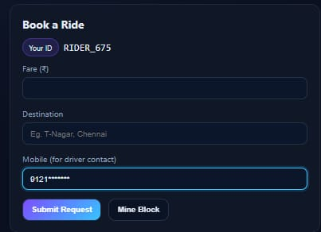
Figure 2. Rider Console
The journey life cycle started with the first ESCROW_PENDING state, which confirmed the system's “transaction” broadcasting functionality. When a rider made a request through the /transactions/new endpoint, the “transaction” was queued to the pending pool straight away. This rapid addition, combined with drivers' capacity to simultaneously query the /transactions/pending endpoint and immediately see these new requests, confirmed the essential role of the ESCROW_PENDING state as a public, real-time listing of available service opportunities, verifying synchronization throughout the distributed environment. The shift into the active phase was also successfully emulated with the show as RIDE_ACCEPTED_IN_PROGRESS state shown in figure 3.
On a driver's acceptance through /ride/accept, the system properly initiated creating a new, associated transaction instead of updating the original record. The ensuing successful fetch of the accepted status by the rider (or driver) through the /driver/active_ride/<driver_id> path ensured that the RIDE_ACCEPTED_IN_PROGRESS state was effectively assigned the intended driver to the ride and moved the service into the active stage. This traceable series of a new, connected transaction for a state transition establishes the effectiveness and integrity of the model of multi-transactional linking in comparison to relying on a single, changeable record.
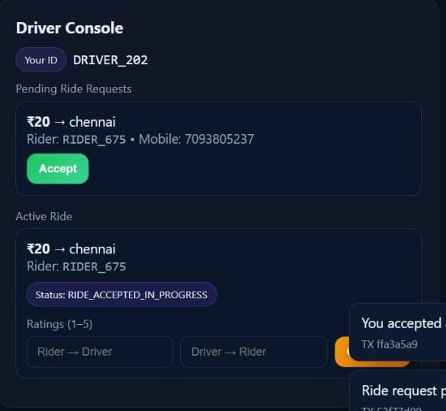
Figure 3. Driver Console
Every activity performed throughout the ride lifecycle—right from the rider's request to the driver's acceptance—were appropriately captured and logged, testifying to the system's adherence to an immutable audit trail. In invoking the mining process, all outstanding transactions were grouped together, closed into a new block, and appended to the chain. Confirmation through the chain output repeatedly verified that all the blocks were properly chained by the SHA-256 hash as shown in figure 4, with the 'previous_hash' of the next block precisely matching the 'hash' of the previous block, thus authenticating the very foundation of data security and cryptographic immutability. In addition, the records in the mined blocks ensured accurate sequencing of transaction states, unmistakably demonstrating the initial ESCROW_PENDING transaction, followed by RIDE_ACCEPTED_IN_PROGRSS transaction as shown in figure 4, which together ensured a clear, immutable history of the service agreement acceptable for dispute resolution. Reputation ledger was successfully updated, ensuring that the scoring logic is rightfully and solely attributed to the ESCROW_RELEASED_COMPLETED state. The system ensures transparent ride tracking and accurate reputation updates tied to completed transactions.
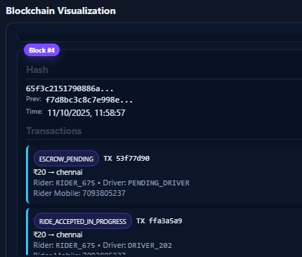
Figure 4. Blockchain Visualizations
Completion of the trip via the /ride/complete endpoint successfully generated the final transaction, mandating the inclusion of both the driver's and rider's ratings. This transaction, once mined, represented the final state, signaling service closure and settlement. Following the mining of the final block, the /reputation/<user\_id> endpoint showed updated scores, confirming that the _process_mined_transactions function successfully isolated the completed transaction and applied the reputation logic. For instance, a 5-star rating on a high-fare transaction resulted in a measurably larger increase in the user's reputation score compared to a neutral 3-star rating, which validates the fare-based scaling formula of the dynamic reputation mechanism, ensuring that score changes are proportional to the economic significance of the interaction.

CONCLUSION
The suggested decentralized ride-sharing system rectifies well the shortcomings of conventional centralized systems through the usage of blockchain technology for secure, transparent, and equitable transactions. Through the implementation of a private blockchain using a “Proof of Authority (PoA)” consensus algorithm, the system realizes quicker validation as well as lower operational expenses than that of public blockchain implementations. The addition of decentralized, peer-to-peer (P2P) ride matching eliminates intermediaries, allowing for direct and reliable communication between drivers and riders. Services like decentralized identity verification, escrow payment, and an immutable reputation system provide increased privacy, integrity of data, and justice within the system. The entire system illustrates how blockchain technology can revolutionize mobility services through increased efficiency, reliability, and end-user trust.

FUTURE SCOPE
The future, this decentralized system can be enhanced by adding token-based payments for financial transactions and reward systems. AI-based ride forecasting and pricing models integration would enhance route optimization and matching accuracy. The system could also implement off-chain storage or side-chain solutions to manage large amounts of ride data efficiently. The use of IoT-based vehicle tracking, multi-signature smart contracts, and cross-chain interoperability would add further security, transparency, and scalability. Extending the network to accommodate multi-city operations and connections with electric or autonomous vehicle fleets can enable the platform to transition to a smart mobility ecosystem.

REFERENCES
- Khadija Rammeh Houerbi, Dorra Machfar, Hella Kaffel-Ben Ayed, “Blockchain for Ridesharing: A Systematic Literature Review,” 2023 International Conference on Smart Applications, Communications and Networking (SmartNets), Istanbul, Türkiye, July 2023. DOI: 10.1109/SmartNets58706.2023.10215951
- Daeun Lee, Soochang Park, Woojin Park, Taehun Yang, Sang-Ha Kim, “Fine-grained Passenger-Vehicle Coupling Management for Secure Ride-Sharing Services,” 2023 IEEE 97th Vehicular Technology Conference (VTC2023), Florence, Italy, June 2023. DOI: 10.1109/VTC2023-Spring57618.2023.10200141
- J. Wessly, R. Durga, “Enhancing Car Pooling Systems Transactions using Consortium Blockchain-based Randomized Integrity Distributed Exchange Approach,” 2024 8th International Conference on Electronics, Communication and Aerospace Technology (ICECA), Coimbatore, India, November 2024. DOI: 10.1109/ICECA63461.2024.10801149
- Arunkumar J, Aswathy M, Rohit Mathew Samuel, Sai Shibu N B, “Design of Blockchain and Smart Contract enabled Ride Sharing Platform,” 2024 IEEE International Conference for Women in Innovation, Technology & Entrepreneurship (ICWITE), Bangalore, India, February 2024. DOI: 10.1109/ICWITE59797.2024.10502621
- Klimis S. Ntalianis, Nikos E. Mastorakis, “Quality of Experience Oriented Eco-Friendly Taxi-Ride Sharing Recommendation Framework,” IEEE Access, Volume: 12, October 2024. DOI: 10.1109/ACCESS.2024.3485221
- Yafei Li, Huiling Li, “Utility-Aware Dynamic Ridesharing in Spatial Crowdsourcing,” IEEE Transactions on Mobile Computing, Volume: 23, Issue: 2, February 2024. DOI: 10.1109/TMC.2022.3232215
- Andre Eka Putra Simanjuntak, Nungki Selviandro, Gia Septiana Wulandari, “Comparison of A-Star and IDA-Star Algorithms in Ride-Sharing AV Route Implementation for Warehousing,” 2024 IEEE International Conference on Artificial Intelligence and Mechatronics Systems (AIMS), Bandung, Indonesia, February 2024. DOI: 10.1109/AIMS61812.2024.10512427
- J. Wessly, R. Durga, “Blockchain Ethereum-Based Decentralized Secure Ride-Sharing Framework for Carpooling System,” 2024 4th International Conference on Ubiquitous Computing and Intelligent Information Systems (ICUIS), Gobichettipalayam, India, December 2024. DOI: 10.1109/ICUIS64676.2024.10866435
- “Towards Efficient Urban Network Mobility: A Cloud-Based Ride-Sharing System,” 2024 International Wireless Communication and Mobile Computing, Ayi Napa, Cyprus, May 2024. DOI: 10.1109/IWCMC61514.2024.10592395
- Omar Ait Oualhaj, Ali Azougaghe, Assia Naja, Abdelfettah Mabrouk, “Development of Campus Ride-Sharing Application for Shuttle Rides,” 2024 IEEE 5th International Conference on Electro-Computing Technologies for Humanity (NIGERCON), Ado Ekiti, Nigeria, November 2024. DOI: 10.1109/NIGERCON62786.2024.10927345
- Anu B Kempannavar, Aahana Nagesh Nayak, Akash Nair, “A Novel Ride Discovery Scheme for Ride Sharing Systems: a DQN Approach,” 2025 11th International Conference on Communication and Signal Processing (ICCSP), Melmaruvathur, India, June 2025. DOI: 10.1109/ICCSP64183.2025.11088810
- Avani Acharya, Pradeep Kanchan, Ashlin Dsouza, Chaithra M, “Decentralization, Customization, and Emergency Assistance: The Next Generation of Ride-Sharing,” 2025 IEEE International Conference on Interdisciplinary Approaches in Technology and Management for Social Innovation (IATMSI), Gwalior, India, March 2025. DOI: 10.1109/IATMSI64286.2025.10985318
- Wanxin Li, Collin Meese, Mark Nejad, Hao Guo, Jie Zhang, “Bidirectional Authentication for Safe Ridesharing Empowered by Permissioned Blockchain,” 2025 IEEE Global Blockchain Conference (GBC), Shanghai, China, June 2025. DOI: 10.1109/GBC60041.2025.11134467
- Aqsa Ashraf Makhdomi, Iqra Altaf Gillani, “Collaborative Fair Route Planning in Decentralized Platforms: A Game Theoretic Perspective,” IEEE Transactions on Intelligent Transportation Systems (Early Access), July 2025. DOI: 10.1109/TITS.2025.3581701

