Textile Waste Intelligence Platform
Milestone 2 — Cloth Analysis Report
Material Recognition & Waste Classification Engine Output
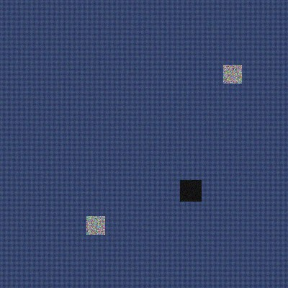
Fig. 1 — Sample garment submitted for analysis

1. Report Summary
Report Type | Automated Textile Waste Classification Report
Generated | 2026-07-24
Sample Item | Woven garment sample (sample_denim_garment.jpg)
Pipeline Stage | Milestone 2 — Weeks 3 & 4
Predicted Material | Nylon
Waste Category | Reusable
Recyclability Score | 84.3 / 100

2. Textile Image Analysis Engine — Visual Features
The image is resized and passed through the color, texture, pattern, damage, and contamination analysis stages. Results below are the raw numeric outputs (0–1 normalized unless noted).
Feature | Value
Mean Color (RGB) | 55.2, 69.8, 109.6
Brightness | 0.2745
Saturation | 0.4969
Color Spread (std) | 0.033
Texture Roughness | 0.0365
Texture Uniformity | 0.7282
Edge Density (pattern) | 0.0182
Pattern Regularity | 0.9947
Damage Score | 0.0938
Contamination Score | 0.0174

3. Visual Analysis Outputs
Each stage of the Image Analysis Engine produces a visual output alongside its numeric score, so results can be checked by eye. All images below are also included as separate downloadable PNG files in the reports/images folder.
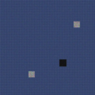
Fig. 2 — Resized input (128×128) as seen by the model

Fig. 3 — Grayscale (luma) used for texture/edge analysis
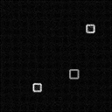
Fig. 4 — Edge / pattern map (gradient magnitude → weave regularity)

Fig. 5 — Texture roughness heatmap (blue = smooth, red = high local variance)
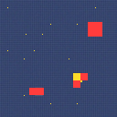
Fig. 6 — Damage (red) & contamination (yellow) regions overlaid on the original

Fig. 7 — Dominant color swatch (mean RGB)

4. Material Classification Engine
Predicted Material | Nylon
Confidence | 51.7%
Fiber Category | Synthetic
Blend Type | Blended
Fiber Composition | Nylon 70% / Polyester 30%
Quality Estimate | Excellent (score 0.782)
Model | nearest-centroid (Milestone 2 baseline, 10-class)
Top candidate materials ranked by feature distance (closer = more likely):
- 1. Nylon — distance 0.6363
- 2. Polyester — distance 0.6455
- 3. Silk — distance 0.7448
- 4. Rayon — distance 0.7543

5. Textile Waste Classification Engine
Waste Category | Reusable
Recyclability Score | 84.3 / 100
Reuse Potential | High
Damage Detected | No
Contamination Detected | No
Disposal Recommendation:
Clean and list for direct reuse/resale or donation; item is in wearable condition.

6. Recycling Recommendation Engine
Recommended recycling / reuse routes for this item, based on its waste category:
- Donation
- Fabric Reuse

7. Supported Reference Data
Supported Materials (10):
Cotton, Polyester, Wool, Silk, Linen, Denim, Nylon, Rayon, Acrylic, Mixed Fabrics
Waste Categories (6):
Recyclable, Reusable, Repairable, Upcyclable, Compostable, Hazardous Textile Waste
Recycling Routes (7):
Fiber Recycling, Mechanical Recycling, Chemical Recycling, Fabric Reuse, Upcycling, Donation, Industrial Recovery

8. Notes & Methodology
- Visual features are computed with PIL + NumPy only (no external CV/DL dependency), keeping the pipeline lightweight and fully auditable.
- Material classification uses a nearest-centroid model over domain-informed reference profiles — a transparent baseline, not a black-box deep model, appropriate for this milestone since no labeled fabric-image dataset was available.
- Waste classification is a rule-based decision layer combining material type with damage/contamination signals, so every category decision can be traced back to a specific rule.
- This report was generated from a representative sample image to demonstrate the full analysis pipeline end-to-end. Uploading real garment photos through the running application (analysis.html → /api/analysis/upload) produces the same report structure with live-computed values, and persists the result to analysis history.
- Every visualization in Section 3 (resized input, grayscale, edge map, texture heatmap, damage/contamination overlay, color swatch) is also saved as a standalone PNG in reports/images/, so any single output can be downloaded and used on its own — e.g. for a slide, a QA ticket, or side-by-side comparison across garments.

