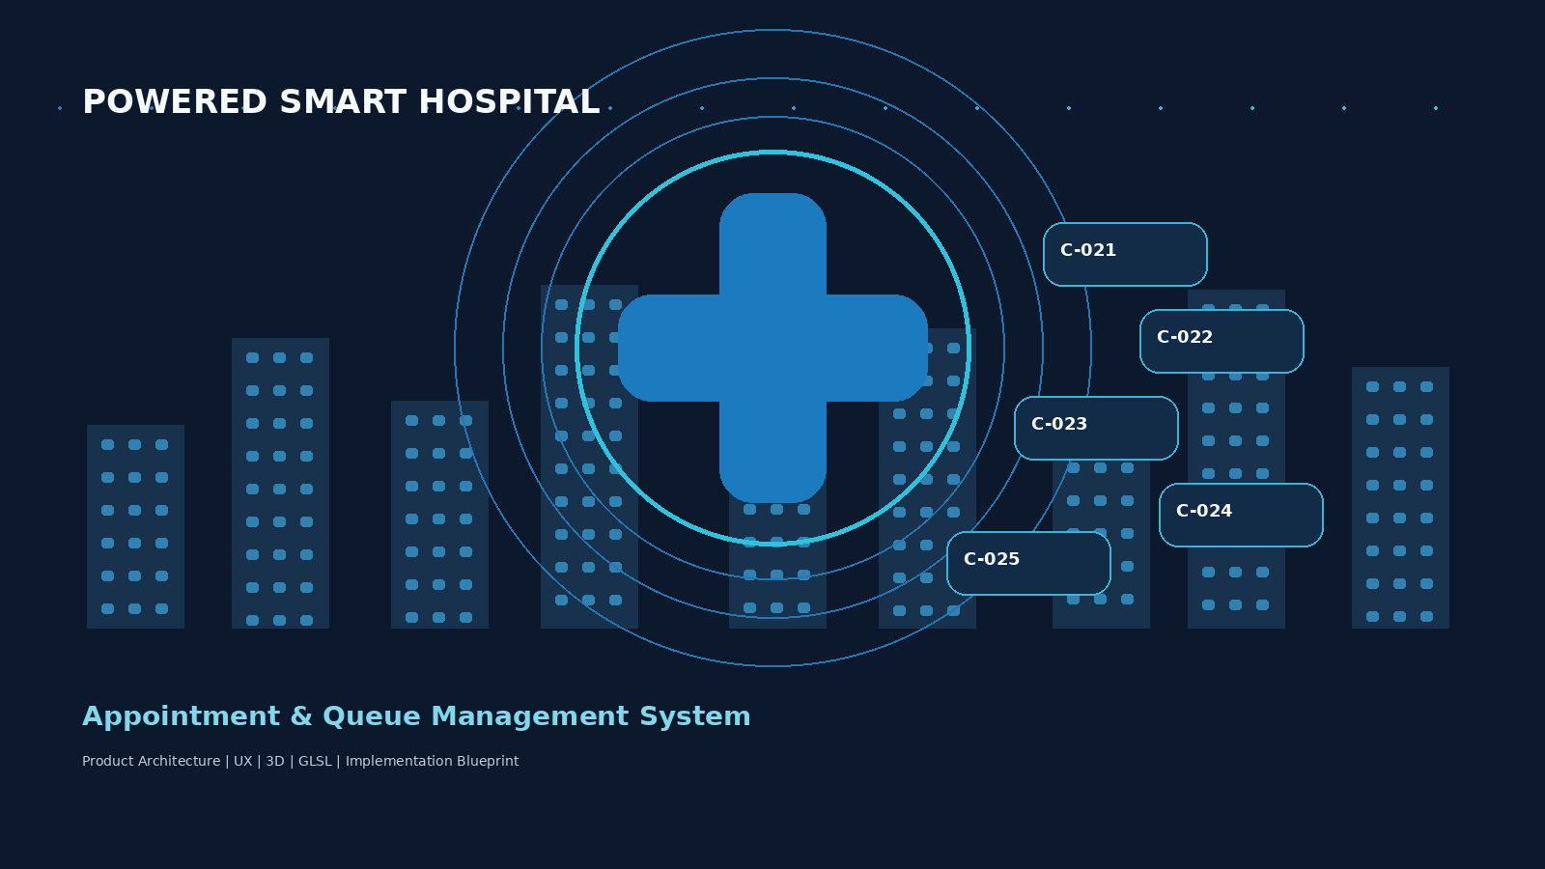
POWERED SMART HOSPITAL
Appointment & Queue Management System
MASTER PRODUCT, UX, TECHNICAL & 3D IMPLEMENTATION BLUEPRINT
Prepared as the working specification for a real-life hospital workflow prototype

1. Executive Summary
This document converts the project idea into an implementation-ready plan for a realistic hospital appointment and queue management website. The core design decision is to treat an appointment request, a confirmed appointment, a check-in event, a queue token and a completed consultation as separate operational states. That prevents the system from behaving like a simple random appointment form.
The design combines a clear hospital operations model with a futuristic 3D visual layer. The 3D/WebGL/GLSL layer is decorative and informational; critical hospital actions remain conventional HTML/CSS controls so the system stays readable, testable and accessible.

2. Research Re-check: What Was Verified and What Changed
Topic | Verified finding | Design consequence
Hospital scheduling model | HL7 FHIR separates Schedule/Slot availability from actual Appointments; clinical scheduling can be more complex and queue-like than a consumer calendar. [1][2] | Keep request, schedule/slot decision, confirmed appointment and queue entry as different concepts.
India digital-health context | ABDM currently provides sandbox building blocks around ABHA services and consent management; the platform is relevant context for a future India-facing integration, not a requirement for this no-API prototype. [3] | Design patient identity/consent concepts so a future ABDM integration can be added without redesign.
Privacy & security | WHO stresses cybersecurity/privacy risk management across digital health information systems; OWASP recommends robust authentication monitoring and logging. [4][5] | Include role-based access, audit events, privacy boundaries and secure error handling in the blueprint.
Accessibility | WCAG 2.2 remains the current W3C accessibility recommendation, with AA covering additional usability requirements including target size and accessible authentication. [6][7] | The futuristic UI must still support keyboard access, readable contrast, visible focus and accessible forms.
Double-click HTML constraint | MDN explicitly notes that JavaScript modules loaded from file:// can run into CORS/security errors and should be tested through a server. [8] | Do not depend on ES-module imports for the double-click prototype. Use classic scripts or a built single-file/bundled output.
Imba | Official Imba documentation describes Imba as compiling to JavaScript and provides a standard project workflow. [9] | Imba can be used as a source/component layer, but the deliverable used for double-click execution must be compiled into browser-ready assets.
OpenSCAD | Official documentation supports exporting models such as STL and other formats, and command-line export is supported. [10][11] | Use OpenSCAD to create parametric hospital/medical objects, then convert/optimize as needed for WebGL.
Result of the re-check: the original direction was correct, but the operating model needed stronger separation between request, appointment, check-in and token, plus explicit security, accessibility and local-file execution constraints.

3. Project Scope & Objectives
- Build a realistic appointment request and queue management workflow for a hospital setting.
- Give hospital staff control over which requested appointments become confirmed appointments.
- Generate queue tokens only after the patient enters the active queue through check-in/queue admission.
- Provide role-specific dashboards for patients, reception/operators, doctors and administrators.
- Create a polished 3D visual identity without allowing 3D effects to obstruct hospital actions.
- Keep the first prototype runnable by opening index.html directly, with no mandatory API key or cloud backend.

4. Users, Roles & Responsibilities
Role | Primary goal | Core actions | Critical permissions
Patient | Request care and understand waiting position | Request, track, confirm, check-in, view token, track queue, view history | Own records + permitted appointment/queue views
Reception / Operator | Convert requests into operational appointments and manage arrivals | Review, approve, reject, offer alternatives, reschedule, check-in, issue/admit token, manage queue | Operational appointment + queue control
Doctor | Run the consultation queue | View today, call next, recall, skip/hold, complete consultation | Own queue + clinical workflow actions
Administrator | Configure hospital operations | Doctors, departments, schedules, rules, capacity, reports, users | System configuration and oversight

5. Core Real-Life Workflow
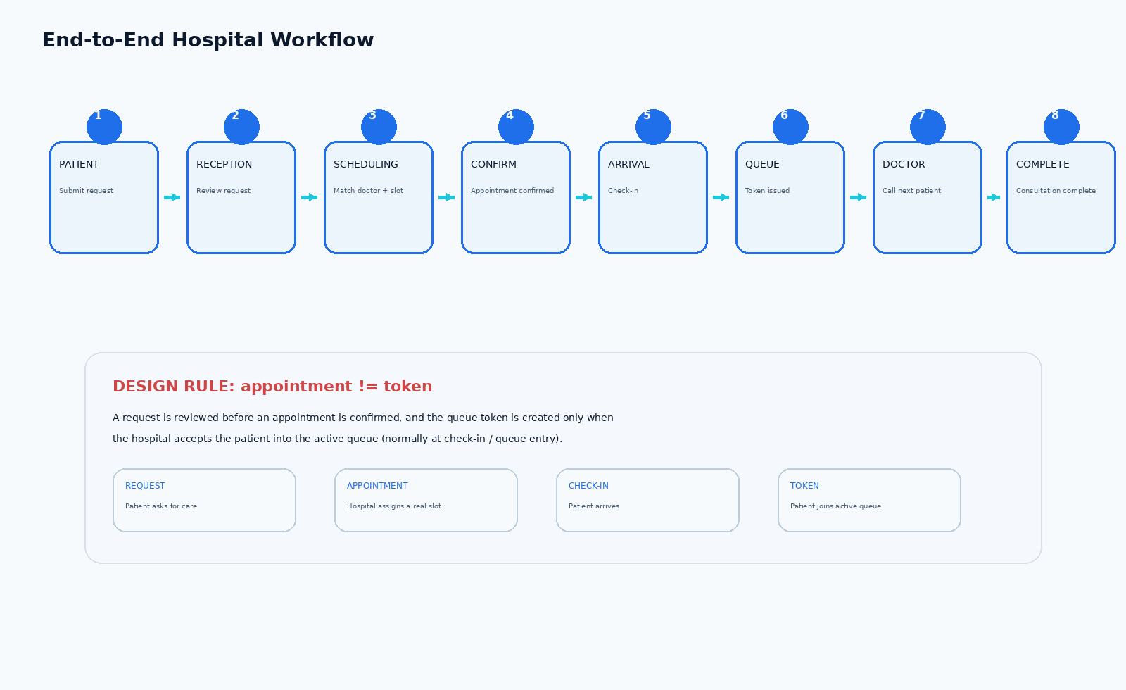
Figure 1. End-to-end workflow and the separation between appointment confirmation and queue token generation.
The central rule is: an appointment request is not automatically an appointment, and an appointment is not automatically a queue token. A hospital operator or scheduling process must review the request, check actual availability and create the confirmed appointment. The patient then arrives and checks in before entering the active queue.

6. Appointment State Model
Object | Recommended states | Meaning
Appointment Request | DRAFT -> SUBMITTED -> UNDER_REVIEW -> APPROVED / ALTERNATIVE_OFFERED / REJECTED / CANCELLED | A patient intent/request that the hospital still has to act on.
Appointment | CONFIRMED -> RESCHEDULED -> CHECKED_IN -> IN_QUEUE -> IN_CONSULTATION -> COMPLETED / NO_SHOW / CANCELLED | A real booking tied to a doctor/service schedule.
Queue Entry / Token | WAITING -> CALLED -> IN_CONSULTATION -> COMPLETED; with SKIPPED / RECALLED / HELD as operational states | A patient currently participating in the department/doctor queue.

7. Queue & Token Architecture
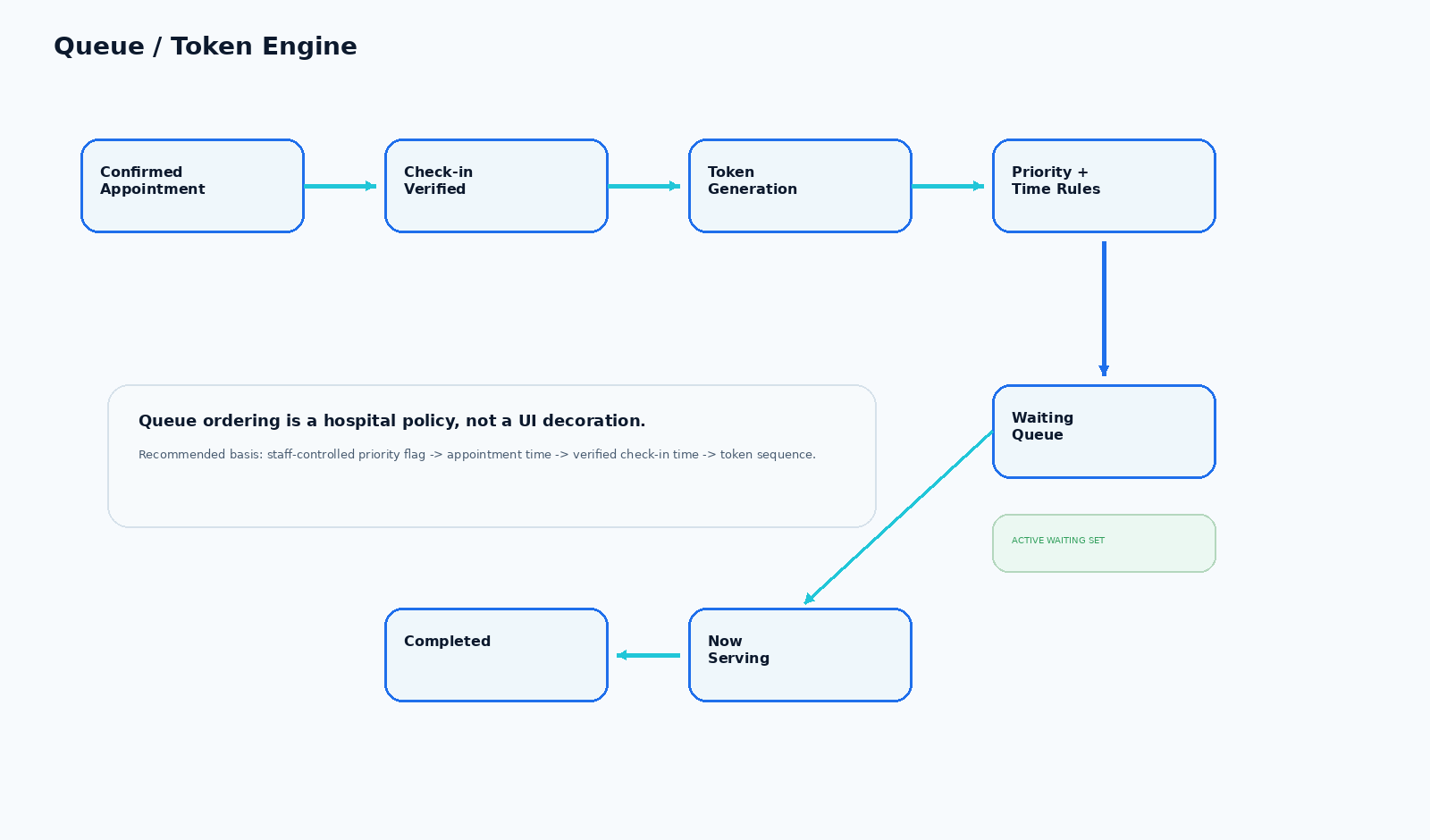
Figure 2. Recommended queue engine. The exact ordering policy should be configurable by hospital policy rather than hard-coded as a universal “first come, first served” rule.
Suggested token format: use a department/queue prefix plus a sequence number, such as C-021 for Cardiology or N-014 for Neurology. The prefix identifies the queue and reduces ambiguity across departments.
Queue state | Patient meaning | Doctor meaning | Reception meaning
WAITING | Waiting for call | Next/remaining work | Patient is active in queue
CALLED | Must proceed to consultation | Patient has been called | Monitor response / recall if needed
IN_CONSULTATION | Being seen | Consultation active | Queue position temporarily occupied
COMPLETED | Done | Consultation finished | Close queue entry
NO-SHOW / SKIPPED | Missed or deliberately skipped | Move forward | May recall or mark outcome

8. Screen Architecture & Page Connections
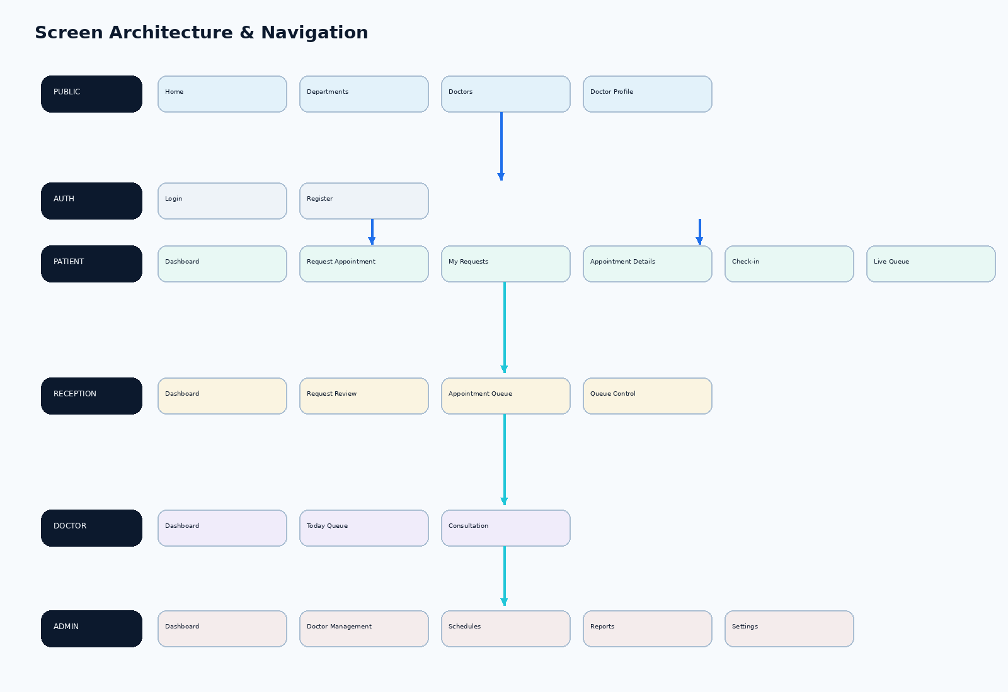
Figure 3. High-level navigation architecture.
The full prototype is best organized as approximately 20 primary screens/views. Several are role dashboards or management views; they do not all need independent visual shells if a single-page application/router implementation is later preferred.
# | Screen | Role | Key content
01 | Home / Landing | Public | Hero, how-it-works, departments, doctors, queue explanation, footer
02 | Departments | Public | Department cards, doctor counts, availability entry points
03 | Doctor Directory | Public | Search/filter by department, specialty, availability
04 | Doctor Profile | Public | Doctor identity, specialty, schedule, request entry
05 | Login | Auth | Secure sign-in and role routing
06 | Registration | Auth | Patient account creation and patient ID
07 | Patient Dashboard | Patient | Upcoming appointment, request status, queue status
08 | Request Appointment | Patient | Department -> doctor -> reason -> preferred date/time -> review
09 | My Requests | Patient | Request tracking and status timeline
10 | Appointment Details | Patient | Confirmed booking, doctor, date, room, status
11 | Check-in | Patient | Arrival confirmation and queue admission
12 | Live Queue | Patient | Token, now serving, patients ahead, estimate, queue line
13 | Reception Dashboard | Reception | Operational KPIs and incoming work
14 | Request Review | Reception | Patient/request data + availability + decision actions
15 | Queue Control | Reception | Call, recall, skip, hold, complete
16 | Doctor Dashboard | Doctor | Current patient, next patient, queue controls, consultation entry
17 | Admin Dashboard | Admin | Hospital-wide overview
18 | Doctor Management | Admin | Doctors, departments, status, specialty
19 | Schedule Management | Admin | Working hours, breaks, capacity, blocked periods
20 | Reports & Settings | Admin | Wait times, no-shows, workload, rules, configuration
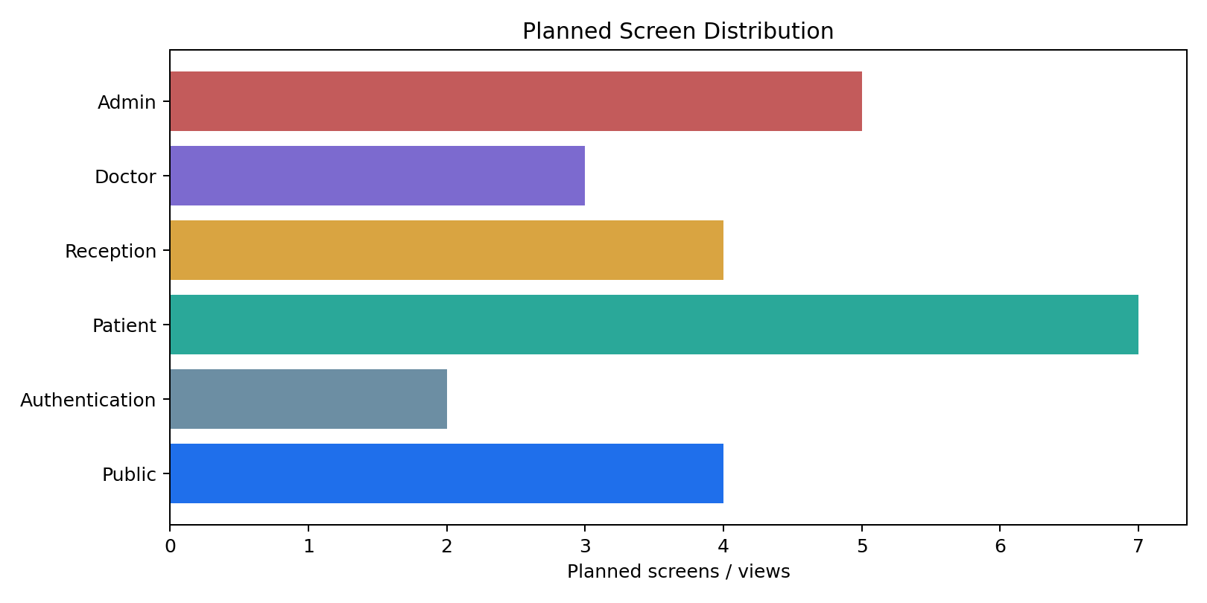
Figure 4. Planned screen distribution by functional area.

9. Screen-by-Screen Content Specification
# | Screen | Required content
01 | 01 Home / Landing | Hero 3D hospital scene; primary actions; How It Works; departments; featured doctors; live queue concept; trust/safety note; footer.
02 | 02 Departments | Department cards; specialty description; active doctor count; service availability; search/filter; “View Doctors” action.
03 | 03 Doctor Directory | Search; department filter; specialty filter; availability filter; doctor cards with name, specialty, experience, available times, profile/request actions.
04 | 04 Doctor Profile | Doctor identity; qualifications; specialty; experience; department; available days; working hours; queue status; appointment request action.
05 | 05 Login | Email/mobile or hospital-approved identifier; password; accessible error state; forgot password; registration link; role-aware routing after login.
06 | 06 Registration | Name; DOB; gender; mobile; email; address; emergency contact; password; consent/privacy acknowledgement; generated patient ID.
07 | 07 Patient Dashboard | Welcome; patient ID; upcoming appointment; request status; live queue card; quick actions; history/profile links.
08 | 08 Request Appointment | Department -> doctor -> reason for visit -> follow-up flag -> preferred date -> preferred time range -> review -> submit request.
09 | 09 My Requests | Request cards; status timeline; submitted date; requested doctor/department; patient-entered reason; alternative offer response; cancel where policy allows.
10 | 10 Appointment Details | Appointment ID; doctor; department; date/time; location/room; confirmed status; check-in readiness; cancellation/reschedule policy.
11 | 11 Check-in | Appointment verification; arrival confirmation; hospital/department confirmation; check-in result; queue-admission message; token reveal.
12 | 12 Live Queue | Queue name; now serving; patient token; patients ahead; estimated wait; ordered token list; last-updated indicator; reduced-motion alternative.
13 | 13 Reception Dashboard | Pending requests; today appointments; waiting patients; active queues; exceptions; quick links to review and queue control.
14 | 14 Request Review | Patient summary; request details; reason; preferred window; doctor availability; slot/capacity information; Approve/Alternative/Reschedule/Reject actions; reason for decision.
15 | 15 Queue Control | Queue selector; current token; waiting list; call; recall; skip; hold; complete; operational notes; exception log.
16 | 16 Doctor Dashboard | Today schedule; active queue; current token; next token; patient context needed for workflow; call/recall/hold/complete actions.
17 | 17 Admin Dashboard | Hospital KPIs; department workload; doctor availability; queue performance; request backlog; system alerts.
18 | 18 Doctor Management | Doctor records; department; specialty; active/inactive status; working pattern; edit/add actions.
19 | 19 Schedule Management | Doctor schedule; working days; start/end; breaks; capacity; blocked periods; open/closed slots; conflict warnings.
20 | 20 Reports & Settings | Average wait; queue length; no-shows; appointment volume; doctor utilization; peak hours; queue rules; token format; system preferences.

10. Patient Journey
1. Find department or doctor
2. Open doctor profile
3. Start appointment request
4. Enter reason for visit and preferred timing
5. Submit request
6. Track 'Under Review' status
7. Receive hospital decision
8. Confirm accepted alternative if offered
9. Arrive at hospital and check in
10. Receive queue token
11. Track live queue
12. Respond when called
13. Consultation completed
14. View appointment history

11. Reception / Operator Journey
1. Open incoming request queue
2. Review patient identity and request context
3. Check doctor/department availability
4. Select a valid time slot or approved alternative
5. Approve / alternative / reschedule / reject
6. Patient sees updated request state
7. On arrival, verify check-in
8. Admit patient to department queue and generate token
9. Monitor queue exceptions
10. Recall / skip / hold when operationally necessary
11. Close completed entries
12. Review daily operational metrics

12. Doctor Journey
1. Open today’s schedule
2. See active queue
3. Review current token
4. Call next patient
5. Recall if patient misses the call
6. Pause/hold queue when needed
7. Complete consultation
8. Move queue to the next active token
9. Close day / review remaining queue

13. Wireframe Set
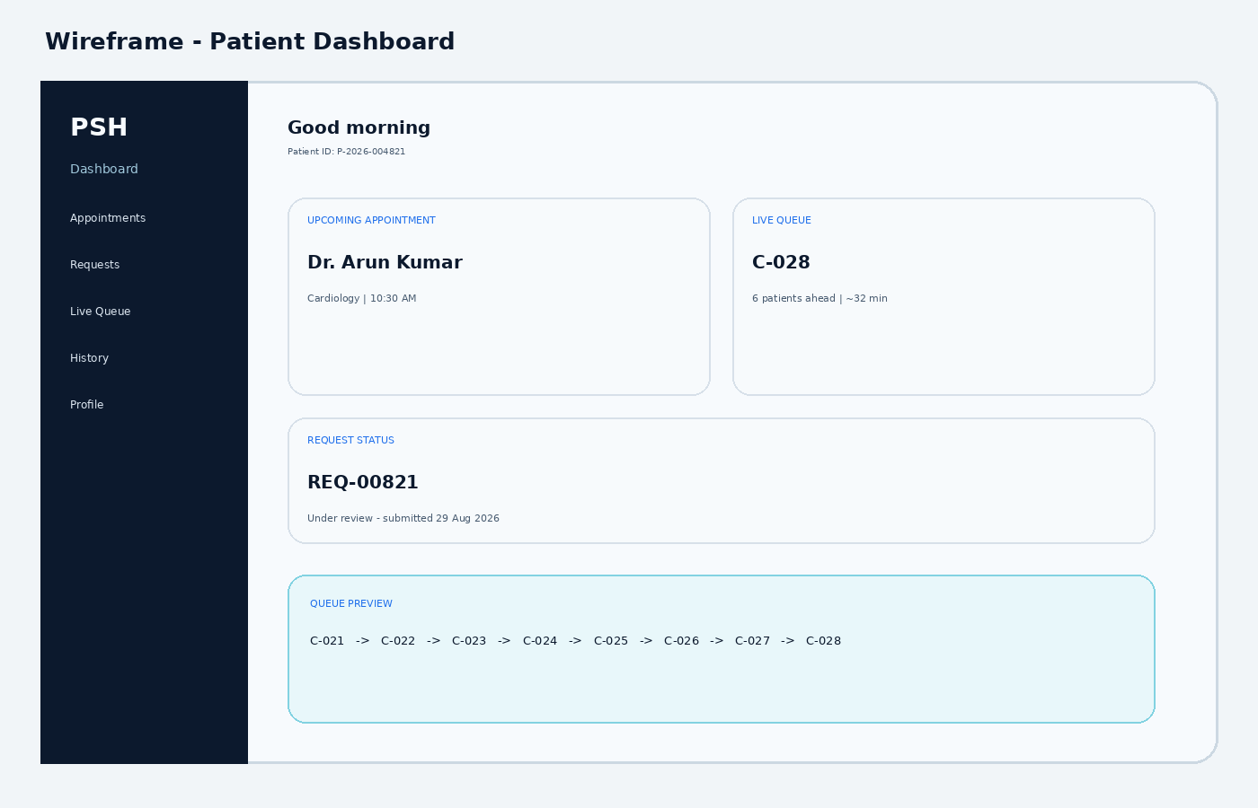
Figure 5. Patient dashboard wireframe.
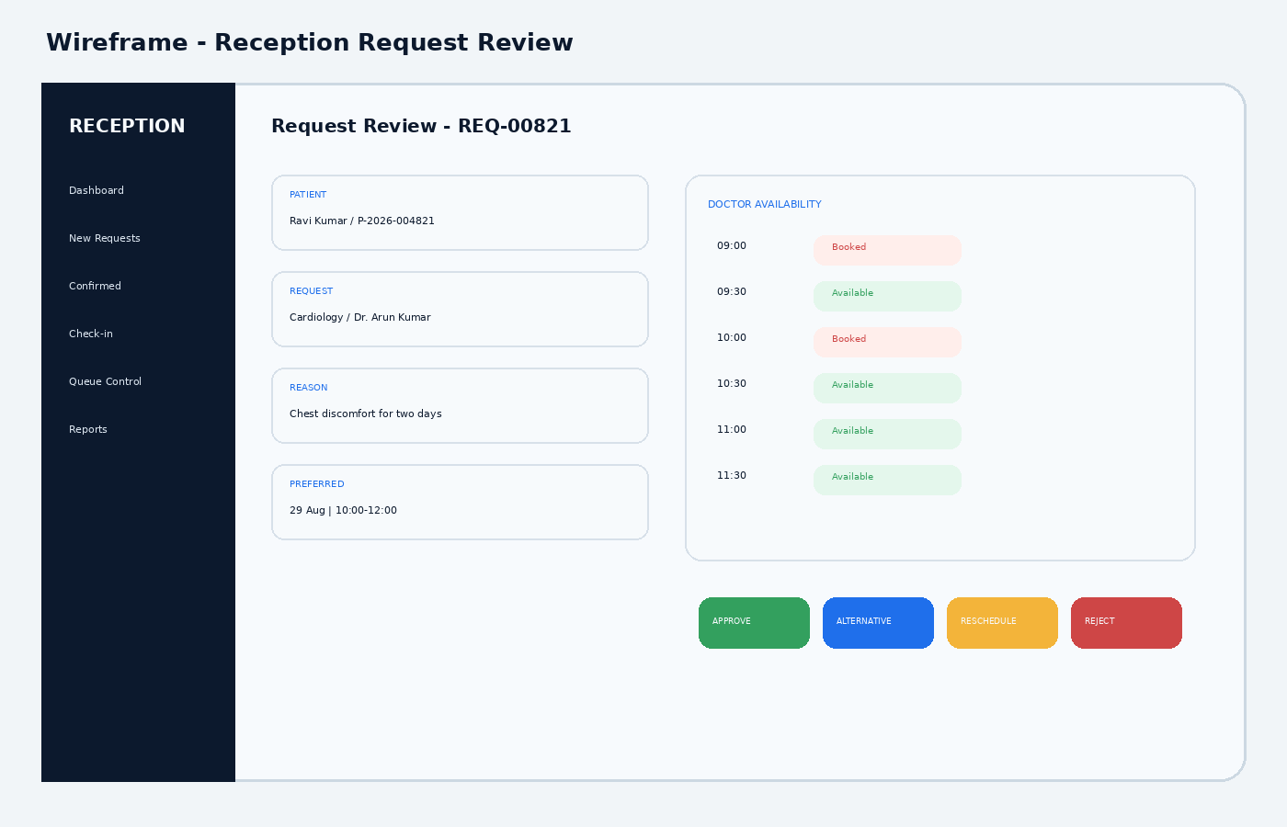
Figure 6. Reception request-review wireframe.
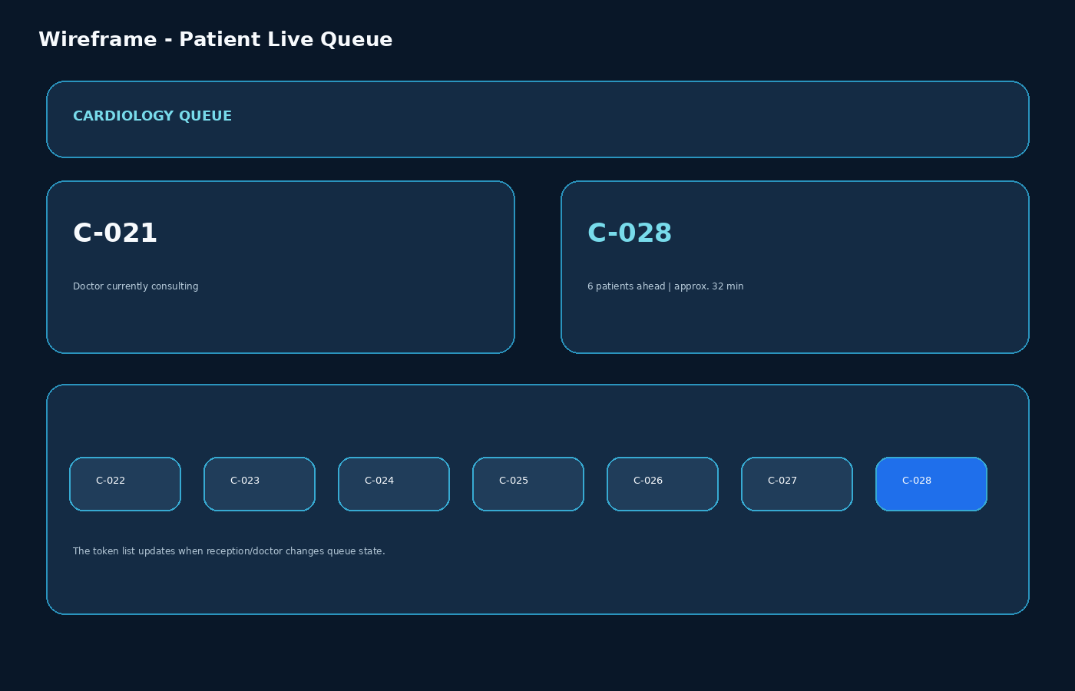
Figure 7. Live queue wireframe.

14. 3D / GLSL / OpenSCAD Visual System
Recommended visual language: “Futuristic Medical Command Center.” Use dark navy/deep blue surfaces, high-contrast text, restrained cyan/teal accents, glass-like panels and controlled depth. Avoid a gaming aesthetic. The visual treatment should feel advanced but still appropriate for a hospital.
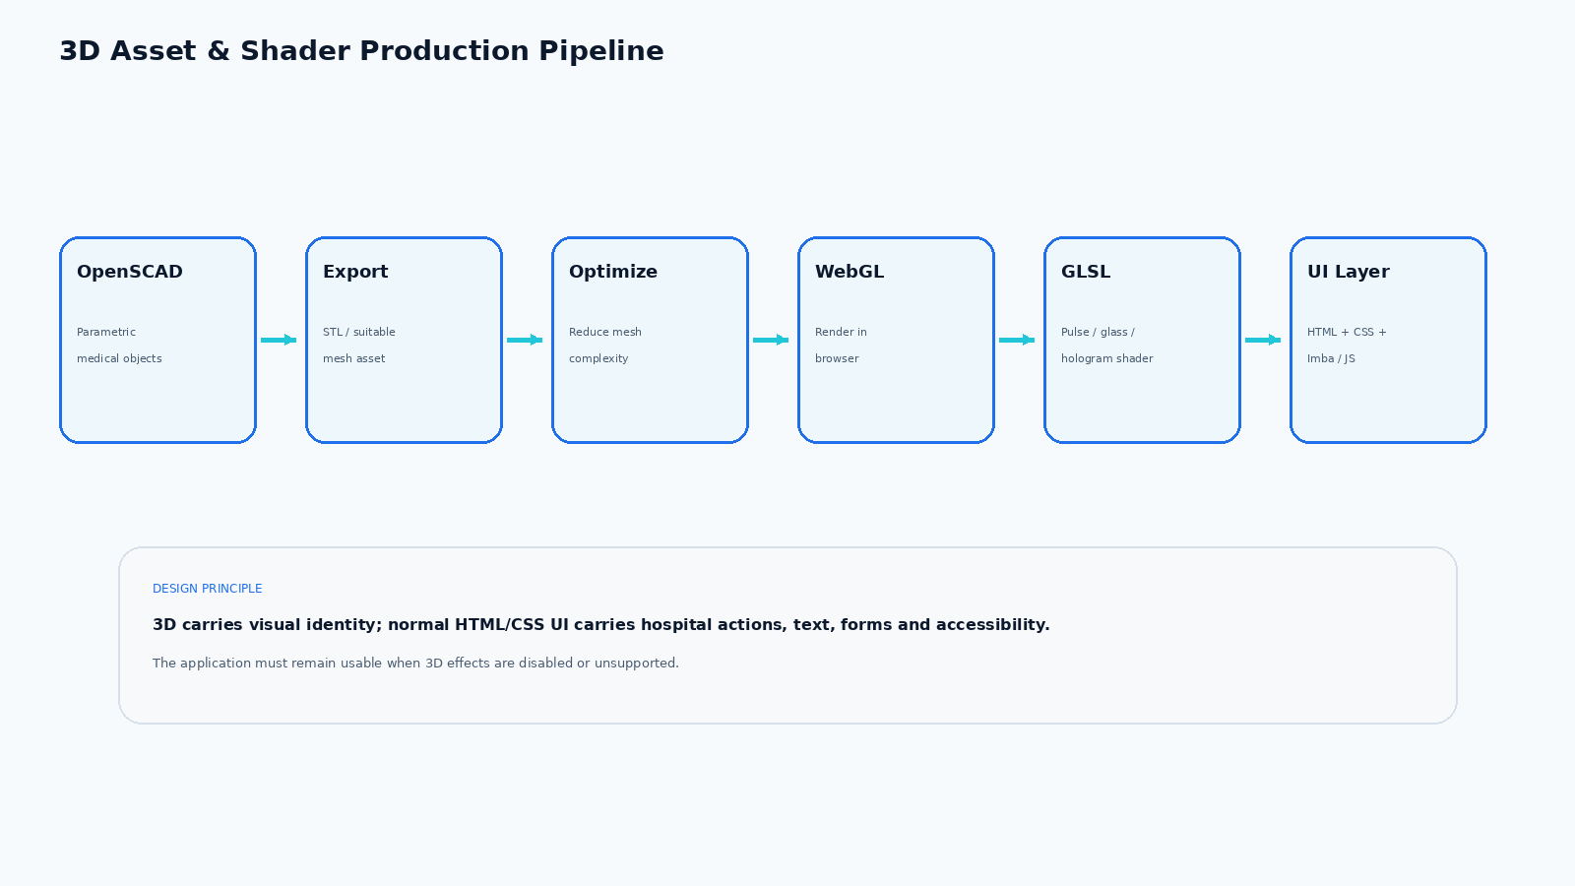
Figure 8. Recommended 3D asset pipeline.

15. 3D Object Production List
Asset class | Recommended objects | Use
Brand / identity | Medical cross, hospital emblem, queue ring, pulse line | Logo, hero, transitions
Hospital environment | Hospital building, reception desk, room, waiting chair, signage | Home, service overview
Clinical objects | Stethoscope, ECG monitor, examination bed, monitor, medical cross | Departments, visual explanations
Queue objects | Token tiles, floating numbered nodes, queue lane | Live queue and dashboards
Decorative system effects | Particles, data arcs, hologram panels, scan lines | Background / atmosphere

16. GLSL Effects
- Medical pulse / ECG-inspired background motion
- Soft holographic glass refraction / edge glow
- Slow particle field for depth
- Subtle scanning sweep for dashboard hero
- Queue-token flow highlight when the active token changes
- Ambient animated gradient/noise texture
Important implementation rule: shader effects must be non-essential. The same page should remain readable and functional when the WebGL layer is hidden, disabled, unsupported or reduced for performance.

17. Technology Stack
Layer | Technology | Decision
Document structure | HTML5 | Mandatory base. Every important interaction must exist in semantic HTML.
Styling | Advanced CSS | Layout, responsive design, glass surfaces, transitions, state styles.
Application logic | JavaScript + optional Imba | Use plain JS for maximum direct-file reliability; use Imba where its component/state model provides value. [9]
3D rendering | WebGL | Browser GPU layer for 3D scene and effects.
Shaders | GLSL | Custom visual effects in the WebGL layer.
3D modelling | OpenSCAD | Parametric asset authoring; export STL/other supported formats, then optimize for web. [10][11]
Prototype persistence | localStorage / JSON | Enough for a self-contained academic/demo prototype without APIs.
Backend | None initially | Keep architecture backend-ready, but do not require one for v1.
API keys | None | The first prototype should run without API keys.

18. Critical “Double-Click index.html” Constraint
The requirement that the project work when index.html is opened directly has a major technical consequence. Browser ES modules loaded from file:// can run into CORS/security restrictions. [8] Therefore the first prototype should avoid a dependency on browser-side import statements that require an HTTP server.
- Use classic <script src="..."> loading or a bundled browser-ready JavaScript file.
- Do not make core functionality depend on fetch() reading local JSON files.
- Keep demo data in JavaScript objects or embedded JSON that is already inside the page bundle.
- Use localStorage for persistence in the prototype.
- Treat the build/compile stage as separate from the final double-click deliverable.
- Test the exact final deliverable by closing any development server and opening index.html directly.

19. Data Model
Entity | Key fields | Linked to | Purpose
Patient | patientId, name, DOB, gender, contact, address, emergencyContact | Requests, appointments, queue entries | Patient identity
Department | departmentId, name, description | Doctors, queues, schedules | Clinical service group
Doctor | doctorId, name, specialty, departmentId, status | Schedules, appointments, queue | Care provider
Schedule / Slot | scheduleId, doctorId, date, start, end, status, capacity | Appointment | Defines actual availability
Appointment Request | requestId, patientId, departmentId, doctorId, reason, preferredPeriod, status | Appointment | Captures patient request before confirmation
Appointment | appointmentId, requestId, slotId, doctorId, patientId, status | Check-in, queue | Confirmed booking
Check-in | checkInId, appointmentId, timestamp, verifiedBy | Queue | Records arrival / admission
Queue Entry | queueEntryId, token, appointmentId, priorityFlag, state, timestamps | Doctor / department queue | Operational queue participation
Consultation | consultationId, appointmentId, doctorId, start/end, outcomeStatus | Appointment | Completion record
Audit Event | eventId, actor, role, action, timestamp, target | All major workflows | Accountability and troubleshooting
FHIR terminology is useful as a conceptual reference even when this prototype does not implement FHIR APIs. HL7 separates Schedule/Slot availability from Appointment data, which reinforces the design above. [1][2]

20. Security, Privacy & Safety Requirements
- Role-based access: patients cannot access reception/doctor/admin screens.
- Audit important workflow events: login failures, approval/rejection, schedule changes, queue actions and account changes. [5]
- Minimize sensitive information shown on public queue displays. Show token and queue status rather than exposing patient names in a waiting-room display.
- Do not infer or automatically diagnose medical conditions from the patient’s reason-for-visit text. The reason field is operational context, not a diagnostic engine.
- Use clear consent/privacy messaging and keep a future path for India-specific digital-health integration such as ABDM if the project later expands. [3][4]
- For a real deployment, apply the organization’s applicable health, privacy, cybersecurity and record-retention requirements; this blueprint is an academic/product architecture document, not a legal compliance certification.

21. Accessibility & Usability Requirements
- Target WCAG 2.2 AA as the practical design benchmark. [6][7]
- All critical buttons and form fields must work with keyboard navigation.
- Use visible focus states and sufficiently large click/tap targets.
- Do not encode queue meaning only with color; pair colors with text/state labels.
- Use readable font sizes and strong contrast in the dark 3D theme.
- Provide a “Reduce motion / simplified mode” option for the 3D-heavy experience.
- Ensure forms expose labels and validation errors in text, not only animation or color.

22. Design System / Reusable UI Components
Component | Purpose
Global header | Reusable across patient, staff or admin screens where applicable.
Role-aware sidebar | Reusable across patient, staff or admin screens where applicable.
Primary / secondary / destructive buttons | Reusable across patient, staff or admin screens where applicable.
Status badge | Reusable across patient, staff or admin screens where applicable.
Request status timeline | Reusable across patient, staff or admin screens where applicable.
Doctor card | Reusable across patient, staff or admin screens where applicable.
Department card | Reusable across patient, staff or admin screens where applicable.
Schedule/slot cell | Reusable across patient, staff or admin screens where applicable.
Appointment summary card | Reusable across patient, staff or admin screens where applicable.
Queue token card | Reusable across patient, staff or admin screens where applicable.
Now-serving display | Reusable across patient, staff or admin screens where applicable.
Queue row | Reusable across patient, staff or admin screens where applicable.
Search + filter bar | Reusable across patient, staff or admin screens where applicable.
Date/time selector | Reusable across patient, staff or admin screens where applicable.
Modal / confirmation dialog | Reusable across patient, staff or admin screens where applicable.
Toast / notification | Reusable across patient, staff or admin screens where applicable.
Empty state | Reusable across patient, staff or admin screens where applicable.
Loading state | Reusable across patient, staff or admin screens where applicable.
Error state | Reusable across patient, staff or admin screens where applicable.
Table / pagination control | Reusable across patient, staff or admin screens where applicable.
Metric card | Reusable across patient, staff or admin screens where applicable.
3D scene shell | Reusable across patient, staff or admin screens where applicable.
Shader background layer | Reusable across patient, staff or admin screens where applicable.

23. Animation & Transition Rules
Motion tier | Typical duration | Examples
Micro interaction | 150-250 ms | Button hover, focus, badge change
Page transition | 400-700 ms | Dashboard/view transition, modal enter/exit
3D ambience | 2-8 s loops | Particles, slow object drift, shader noise
Queue event | 500-1200 ms | Token moves, active state highlight
Never allow animation to delay a critical hospital action. Respect reduced-motion preferences.

24. Implementation Roadmap
Phase | Workstream | Exit condition
Phase 1 | Requirements lock | Freeze roles, states, screens, rules and data model.
Phase 2 | Static UI | Build all HTML/CSS layouts and navigation with dummy data.
Phase 3 | Patient workflow | Implement request, tracking, confirmation, check-in and queue views.
Phase 4 | Reception workflow | Implement request review, scheduling decision and queue control.
Phase 5 | Doctor workflow | Implement doctor queue and consultation completion.
Phase 6 | Admin workflow | Implement doctors, schedules, rules and reporting.
Phase 7 | Persistence | Add localStorage-backed demo data/state.
Phase 8 | 3D | Add WebGL scene and OpenSCAD-derived assets.
Phase 9 | GLSL / motion | Add shaders and controlled transitions.
Phase 10 | Testing | Run workflow, state, visual, accessibility and direct-file tests.
Phase 11 | Final build | Produce clean folder and verify index.html double-click behavior.

25. Test Scenarios
Scenario | Expected result | Critical area | Priority
Patient submits request | Request appears as SUBMITTED / UNDER_REVIEW; no token created | Core workflow | P0
Reception approves valid request | Confirmed appointment created for an actual available slot | Scheduling | P0
Requested slot unavailable | Staff can offer an alternative or reschedule without creating a false booking | Scheduling | P0
Patient checks in | Appointment becomes CHECKED_IN / IN_QUEUE and token is issued | Queue entry | P0
Doctor calls next | Current token changes to CALLED | Doctor queue | P0
Patient misses call | Staff can recall or skip with auditable state change | Exception flow | P0
Consultation completes | Queue entry and appointment move to COMPLETED | End state | P0
Two departments active | Tokens remain unambiguous via queue prefix | Queue isolation | P0
Invalid direct URL/role access | Unauthorized role is routed away from restricted screen | Security | P0
Open index.html directly | Core prototype loads without a development server | Delivery constraint | P0
Reduce motion | 3D motion is reduced without hiding critical information | Accessibility | P1
WebGL unavailable | 2D/HTML UI remains usable | Graceful degradation | P1

26. Recommended Project Folder Structure
smart-hospital/
├── index.html
├── pages/
│ ├── departments.html
│ ├── doctors.html
│ ├── doctor-profile.html
│ ├── login.html
│ ├── register.html
│ ├── patient-dashboard.html
│ ├── appointment-request.html
│ ├── my-requests.html
│ ├── appointment.html
│ ├── check-in.html
│ ├── live-queue.html
│ ├── reception-dashboard.html
│ ├── request-review.html
│ ├── queue-control.html
│ ├── doctor-dashboard.html
│ ├── admin-dashboard.html
│ ├── doctor-management.html
│ ├── schedule-management.html
│ └── reports.html
├── css/
│ ├── global.css
│ ├── layout.css
│ ├── components.css
│ ├── 3d.css
│ ├── animations.css
│ └── responsive.css
├── js/
│ ├── app.js
│ ├── navigation.js
│ ├── auth.js
│ ├── appointments.js
│ ├── queue.js
│ ├── dashboard.js
│ └── storage.js
├── glsl/
├── models/
├── openscad/
├── assets/
└── data/
└── demo-data.js

27. Logo & Brand Direction
Recommended mark: a medical cross integrated with a circular queue path / pulse line and a small digital-node motif. The shorthand “PSH” can be used in compact contexts, with “Powered Smart Hospital” as the full lock-up.
Primary mark: Medical cross + circular queue path
Compact mark: PSH
Full lock-up: PSH | Powered Smart Hospital
Tone: Trusted, advanced, calm, operational, medical
Avoid: Gaming, neon cyberpunk, cartoon hospital imagery

28. Research Sources
[1] HL7 FHIR R5 - Schedule - Schedule defines time-slot availability separately from actual appointments. https://www.hl7.org/fhir/schedule.html
[2] HL7 FHIR R4 - Appointment - Highlights the greater complexity of clinical/hospital scheduling and queue-like processes. https://hl7.org/fhir/R4/appointment.html
[3] Ayushman Bharat Digital Mission (ABDM) - Current India digital-health context: ABHA, consent management and sandbox integration building blocks. https://abdm.gov.in/
[4] WHO Europe - Cybersecurity & privacy maturity for digital health - Framework for cybersecurity/privacy risk assessment in digital health information systems. https://www.who.int/europe/publications/i/item/WHO-EURO-2025-11827-51599-78854
[5] OWASP Authentication Cheat Sheet - Authentication monitoring, failure logging and related security practices. https://cheatsheetseries.owasp.org/cheatsheets/Authentication_Cheat_Sheet.html
[6] W3C WCAG 2.2 - Accessibility standard covering web content and applications. https://www.w3.org/TR/WCAG22/
[7] W3C - What’s New in WCAG 2.2 - New criteria including focus, target size and accessible authentication. https://www.w3.org/WAI/standards-guidelines/wcag/new-in-22/
[8] MDN - JavaScript Modules - Local file/file:// module loading can encounter CORS restrictions. https://developer.mozilla.org/en-US/docs/Web/JavaScript/Guide/Modules
[9] Imba - Getting Started - Official Imba project workflow and compilation model. https://imba.io/start
[10] OpenSCAD User Manual - Supported import/export formats and modeling documentation. https://files.openscad.org/documentation/manual/OpenSCAD_User_Manual.html
[11] OpenSCAD - Command Line Environment - Command-line export workflow. https://files.openscad.org/documentation/manual/Using_OpenSCAD_in_a_command_line_environment.html

29. Final Architecture Decisions (Locked for Build)
- Appointment requests require hospital review before confirmation.
- Confirmed appointment, check-in and queue token are separate objects/states.
- Tokens use department/queue prefixes rather than one global random number.
- Queue policy is configurable and operationally controlled.
- Patient-facing displays minimize personal information; token/status is preferred over public patient names.
- HTML5 + advanced CSS is mandatory.
- JavaScript is the reliable browser runtime; Imba is optional as an authoring layer but must compile to browser-ready JS.
- GLSL/WebGL is used for the visual layer, never as the sole carrier of critical information.
- OpenSCAD is the parametric 3D asset source; exported meshes are optimized before browser use.
- No API keys and no mandatory backend are required for the initial prototype.
- The final build must be tested by opening index.html directly.
- The design targets a futuristic medical command-center appearance while maintaining hospital usability and WCAG 2.2-oriented accessibility.
END OF MASTER BLUEPRINT

