My SQL Project: Second Hand Car Dealer

1. Read Cars data
2. Total cars: To get a count of Total Records
3. The manager asked the employee How many cars will be available in 2023?
4. The manager asked the employee How many cars will be available in 2020,2021,2022
5. Client asked me to print the total of all cars by year, I don’t see all the details.
6. Client asked to car dealer agent How many diesel cars will there be in 2020?

1) **select * from car_dekho;**

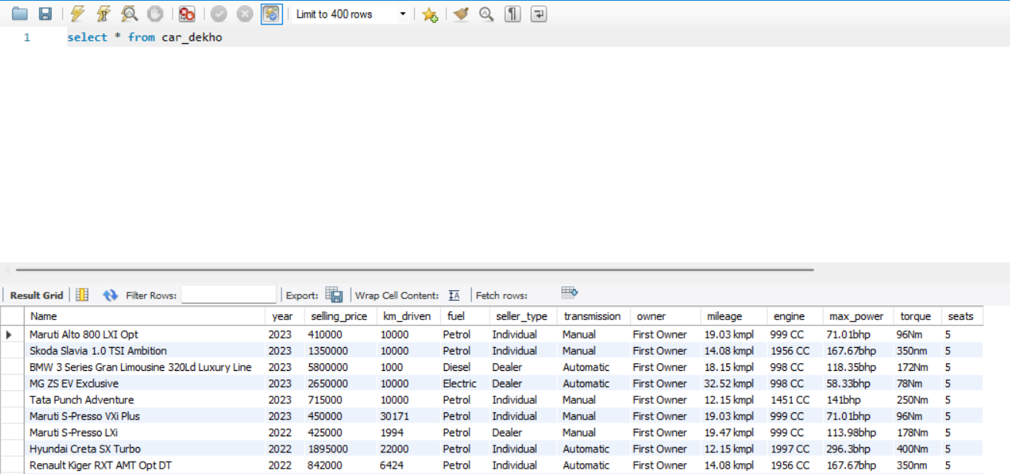

2) select count(*) as Total_Cars from car_dekho; 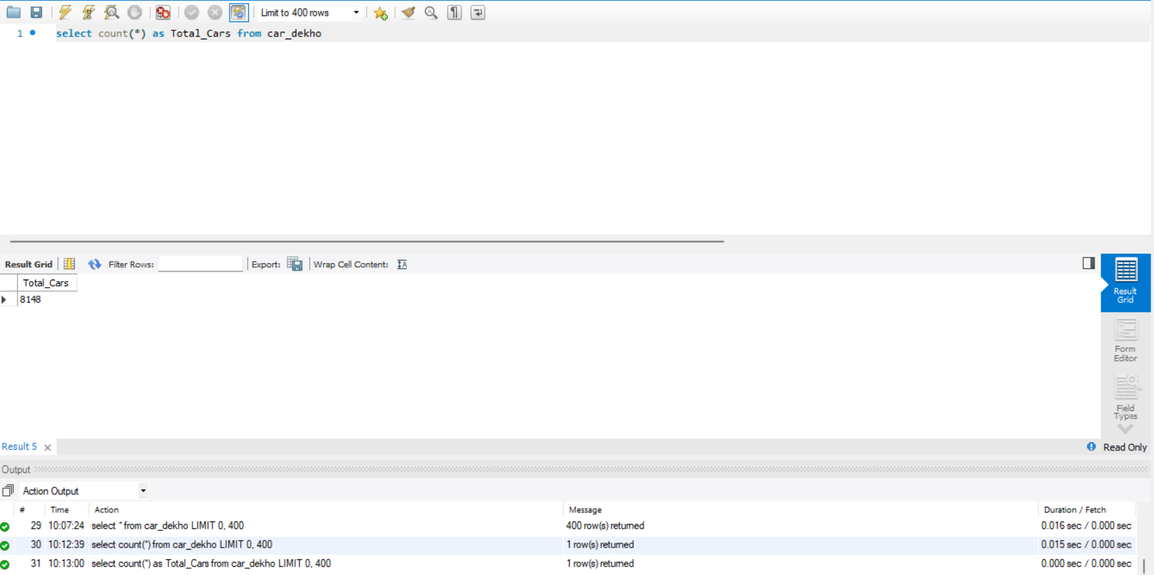

3) select count(*) as Total_cars_2023 from car_dekho where year = 2023; 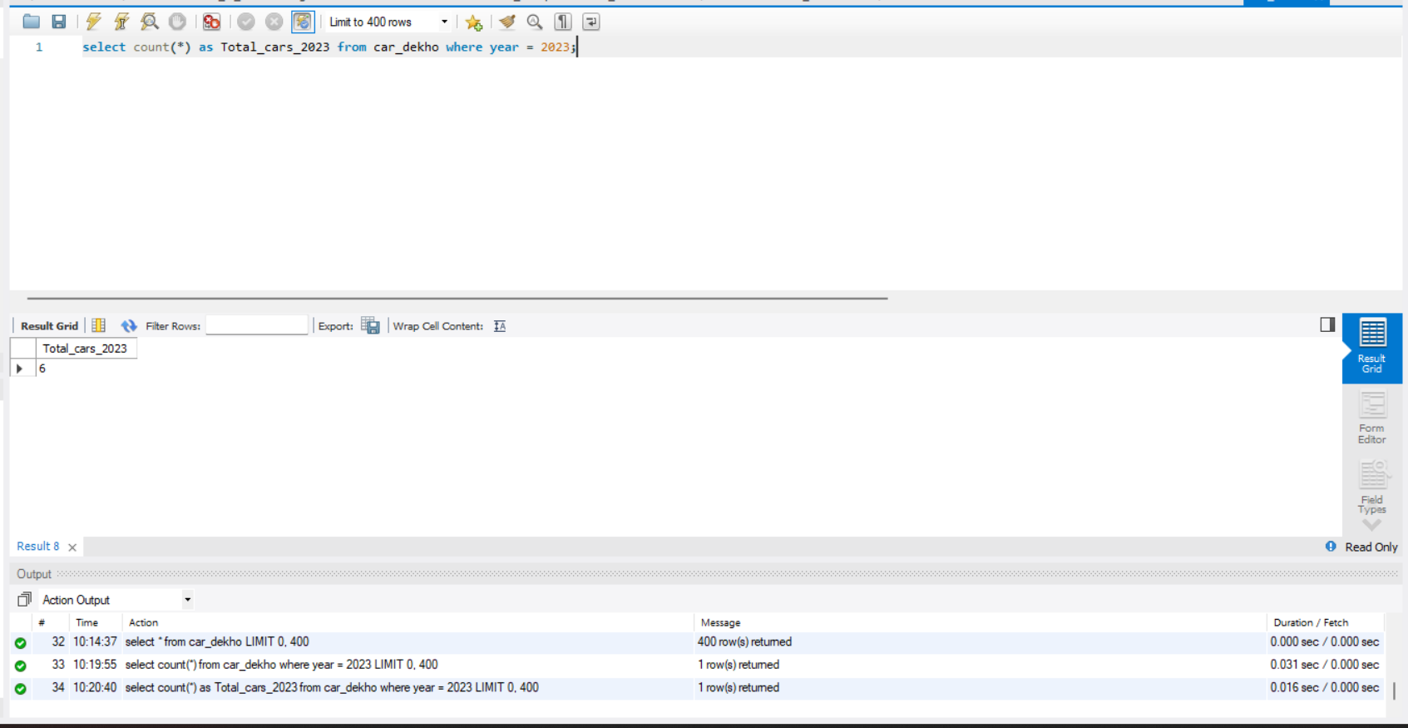

4) select count(*) as Total_cars_2020 from car_dekho where year = 2020; 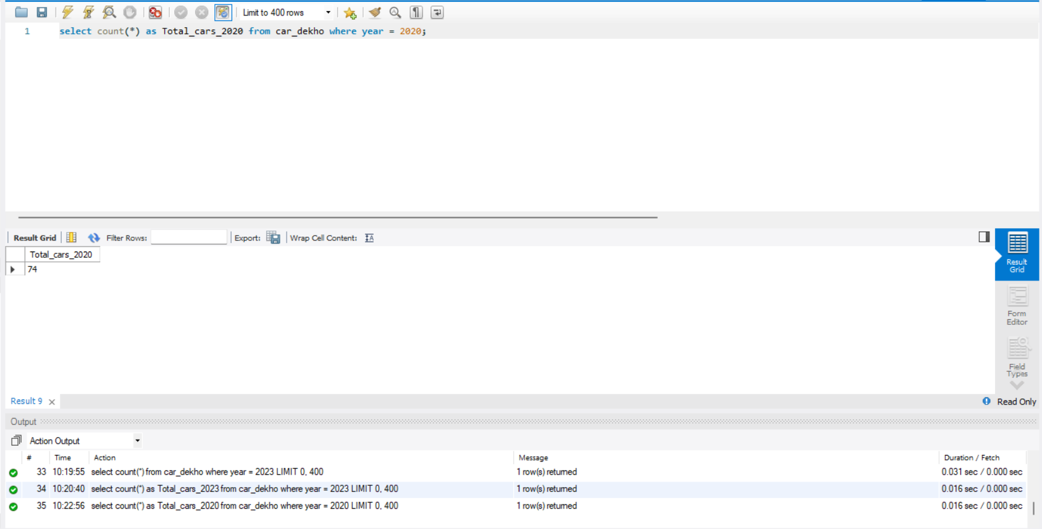

2021:-

select count(*) as Total_cars_2021 from car_dekho where year = 2021; 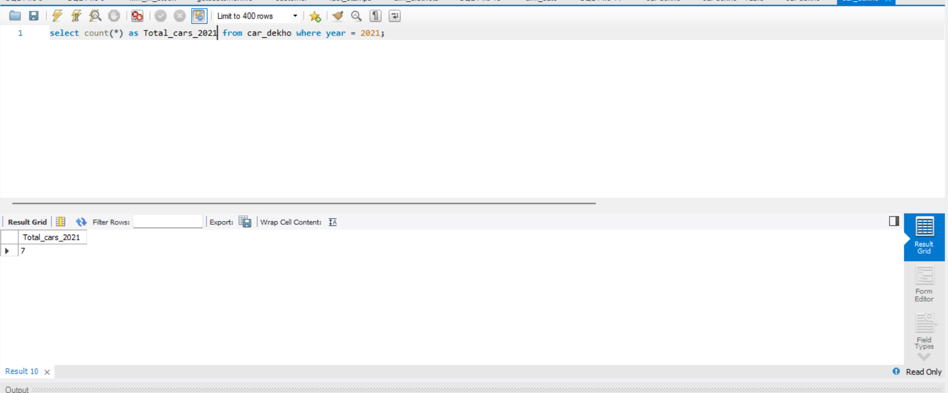

2022:-

select count(*) as Total_cars_2022 from car_dekho where year = 2022;

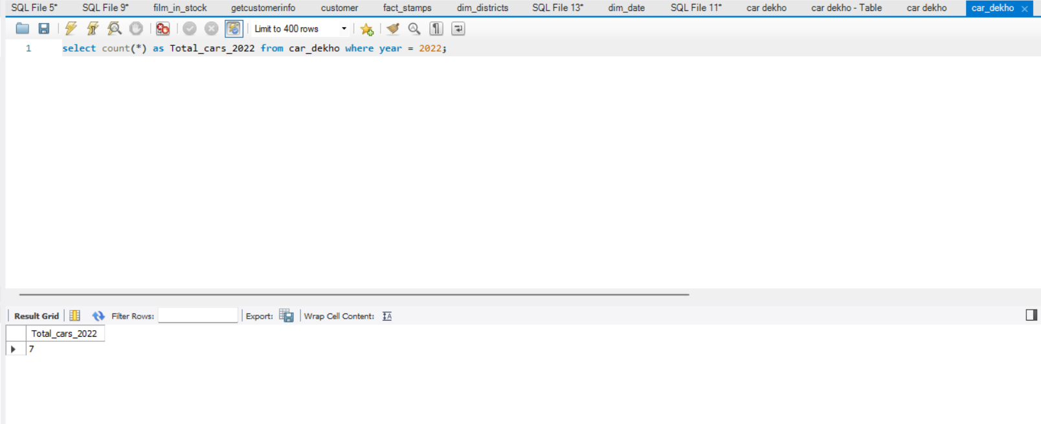

5) select year,count(*) as Total_cars from car_dekho where year in (2020,2021,2022) group by year;

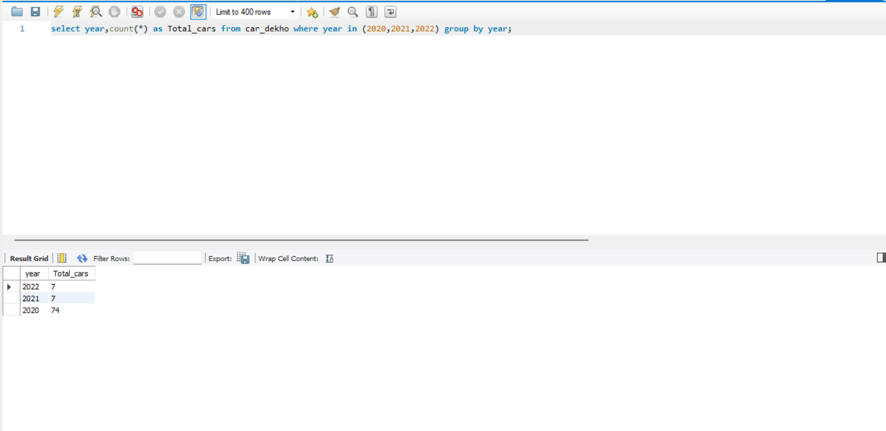

1. select year,count(*) as Total_Cars from car_dekho where year = 2020 and fuel = "Diesel";

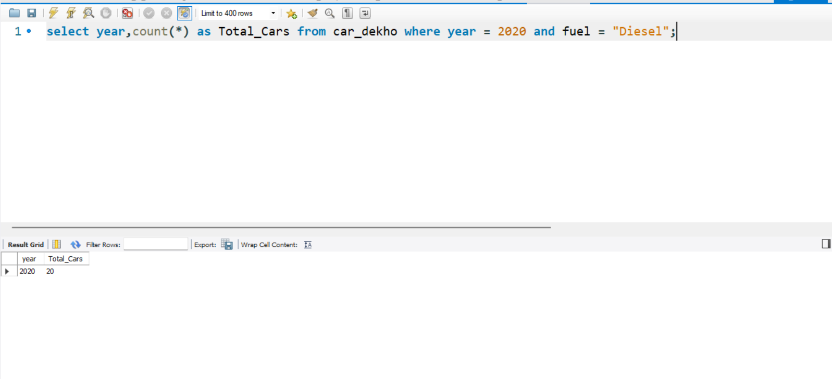

Data source link below:-

https://drive.google.com/file/d/1bn_gDrdZS_3ubgL6S3i_xy-0M2w4U_he3/view?usp=drive_link