A Java project regarding voting system



VOTING/POLLING SYSTEM

Link to project:

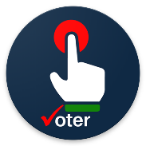

ONE MAN! ONE VOTE!

An Online Voting/Polling System (OVS) based on Java, MySQL, JSP, HTML

Lokireddy Chakridhar Reddy & Rahan -CSO G2, CSE : CSP116

*Project done and nourished in the subject of “Design and Creativity” in Sharda School of Engineering and Technology, Sharda University, Uttar Pradesh*

# A R T I C L E I N F O

*Keywords:*

Online Voting/Polling System

Content Management

Web Based Application Intelligent system

Automated transaction

# A B S T R A C T

We describe an online dynamic voting/polling web application named ‘‘OVS’’, developed according to the research and teachings our faculty, Mr Sushant Jhingran taught us and with the help from YouTube and internet. There exist two types of users: candidates who are going to register to gain support and of course, VOTE and users who are going to vote for their respective candidates in order to make them win the election. We used Eclipse IDE for Enterprise Java and Web Developers 2023-03, MySQL Workbench 8.0 CE, MySQL Connector and many more. To be able to have this opportunity to represent our team to bring success to this project is regarded such a great achievement to our team and members.

## 1. Introduction

Welcome to our innovative voting system project, a state-of-the-art application that aims to transform the way we conduct elections in our country. Using user-friendly technologies like Java, Servlet, MySQL, and JSP, this project combines advanced programming, web development, and database management to create an efficient, secure, and easy-to-use platform for both voters and electoral authorities.

The voting system is a crucial part of any democratic country. It gives citizens the important right to choose their leaders and play an active role in shaping the future of their nation. By creating a modern and technologically advanced voting system, we have the opportunity to make a significant impact on our country's development in several important ways. There are a number of points which talks about the importance of voting in our country. Some of them include:

1. Democratic Participation: The foundation of a strong democracy lies in citizens' active involvement. The voting system encourages everyone to participate by giving them a fair chance to share their opinions and cast their votes. This inclusivity ensures that every citizen's voice matters and empowers them to contribute to decision-making, which strengthens their sense of belonging and citizenship.
2. Transparent and Fair Elections: A reliable voting system promotes transparency and fairness during elections. By using technologies like Java, Servlet, MySQL, and JSP, we can create a smooth and reliable system that minimizes mistakes, prevents fraud, and accurately counts and records votes. This builds trust in the electoral process, upholds democratic values, and provides a solid foundation for our country's development.
3. Political Stability: A well-functioning voting system helps maintain stability within the country. When citizens have faith in the electoral process and trust that their votes are counted accurately, they are more likely to accept the election outcomes, even if their preferred candidates don't win. This acceptance reduces the potential for conflicts, social unrest, and political instability, creating an environment conducive to sustained development and progress.
4. Accountability and Good Governance: The voting system plays a vital role in holding elected representatives accountable for their actions. By participating in elections, citizens have the power to choose leaders who align with their values and aspirations for the country. This accountability promotes good governance, where elected officials are motivated to act in the best interest of the nation, fulfil their promises, and address the needs of the people they serve. Through this system, we can contribute to creating a responsible and effective government that actively supports the country's development.
5. Representation of Diverse Voices: Our country is a diverse nation with people from various backgrounds and perspectives. A well-designed voting system ensures that all citizens, regardless of their background or gender, have a fair opportunity to have their voices heard in the political process. By providing an inclusive platform for diverse participation, we promote unity, harmony, and social cohesion, creating a fertile ground for collective growth and development.

Through our Java, Servlet, MySQL, and JSP-powered voting system project, our goal is to go beyond traditional voting methods and revolutionize how elections are conducted. By using user-friendly technologies, we aim to create a simple, secure, and accessible platform that empowers citizens to actively participate in the democratic process. Our mission is to contribute significantly to our country's development by upholding democratic values, promoting transparency, fostering accountability, ensuring political stability, and amplifying the voices of all citizens.



Our voting system application is a user-friendly and advanced platform designed to transform the way elections are conducted. Developed in Eclipse IDE for developers using Java, JSP, MySQL, Servlet, and HTML technologies, our application simplifies the entire voting process and ensures security for both voters and election authorities. With our intuitive interface and powerful features, our voting system makes it easy for citizens to participate in elections and contribute to the development of our country. Features of the voting system application that we made includes the following points.

1. A customised home page: The index page we made is one of the highlights of our project. As it is said, "Getting started is the hardest part, but once you take that first step, you're already halfway there." The index/home page is exquisite and detailed as we have denoted the quote “ONE MAN ONE VOTE” at the top left which is also a significant part of the home page. For the background we used a modern voting image in which the "VOTE" text is written at the centre with people with all sort of abilities or disabilities irrespective of their gender, caste, creed, race, colour is expressing their thoughts to vote and continue this tradition we are following since a very long time now. A person with a disability and normal person with no disabilities should vote! At the index page, there is numerous options to go. We have made a navbar so as to select and go through pages like Home, About, Candidates, Announcements and Result. The home page is for when you login, the dashboard opens up and you can finally VOTE! It is a significant button there as it contains the main functionality which is to vote… At the side, we have "About" button which contains the details of our very own web page. It contains the needful techniques, methods and need to Vote in our democracy and system. The about page is significant for the needs and importance to vote. The candidates button redirects you to the details of the candidates…

**Fig. 1. Navbar**

The candidates page will show you the number of candidates, the name of the candidate, their respective date of births, respective father’s name and their eligibility to vote. Hence the Candidates page is complete with these data and hence we can move to "Announcements" page. The announcements page is all about the dates, news and information about voting and everything. The "announcements" page contains various information like, time and date for voting purpose, and the news regarding the change in any pre decided event or anything related to the change in required event.

The Announcement page also lets you know the media perspective and views from famous personalities. Next up, is the "Results" button. The results button is for the display of results. The result page is the page where all the voting data joins together. The result page shows all the vote in a pie chart and hence the winner of the voting system of the particular time. The result page plays an important role as the result page is the ending of the page. It is the last page where one should be in this project.

The voting result page in our voting system project, developed using Java, Python, MySQL, JSP, and HTML, is a crucial component that provides real-time and accurate information about the election outcome. This page presents the consolidated results in a user-friendly and visually appealing manner, allowing both election authorities and the general public to access and analyse the data.

Using Python scripts, the voting result page retrieves the data from the MySQL database, where the votes are securely stored. The page then utilizes JSP and HTML to dynamically generate tables, charts, and graphs to present the results. This combination of technologies ensures seamless integration, efficient data retrieval, and interactive visual representation of the voting outcome. Overall, the voting result page in our voting system project serves as a vital resource for stakeholders to access, analyse, and interpret the election outcome. Its integration of Java, Python, MySQL, JSP, and HTML technologies ensures a seamless, secure, and informative presentation of the voting results, contributing to a transparent and democratic electoral process.

Next Up is the “login” button where users can login if they already registered. The login page in our voting system project, developed using Java, Python, MySQL, JSP, and HTML, serves as the gateway for authorized users to access the system. It provides a secure and intuitive interface where voters, election authorities, and administrators can log in to perform their respective roles. The login page contains strong authentication mechanisms, ensuring that only valid users with actual credentials can gain entry. By combining the power of Java, Python, and MySQL, we can implement robust user authentication and verification processes, while JSP and HTML enable us to create a visually appealing and user-friendly login interface.

Next is the "register" button which is used by new users who aren’t able to login. It's a straightforward and easy-to-use page created using Java, Python, MySQL, JSP, and HTML. On this page, citizens enter their basic information, such as their name, address, and date of birth, through a simple form. This information is securely stored in a MySQL database. The registration page also includes checks to ensure the accuracy of the provided details. Once registered, citizens gain access to the voting system, enabling them to exercise their right to vote and contribute to the progress of our nation. Also, at the footer we provided our names to contact while facing any issue. It enhances the page and sets up accordingly.

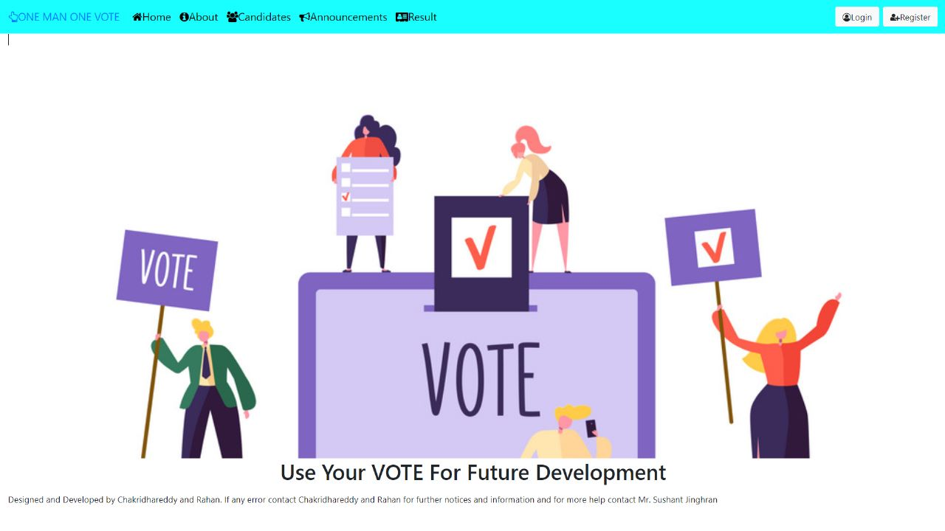

**Fig. 2. Index Page.**

## About

We all have someplace to live, someplace where we have a shelter, somewhere we feel safe and when somewhere where our heart resides. The about page gives the information regarding our website application. In the about page, we have information regarding the importance of voting in the system in our system. The about page gives various information regarding the "revolutionary way to vote". "The revolutionary way to vote" refers to a ground-breaking and innovative approach to the traditional voting process. It signifies a departure from traditional methods and the adoption of new technologies and practices that significantly enhance the efficiency, accessibility, and transparency of elections. Instead of following traditional methods, it introduces new technologies like Java, Python, MySQL, JSP, and HTML to make voting easier and better. The revolutionary way to vote focuses on transparency and fairness. It provides voters with detailed information about the candidates, helping them make informed decisions. It is designed to be accessible to everyone, with features like different languages and support for people with disabilities.

Beneath this valuable piece of information lies the introduction to our java project which introduces you ‘all to our voting system which is unique in its own way. We have described ourselves later on and have described what our views and objectives are on this project. We have stated our goal towards the end of the project and hence we hope we are able to do so in the end.

The key features and importance about the project are described in a brief way below.

1. User-Friendly Interface: Keeping the pages simple and more understandable so that each and every citizen- literate or illiterate (about the websites and tech) are able to vote is an extremely important task. For achieving this task, we have made the design simpler and easier for users to operate. We as a group tried our everything to make this project more understandable and unique so that each and every citizen is able to vote because each and every person has the "RIGHT TO VOTE". The citizens are able to vote in an easy manner by just clicking on buttons which says exactly what they wanna do. After taking few feedbacks from our batchmates, we came to know about the quality of this project as an easy and simple way to vote without any physical work and its quite accurate and no users can login/register twice.
2. Secure Authentication: Maintaining the system to be more secure is another task which needs to completed securely. Secure authentication is a crucial aspect of our voting system project, implemented using Java, to ensure that only eligible voters can access the system and cast their votes. We have incorporated robust security measures to protect the integrity of the voting process and maintain the confidentiality of voter information. In our voting system, authentication is performed through a multi-step process. When users register, their information is securely stored in a database using encryption techniques. When they attempt to log in, their credentials are verified against the stored encrypted data to ensure a match. To enhance security, we employ strong password policies, including password complexity requirements and hashing algorithms to store passwords securely. This ensures that even in the event of a data breach, sensitive information remains protected.
3. Efficient Database Management: In our voting system project, we employ Java for efficient and robust database management. Java provides a powerful set of tools and frameworks that facilitate seamless interaction with the database, ensuring secure storage and retrieval of voting-related data. With Java, we design the structure of the database tables to represent voters, candidates, and election results accurately. We can perform various operations on the database, like adding, updating, and retrieving data. We used the MySQL database and workbench in order to connect the database and eclipse code. In summary, Java helps us manage the voting system's database smoothly, ensuring secure connections, efficient data storage, and retrieval.
4. Real Time Updates: Giving our users real time updates about the ongoing or upcoming voting process. For the engagement of the users, we provide all the real time updates in a fast way and keep all the users and candidates informed about the whole voting system. All the users and participating candidates will be able to monitor the voting process in a manner which is satisfactory!
5. Data Analytics: Analysing voting data can provide valuable insights and help identify patterns or trends. We plan to incorporate data analytics capabilities into our project, allowing administrators to analyse voting patterns, voter demographics, and other relevant metrics. This information can be utilized to improve future elections and make informed decisions. Data analytics is given more power by the usage of MySQL and the usage of bar graphs to enhance the results. It makes sense by depicting the data through pictorial representation to make it attractive and stylish and easy to check for all the citizens using the webpage!

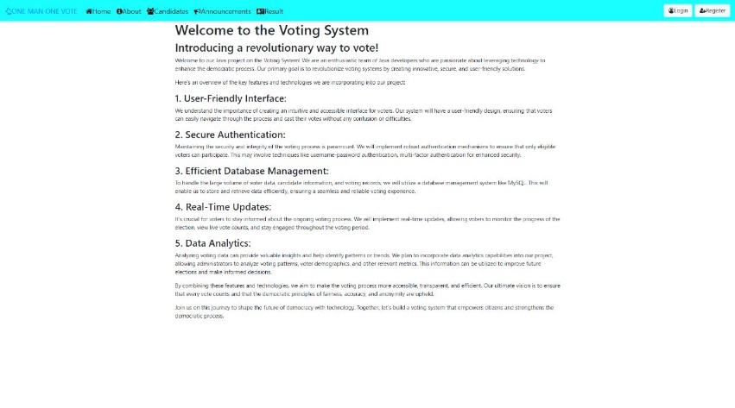

**Fig. 3. Data in About page**

## 3. Candidates

The "Candidate’s" page is a wholly another page which has sub-buttons and various other functions which focuses mainly on the "Candidates". The candidates are the building blocks of the voting system. They are the users to whom the voters vote for and play a very important role in the voting system. We designed our page in such a way that new candidates can register their place and old candidates can update their information according to their comfort. The candidate’s page is made in a similar manner to the home page. The home page had an exquisite cover page and we tried our very best to give an extravagant cover page to the candidate page as it depicts "Follow Democracy, Make Democracy" also it shows a man at the centre who promotes "Voting". The page looks extravagant as it is. The Candidate's Page is a vital component of our voting system project in Java, designed to provide comprehensive information about each candidate running for a specific position. This page serves as a platform for voters to learn more about the candidates and make informed decisions during the election process.

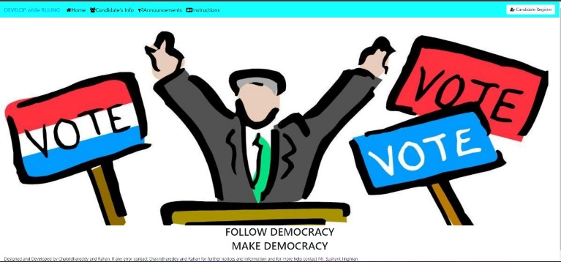

**Fig.4. Candidates Page**

1. Candidate’s Info: The candidate’s info page is a page which shows all the information regarding the candidate. All the candidate’s details like his/her name, his/her party name, their age, their dob, etc are provided in this page. We designed this page in such a way that all the data will be available in a tabular form such that it would be easy to read and understand.
2. Announcements: The announcements page in "candidates" page is a page designated to give valuable announcements about the candidate’s data and everything related to the candidate.

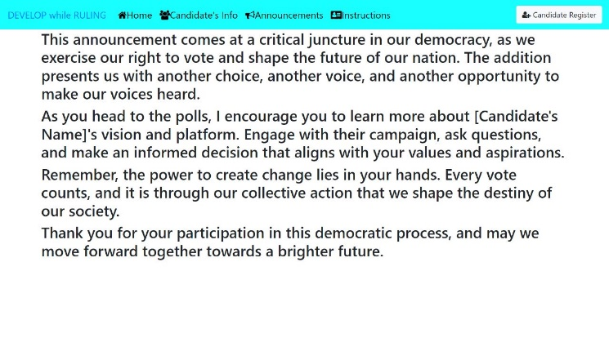

**Fig. Announcements page in Candidates Page**

1. Instructions: This page called the "Instructions" page is the page which is for candidates to follow such that they register their name successfully and cast their name into the register book. Their precious data is registered into the data page and hence made visible to the voters to vote. This instructions page is there to tell the candidates on how to register and login into the database and register their name.

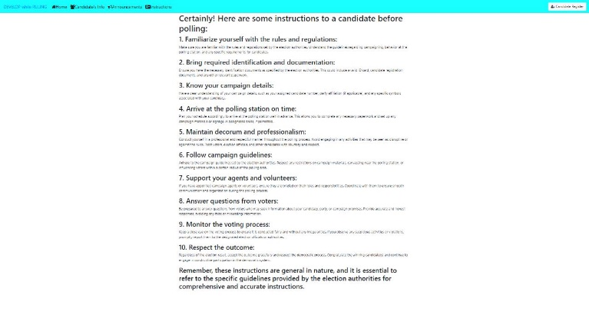

**Fig. Instructions Page in Candidates Page**

1. Candidate Register: The "candidate register" page is the page through which the candidate registers their name into the database. This button takes you to a new page where specific details are asked to the new candidate user like "full name", "date of birth", "father’s name", "native state", etc. Upon filling out this form, the user is shown that registration is successful and hence your data is kept in the database.

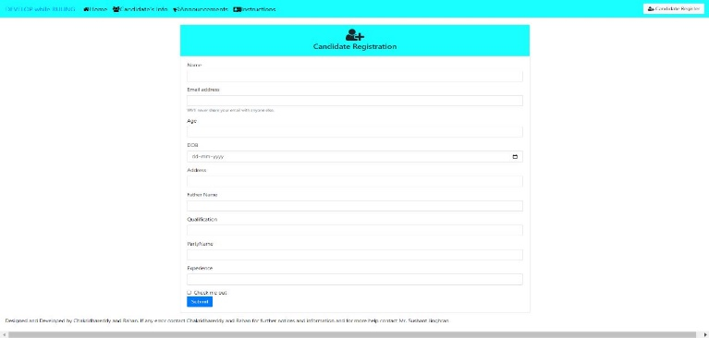

**Fig. Candidates Register Page**

## Announcements

The announcements page on the home page of a voting platform serves as a vital information hub for voters, providing updates, happenings, and important dates related to the voting phase. It ensures that voters are well-informed about the electoral process and encourages active participation. Here’s an overview of what you can include on an announcements page:

1. Election Dates: Clearly display the dates for upcoming elections, including the start and end of registration, voting days, and any run-off elections if applicable. This helps voters plan their participation and ensure they don’t miss any crucial deadlines.
2. Voting Locations: Provide information about the designated voting locations, including addresses, timings, and any special instructions. This ensures that voters know where to go to cast their vote and minimizes confusion.
3. Voting Procedures: Explain the step-by-step process of casting a vote, whether it’s in-person voting, mail-in ballots, or electronic voting systems. Include details about identification requirements, ballot marking instructions, and any other relevant information to guide voters through the process.
4. Voter Registration: Highlight the importance of voter registration and provide clear instructions on how to register. Include links or resources for online registration if available. Emphasize any registration deadlines to ensure that potential voters take timely action.
5. Candidate Information: If applicable, provide a section that introduces the candidates running for office. Include brief profiles, party affiliations, and their stance on key issues. This allows voters to make informed decisions and encourages them to participate in the electoral process.
6. Election News and Updates: Share the latest news and updates related to the election, such as changes in polling locations, new candidate announcements, or any developments that may impact the voting process. This keeps voters informed and engaged throughout the election period.
7. Voter Education Resources: Include links to educational resources that provide comprehensive information about the voting process, such as voter guides, educational videos, or official election websites. This empowers voters with knowledge and encourages them to participate confidently.
8. Contact Information: Provide contact details for the election commission or relevant authorities so that voters can seek assistance or clarification if needed. Include phone numbers, email addresses, or an online contact form for easy communication.
9. Social Media Integration: Incorporate links to your social media accounts, enabling voters to follow updates, ask questions, and engage in discussions related to the election. Social media platforms can be a powerful tool for disseminating information and fostering community engagement.

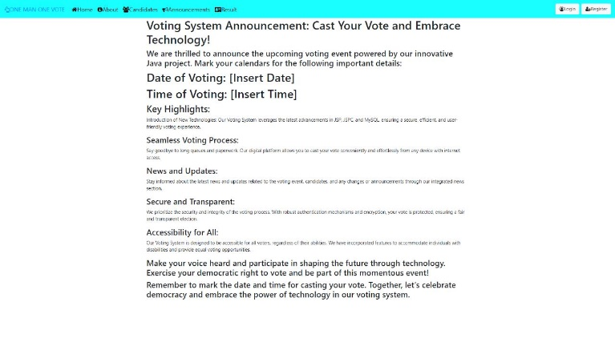

**Fig. Announcements Page**

## 5. Result

The "Result" page is the page where the result depicted in pictorial representation is shown. The voting results page on a home page serves as a platform to present the outcome of a voting phase in a visual and easily understandable manner. It provides users with a pictorial representation of the voting results, enabling them to quickly grasp the outcome without the need to go through detailed data or lengthy explanations. Here's an overview of the key components typically found on a voting results page:

1. Header: The top section of the page contains a header that typically includes the title or topic of the voting phase. It helps users identify the specific vote they are viewing the results for.
2. Summary Statistics: Below the header, there is usually a section dedicated to summary statistics. This area presents key figures related to the voting results, such as the total number of votes cast, the percentage of participation, or any other relevant metrics that provide an overview of the voting outcome.
3. Bar Charts: Bar charts are a popular choice to display the distribution of votes among different options or candidates. Each option is represented by a vertical bar, with the length of the bar indicating the proportion of votes received. This allows users to compare the vote counts visually.
4. Additional Details: Depending on the complexity of the voting phase and the needs of the users, the page may include supplementary information such as individual vote counts, demographic breakdowns, or comparisons with previous votes. These details can be presented in tables, charts, or interactive elements to allow users to explore the results in more depth if desired.

By incorporating these elements, a voting results page can effectively communicate the outcome of a voting phase in a visually appealing and easily understandable manner, allowing users to quickly grasp the key information and draw insights from the presented data.

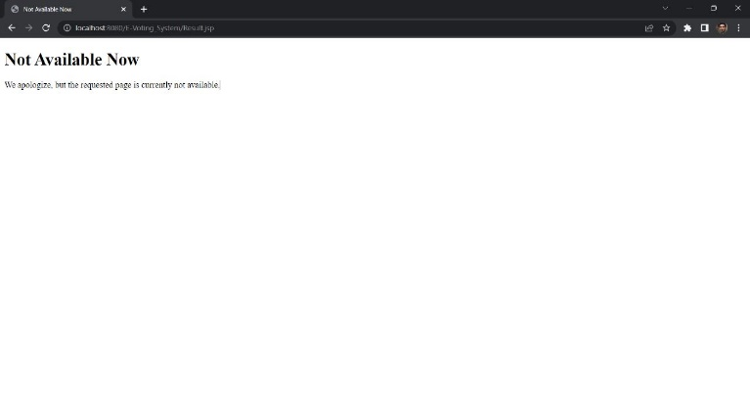

**Fig. Results Page**

## 6. Login and Register

The "**Login**" and "**Register**" button are present on the navbar of the home page. The "Login" button redirects you to the login page and the "Register" button redirects you to the register page. No user can login without registering first. A new window is opened after clicking register as it requires various fields like "Name", "Father’s Name", "DOB", etc. After registration, you can login into the homepage.

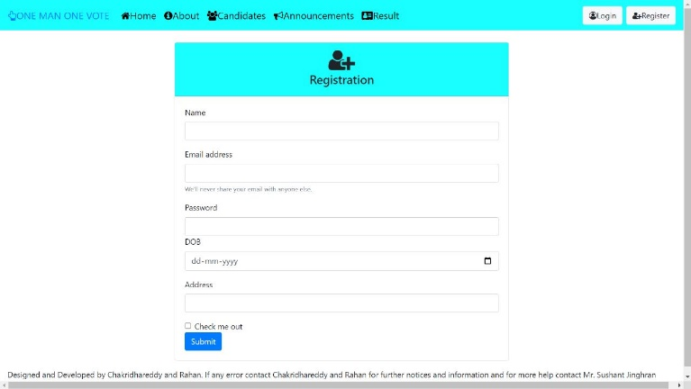

**Fig. Registration Page**

The login and register pages are essential components of a website's home page, as they allow users to access personalized features and interact with the site. Voting process is done only after the logging in the account and for logging in… you need to register :)

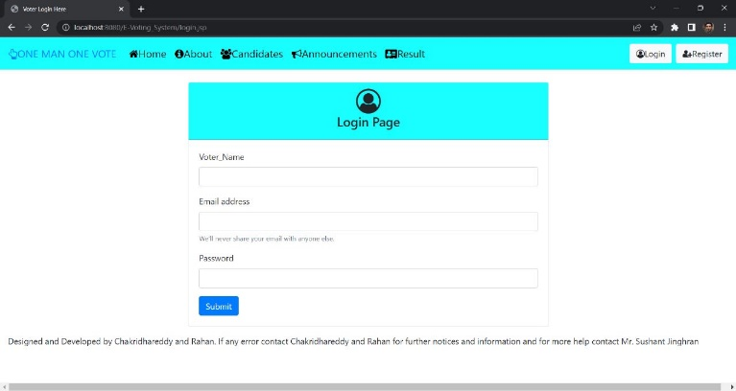

**Fig. Login Page**

## 7. Voter Page

The "Voter" page is the page where all the voters come to when they finally login. The "Login" page contains another new navbar which has different meanings and aspects. It contains a title which says "Use Your Vote".

The phrase "use your vote" means to participate in an election or decision-making process by casting your vote or making your choice. It encourages individuals to exercise their right to vote and have a say in important matters that affect them and their community. When you use your vote, it means you are taking part in a democratic process where everyone's opinion counts. By casting your vote, you are expressing your preference or selecting the candidate or option you believe is the best. It allows you to have a voice and contribute to shaping the outcome of an election or decision. Using your vote is a way to make your opinion count and have a direct impact on the choices made by your community, city, or even your country. It ensures that your views and interests are represented and taken into account when decisions are being made. Remember, using your vote is an important way to participate in the democratic process and make a difference in the direction and future of your society.

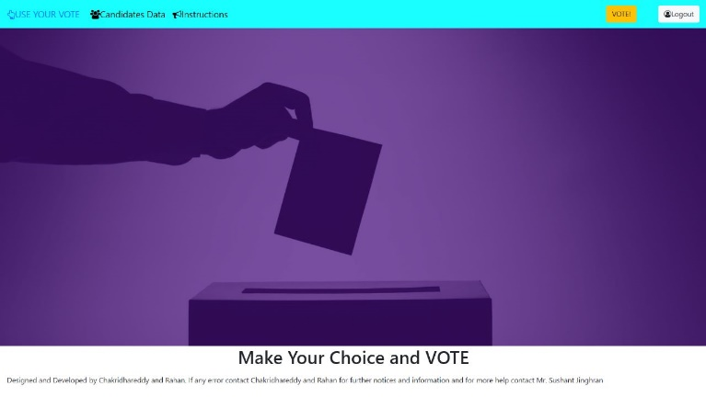

**Fig. Voter’s Page**

The home page carries more information on the navbar. One is "Candidate Data". This is repeated so much times because this is one of the important aspects of the project. The candidate data page carries a table with information about the participating candidates who are contesting in this round. It’s given in a tabular form. The candidate data table gives information about the participating candidate like their name, their qualifications, their party name, etc

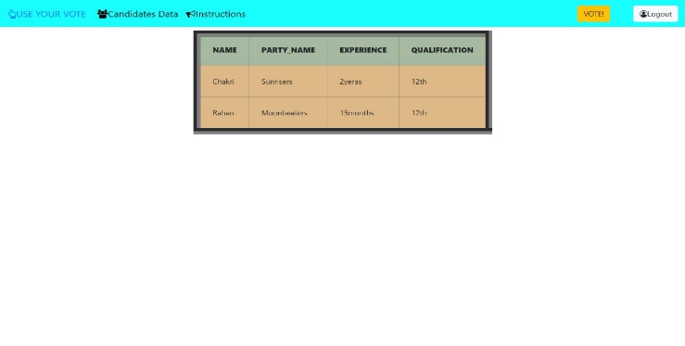

**Fig. Candidate’s Data page In Voter’s Page**

Instructions have also been repeated many a times as it’s also an important aspect in our voting system. The instructions button in the home page as it provides information about how to cast your vote and how to necessitate the need for voting. Voting process is a simple thing to do in our system. The procedure and right values that need to be done is included in the instructions button.

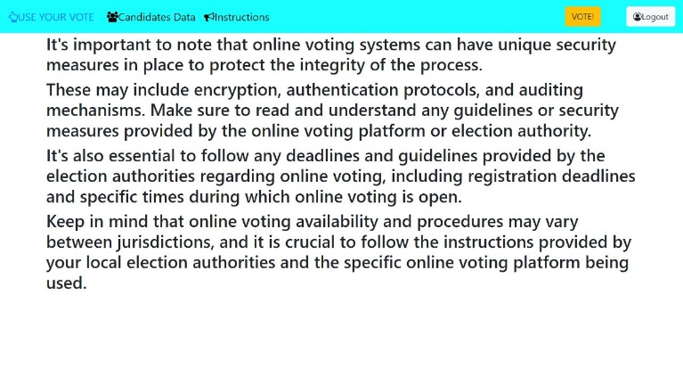

**Fig. Instructions Page in Voter’s Page**

The most important button on this project which depicts the whole need for this system is the "VOTE!" button. This button enables the voters to finally vote. Upon clicking this button, you will be redirected to a new page which will ask you to vote for the candidate. It will be completely online and there would be no need for you to go to different places on the globe to cast your vote. It’s simple. You just need to press the empty column next to the candidate you actually wanna vote. Upon submit thereafter, you will complete the voting process. Your vote will be recorded and hence your voting process is complete. The voting page is a table-based page which is a page designed only for voters and no candidate can login into that page. The database is set such that only the voters can cast their vote and no candidate can cast for their own vote. The table for voting will contain the party name, full name of the candidate, their Date of birth, their qualifications, etc. this would also help the voters for a final check up on selecting their leader appropriately and accurately for one last time.

The logout button is at the rightmost end of the page where voters can use this button to go back to the homepage where all the voting system can be restarted with another new user.

## Usage of MySQL

In your voting system project using Java, JSP, HTML, and other technologies, MySQL can be used to store and organize the important information related to the voting process. You can think of MySQL as a secure and efficient storage place, like a big electronic filing cabinet, where you can keep track of all the data for your voting system.

Here’s how we used MySQL in our project:

1. Data Storage: MySQL allows you to store information in a structured way. You can create tables, which are like labelled compartments, to hold different types of data. For example, you can have a table for storing user details, another for votes, and so on.
2. User Authentication and Authorization: MySQL helps you keep track of user accounts securely. You can store usernames and passwords in the database so that users can log in and access the voting system. It helps ensure that only authorized users can participate in the voting.
3. Recording Votes: MySQL allows you to keep a record of all the votes cast by users. Each vote can be saved in the database, associating it with the voter and their chosen candidate or option. This helps you keep track of who voted for whom.
4. Data Analysis and Reporting: MySQL enables you to analyse the voting data and generate reports. You can ask MySQL questions about the data using a special language called SQL. For example, you can ask it to calculate the total number of votes for each candidate or generate graphs to visualize the voting patterns.

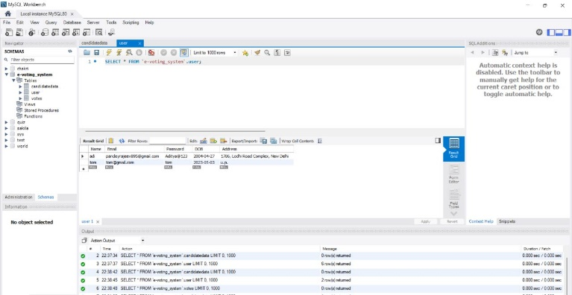

**Fig. Usage of MySQL (i)**

To use MySQL in your project, you need to connect your Java application to the MySQL database. This connection allows your Java code to talk to the database, retrieve information, and update the data when needed.

By using MySQL in your voting system project, you can store and manage voting data, authenticate users, record votes, analyse the data, and keep it secure. It helps create a reliable system that can handle the complexities of the voting process.

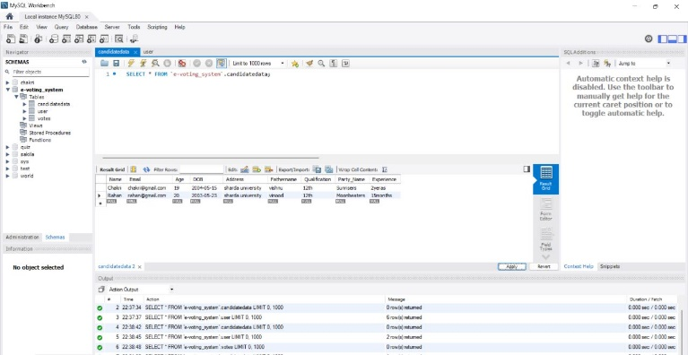

**Fig. Usage of MySQL (ii)**

## IMPACT

Accessibility and Convenience: Online voting can greatly enhance accessibility for voters, especially those who face physical disabilities, live in remote areas, or are unable to visit polling stations due to various reasons. It allows voters to participate in the democratic process conveniently from their own homes or any location with internet access.

Increased Voter Turnout: The ease and convenience of online voting can potentially lead to higher voter turnout. By removing barriers such as travel, long queues, and limited polling hours, more people may be motivated to participate in elections, thus strengthening the democratic process.

Cost Efficiency: Online voting systems have the potential to reduce costs associated with traditional voting methods. Expenses related to printing ballots, staffing polling stations, and transporting materials can be significantly reduced. However, it's important to note that the initial investment in developing and implementing a secure online voting system can be substantial.

Speed and Efficiency: Online voting has the potential to expedite the vote counting process, as the system can automatically tally votes, eliminating the need for manual counting. This can lead to faster election results and reduce the likelihood of errors that can occur during manual counting.

Improved Accuracy: Online voting systems can minimize the risk of human error that can occur during the voting and counting process. By utilizing secure and robust technology, the chances of miscounting or misinterpreting votes can be reduced, thereby increasing the accuracy of election outcomes.

Enhanced Security Measures: Implementing a secure online voting system is crucial to ensure the integrity of the electoral process. It requires robust security protocols, encryption methods, and authentication mechanisms to protect against hacking attempts, data breaches, and voter fraud. Implementing strong security measures is vital to maintain public trust in the system.

## References

1. Vidhi Khatwani, Polling-System-Java-Application, Engineering Undergrad., Symbiosis Institute of Technology, Pune

1. Saba ÜRGÜP, Bursa Technical University, Turkey ~ CSE (S4) (2015) 61–68.

2. Candida Noronha, Fr. Conceicao Rodrigues College of Engineering, Senior at Fr. CRCE pursuing B.E. in CSE,

3. Bharati Panigrahi, Under Graduate Student with Data Science as major from Mukesh Patel School of Technology Management and Engineering, NMIMS University (Mumbai Campus)

4. Joshua Bloch, Wrote the java collections framework and the java. Math package. Author of bestselling guide on writing effective java.

5. Martin Ordersky, author of current java compiler. Creator of the Scala language.

6. Doug Cutting, author of Lucene, Nutch(co-author), and Hadoop.

7. Doug Lea, added efficient concurrent collections to java.util. Best selling author on java concurrency practices.

8. Code with Harry, programmer, web developer teacher, and creator of YouTube Pay videos.

9. JP INFOTECH, Topmost service provider based on Information Technology (IT), who ensures to provide essential solution for software needs with premium results.

10. SatputeAcademy, YouTube

11. Shradha, Ex-Microsoft Software Engineer, DRDO, Apna College, YouTube

12. Codebun, YouTube

13. Pankaj Panjwani, YouTuber, Video maker, C Programming, C++, JAVA, PHP, MYSQL, Python, Django, HTML, CSS, Oracle, Data Structure, TOC, ADA, Digital Electronics, Bootstrap, Java NetBeans, C Graphics, C Mouse Programming, C Graphics Programming, ASP.NET, C#. NET, Compiler Design, CSO

14. Oracle Java Tutorials: The official Java tutorials provided by Oracle cover a wide range of topics related to Java programming. They offer comprehensive guides on core Java concepts, database connectivity, and web development with Java. You can find tutorials on JDBC (Java Database Connectivity) for connecting to MySQL and building database-driven applications.

15. Java EE (Enterprise Edition) Documentation: Java EE is a set of specifications and APIs for building enterprise-level applications. The Java EE documentation provides detailed information about various Java EE components, including Java Server Pages (JSP) and servlets, which are commonly used in web application development. You can learn about the best practices and usage of these technologies in your voting system project.

16. Apache Tomcat Documentation: Apache Tomcat is a popular web server and servlet container that can host Java web applications. The official documentation for Tomcat provides information on installation, configuration, and deployment of Java web applications. It will guide you in setting up your development environment and deploying your voting system project on Tomcat.

17. MySQL Documentation: The official documentation for MySQL offers comprehensive guides on using and managing the MySQL database. You can learn about creating databases, designing tables, executing SQL queries, and managing data. It will help you understand how to interact with the MySQL database using Java and JDBC.

18. Stack Overflow: Stack Overflow is a popular question and answer platform for programming-related queries. It has a vast collection of questions and answers related to Java development, including topics like JDBC, JSP, and web development. You can search for specific questions or browse through related threads to find solutions or insights into common challenges faced in Java projects.

19. GitHub: GitHub is a code hosting platform that allows developers to collaborate and share their projects. You can search for open-source voting system projects written in Java on GitHub. Exploring these projects can provide you with ideas, code examples, and best practices that you can adapt for your own project.

20. James Gosling: The creator of the Java programming language.

21. Joshua Bloch: An influential figure in the Java community, known for his work on Java collections and effective Java programming practices.

22. Martin Fowler: An author and speaker who covers various software development topics, including Java best practices and design patterns.

23. Adam Bien: A renowned Java EE expert, consultant, and author with expertise in building enterprise Java applications.

24. Arun Gupta: A technology evangelist and author specializing in Java EE and web application development.

25. Craig Mullins: An expert in database management systems and author of books on database design and development.

26. Contributors to Apache Tomcat: The Apache Tomcat project is open-source, and you can find contributors who have in-depth knowledge of Tomcat and Java web application development.

27. The Java Community: Participate in online Java communities and forums like Java Reddit, Java Ranch, and the Oracle Community to connect with experienced developers who can provide guidance and insights.

28. Bootstrap 4, website URL: getbootstrap4.com