Autoscaling Groups

1. Create one vpc in N.virginia region.
   * + - Login to AWS Console:

Navigate to the AWS Console

Choose the region N. Virginia (us-east-1) from the region selector.

* + - * + Open VPC Console:

Go to the VPC Dashboard

* + - * + Create a VPC:

Click on Create VPC.

In the *VPC settings* page, select VPC only or VPC and more depending on the resources you want.

* + - * + Provide the details:

Name tag: Assign a name for the VPC, e.g., My-VPC.

IPv4 CIDR block: Specify the IP range, e.g., 198.168.0.0/24.

IPv6 CIDR block (Optional): You can choose an Amazon-provided IPv6 CIDR block.

Tenancy: Default or dedicated (Default is most common).

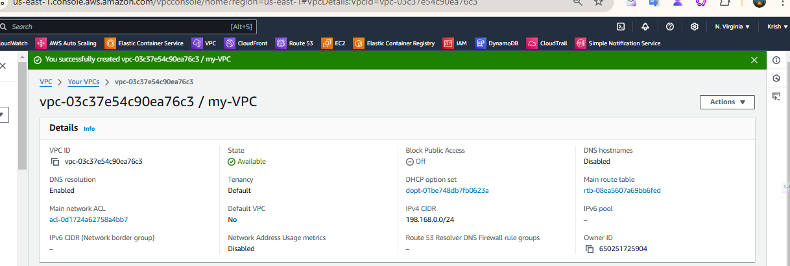

1. Create two subnets. One Public subnet and one private subnet.

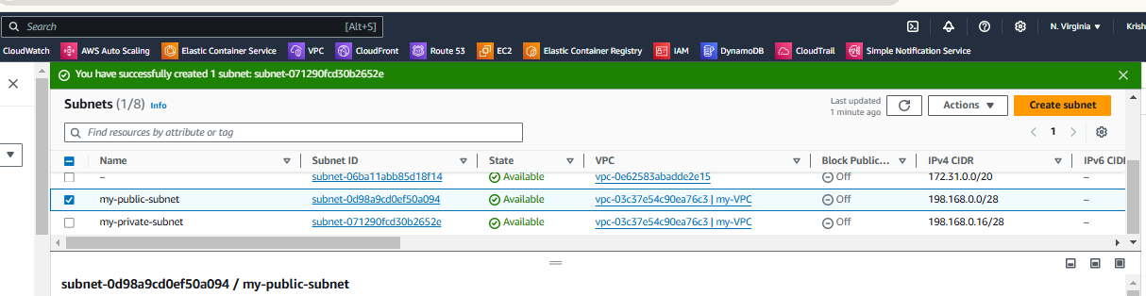

1. 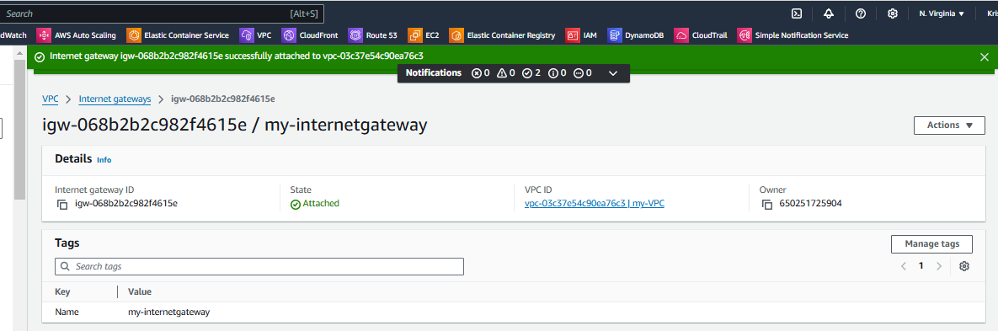Provide the IGW to the vpc.
2. Create One public RT and one private RT.

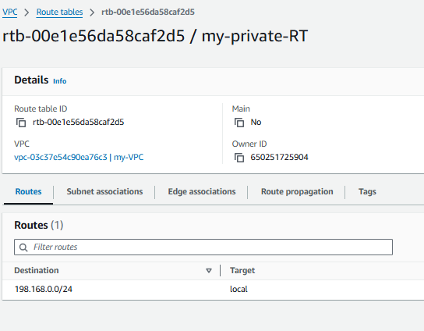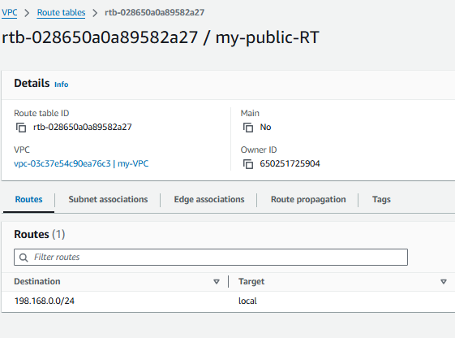

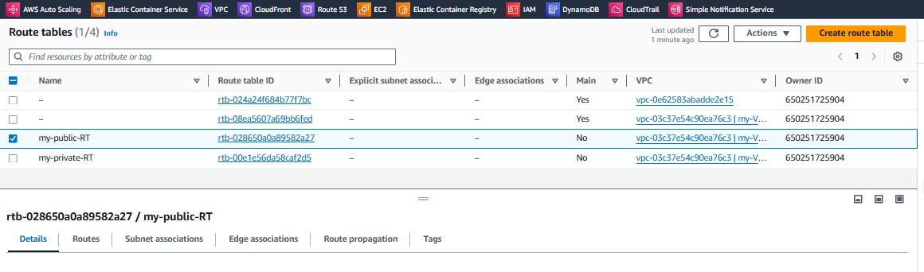

1. Deploy NAT gateway on public subnet and attach the NAT gatewat to private subnet.

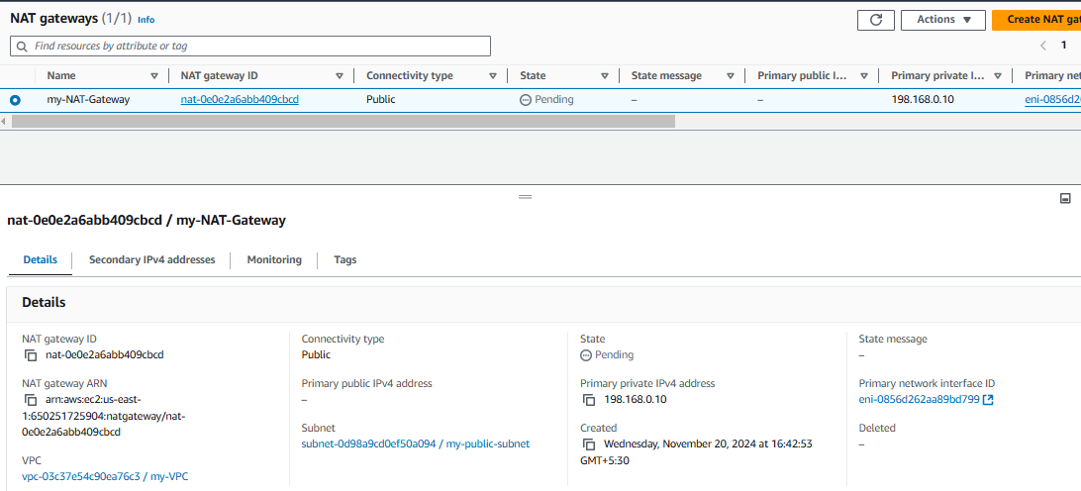

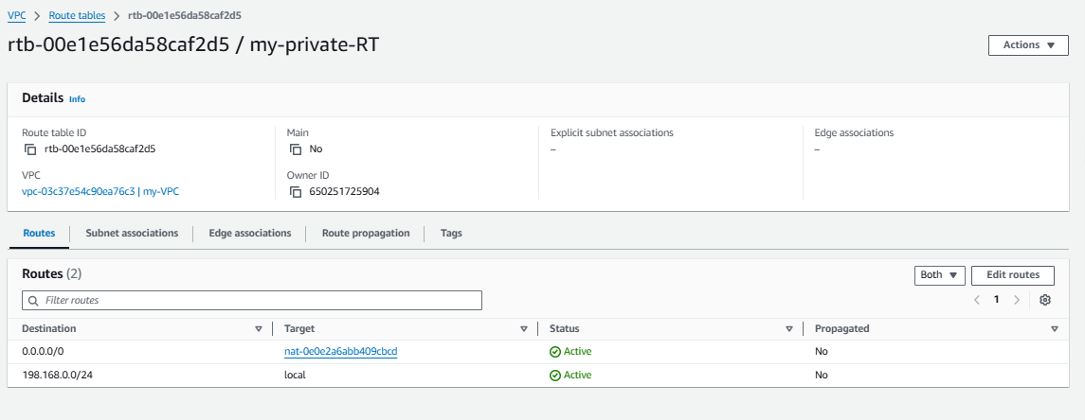

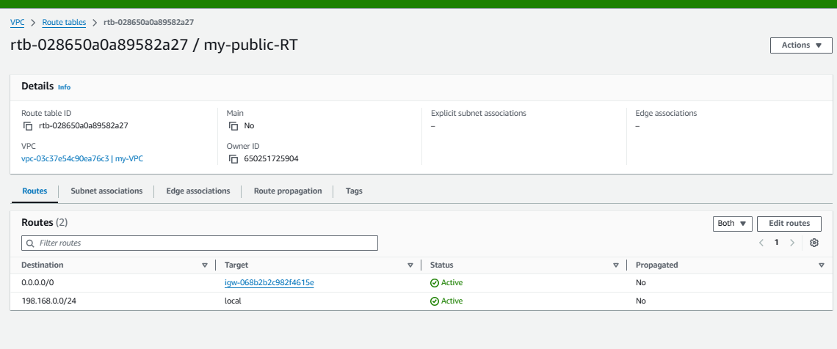

1. Create Two instances,one in public subnet and one in private subnet.

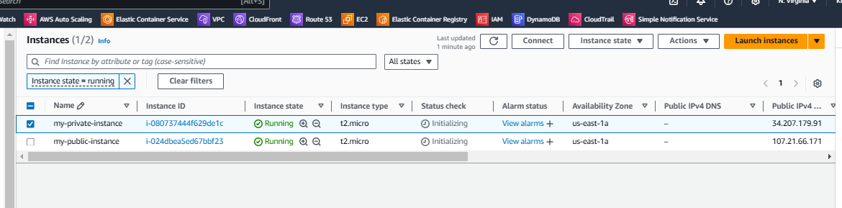

1. 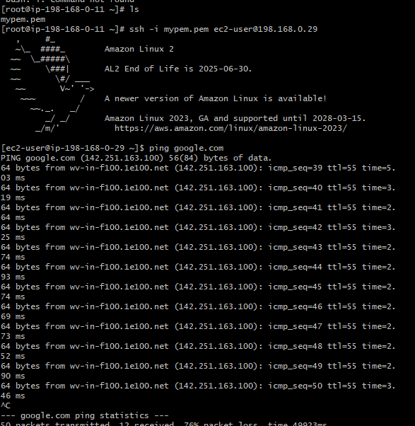Deploy Apache server on both the ec2 instances with sample index.html file.

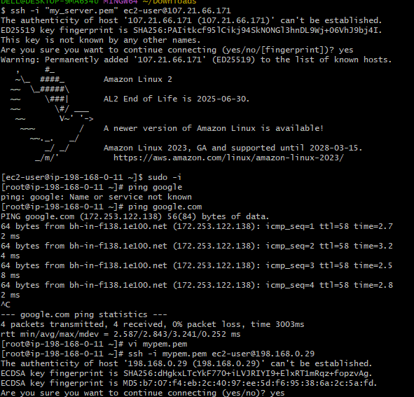

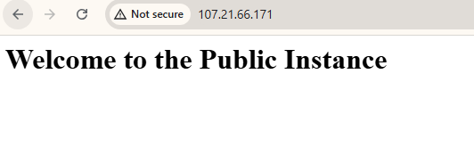

1. Store the vpc flow logs to cloudwtach group.

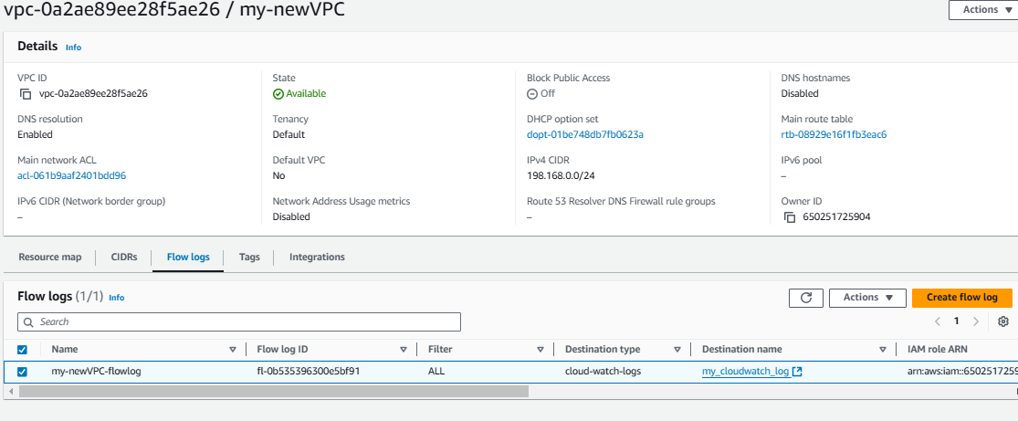

1. Create Monitoring Dashboards to monitor cpu utilization and to monitor apache service.

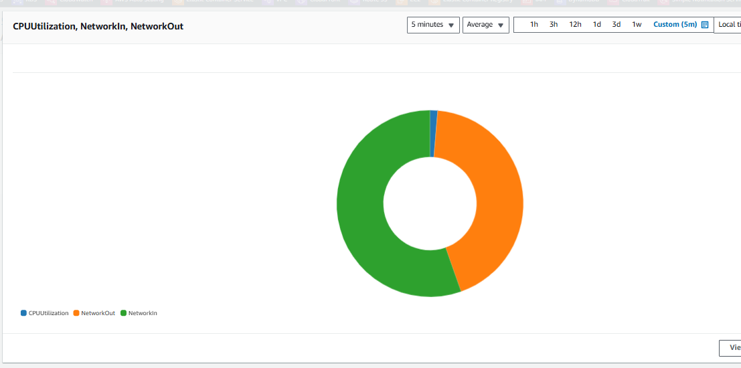

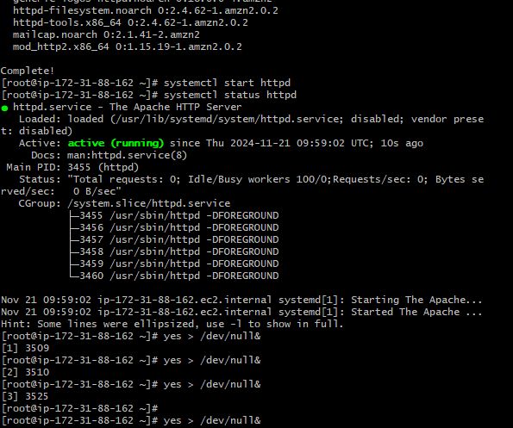

1. CPU utilizationis more than 70% then it should triggere Autoscaling and launch new instance.

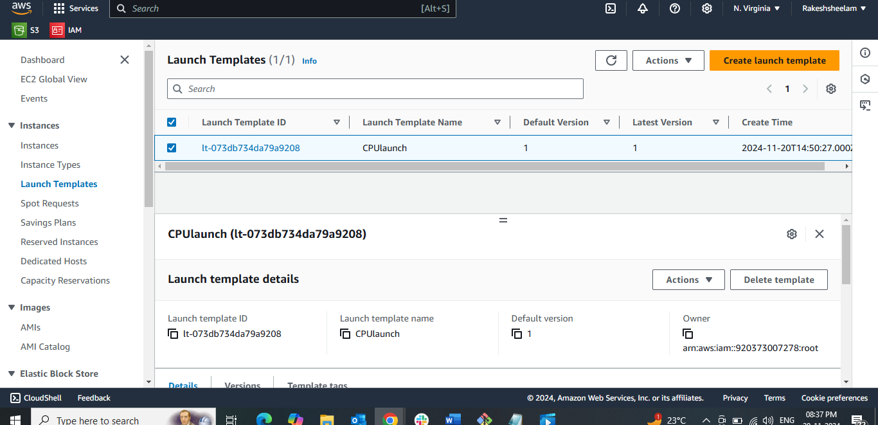

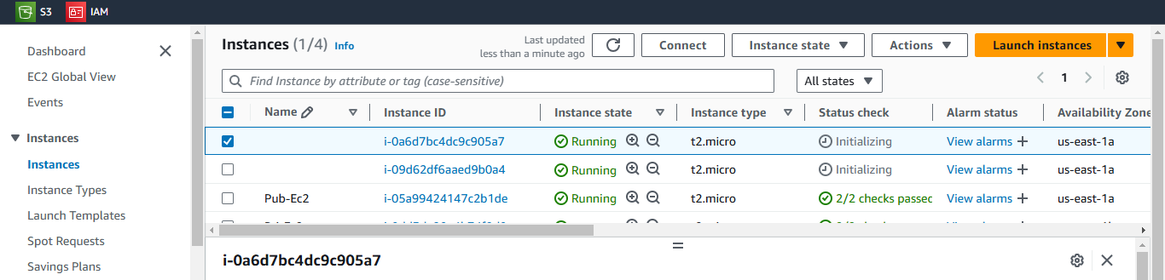

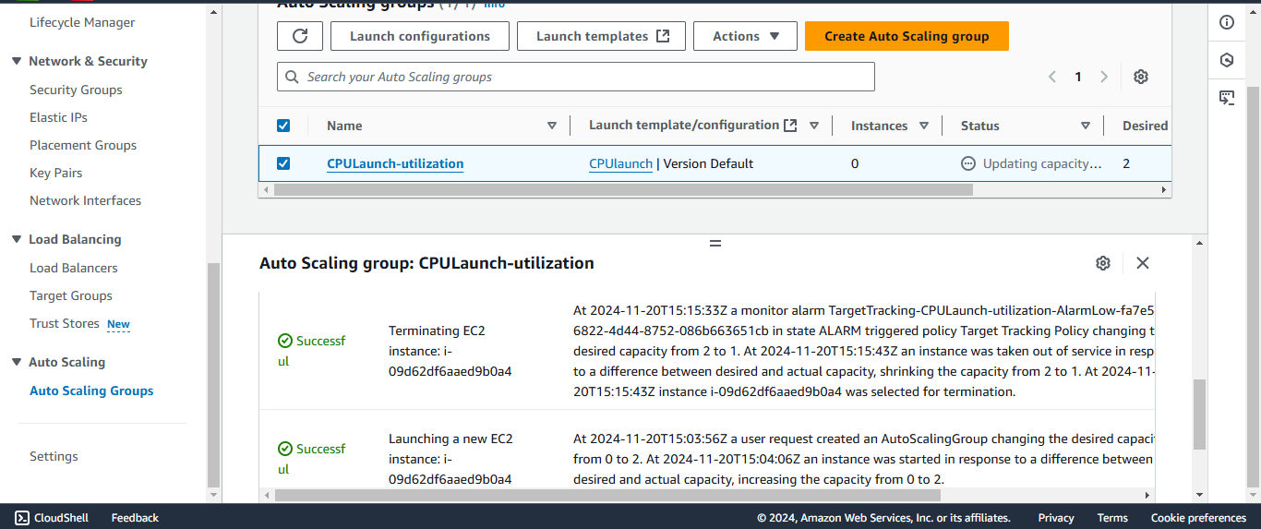

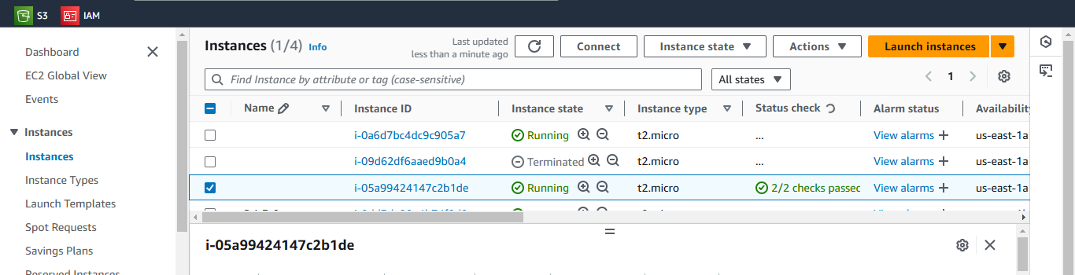

1. Create one application load balancer and attach the load balancer to both the ec2 instances.

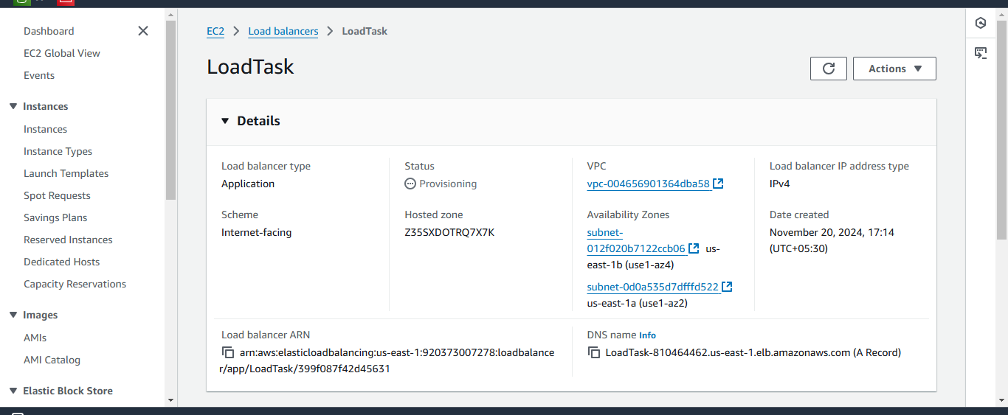

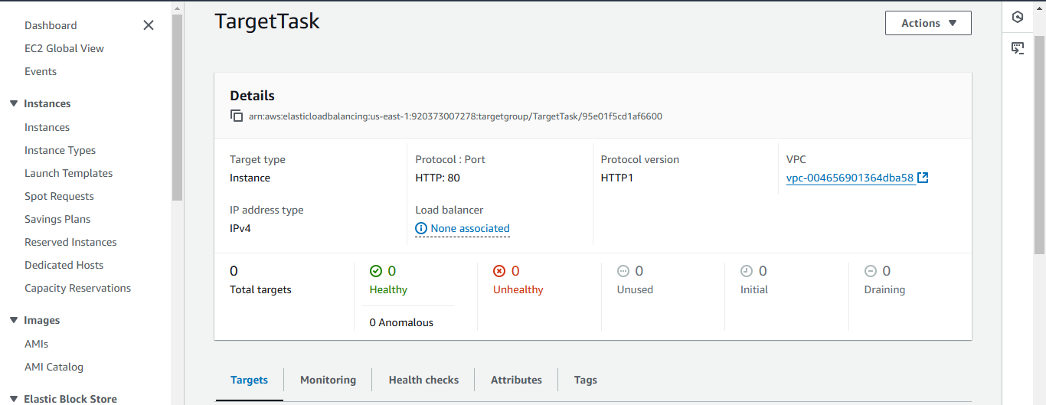

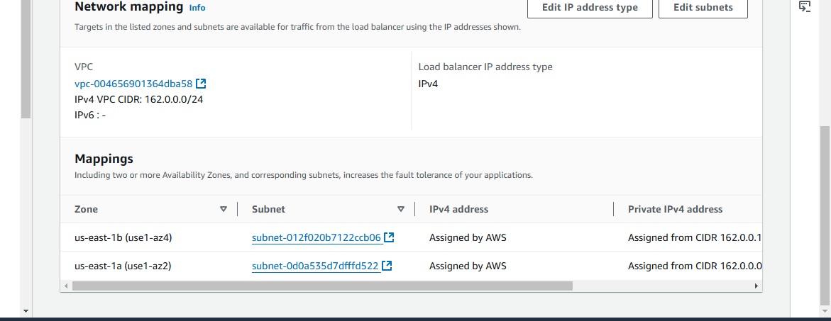

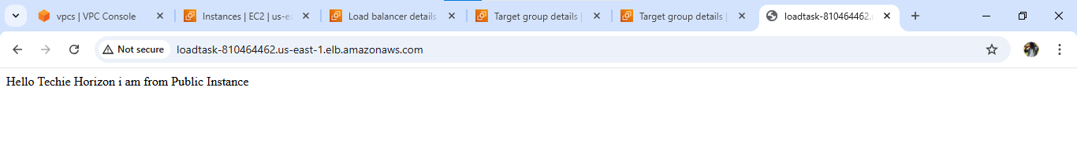

1. Store Application load balancer logs to s3.

