**Bash Script**

1. **Create on Bash script to check if a directory is available or not.**

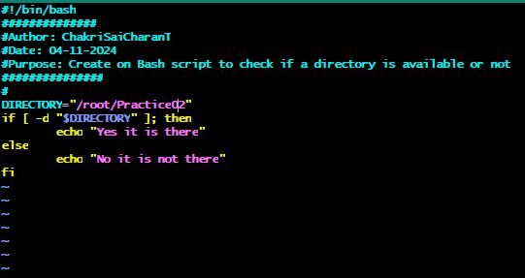

#!/bin/bash

##############

#Author: ChakriSaiCharanT

#Date: 04-11-2024

#Purpose: Create on Bash script to check if

a directory is available or not

###############

#

DIRECTORY="/root/Practice02"

if [ -d "$DIRECTORY" ]; then

echo "Yes it is there"

else

echo "No it is not there"

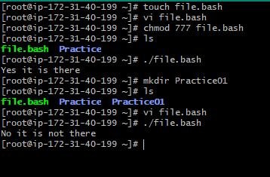fi

output: Yes it is there

1. **Create a bash script which will create multiple files.**

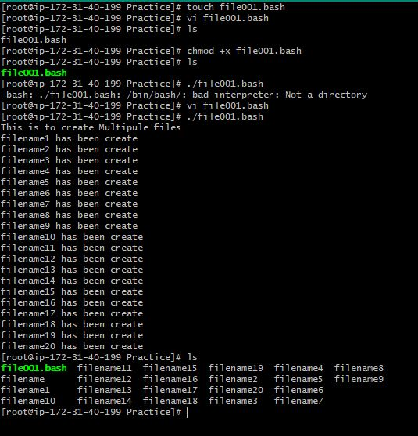

for i in (1..10); do touch file$i.txt; done

(or)

#!/bin/bash

echo “This is my first bash script”

touch filename

for (( int i=1;i<=100;i++ ));

do

cp filename filename$i

echo “filename$i has be created”

done

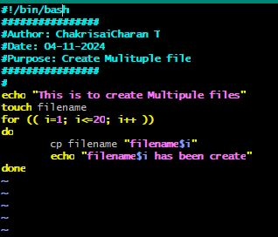

1. **Create a bash script to take backup of a directory.**

#!/bin/bash

###############

#Author: ChakriSaiCharan T

#Date: 04-11-2024

#Purpose: Create a bash script to backup of a directory

#

# Variable

SOURCE_DIR="/root/Practice"

BACKUP_DIR="/root/Practice01"

tar -czf "$BACKUP_DIR/backup_$(date +%Y%m%d).tar.gz" "$SOURCE_DIR"

echo "Backup of $SOURCE_DIR completed and saved to $BACKUP_DIR"

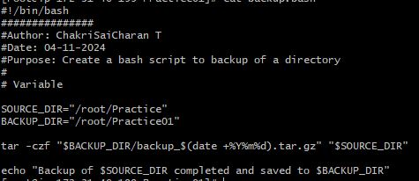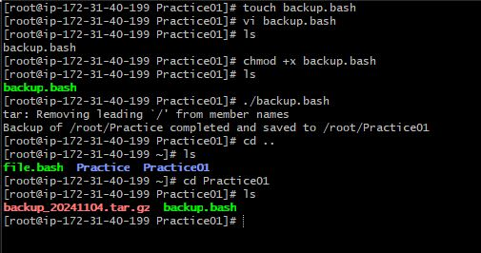

1. 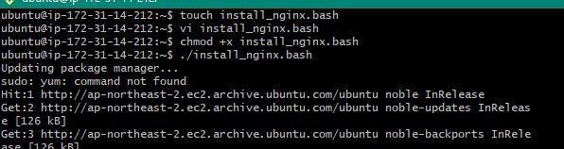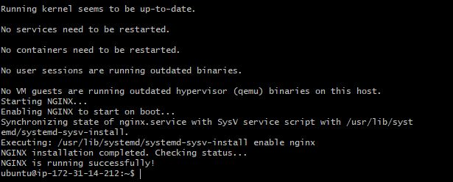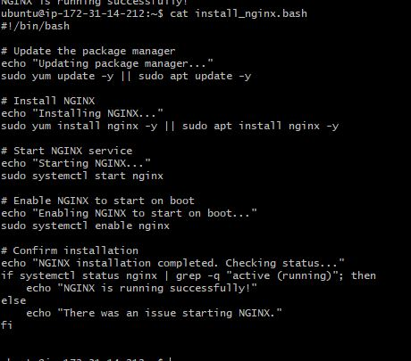**Create a bash script to install nginx in ec2 server.**

1. Create a bash script to check list if nginx service is running or not,if not running then script should start the service.

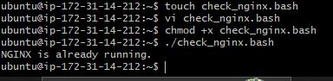 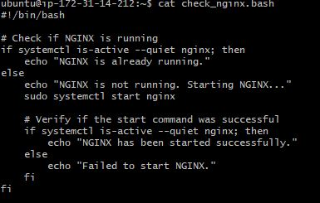

1. Create a bash script to install ApacheTomcat in ec2 server.

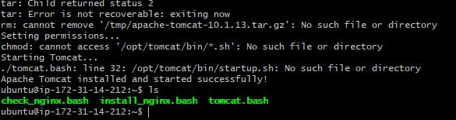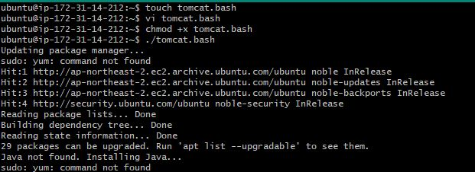

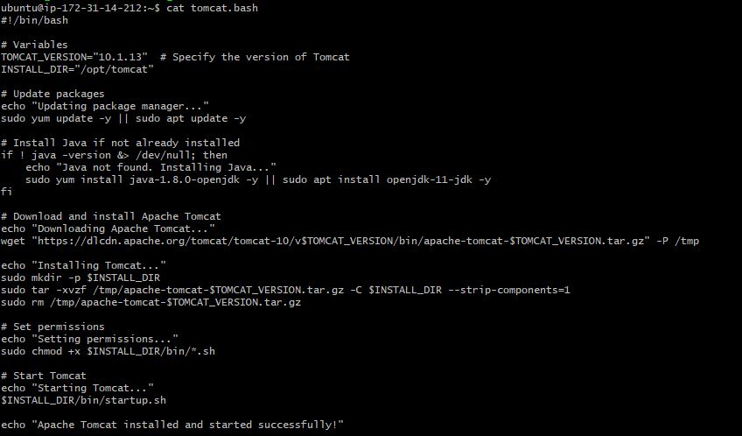

1. Create a bash script for calculator.

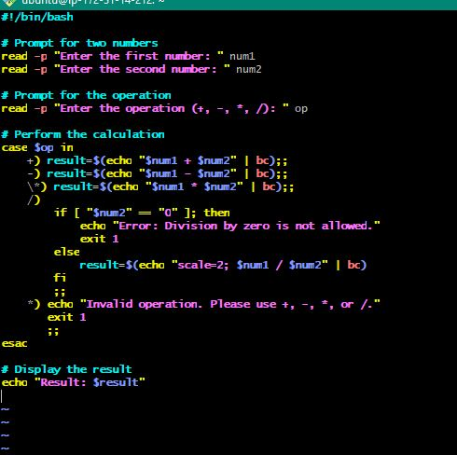

#!/bin/bash

# Prompt for two numbers

read -p "Enter the first number: " num1

read -p "Enter the second number: " num2

# Prompt for the operation

read -p "Enter the operation (+, -, *, /): " op

# Perform the calculation

case $op in

+) result=$(echo "$num1 + $num2" | bc);;

-) result=$(echo "$num1 - $num2" | bc);;

\*) result=$(echo "$num1 * $num2" | bc);;

/)

if [ "$num2" == "0" ]; then

echo "Error: Division by zero is not allowed."

exit 1

else

result=$(echo "scale=2; $num1 / $num2" | bc)

fi

;;

*) echo "Invalid operation. Please use +, -, *, or /."

exit 1

;;

esac

# Display the result

echo "Result: $result"

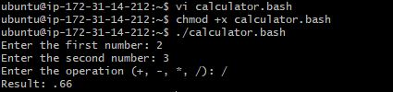

1. 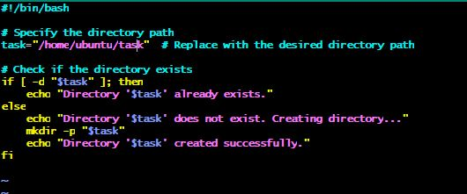Create a bash script to check if directory is avaialble or not,if not then create a directory.

#!/bin/bash

# Specify the directory path

task="/home/ubuntu/task"

# Check if the directory exists

if [ -d "$task" ]; then

echo "Directory '$task' already exists."

else

echo "Directory '$task' does not exist. Creating directory..."

mkdir -p "$task"

echo "Directory '$task' created successfully."

fi

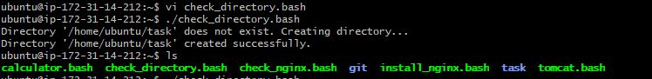

1. Create bash script to delete last 3 lines for a file.

