06-11-2024 Bash Script

1. 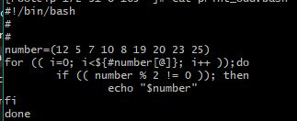Bash script to print odd numbers from the list: (12,5,7,10,8,19,20,23,25)

#!/bin/bash

numbers=(12 5 7 10 8 19 20 23 25)

for num in "${numbers[@]}"

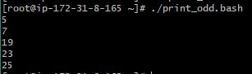do

if (( num % 2 != 0 )); then

echo "$num"

fi

done

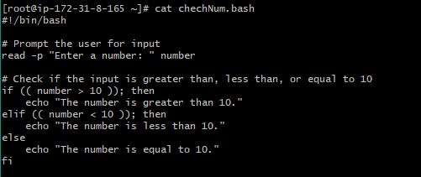 2) Bash script to take an input from the user and check if it’s greater than or less than 10

#!/bin/bash

read -p "Enter a number: " number

if (( number > 10 )); then

echo "The number is greater than 10."

elif (( number < 10 )); then

echo "The number is less than 10."

else

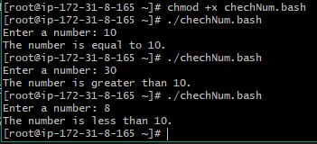 echo "The number is equal to 10."

Fi

1. 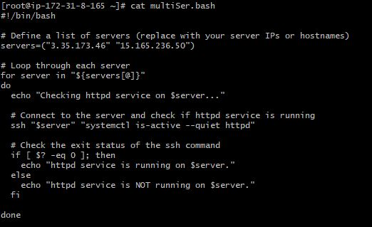Bash script to log in to multiple servers and check if httpd service is running

#!/bin/bash

servers=("15.165.236.50" "3.35.173.46")

for server in "${servers[@]}"

do

echo "Checking httpd service on $server..."

ssh "$server" "systemctl is-active --quiet httpd"

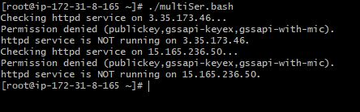

if [ $? -eq 0 ]; then

echo "httpd service is running on $server."

else

echo "httpd service is NOT running on $server."

fi

done

1. Bash script to check log files from a specified path and delete files older than 20 days



#!/bin/bash

# Directory containing log files

LOG_DIR="/var/log/httpd"

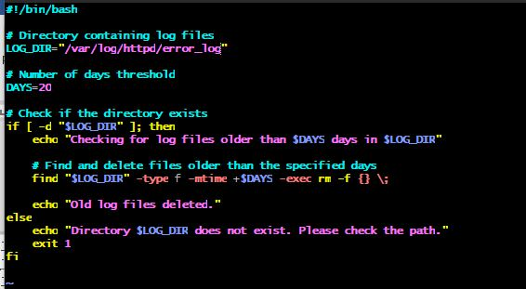# Number of days threshold

DAYS=20

# Check if the directory exists

if [ -d "$LOG_DIR" ]; then

echo "Checking for log files older than $DAYS days in $LOG_DIR"

# Find and delete files older than the specified days

find "$LOG_DIR" -type f -name "*.log" -mtime +$DAYS -exec rm -f {} \;

echo "Old log files deleted."

else

echo "Directory $LOG_DIR does not exist. Please check the path."

exit 1

fi

1. 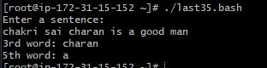 Bash script to print the 3rd and 5th words from user input

#!/bin/bash

# Prompt the user for input

echo "Enter a sentence:"

read user_input

# Use 'set' to parse the input into positional parameters

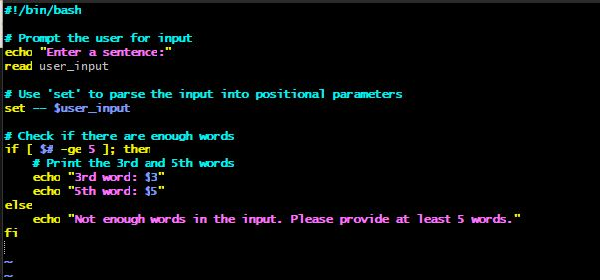set -- $user_input

# Check if there are enough words

if [ $# -ge 5 ]; then

# Print the 3rd and 5th words

echo "3rd word: $3"

echo "5th word: $5"

else

echo "Not enough words in the input. Please provide at least 5 words."

Fi

1. Bash script to print numbers from 1 to 100 and then separate them into odd and even numbers

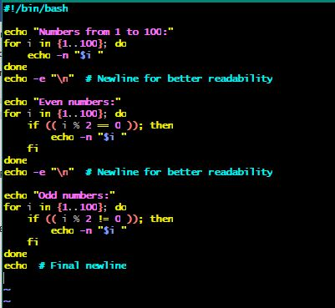#!/bin/bash

echo "Numbers from 1 to 100:"

for i in {1..100}; do

echo -n "$i "

done

echo -e "\n" # Newline for better readability

echo "Even numbers:"

for i in {1..100}; do

if (( i % 2 == 0 )); then

echo -n "$i "

fi

done

echo -e "\n" # Newline for better readability

echo "Odd numbers:"

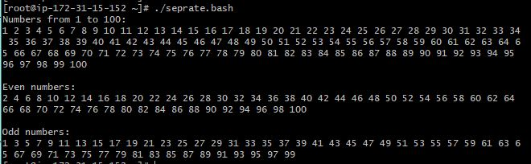for i in {1..100}; do

if (( i % 2 != 0 )); then

echo -n "$i "

fi

done

echo # Final newline