**Task on Ec2**

**1)Launch one ec2 using Amazon Linux 2 image and add script in user data to install Apache.**

* + Login to AWS Management console
  + Navigate to Ec2 Dashboard and click on Lunch instance
  + Provide details
    - Name and tags: Give a name at your creating required Instance
    - Application and OS image (AMI): Select Amazon Linux 2 AMI
    - Instance type: Choose t2.micro (it is selected type)
    - Key pair: create a key pair access to your instance.
    - Network Settings
      * + Security group name : Add security group will be added to all network interfaces (My_Security_Group).
        + Description : Help you identify the security group (Allowing specific port number).
        + Ensure to **allow HTTP traffic (port 80)** in the security group rules.
  + Select Advanced Details add User data Script to Install Apache(httpd).

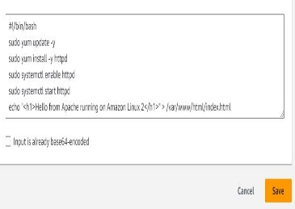

Script:

#!/bin/bash

sudo yum update -y

sudo yum install -y httpd

sudo systemctl enable httpd

sudo systemctl start httpd

echo “<html><body><h1>Hello from Apache install in Amazon

Linux 2</h1></body></html>” > /var/www/html/index.html

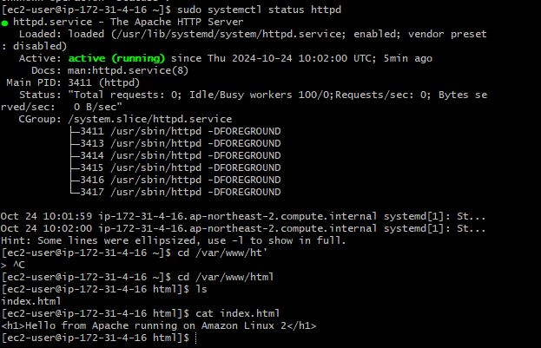

* + In CLI
    - Run 🡪 sudo systemctl status httpd
    - Change the Directory 🡪 cd /var/www/html
    - View the content on file 🡪 cat index.html

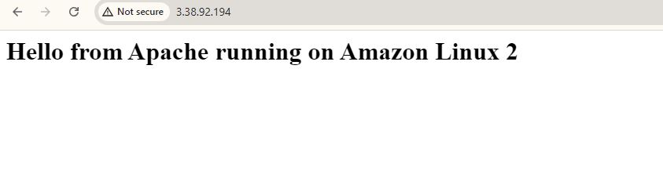

* + Browse
    - Browse the IP address with help of port number

<ip:80>

**2) Launch one ec2 using Ubuntu image and add script in user data to install Nginx.**

* + Login to AWS Management console
  + Navigate to Ec2 Dashboard and click on Lunch instance
  + Provide details
    - Name and tags: Give a name at your creating required Instance(i.e., ‘Nginx-Ubuntu-EC2’)
    - Application and OS image (AMI): Select Ubuntu Server 22.04 LTS
    - Instance type: Choose t2.micro (it is selected type)
    - Key pair: create a key pair access to your instance.
    - Network Settings
      * + Security group name : Add security group will be added to all network interfaces (My_Security_Group).
        + Description : Help you identify the security group (Allowing specific port number).
        + Ensure to **allow HTTP traffic (port 80)** in the security group rules.
  + Select Advanced Details add User data Script to Install Nginx.

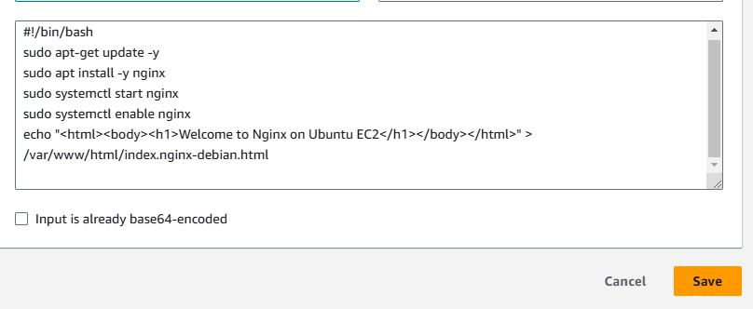

Script:

#!/bin/bash

sudo apt-get update -y

sudo apt install -y nginx

sudo systemctl start nginx

sudo systemctl enable nginx

echo “<h1>Welcome to Nginx on Ubuntu Ec2</h1>” >

/var/www/html/index.nginx-debian.html

or

echo “<h1>Welcome to Nginx on Ubuntu Ec2</h1>” >

/usr/share/nginx/html/index.html

**There are two different default location nginx**

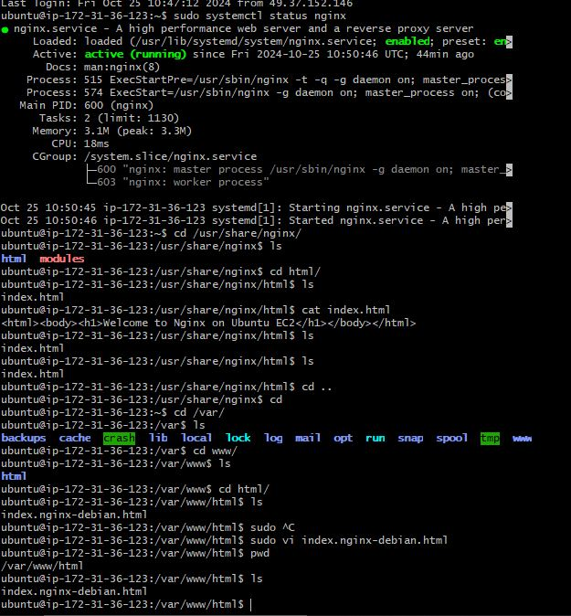/usr/share/nginx/html/

/var/www/html/

* + In CLI
    - Run 🡪 sudo systemctl status nginx
    - Change the Directory 🡪 cd /var/www/html
    - View the content on file 🡪 cat index. nginx-debian .html

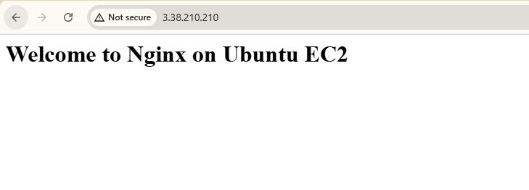

* + Browse
    - Browse the IP address with help of port number

<ip:80>

**3) Launch one windows server and install tomcat in windows.**

* + Login to AWS Management console
  + Navigate to Ec2 Dashboard and click on Lunch instance
  + Provide details
    - Name and tags: Give a name at your creating required Instance(i.e., Window)
    - Application and OS image (AMI): Select Microsoft windows Server 2022 or 2019
    - Instance type: Choose t2.micro (it is selected type).
    - 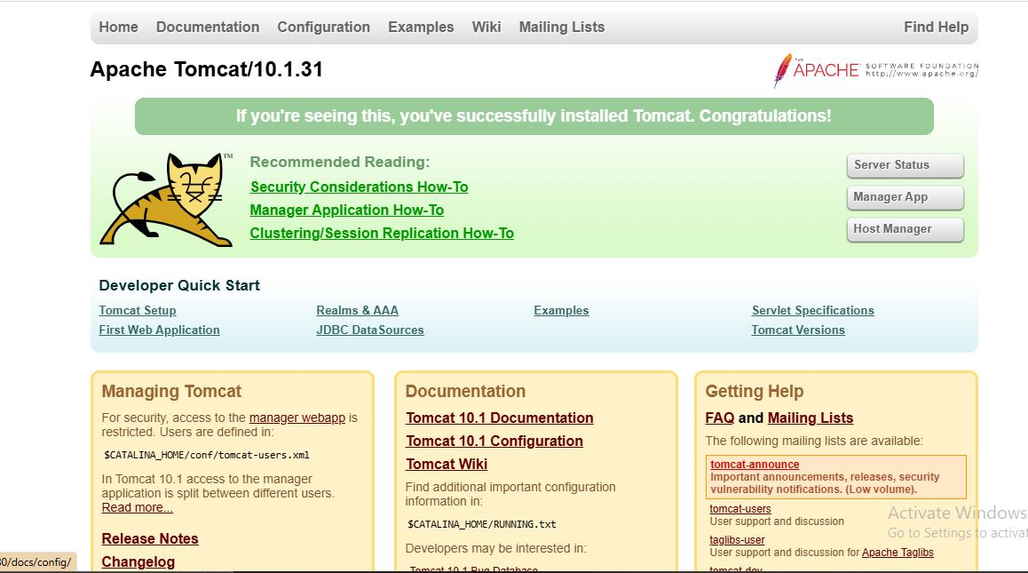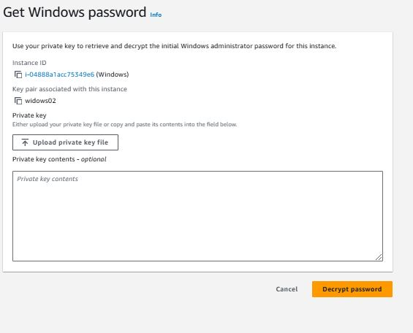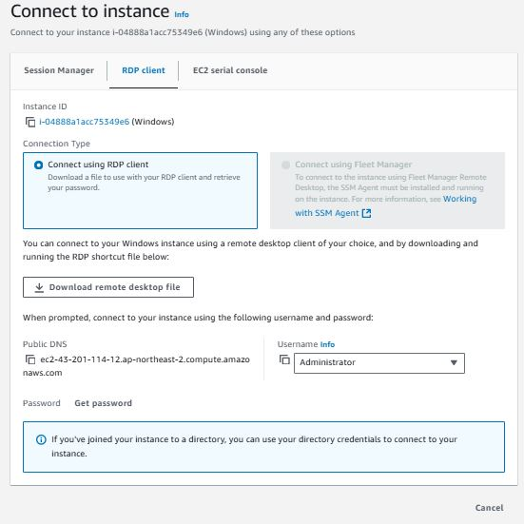Key pair: create a key pair access to your instance.

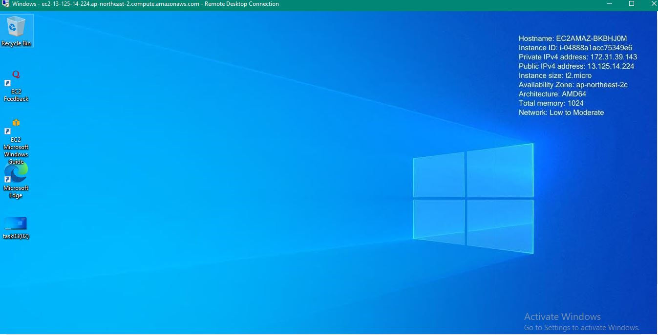

4**) Take snapshot of the instane created in Task 1**

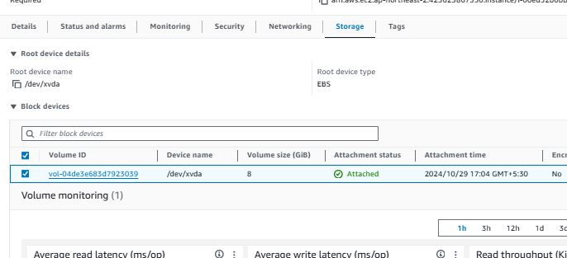

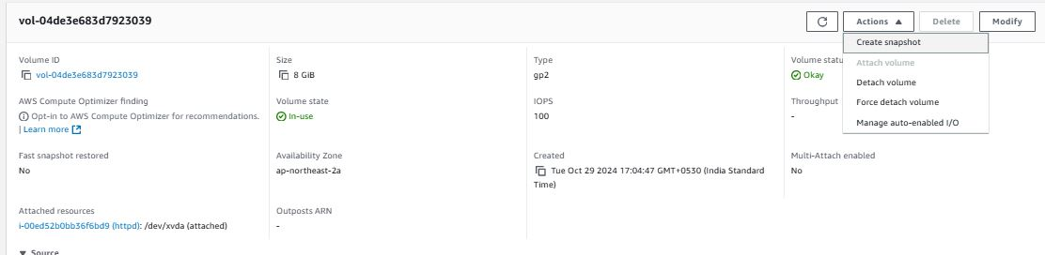

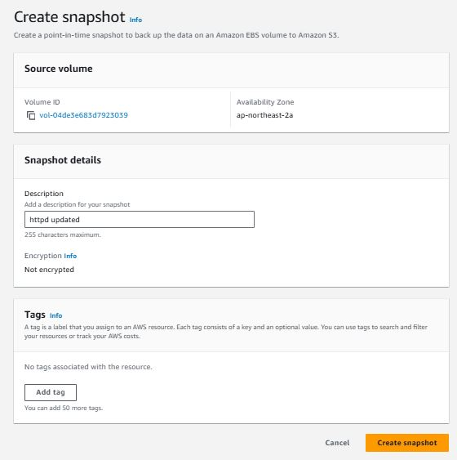

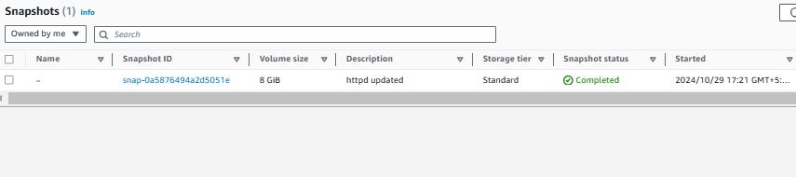

**5) Assign password less authentication for ec2 created on Task 2.**

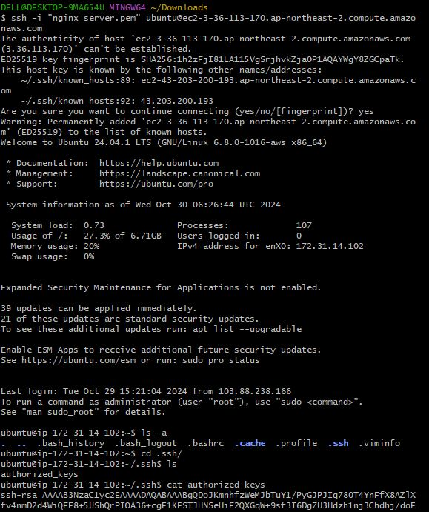

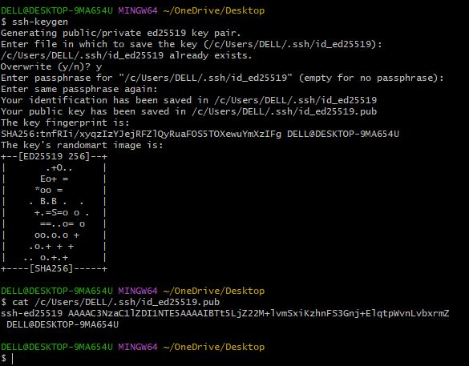

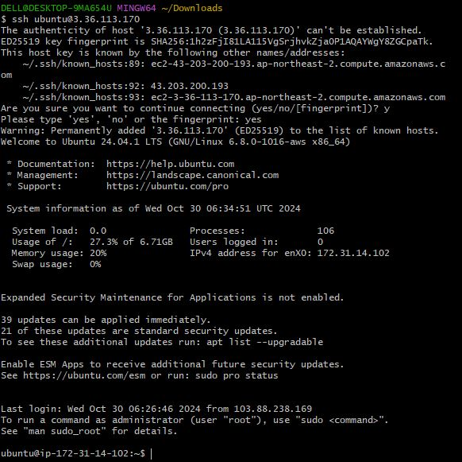

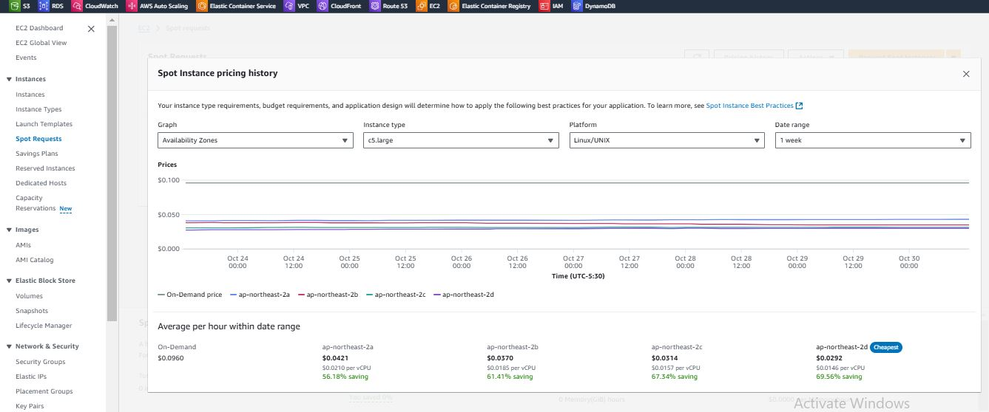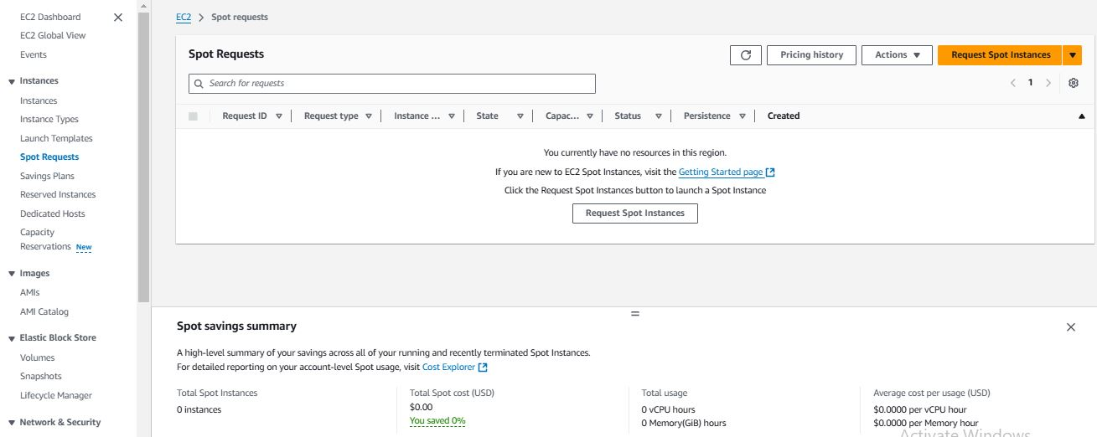6) Launch any ec2 using spot purchasing option.

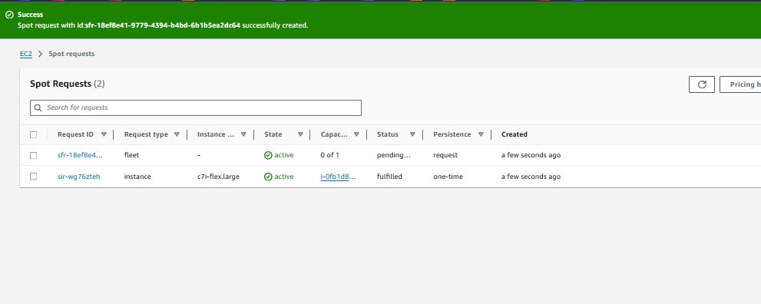

7) Enable Termination policy on ec2 created in Task 2.

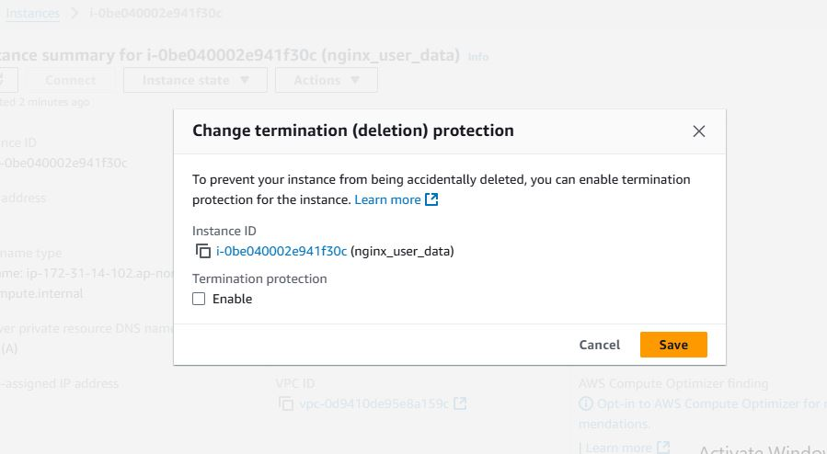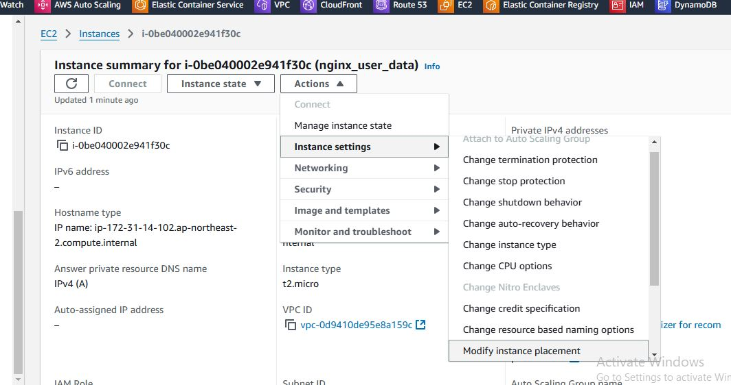

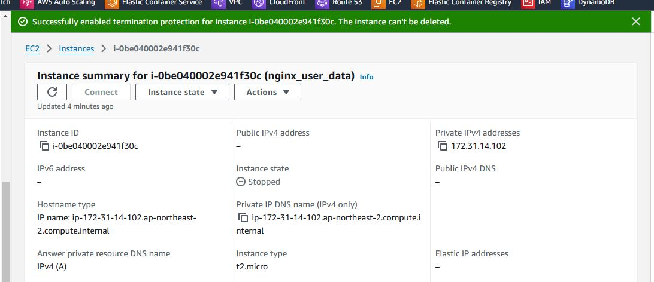

8) Launch one ec2 using Aws CLI.

