Git And Git Hub

1)Install git

$**yum install git 🡪 $git init**

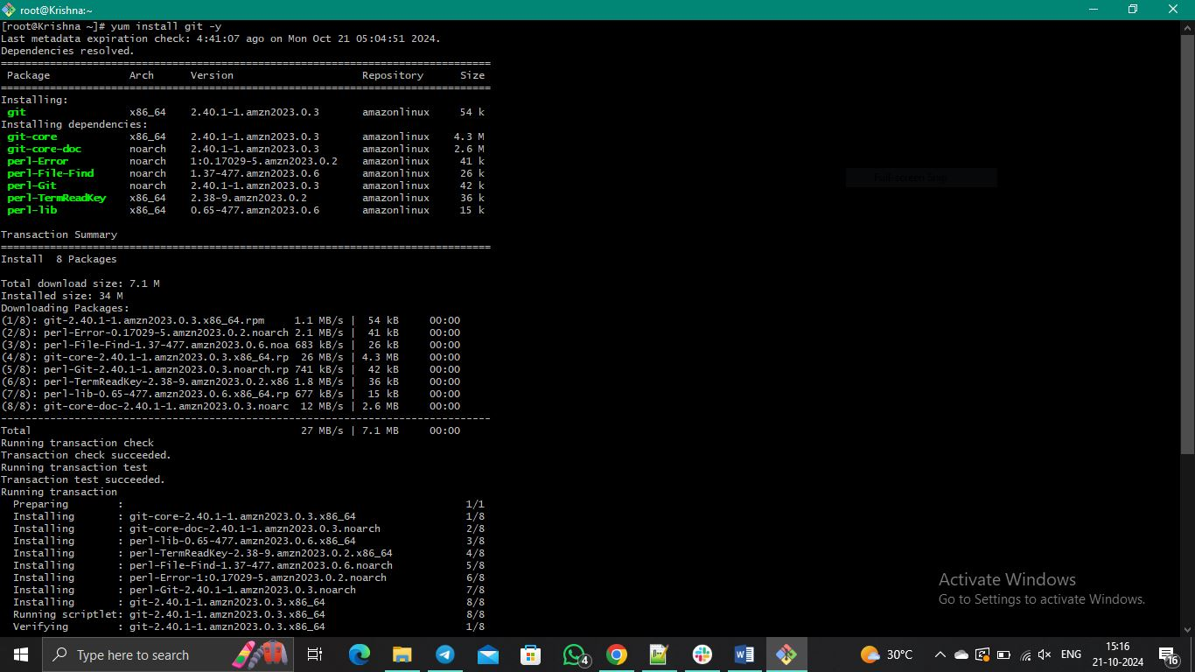

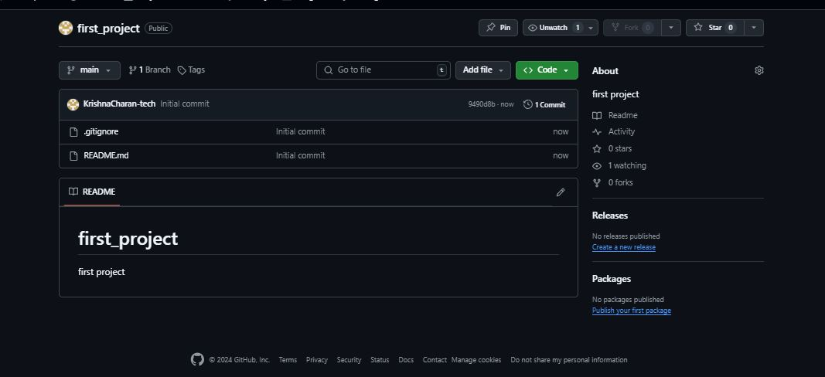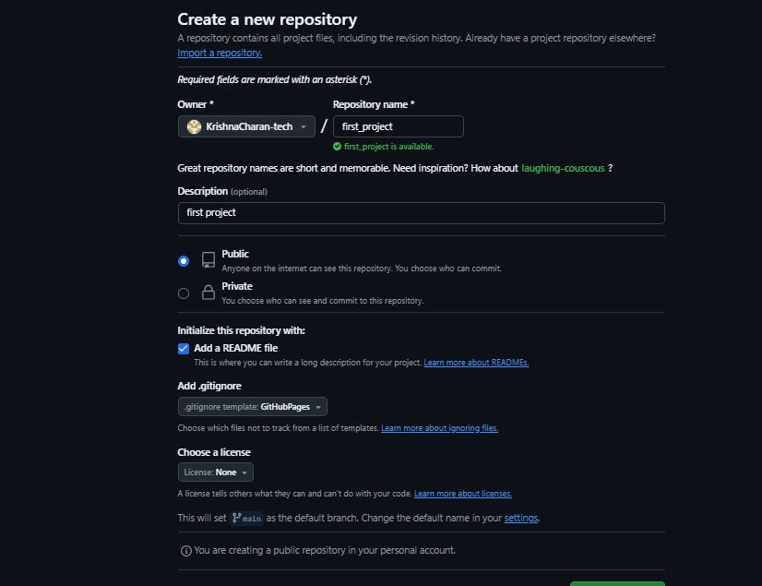 2) Create a repo in github with README.md and .ignore file.

3) Clone the created repo to local.

$**git clone (repository_url)**

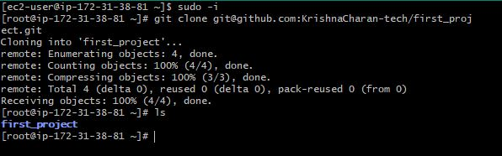

4) Create two files in local repo.

$**touch (filename)**

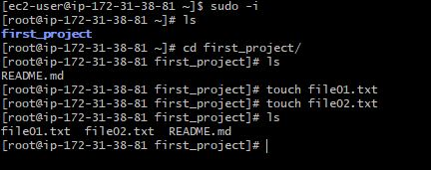

5) Commit two files and push to central Repository.

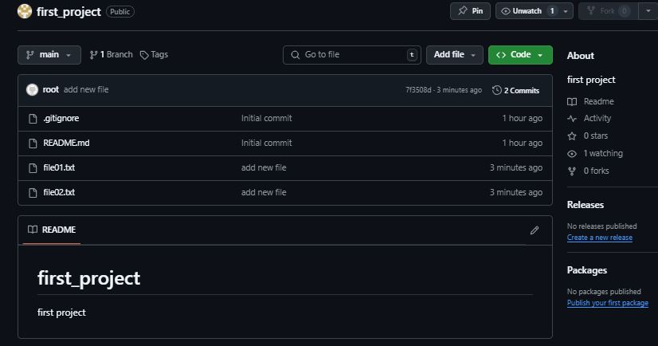 $**git status 🡪 $git add (filename) 🡪 $git commit -m (“message for the files”)**

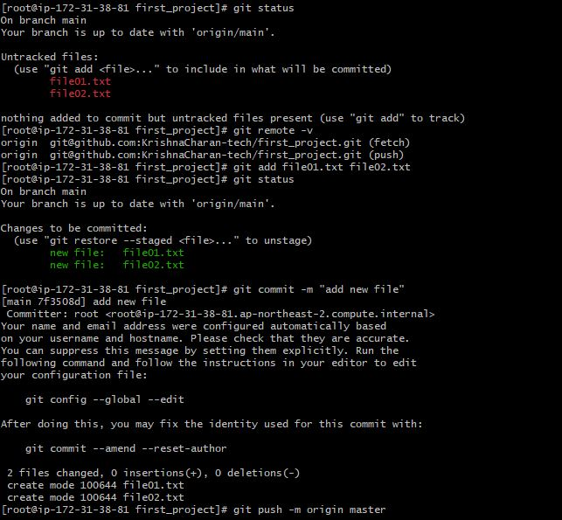

6) Create a branch in local and create a sample file and push to central.

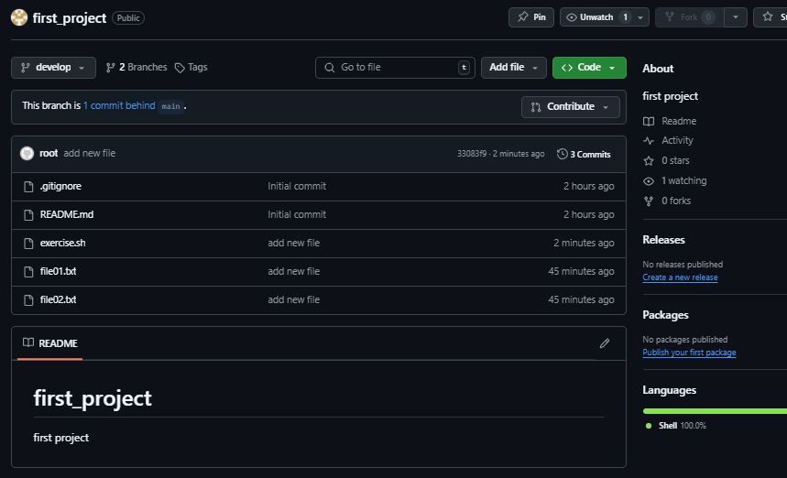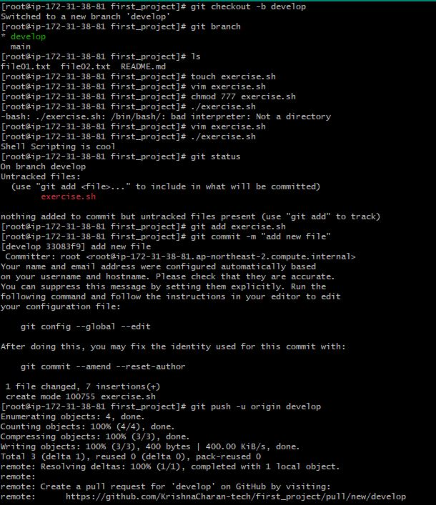 **$git branch <branch name> 🡪 $git checkout <branch name> 🡪 $touch <file name> 🡪 $git add <file name> 🡪 $git commit -m “new message” 🡪 $git push -u origin main**

7) Create a branch in github and clone that to local.

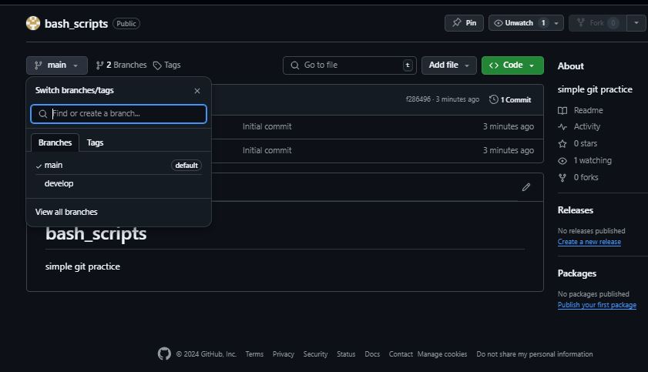 $**git colne <branch url>**

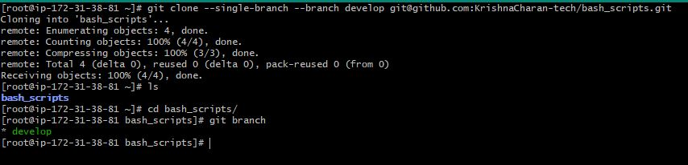

8) Merge the created branch with master in git local.

**$git branch <branch name> 🡪 $git checkout <branch name> 🡪 $git merge <branch name>**

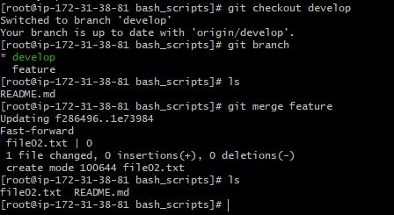

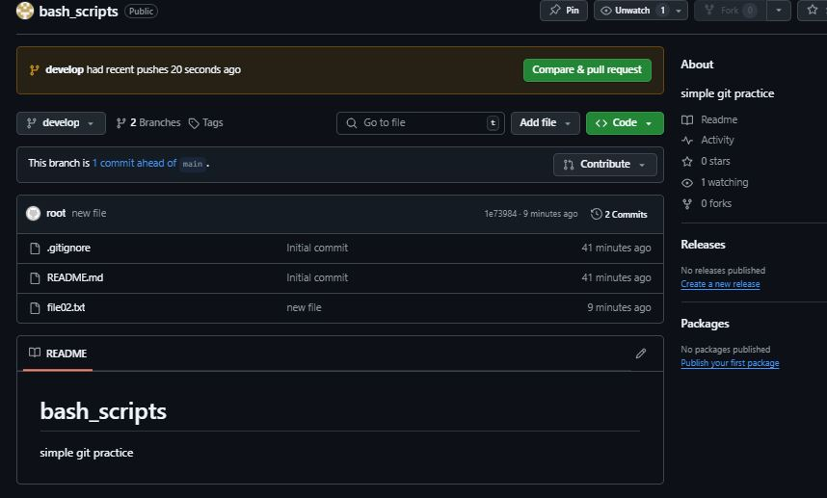 9) Merge the created branch with master in github by sending a pull request.

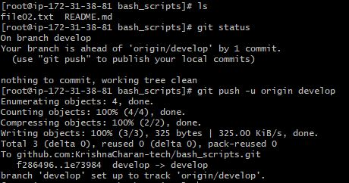

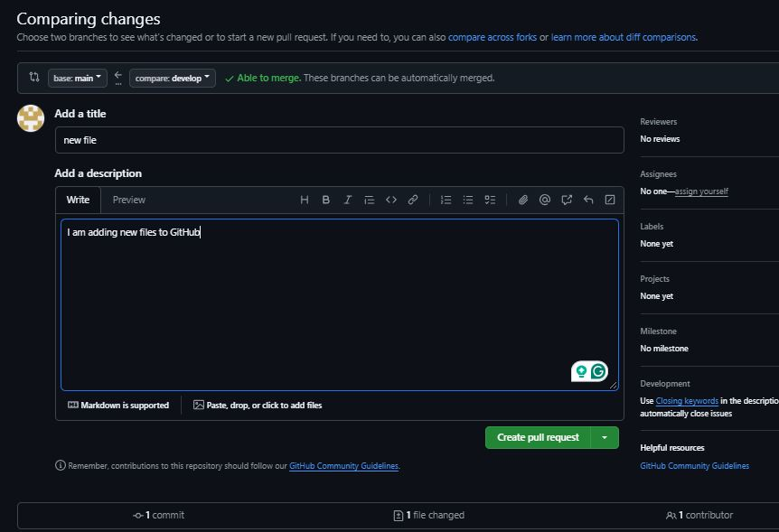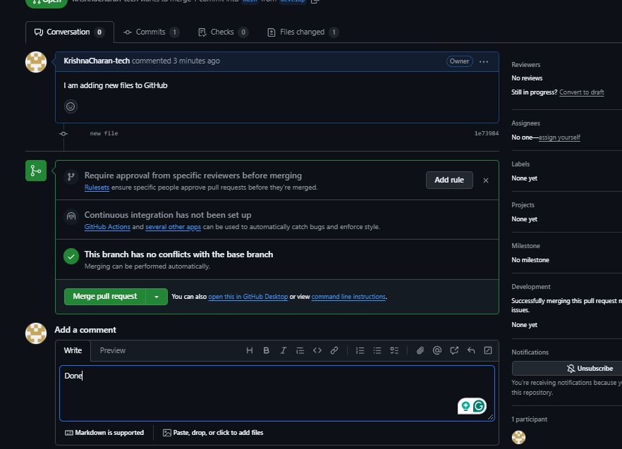

10) create a file in local and send that to branch in github

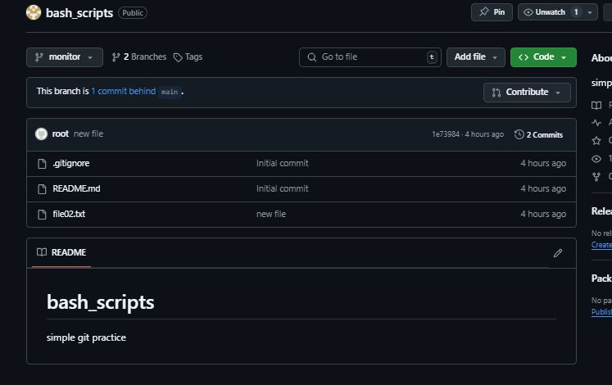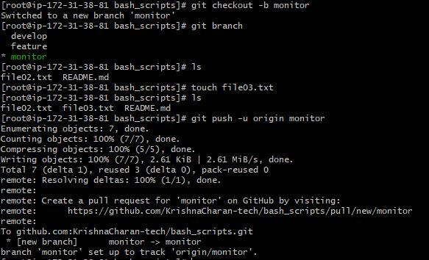 $**git checkout -b <branch name> 🡪 $touch <file name> 🡪 $git add <FN> 🡪 $git commit -m “message” 🡪 $git push -u origin <branch name>**

11) clone only a branch from github to local.

$**git clone –single-branch --branch <branch name> <repository url>**

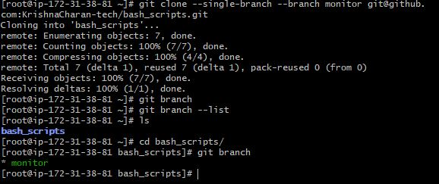

12) create a file with all passwords and make that untrackable with git.

$**vi password 🡪 add in 🡪 $vi .gitignore 🡪 $git push origin main**

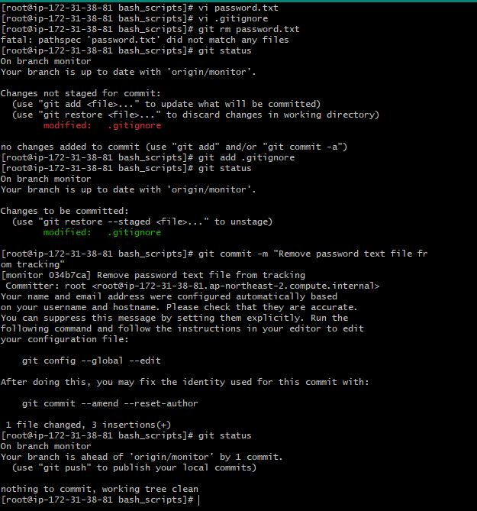

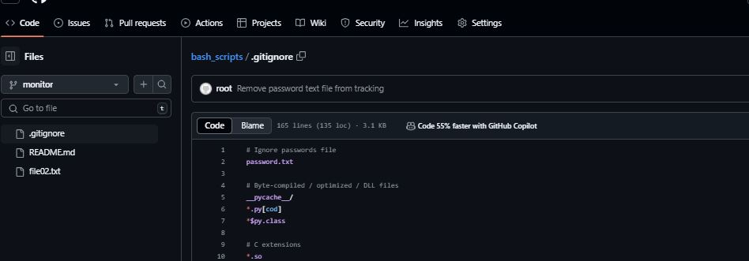

13) make a commit and make that commit reset without savings changes.

$**git log 🡪 $git reset –-head HEAD~1**

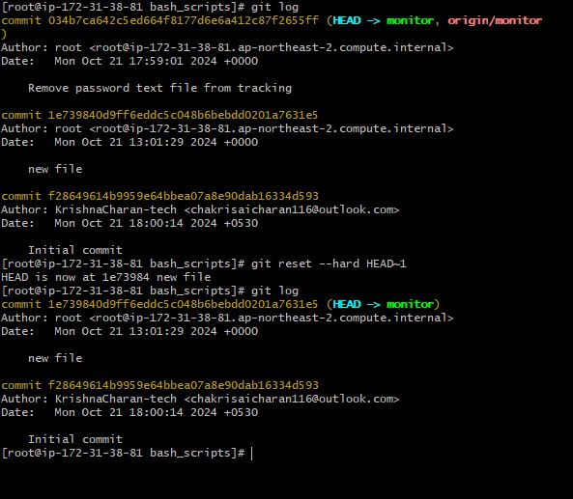

14) Revert a commited commit to the older version.

$**git log 🡪 $git reset –-hard <commit id>**

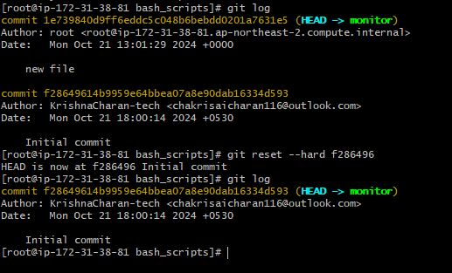

15) push a file to stash without savings the changes and work on another file.

**$git stash**



16) undo the stash file and start working on that again.

$**git stash 🡪 $git stash list 🡪 $git stash apply stash@{0}**

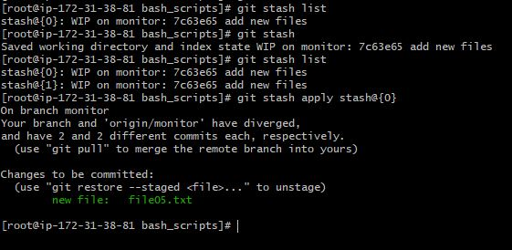

17) generate a ssh-keygen and configure into github.

**$ssh-keygen 🡪 $cat <public key>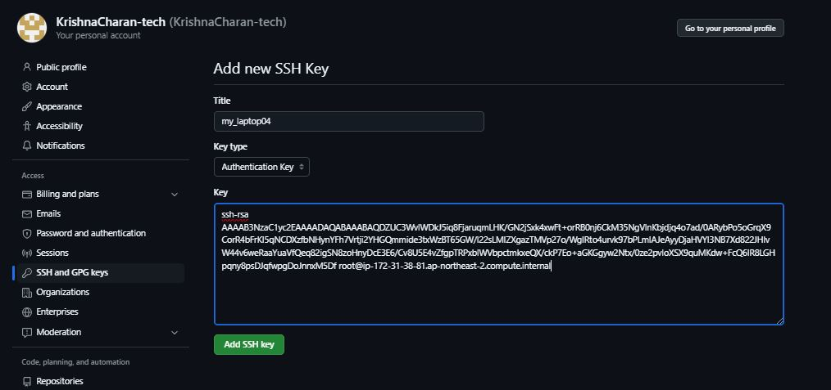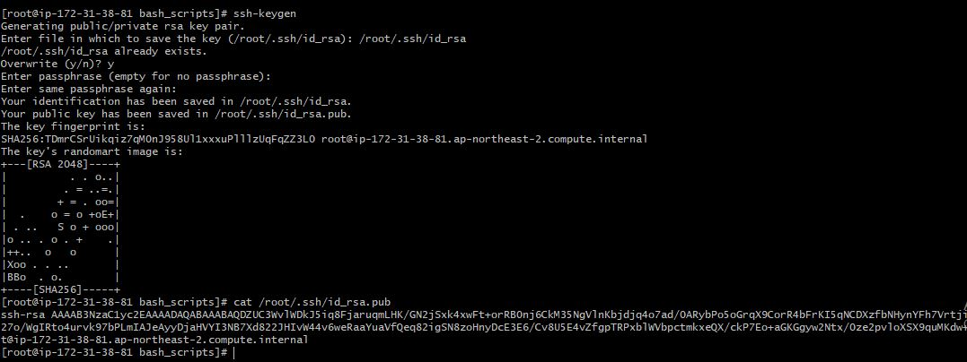 🡪 copy the key 🡪 go to github 🡪 settings 🡪 ssh & GPG keys 🡪 click new SSH key 🡪 past the public key**

18) configure webhooks to github.

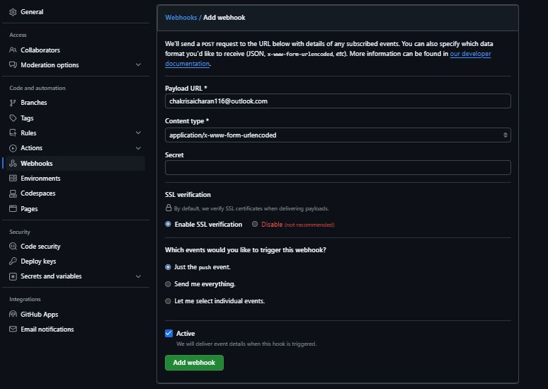

19) basic understanding of .git file.

20) Check all the logs of git.

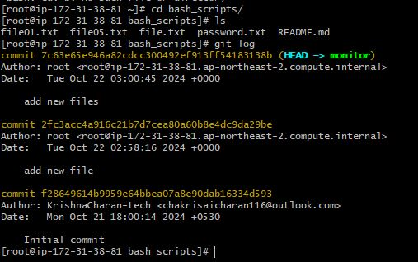 **$git log**

21) Rename the commit message.

$**git log 🡪 $git commit –-amend 🡪 edit commit message 🡪 exist 🡪 check git log**

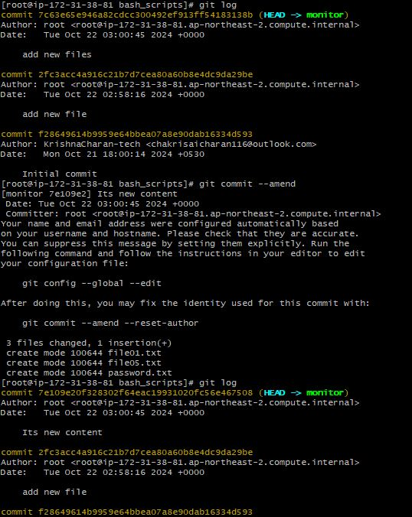

22) Merge multiple commits into single commit.

**$git log 🡪 $git rebase -i HEAD~3 🡪 rename the commit message first line pick and second line squash <commit id> commit message 🡪 edit the commit message 🡪 save and exist :wq! 🡪 $git log**



