Tasks On RDS

1. Create mariadb db on ec2.

Lunch One Instance 🡪 Copy the SSH key in your local terminal

Then use the following steps

* For installing the Mariadb in your ec2
* sudo yum update -y
* sudo yum install -y mariadb-server
* sudo systemctl start mariadb
* sudo systemctl enable mariadb
* 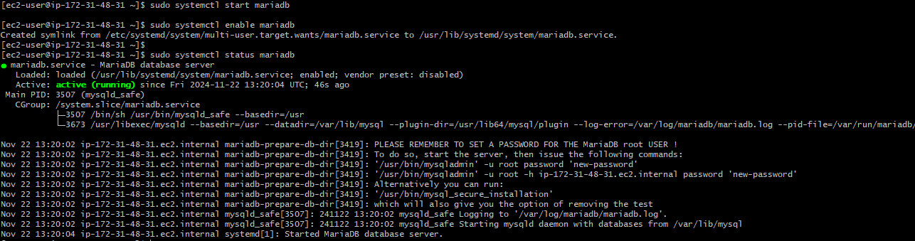sudo systemctl status mariadb

1. 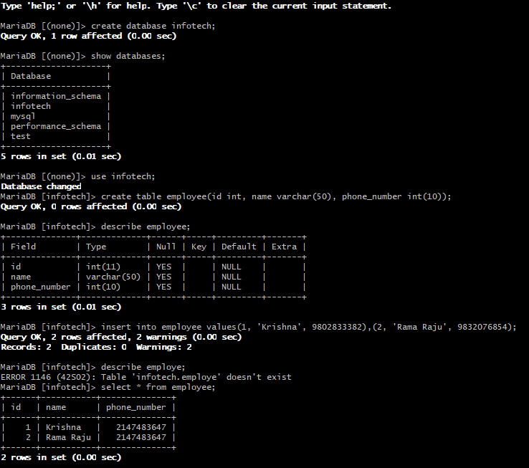Insert some dummy data.

To insert dummy date on database

First you need to create database in the server you need to follow the steps 🡪

Create database <databasename>

Use <databasename>

Create table <tablename>(id int, name varchar(10));

Insert into <tablename> values(1, ‘some’),(2, ‘some’);

Select \* from <tablename>

1. Take the backup of dummy data on ec2.

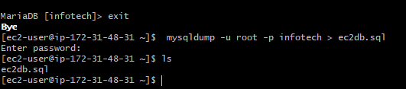

1. launch Mariadb RDS instance.

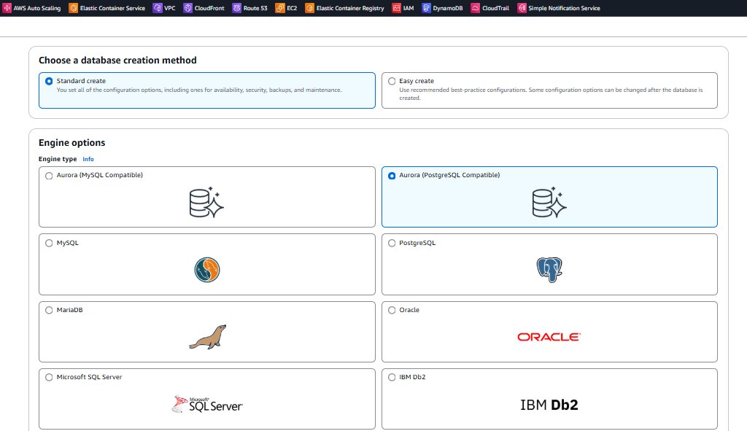

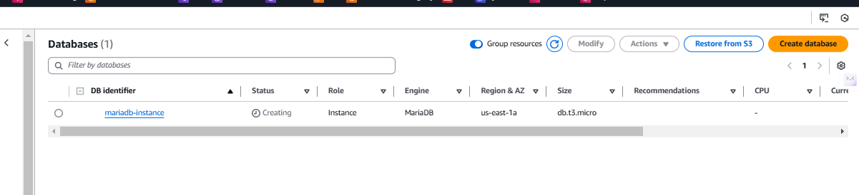

1. Migrate database from ec2 to RDS.