Route53

1. Configure VPC peering in cross regions.(Need to do this again)
   * + - Log in to the AWS Management Console and navigate to the VPC Dashboard.
       - Go to Peering Connections on the left panel and click Create Peering Connection.
       - Specify the following:
         * Name for the peering connection (optional but recommended).
       - Requester VPC: Select the VPC in the first region.
       - Accepter VPC: Choose the second VPC (in the other region) you want to peer with. You can select a VPC from:
         * Another AWS account: Enter the AWS account ID and select the VPC in that account.
         * Your own account but in a different region.
         * Review the details and click Create Peering Connection.

### Accept the Peering Connection

* + - * + In the Accepter VPC’s region, go to the VPC Dashboard.
      * Go to Peering Connections, find the peering request, select it, and click Actions > Accept Request.
      * Confirm the acceptance.
    - **In the Requester VPC**:
      * Go to Route Tables in the VPC dashboard.
      * Select the appropriate route table and click Edit Routes.

Add a new route:

Destination: The CIDR block of the Accepter VPC.

Target: The VPC Peering Connection ID.

Save the route.

* + - * **In the Accepter VPC** (in the other region):

Repeat the same steps to add a route for the CIDR block of the Requester VPC, using the same VPC Peering Connection ID.

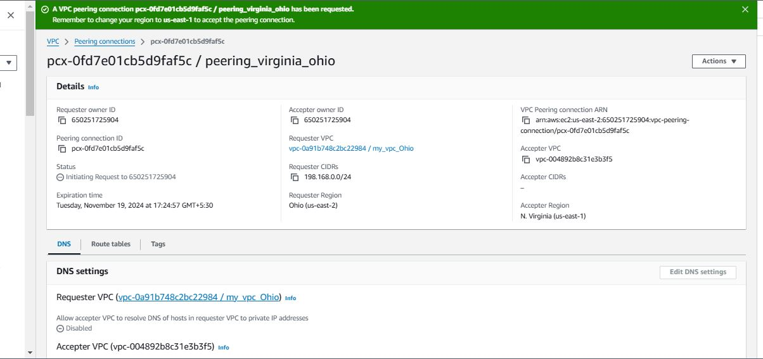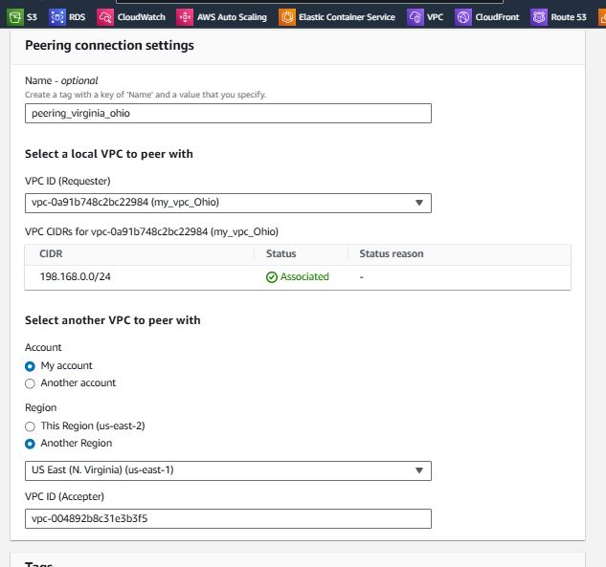

Peering Connection(Requester)

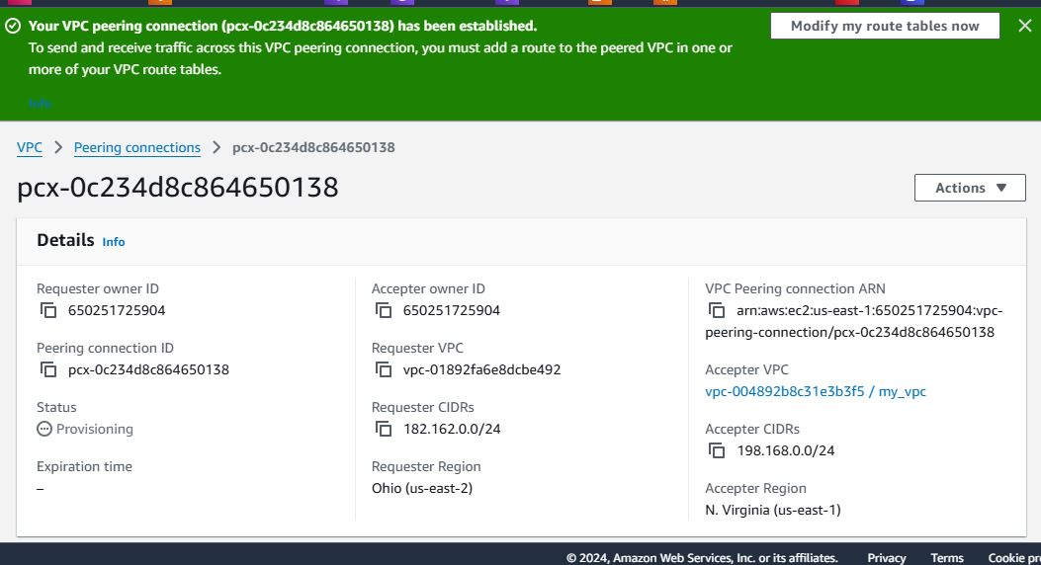

Peering Connection(Accepter)

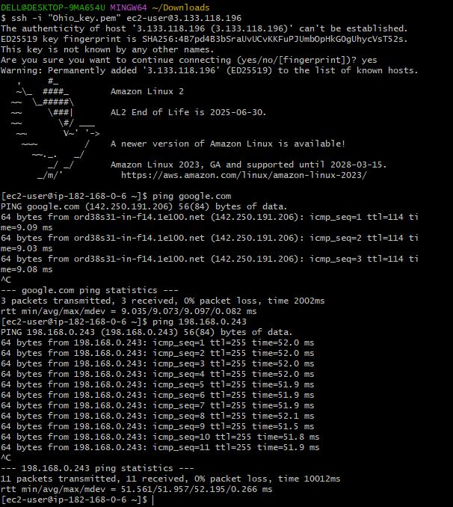

OutPut Peering Connection cross Region

1. Purchase one domain from GoDaddy.

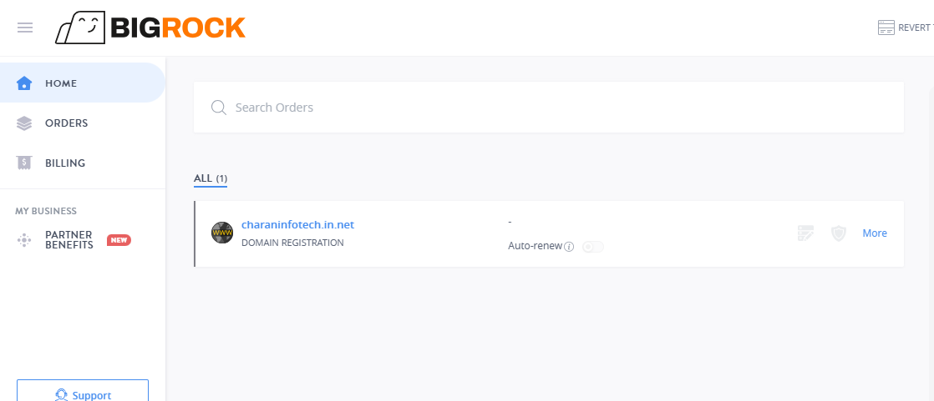

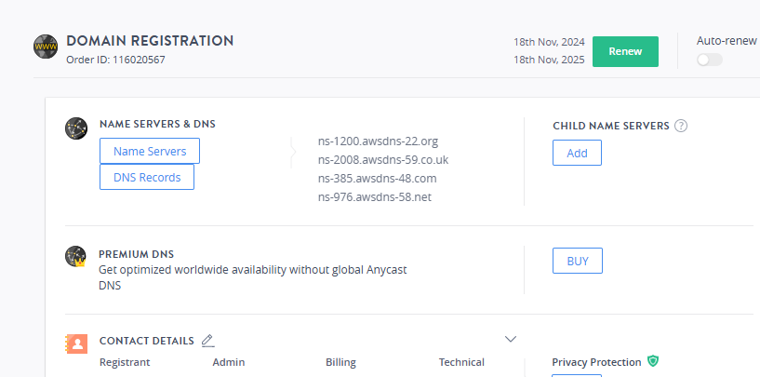

1. Deploy static website in s3.

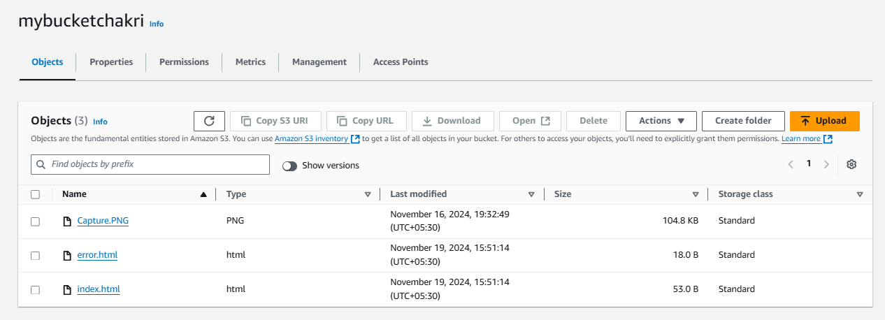

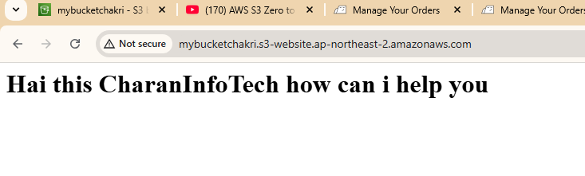

1. Create Route53 hosted zone and MAP the domain with CDN.

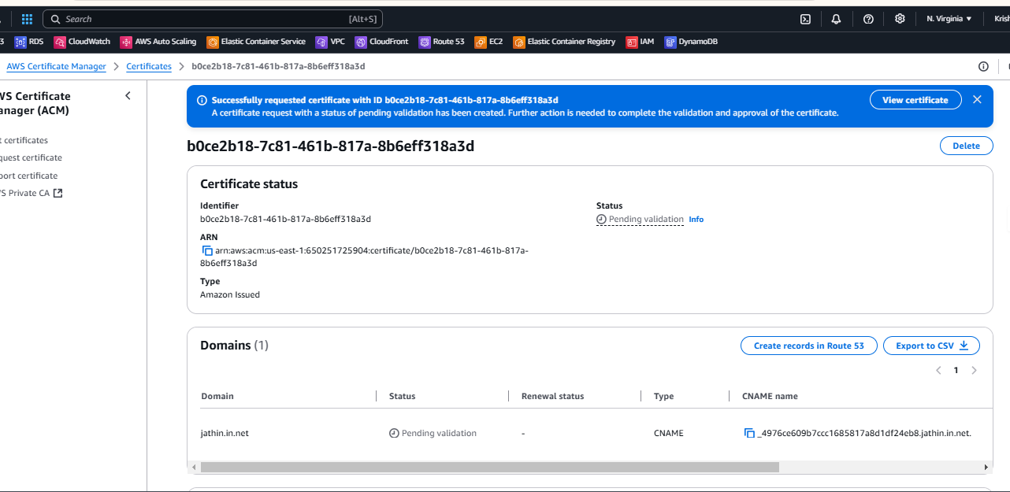

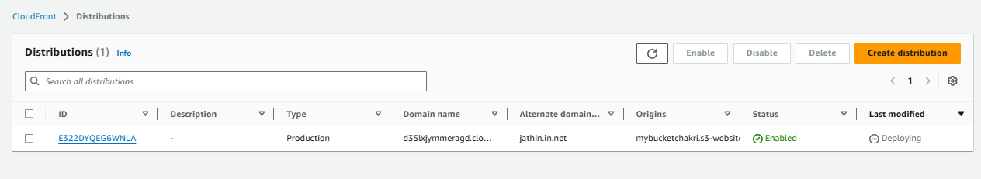

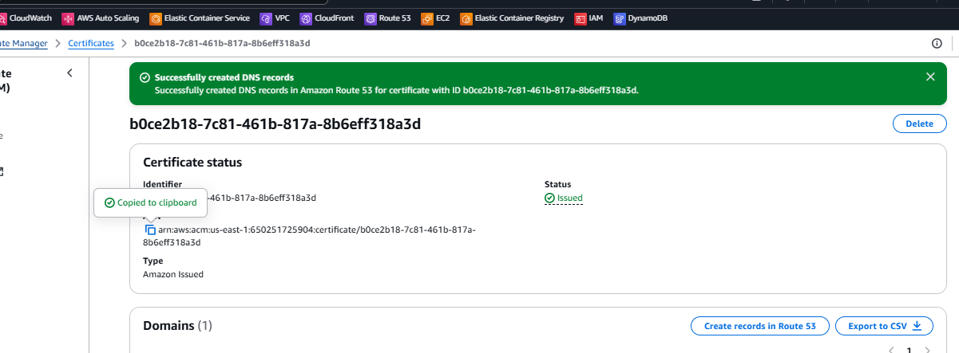

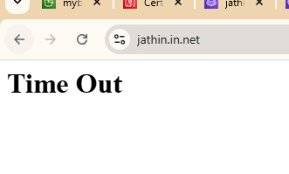

1. Create CDN and attach one SSL certificate.

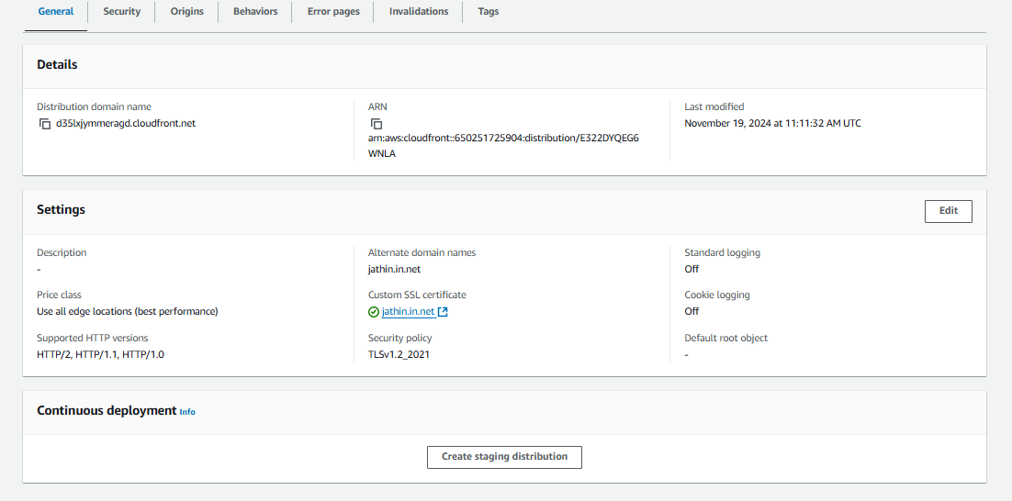

6) Update the index.html in s3 bucket and the updated file should be accessible by using domain name.





1. Share the Domain name in slack to test the connectivity.

Jathin.in.net