Task 2 On VPC

1. Create one VPC,with 1 one public subnet and 1 private subnet.

### Create the VPC

* + - * + Go to the VPC Dashboard in the AWS Console.
        + Click on Create VPC.
        + Select VPC Only or VPC and More depending on your preferred setup (selecting "VPC and More" can automatically create some of the resources).
        + Provide:

Name: Choose a name (e.g., MyVPC).

IPv4 CIDR Block: Enter a CIDR block (e.g., 198.168.0.0/24).

* + - * + Click Create VPC.

### Create a Public Subnet and Private Subnet

* + - * + In the VPC Dashboard, select Subnets from the left-hand menu, then click Create Subnet.
        + Provide:

Name: Choose a name (e.g., PublicSubnet and PrivateSubnet).

VPC: Select the VPC you just created.

Availability Zone: Choose an availability zone for this subnet.

IPv4 CIDR Block: Enter a CIDR block (e.g., 198.168.0.0/24 and 198.168.0.16/24).

* + - * + 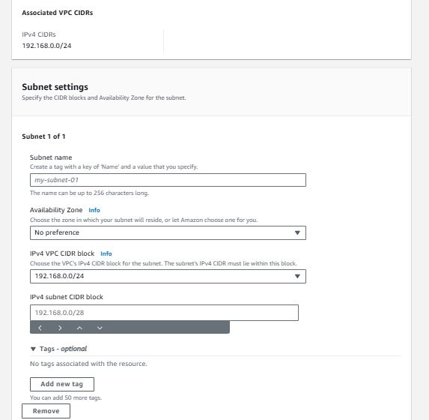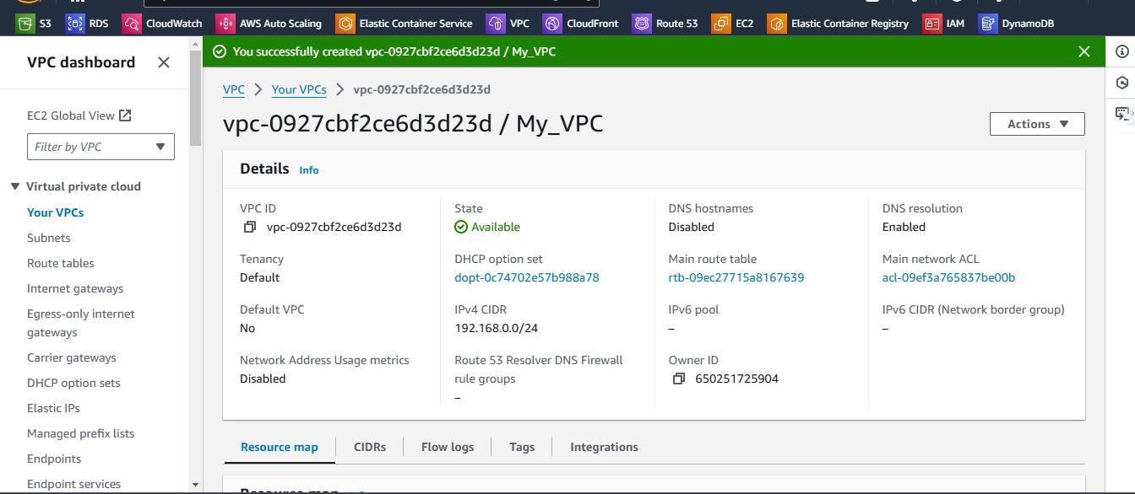Click Create Subnet.

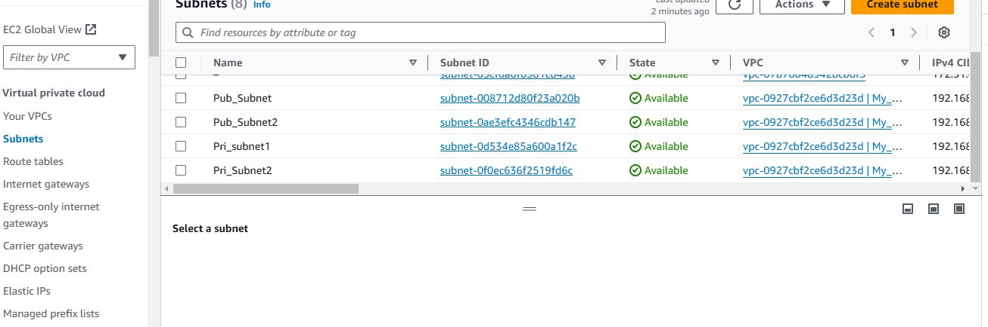

1. Enable VPC peering for cross region.
   * + - Log in to the AWS Management Console and navigate to the VPC Dashboard.
       - Go to Peering Connections on the left panel and click Create Peering Connection.
       - Specify the following:
         * Name for the peering connection (optional but recommended).
       - Requester VPC: Select the VPC in the first region.
       - Accepter VPC: Choose the second VPC (in the other region) you want to peer with. You can select a VPC from:
         * Another AWS account: Enter the AWS account ID and select the VPC in that account.
         * Your own account but in a different region.
         * Review the details and click Create Peering Connection.

### Accept the Peering Connection

* + - * + In the Accepter VPC’s region, go to the VPC Dashboard.
      * Go to Peering Connections, find the peering request, select it, and click Actions > Accept Request.
      * Confirm the acceptance.
    - **In the Requester VPC**:
      * Go to Route Tables in the VPC dashboard.
      * Select the appropriate route table and click Edit Routes.

Add a new route:

Destination: The CIDR block of the Accepter VPC.

Target: The VPC Peering Connection ID.

Save the route.

* + - * **In the Accepter VPC** (in the other region):

Repeat the same steps to add a route for the CIDR block of the Requester VPC, using the same VPC Peering Connection ID.

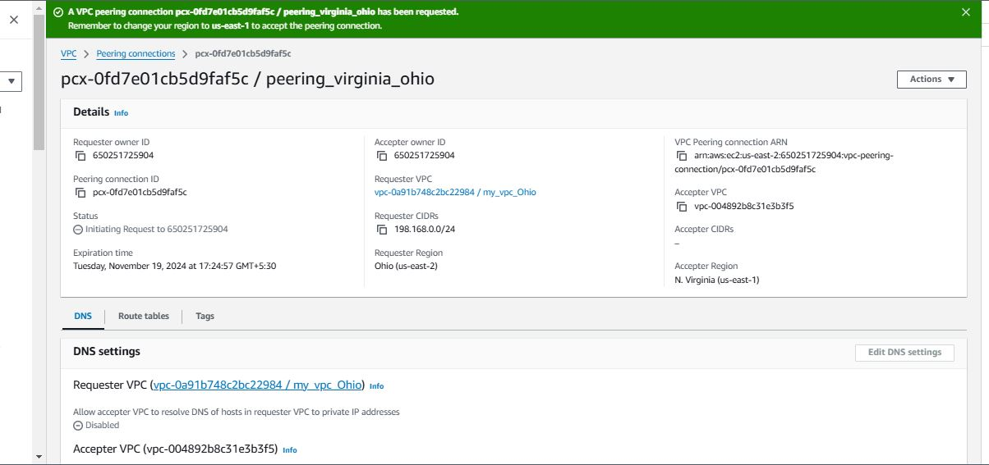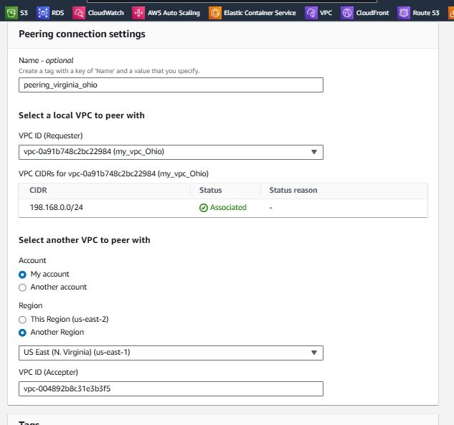

Peering Connection(Requester)

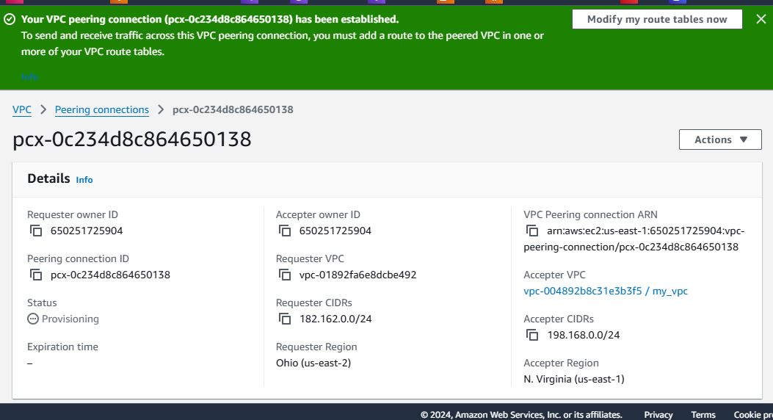

Peering Connection(Accepter)

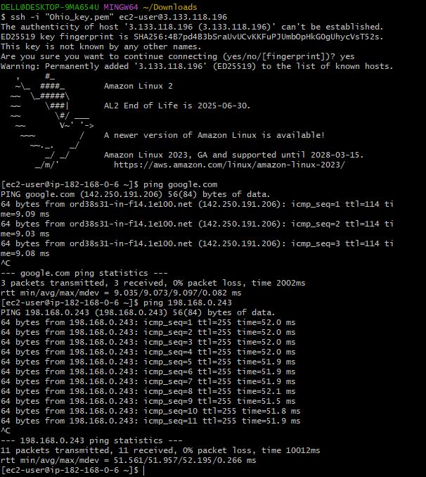

OutPut Peering Connection cross Region

1. Enable VPC peering for cross account. (You can collaborate with your friend and do this task).

### Gather Information from Both Accounts

Make sure you have:

**Account IDs** of both AWS accounts.

**VPC IDs** and **CIDR blocks** for each VPC you intend to peer.

Ex:- Account ID :- 6-0------9-4

VPC IDs:- vpc-ab34-------bc34-

### Create a VPC Peering Connection (Requester Account)

**Log in to the AWS Management Console** in your account and navigate to the **VPC Dashboard**.

In the left-hand panel, click on **Peering Connections** and then **Create Peering Connection**.

Fill in the following details:

**Name tag** (optional but recommended).

**VPC (Requester)**: Select your VPC ID.

**Account**: Choose **Another AWS Account** and enter your friend’s **AWS Account ID**.

**VPC (Accepter)**: Enter your friend's VPC ID.

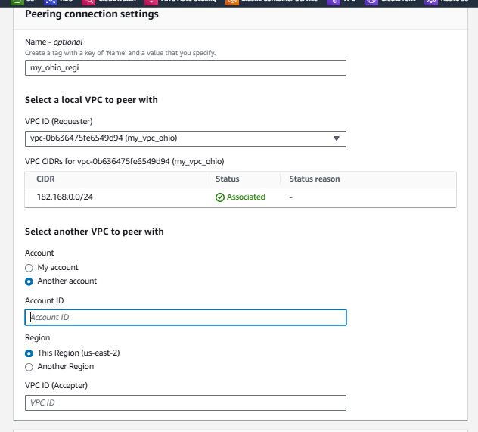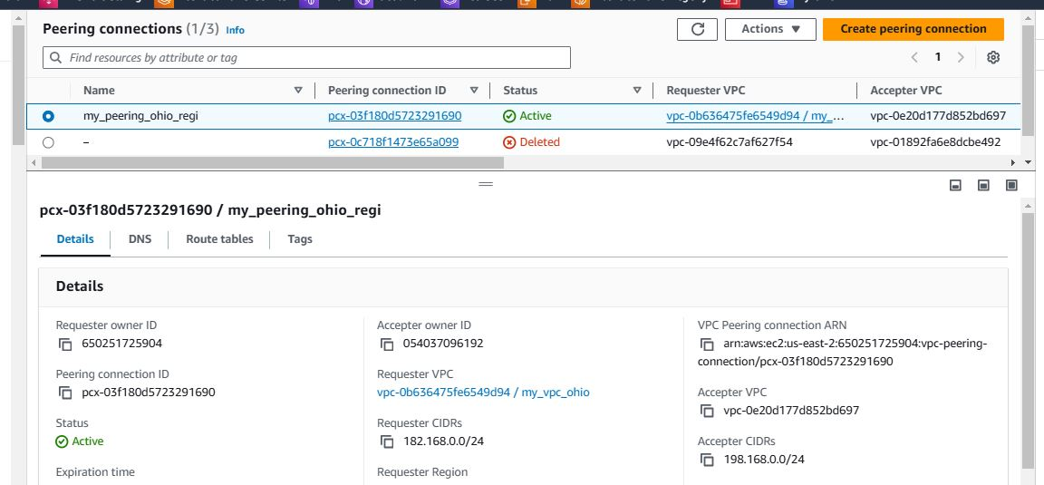Click **Create Peering Connection**.

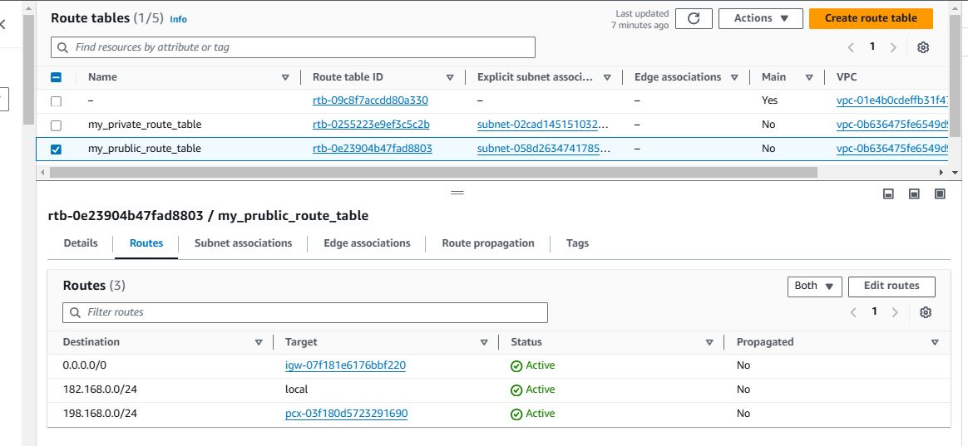

Peering Connection(Another Account)

### Accept the VPC Peering Connection (Accepter Account)

**Ask your friend to log in** to their AWS Management Console and navigate to the **VPC Dashboard**.

Go to **Peering Connections**, locate the peering request, select it, and click **Actions** > **Accept Request**.

Confirm the acceptance.



Peering Connection(Accepter Account)

### Update Route Tables in Both VPCs.

**In the Requester Account (your account)**:

Go to **Route Tables** in the VPC dashboard.

Select the route table associated with your VPC and click **Edit Routes**.

Add a new route with:

**Destination**: The CIDR block of your friend's VPC.

**Target**: The VPC Peering Connection ID.

Save the route.

**In the Accepter Account (your friend’s account)**:

Your friend should repeat the same steps to add a route with:

**Destination**: Your VPC's CIDR block.

**Target**: The same VPC Peering Connection ID.



Route Table(Modify Route) Output Peering connection(Another Account)

1. Setup VPC End Point.

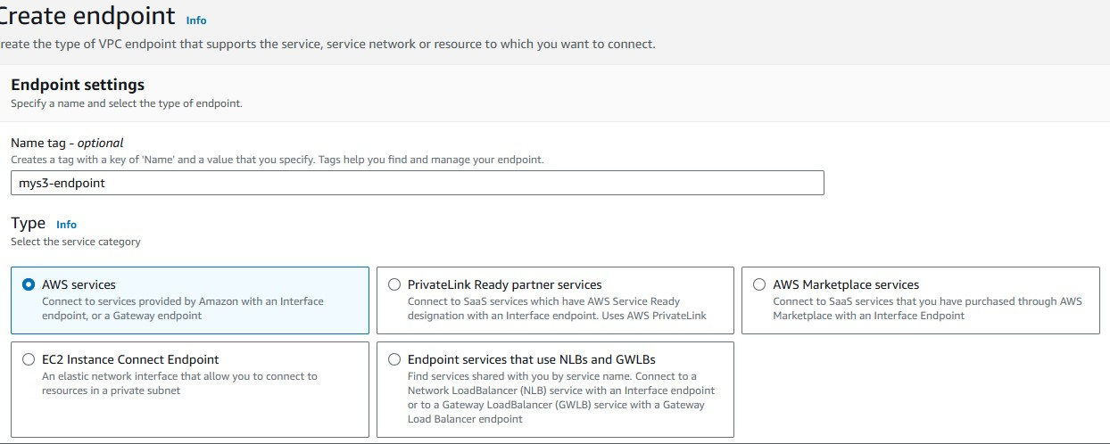

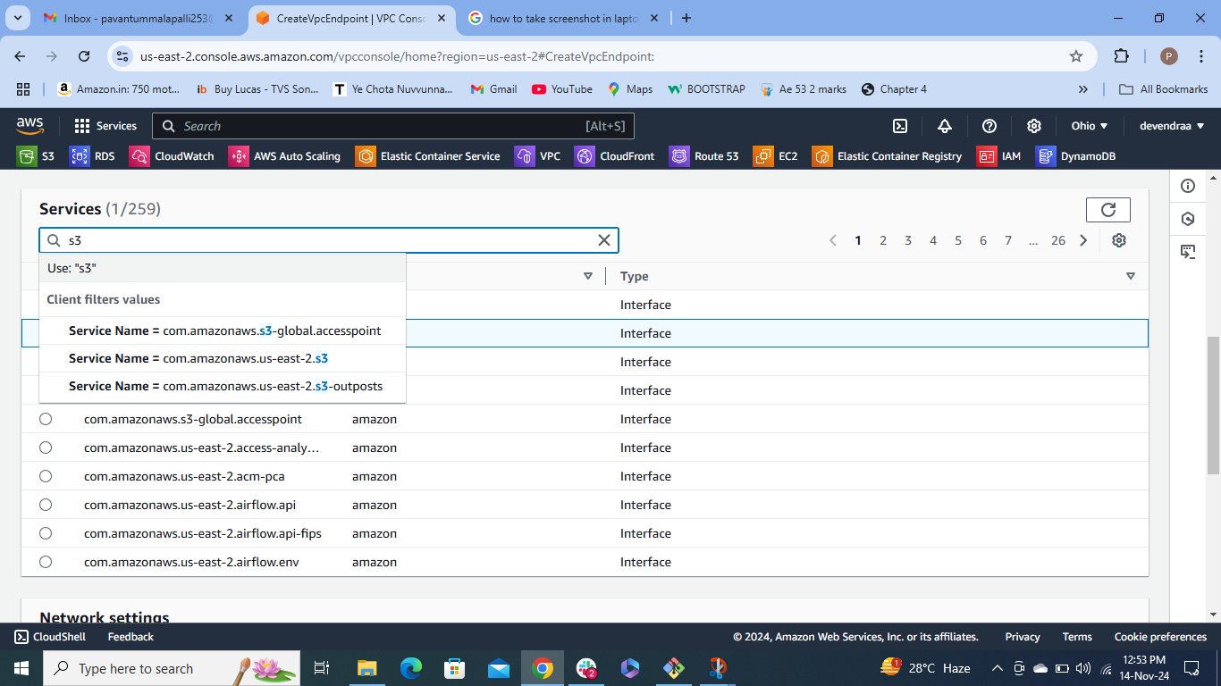

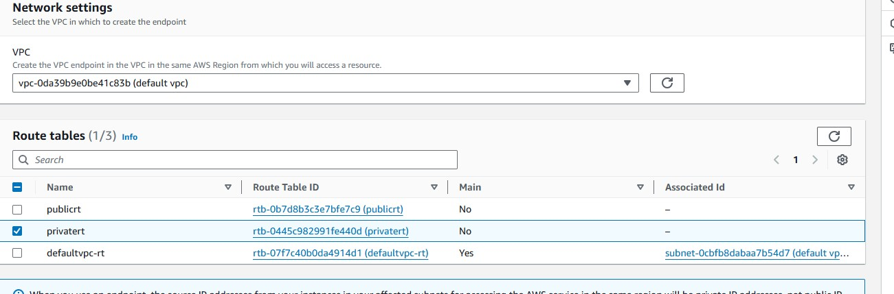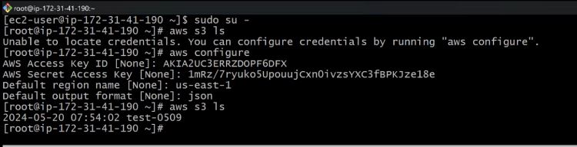

5) Setup VPC Transist gateway.

