WEEK-7 SKILL — Student Records CRUD API

POST:

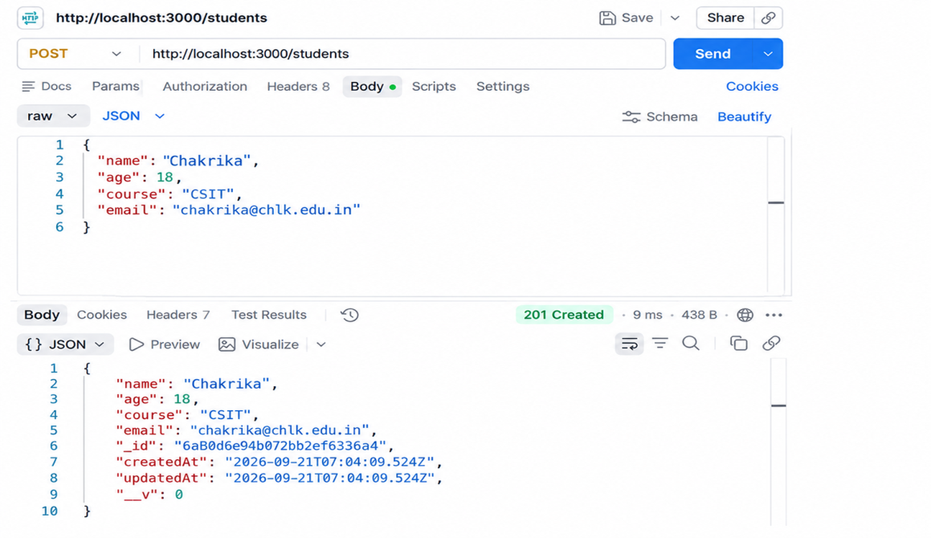

After POST in mongosh:
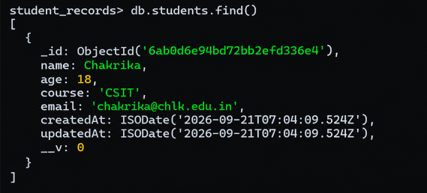

GET all data:

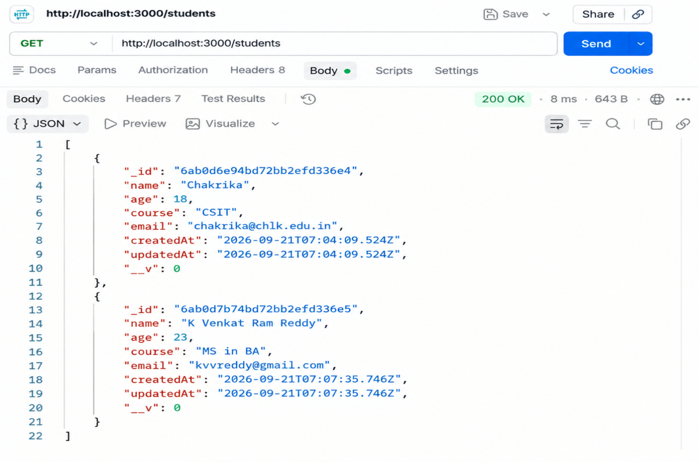

GET all data in mongosh:
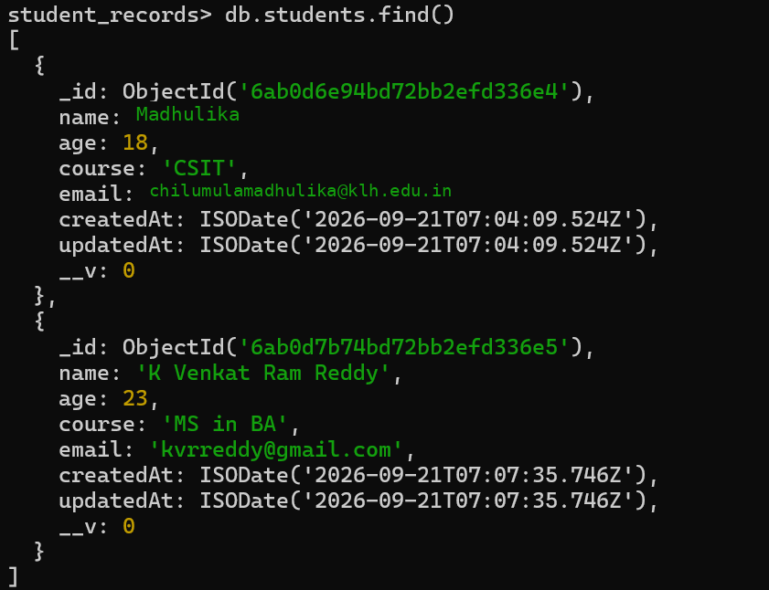

GET one with specific id:
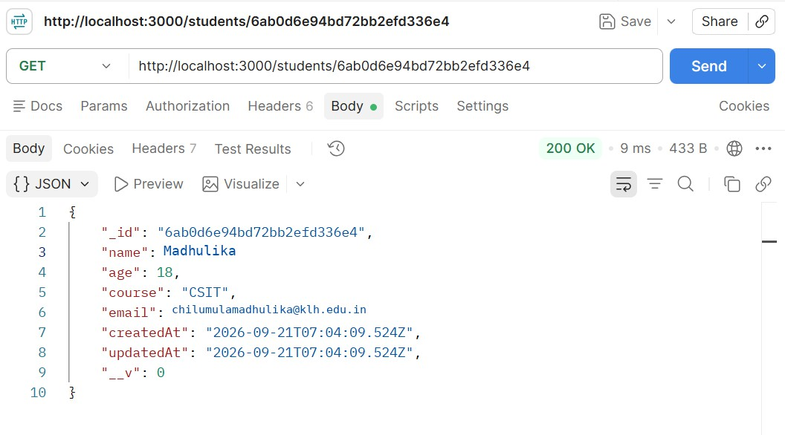
PATCH→changed age from 23 to 25:
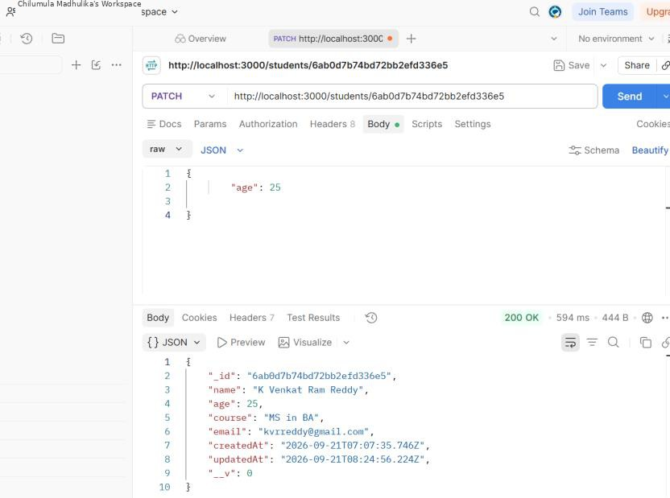

After modification of age output in mongosh:
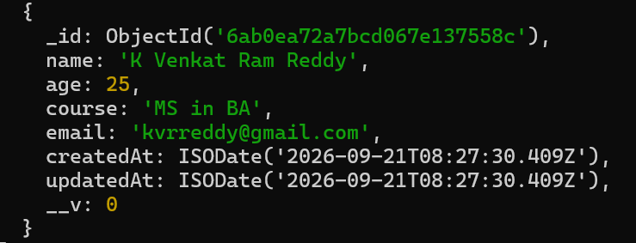

DELETE:
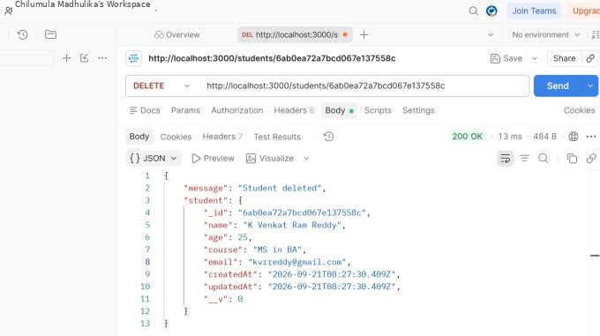

Observation of output in mongosh:
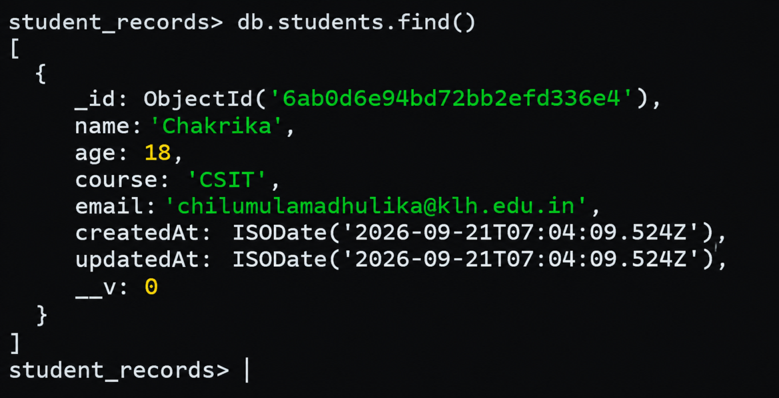

Folder Structure:
Week_7_StudentRecordsAPI
├── controllers
└── studentController.js
├── models
└── Student.js
├── routes
└── studentRoutes.js
├── server.js

├── package.json

Code:
package.json
{
"name": "week_7_studentrecordsapi", "version": "1.0.0",
"type": "module",
"description": "",
"main": "server.js", "scripts": {
"start": "node server.js", "dev": "nodemon server.js"
},
"keywords": [],
"author": "",
"license": "ISC", "dependencies": {
"express": "^5.2.1",
"mongoose": "^9.10.1"
},
"devDependencies": { "nodemon": "^3.1.14"
}
}

models/Student.js
import mongoose from 'mongoose';

const studentSchema = new mongoose.Schema({ name: {
type: String, required: true, trim: true
},
age: {
type: Number, required: true, min: 16,
max: 100
},
course: { type: String,
required: true, trim: true
},
email: {
type: String,

}
}, {
required: true, unique: true, lowercase: true

timestamps: true
});

const Student = mongoose.model('Student', studentSchema); export default Student;

controllers/studentController.js
import Student from '../models/Student.js';

export const createStudent = async (req, res) => { try {
const student = await Student.create(req.body); res.status(201).json(student);
} catch (error) {
res.status(400).json({ error: error.message });
}
};

export const getAllStudents = async (req, res) => { try {
const students = await Student.find(); res.status(200).json(students);
} catch (error) {
res.status(500).json({ error: error.message });
}
};

export const getStudentById = async (req, res) => { try {
const student = await Student.findById(req.params.id);

if (!student)
return res.status(404).json({ message: 'Student not found' });

res.status(200).json(student);
} catch (error) {
res.status(400).json({ error: error.message });
}
};

export const updateStudent = async (req, res) => { try {

const student = await Student.findByIdAndUpdate( req.params.id,
req.body,
{ new: true, runValidators: true }
);

if (!student)
return res.status(404).json({ message: 'Student not found' });

res.status(200).json(student);
} catch (error) {
res.status(400).json({ error: error.message });
}
};

export const deleteStudent = async (req, res) => { try {
const student = await Student.findByIdAndDelete(req.params.id);

if (!student)
return res.status(404).json({ message: 'Student not found' });

res.status(200).json({ message: 'Student deleted', student
});
} catch (error) {
res.status(400).json({ error: error.message });
}
};

routes/studentRoutes.js
import express from 'express'; import {
createStudent, getAllStudents, getStudentById, updateStudent, deleteStudent
} from '../controllers/studentController.js'; const router = express.Router();
router.post('/', createStudent); router.get('/', getAllStudents); router.get('/:id', getStudentById);

router.patch('/:id', updateStudent); router.delete('/:id', deleteStudent);

export default router;

server.js

import express from 'express'; import mongoose from 'mongoose';
import studentRoutes from './routes/studentRoutes.js';

const app = express(); const PORT = 3000;
app.use(express.json()); app.get('/', (req, res) => {
res.json({
message: 'Student Records API is running'
});
});
app.use('/students', studentRoutes); mongoose.connect('mongodb://127.0.0.1:27017/student_records')
.then(() => {
console.log('MongoDB connected');

app.listen(PORT, () => {
console.log(`Server running on http://localhost:${PORT}`);
});
})
.catch((error) => {
console.error('MongoDB connection failed:', error.message);
});

