Practical-10
1.
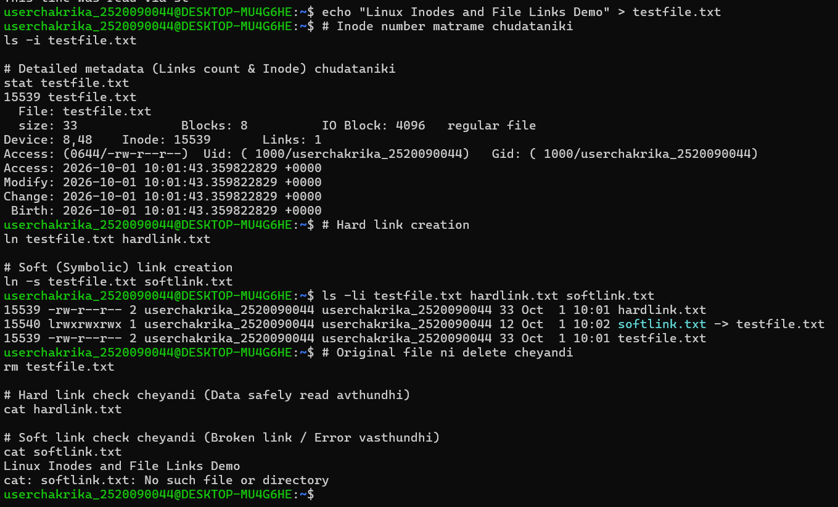

2.
Code:-
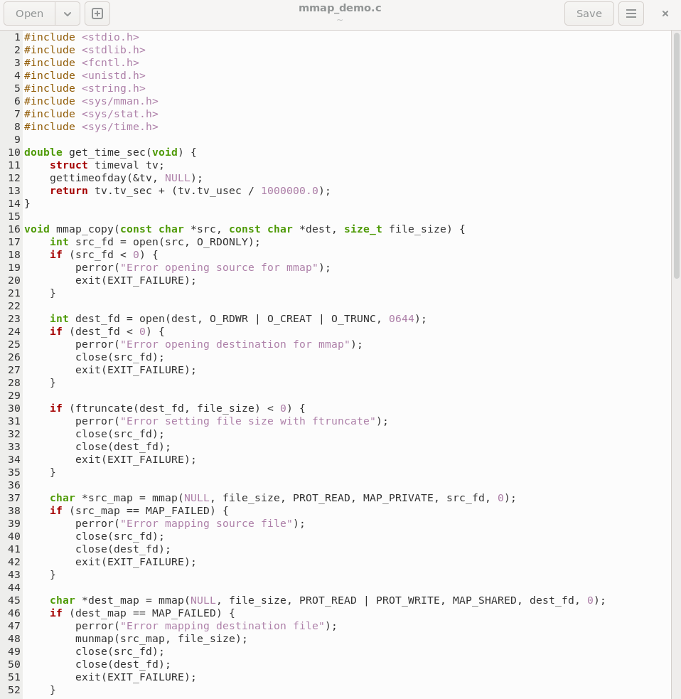
Output:-
- Compile with optimization:
- Create a 200MB test dummy file
- Execute the comparison tool

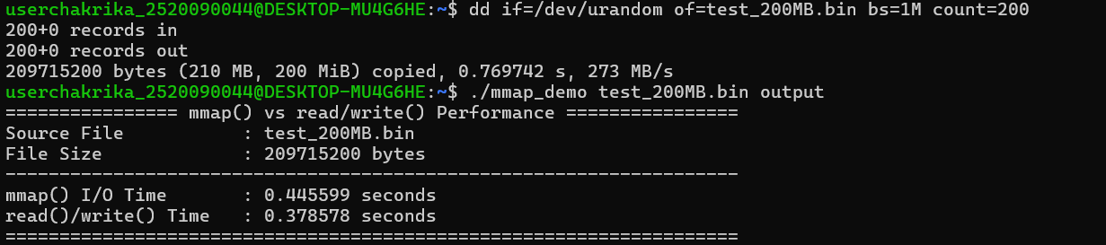
- Verify the files are identical bit-for-bit

