Skill-7:-
1.
Code:-
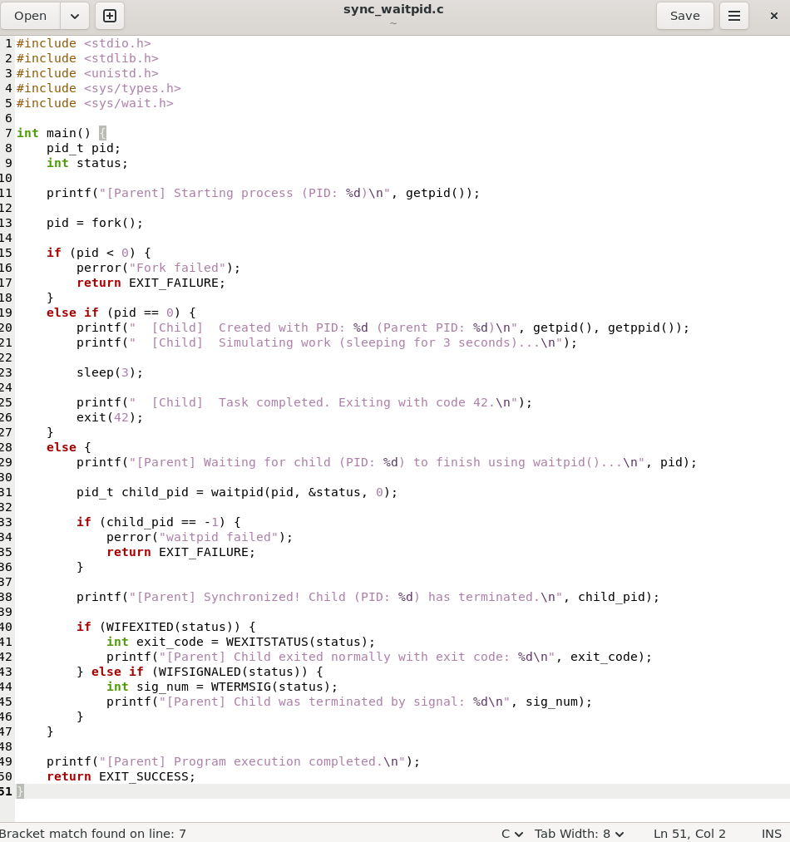
Output:-
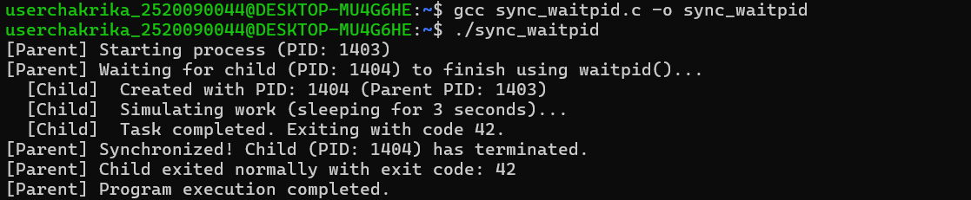
2.
Code:-
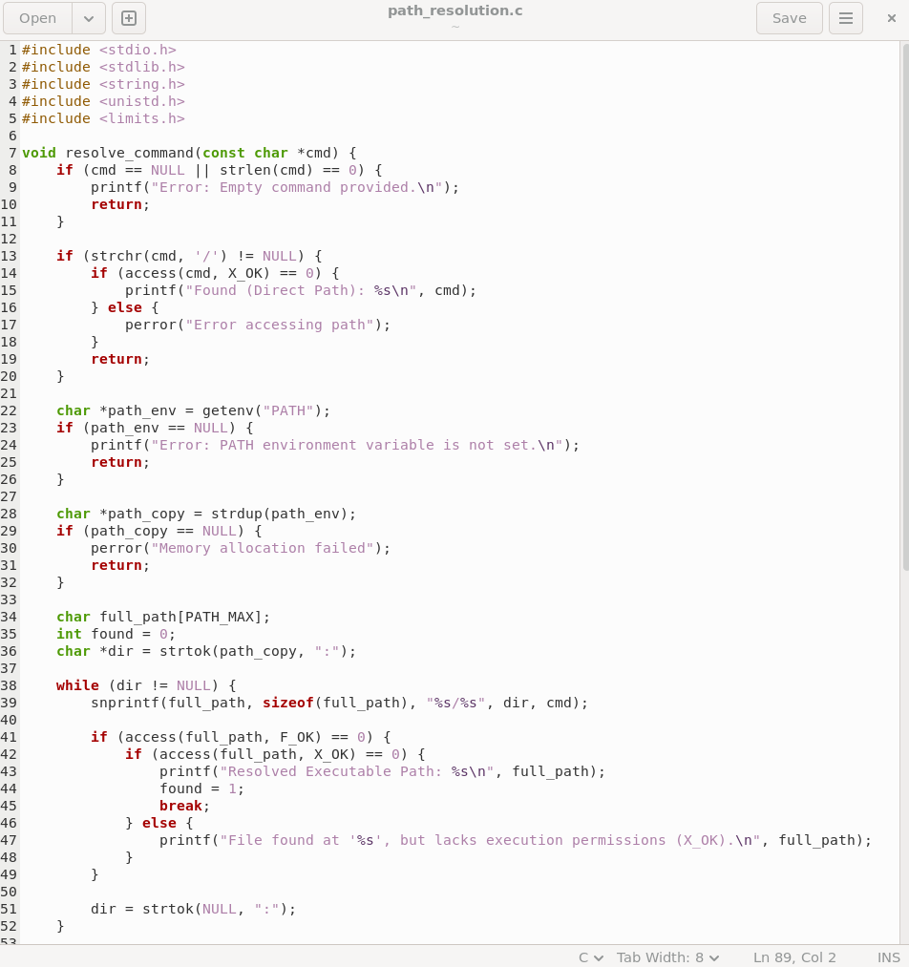
Output:-
