**Problem 1**

**1.1 Initialization**

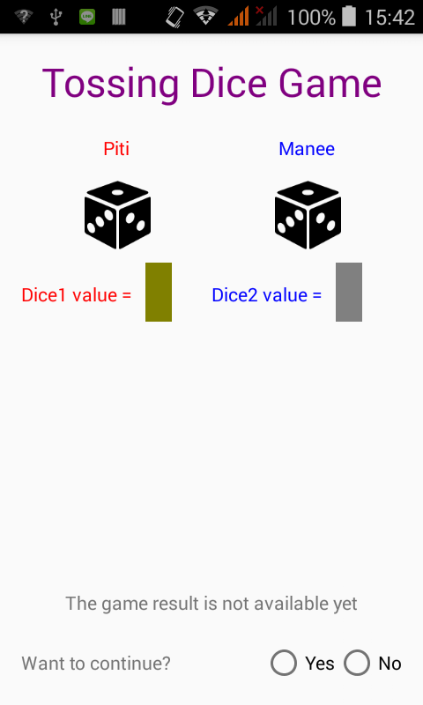

Score = 0.75

**1.2 Reading from a file**

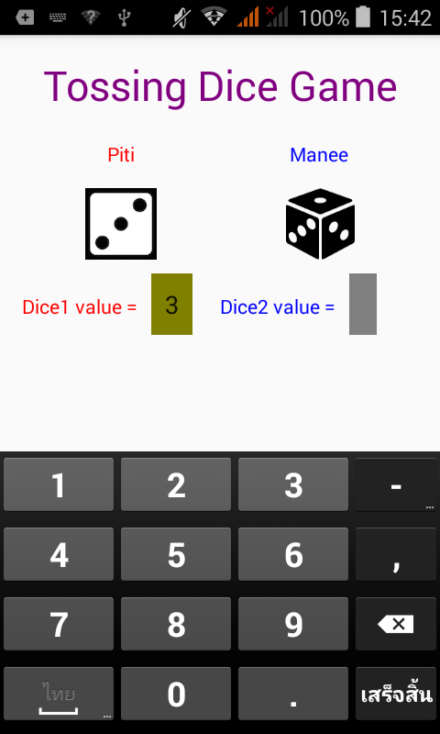

Score = 2

**1.3 Update the play result correctly**

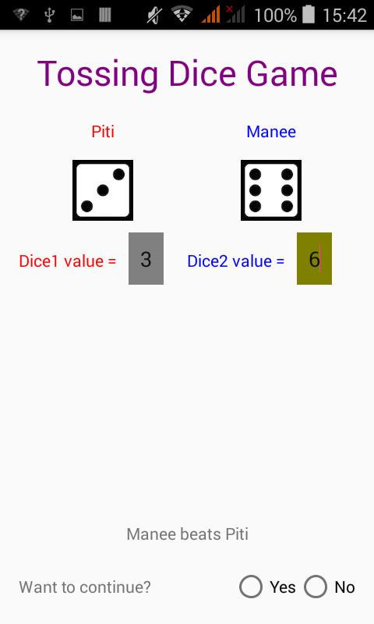

Score = 1

**Problem 2**

**2.1 Intent**

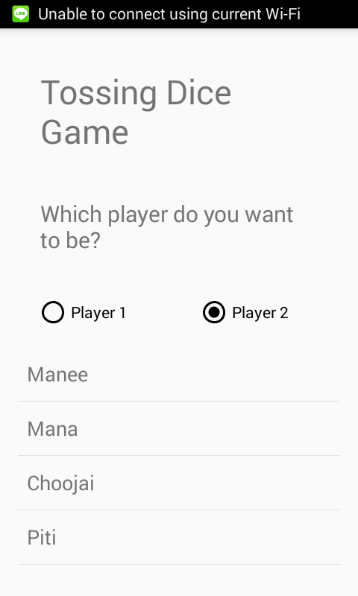

Score = 1.75

**2.2 Start Activity for result**

Not finish yet

Score = 0.5

**2.3 Saving and Restoring state**

Not finish yet

Score = 0.5