**URL:**

localhost:8080/mobileApp/rest/order/postOrder

**Expected input JSON format:**

{"tacos":[{"tacoName":"veggie","quantity":2},{"tacoName":"chickenOrBeef","quantity":1},{"tacoName":"chorizo","quantity":1}]}

Quantity MUST be a +ve integer number. If quantity is 0, please do not include the JSON entry.

**Output format:**

{"tacos":[{"tacoName":"veggie","quantity":2},{"tacoName":"chickenOrBeef","quantity":1},{"tacoName":"chorizo","quantity":1}],"orderBillingAmount":11.5,"discountApplied":2.3,"finalAmount":9.2,"statusCode":200,"statusMessage":"OK"}

**Pretty output format:**

{

"tacos": [

{

"tacoName": "veggie",

"quantity": 2

},

{

"tacoName": "chickenOrBeef",

"quantity": 1

},

{

"tacoName": "chorizo",

"quantity": 1

}

],

"orderBillingAmount": 11.5,

"discountApplied": 2.3,

"finalAmount": 9.2,

"statusCode": 200,

"statusMessage": "OK"

}

**Example: (Tested locally using Postman)**

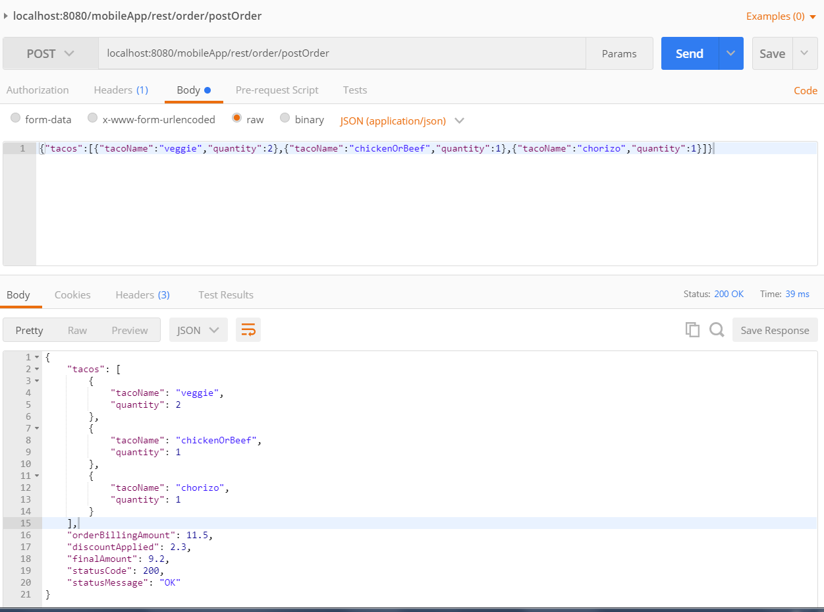

Note:

The prices of menu items, discount % is controlled via a constants file.