Evaluating Dashboard Design Effectiveness in Data Analytics Using Tufte’s Data Visualization Principles

Chantsalmaa Jamiyangarav

A Thesis Submitted in Partial Fulfilment
of the requirements for the
Degree of
Master of Science in Data Analytics



September 2026

Supervisor: Kislay Raj

ABSTRACT
1 Introduction 4
1.1 Background and Context 4
1.2 Research Problem 5
1.3 Research Aim 6
1.4 Research Objectives 6
1.5 Research Questions 7
1.6 Research Approach 7
1.7 Significance of the Study 8
1.8 Dissertation Structure 9
2 Literature Review 10
2.1 Overview of Reviewed Literature 10
2.2 Dashboard Design and Data Visualization 14
2.3 Tufte’s Visualization Principles 14
2.4 Human Perception and Cognitive Load 15
2.5 Dashboard Usability and User Experience 16
2.6 Dashboard Evaluation and Effectiveness 17
2.7 Literature Review Synthesis 19
3 Research Gap 20
4 Domain and Problem Area 21
4.1 Domain Area 21
4.2 Problem Area 22
5 Research Methodology 22
5.1 Research Approach 22
5.2 Data Source and Dataset 23
5.3 Data Preparation and Pre-processing 24
5.4 Exploratory Data Analysis (EDA) 25
5.5 Statistical Analysis and Model Diagnostics 25
5.6 Predictive Modelling 26
5.7 Hyperparameter Tuning 27
5.8 Model Evaluation 27
5.9 Analysis Architecture 28
6 Results 29
6.1 Data Overview 29
6.2 Exploratory Data Analysis 30
6.2.1 Task Completion Time 30
6.2.2 SGLT Distribution 31
6.3 Repeated-Measures ANOVA Results 31
6.3.1 Bonferroni-Adjusted Post-hoc Comparisons 32
6.4 Mixed-Effects Regression Results 32
6.5 Mixed-Effects Model Diagnostics 33
6.5.1 Normality of Residuals 33
6.5.2 Residual Variance Assessment 34
6.6 Cluster-Robust OLS Sensitivity Analysis 34
6.7 Predictive Model Comparison 35
6.8 Actual vs Predicted Cognitive Workload 36
6.9 Summary of Key Findings 36
7 Discussion 37
7.1 Overview of Findings 37
7.2 Discussion of Research Question 1 38
7.3 Discussion of Research Question 2 39
7.4 Discussion of Predictive Modelling Findings 41
7.5 Study Limitations 42
7.6 Practical Recommendations for Dashboard Design 43
8 Conclusion 44
References

Evaluating Dashboard Design Effectiveness in Data Analytics Using Tufte’s Data Visualization Principles
Chantsalmaa Jamiyangarav
MSc in Data Analytics, CCT College, Dublin, Ireland, 2025302@student.cct.ie
ARTICLE INFO

Keywords:
Dashboard Evaluation
Data Visualisation
Dashboard Design
Cognitive Workload
Tufte’s Principles
Regression Analysis

ACRONYMS

Acronym | Full Form
ANOVA | Analysis of Variance
DB | Dashboard
EDA | Exploratory Data Analysis
HCD | Human-Centred Design
IQR | Interquartile Range
KNN | K-Nearest Neighbours
MSE | Mean Squared Error
OLS | Ordinary Least Squares
R² | R-squared
RQ | Research Question
UX | User Experience

ABSTRACT
Data visualisation plays an important role in data analytics by enabling complex information to be presented in a form that supports interpretation and decision-making. Dashboards are widely used for this purpose; however, their effectiveness depends not only on the information presented but also on how clearly that information is organised and communicated. Poor dashboard design may increase cognitive effort, reduce interpretability and affect user performance. Edward Tufte’s visualisation principles provide an established theoretical foundation for effective information presentation by emphasising clarity, precision and the reduction of unnecessary visual elements.
This study evaluates dashboard design effectiveness using secondary experimental data, with particular attention to user performance, completion time and cognitive workload. The dataset contains 1,008 observations from 63 participants, with each participant contributing 16 observations across different dashboard conditions. The analysis includes descriptive statistics, exploratory data analysis, repeated-measures Analysis of Variance (ANOVA), Bonferroni-adjusted post-hoc comparisons, mixed-effects regression, model diagnostics, cluster-robust Ordinary Least Squares (OLS) sensitivity analysis and predictive modelling. Six predictive regression models are compared using Mean Squared Error (MSE) and R-squared (R²).
The repeated-measures ANOVA identified statistically significant differences in user performance across the eight dashboard designs, F(7, 434) = 11.904, p < 0.001. Bonferroni-adjusted paired comparisons identified ten statistically significant differences between specific dashboard pairs. In the mixed-effects regression model, Data Understanding (β = 0.568, p = 0.002) and Order &

Grouping (β = 0.675, p < 0.001) were significantly associated with overall cognitive workload, while Type, SGLT and Information Overload were not statistically significant. Residual diagnostics indicated departures from normality and non-constant variance. A cluster-robust OLS sensitivity analysis supported the significance of Data Understanding and Order & Grouping, while the significance of Type differed between the two inferential approaches.
Predictive modelling demonstrated limited performance. Linear Regression achieved the lowest MSE (8.698) and the highest R² (0.033) among the six models, followed closely by Ridge Regression. Lasso Regression, Decision Tree Regression, Random Forest Regression and K-Nearest Neighbours Regression produced negative R² values on the test data. These results indicate that greater model complexity did not improve the prediction of cognitive workload using the variables available in the dataset.
Overall, the findings indicate that dashboard design is associated with differences in user performance and that Data Understanding and Order & Grouping are consistently related to cognitive workload across the primary and sensitivity analyses. These findings can be interpreted through Tufte’s broader principles of clear, structured and efficient information presentation. However, the secondary dataset does not directly measure individual Tufte principles and the predictive models demonstrate limited explanatory usefulness. The findings should therefore be interpreted as associations rather than causal effects. Future research could directly operationalise visualisation principles, incorporate additional participant and task characteristics and continue to use statistical methods appropriate for repeated observations.

Introduction

Background and Context
Data has become an important resource for organisations operating in increasingly complex and information-intensive environments. Businesses and public organisations collect large volumes of data from operational systems,
customer interactions, digital platforms, financial transactions, and other sources. However, the availability of data alone does not guarantee effective decision-making. Data must be transformed into information that users can understand, interpret, and apply in a practical context. Data visualisation plays an important role in this process by presenting complex information through graphical forms that can support faster interpretation and the identification of patterns, trends, and relationships.
Dashboards are one of the most widely used forms of data visualisation in modern analytics environments. They combine multiple visual elements, such as charts, indicators, tables, and performance measures, within a single interface. Their purpose is to provide users with an accessible overview of important information and to support monitoring, analysis, and decision-making. Effective dashboard design can reduce the time required to locate relevant information and help users understand complex datasets. In contrast, poorly organised dashboards may increase cognitive effort, make information more difficult to interpret, and negatively affect task performance.
Dashboard effectiveness is influenced not only by the accuracy of the underlying data but also by the way information is visually organised and presented. Factors such as layout, grouping, visual complexity, chart selection, and information density can affect how users interact with a dashboard. When a dashboard contains excessive or poorly organised information, users may require additional mental effort to identify relevant content. This can increase cognitive workload and may contribute to longer task completion times or reduced task accuracy.
These concerns are closely related to Edward Tufte’s principles of information visualisation. Tufte (2001) emphasises clarity, precision, efficient presentation of information, and the reduction of unnecessary visual elements. His work introduced concepts such as the data-ink ratio, chartjunk, and graphical integrity. These principles encourage designers to maximise meaningful information while minimising visual elements that do not contribute to understanding. Tufte’s framework therefore provides a useful theoretical perspective for examining dashboard effectiveness and the relationship between visual design, usability, and interpretability.
Previous research has also demonstrated that visualisation effectiveness depends on human perceptual and cognitive processes. Cleveland, W.S. and McGill (1985) showed that different graphical forms influence the accuracy with which users perceive quantitative information. Ware (2012) further emphasised the importance of human perception and cognitive processing in information visualisation. Research on dashboard design also
indicates that usability and effectiveness should be considered in relation to how users interact with and interpret the information presented, rather than being evaluated through visual appearance alone.
This dissertation builds on these ideas by examining dashboard design effectiveness using secondary experimental data. The analysis considers user performance, task completion time, usability-related factors, and cognitive workload across different dashboard conditions. Statistical and predictive modelling techniques are used to investigate whether dashboard-related characteristics are associated with measurable differences in user outcomes. Tufte’s visualisation principles are used as a theoretical framework for interpreting these findings, rather than as directly measured experimental variables.

Research Problem
Although dashboards are widely used in business intelligence and data analytics, there remains a practical challenge in determining which design characteristics contribute to effective user interaction. A dashboard can contain accurate and relevant information while still being difficult to use if the information is poorly structured, visually complex, or difficult to interpret. As a result, technical accuracy alone is not sufficient for evaluating dashboard quality.
Many dashboard design recommendations are based on established visualisation principles and design guidelines. However, dashboard effectiveness should also be examined through measurable user outcomes. In particular, it is important to understand whether differences in dashboard design are associated with differences in task performance, completion time, usability, and cognitive workload.
Cognitive workload is especially relevant because users have limited cognitive resources
when processing information. If a dashboard requires excessive effort to understand its structure, locate relevant information, or interpret visual elements, additional cognitive resources may be required to complete the analytical task. This may affect both the efficiency and accuracy of user performance.
The research problem addressed in this dissertation is therefore the relationship between dashboard design characteristics and measurable user outcomes. The study examines whether different dashboard conditions are associated with differences in user performance and completion time, and investigates whether selected dashboard-related variables can explain or predict overall cognitive workload.
The secondary experimental dataset used in this study contains repeated observations collected from participants under different dashboard conditions. This provides an opportunity to compare dashboard designs and examine several measures related to performance, usability, and cognitive effort. The study uses descriptive statistics, exploratory data analysis, statistical testing, regression analysis, and predictive modelling to investigate these relationships. The repeated-observation structure of the dataset is also considered when interpreting the statistical results and the limitations of the analysis.

Research Aim
The aim of this research is to evaluate the effectiveness of dashboard design in data analytics using secondary experimental data, with particular emphasis on dashboard usability, user performance, and cognitive workload.
The study examines how dashboard design characteristics are associated with measurable user outcomes, including task performance, completion time, and perceived cognitive effort. Tufte’s visualisation principles are used as a theoretical framework for interpreting findings relating to information organisation, usability, and interpretability.
Statistical analysis and predictive modelling are used to examine relationships between dashboard-related factors and cognitive workload and to assess how effectively the available variables can predict overall cognitive workload.

Research Objectives
To achieve the research aim, the study has the following objectives:
- To evaluate dashboard design using user performance and usability measures obtained from a secondary experimental dataset.
- To investigate the relationship between dashboard design and user task accuracy, task completion time, and perceived usability.
- To examine the relationship between dashboard design and users’ perceived cognitive workload, including mental demand, physical demand, temporal demand, effort, frustration, and perceived performance.
- To identify dashboard design issues associated with dashboard usability and interpretability.
- To provide evidence-based recommendations for effective dashboard design based on the empirical findings and established information visualisation principles

Research Questions
This dissertation addresses the following research questions:
RQ1: How do different dashboard designs relate to users’ task performance, completion time and cognitive workload?
RQ2: How can the observed relationships between dashboard-related factors, user performance and cognitive workload be interpreted through Tufte’s data visualisation principles?
The first research question focuses on measurable user outcomes, including task performance, completion time and cognitive workload. These outcomes are examined using the secondary experimental dataset by comparing different dashboard designs and analysing the relationships between dashboard-related factors and user outcomes. The repeated-measures structure of the dataset is taken into account when evaluating differences between dashboard designs and relationships between the measured variables.
The second research question interprets the observed relationships between dashboard-related factors, user performance, and cognitive workload through Tufte’s data visualisation principles. The secondary dataset does not directly measure adherence to individual Tufte principles. For this reason, Tufte’s principles are used as a theoretical framework to interpret empirical findings related to information organisation, data understanding, dashboard design and cognitive workload, rather than as directly measured experimental variables.
This distinction maintains alignment between the research questions, the available dataset, and the statistical analysis. The empirical findings are interpreted as associations rather than causal effects, while Tufte’s principles provide a theoretical basis for discussing how the observed findings may relate to dashboard clarity, usability and interpretability.

Research Approach
The study follows a quantitative research approach using a secondary experimental dataset containing 1,008 observations from 63 participants. Each participant contributed multiple observations across different dashboard conditions, creating a repeated-measures structure. The analysis therefore considers the dependence between observations from the same participant when examining differences between dashboard designs and relationships with cognitive workload.
The analytical process begins with data preparation and cleaning, followed by descriptive statistics and exploratory data analysis. Distribution analysis, outlier detection, normality assessment, and correlation analysis are used to understand the characteristics of the dataset before inferential statistical analysis and predictive modelling.
A repeated-measures Analysis of Variance (ANOVA) is used to examine whether user performance differs significantly across the eight dashboard designs while accounting for repeated observations from the same participants. Following the significant ANOVA result, paired post-hoc comparisons with Bonferroni adjustment are used to identify specific dashboard pairs with significant performance differences.
A mixed-effects regression model is used as the primary inferential regression method to examine associations between selected dashboard-related factors and overall cognitive workload. Participant is included as a grouping variable to account for repeated observations within individuals. Model residuals are assessed for normality and variance patterns. A cluster-robust OLS regression is also conducted as a sensitivity analysis to examine whether the main regression findings remain consistent when standard errors account for within-participant clustering.
In addition to the inferential statistical analysis, six predictive regression models are evaluated: Linear Regression, Ridge Regression, Lasso Regression, Decision Tree Regression, Random Forest Regression, and K-Nearest Neighbours (KNN) Regression. Their predictive performance is compared primarily using Mean Squared Error (MSE) and R-squared (R²), with cross-validation and hyperparameter tuning applied where appropriate. This comparison examines whether more complex modelling approaches improve the prediction of cognitive workload compared with a standard linear model.
Tufte’s visualisation principles are not treated as directly measured variables in the statistical models. Instead, they provide a theoretical framework for interpreting the observed relationships between dashboard-related factors, user performance, and cognitive workload. This approach maintains alignment between the available secondary data, the statistical analysis, and the theoretical focus of the dissertation without treating Tufte adherence as an empirically measured construct.

Significance of the Study
This research is significant because dashboards increasingly influence how users interact with analytical information. Organisations may invest considerable resources in data collection and analytical systems, but the value of these systems can be reduced when information is presented in a way that is difficult to understand or interpret. Evaluating dashboard effectiveness from the user perspective is important for understanding how dashboard design relates to practical analytical outcomes.
By examining user performance, completion time, dashboard-related factors, and cognitive workload, this dissertation evaluates dashboard effectiveness from a user-centred perspective. Rather than evaluating dashboards only according to their visual appearance, the study considers measurable outcomes that reflect how users interact with and respond to the information presented.
The study combines inferential statistical analysis with predictive modelling. Repeated-measures ANOVA is used to examine differences in performance across dashboard designs while accounting for observations from the same participants, followed by paired post-hoc comparisons with Bonferroni adjustment. A mixed-effects regression model examines associations between dashboard-related factors and cognitive workload while accounting for participant-level repeated observations. A cluster-robust OLS regression is also used as a sensitivity analysis to assess the consistency of the main regression findings. In addition, six regression models are compared to evaluate the predictive usefulness of the available variables. This combination distinguishes between identifying statistically significant associations and assessing predictive performance.
Tufte’s visualisation principles provide a theoretical perspective for interpreting the empirical findings. The study does not claim that the dataset directly measures adherence to individual Tufte principles. Instead, these principles are used as an interpretive framework for discussing findings related to information organisation, data understanding, dashboard design, user performance, and cognitive workload. This distinction avoids attributing empirical or causal effects to design principles that were not directly measured in the available dataset.
The findings may contribute to a better understanding of the relationships between dashboard design and user outcomes and may support evidence-based recommendations for clearer and more usable dashboard design. The use of statistical methods that account for repeated participant observations strengthens the analysis of the available data, while the limitations associated with secondary data, model assumptions, and weak predictive performance are considered when assessing the wider applicability of the findings.

Dissertation Structure
The remainder of this dissertation is organised into several chapters. Chapter 2 reviews the literature relating to data visualisation, dashboard design, cognitive workload, usability and Tufte’s principles of information visualisation. Chapter 3 identifies the research gap and explains how the present study addresses limitations identified in previous research.
Chapter 4 defines the research domain and problem area, focusing on dashboard design effectiveness, user interaction and the analytical context of the study. Chapter 5 presents the research methodology, including data preprocessing, exploratory analysis, repeated-measures statistical analysis, mixed-effects modelling, model diagnostics, sensitivity analysis, predictive model development, hyperparameter tuning and model evaluation. Chapter 6 presents the empirical results, including descriptive and exploratory findings, repeated-measures ANOVA, Bonferroni-adjusted post-hoc comparisons, mixed-effects regression, cluster-robust sensitivity analysis and predictive model comparison.
Chapter 7 discusses the findings in relation to the research questions and existing literature. Particular attention is given to interpreting the observed relationships through Tufte’s visualisation principles without treating these principles as directly measured variables. Chapter 8 concludes the dissertation by summarising the main findings, discussing the study limitations, presenting evidence-based recommendations and identifying directions for future research.

Literature Review

Overview of Reviewed Literature
This literature review examines the main theoretical and empirical research relevant to evaluating dashboard design effectiveness. The reviewed literature focuses on five closely related areas: dashboard design and data visualisation, dashboard complexity, Tufte’s visualisation principles, human perception and cognitive workload and dashboard usability and effectiveness. These areas provide a theoretical foundation for examining
relationships between dashboard design, user performance, completion time and cognitive workload.
Previous research indicates that dashboard effectiveness cannot be evaluated solely on the basis of visual appearance. Effective dashboards should communicate relevant information clearly, organise information appropriately and support users in completing analytical tasks efficiently. Research on graphical perception and cognitive workload also suggests that the organisation and presentation of information can affect the effort required to understand visual information. Tufte’s visualisation principles provide a theoretical perspective for considering clarity, simplicity, precision and the reduction of unnecessary visual elements. In the present study, these principles are used as an interpretive framework rather than as directly measured characteristics of the dashboard designs.
The reviewed studies are considered in terms of their theoretical contributions, empirical findings, methodological approaches and limitations. Particular attention is given to how previous studies have measured dashboard effectiveness and user outcomes, whether their research designs adequately account for differences between users and repeated observations and where findings remain inconsistent or limited. This critical comparison helps to establish the specific research gap addressed by the present study.
These areas of literature are relevant because the empirical analysis uses secondary experimental data containing repeated observations of user performance, task completion time, dashboard-related factors and cognitive workload across different dashboard conditions. The literature provides a basis for interpreting the inferential and predictive findings and for considering the observed relationships through established principles of information visualisation. Table 1 summarises the key studies reviewed, including their research focus, methodological approach, main findings, limitations and relevance to the present research.

Table 1. Summary of Key Literature Reviewed
Author(s) / Year | Research Focus | Method / Approach | Key Findings / Contribution | Limitations | Relevance to This Study
Cleveland and McGill (1985) | Graphical perception | Experimental studies of graphical perception | Demonstrates that graphical encodings differ in how accurately quantitative information can be perceived. | Focuses on graphical perception rather than complete dashboard environments | Provides empirical foundations for understanding relationships between visual encoding and user interpretation
Tufte (2001) | Information visualisation principles | Theoretical and design framework | Emphasises graphical integrity, clarity and efficient presentation of quantitative information | Provides design principles rather than an experimental measure of dashboard effectiveness | Provides the theoretical framework used to interpret the empirical findings rather than a directly measured variable
Few (2013) | Dashboard design | Design principles and guidance | Emphasises concise and accessible presentation of information for at-a-glance monitoring | Primarily design-oriented rather than an experimental evaluation of user outcomes | Supports interpretation of dashboard clarity and information organisation
Ware (2012) | Visual perception and cognition | Perception-based visualisation framework | Explains relationships between visual processing, cognition and information interpretation | Broad visualisation framework rather than a dashboard-specific experiment | Connects information presentation with cognitive processing
Sweller (1988) | Cognitive load | Theoretical and experimental analysis of problem solving | Shows that demanding problem-solving processes can consume cognitive processing capacity. | Developed primarily in a learning and problem-solving context rather than dashboard interaction | Provides theoretical grounding for the study of cognitive workload
Heer and Bostock (2010) | Graphical perception | Crowdsourced graphical perception experiments | Replicated earlier perception experiments and demonstrated the viability of crowdsourcing for evaluating visualisation designs. | Examines specific graphical encodings rather than complete dashboards | Provides empirical evidence that visual design choices can be evaluated through user performance
Janes, Sillitti and Succi (2013) | Dashboard design | Dashboard design framework | Discusses principles for designing effective dashboards | Primarily design-focused and does not directly examine cognitive workload | Supports practical considerations for effective dashboard design
Knaflic (2015) | Data communication and visualisation | Practical visual design framework | Emphasises reduction of clutter and clear communication of important information | Practitioner-oriented rather than a controlled empirical dashboard study | Supports interpretation of information organisation and visual clarity
Saket, Endert and Demiralp (2016) | Visualisation effectiveness | Task-based empirical evaluation | Demonstrates that the effectiveness of visualisations depends on the analytical task | Focuses on basic visualisations rather than complete dashboard environments | Supports examining user performance across different visual presentation conditions
Karami, Langarizadeh and Fatehi (2017) | Dashboard effectiveness | Delphi study | Identifies seven categories of dashboard evaluation criteria, including visual design, information delivery and user customisation. | Developed within a healthcare context using expert-derived criteria | Supports systematic consideration of dashboard effectiveness dimensions
Bhutani (2019) | Dashboard user experience | UX-focused dashboard study | Examines information retrieval and user experience in dashboard interaction | Context-specific examination of dashboard information retrieval | Supports consideration of usability and information retrieval in dashboard effectiveness
Burnay et al. (2020) | BI dashboard user experience | Quality construct and dashboard modelling approach | Develops a user-experience perspective for the specification and design of supportive BI dashboards. | Focuses primarily on BI dashboard specification and modelling | Connects dashboard characteristics with user experience
Camargo et al. (2020) | System trustworthiness dashboard | Dashboard development and evaluation | Develops a dashboard for visualising system trustworthiness properties | Application is specific to system trustworthiness rather than general dashboard use | Demonstrates dashboard use for presenting complex multidimensional information
Sarikaya et al. (2019) | Dashboard characteristics and use | Literature review and analysis of dashboard examples | Develops a dashboard design space and identifies dashboard types, design goals and levels of interaction. | Broad conceptual characterisation rather than a controlled user-performance experiment | Provides a broader conceptual understanding of dashboard design and use
Zhuang, Concannon and Manley (2022) | Dashboard evaluation | Systematic review and evaluation framework | Identifies the lack of consistent dashboard evaluation approaches and proposes a structured evaluation framework. | Developed from healthcare dashboard literature | Supports systematic and multidimensional dashboard evaluation
Myllynen and Kamau (2025) | Evolution of dashboard design | Review of dashboard design practices | Discusses the movement from static reporting towards interactive and real-time dashboards and user-centred design. | Broad review of design practices rather than controlled experimental evaluation | Provides contemporary context for dashboard design and decision support
Meier et al. (2025) | Interactive dashboards in primary care | Systematic review | Finds some evidence of improved outcomes when dashboards form part of wider interventions, while standalone dashboard findings are mixed. | Only six eligible studies were identified and substantial heterogeneity limited generalisability. | Demonstrates that dashboard effectiveness is context-dependent and that stronger evaluation methods are needed
Izzati et al. (2026) | User-centred dashboard design | Design Thinking and UEQ-based evaluation | Evaluates dashboard design from a user-centred perspective | Context-specific dashboard implementation limits broader interpretation | Provides recent evidence for incorporating user experience into dashboard evaluation
Zarqan et al. (2026) | BI dashboard and KPI monitoring | Human-Centred Design with SUS and UEQ evaluation | Reports high usability in a dashboard developed for sales KPI monitoring and evaluates it with 15 internal stakeholders. | Small, organisation-specific participant group limits generalisability | Provides recent evidence for user-centred evaluation of BI dashboards

Dashboard Design and Data Visualization
Data visualisation has become an essential component of modern data analytics because it enables users to interpret complex information efficiently and supports data-driven decision-making. Dashboards, in particular, are widely used to present summarised information in a concise and interactive format. According to Few (2013), dashboards are designed to display key information required for monitoring and decision-making at a glance. Similarly, Sarikaya et al. (2019) argue that dashboards differ from general visualisation systems because they are designed for specific goals, users, and analytical tasks.
Research on dashboard design suggests that effective dashboards should support users in achieving their goals rather than simply displaying large amounts of information. Janes, Sillitti and Succi (2013) argue that many dashboards fail because they prioritise visual complexity and graphical features over usability and information clarity. Effective dashboard design therefore requires the careful selection of relevant data and appropriate visualisation techniques. Dashboards should present summarised information in a way that supports user understanding without distracting attention from the primary analytical task.
Recent research also emphasises the importance of simplicity, consistency, and relevance in dashboard design. Myllynen and Kamau (2025) explain that effective dashboards should prioritise simplicity and minimise unnecessary visual complexity to avoid information overload and decision fatigue. Appropriate visualisation techniques, such as charts, graphs, and heatmaps, can improve readability, pattern recognition, and trend analysis. Modern dashboards may also support data-driven decision-making through interactive and responsive interfaces.
These ideas are relevant to the present study because dashboard effectiveness is examined through measurable user outcomes rather than visual appearance alone. The empirical analysis considers task performance, completion time, usability-related factors, and cognitive workload under different dashboard conditions. This provides a basis for examining whether differences in dashboard conditions are associated with differences in user outcomes.
The literature therefore identifies clarity, simplicity, information organisation, and task relevance as important characteristics of effective dashboard design. These characteristics provide a foundation for examining relationships between dashboard conditions, user performance, usability, and cognitive effort in the present study.

Tufte’s Visualization Principles
A major theoretical foundation for this study is Edward Tufte’s work on data visualisation. In The Visual Display of Quantitative Information, Tufte (2001) argues that effective visualisations should communicate quantitative information clearly, precisely and efficiently. A central concept in his work is the reduction of unnecessary decorative elements, described as “chartjunk”, which may distract attention from the information being presented.
Tufte (2001) also introduces the concept of the “data-ink ratio”, which emphasises the proportion of a graphic devoted to displaying meaningful data. This principle encourages the removal of non-essential visual elements and greater emphasis on the data itself. Clarity, readability and precision are consequently important considerations when presenting quantitative information.
These principles are relevant to dashboard design because dashboards may contain multiple visual elements that compete for user attention. Complex layouts, unnecessary decoration and poorly organised information may make analytical information more difficult to interpret. Tufte’s framework therefore provides a theoretical basis for considering how clarity, information organisation and unnecessary visual complexity may relate to users’ interaction with dashboard information.
The application of Tufte’s principles in the present study is interpretive rather than experimental. The secondary dataset does not directly measure adherence to Tufte’s principles, nor does it contain measures of concepts such as the data-ink ratio or chartjunk. It is therefore not possible to statistically test whether adherence to an individual Tufte principle produces differences in user outcomes. Instead, the framework is used to interpret empirical findings relating to information organisation, data understanding, dashboard conditions, user performance and cognitive workload.
This distinction is important because Tufte’s work primarily provides principles for effective information presentation rather than variables directly measured in the available dataset. In this dissertation, the framework is used to support theoretical interpretation of the observed relationships rather than to establish causal effects of Tufte-based design. This approach aligns the theoretical framework with the second research question while recognising the limitations of using secondary experimental data to evaluate visualisation principles indirectly.

Human Perception and Cognitive Load
Beyond general design principles, research in graphical perception and cognitive psychology demonstrates the importance of human cognitive limitations in visualisation effectiveness. Cognitive Load Theory, introduced by Sweller (1988), proposes that human cognitive capacity is limited and that complex information can place substantial demands on cognitive processing. When information is difficult to process or contains multiple interacting elements, the cognitive resources required for understanding may increase.
This perspective is relevant to dashboard design because dashboards can contain multiple charts, indicators, filters and data categories presented simultaneously. When information is poorly organised or unnecessarily complex, users may require greater cognitive effort to locate, process and interpret relevant information. Sweller’s (1988) work provides a theoretical basis for considering how the structure and complexity of presented information may relate to the cognitive demands experienced by users. However, Cognitive Load Theory was developed primarily within the context of learning and problem solving rather than specifically for dashboard evaluation, which should be considered when applying it to dashboard research.
Research in graphical perception provides additional evidence that the way quantitative information is visually represented can affect interpretation. Cleveland and McGill (1985) demonstrated that graphical perception varies across different visual encoding methods, with some graphical forms supporting more accurate quantitative judgements than others. Heer and Bostock (2010) extended this area of research through crowdsourced graphical perception experiments, providing further evidence that characteristics of visual representations can affect the accuracy of users’ judgements. These studies provide empirical support for the importance of visual encoding, although they focus on specific graphical representations rather than complete dashboard environments.
Ware (2012) further emphasises the relationship between visual design and human perceptual processing. Visual characteristics such as colour, layout, hierarchy, spacing and spatial organisation can influence how information is perceived and interpreted. This perspective complements graphical perception research by highlighting the importance of designing visual information in ways that correspond with human perceptual capabilities. However, these principles provide a broader theoretical account of visual perception rather than direct experimental evidence about the dashboard conditions examined in the present study.
These concepts provide a theoretical basis for interpreting the cognitive workload measures available in the secondary experimental dataset. The dataset contains measures of mental demand, physical demand, temporal demand, perceived performance, effort and frustration, which are combined in the available overall workload measure used in the analysis. This allows relationships between dashboard-related factors and cognitive workload to be examined while recognising that the dataset does not directly operationalise Cognitive Load Theory itself.
Human perception and Cognitive Load Theory consequently provide complementary perspectives for interpreting the relationships examined in this study. Graphical perception research demonstrates that visual representation can affect the accuracy of quantitative interpretation, while cognitive theory provides a basis for considering the demands placed on users when processing information. In the present study, these perspectives support the interpretation of relationships between dashboard-related factors, user performance and cognitive workload without assuming that the observed statistical associations represent direct causal effects.

Dashboard Usability and User Experience
Usability and user experience (UX) have become important considerations in dashboard research because dashboards provide an interface through which users access, interpret
and interact with analytical information. Burnay et al. (2020) approach Business Intelligence dashboard quality from a user-experience perspective, emphasising that effective dashboard design involves more than technical functionality. Their work contributes a framework for considering the qualities required to support users when interacting with Business Intelligence dashboards. This perspective extends dashboard evaluation beyond system performance towards the experience of the user.
Human-Centred Design (HCD) research similarly emphasises the importance of considering user requirements during dashboard development. Zarqan et al. (2026) applied a human-centred design approach to the development of a Business Intelligence dashboard for sales KPI monitoring. Their study demonstrates the practical value of incorporating stakeholder requirements and user evaluation into dashboard development. However, the evaluation involved a relatively small and organisation-specific group of users, which limits the extent to which the findings can be generalised to other dashboard contexts.
Recent research has also applied user-centred approaches to dashboard development and evaluation in different organisational settings. Izzati et al. (2026), for example, examine the design and evaluation of a cash flow monitoring dashboard for higher education using Design Thinking and a user-experience evaluation framework. This reflects a broader movement towards evaluating dashboards from the perspective of their intended users rather than relying only on technical or visual design criteria. However, findings from context-specific dashboard implementations should be interpreted carefully when considering their relevance to different users, tasks and analytical environments.
Bhutani (2019) also considers user experience in relation to retrieving information through dashboards, further illustrating the importance of examining how users interact with presented information. Together, these studies indicate that dashboard evaluation can benefit from considering user interaction and experience alongside technical functionality. At the same time, differences in organisational context, evaluation methods and user groups make it difficult to establish a single set of usability characteristics that will produce the same outcomes across all dashboard environments.
In the present study, usability is not treated as a single directly measured outcome. Instead, the available secondary dataset provides measures of user performance, task completion time, dashboard-related factors and cognitive workload. These variables allow aspects relevant to users’ interaction with dashboard information to be examined without claiming that the dataset provides a comprehensive measure of dashboard usability or user experience.
The literature suggests that user-centred dashboard evaluation should consider how information presentation relates to users’ ability to understand and work with analytical information. This perspective is particularly relevant to the dashboard-related factors examined in the present study, including Data Understanding and Order & Grouping. The statistical analysis examines their associations with cognitive workload, while the broader implications of these relationships for dashboard usability and interpretability are considered through the existing dashboard design literature

Dashboard Evaluation and Effectiveness
A significant body of research has examined how dashboard effectiveness can be evaluated beyond visual appearance alone. Karami, Langarizadeh and Fatehi (2017) identified several criteria relevant to effective dashboards, including user customisation, knowledge discovery, security, information delivery, alerting, visual design and system integration. Their work demonstrates that dashboard effectiveness is multidimensional rather than dependent on a single design characteristic. However, the criteria were developed within a healthcare context and through expert evaluation, which may limit their direct applicability to other dashboard environments and user populations.
Zhuang, Concannon and Manley (2022) similarly demonstrate the need for a structured approach to dashboard evaluation through their review of healthcare dashboard implementation and evaluation research. Their framework highlights the importance of considering dashboard characteristics, users and evaluation approaches when assessing effectiveness. The study provides a systematic basis for dashboard evaluation, although its healthcare focus means that its findings should be applied cautiously to other analytical contexts. Camargo et al. (2020) also examined dashboard evaluation in the context of system trustworthiness, illustrating the role of usability evaluation in identifying potential improvements to dashboard interfaces. These studies demonstrate the value of evaluating dashboards in relation to their intended users and contexts rather than relying solely on visual design criteria.
Empirical research further indicates that visualisation effectiveness can depend on the analytical task being performed. Saket, Endert and Demiralp (2016) compared the effectiveness of basic visualisations across different data and task conditions and found that visualisation performance varied according to the task. This suggests that a visual representation that performs effectively for one analytical task may not necessarily be equally effective for another. Their study provides empirical support for task-dependent visualisation selection, although its focus on basic visualisation types differs from the more complex dashboard environments considered in the present study.
Systematic review evidence also demonstrates the difficulty of establishing consistent conclusions about dashboard effectiveness. Meier et al. (2025), in their systematic review of interactive dashboards used as audit and feedback tools in primary care, identified variation in outcomes across the included studies. Dashboards implemented as part of broader interventions showed evidence of effectiveness in some cases, while evidence for dashboards used as standalone interventions was mixed. The relatively small number of included studies and differences in interventions and evaluation approaches limit the generalisability of the findings. This variation reinforces the importance of considering context and evaluation methodology when interpreting dashboard effectiveness. Together, these studies support a multidimensional approach to dashboard evaluation. User performance and completion time can provide evidence about task-related outcomes, while cognitive workload can provide information about the demands experienced by users during interaction with dashboard information. Examining multiple outcomes can therefore provide a broader perspective than assessing dashboards solely according to visual appearance or a single usability criterion.
This multidimensional perspective is consistent with the analytical approach adopted in the present study. Repeated-measures analysis is used to examine differences in user performance across dashboard designs, while mixed-effects regression examines associations between dashboard-related factors and cognitive workload while accounting for repeated observations from the same participants. Predictive modelling provides a separate assessment of how effectively the available variables predict cognitive workload. This distinction allows inferential relationships and predictive usefulness to be evaluated separately rather than treating statistical association as evidence of strong predictive performance.

Literature Review Synthesis
The reviewed literature demonstrates that dashboard effectiveness is associated with several interconnected factors, including visual clarity, information organisation, task requirements, usability, human perception and cognitive workload. Dashboard effectiveness cannot be understood solely through visual appearance or technical functionality. Its evaluation also requires consideration of how users interact with information and how effectively they complete analytical tasks.
Research on dashboard design consistently emphasises clarity, simplicity, appropriate information organisation and alignment with user needs. Tufte’s visualisation principles provide a theoretical perspective for considering the reduction of unnecessary visual complexity and the clear presentation of quantitative information. Research on graphical perception and cognitive workload complements this perspective by demonstrating that visual representation and information complexity are relevant to how users perceive, process and interpret information.
The literature on usability and dashboard evaluation further indicates that effectiveness is multidimensional. Measures such as user performance, completion time and cognitive workload provide different perspectives on users’ interaction with analytical information. At the same time, previous research varies considerably in its evaluation methods, user populations, application contexts and types of visualisation examined. Some studies focus on individual graphical representations, while others evaluate complete dashboards within specific organisational or healthcare settings.
These methodological differences make it difficult to generalise findings across dashboard contexts.
A further limitation is that design principles and empirical user outcomes are not always evaluated together. Design-oriented literature provides guidance on characteristics associated with effective information presentation, while empirical studies demonstrate that visualisation effectiveness can vary according to the task, users and context. Consequently, design principles alone cannot establish how particular dashboard conditions are associated with measurable user outcomes. Empirical analysis is required to examine these relationships while recognising the contextual nature of dashboard effectiveness.
These limitations provide the theoretical basis for the present study. The secondary experimental dataset allows user performance, completion time, dashboard-related factors and cognitive workload to be examined across different dashboard conditions. Statistical methods that account for repeated observations are used to examine performance differences and associations between dashboard-related factors and cognitive workload. Predictive modelling provides a separate assessment of the predictive usefulness of the available variables.
Tufte’s principles are used as a theoretical framework for interpreting the empirical findings rather than as directly measured variables. In particular, findings relating to information organisation, data understanding, user performance and cognitive workload can be considered through established visualisation principles without treating them as direct measurements of Tufte adherence or evidence of causal effects.
The literature reviewed in this chapter establishes a foundation for examining dashboard effectiveness through measurable user outcomes while also revealing limitations in the existing evidence. Differences in evaluation methods, context-specific studies and the limited integration of visualisation principles with measurable behavioural and cognitive outcomes create a basis for the research gap addressed by the present study. The following chapter defines this research gap more specifically and explains how the present research responds to it.

Research Gap
Despite the growing body of research on dashboard design, data visualisation, usability and user experience, several limitations remain in the existing literature. Previous studies have evaluated dashboards across different domains, including Business Intelligence, healthcare, education and organisational decision support. While these studies provide evidence relating to visual design, user-centred development and dashboard evaluation, they differ considerably in their research contexts, evaluation methods and measured outcomes. This variation makes it difficult to establish consistent conclusions about the relationship between dashboard design and measurable user outcomes.
Existing research also indicates that visualisation effectiveness is dependent on the analytical task and context. Studies of graphical perception and basic visualisations demonstrate that different forms of visual representation can produce differences in users’ quantitative judgements and task performance (Cleveland and McGill, 1985; Heer and Bostock, 2010; Saket, Endert and Demiralp, 2016). In contrast, dashboard evaluation research often focuses on particular organisational or domain-specific applications (Karami, Langarizadeh and Fatehi, 2017; Zhuang, Concannon and Manley, 2022; Meier et al., 2025). Taken together, these studies provide valuable but fragmented evidence, leaving a need to examine multiple measurable user outcomes within the same dashboard evaluation context.
A further limitation concerns the integration of cognitive workload with dashboard-related and task-performance measures. Cognitive Load Theory provides a theoretical basis for understanding the demands associated with processing complex information (Sweller, 1988), while visual perception research demonstrates that the representation and organisation of information can affect interpretation. However, the reviewed dashboard literature does not consistently examine user performance and cognitive workload together when evaluating differences between dashboard conditions. Examining these outcomes within the same dataset can provide a more comprehensive understanding of the relationships between dashboard design and user interaction.
A related theoretical gap concerns the relationship between established visualisation principles and empirical user outcomes. Tufte (2001) provides influential principles concerning clarity, information presentation and the reduction of unnecessary visual elements, but these principles function primarily as design guidance rather than directly measured empirical variables in the available secondary dataset. The present study does not attempt to construct or infer a measure of Tufte adherence. Instead, empirical findings relating to information organisation, data understanding, user performance and cognitive workload are interpreted through Tufte’s principles after the statistical relationships have been established.
The present study addresses these gaps by examining multiple measurable user outcomes within a secondary experimental dataset containing repeated observations from the same participants across different dashboard conditions. Differences in user performance are examined using a repeated-measures approach, while associations between dashboard-related factors and cognitive workload are evaluated using a mixed-effects model that accounts for participant-level dependence. Predictive modelling is used separately to assess whether the available variables provide useful predictions of cognitive workload. This distinction enables statistical association and predictive usefulness to be evaluated separately. The empirical findings are subsequently interpreted in relation to the wider dashboard design literature and Tufte’s visualisation principles without treating Tufte adherence as a directly measured construct.

Domain and Problem Area

Domain Area
This study is situated within the field of Data Analytics, with a particular focus on data visualisation, dashboard design, user interaction and dashboard evaluation. Dashboards represent an important component of data analytics because they present analytical information in visual forms intended to support interpretation, monitoring and decision-making.
The research examines dashboard effectiveness from a user-centred and quantitative perspective. Rather than evaluating dashboard quality solely through visual appearance, the study considers measurable outcomes associated with users’ interaction with different dashboard conditions. These include user performance, task completion time, dashboard-related factors and perceived cognitive workload.
The study also draws on established information visualisation theory, particularly Tufte’s principles of clear and efficient information presentation. These principles provide a theoretical framework for interpreting empirical findings relating to information organisation, data understanding, user performance and cognitive workload. Tufte’s principles are not treated as directly measured variables within the statistical analysis and the study does not attempt to quantify adherence to individual principles.
The research domain brings together data analytics, information visualisation, user interaction with analytical information, statistical analysis and predictive modelling. This combination provides a framework for examining measurable user outcomes across different dashboard conditions and interpreting the observed relationships within the wider theoretical context of dashboard design and information visualisation.

Problem Area
Although modern dashboards provide powerful methods for presenting analytical information, their effectiveness depends on more than technical functionality or the accuracy of the underlying data. Users must be able to locate relevant information, understand how information is organised, interpret visual elements and complete analytical tasks without unnecessary cognitive effort.
Dashboard conditions involving poorly organised, difficult-to-understand or visually demanding information may be associated with differences in user performance, completion time and perceived cognitive workload. These relationships cannot be determined reliably from visual inspection or general design principles alone and require empirical analysis of measurable user outcomes.
The problem addressed in this study concerns how different dashboard designs and dashboard-related factors are associated with user performance, completion time and cognitive workload. The secondary experimental dataset contains repeated observations from the same participants across different dashboard conditions, allowing differences in user outcomes to be examined while accounting for the dependence between observations. Dashboard-related factors, including Data Understanding and Order & Grouping, can also be examined in relation to overall cognitive workload.
The study addresses this problem through descriptive and exploratory analysis, repeated-measures statistical analysis, mixed-effects regression and predictive modelling. Tufte’s visualisation principles provide a theoretical framework for interpreting the empirical findings in relation to information clarity, organisation and unnecessary visual complexity. As adherence to individual Tufte principles is not directly measured in the available dataset, the study does not treat Tufte’s principles as statistical variables or make causal claims about their effects on user outcomes.

Research Methodology

Research Approach
This study adopts a quantitative research approach to evaluate dashboard design effectiveness using a secondary experimental dataset. The analysis focuses on measurable user outcomes, including user performance, task completion time and cognitive workload across different dashboard conditions. The dataset contains 1,008 observations from 63 participants, with repeated observations from each participant. This repeated-measures structure is taken into account in the inferential statistical analysis.
The analytical process includes data preparation and cleaning, descriptive statistics, exploratory data analysis, statistical testing, regression analysis and predictive modelling. A repeated-measures Analysis of Variance (ANOVA) is used as the primary method for examining whether user performance differs significantly across the eight dashboard designs while accounting for repeated observations from the same participants. Following the significant repeated-measures ANOVA, paired post-hoc comparisons with Bonferroni adjustment are used to identify specific dashboard pairs with significant performance differences.
A mixed-effects regression model is used as the primary inferential regression method to examine associations between selected dashboard-related factors and overall cognitive workload. Participant is included as a grouping variable to account for repeated observations within individuals. Model residuals are assessed for normality and variance patterns. A cluster-robust OLS regression is also conducted as a sensitivity analysis to examine whether the main findings remain consistent when standard errors account for within-participant clustering.
In addition to the inferential statistical analysis, six regression models are compared to examine predictive performance: Linear Regression, Ridge Regression, Lasso Regression, Decision Tree Regression, Random Forest Regression and K-Nearest Neighbours (KNN) Regression. Model performance is evaluated primarily using Mean Squared Error (MSE) and R-squared (R²), with cross-validation and hyperparameter tuning applied where appropriate. This comparison assesses whether more complex or regularised modelling approaches improve the prediction of overall cognitive workload relative to standard Linear Regression.
Tufte’s visualisation principles are not included as directly measured predictor variables in the statistical models. Instead, they are used as a theoretical framework for interpreting empirical findings relating to information organisation, data understanding, user performance and cognitive workload. This allows the findings to be considered in relation to established visualisation theory without treating adherence to Tufte’s principles as an empirically measured construct.

Data Source and Dataset
This study uses a secondary experimental dataset rather than collecting new primary data. The dataset contains observations of participants completing tasks under different dashboard conditions and includes measures relating to task performance, completion time, dashboard-related characteristics and perceived cognitive workload.
The dataset contains 1,008 observations from 63 participants, with each participant contributing 16 observations. This creates a repeated-measures structure because multiple observations are associated with the same participant and cannot be assumed to be completely independent. This structure is explicitly considered in the inferential analysis through repeated-measures ANOVA and mixed-effects regression, with participant identity used to account for within-participant dependence where appropriate.
The experimental dataset contains eight dashboard designs (D1–D8) representing different dashboard design issues. According to the dataset documentation, these conditions relate to information overload, inappropriate data order and
grouping, ineffective data presentation and misaligned visual literacy expectations. The dashboard conditions documented in the source dataset are summarised in Table 2.
Table 2. Dashboard Conditions in the Secondary Dataset
Dashboard | Description
D1 | Problematic version of the information overload dashboard
D2 | Adapted version of the information overload dashboard
D3 | Problematic version of the inappropriate data order and grouping dashboard
D4 | Adapted version of the inappropriate data order and grouping dashboard
D5 | Problematic version of the ineffective data presentation dashboard
D6 | Adapted version of the ineffective data presentation dashboard
D7 | Problematic version of the misaligned visual literacy expectations dashboard
D8 | Problematic version of the misaligned visual literacy expectations dashboard

The descriptions in Table 2 reproduce the classification provided in the dataset documentation. Both D7 and D8 are labelled as problematic versions in the available documentation. This wording is retained to accurately reflect the source rather than assuming an alternative classification.
The main variables used in the analysis include participant identifier (P), dashboard design (DB), Type, Issue, SGLT, task completion time (Time), performance (performance) and cognitive workload measures. The workload measures include mental demand, physical demand, temporal demand, perceived performance, effort and frustration. These variables represent different dimensions of the workload reported by participants during the experimental tasks.
An overall cognitive workload variable (avg_all) is available in the secondary dataset and is used as the dependent variable in the inferential regression analysis and as the target variable in the predictive modelling analysis. The individual workload-related measures are retained for descriptive and exploratory analysis.
For the inferential regression analysis, the selected predictors include Type, SGLT, Data Understanding, Information Overload and Order & Grouping. The issue-related predictors are derived from the Issue variable through categorical encoding. These variables are examined for their associations with overall cognitive workload. The mixed-effects model includes participant (P) as the grouping variable to account for repeated observations from the same individuals.
Initial data-quality inspection identified no missing values and no duplicate records. No observations were removed because of missing or duplicate data during the initial cleaning stage. The dataset was subsequently examined for variable types, distributions, potential outliers and suitability for inferential and predictive analyses.

Data Preparation and Pre-processing
Before statistical analysis and model development, the dataset was prepared to ensure consistency and suitability for analysis. Variable types were inspected to confirm that numerical and categorical variables were correctly identified. The dataset was also checked for missing values and duplicate records. No missing values or duplicate observations were identified, so no records were removed for these reasons.
Categorical variables were converted into numerical form where required for regression modelling. The Type variable contained two categories, Baseline and Intervention, and was encoded as a binary variable. The Issue variable contained four categories: Data Understanding, Infor Overload, Order Grouping and Data Presentation. Dummy variables were created from these categories to allow the categorical information to be included in the regression models while retaining one category as the reference category.
Potential outliers were examined using the Interquartile Range (IQR) method. Several high values were identified in the Time variable, while no outliers were identified in the performance variable using this method. The identified Time values were retained because they represented plausible task completion times rather than clear data-entry errors. This avoided removing potentially meaningful variation in participant behaviour solely on the basis of a statistical threshold.
For predictive modelling, the prepared data was divided into training and testing sets using an 80/20 split. The larger training portion provided sufficient observations for model development, while the held-out test set provided an independent portion of the available data for evaluating predictive performance on observations not used during model fitting. The same split was maintained across the six regression models to support a consistent comparison of their predictive performance.
Feature scaling was applied where required by the modelling approach, particularly for Ridge Regression, Lasso Regression and K-Nearest Neighbours Regression. Scaling was performed using parameters derived from the training data to avoid introducing information from the test data into model development. The inferential analyses, including repeated-measures ANOVA and mixed-effects regression, were conducted separately from this predictive train-test procedure.

Exploratory Data Analysis (EDA)
An Exploratory Data Analysis (EDA) was conducted to understand the main characteristics and distributions of the dataset before inferential analysis and predictive modelling. Descriptive statistics were calculated for the numerical variables, including the mean, median, standard deviation, minimum and maximum values. The distributions of key variables were examined using visualisations such as histograms and boxplots.
Task completion time showed a positively skewed distribution, with most observations having relatively short completion times and a smaller number of high values. The distribution of SGLT scores was also examined to understand the frequency of different SGLT levels. Correlation analysis was used to explore relationships between numerical variables and to identify potentially strong relationships between predictors before regression modelling. The EDA provided an initial understanding of the dataset and informed the subsequent inferential and predictive analyses.

Statistical Analysis and Model Diagnostics
Inferential statistical analysis was conducted to examine differences in user performance across dashboard designs and associations between dashboard-related factors and cognitive workload. A significance level of 0.05 was used for statistical testing. Because each of the 63 participants contributed repeated observations, statistical methods that account for within-participant dependence were used as the primary inferential approaches.
A repeated-measures Analysis of Variance (ANOVA) was used to examine whether user performance differed significantly across the eight dashboard designs. Dashboard design was treated as the within-subject factor and performance as the dependent variable. Where multiple observations were available for the same participant and dashboard design, performance values were aggregated using the mean for the repeated-measures analysis. Following a significant overall ANOVA result, paired comparisons were conducted between dashboard designs with Bonferroni adjustment to control for the increased risk of Type I error arising from multiple comparisons.
A mixed-effects regression model was used as the primary inferential regression method to examine associations between selected dashboard-related predictors and overall cognitive workload (avg_all). The model included Type, SGLT, Data Understanding, Information Overload and Order & Grouping as predictors, with participant (P) included as the grouping variable. This approach accounts for the dependence between repeated observations from the same participant while estimating associations between the selected predictors and cognitive workload.
Model diagnostics were conducted to assess the residual behaviour of the mixed-effects model. Residual normality was examined visually and using the Shapiro-Wilk test. The relationship between fitted values and the absolute residuals was examined using a residual plot and Spearman correlation to assess evidence of non-constant residual variance. These diagnostic results were considered when interpreting the inferential
findings rather than assuming that all model assumptions were fully satisfied.
A cluster-robust OLS regression was also conducted as a sensitivity analysis. Standard errors were clustered by participant to account for within-participant dependence in the calculation of statistical uncertainty. This analysis was used to assess whether the main predictor findings were consistent with those obtained from the mixed-effects model rather than as a replacement for the primary mixed-effects analysis.

Predictive Modelling
Six regression models were developed to examine the ability of the selected variables to predict overall cognitive workload (avg_all). Both linear and non-linear modelling approaches were included to compare different predictive methods and to assess whether increased model complexity improved predictive performance.
Linear Regression was used as a baseline model because it provides a simple and interpretable approach for modelling relationships between predictors and a continuous target variable. Ridge Regression and Lasso Regression were included as regularised linear models to examine whether controlling model complexity through regularisation could improve predictive performance.
Decision Tree Regression and Random Forest Regression were included to examine whether non-linear modelling approaches could capture patterns that may not be adequately represented by linear models. K-Nearest Neighbours (KNN) Regression was included as a non-parametric, distance-based approach that predicts outcomes using observations with similar feature values. In total, six models were compared: Linear Regression, Ridge Regression, Lasso Regression,
Decision Tree Regression, Random Forest Regression and K-Nearest Neighbours Regression. The same 80/20 training and testing split was used across all six models to provide a consistent basis for comparing predictive performance. Feature scaling was applied where required by the modelling approach.
The predictive modelling analysis serves a different purpose from the inferential statistical analysis. The mixed-effects regression examines statistical associations between selected dashboard-related factors and cognitive workload while accounting for repeated participant observations, whereas the predictive models assess how accurately the available variables predict cognitive workload in held-out test data. This distinction allows statistical significance and predictive usefulness to be evaluated separately.

Hyperparameter Tuning
Hyperparameter tuning was performed using GridSearchCV with five-fold cross-validation. The tuning process was applied to Ridge Regression, Lasso Regression, Decision Tree Regression, Random Forest Regression and K-Nearest Neighbours Regression. Multiple predefined hyperparameter combinations were evaluated using the training data, and the combination producing the best cross-validation performance based on Mean Squared Error (MSE) was selected for each model.
Five-fold cross-validation divided the training data into five subsets. During each iteration, four subsets were used for model training and the remaining subset was used for validation. This process was repeated across the five folds, allowing each subset to be used for validation
once. Using cross-validation during hyperparameter selection reduced reliance on a single validation split and provided a more consistent basis for selecting model settings.
Linear Regression was retained as the baseline predictive model and did not require hyperparameter tuning.
Table 3. Hyperparameter Search Space Used for Model Tuning
Model | Hyperparameter | Values Tested
Ridge Regression | alpha | 0.1, 1, 10, 100
Lasso Regression | alpha | 0.1, 1, 10, 100
Decision Tree | criterion | squared_error, friedman_mse
 | max_depth | None, 10, 20, 30
 | min_samples_split | 2, 5, 10
 | min_samples_leaf | 1, 2, 4
Random Forest | n_estimators | 50
 | max_depth | None, 10, 20
 | min_samples_split | 2, 5
KNN Regression | n_neighbors | 3, 5, 7, 10
 | weights | uniform, distance

Table 2 presents the hyperparameter values tested during model tuning. GridSearchCV with five-fold cross-validation was used to identify the best parameter combination for each model. Linear
Regression was used as the baseline model and did not require hyperparameter tuning.

Model Evaluation
The predictive performance of the six regression models was evaluated using Mean Squared Error (MSE) and R-squared (R²). The same evaluation metrics and held-out test data were used for all models to provide a consistent basis for comparison.
MSE measures the average squared difference between actual and predicted values, with lower values indicating smaller prediction errors. R² represents the proportion of variation in the target variable accounted for by the predictive model. Higher R² values generally indicate greater predictive usefulness, while values close to zero indicate limited improvement over predicting the mean. Negative R² values indicate that a model performs worse on the test data than a simple mean-based prediction.
The final MSE and R² values were compared across the six models to identify the best-performing model within the models evaluated. The term best-performing is used comparatively and does not imply that the selected model achieved strong predictive performance. Predictive results were interpreted separately from the inferential statistical findings because statistical significance does not necessarily indicate strong predictive accuracy.

Analysis Architecture
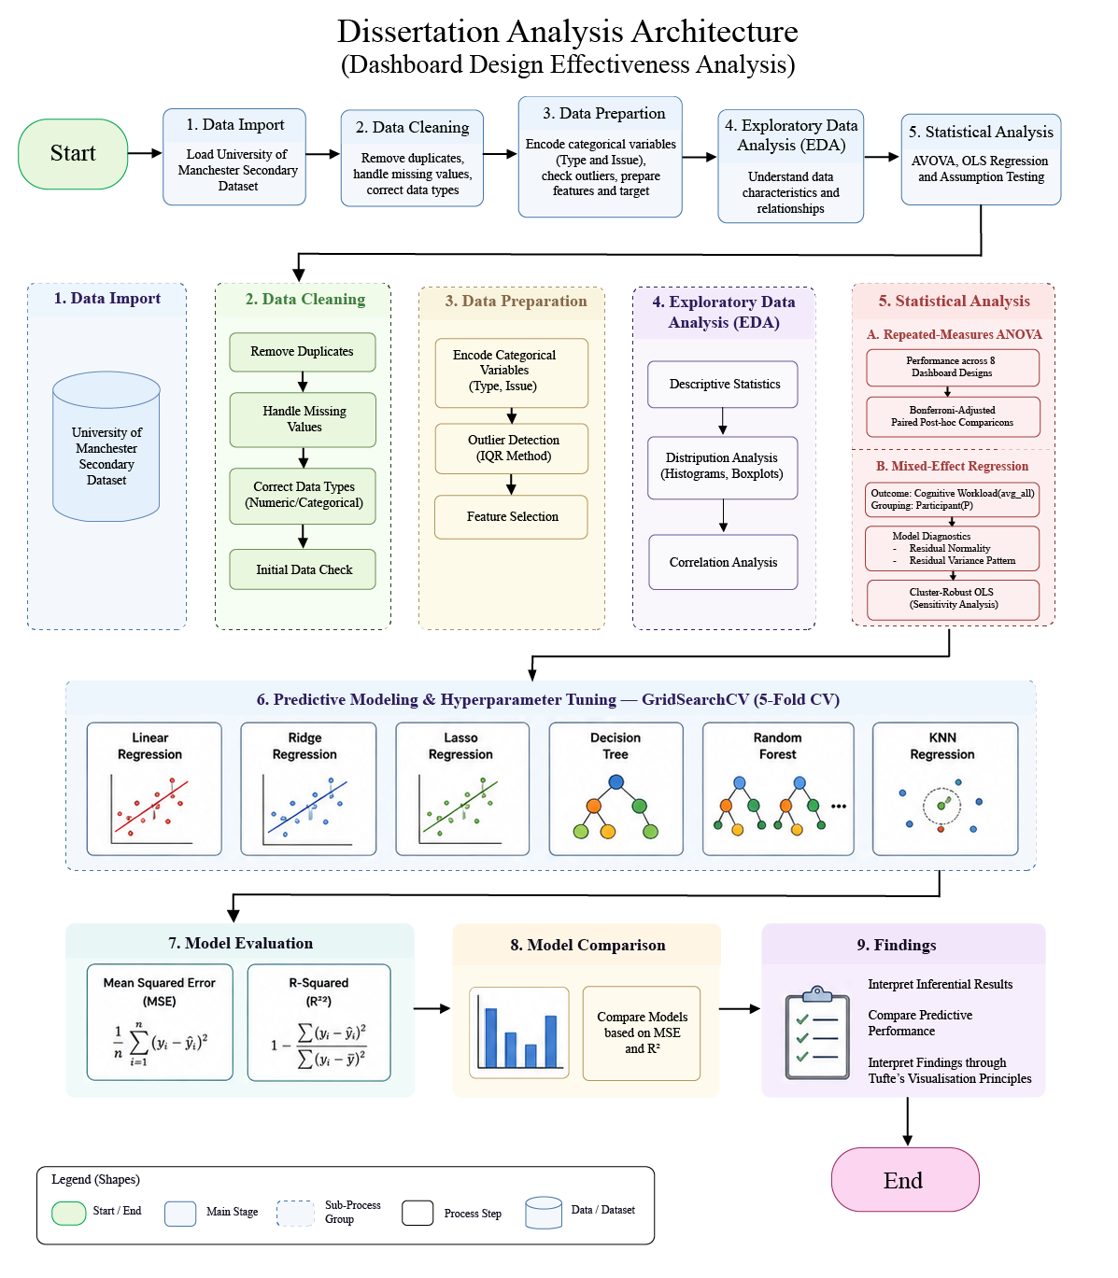
Figure 1 presents the overall analysis architecture used in this study. The workflow begins with data import, cleaning and preparation, followed by exploratory data analysis to examine the characteristics and distributions of the dataset. Inferential analysis is then conducted using repeated-measures. ANOVA and paired post-hoc comparisons to examine performance differences across dashboard designs, while mixed-effects regression is used to investigate associations between dashboard-related factors and cognitive workload while accounting for repeated participant observations. Model diagnostics and a cluster-robust sensitivity analysis are used to support the interpretation of the inferential findings. The workflow also includes predictive modelling using six regression models, followed by hyperparameter tuning with five-fold cross-validation and evaluation using MSE and R². The final stages compare predictive performance and integrate the statistical and predictive findings for interpretation in relation to the research questions and the theoretical framework.
Figure 1. Architecture Diagram
Source Code Repository
The Python code and Jupyter Notebooks used for data preparation, exploratory analysis, statistical analysis and predictive modelling in this study are available in the project GitHub repository.

Results

Data Overview
The final dataset contained 1,008 observations from 63 participants, with 16 observations recorded for each participant. No missing values or duplicate records were identified. Consequently, all 1,008 observations were retained for the analysis.
The dataset included task-related variables, dashboard conditions, user-performance measures and cognitive workload measures. The overall cognitive workload variable (avg_all) was used as the dependent variable in the mixed-effects regression analysis and as the target variable in the predictive modelling stage. As each participant contributed repeated observations, the resulting within-participant dependence was accounted for in the primary inferential analyses through repeated-measures ANOVA and mixed-effects regression.
Table 4. Dataset Overview
Characteristic | Value
Number of participants | 63
Total observations | 1,008
Observations per participant | 16
Missing values | 0
Duplicate records | 0
Regression target | avg_all

The descriptive statistics showed that avg_all had a mean of 6.00 and a standard deviation of 3.02, with values ranging from 0.00 to 18.33. These descriptive results indicate substantial variation in reported cognitive workload across the observations.

Exploratory Data Analysis
Exploratory Data Analysis (EDA) was conducted to examine the distributions and main characteristics of the variables before inferential analysis and predictive modelling. Descriptive statistics, distribution analysis, outlier assessment and correlation analysis were used to examine the data. Particular attention was given to task completion time and SGLT to provide descriptive context for participant responses across the dashboard tasks and for the subsequent statistical analyses.

Task Completion Time
Table 5. Descriptive Statistics for Task Completion Time
Statistic | Value
Count | 1,008
Mean | 3.52
Standard Deviation | 2.92
Median | 2.75
Minimum | 0.40
Maximum | 25.53

Task completion time varied considerably across the 1,008 observations. The mean completion time was 3.52, while the median was 2.75. The higher mean relative to the median suggests a positively skewed distribution, with most observations having relatively short completion times and a smaller number having substantially higher values.
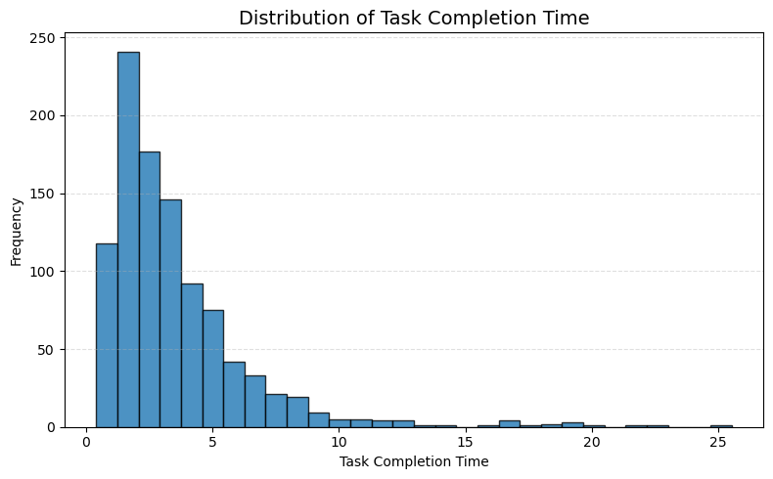
Figure 2. Distribution of Task Completion Time
Figure 2 shows that the distribution of task completion time was positively skewed. Most observations were concentrated between approximately 1 and 5, while a smaller number had substantially longer completion times. The long right tail reflects the presence of high completion-time observations, with the maximum value reaching 25.53. These observations were retained because they represented plausible task completion times rather than clear data-entry errors.

SGLT Distribution
Table 6. Descriptive Statistics for SGLT
Statistic | Value
Count | 1,008
Mean | 2.57
Standard Deviation | 1.09
Median | 3.00
Minimum | 0
Maximum | 4

SGLT scores ranged from 0 to 4, with a mean score of 2.57 and a median of 3.00. The distribution shows that scores were mainly concentrated between 2 and 4, while lower scores occurred less frequently.
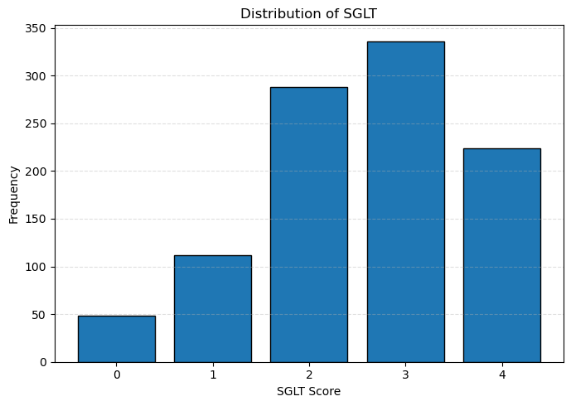
Figure 3. Distribution of SGLT Scores
Figure 3 shows that an SGLT score of 3 was the most frequently observed score, followed by scores of 2 and 4. Scores of 0 and 1 occurred less frequently, indicating that the distribution was concentrated towards the higher SGLT values. This distribution provides descriptive context for the mixed-effects regression analysis, in which SGLT is examined as one of the predictors of overall cognitive workload.

Repeated-Measures ANOVA Results
A repeated-measures ANOVA was conducted to examine whether mean performance scores differed across the eight dashboard designs (DB1–DB8) while accounting for repeated observations from the same participants. Dashboard design was treated as the within-subject factor and performance as the dependent variable.
The analysis identified a statistically significant difference in performance across the eight dashboard designs, F(7, 434) = 11.904, p < 0.001. As the p-value was below the significance level of 0.05, the null hypothesis of equal mean performance across the dashboard designs was rejected. This result indicates that performance differed significantly across the dashboard conditions. The significant repeated-measures ANOVA indicates that performance was not equivalent across all eight dashboard designs. The overall test establishes that differences existed across the dashboard conditions but does not identify which specific dashboard pairs differed. Bonferroni-adjusted paired post-hoc comparisons were therefore conducted to examine the specific differences between dashboard designs.

Table 7. Repeated-Measures Results for Performance Across Dashboard Designs

Analysis | Within-Subject Factor | Dependent Variable | df | F-statistic | p-value | Result
Repeated-Measures ANOVA | DB1–DB8 | Performance | 7,434 | 11.904 | < 0.001 | Significant

Bonferroni-Adjusted Post-hoc Comparisons
Following the significant repeated-measures ANOVA, paired post-hoc comparisons were conducted to identify which dashboard designs differed significantly in performance. As 28 pairwise comparisons were conducted across the eight dashboard designs, Bonferroni adjustment was applied to control for the increased risk of Type I error associated with multiple comparisons.
The analysis identified 10 dashboard pairs with statistically significant differences in performance after Bonferroni adjustment. The significant comparisons are presented in Table 8.
Table 8. Significant Bonferroni-Adjusted Pairwise Comparisons
Dashboard Comparison | Adjusted p-value | Result
DB1 – DB3 | p < 0.001 | Significant
DB1 – DB4 | p < 0.001 | Significant
DB1 – DB7 | p = 0.029 | Significant
DB1 – DB8 | p < 0.001 | Significant
DB2 – DB3 | p = 0.011 | Significant
DB2 – DB8 | p = 0.013 | Significant
DB3 – DB5 | p = 0.005 | Significant
DB3 – DB6 | p = 0.004 | Significant
DB4 – DB5 | p = 0.002 | Significant
DB4 – DB6 | p = 0.001 | Significant

The remaining 18 pairwise comparisons were not statistically significant after Bonferroni adjustment. The comparison between DB7 and DB8 produced an adjusted p-value of 0.0502, which was slightly above the significance threshold of 0.05 and was therefore not statistically significant.

Mixed-Effects Regression Results
A mixed-effects regression model was used to examine the associations between the selected dashboard-related predictors and overall cognitive workload (avg_all) while accounting for repeated observations from the same participants. Participant (P) was included as the grouping variable in the model.
The results showed that Data Understanding and Order & Grouping were statistically significant predictors of cognitive workload. Data Understanding was positively associated with cognitive workload (β = 0.568, p = 0.002), while Order & Grouping also showed a statistically significant positive association (β = 0.675, p < 0.001).
In contrast, Type (β = 0.228, p = 0.076), SGLT (β = 0.228, p = 0.388) and Information Overload (β = 0.177, p = 0.330) were not statistically significant at the 0.05 significance level. The estimated participant-level group variance was 4.996, indicating variability in cognitive workload between participants.

Table 9. Mixed-Effects Regression Results for Overall Cognitive Workload
Predictor | Coefficient (β) | Standard Error | p-value | 95% Confidence Interval | Result
Constant | 4.945 | 0.749 | p < 0.001 | [3.478, 6.412] | Significant
Type | 0.228 | 0.128 | p = 0.076 | [-0.023, 0.479] | Not significant
SGLT | 0.228 | 0.264 | p = 0.388 | [-0.289, 0.745] | Not significant
Data Understanding | 0.568 | 0.181 | p = 0.002 | [0.212, 0.923] | Significant
Information Overload | 0.177 | 0.181 | p = 0.330 | [-0.178, 0.532] | Not significant
Order & Grouping | 0.675 | 0.181 | p < 0.001 | [0.319, 1.030] | Significant

The mixed-effects model therefore identified Data Understanding and Order & Grouping as the two predictors with statistically significant associations with cognitive workload after accounting for repeated observations from the 63 participants. SGLT was not statistically significant in the mixed-effects model.
This finding differs from the initial standard OLS analysis, in which SGLT appeared statistically significant. After participant-level dependence was accounted for in the mixed-effects model, the association between SGLT and cognitive workload was no longer statistically significant. This difference demonstrates the importance of accounting for the repeated-measures structure of the dataset when interpreting the inferential results.
The positive coefficients for Data Understanding and Order & Grouping indicate the direction of the estimated associations within the coding structure used in the analysis. These results should be interpreted as statistical associations rather than evidence that these factors caused changes in cognitive workload.

Mixed-Effects Model Diagnostics
Diagnostic analysis was conducted to assess the residual behaviour of the mixed-effects regression model. Particular attention was given to residual normality and the consistency of residual variance across fitted values. These diagnostics were used to identify potential departures from the
model assumptions and were considered when interpreting the inferential findings.

Normality of Residuals
The normality of the mixed-effects model residuals was assessed visually and using the Shapiro-Wilk test. Visual inspection of the residual distribution indicated departures from normality, particularly towards the tails of the distribution.
The Shapiro-Wilk test produced a test statistic of W = 0.940, p < 0.001. As the p-value was below the significance level of 0.05, the test indicated that the residuals significantly deviated from a normal distribution.

Table 10. Shapiro-Wilk Test for Mixed-Effects Model Residuals
Diagnostic Test | Test Statistic | p-value | Interpretation
Shapiro-Wilk Test | W = 0.940 | p < 0.001 | Residuals deviate from normality
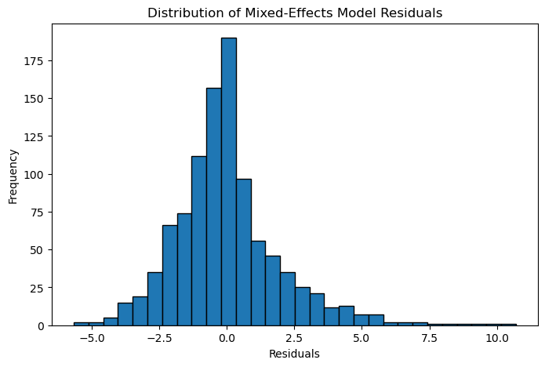
Figure 4. Distribution of Mixed-Effects Model Residuals
Figure 4 illustrates the distribution of the mixed-effects model residuals. The distribution shows departures from normality, which is consistent with the Shapiro-Wilk test result. The significant test result indicates that the residual normality assumption was not fully satisfied. This diagnostic limitation was taken into account when interpreting the mixed-effects regression results.

Residual Variance Assessment
The relationship between fitted values and residual variation was examined to assess whether the residual spread remained approximately constant across the range of predicted cognitive workload values. Visual inspection of the residuals-versus-fitted-values plot indicated that the spread of residuals varied across the fitted values.
Figure 5 shows that the residuals were not distributed with a constant spread across the fitted values. The variation in residual spread provides visual evidence of non-constant residual variance.
To provide an additional diagnostic assessment, a Spearman correlation was calculated between the fitted values and the absolute residuals. A statistically significant positive correlation was identified, Spearman’s ρ = 0.343, p < 0.001. This result, together with the residual plot, provides evidence of non-constant residual variance.

The diagnostic findings indicate that the mixed-effects model residuals departed from normality and showed evidence of non-constant variance. These limitations were considered when interpreting the statistical significance and estimated associations produced by the model. A cluster-robust OLS regression was subsequently conducted as a sensitivity analysis to examine the consistency of the main predictor findings when statistical uncertainty was adjusted for clustering within participants.
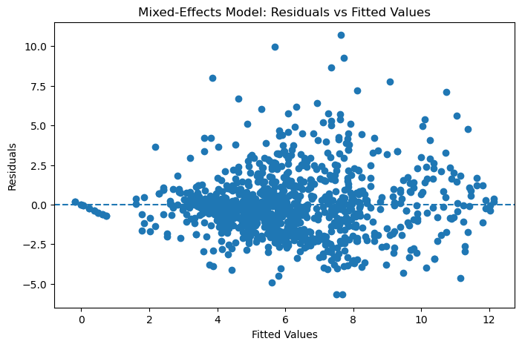
Figure 5. Residuals versus Fitted Values for the Mixed-Effects Model

Cluster-Robust OLS Sensitivity Analysis
A cluster-robust OLS regression was conducted as a sensitivity analysis to assess whether the main findings from the mixed-effects model remained consistent when standard errors were adjusted for clustering within participants. The same dependent variable and predictors used in the mixed-effects regression were included in this analysis, with standard errors clustered by participant (P).
The cluster-robust analysis identified Data Understanding and Order & Grouping as statistically significant predictors of overall cognitive workload. Data Understanding
showed a positive association with cognitive workload (β = 0.568, p = 0.002), while Order & Grouping was also positively associated with cognitive workload (β = 0.675, p = 0.001).
Type was statistically significant in the cluster-robust analysis (β = 0.228, p = 0.022). However, Type was not statistically significant in the primary
mixed-effects model (p = 0.076). This finding was therefore not consistent across the two
modelling approaches and should be interpreted cautiously. SGLT (β = 0.228, p = 0.348)
and Information Overload (β = 0.177, p = 0.350) were not statistically significant.

Table 11. Cluster-Robust OLS Sensitivity Analysis
Predictor | Coefficient (β) | Cluster-Robust SE | p-value | Result
Constant | 4.945 | 0.625 | < 0.001 | Significant
Type | 0.228 | 0.099 | 0.022 | Significant
SGLT | 0.228 | 0.243 | 0.348 | Not significant
Data  Understanding | 0.568 | 0.186 | 0.002 | Significant
Information Overload | 0.177 | 0.189 | 0.350 | Not significant
Order & Grouping | 0.675 | 0.195 | 0.001 | Significant

The cluster-robust sensitivity analysis broadly supported the main findings of the mixed-effects model. In both analyses, Data Understanding and Order & Grouping were statistically significant, while SGLT was not statistically significant. The difference observed for Type indicates that its statistical significance was sensitive to the modelling approach.
These results strengthen the evidence that the associations involving Data Understanding and Order & Grouping were relatively consistent after accounting for the clustered structure of the observations. Nevertheless, the sensitivity analysis does not remove the diagnostic limitations identified in the mixed-effects model and the findings should continue to be interpreted as associations rather than causal effects.

Predictive Model Comparison
Six regression models were evaluated for the prediction of overall cognitive workload: Linear Regression, Ridge Regression, Lasso Regression, Decision Tree Regression, Random Forest Regression and K-Nearest Neighbours (KNN) Regression. Predictive performance was assessed using Mean Squared Error (MSE) and R-squared (R²). Lower MSE values indicate smaller prediction errors, while higher R² values indicate stronger predictive performance.
Table 15. Comparison of Regression Model Performance
Model | MSE | R²
Linear Regression | 8.698 | 0.033
Ridge Regression | 8.729 | 0.029
Lasso Regression | 9.006 | -0.002
Decision Tree | 9.368 | -0.042
Random Forest | 9.304 | -0.035
KNN Regression | 9.942 | -0.106
Linear Regression produced the strongest predictive result among the six models, with the lowest MSE (8.698) and the highest R² (0.033). Ridge Regression performed similarly, producing an MSE of 8.729 and an R² of 0.029. The small difference between these two models indicates that regularisation through Ridge Regression did not improve predictive performance relative to Linear Regression.
Lasso Regression produced an MSE of 9.006 and an R² of -0.002. Decision Tree Regression and Random Forest Regression produced R² values of -0.042 and -0.035, respectively. KNN Regression had the highest prediction error (MSE = 9.942) and the lowest R² (-0.106), making it the weakest-performing model in this comparison.
The negative R² values should not be interpreted as negative relationships between the predictors and cognitive workload. Instead, they indicate that these models performed worse on the held-out test data than a baseline prediction based on the mean target value.
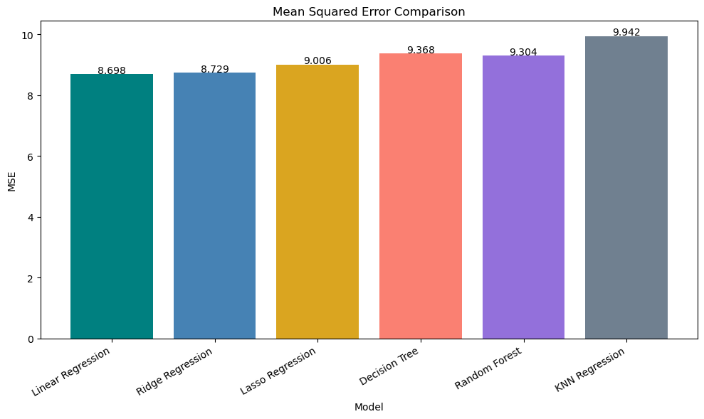
Figure 12. Mean Squared Error Comparison across Regression Models
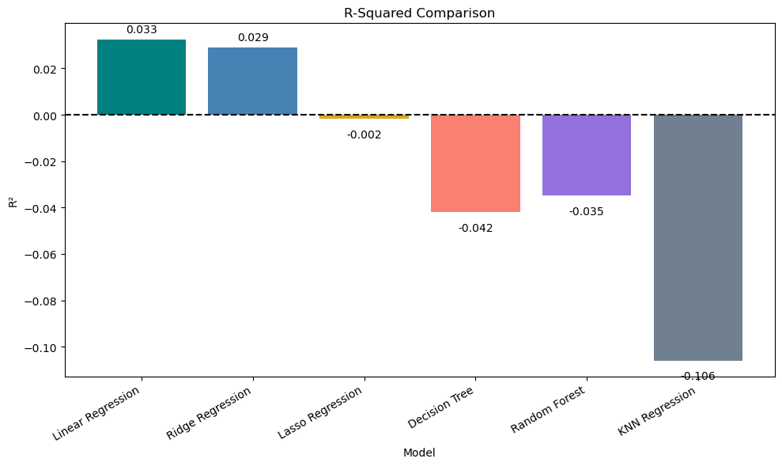
Figure 13. R-Squared Comparison across Regression Models
Figures 12 and 13 compare the predictive performance of the six regression models. Linear Regression achieved the lowest MSE (8.698) and the highest R² (0.033), followed closely by Ridge Regression. In contrast, Lasso Regression, Decision Tree Regression, Random Forest Regression and KNN Regression produced negative R² values. KNN Regression showed the weakest performance, with the highest MSE (9.942) and the lowest R² (-0.106). None of the six models demonstrated strong predictive performance for overall cognitive workload.

Actual vs Predicted Cognitive Workload
Figure 14 compares the actual cognitive workload values with the values predicted by the Linear Regression model. Linear Regression was selected for this comparison because it achieved the best predictive performance among the six models evaluated, with the lowest MSE (8.698) and the highest R² (0.033).
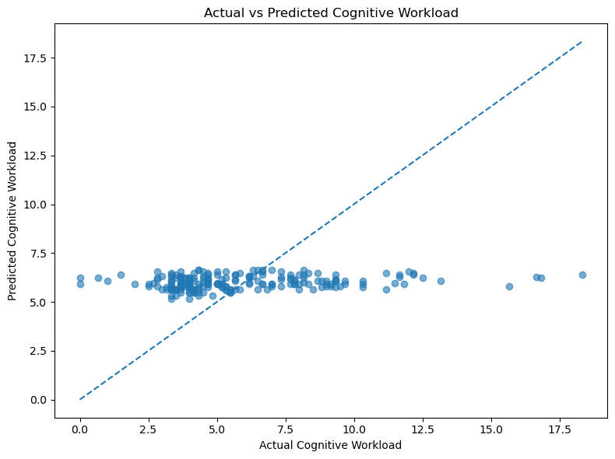
Figure 14. Actual versus Predicted Cognitive Workload Using Linear Regression
The dashed diagonal line represents perfect prediction, where the predicted value is equal to the actual value. Most predicted values were concentrated within a narrow range, approximately between 5 and 7, while the actual cognitive workload values covered a much wider range. This pattern indicates that the model tended to produce predictions close to the mean and was less effective at capturing very low or very high workload values. This is consistent with the low R² value of 0.033 and demonstrates the limited predictive usefulness of the available predictors.

Summary of Key Findings
The repeated-measures ANOVA identified a statistically significant difference in performance across the eight dashboard designs, F(7, 434) = 11.904, p < 0.001, after accounting for repeated observations from the same participants. Bonferroni-adjusted post-hoc comparisons identified statistically significant performance differences between 10 dashboard pairs, indicating that the overall difference was associated with specific dashboard comparisons rather than differences between every dashboard design.
The mixed-effects regression identified Data Understanding and Order & Grouping as statistically significant predictors of overall cognitive workload after accounting for repeated observations within participants. Data Understanding was positively associated with cognitive workload (β = 0.568, p = 0.002), while Order & Grouping also showed a statistically significant positive association (β = 0.675, p < 0.001). In contrast, SGLT (p = 0.388), Type (p = 0.076) and Information Overload (p = 0.330) were not statistically significant in the primary mixed-effects model.
The cluster-robust OLS sensitivity analysis broadly supported the main mixed-effects findings. Data Understanding (p = 0.002) and Order & Grouping (p = 0.001) remained statistically significant, while SGLT remained non-significant (p = 0.348). Type was statistically significant in the cluster-robust analysis (p = 0.022) but not in the mixed-effects model, indicating that this finding was not consistent across the two modelling approaches.
Diagnostic analysis indicated that the mixed-effects model residuals deviated from normality (W = 0.940, p < 0.001) and showed evidence of non-constant residual variance (Spearman’s ρ = 0.343, p < 0.001). These diagnostic limitations were considered when interpreting the inferential findings.
Among the six predictive models, Linear Regression achieved the lowest MSE (8.698) and the highest R² (0.033), followed closely by Ridge Regression. Despite being the best-performing model among those evaluated, Linear Regression explained only a small proportion of the variation in cognitive workload. Lasso Regression, Decision Tree Regression, Random Forest Regression and KNN Regression produced negative R² values, indicating predictive performance below a mean-based baseline on the held-out test data.
Taken together, the findings demonstrate statistically significant differences in performance across specific dashboard designs and significant associations between Data Understanding, Order & Grouping and cognitive workload. At the same time, the weak predictive performance indicates that the available variables provide limited ability to predict individual cognitive workload values. The findings should therefore be interpreted as evidence of statistical associations rather than causal effects.

Discussion

Overview of Findings
This study evaluated dashboard design effectiveness using a secondary experimental dataset, focusing on user performance, task completion time and cognitive workload. The analysis examined differences in performance across dashboard designs, associations between dashboard-related factors and cognitive workload and the predictive usefulness of the available variables.
The repeated-measures ANOVA identified a statistically significant difference in performance across the eight dashboard designs, F(7, 434) = 11.904, p < 0.001. Bonferroni-adjusted post-hoc comparisons further showed that 10 dashboard pairs differed significantly in performance. These findings indicate that performance differences were associated with specific dashboard conditions rather than being consistent across every dashboard comparison.
The mixed-effects regression identified Data Understanding (β = 0.568, p = 0.002) and Order & Grouping (β = 0.675, p < 0.001) as statistically significant predictors of overall cognitive workload after accounting for repeated observations within participants. In contrast, SGLT (p = 0.388), Type (p = 0.076) and Information Overload (p = 0.330) were not statistically significant. The cluster-robust OLS sensitivity analysis broadly supported the findings for Data Understanding, Order & Grouping and SGLT, although the result for Type differed between the two modelling approaches.
The predictive analysis demonstrated limited predictive usefulness of the available variables. Linear Regression achieved the strongest performance among the six models evaluated, with an MSE of 8.698 and an R² of 0.033, but this R² indicates that only a small proportion of variation in cognitive workload was captured by the predictive model. The remaining models did not improve predictive performance, with four producing negative R² values.
These findings indicate that measurable differences and associations exist across the dashboard conditions and dashboard-related factors examined in the study. At the same time, the weak predictive results and mixed-effects model diagnostics indicate that the findings should be interpreted cautiously. The following sections discuss these results in relation to the two research questions and the literature reviewed in Chapter 2.

Discussion of Research Question 1
The first research question asked: How do different dashboard designs relate to users’ task performance, completion time and cognitive workload?
The repeated-measures ANOVA provides evidence that user performance differed significantly across the eight dashboard designs, F(7, 434) = 11.904, p < 0.001, after accounting for repeated observations from the same participants. The Bonferroni-adjusted post-hoc analysis identified 10 statistically significant dashboard comparisons, demonstrating that the overall performance difference was associated with particular dashboard pairs rather than uniform differences between all dashboard conditions.
This finding is consistent with previous research indicating that visualisation effectiveness can depend on the characteristics of the visual representation and the analytical task being performed. Saket, Endert and Demiralp (2016) demonstrated that the effectiveness of different visualisations varied according to task and data conditions. Cleveland and McGill (1985) similarly demonstrated that graphical encoding methods differ in the accuracy with which quantitative information can be interpreted. Although these studies examined visual representations rather than the exact dashboard conditions used in the present dataset, they support the broader view that information presentation is relevant to measurable task performance.
Task completion time also varied considerably across observations. The mean completion time was 3.52, compared with a median of 2.75, and the distribution was positively skewed. Most observations were concentrated at shorter completion times, while a smaller number involved substantially longer completion times. This variation provides evidence that participants did not complete all tasks with the same level of efficiency. However, the descriptive variation in completion time does not by itself establish that particular dashboard characteristics caused longer or shorter completion times.
The mixed-effects regression provides additional evidence concerning cognitive workload. Data Understanding was positively associated with overall cognitive workload (β = 0.568, p = 0.002), while Order & Grouping also showed a statistically significant positive association (β = 0.675, p < 0.001). These relationships remained statistically significant after accounting for repeated observations within participants. The cluster-robust sensitivity analysis produced consistent findings for both predictors, providing additional support for these associations.
In contrast, SGLT was not statistically significant in the mixed-effects model (p = 0.388) or the cluster-robust sensitivity analysis (p = 0.348). This differs from the initial standard OLS result, in which SGLT appeared statistically significant. The change demonstrates the importance of accounting for the repeated-measures structure of the dataset when estimating statistical uncertainty. Type was also not statistically significant in the primary mixed-effects model (p = 0.076), although it reached significance in the cluster-robust analysis (p = 0.022). The evidence concerning Type is therefore less consistent and should be interpreted cautiously.
The significant associations involving Data Understanding and Order & Grouping can be considered in relation to research on cognitive workload and visual perception. Cognitive Load Theory proposes that the processing of complex information places demands on limited cognitive resources (Sweller, 1988). Ware (2012) similarly emphasises the importance of visual organisation, hierarchy and layout in supporting perceptual processing. The present findings are compatible with these perspectives because factors relating to understanding and information organisation were associated with participants’ reported cognitive workload. However, the statistical associations do not demonstrate that these factors directly caused changes in workload.
The predictive modelling results provide an important additional perspective. Linear Regression achieved the strongest predictive performance among the six models evaluated, but its R² of 0.033 indicates limited predictive usefulness. The more complex and regularised models did not improve prediction, and several performed worse than a mean-based baseline on the held-out test data. This distinction demonstrates that variables can show statistically significant associations without providing strong prediction of individual cognitive workload values.
Taken together, the findings address RQ1 by demonstrating significant differences in performance across dashboard designs and significant associations between Data Understanding, Order & Grouping and cognitive workload. Completion time also showed substantial descriptive variation across observations. The results do not establish causal effects of dashboard design, and the weak predictive performance suggests that cognitive workload is likely to involve variation not captured by the variables available in the secondary dataset.

Discussion of Research Question 2
The second research question asked: How can the observed relationships between dashboard-related factors, user performance and cognitive workload be interpreted through Tufte’s data visualisation principles?
The secondary dataset does not directly measure adherence to Tufte’s individual visualisation principles. Measures such as data-ink ratio, chartjunk or graphical integrity were not operationalised as variables in the dataset. Tufte’s framework is therefore used to interpret the empirical findings rather than as a directly tested independent variable.
The mixed-effects results are particularly relevant to this interpretation. Data Understanding (β = 0.568, p = 0.002) and Order & Grouping (β = 0.675, p < 0.001) were significantly associated with overall cognitive workload after accounting for repeated observations within participants. These findings indicate that factors relating to the understanding and organisation of dashboard information were associated with the cognitive workload experienced by participants.
These relationships can be interpreted through Tufte’s (2001) emphasis on clear, precise and efficient presentation of quantitative information. Tufte’s principles encourage the presentation of meaningful information without unnecessary visual elements that may compete for attention. The association involving Order & Grouping is relevant to this theoretical perspective because the organisation of information is related to how users encounter and interpret dashboard content. Similarly, the association involving Data Understanding highlights the importance of presenting analytical information in a form that users can interpret effectively.
These findings also relate to Few’s (2013) emphasis on concise and efficient dashboard communication and to the user-experience perspective discussed by Burnay et al. (2020). Together, these perspectives suggest that dashboard effectiveness extends beyond visual appearance and includes the ability of users to understand and work with the information presented. The empirical results of the present study are compatible with this broader interpretation, particularly because information organisation and understanding were associated with cognitive workload.
Information Overload was not statistically significant in the primary mixed-effects model (β = 0.177, p = 0.330) or in the cluster-robust sensitivity analysis (p = 0.350). The empirical findings therefore do not indicate statistically significant associations for every dashboard-related factor examined. This is important when applying theoretical visualisation principles to the results. A theoretical expectation that unnecessary visual complexity may increase cognitive demands does not imply that every related variable will demonstrate a statistically significant association in a particular dataset.
The significant performance differences across dashboard designs provide further context for interpreting the findings through visualisation theory. The repeated-measures analysis demonstrated that participants did not perform equivalently across all dashboard conditions. However, because the dataset does not directly quantify individual Tufte principles, these differences cannot be attributed empirically to greater or lower adherence to Tufte’s framework.
The findings therefore support an interpretive rather than experimental application of Tufte’s principles. They are compatible with the broader theoretical importance of clarity, information organisation and efficient presentation, but they do not demonstrate that adherence to individual Tufte principles directly improves performance, usability or interpretability. Direct evaluation of such effects would require a study in which individual visualisation principles were explicitly operationalised and experimentally measured.
This interpretation maintains the distinction between what was measured empirically and how the results are understood theoretically. The statistical analysis provides evidence concerning dashboard conditions, performance and cognitive workload, while Tufte’s principles provide a framework for considering the implications of these relationships for dashboard design.

Discussion of Predictive Modelling Findings
Six regression models were compared to assess their ability to predict overall cognitive workload. Linear Regression achieved the strongest predictive performance, with the lowest MSE (8.698) and the highest R² (0.033). Ridge Regression produced a similar result, with an MSE of 8.729 and an R² of 0.029, while Lasso Regression, Decision Tree Regression, Random Forest Regression and KNN Regression showed weaker predictive performance.
The more complex modelling approaches did not improve prediction compared with the simpler linear models. Decision Tree and Random Forest Regression can represent non-linear relationships, yet both produced negative R² values on the held-out test data. KNN Regression produced the weakest result, with an MSE of 9.942 and an R² of -0.106. For the predictors available in this study, increased model complexity therefore did not provide a predictive advantage.
The negative R² values produced by Lasso Regression, Decision Tree Regression, Random Forest Regression and KNN Regression should not be interpreted as negative relationships between the predictors and cognitive workload. Instead, a negative test R² indicates that the model performed worse on the held-out test data than a baseline prediction based on the mean target value. This distinction is important because predictive performance and the direction of statistical associations represent different aspects of the analysis.
Linear Regression also demonstrated limited predictive usefulness despite ranking first among the six models. Its R² of 0.033 indicates that approximately 3.3% of the variation in cognitive workload in the held-out test data was captured by the model. The Actual versus Predicted plot provides further evidence of this limitation. Predicted values were concentrated within a relatively narrow range, approximately between 5 and 7, while the actual workload values covered a substantially wider range. The model therefore tended to produce predictions closer to the mean and was less effective at capturing observations with particularly low or high cognitive workload.
The weak predictive performance suggests that the selected variables contained limited information for predicting individual cognitive workload values. Cognitive workload may also be associated with participant characteristics, task characteristics or contextual factors that were not represented by the available secondary dataset. These potentially omitted variables provide one plausible explanation for the low predictive performance, although their contribution cannot be established from the present data.
The predictive findings also demonstrate an important distinction between statistical association and predictive usefulness. Data Understanding and Order & Grouping were statistically significant in the primary mixed-effects regression, yet the predictive models explained only a small proportion of variation in cognitive workload. Statistically significant associations between particular variables therefore did not translate into strong prediction of individual workload values.
For the variables available in this study, Linear Regression provided the strongest predictive result, but the low R² indicates that none of the six models predicted cognitive workload effectively. The comparison demonstrates that applying more complex algorithms does not necessarily improve prediction when the available predictors contain limited information about the target outcome.

Study Limitations
This study has several limitations that should be considered when interpreting the findings. One limitation arises from the use of secondary data. The dataset was originally collected for an existing experiment, which restricted the analysis to the variables already available. Additional participant, task and contextual characteristics that may help explain user behaviour and cognitive workload could not be collected. This limits the extent to which the observed outcomes can be explained using the available variables.
The structure of the dataset presents an additional methodological consideration. The 1,008 observations were obtained from 63 participants, with each participant contributing 16 observations. Observations from the same participant cannot be assumed to be fully independent. To address this structure, repeated-measures ANOVA was used for the performance analysis and participant-level grouping was incorporated into the mixed-effects regression. A cluster-robust OLS regression was also conducted as a sensitivity analysis. Although these approaches account for within-participant dependence more appropriately than standard OLS alone, the repeated-measures structure remains an important consideration when interpreting and generalising the findings.
The mixed-effects model diagnostics also identified limitations. The Shapiro-Wilk test indicated that the model residuals deviated from normality (W = 0.940, p < 0.001), while the relationship between fitted values and absolute residuals provided evidence of non-constant residual variance (Spearman’s ρ = 0.343, p < 0.001). These diagnostic findings indicate that the model assumptions were not fully satisfied and require caution when interpreting the estimated associations and statistical significance of the predictors.
Predictive performance was also limited. Linear Regression, the strongest-performing model among the six predictive approaches evaluated, achieved an R² of only 0.033 on the held-out test data. This indicates that the available predictors captured only a small proportion of the variation in cognitive workload. Participant characteristics, task characteristics or contextual factors not represented in the secondary dataset may contribute to the unexplained variation. The findings therefore provide limited evidence for predicting individual cognitive workload values.
A further limitation concerns the application of Tufte’s data visualisation principles. The dataset did not contain direct measures of individual principles such as data-ink ratio, chartjunk or graphical integrity. Tufte’s framework was therefore used as a theoretical basis for interpreting observed relationships involving dashboard-related factors rather than as a directly measured independent variable. Consequently, the study cannot determine whether adherence to individual Tufte principles directly improves performance, usability, interpretability or cognitive workload.
The secondary and experimental nature of the dataset also limits the generalisability of the findings. The results reflect the participants, tasks, dashboard conditions and variables represented in the available data and may not generalise directly to other user populations, dashboard applications or organisational contexts. Furthermore, the analyses identify statistical associations and differences rather than causal effects. The findings should therefore be interpreted within the specific scope of the dataset and study design.
These limitations define the boundaries within which the findings should be interpreted and identify areas that could be addressed through future research.

Practical Recommendations for Dashboard Design
The findings of this study identify several practical considerations for the design and evaluation of data analytics dashboards. Particular attention should be given to information organisation. Order & Grouping was significantly associated with cognitive workload in both the mixed-effects model and the cluster-robust sensitivity analysis. Dashboard designers should therefore consider how related information is arranged and grouped, using logical and consistent structures that support users in locating and interpreting relevant content.
Clear presentation of information should also be prioritised. Data Understanding was significantly associated with cognitive workload across both inferential approaches. Dashboard information should therefore be presented using clear labels, appropriate visualisations, consistent terminology and logical information structures. These practices may support users in interpreting the information presented, although the findings of this study do not establish that they directly reduce cognitive workload.
Visual simplicity should be considered alongside the analytical purpose of the dashboard. Charts, colours and decorative elements should serve a clear informational or analytical function rather than being added primarily for visual effect. This recommendation is consistent with Tufte’s (2001) emphasis on clear and efficient presentation and the reduction of unnecessary visual elements. However, this recommendation is theoretically informed rather than directly tested in the present study because individual Tufte principles were not measured in the dataset.
Dashboard design should also consider differences between users, tasks and analytical contexts. The limited predictive performance of the six models indicates that the variables available in this study provided little ability to predict individual cognitive workload values. Linear Regression, despite achieving the strongest predictive performance, produced an R² of only 0.033. Dashboard evaluation should therefore not assume that a small set of design-related variables can fully explain or predict users’ cognitive workload. User testing across different tasks, user groups and contexts may provide additional evidence about how dashboards are experienced.
Dashboard evaluation should extend beyond visual appearance alone. The present study considered task performance, completion time and cognitive workload, which provide different forms of evidence about users’ interactions with dashboard information. The significant differences in performance across dashboard designs further demonstrate the value of evaluating user outcomes rather than relying solely on visual inspection. Combining performance measures with workload and usability-related evidence can provide a broader basis for evaluating dashboard effectiveness and informing future design decisions.

Conclusion
This study evaluated dashboard design effectiveness in data analytics by examining user performance, task completion time and cognitive workload and by interpreting the findings through Tufte’s data visualisation principles. A secondary experimental dataset containing 1,008 observations from 63 participants was analysed using descriptive statistics, repeated-measures ANOVA, mixed-effects regression, cluster-robust sensitivity analysis and six predictive regression models.
The repeated-measures ANOVA identified a statistically significant difference in performance across the eight dashboard designs, F(7, 434) = 11.904, p < 0.001. Bonferroni-adjusted post-hoc comparisons identified significant differences between 10 dashboard pairs, demonstrating that performance differences were associated with specific dashboard conditions rather than being consistent across every dashboard comparison. Task completion time also showed substantial variation across observations, although the descriptive analysis does not establish that particular dashboard characteristics caused these differences.
The mixed-effects regression identified Data Understanding (β = 0.568, p = 0.002) and Order & Grouping (β = 0.675, p < 0.001) as statistically significant predictors of overall cognitive workload after accounting for repeated observations within participants. SGLT, Type and Information Overload were not statistically significant in the primary mixed-effects model. The cluster-robust OLS sensitivity analysis broadly supported the findings for Data Understanding and Order & Grouping, while the result for Type differed between the two approaches. The mixed-effects model diagnostics also identified departures from residual normality and evidence of non-constant residual variance, requiring appropriate caution in the interpretation of the inferential findings.
The predictive modelling analysis demonstrated limited predictive usefulness of the available variables. Linear Regression achieved the strongest performance among the six models, with an MSE of 8.698 and an R² of 0.033, followed closely by Ridge Regression. Lasso Regression, Decision Tree Regression, Random Forest Regression and KNN Regression did not improve predictive performance. These findings demonstrate that increased model complexity did not provide a predictive advantage for the variables available in this dataset. They also highlight the distinction between statistical association and predictive usefulness, as significant associations for individual predictors did not translate into strong prediction of cognitive workload.
In relation to the first research question, the findings demonstrate that user performance differed significantly across dashboard designs and that Data Understanding and Order & Grouping were significantly associated with cognitive workload. Completion time also varied substantially across observations. These findings provide evidence of relationships between dashboard conditions, information-related factors and user outcomes, but they do not establish causal effects of dashboard design.
The second research question was addressed by interpreting the empirical findings through Tufte’s data visualisation principles. The associations involving Data Understanding and Order & Grouping are compatible with the broader theoretical importance of clear, structured and efficient information presentation. However, the dataset did not directly operationalise or measure individual Tufte principles. Tufte’s framework therefore provides an interpretive basis for understanding the findings rather than a directly tested independent variable.
The study contributes to dashboard evaluation by integrating performance analysis, cognitive workload analysis and predictive modelling while accounting for the repeated-measures structure of the experimental data. The findings highlight the relevance of information organisation and understanding while also demonstrating the limited ability of the available variables to predict individual cognitive workload. Dashboard effectiveness should therefore be evaluated using multiple forms of evidence and considered in relation to users, tasks and design contexts rather than being reduced to individual visual characteristics.
Future research could use experimental designs that directly operationalise individual visualisation principles and examine their relationships with user outcomes. Additional participant characteristics, task-related variables and contextual factors could also be incorporated to investigate sources of cognitive workload not represented in the present secondary dataset. Future studies should continue to use statistical approaches appropriate for repeated observations, such as repeated-measures and mixed-effects methods. Such research could provide a stronger basis for understanding how dashboard design characteristics relate to usability, performance and cognitive workload.

References
- Bhutani, M. (2019) Enhancing User Experience While Retrieving Information via Dashboard.
- Burnay, C., Bouraga, S., Faulkner, S. and Jureta, I. (2020) User-Experience in Business Intelligence: A Quality Construct and Model to Design Supportive BI Dashboards*.
- Camargo, D., Gaia, F.N., Basso, T. and Moraes, R. (2020) A Dashboard for System Trustworthiness Properties Evaluation.
- Cleveland, W.S. and McGill, R. (1985) Graphical Perception and Graphical Methods for Analyzing Scientific Data. Science, 229(4716), pp. 828–833.
- Few, S. (2013) Information Dashboard Design: Displaying Data for At-a-Glance Monitoring. 2nd edn. Burlingame, CA: Analytics Press.
- Heer, J. and Bostock, M. (2010) ‘Crowdsourcing Graphical Perception: Using Mechanical Turk to Assess Visualization Design’, ‘Proceedings of the SIGCHI Conference on Human Factors in Computing Systems (CHI 2010)’, Atlanta, Georgia, USA, pp. 203–212.
- Izzati, R., Wiyono, B.H., Mahendra, R.A.C. and Amalia, B. (2026) Designing and Evaluating a User-Centered Cash Flow Monitoring Dashboard for Higher Education Using Design Thinking and UEQ Framework.
- Janes, A., Sillitti, A. and Succi, G. (2013) Effective Dashboard Design.
- Karami, M., Langarizadeh, M. and Fatehi, A. (2017) Evaluation of Effective Dashboards: Key Concepts and Criteria.
- Knaflic, C.N. (2015) Storytelling with Data: A Data Visualization Guide for Business Professionals. Hoboken, NJ: John Wiley & Sons.
- Meier, F.L., Jäger, L., Senn, O., Markun, S. and Burgstaller, J.M. (2025) ‘Effectiveness of interactive dashboards as audit and feedback tools in primary care: A systematic review’, PLOS One, 20(6), e0327350. doi: 10.1371/journal.pone.0327350.
- Myllynen, T. and Kamau, E. (2025) The Evolution of Dashboard Design: Best Practices for Data Visualization in Decision Support Systems.
- Saket, B., Endert, A. and Demiralp, Ç. (2016) ‘Data and Task Based Effectiveness of Basic Visualizations’, ‘Proceedings of the 2016 CHI Conference on Human Factors in Computing Systems’, pp. 5713–5724.
- Sarikaya, A., Correll, M., Bartram, L., Tory, M. and Fisher, D. (2019) ‘What Do We Talk About When We Talk About Dashboards?’, ‘IEEE Transactions on Visualization and Computer Graphics’, 25(1), pp. 682–692.
- Sweller, J. (1988) ‘Cognitive Load During Problem Solving: Effects on Learning’, ‘Cognitive Science’, 12(2), pp. 257–285.
- Tufte, E.R. (2001) The Visual Display of Quantitative Information. 2nd edn. Cheshire, CT: Graphics Press.
- Ware, C. (2012) Information Visualization: Perception for Design. 3rd edn. Burlington, MA: Morgan Kaufmann.
- Zarqan, I.A., Nugraha, D.Y., Sitompul, G.T. and Nababan, A.A. (2026) ‘Developing Business Intelligence Dashboard for Sales KPI Monitoring in Advertising Agency: A Human-Centered Design Approach’, JDMIS: Journal of Data Mining and Information Systems, 4(1), pp. 19–25. doi: 10.54259/jdmis.v4i1.6596.
- Zhuang, M., Concannon, D. and Manley, E. (2022) ‘A Framework for Evaluating Dashboards in Healthcare’, IEEE Transactions on Visualization and Computer Graphics.

- GitHub repository: https://github.com/Chakuunaa/Evaluating-Dashboard-Design-Effectiveness-in-Data-Analytics.git

