# Project: - **Elastic Search and Kibana Setup on Docker with SSL**

Here is the server configuration details on which we had configured the test account to complete your requirements. Please follow the same and execute the steps those we mentioned here.

1. Prerequisites: - Make sure you have already installed both [Docker Engine](https://docs.docker.com/install/) and [Docker Compose](https://docs.docker.com/compose/install/).
2. Installed Software Version:
3. Ubuntu Version : - Ubuntu 18.04.3
4. Docker Version :- 18.09.7
5. Docker Compose Version : - 1.17.1
6. Download docker files form below GITHUB repo url and run in mentioned sequence. This will create container for Elastic search and Kibana and assign SSL Certificate to containers-

GitHub Url- <https://github.com/aakashsanadaya/docker.git>

1. Elastic-Docker-compose file
2. .env file

Command-

#docker-compose -f elastic-docker-tls.yml up –d

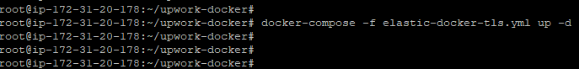

**Note: - In docker file, the given path of SSL certificates is "/root/Certs". This is created on Docker host/server and where we put all the certificates. Please follow the same directory structure at your end (if you different certificate location then you have to modify it in docker file as well). For reference please follow the screenshot.**

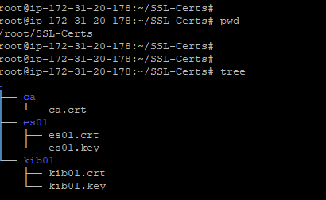

1. Once both containers are created, you need to login into the elastic server container and reset the password. Only after doing this kibana communicate with elastic server and you can access it publicly via 5601 port.

#docker ps –a **(check elastic container id)**

#docker exec –it –u 0 <containerID> bash

1. To setup new passwords please use below command.

#elasticsearch-setup-passwords interactive --url https://es01:9200

Note: - Please also noted the password of kibana user we need to update the same password in a docker-compose file and relaunch the container again

1. Stop running kibana container by below command-

# docker-compose stop

1. Start and run docker-comper file again-

# docker-compose -f elastic-docker-tls.yml up –d

Note: use user name as “elastic” to login into kibana and password as you reset in step 5