WEEK -4
Create a Spring Web Project using Maven
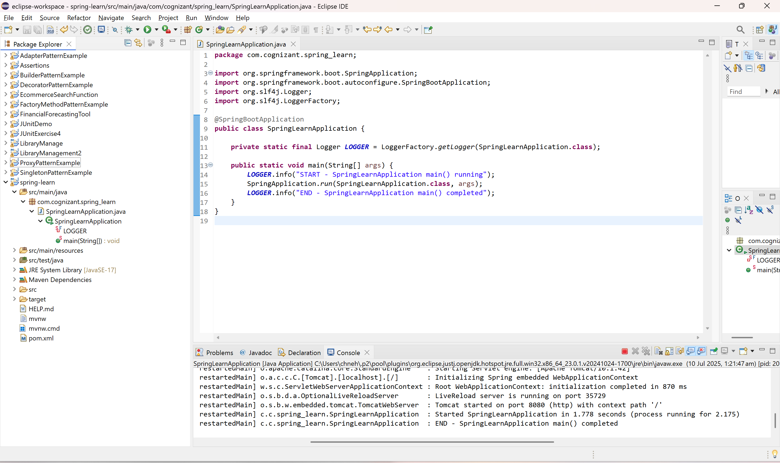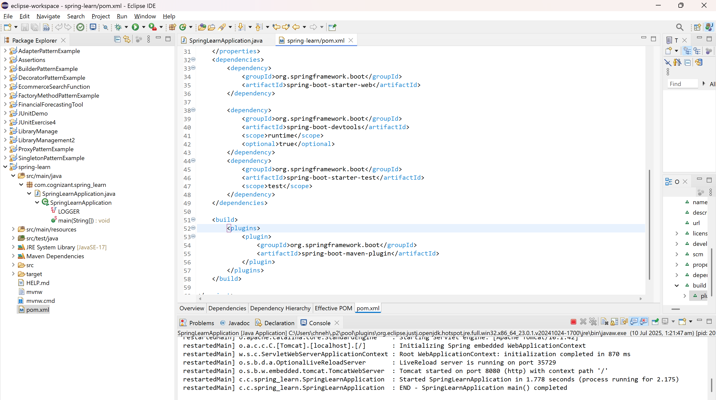

Spring Core – Load SimpleDateFormat from Spring Configuration XML
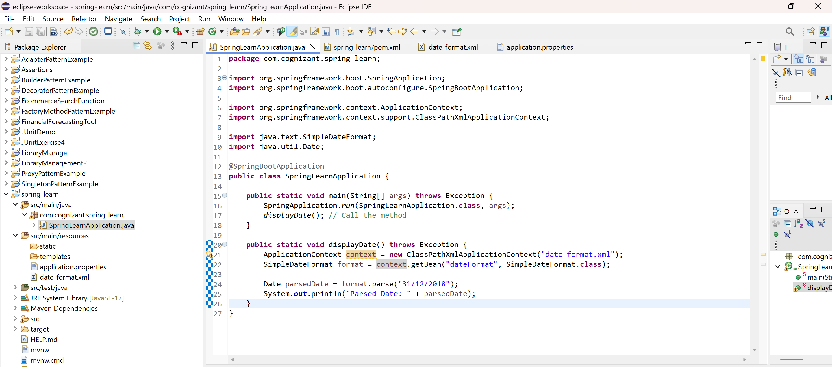
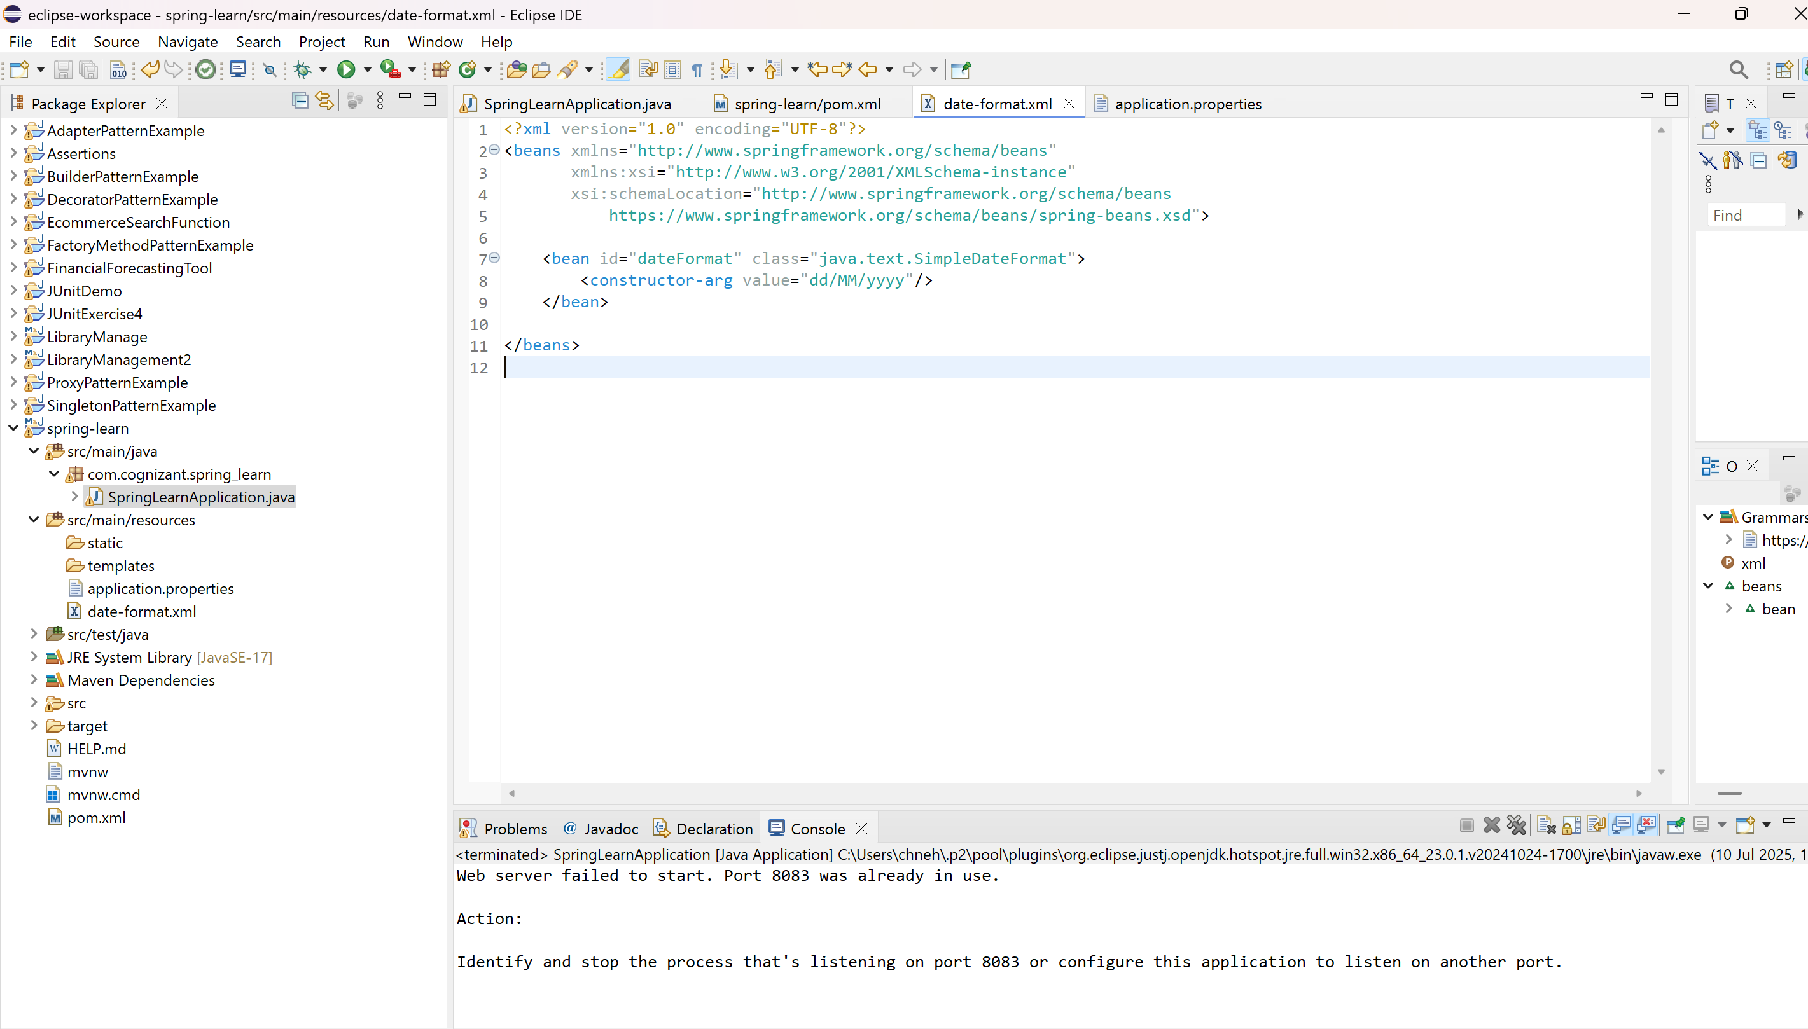
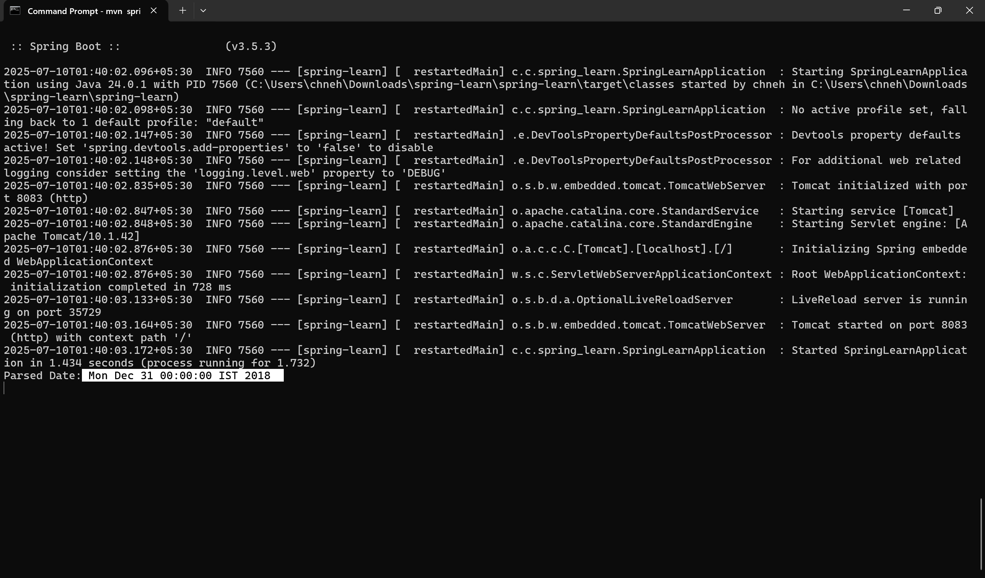

Hello World RESTful Web Service
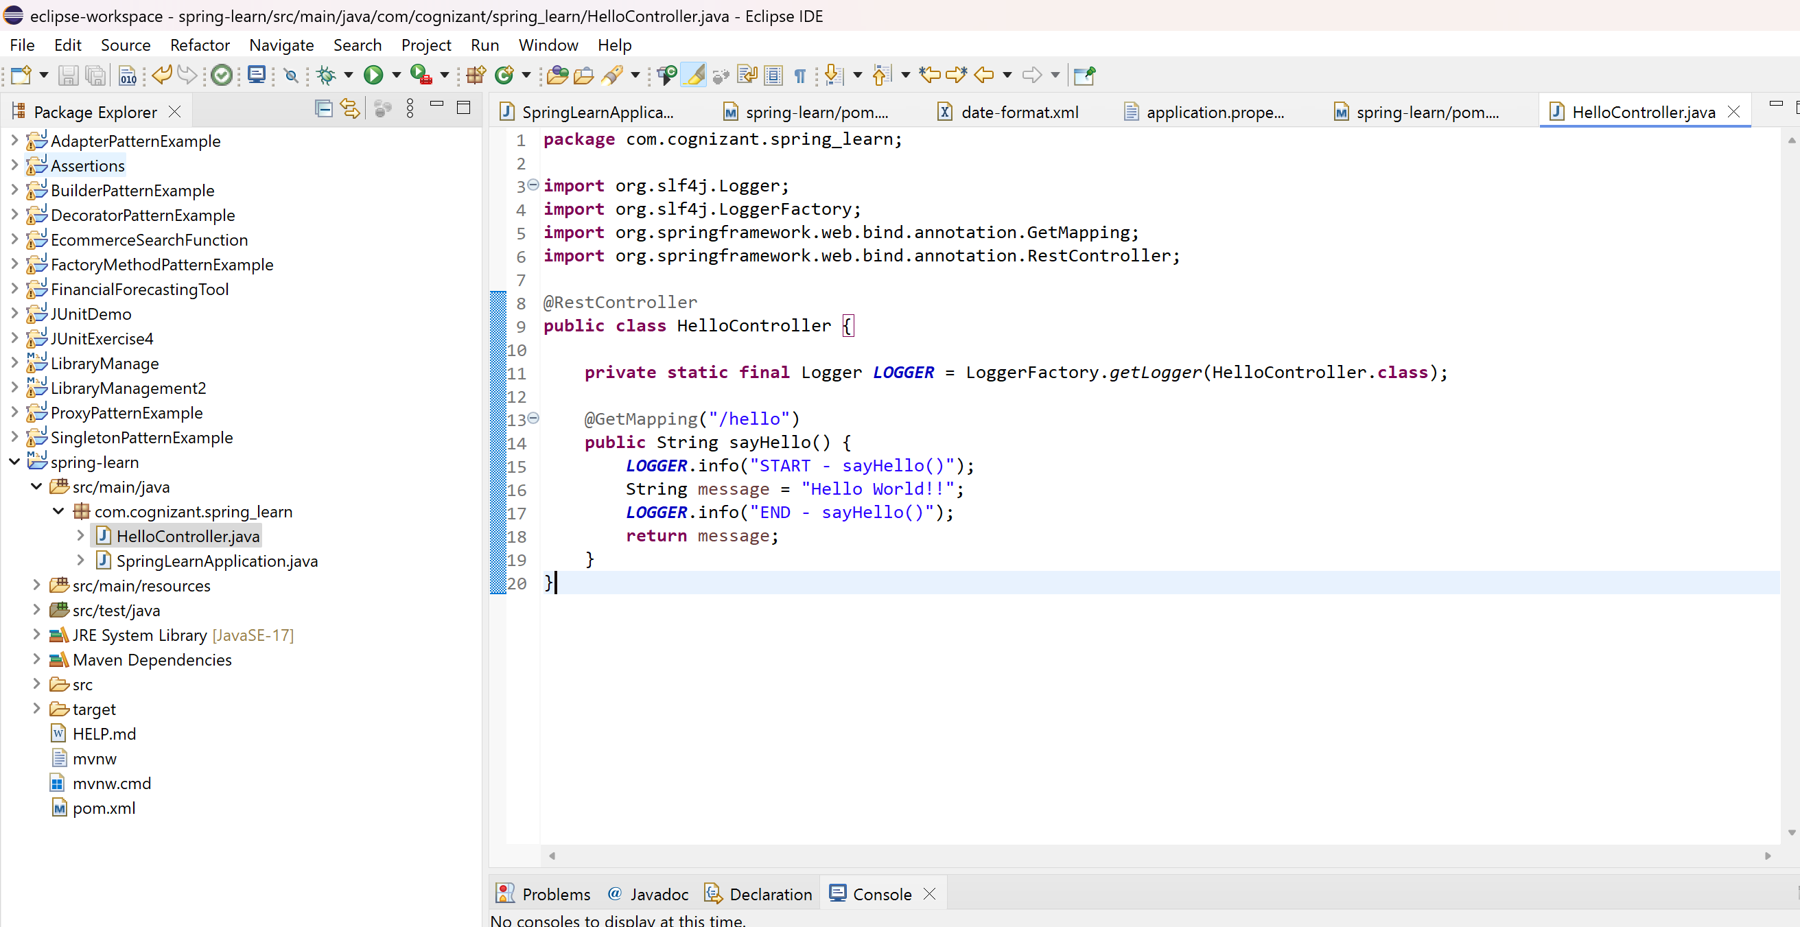
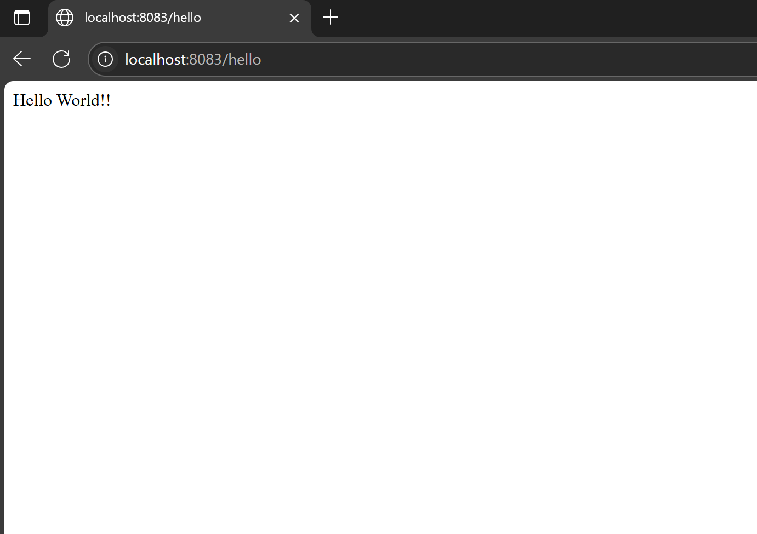

REST - Country Web Service
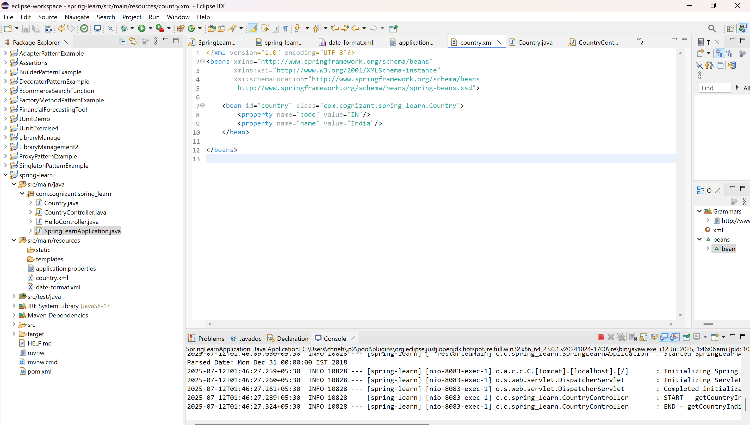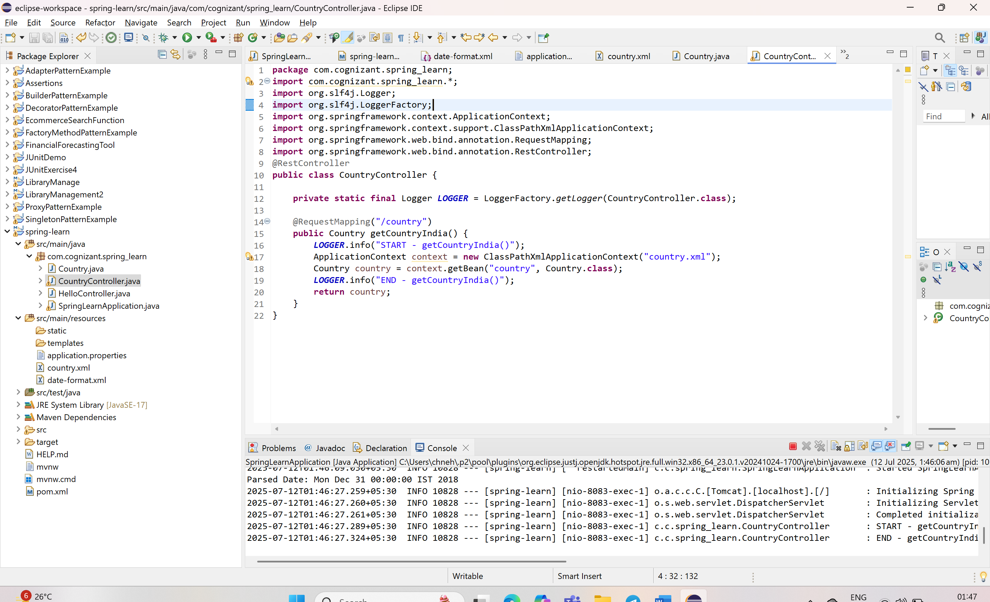
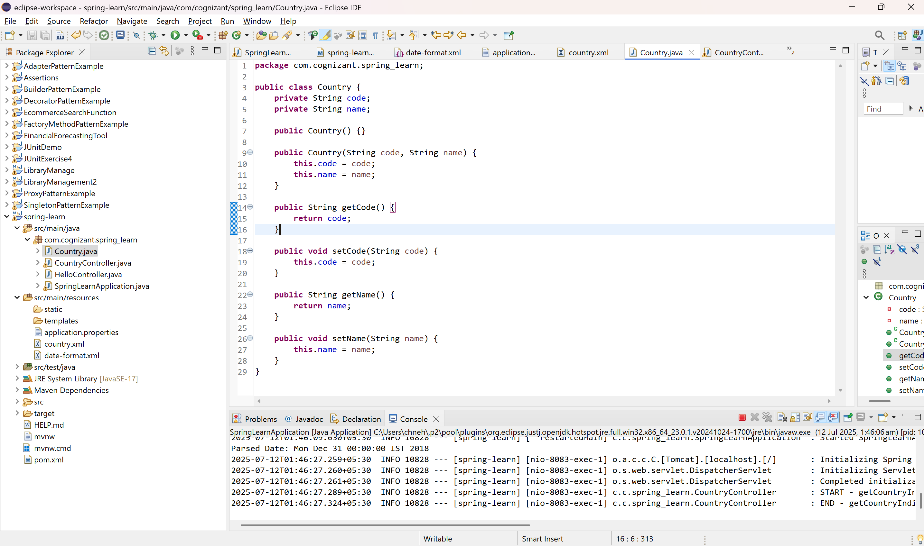
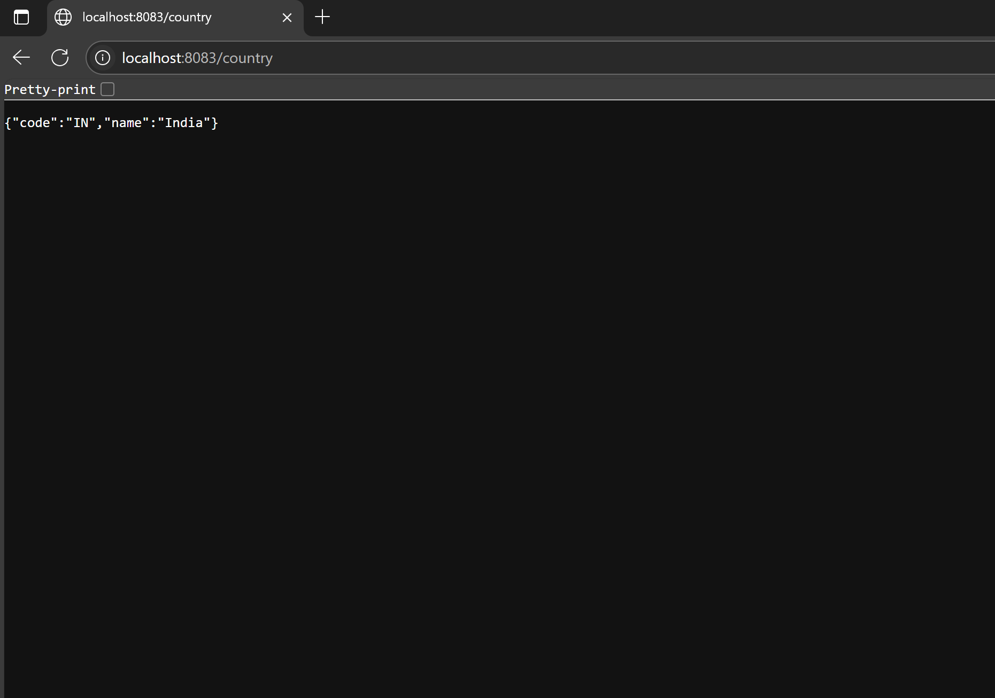

What happens in the controller method?
- Spring handles the GET request to /country.
- getCountryIndia() method is called.
- It loads the ApplicationContext using country.xml.
- Fetches the country bean.
- Returns it as the response.

How is the bean converted to JSON?
- Spring Boot uses Jackson under the hood.
- When you return a Java object (Country), @RestController + Jackson auto-converts it to JSON using HttpMessageConverters.

Network Tab in Browser Developer Tools
- Open Chrome
- Access: http://localhost:8083/country
- Click the request row → Check Headers
  - You will see:
    - Content-Type: application/json
    - Status: 200 OK

Headers Tab in Postman
- Click Headers tab after hitting /country
- You’ll see:
  - Content-Type: application/json
  - Date, Content-Length, Server, etc.

REST - Get country based on country code
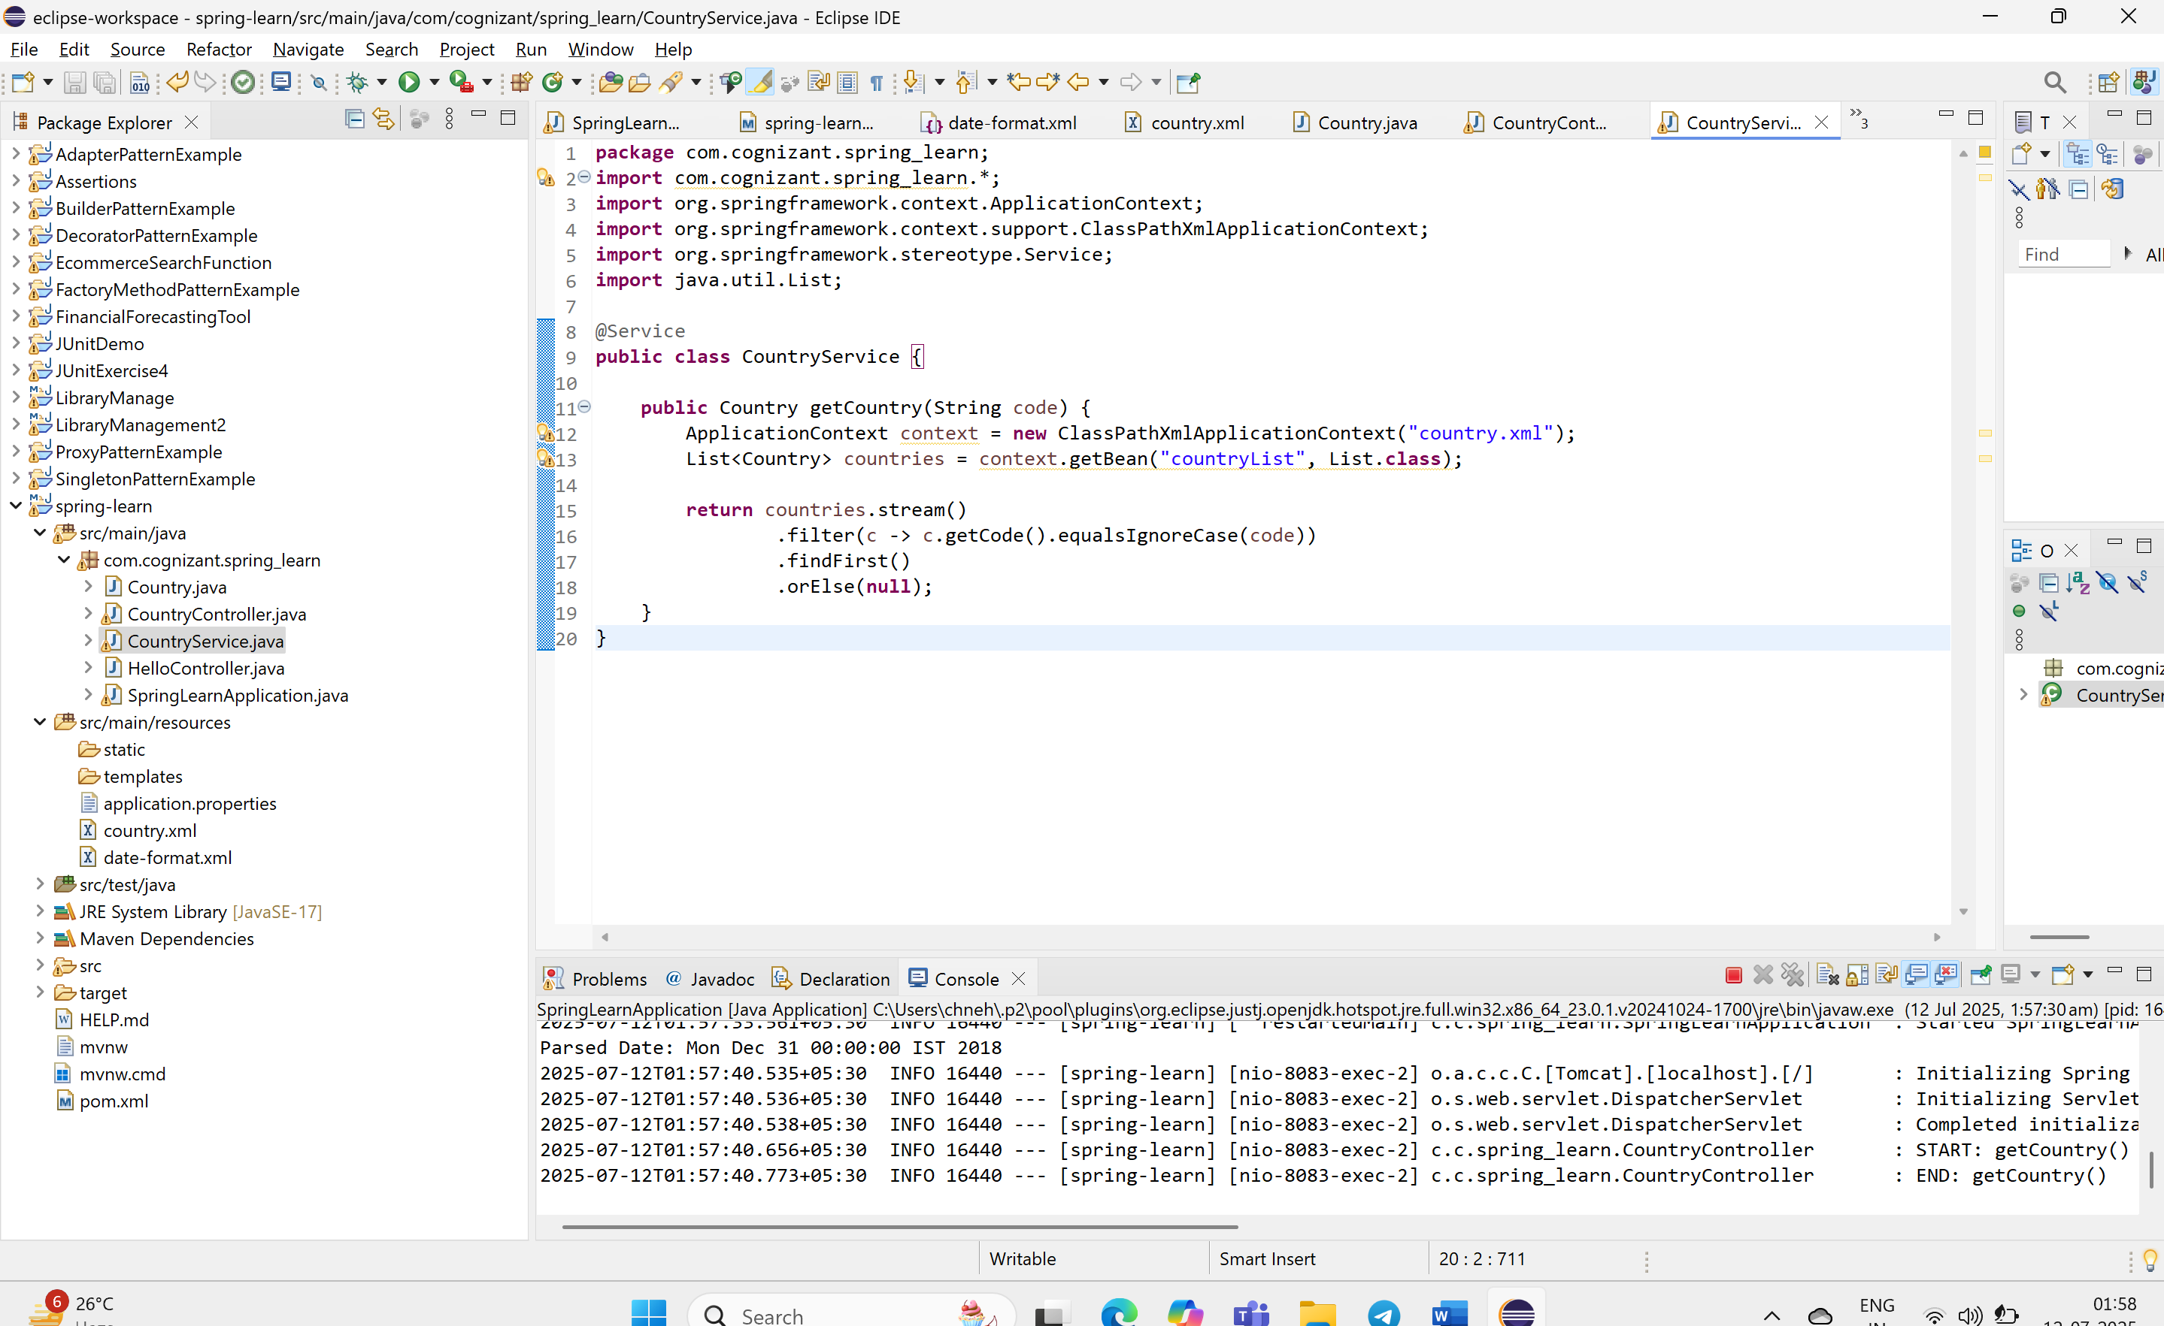
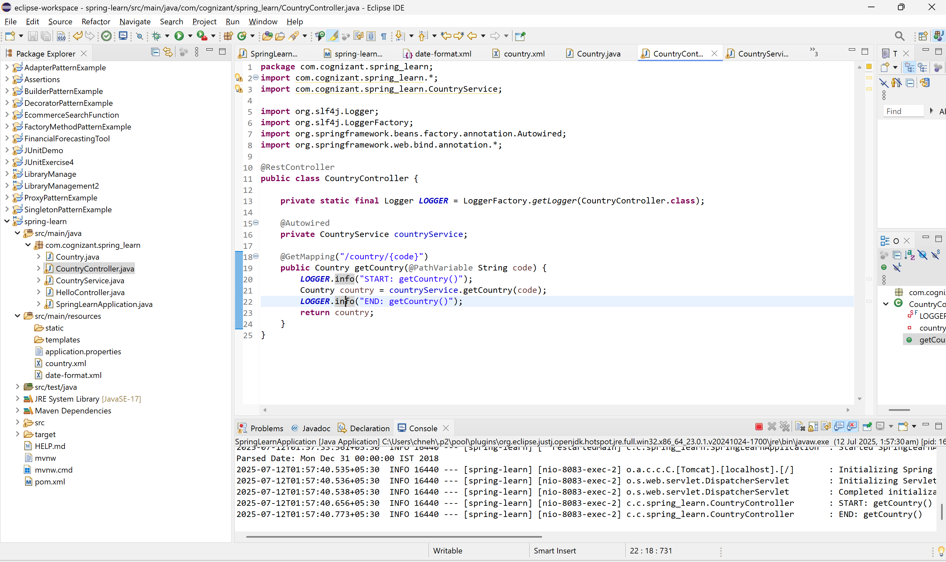
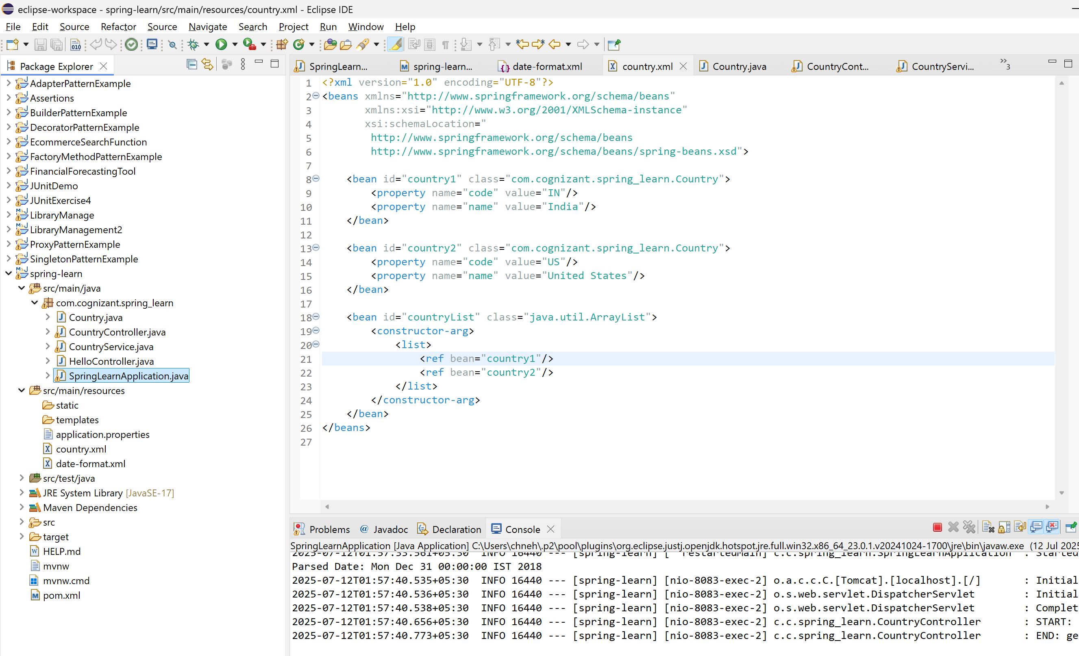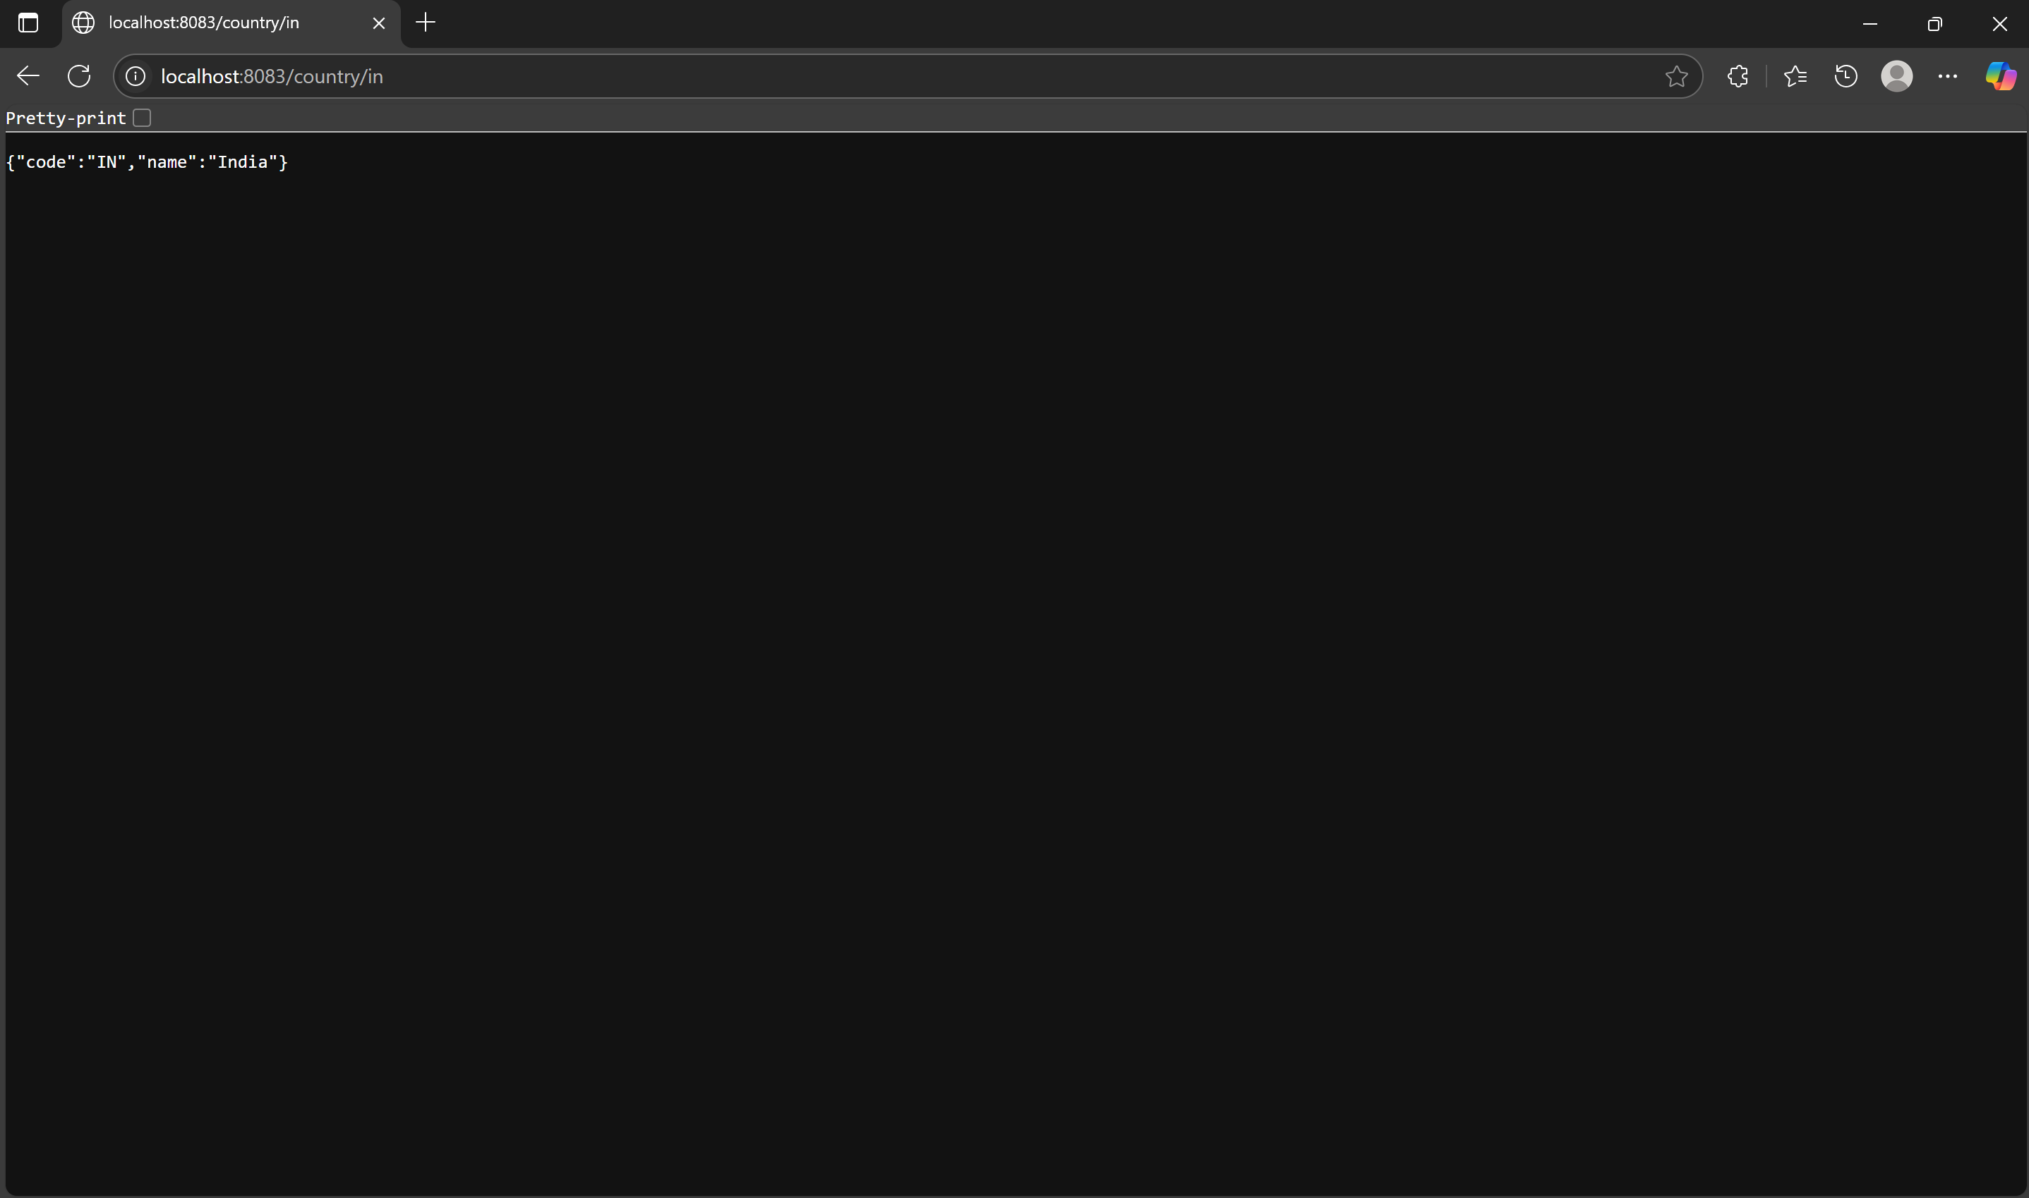

🔹 What happens in the controller method?
- @PathVariable extracts {code} from URL.
- The controller calls countryService.getCountry(code).
- The service looks up the country list from country.xml and finds the country (case-insensitively).
- The result is returned as a Country object.

🔹 How is the bean converted into JSON?
- The @RestController annotation + Jackson (included in Spring Boot) auto-converts any Java object returned into a JSON response using MappingJackson2HttpMessageConverter.

🔹 Where to see HTTP Headers
- Browser:
  - Open DevTools → Network → Click /country/in → Headers tab.
- Postman:
  - Click Headers tab to view Content-Type: application/json, 200 OK, etc.

Create authentication service that returns JWT
