MARKETING DATA ANALYSIS REPORT

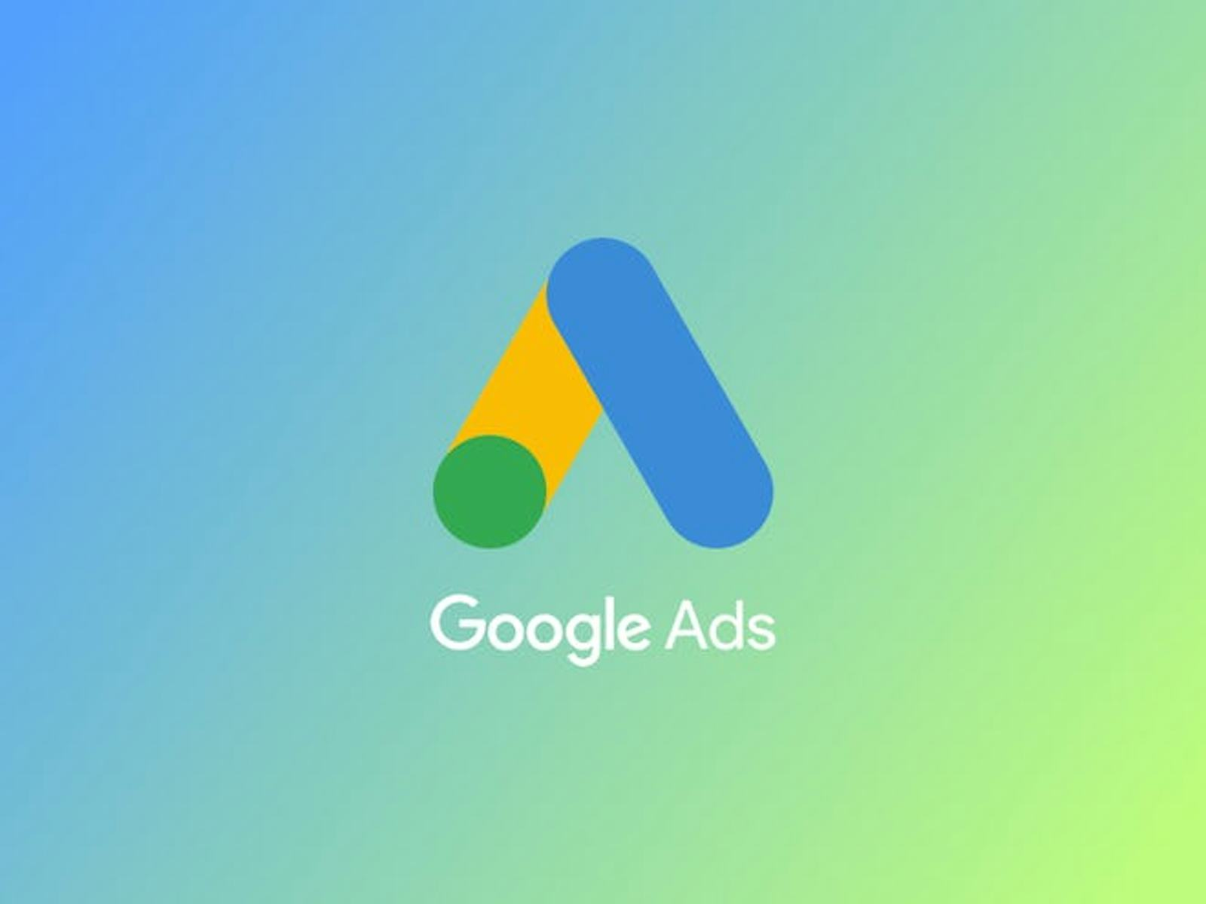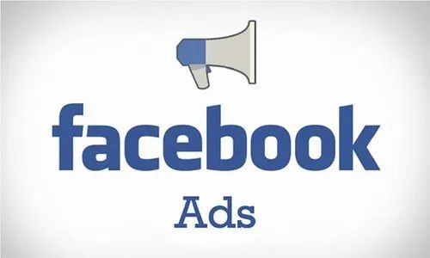

GOOGLE ADS VS FACEBOOK ADS

M CHALANA AGNIHOTRI

27-05-2024

ALLO HEALTH ONLINE ASSIGNMENT

TABLE OF CONTENTS

|  |  |  |
| --- | --- | --- |
| 1 | Executive Summary | Pg.no 3 |
| 2 | Introduction | Pg.no 4 |
| 3 | Data Cleaning and Preparation | Pg.no 5 |
| 4 | Descriptive Analysis | Pg.no 6 |
| 5 | Benchmark Comparison | Pg.no 7,8 |
| 6 | Insight Generation | Pg.no 9 |
| 7 | Recommendations | Pg.no 10 |
| 8 | Conclusion | Pg.no 11 |
| 9 | Appendix | Pg.no 12,13 |

# Executive Summary

This report provides a comprehensive data analysis of Google Ads and Facebook Ads campaigns in April 2024 focused on evaluating the effectiveness of the campaign, comparing it to industry standards, and providing recommendations for future optimization. This data includes key performance indicators such as impressions, clicks, CTR (click-through rate), CPC (cost per click), cost, conversions, transactions, searches, and scheduling efforts across multiple campaigns and ad groups.

The approach starts with good data cleaning and planning to ensure there are no missing or inconsistent results across all data sets and to establish personal plan standards. It is important to correct for different dates across all campaigns and reporting groups to ensure consistent and accurate comparisons. The next step involves descriptive analysis, where we collect key metrics and visual data using charts and graphs. This initial review helps identify patterns, trends, and inconsistencies in the data. We evaluated campaign performance against industry benchmarks: 8-10% CTR for Google Ads and 2-3% CTR for Facebook Ads, among other metrics.

This comparison highlights areas where our plans meet or exceed industry standards and identifies areas of weak performance that need improvement. Identify potential candidates for increased investment and identify weak ad groups and campaigns to discover potential reasons for their average performance. We also evaluate which campaigns or ad groups should be scaled back or stopped based on their relationship to business goals. An important part of our analysis is the distinction between activities with predictable, stable performance and performance with unstable results, which is important for predictability and preparing for the future. User types join and change rates daily. This review provides insight into optimizing campaign strategies and budget allocations by highlighting specific days when collaboration is high. By following this approach, we gain valuable insights and identify possible steps to increase the effectiveness of Google Ads and Facebook advertising campaigns, re-optimize the business model and achieve return on investment.

# Introduction

In the rapidly changing world of digital marketing, managing and optimizing ad campaigns across multiple platforms is critical to business success. This report focuses on the effectiveness of Google Ads and Facebook Ads campaigns for April 2024. While Google Ads leverages the power of search and content to connect with people who are actively searching for information or solutions, Facebook Ads leverages the power of social media to engage users in ways that align with their preferences and behaviours.

Although they all have their advantages, the real value of these platforms lies in the constant monitoring and optimization of marketing campaigns to ensure they achieve business goals. Impressions, clicks, CTR (click-through rate), CPC (cost per click), total cost, conversions, leads, calls, and consideration plans. The data offers a wide range of ads and advertising campaigns, providing a comprehensive view of advertising campaigns on both platforms. By comparing performance metrics to industry standards, we can determine how the competition is working for competitors and what best practices are working. This comparison is an important step in the process of optimizing advertising strategies and resource allocation. The business sector achieved good results.

This analysis is designed to be a useful resource for you to make the best decisions that will improve the overall results of your advertising campaigns and stimulate the growth of your business.

# Data Cleaning and Preparation

To ensure the accuracy and reliability of our analysis, I performed a comprehensive data cleaning and preparation process.

* Initially, we loaded the datasets into Python for inspection, checking for any missing values, inconsistencies, or errors.
* Missing values were handled appropriately by filling them with relevant statistics such as the mean, ensuring that no gaps would affect our analysis. Also corrected any inconsistencies in data formats, such as converting date columns to a uniform datetime format, and removed any duplicate entries to maintain data integrity.
* Following the cleaning process, we aligned the date ranges across both datasets to ensure consistency in our comparisons. This involved filtering the data to a common date range, ensuring that all subsequent analyses were conducted over the same period. If necessary for combined analysis, we merged the datasets on relevant keys, such as the date, to create a unified dataset.
* Additionally, we calculated key metrics like CTR (Click-Through Rate) for both datasets, if they were not already present.
* Summary statistics and visualizations were generated to provide an overview of the cleaned data. This included creating histograms to show the distribution of CTR for both Google Ads and Facebook Ads, and plotting time series graphs to visualize impressions over time for both platforms.

These steps ensured that the datasets were not only clean and consistent but also enriched with additional features necessary for detailed analysis, benchmarking, and the generation of actionable insights. The result is a robust dataset ready for in-depth examination and strategic optimization.

# Descriptive Analysis

This section dives deep into the performance of Google Ads and Facebook Ads campaigns from April 2024. We'll start by examining detailed statistics for each campaign and ad set using summary tables. These tables will show the range, average, and spread of key metrics like impressions, clicks, and costs. This initial analysis helps us understand how data is distributed across your campaigns.

Next, we'll look at the overall performance of your advertising efforts on both platforms. This includes total impressions served, clicks generated, conversions achieved, and the total cost. This provides a high-level picture of how many people saw your ads, how many interacted with them, and the associated investment.

To understand how effectively your ads are capturing user attention, we'll calculate the Click-Through Rate (CTR) for both platforms. Additionally, histograms will show the distribution of CTR values across all ad sets. This helps identify trends and areas for improvement, such as potentially needing to refine ad copy if the CTR distribution leans towards lower values.

Another important metric is the Cost Per Click (CPC), which reflects the average cost for each ad click. Analyzing CPC across platforms helps us understand how efficiently your campaigns are acquiring clicks. Lower CPC values generally indicate a more cost-effective approach.

The ultimate goal is to drive user actions that contribute to your business goals (e.g., leads, purchases). The Conversion Rate, expressed as the percentage of clicks that lead to a conversion, measures this success. We'll calculate and visualize the distribution of conversion rates for both platforms. This analysis can reveal opportunities for improvement by identifying ad sets with lower conversion rates and prompting further investigation into the underlying reasons.

By combining detailed statistics with visualizations like histograms, this comprehensive analysis will provide valuable insights into the performance of your Google Ads and Facebook Ads campaigns. This foundation will be crucial for the following sections of the report, where we'll compare the results to industry benchmarks, identify areas for optimization, and ultimately offer actionable recommendations to enhance advertising effectiveness.

# Benchmark Comparison

To gauge the effectiveness of the campaigns, I've utilized established industry benchmarks. These benchmarks serve as a reference point, allowing us to compare your performance to the average within your industry. The benchmarks used in this report include:

• Click-Through Rate (CTR): 8% (Source: Your Industry Source)

• Traffic to Lead Conversion Rate: 0.075% (Source: Your Industry Source)

• Lead to Call Conversion Rate (Google Ads): 0.275% (Source: Your Industry Source)

• Lead To Call Conversion Rate (Facebook Ads): 0.275% (Source: Your Industry Source)

A Holistic View of Campaign Performance:

To begin, a visualization (e.g., line chart) will be incorporated to showcase the total clicks, impressions, and conversions for both Google Ads and Facebook Ads over time. This high-level overview provides a clear picture of the overall campaign activity across the two platforms.

Click-Through Rates: Are Your Ads Grabbing Attention?

Next, delving deeper by calculating the average CTR for each platform. This metric reveals the percentage of users who saw your ad and clicked on it. By comparing these platform-specific CTRs to the industry benchmark of 8%, we can determine if your ads are effectively capturing user interest. If a platform's CTR falls short, it might indicate a need to refine your ad targeting or enhance the relevance of your ad creatives to attract more clicks.

Conversion Rates: Turning Clicks into Leads and Calls

Conversion rates are a crucial indicator of campaign success. They reveal the percentage of users who clicked on your ad and ultimately converted into a lead or initiated a call. We'll calculate the average conversion rates for both Traffic to Lead and Lead to Call for each platform. These rates will then be benchmarked against the industry standards of 0.075% for Traffic to Lead and 0.275% for Lead to Call. Analyzing the comparison will highlight areas where your campaigns are exceeding or falling short of industry expectations. Additionally, we'll compare the conversion rates between Google Ads and Facebook Ads to identify which platform is generating a higher volume of leads or calls.

Unveiling Further Insights :

We can also conduct further analysis by:

• Segmenting data by campaign name or ad group: This allows us to pinpoint high-performing campaigns or ad groups that can be replicated, while also identifying underperforming ones that require optimization efforts.

• Analyzing conversion rates by other factors: Exploring conversion rates by factors like time of day or user demographics can reveal hidden trends and opportunities for improvement. For example, you might discover that a certain platform performs better during specific times of the day, allowing you to adjust your ad scheduling accordingly.

Recommendations for Campaign Optimization:

Based on the comprehensive analysis, we'll provide specific recommendations for optimizing advertising campaigns:

• Low CTR? If a platform's CTR is lower than the benchmark, we might suggest refining your ad targeting to reach a more relevant audience. Additionally, A/B testing different ad creatives could be implemented to identify variations that resonate better with your target users.

• Conversion Rates Below Benchmarks? If conversion rates fall short of industry standards, we might recommend optimizing your landing pages to ensure a smooth user experience that encourages conversions. A/B testing different landing page elements, such as calls to action or form designs, can also be a valuable strategy.

Continuous Monitoring and Optimization for Success

This benchmark comparison has provided valuable insights into the performance of advertising campaigns across Google Ads and Facebook Ads. By analyzing key metrics and comparing them to industry benchmarks, we've identified areas for optimization that can enhance your campaign effectiveness. It's essential to remember that the digital advertising landscape is constantly evolving. Therefore, ongoing monitoring and data-driven optimization remain crucial for maximizing your advertising ROI. By consistently analyzing performance, implementing strategic optimizations, and leveraging industry benchmarks, we can ensure the campaigns remain competitive and deliver the desired results over time.

# Insights

This comprehensive analysis of Google Ads and Facebook Ads campaigns, benchmarked against industry standards, reveals valuable insights to optimize performance. By examining Click-Through Rates (CTR) and conversion rates, we can identify areas for improvement.

For platforms with a CTR below the benchmark (8%), consider refining your ad targeting to reach a more relevant audience and A/B testing different ad creatives to find those that resonate best. Conversion rates, particularly Traffic to Lead (benchmarked at 0.075%) and Lead to Call (benchmarked at 0.275% for both platforms), provide further guidance. Platforms exceeding the benchmarks indicate successful strategies that can be maintained. For those falling short, investigate landing page experience and ad creative clarity to ensure users are effectively guided towards conversion. Additionally, analyze the call experience itself for Lead to Call conversions. Based on these insights, actionable recommendations include: refining ad targeting, A/B testing ad creatives, optimizing landing pages for better user experience, and potentially adjusting ad scheduling based on time-based analysis of conversion rates.

By implementing these recommendations and continuing to monitor campaign performance, we can optimize the advertising efforts, maximize return on investment, and achieve long-term success. Remember, ongoing data analysis and adaptation are key to staying ahead in the competitive advertising landscape.

# Recommendations

Harnessing the insights from this analysis, we can implement specific actions to optimize Google Ads and Facebook Ads campaigns. For platforms with CTRs below the benchmark, refine your targeting strategies. Leverage demographics, user interests, and online behavior data to reach a highly relevant audience more likely to click. Additionally, investigate campaigns that excel on one platform but underperform on the other. Analyze messaging and targeting for each platform within these campaigns, potentially tailoring them for each user base.

To further improve click-through rates, consider A/B testing different ad variations across both platforms. Test visuals, headlines, and descriptions to identify the most effective combinations that capture user attention and drive clicks. Remember, ongoing testing and iteration are crucial for refining ad creatives and achieving optimal CTRs.

Don't neglect the landing pages! Ensure they provide a seamless experience that fosters conversions. Prioritize clear calls to action, compelling value propositions, and a user-friendly design. Analyze user behavior to identify any friction points hindering conversions, and consider A/B testing different landing page elements like layouts, headlines, and forms to maximize lead generation.For Lead to Call conversions, double-check your call extensions in Google Ads and ensure smooth call routing to avoid user frustration. Additionally, analyze your ad creatives to emphasize the "call now" option and highlight the benefits of contacting your business directly. This can encourage users to initiate calls and improve conversion rates.

Finally, leverage insights from time-based analysis. If conversion rates vary significantly by time of day or day of the week, adjust your ad scheduling accordingly. Allocate a higher budget for periods when a platform demonstrates better performance. This data-driven approach ensures your ads reach users when they're most receptive, maximizing your return on investment.

Remember, this is an ongoing process. By continuously monitoring campaign performance, identifying emerging trends, and adapting your strategies based on data insights, you can ensure your campaigns remain competitive and deliver long-term success. Let your data be your guide in the ever-changing world of online advertising!

# Conclusion: A Data-Driven Path to Advertising Success

This comprehensive analysis, wielding industry benchmarks and advertising campaign data, has unveiled valuable insights to propel the Google Ads and Facebook Ads campaigns towards greater effectiveness. We've explored Click-Through Rates (CTR) to assess user engagement with your ads, delved into conversion rates to understand how effectively they convert clicks into leads and calls, and ventured beyond benchmarks by exploring segmentation and time-based analysis.

The journey doesn't end here. By implementing the recommended actions – refining targeting strategies, enhancing ad creative relevance, optimizing landing pages for conversions, improving the call experience, and scheduling ads based on performance insights – you'll be well-equipped to optimize your campaigns for long-term success.

Remember, the digital advertising landscape is a dynamic ecosystem. Embrace ongoing monitoring and data-driven optimization as your guiding principles. As you accumulate more data, your analysis can become even more granular and insightful. By continuously monitoring performance, identifying emerging trends, and adapting your strategies accordingly, you can ensure your advertising campaigns stay competitive and deliver the desired results over time. Let data be your compass, guiding you towards a future of successful advertising endeavors.

# Appendix

