**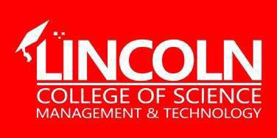  
Lincoln College of Science, Management and Technology**

**Name: SOKOMBA CHALCEDONY ARIEL**

**Department: COMPUTER SOFTWARE ENGENEERING**

**Student-ID: LUC-NGA-002-ADM-1000817**

**Semester: SEMESTER 4**

**Tilte: PSA REPORT**

# **PRACTICAL SKILLS APPLICATION (PSA) REPORT**

**FOR SEVLENT SOFTWARE SOLUTIONS**

**Semester Outcome: Website and Mobile App Development using Laravel and React**

**Company Name: Sevlent Software Solutions**

**Location: Block 7 flat 5, Mambila, Maitama, Abuja**

**Lecturer Name: Ibrahim I.  
Role: Lecturer & Supervisor, Practical Skills Application**

**Submission Date: 08/05/2025**

**Institution: Lincoln College of Science, Management and Technology**

**Department: Computer Software Engineering**

**Introduction**

This Practical Skills Application (PSA) report outlines the development activities carried out in collaboration with ***Sevlent Software Solutions***, a Nigerian-based software development and learning center. The PSA forms part of the semester's academic requirements, allowing the application of theoretical concepts in a real-world setting. The focus was on using Laravel for web development and React Native for mobile development, enabling students to bridge the gap between classroom learning and industry expectations.

As the supervising lecturer, I took on both advisory and participatory roles—ensuring that the work carried out met academic standards while aligning with industry-specific workflows. The core aim was to implement full-stack development skills in practical environments, using modern frameworks like Laravel (PHP) and React Native (JavaScript) to build scalable, responsive, and user-centric applications.

This experience illustrated the practical relevance of front-end and back-end technologies, emphasizing hands-on learning and strengthening students' confidence in developing professional-grade applications.

**Company Overview**

**Sevlent Software Solutions** is a Nigerian technology firm that offers training in programming languages, digital tutorials, and computer science consultations. The company caters to a variety of sectors including education, logistics, retail, and public administration. Sevlent focuses on providing scalable and effective solutions using cutting-edge technologies, including web and mobile platforms.

The company's dedication to innovation and software quality made it an ideal partner for this PSA. By participating in one of Sevlent’s internal development projects, students and faculty had the opportunity to work within a professional coding environment, applying Laravel and React Native to deliver usable components and real-time interactions.

During the PSA period, Sevlent provided access to a live front-end project, which allowed us to contribute to the development of both web and mobile versions. Emphasis was placed on optimizing performance, ensuring responsive design, and aligning with UX/UI best practices.

**Objectives of the PSA**

The primary objectives of the PSA engagement were to:

* Apply theoretical knowledge in a practical setting using Laravel (Web) and React Native (Mobile).
* Gain exposure to real-world front-end, back-end, and mobile development workflows.
* Design, build, and deploy responsive UI components within a live system.
* Collaborate with software professionals to solve technical challenges and deliver working solutions.

**Problem Statement**

Enhancing Digital Visibility for **Sevlent Software Solutions**

**Introduction of the Problem**

Despite its technical expertise, **Sevlent Software Solutions** lacked a strong digital presence. There was no official website or mobile platform for potential clients to interact with, which significantly limited the firm’s market visibility. In today’s digitally driven landscape, having an accessible online presence is critical for client engagement, brand recognition, and growth.

Significant Effects of the Problem

The absence of a digital platform led to limited outreach, reduced credibility, and missed business opportunities. Many potential clients—especially beginners in computing—could not easily discover or access Sevlent's services. As a result, the company faced challenges in building trust, attracting new clients, and expanding its user base.

**Proposed Solution**

To address this issue, I proposed the development of a cross-platform digital solution, leveraging Laravel for the website and React Native for the mobile application. The plan included:

* Developing a professional, SEO-optimized website to showcase Sevlent’s services and facilitate client inquiries.
* Building a mobile app with intuitive navigation and modern UI/UX design to enhance accessibility.
* Hosting the web application on a reliable platform like Vercel or Netlify for fast and global access.

This digital infrastructure would help improve client engagement, build brand credibility, and support Sevlent’s growth strategy in the software development sector.

**ScreenShots**

**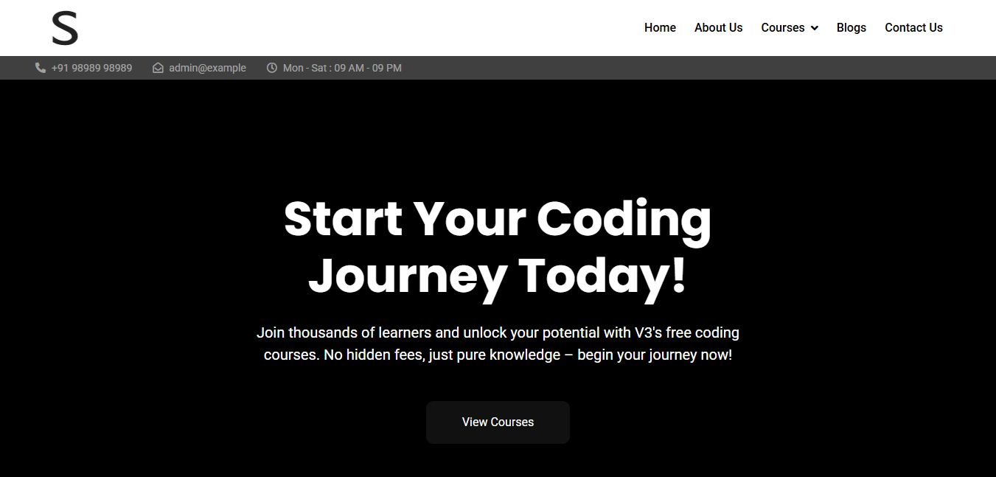  
The Landing Page**The Landing Page is the digital front door of our website, featuring a sleek, intuitive design that immediately orients visitors.  
 **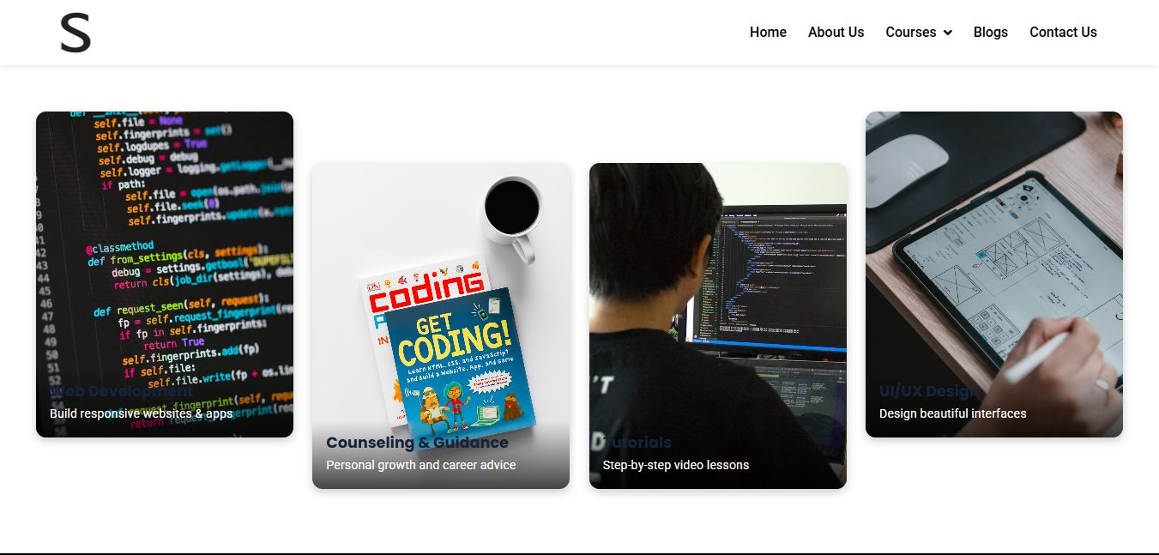  
Offers on the website   
The *Offers* section highlights promotions, discounts, limited-time deals, or special programs to incentivize user engagement, drive conversions, and enhance customer retention  
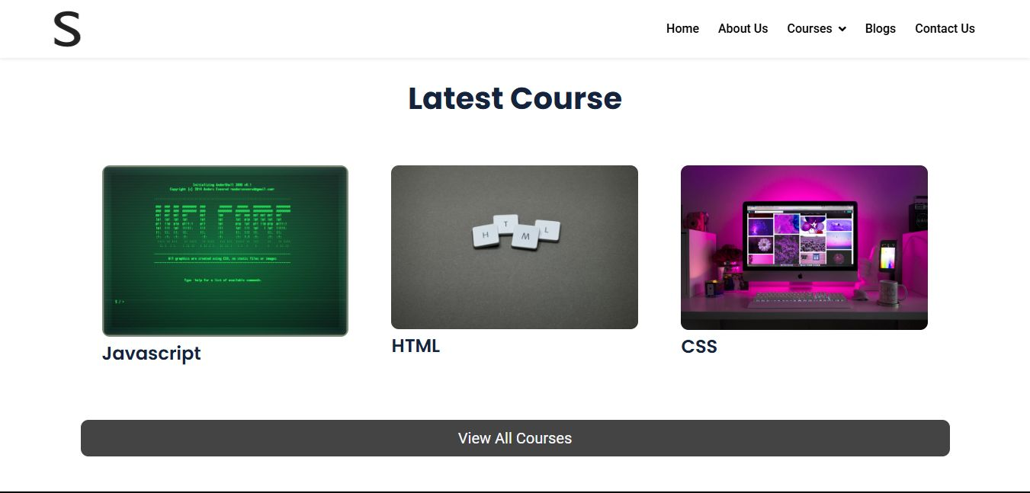  
The available courses**  
The *Available Courses* section provides users with a centralized catalog of educational programs, training modules, or learning resources offered by an institution, platform, or organization  
 **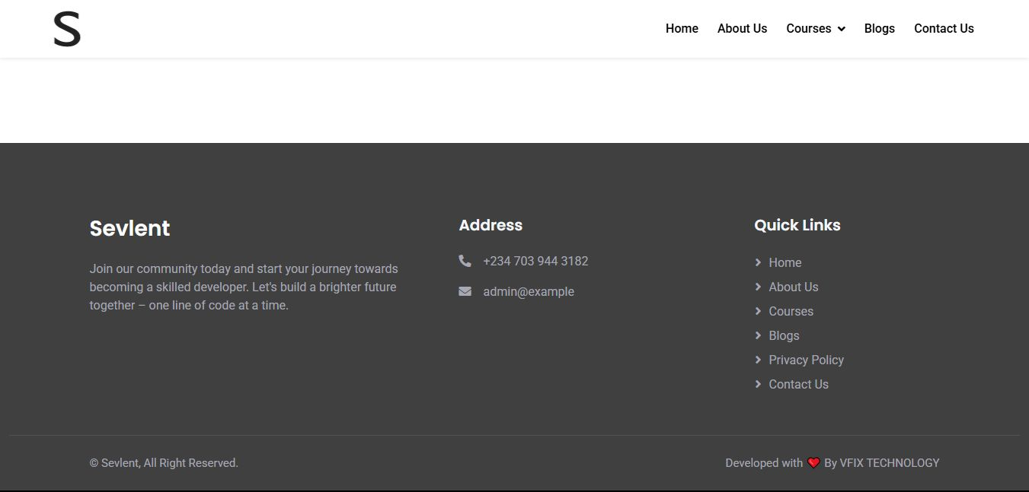  
The Footer**provide structured access to secondary content. Unlike primary menus, it offers consistent site-wide utility, ensuring visitors can find essential links, legal details, and company information regardless of their location on the site  
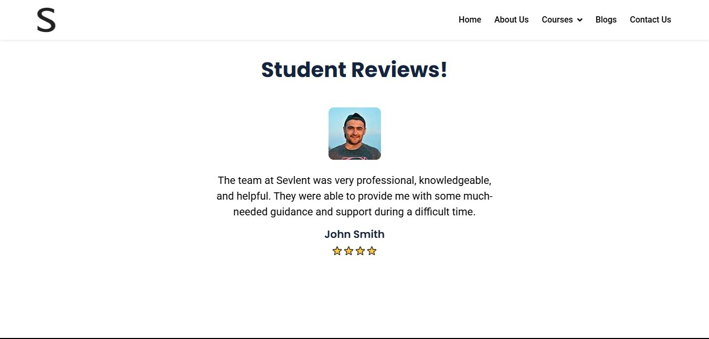  
**Testimonials**  
The section serves as a curated collection of feedback from clients, users, or partners, providing third-party validation of the quality, effectiveness, or impact of a product, service, or organization  
  
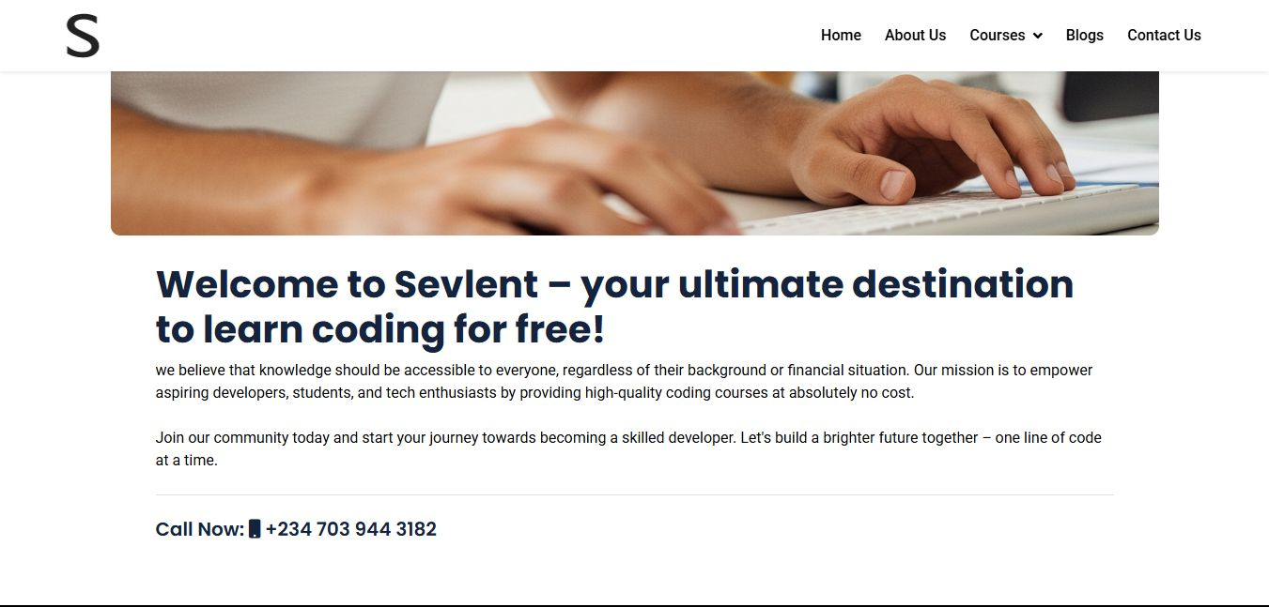  
**About the website**  
This section provides information about the website—its purpose, goals, and what users can expect. Learn why the platform was created and what it aims to offer  
  
**The blog page**Browse articles, updates, and insights related to various topics. New posts are added regularly to keep you informed and engaged  
  
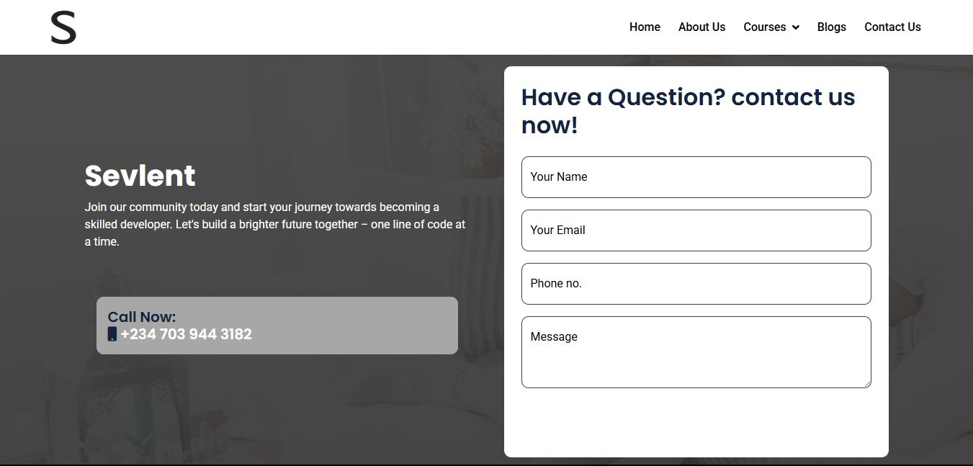  
**The contact section**Use this section to get in touch. Submit inquiries, report issues, or provide feedback through the available form or contact details 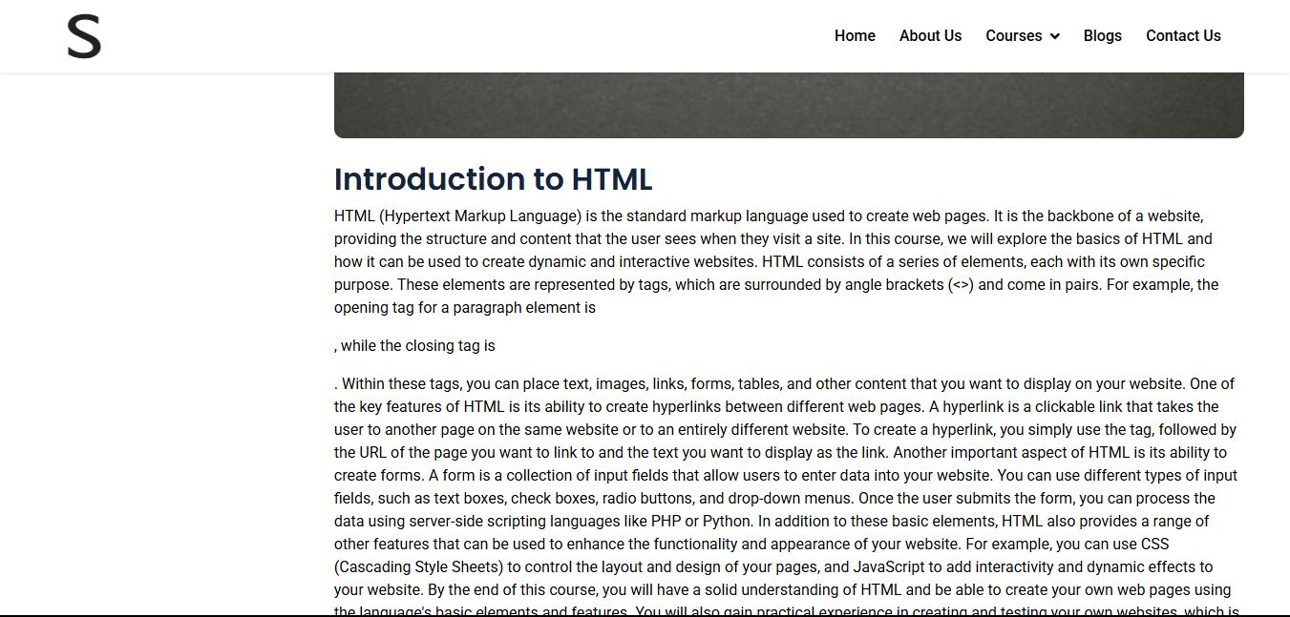  
**Courses description**   
Each course includes structured content, guided lessons, and practical activities to support your learning journey. Whether you're a beginner or looking to advance, there’s something here for everyone.  
  
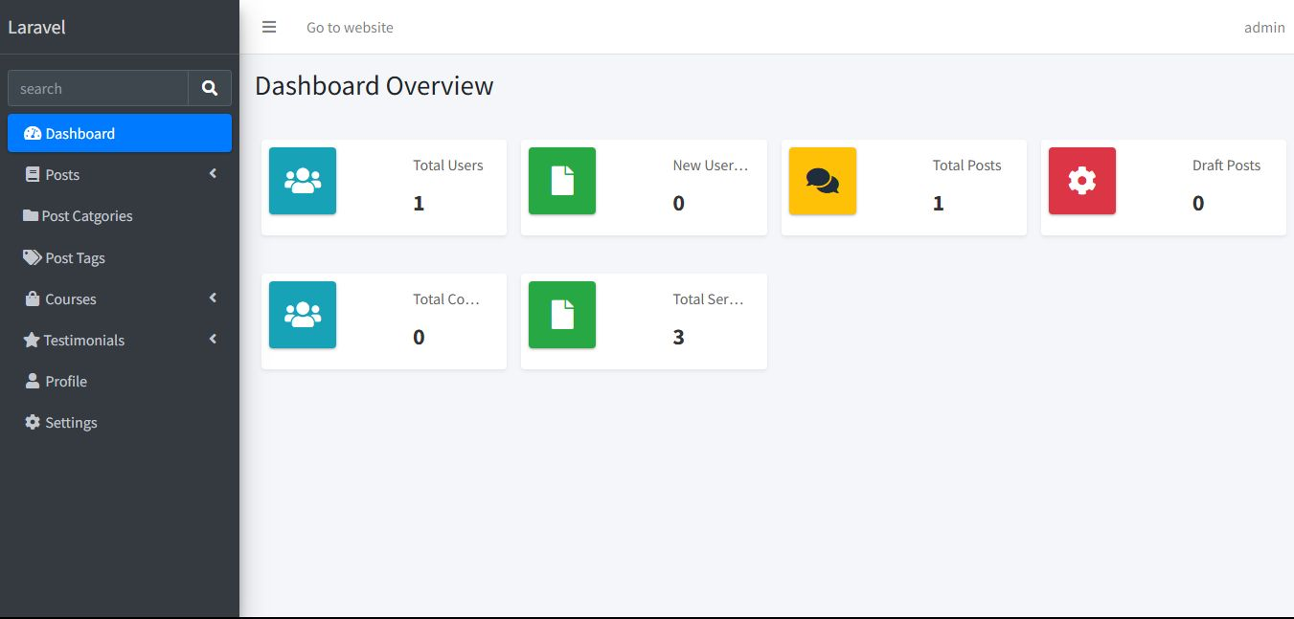  
**The landing page for the dashboard**  
Welcome to your dashboard! This is the main landing page where you can get an overview of your activity, access important tools, and navigate to different sections like posts, settings, and categories. It’s designed to help you manage your content and account efficiently, all in one place  
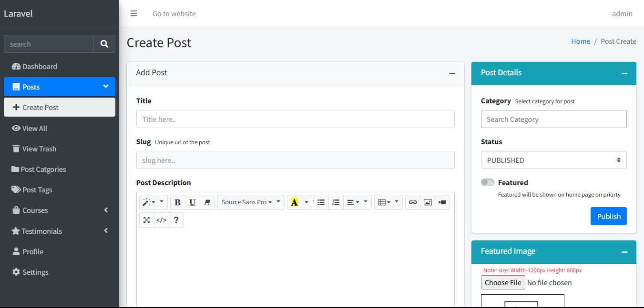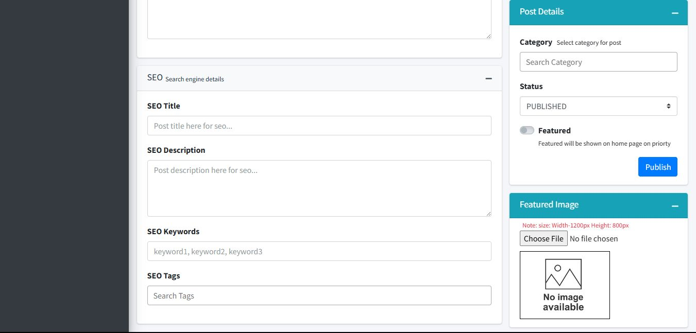  
**The section to create posts**Use this section to write and publish new posts. Share your ideas, updates, or content with others in just a few steps.  
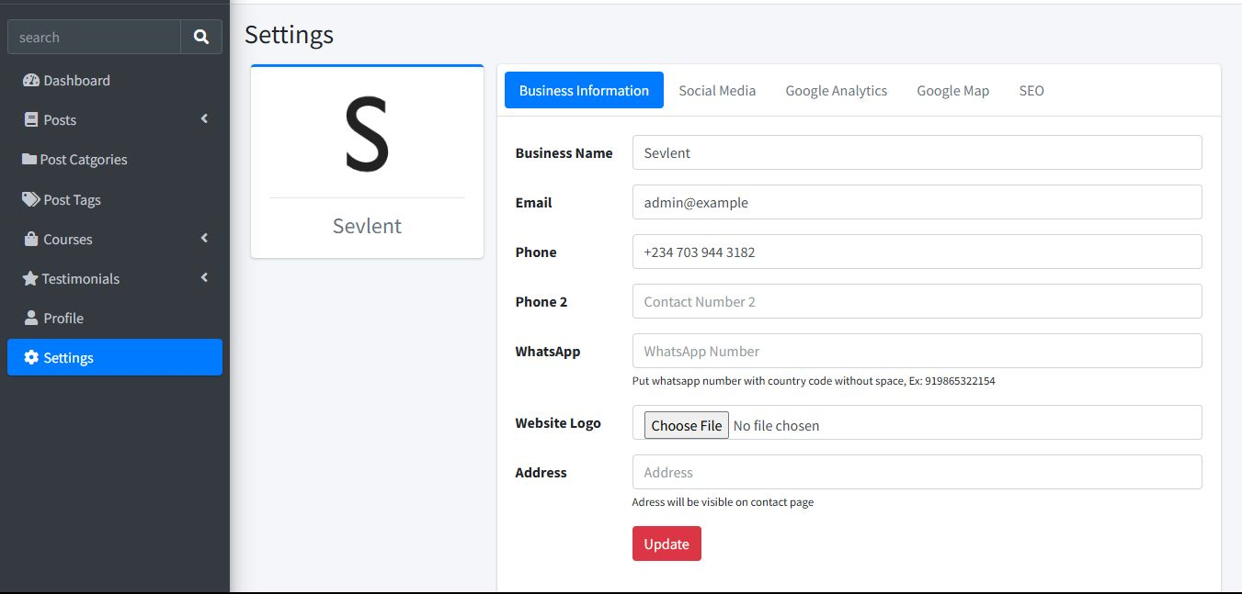  
**The setting page so change things about website**Manage your preferences and customize how the website works for you. Update account details, adjust notifications, and change site appearance or behavior  
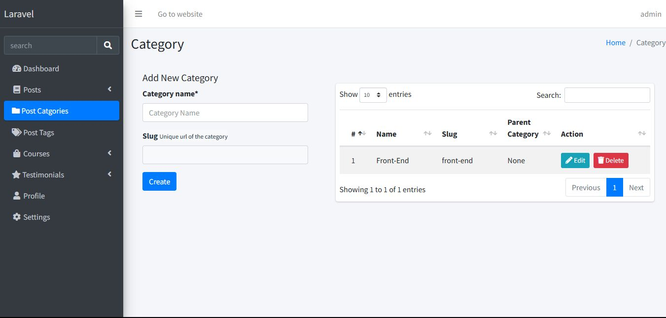  
**The section to view all categories for posts**  
Browse all post categories here to easily find content based on your interests. Each category groups related posts, making it simple to explore specific topics.  
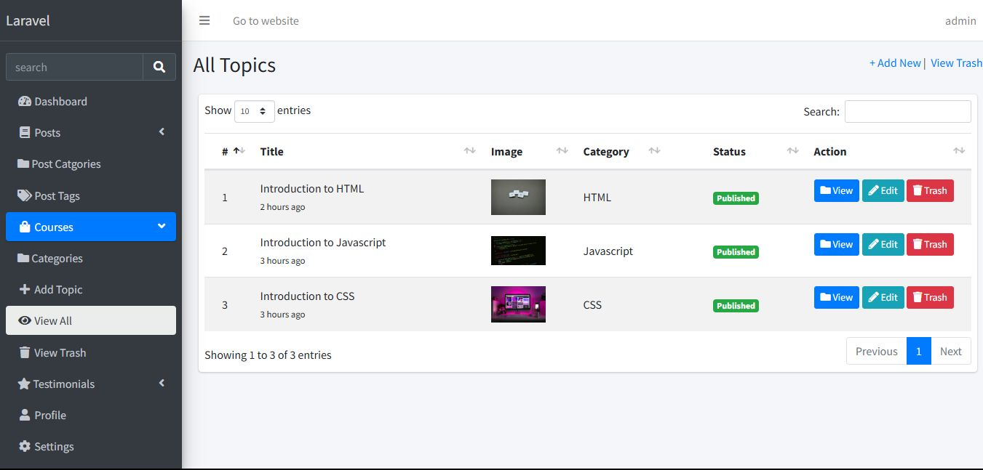  
**The section to view all topics/courses available**Here, you’ll find a complete list of all the topics and courses currently offered. Whether you're looking to explore a new subject or deepen your knowledge in a specific area, this section helps you discover what's available.  
  
**React App ScreenShots**

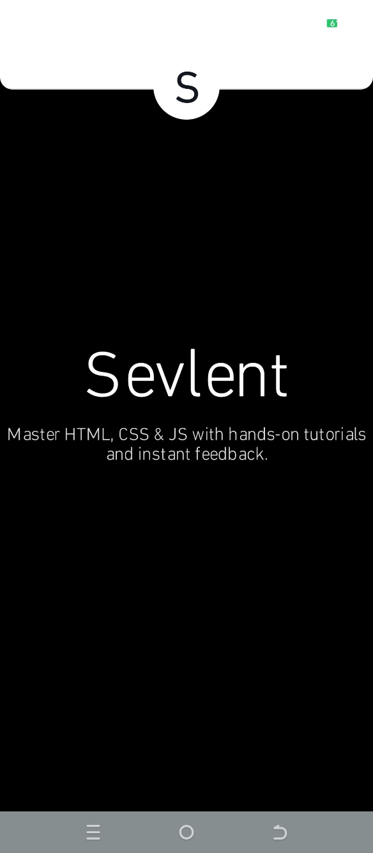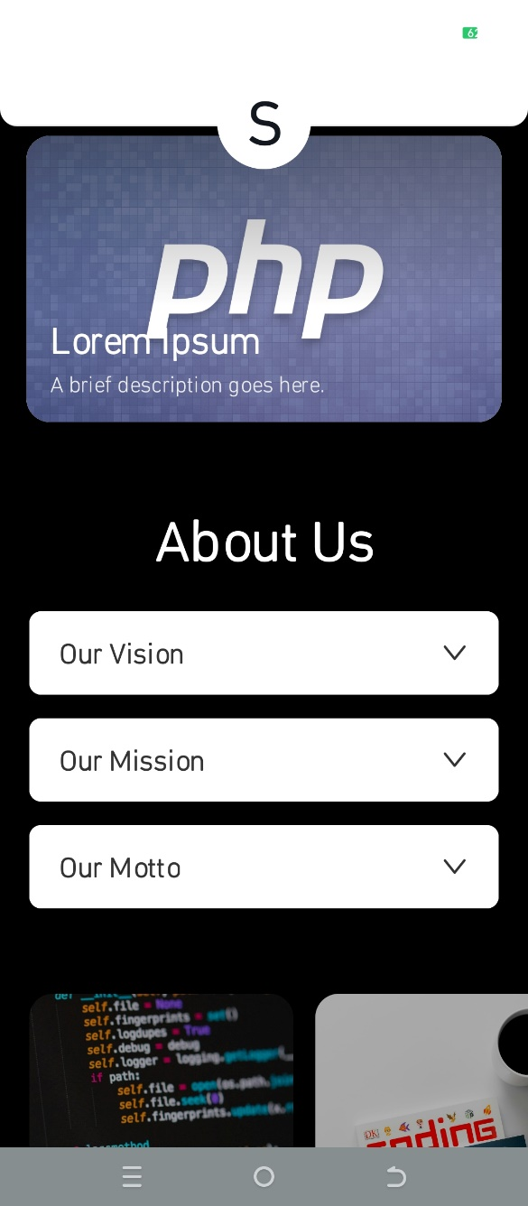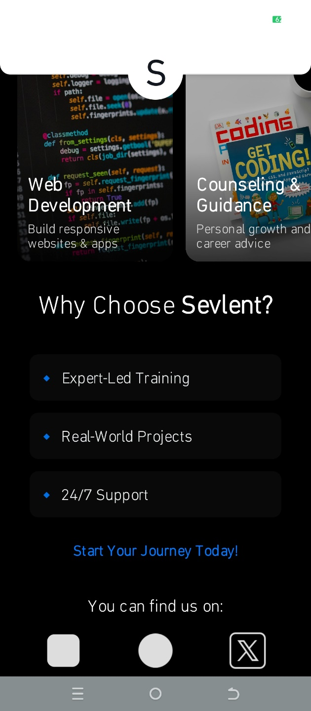

Features of this section may include:

* A categorized list of all topics or course areas (e.g., Technology, Business, Art, Science).
* Course titles, short descriptions, and difficulty levels (Beginner, Intermediate, Advanced).

Methodology / Activities Undertaken

The development process began with a requirements analysis, followed by wireframing and prototyping using Figma. After validating the design, development proceeded using Laravel for the website and React Native for the mobile app (with Expo as the framework).

Key Tasks:

* Created reusable and optimized components in both Laravel and React Native.
* Integrated backend services and a MySQL database for dynamic content rendering.
* Implemented navigation, API calls, and styling within the Expo-based React Native environment.
* Participated in code reviews and team scrums for feedback and collaboration.

**Tools & Technologies Used**

* Frameworks & Libraries: Laravel, React Native (Expo)
* Languages: JavaScript (ES6+), PHP, HTML5, CSS3
* Database: MySQL
* Pre-hosting: Github
* Design Tool: Figma
* Development Environment: Visual Studio Code

**Challenges Faced**

Several obstacles were encountered throughout the project, including:

* Adapting to Sevlent’s specific coding standards and workflows.
* Balancing academic development patterns with industry-focused solutions.
* Designing both the logo and a functional dashboard system.
* Managing Laravel components across multiple, interconnected pages.
* Navigating advanced concepts such as routing, models, controllers, and database migrations in Laravel.
* Handling React Native complexities like nested components, useState, and third-party libraries.
* Ensuring mobile responsiveness and compatibility across various screen sizes.

These challenges were overcome through self-guided research, consistent feedback from peers, and iterative testing.

**Results / Outcomes**

The PSA project resulted in the successful design and partial deployment of a responsive web interface for one of Sevlent’s client-facing platforms. Students gained substantial hands-on experience in real-time development, while Sevlent benefited from an improved user experience prototype.

The working version of the website and mobile app prototype can be accessed at:  
<https://github.com/Chalcepro/Sevlent> and <https://github.com/Chalcepro/Sevlent-mobile->

**Lessons Learned**

Key lessons from this experience include:

* A deeper understanding of native mobile development and modern web frameworks.
* Recognition of best practices—and common pitfalls—in building scalable UI systems.
* Importance of consistency in testing, code organization, and version control.
* Gained confidence in transitioning from academic theory to industry-level application.

**Conclusion**

This PSA engagement with **Sevlent Software Solutions** successfully demonstrated how academic concepts can be effectively applied in real-world software development environments. The project validated the versatility and power of Laravel in full-stack web development and highlighted the utility of React Native for cross-platform mobile applications.

Students benefited from practical exposure, and Sevlent gained a foundation for future digital platforms. The collaboration also reinforced the importance of agile development, teamwork, and continuous learning in today’s dynamic tech ecosystem.