WATERBILL NG - AUTOMATED WATER BILLING MANAGEMENT SYSTEM
Project Documentation
Submitted By:
Chalcedony Sokomba Ariel
Matric Number: LUC-NGA-002-ADM-1000817
Submitted To:
Department of Computer Software Engineering
Lincoln College of Science, Management and Technology
In Partial Fulfillment of the Requirements for the Award of
National Innovation Diploma (NID) in Computer Software Engineering
November 2025

TABLE OF CONTENTS
Chapter One: Introduction
Chapter Two: Literature Review
Chapter Three: System Analysis and Design
Chapter Four: Implementation and Evaluation
Chapter Five: Summary, Recommendations and Conclusion

CHAPTER ONE: INTRODUCTION
1.1 Background of Study
The WaterBill NG system was developed to address the community based problem whereby disputes, complaints and quarrels occur when members either mention that they did pay for service (water utility service) and not get served or not pay and were given due to the inefficient way the admins handle and record the information (receipts) passed by the tenants or landlords respectively.
The system (WaterBill NG) emerged from critical challenges in rural Nigerian water utility management. Traditional approaches using manual record-keeping, paper-based tracking, and social media-mediated payments have proven inadequate for modern community needs. This technological gap has led to numerous service disputes, payment verification issues, and operational inefficiencies that affect both service providers and community members.
The inspiration for this project came from observing real-world challenges in rural African communities where water service management remains largely analog. The absence of digital systems creates bottlenecks in service delivery, payment processing, and customer relationship management, ultimately affecting the quality of essential water services. The current system used to register paid and non paid members whether for water utility service or maintenance is by pen and paper. Though still good and draws the admins attention directly to the members at all times, one error is enough to start cause large scale issues.
The process currently used is to ask everyone to pay the amount they need to, and send the receipt received directly to a WhatsApp group and then the admins take note of the person, the amount paid and then register that name on paper (Do Note that the “paper” referred to is still a structured document with the names of all members).
Other systems similar applications/systems that could solve this problem where designed to only serve the large scaled companies and not a small group of people, and designed for more developed nations. They act more like a central hub for admins or at least to what I could find, by displaying information about the pump, payments made, system analysis for the week, month, or year. The problem why those applications do not fit in this scenario is directed to the user friendly side of things, the nation in general has not reached the level where high end tech and automation has been implemented successfully to technology (pumps, electricity/power, farming and more). Most tasks done is majorly manual and the rest a few clicks on a device designed for the job. The nation has not reached such a level to make use of the feature presented by those applications, which is why this system is designed to seamlessly blend in with the current method and not take the community or country by surprise with features that leaves the people in shock or confusion.

1.2 Statement of the Problem

In many parts of Nigeria, water billing is still done manually, leading to inefficiency, confusion, and disputes among community members. The reliance on handwritten records and verbal confirmations often results in inaccurate billing, delayed payments, and missing documentation. These issues are largely due to human error, lack of proper monitoring systems, and the absence of digital record-keeping tools to track usage and payments effectively.
According to estimates in 2021, Nigeria had about 2,313,566 water points, with roughly 60% being rural pumps that operate without automated management systems.
This means over a million water facilities are still dependent on traditional processes that are slow, unreliable, and prone to error. In rural and semi-urban communities, such systems make it difficult to verify payments, identify defaulters, or maintain transparency between users and local water authorities. This often leads to mistrust, unnecessary disputes, and even abandonment of community water projects.
To solve these challenges, there is a need for an automated water billing system that can simplify payment collection, ensure accurate record-keeping, and promote accountability. The proposed WaterBill System seeks to replace manual methods with a digital solution that records transactions, tracks payments, and reduces human error.
By doing so, it enhances transparency, efficiency, and trust in the management of water services across communities.

1.3 Aim and Objectives
The aim of this project is to design and implement an automated water billing system that simplifies the process of managing and recording water payments within communities. The system is intended to reduce the challenges associated with manual billing methods by introducing a more transparent, reliable, and efficient platform for both administrators and users.
The main objective is to eliminate errors that often occur in manual data entry, record loss, or miscommunication between water agents and consumers. By digitizing the billing process, the system ensures that all transactions are properly recorded, stored, and easily retrievable. This contributes to improved accountability, faster processing of bills, and a more organized method of managing community water funds.
Another objective is to promote transparency and trust in local water management. With automated records and clear payment histories, both consumers and administrators can have a shared view of transactions, thereby reducing misunderstandings or disputes. The system also provides an avenue for users to easily verify their payment status and for administrators to monitor overall revenue collection.
Lastly, the project seeks to encourage the adoption of digital solutions in local communities as a step towards modernization and sustainability. By introducing a user-friendly and cost-effective billing platform, it demonstrates how technology can be applied to solve everyday problems, improve service delivery, and support the efficient management of essential community resources like water.

1.4 Significance of the Study
This study demonstrates the importance of integrating digital technology into community-based water management systems. By addressing the inefficiencies of manual billing, it highlights how automation can reduce human error, promote transparency, and improve accountability in handling water payments. The project serves as a practical example of how simple technological solutions can be used to solve real-life problems that affect local communities.
The WaterBill System is significant because it provides an organized and user-friendly approach to billing that benefits both administrators and consumers. For administrators, it simplifies record management, reduces paperwork, and ensures that payment information is securely stored and easily accessible. For users, it eliminates confusion, prevents double billing, and allows them to view their payment history or outstanding bills with ease.
Furthermore, the study contributes to the growing need for digital transformation in public utility services. It emphasizes the potential of local innovations in supporting national development goals, particularly in improving service delivery, transparency, and accountability. By promoting an automated water billing solution, the project encourages the use of modern technology as a tool for sustainable development in Nigeria and other developing regions.

1.5 Scope and Limitation of the Study
The scope of this project covers the development of a web-based water billing system designed to manage and record payment details for community water services. The system provides two levels of access — one for administrators and another for regular users. Administrators can manage users, update payment records, and track overall water bill transactions, while users can view their payment history, confirm accepted payments, and monitor their account status. The system also supports the generation of documents related to payment records, serving as a digital record for both ends.
The project focuses primarily on small communities and local water points where billing is often done manually. It is developed for web browsers, ensuring accessibility through mobile phones and computers without the need for a dedicated desktop or mobile application. This approach was chosen due to the higher number of mobile users in such communities and to reduce the redundancy of creating multiple versions of the same platform. The system was developed over a period of six to seven months, with progressive improvements made to the interface, data management structure, and user functionality.
However, the study has several limitations. The current version does not yet support online payment integration, meaning all payment entries must be manual (receipt uploads) by users and then approved by admins. The system is not designed for large-scale or nationwide deployment at this stage, as it is intended to serve smaller communities where it can be easily managed and maintained. Performance may vary depending on internet connectivity and server response time, leading to occasional delays in loading or data processing.
Furthermore, there is no sensor or meter integration to automatically track water usage, as most local pumps do not yet support such technology. Despite these constraints, the system successfully demonstrates the feasibility and benefits of automating water bill management using a simple, accessible web-based approach.

1.6 Definition of Terms
OCR (Optical Character Recognition):
A technology used to convert different types of documents, such as scanned paper, PDF files, or images captured by a digital camera, into editable and searchable data. In this project, OCR is utilized to extract and verify information from uploaded payment receipts, ensuring that the payment details entered by the user match the actual transaction.
Paystack Integration:
Refers to the process of connecting an online payment platform, such as Paystack, to a web application for the purpose of automating payments and transaction verification. Although this feature was considered during development, it was not implemented due to partnership and verification limitations. Users instead manually enter payment information.
OPay:
A digital financial service platform that allows users to send and receive money electronically. The system acknowledges O’Pay as a possible payment method for future updates but does not currently support full integration. Transactions through this method are currently done manually using account details, with users uploading proof of payment afterward.
Manual Payment – Receipt Upload:
A payment method where the user uploads a scanned or photographed receipt as proof of payment and enters the amount paid. This ensures that transactions are verifiable, reducing the chance of false entries and maintaining accountability in the system.
Manual Payment – Cash:
A payment method where the user physically meets the administrator to pay the water bill in cash. The administrator then manually records the payment in the admin dashboard. This provides an option for users who cannot upload receipts or prefer in-person payment.
Administrator:
A user with privileged access to the system who can manage other users, review uploaded receipts, confirm transactions, and maintain overall system records. The administrator ensures that all user-submitted data is accurate and up-to-date.

User:
An individual or consumer registered on the system who can submit payment details, upload receipts, make cash payments in-person, and view their payment history. Users interact with the system primarily via the web interface on mobile devices.

CHAPTER TWO: LITERATURE REVIEW

2.1 Introduction
This chapter reviews literature related to water billing and automation, focusing on the challenges of manual water billing, the benefits of digital solutions, and the design considerations necessary for small community water systems.
Manual water billing has been shown to cause inefficiencies, inaccuracies, and disputes between users and administrators, particularly in low-resource or rural contexts. Digital and web-based systems can help reduce human error, improve transparency, and simplify record-keeping.
The chapter further explores theoretical and practical frameworks for technology adoption in rural communities, highlighting the factors that influence the acceptance and use of digital solutions for utility management. Finally, it reviews related works, including case studies and existing billing platforms, to identify gaps that the WaterBill System aims to address.

2.2 Theoretical Framework
The development of the WaterBill System is guided by technology adoption theories in rural contexts, particularly the Technology Acceptance Model (TAM). TAM suggests that users’ willingness to adopt new technology is influenced by perceived ease of use and perceived usefulness. For small community water systems, adoption is affected by users’ familiarity with digital tools, accessibility to devices, and trust in the system to handle data securely.
In addition, the Diffusion of Innovation Theory informs the approach to rolling out the system. It highlights how innovations are communicated and spread among users over time. In the context of WaterBill, this involves demonstrating the benefits of web-based billing, providing user-friendly interfaces, and ensuring administrators can manage records reliably. These theories provide a framework for understanding potential challenges in implementing the system and guiding design decisions to improve user acceptance.

2.3 Review of Related Work
Several studies and projects have addressed the digitization of water billing and utility management.
- Online Web-Based E-Billing Water System: A Case Study of NWSC demonstrated the challenges of manual billing and proposed a web-based system to reduce delays and inaccuracies in payment tracking.
- Automated Prepaid Water Meter Design explored integrating digital meters with billing systems to minimize physical intervention and improve transparency, though this approach requires more infrastructure than many small communities can support.
- IoT-Based Smart Water Meter and Billing Systems in Rwanda showed that real-time monitoring and automated billing could enhance transparency and accountability, but the high cost and technical requirements limit adoption in low-resource areas.
- Additionally, the LinkedIn case study by Carrie Cosgrove provided practical insights into user experience design for utility billing websites, particularly the workflows between administrators and users, which inspired features such as payment history, and admin verification.
While these works illustrate the potential benefits of digital and automated water billing, most focus on large-scale utilities or require expensive hardware integration. There is a clear gap in systems designed for small communities, particularly those that combine semi-manual processes (receipt uploads and cash payment recording) with a simple, accessible web interface.
The WaterBill System addresses this gap by offering a practical solution tailored to small community contexts, leveraging web accessibility, administrator verification, and manual input methods while avoiding reliance on costly IoT devices or full-scale online payment integration.

CHAPTER THREE: SYSTEM ANALYSIS AND DESIGN

3.1 Analysis of the Existing System
The current billing framework relies on manual registers that list subscribers requiring service, rather than automated meter readings. Payments are processed either via digital receipt uploads(whatsapp) or by cash handed directly to the administrator, who also fulfills the roles of billing clerk and cashier. Uploaded receipts include the paid amount and the bank name, while cash payments are recorded by the administrator on a printed document under the respective name of the subscriber.
Due to the consolidation of roles and absence of distinct meter-reading, billing clerk and cashier functions, the process is susceptible to delays, inaccuracies and entry errors. The lack of automated verification through payment gateways or sensors means payment authenticity and timing cannot be reliably checked by the system. Maintenance transactions and regular subscription payments are handled without differentiated workflows, increasing administrative overhead and risk of oversight.
Because the system does not perform automatic matching of payment records against external statements or logs, the process of payment reconciliation remains minimal, informal and highly dependent on manual checks by the administrator. The absence of sensor-based usage data, large-scale automation and full payment integration limits scalability, slows response time and reduces transparency for both administrators and subscribers.
3.2 Weaknesses of the Existing System
- The error rate is high because payment details are manually entered by a single administrator handling multiple roles, increasing the risk of incorrect or missing entries.
- Transparency is limited as subscribers cannot instantly verify that their payments have been accurately recorded or their account status updated.
- Processing times are slow
- Scalability is constrained as subscriber numbers grow or maintenance payment events increase, the manual workflow places greater burden on the administrator and becomes less efficient.
- Absence of automated verification means there is no reliable cross-check of payment receipts with bank or gateway data, weakening audit control and opening the possibility of unnoticed discrepancies.
- Data storage is vulnerable: payment records are held in registers rather than a structured, secured database, making the system more susceptible to data loss, duplication or mis‐association of payments.
- Reporting and analytics are inadequate: generating meaningful summaries such as outstanding balances, maintenance funds usage or payment trends requires excessive manual effort and is not timely.
- Maintenance payments and regular subscription payments share the same manual process though the former often demand more rigorous financial tracking, resulting in disproportionate workload and potential oversight.

3.3 Data Collection Techniques
Data for this study were collected using a combination of methods to ensure comprehensive coverage of user behavior, administrator practices and system features. These methods include observation, interviews, documentation review, and questionnaires.
Observation: The administrator’s workflow and system interactions were observed directly within the web-based billing environment. The aim was to record how payments (receipt uploads or cash payments) are entered, how user histories are updated, and how the administrator handles maintenance-related financial tasks. Observation of system usage allowed capture of real usage patterns and bottlenecks. Literature supports that observation provides detailed qualitative data and context of user/system interaction.
Interviews: Semi-structured interviews were conducted with the administrator and a sample of users (subscribers) to gather their experiences, perceptions and challenges of the existing system. The administrator’s responses focused on workflow issues, manual payment entry and verification tasks. The users’ responses covered ease of payment, transparency issues and system responsiveness. Interviews allow exploration of deeper insights that observation alone cannot capture.
Documentation Review: Existing records and registers of the service, payment logs, uploaded receipt files and user databases were reviewed. This technique provided secondary data about the current payment and recording practices, common errors, outstanding balances and system configuration. Documentation review complements primary data by providing historical and structural context.

3.4 Analysis of the Proposed System
The proposed system named WaterBill NG introduces automation of payment tracking and user account management in the water billing process. It replaces the current manual framework of registers and single-administrator entries with a web-based interface that enables standardized transaction recording, document upload, and status review by both administrator and subscriber. The central payment record module requires receipt image uploads with the amount paid and bank name, and supports manual cash payment entries by the administrator, thus accommodating both digital-receipt and in-person payments.
User history and payment status data are stored in a structured database, allowing the system to generate user account summaries and payment history reports. This improves information access and accountability compared to the prior register-based system. As part of the proposed system, the administrator dashboard enables review of submitted receipts, marking of accepted payments, and generation of document-type records. The design supports ease of use for mobile-browser access, reflecting the high mobile usage rate in the target communities and simplifying subscriber interaction without requiring a dedicated mobile app or desktop version.
The system also introduces validation logic for receipt uploads, basic anomaly checks (for example, amount below expected range) and a standardized workflow for cash-payment entry by the administrator. Although full online payment gateway integration and sensor-based usage monitoring are scheduled for future phases, the current implementation closes many of the gaps identified in the existing system: reducing reliance on handwritten registers, improving transaction record accessibility, reducing verification delays, and enhancing transparency for subscribers and administrators. In combination, these features contribute to improved accuracy, faster processing and greater operational control in the water billing process.

3.5 System Algorithm
User Registration Flow
Start.
- User accesses the registration interface.
- User enters required details (name, contact, account identifier, etc.).
- The system checks if the subscriber’s account identifier already exists:
- If yes, system displays "Account exists" message → go to end.
- If no, proceed.
- System validates the entered data (format, required fields).
- If validation fails, show error message → return to step 3.
- If validation succeeds, system creates a new user record in the database.
- System sends confirmation (e.g., email or on-screen message) to subscriber.
- End of registration.
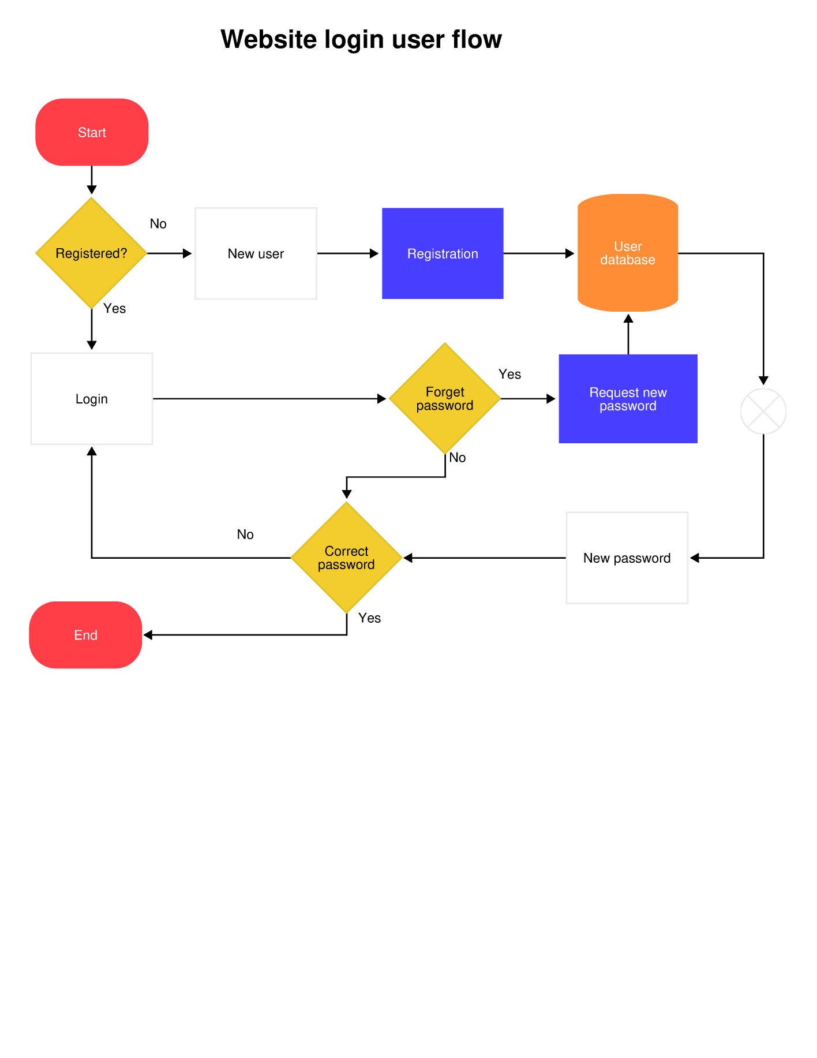

Payment Verification & Recording Flow
- Start.
- Subscriber chooses payment method:
  - Option A: Upload receipt.
  - Option B: Cash payment to administrator.
- If upload receipt:
a. Subscriber uploads image of receipt and enters amount paid, bank name.
b. System stores receipt image and entered details in a temporary verification queue.
c. Administrator reviews queued entries:
  - If receipt image or amount details are invalid, mark as “Rejected” → notify subscriber → end.
  - If valid, mark as “Accepted”.
d. System updates subscriber’s payment history, sets payment status to “Paid”, records date/time of verification.
- If cash payment:
a. Administrator enters payment details manually (subscriber, amount, bank name, date).
b. System updates subscriber’s payment history, sets payment status to “Paid”.
- System generates a document record for the transaction (not a receipt, but document of record).
- System stores transaction in database under subscriber account, updates outstanding balance if any.
- End.
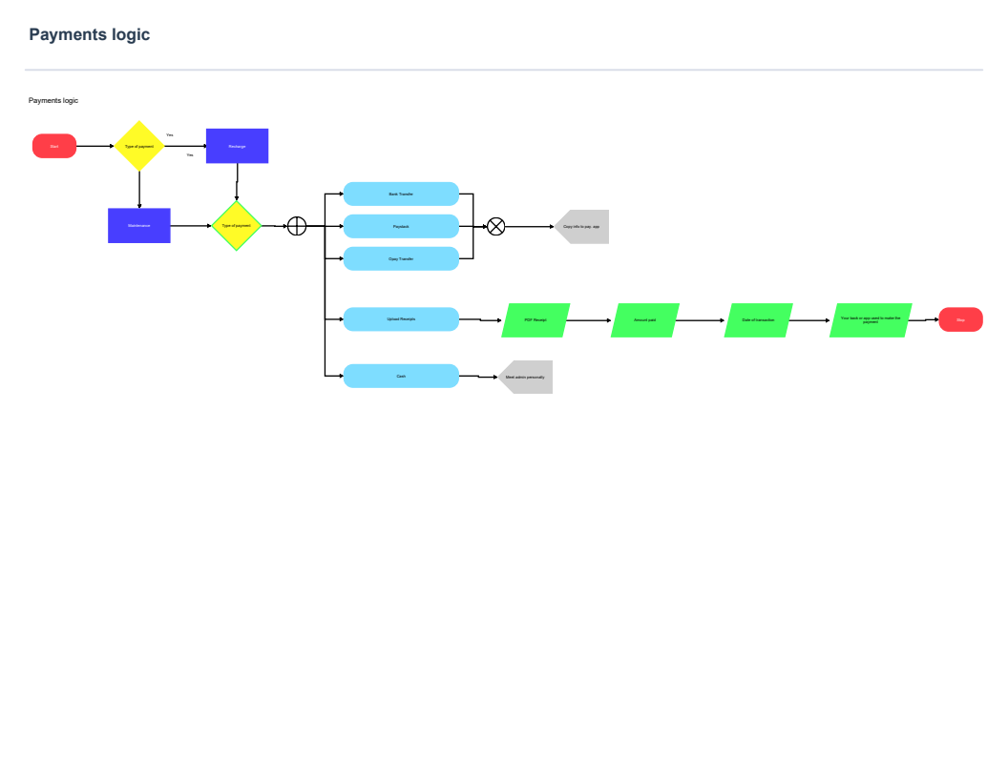
Administrative Functions
- Monitor subscription status
- Generate reports
- Manage user accounts
- Process payment verification

CHAPTER FOUR: IMPLEMENTATION AND EVALUATION

4.1 Program Development
Development Methodology:
The WaterBill NG system was developed using an Agile development approach, allowing for iterative cycles and continuous feedback from stakeholders. This methodology ensured flexibility in addressing changing requirements, rapid identification of issues, and incremental improvements throughout the development process.
Technology Stack:
The system leverages modern and widely-supported technologies to ensure reliability, scalability, and user-friendly interaction:
- Backend: PHP 8.1.3, chosen for its server-side scripting capabilities and seamless integration with MySQL.
- Database: MySQL, used for secure storage and efficient retrieval of user, billing, and payment data.
- Frontend: HTML5, CSS3, and JavaScript, providing a responsive and interactive user interface compatible across devices.
- Payment Gateway: Paystack API, enabling secure and automated online payments.
- OCR Processing: Tesseract OCR, used to extract and validate information from uploaded payment receipts.
- Server Environment: Nginx, ensuring reliable hosting and smooth handling of user requests (infinityfree).
Development Timeline:
The development of WaterBill NG followed a structured phase-based timeline:
- Phase 1 – Requirements Analysis and literature: Gathering user needs, defining system specifications, and designing database schemas and interface layouts – 2 months
- Phase 2 – Core System Development and System Design: Implementing the main modules, including user registration, payment submission, and admin dashboards – 2 months
- Phase 3 - Payment Integration Implementation: Integrating the Paystack API to handle secure online transactions and updating system records automatically 1 - month
- Phase 4 - Testing, Refinement and Evaluation: Conducting unit, integration, and system testing to identify bugs, optimize performance, and ensure usability. – 1 month
- Phase 5 - Deployment Preparation: Finalizing configurations, securing server settings, and preparing the system for public release – 2 weeks.
- Phase 6 - Documentation and presentation: Proper documentation stating all about the system and project scheme – 2 weeks

4.2 System Requirements
To ensure smooth installation and operation of the WaterBill NG system, both software and hardware requirements have been identified. These specifications support optimal performance, security, and user experience.
Software Requirements:
- Operating System: Windows 10 or higher, Linux (Ubuntu 20.04+), or macOS.
- Web Server: Nginx 1.18+ to host the PHP application.
- Backend: PHP 8.1.3 or higher for server-side scripting.
- Database: MySQL 8.0+ for secure data storage and management.
- Web Browser: Google Chrome, Mozilla Firefox, or Microsoft Edge (latest versions) for client access.
- Payment Integration: Paystack API for secure online payments.
- OCR Software: Tesseract OCR for receipt data extraction.
- Code Editor / IDE: VS Code, Sublime Text, or PHPStorm for development and maintenance.
Hardware Requirements:
- Processor: Minimum Intel Core i3 or equivalent; recommended Intel Core i5 or higher.
- RAM: Minimum 4 GB; recommended 8 GB or higher for smooth multitasking and server operations.
- Storage: Minimum 50 GB free disk space for the application, database, and user-generated files.
- Network: Reliable internet connection for payment processing, system updates, and client-server communication.
- Optional: External backup storage (HDD or SSD) for database and file backup.

4.3 System Interface
The WaterBill NG system provides a user-friendly interface for both general users and administrators. It is designed for clarity, simplicity, and ease of navigation. Key components include:
1. Login Forms:
- Secure login page for users and admins.
- Input fields for username/email and password.
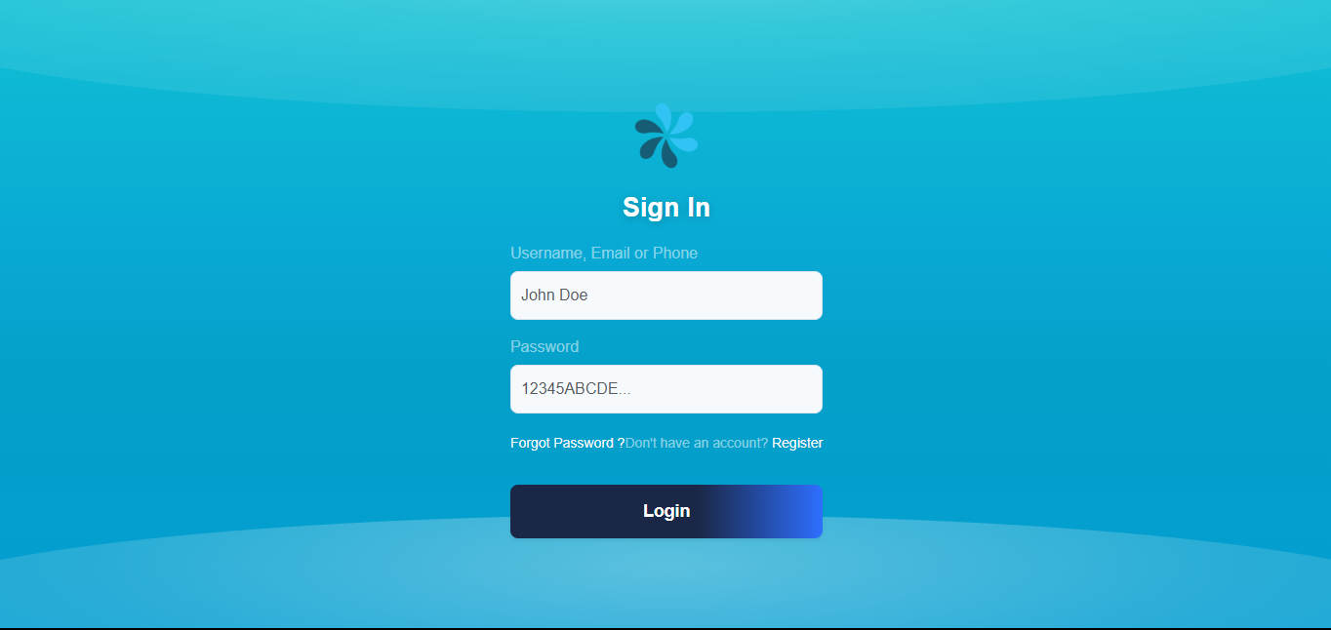
- Option for password recovery.

2. User
Dashboard:
- Displays user account information, payment history, and bill details.
- Provides options to upload payment receipts and view confirmation statuses.
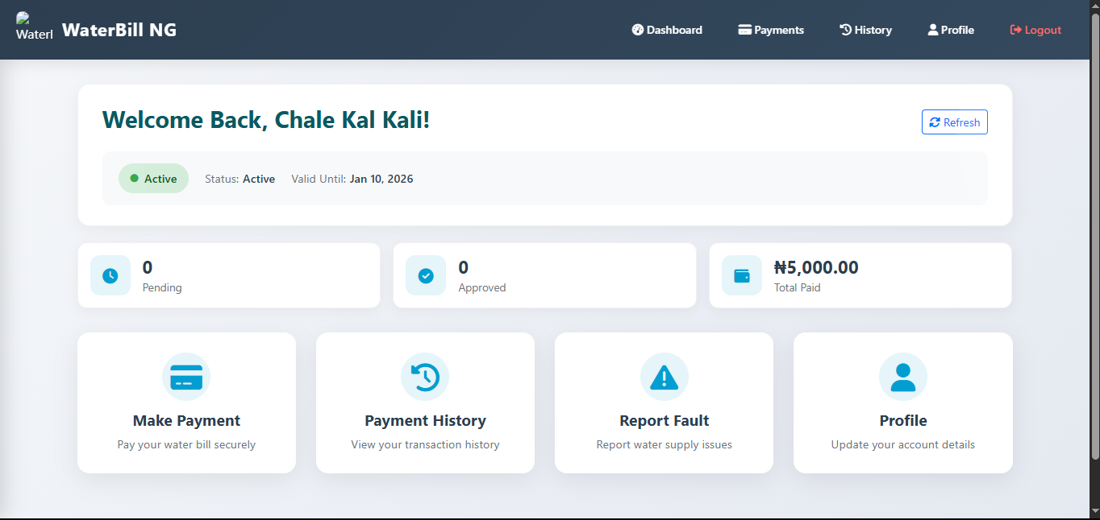
- Interactive elements for filtering or exporting records.

3. Admin Section:
- Access-controlled admin panel for managing users, payments, and system settings.
- Features for approving or rejecting uploaded receipts, generating reports, and exporting data.
- Summary panels with charts or tables for quick insights.

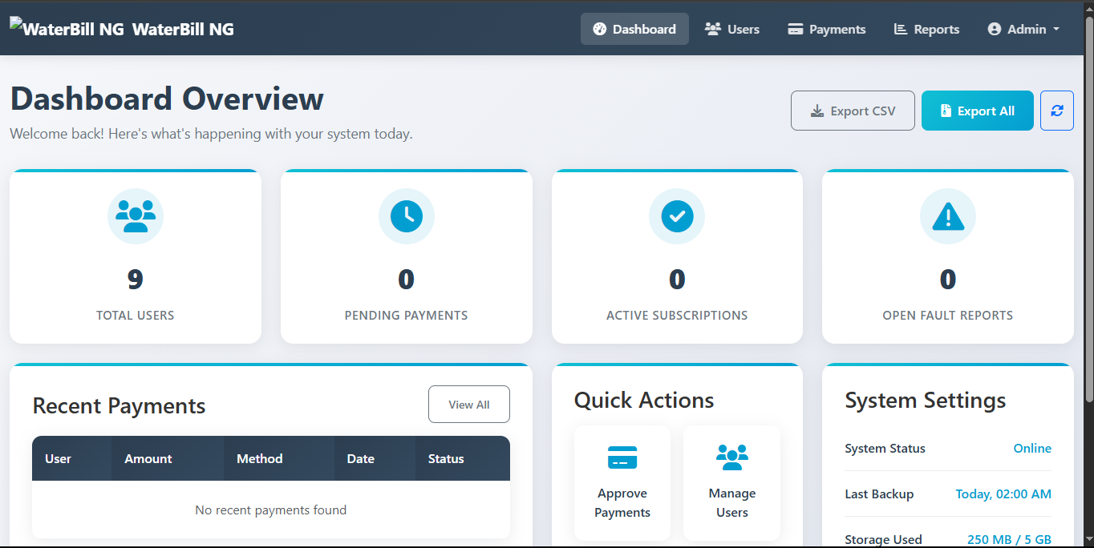
4.

Navigation and Interaction:
- Responsive menu for easy movement between pages.
- Buttons and forms designed with consistent styling for clarity.
- Visual feedback on actions (e.g., confirmation messages, error alerts).
Summary:
The system interface prioritizes usability, ensuring that users can efficiently complete tasks like bill payment and receipt submission, while administrators can monitor and manage operations effectively.

4.4 System Testing and Performance
To ensure that the WaterBill NG system operates efficiently, reliably, and securely, comprehensive testing was carried out at various stages of development. The testing strategy focused on identifying bugs, verifying functionality, and evaluating overall system performance.
1. Unit Testing:
- Individual modules such as user registration, login, payment processing, and receipt verification were tested independently.
- Each function was validated to ensure it performs the intended task correctly.
- Errors or exceptions were documented and resolved promptly.
2. Integration Testing:
- Combined modules were tested to ensure seamless interaction between components.
- For example, after a user uploads a receipt, the system correctly processes the OCR data, updates the payment status, and reflects it on the user dashboard.
- Payment gateway integration with Paystack API was tested for successful and failed transactions.
3. System Testing:
- The entire system was tested in a simulated environment.
- Verified end-to-end workflows, including user registration, bill submission, receipt approval, and admin reporting.
- Checked system behavior under normal and peak load conditions.
4. User Acceptance Testing (UAT):
- Real users were engaged to test the system based on typical scenarios.
- Feedback was collected on usability, interface clarity, and system responsiveness.
- Necessary adjustments were implemented to improve the user experience.
5. Performance Testing:
- Response times for key actions such as logging in, uploading receipts, and viewing payment history were measured.
- The system was optimized to handle concurrent users efficiently without significant delays.
- Database queries were optimized to reduce load time and improve data retrieval speed.

4.5 System Training

Although system training for WaterBill NG has not been fully conducted yet, a comprehensive training plan has been prepared to ensure that both end-users and system administrators can use the system effectively.
Training Objectives:
- Familiarize users with the system interface and features.
- Ensure administrators understand how to approve payments, generate reports, and manage user accounts.
- Minimize errors during receipt submission and payment processing.
- Provide guidance for troubleshooting common issues.
Planned Training Activities:
- User Training:
  - Demonstrations on logging in, uploading payment receipts, and viewing payment history.
  - Step-by-step guidance on handling failed transactions or errors.
- Administrator Training:
  - Instructions on managing user accounts, approving/rejecting payments, and exporting reports.
  - Overview of security protocols and data management best practices.
Training Materials:
- User manuals with screenshots and instructions.
- Quick reference guides for common tasks.
- Video tutorials demonstrating key system functions.
Future Steps:
- Conduct live or virtual training sessions once the system is deployed.
- Collect feedback from trainees to refine training materials.
- Provide ongoing support through helpdesk or support channels.

4.6 Conversion to Proposed System
The transition from a manual water billing system to the WaterBill NG digital platform involves careful planning to ensure data integrity, minimal disruption, and smooth adoption by users and administrators.
1. Current Manual System:
- Records of water consumption and payments are maintained using physical ledgers or spreadsheets.
- Payment tracking relies on paper receipts, which can be lost or mismanaged.
- Administrators manually calculate bills, verify payments, and generate reports, leading to potential errors and delays.
2. Proposed Digital System:
- Automated recording of user accounts, water bills, and payments.
- Digital receipt uploads with OCR processing for quick verification.
- Admin dashboards for monitoring, approving payments, and exporting data.
- Enhanced reporting tools for better decision-making and transparency.
3. Conversion Process:
- System Configuration: User accounts, bill templates, and admin privileges will be set up in the new system.
- Parallel Run: For a short period, both manual and digital systems may operate simultaneously to verify accuracy and allow users to adjust.
- Full Adoption: Once confidence in the system is established, the manual process will be completely phased out.

4. Advantages of Conversion:
- Reduces errors associated with manual calculations and record-keeping.
- Improves payment tracking and reporting efficiency.
- Allows faster verification of uploaded receipts through OCR.
- Provides convenient access for users to view payment history and make online payments.
- Enhances administrative oversight with real-time dashboards and exportable reports.

4.7 System Documentation
System documentation for WaterBill NG provides a structured and detailed description of the system’s internal workings, code structure, and operational guidelines. It is intended to support developers, maintainers, and future enhancements.
1. Internal Code Documentation:
- Comments and Annotations: All PHP, JavaScript, and CSS files include descriptive comments explaining the purpose of functions, classes, variables, and major logic blocks.
- Function and Module Descriptions: Each function or module specifies its input parameters, expected output, and role within the system.
- Coding Standards: Consistent naming conventions, indentation, and modular coding practices were followed to enhance readability and maintainability.
2. Database Documentation:
- Schema Description: All tables, fields, relationships, and constraints are documented.
- ER Diagrams: Entity-Relationship diagrams provide a visual representation of the database structure.
- Data Flow Notes: Documentation details how data moves between modules, the database, and external services like the Paystack API and OCR module.
3. User and Administrator Guides:
- User Manual: Explains how to log in, upload receipts, view payment history, and interact with system features.
- Admin Manual: Provides step-by-step instructions for managing users, approving payments, generating reports, and exporting data.
- Troubleshooting Guide: Common issues and their resolutions are documented to assist users and admins in resolving minor problems independently.
4. Maintenance and Update Guidelines:
- Guidelines are provided for future developers to safely modify or extend the system.
- Instructions include updating database schemas, integrating additional features, or upgrading APIs without disrupting existing functionality.

4.8 System Maintenance
System maintenance ensures that WaterBill NG remains reliable, secure, and up-to-date throughout its operational lifecycle. Maintenance activities focus on detecting and correcting issues, improving performance, and implementing new features as needed.
1. Routine Maintenance:
- Database Management: Regular backups of user and payment data to prevent data loss.
- Server Health Checks: Monitoring server performance, storage, and uptime to ensure uninterrupted service.
- Log Monitoring: Reviewing system logs to identify errors, failed transactions, or unusual activity.
- Security Updates: Applying patches to the server, PHP, and other system components to prevent vulnerabilities.

2. Version Control and Updates:
- Code Management: All source code is maintained under a version control system (e.g., Git), enabling tracking of changes, rollback to previous versions, and collaborative development.
- Scheduled Updates: New features, bug fixes, and performance enhancements are deployed in controlled updates to minimize disruption.
- Change Documentation: All updates and modifications are documented, including the nature of changes, date, and responsible developer.
3. User Support and Feedback:
- Issue Reporting: Users and administrators can report bugs or system issues, which are logged for prompt resolution.
- Continuous Improvement: Feedback is analyzed to identify areas for improvement in functionality, usability, or performance.
4. Future Maintenance Plans:
- Periodic performance testing to ensure the system can handle increasing user loads.
- Integration of new technologies or APIs as needed.
- Long-term scalability planning to accommodate future expansion.
Summary:
Regular system maintenance and robust version control ensure that WaterBill NG continues to operate efficiently, securely, and reliably, while also allowing the system to adapt to future needs and technological advancements.

CHAPTER FIVE: SUMMARY, RECOMMENDATIONS AND CONCLUSION

5.1 Summary
WaterBill NG is a comprehensive digital solution designed to automate water billing and payment processes for communities, replacing the traditional manual system. By integrating features such as online receipt uploads, OCR-based payment verification, and an admin dashboard, the system significantly reduces human errors, improves accuracy, and streamlines operations.
The platform provides a user-friendly interface for residents to view bills, make payments, and track their payment history, while administrators benefit from efficient monitoring, quick payment approvals, and robust reporting tools.
Through its development, testing, and proposed implementation, WaterBill NG demonstrates the potential to:
- Increase transparency in billing and payment processes.
- Enhance data security and reliability.
- Reduce administrative workload and improve service delivery.
- Enable scalability for future expansion or integration with other community services.
Overall, WaterBill NG represents a modern, efficient, and sustainable approach to community water management, aligning technological innovation with practical service needs.

5.2 Recommendations
To further enhance the effectiveness and capabilities of WaterBill NG, the following recommendations are proposed for future development:
1. IoT Sensor Integration:
- Implement smart water meters connected to the system to automatically record consumption in real-time.
- Reduce reliance on manual readings and improve billing accuracy.
- Enable predictive maintenance by monitoring water usage patterns and detecting leaks.
2. Advanced Analytics and Reporting:
- Incorporate data analytics tools to generate detailed insights on consumption trends, peak usage times, and payment behaviors.
- Enable administrators to make data-driven decisions for resource allocation and community planning.
- Implement dashboards with visual analytics for easy interpretation of key metrics.
3. Mobile Application Development:
- Develop a mobile app version of WaterBill NG to improve accessibility for users.
- Provide push notifications for bill reminders, payment confirmations, and system updates.
4. Enhanced Security Measures:
- Integrate two-factor authentication and stronger encryption for user accounts and payment data.
- Regularly update security protocols to guard against emerging cyber threats.
5. Scalability and Integration:
- Design the system to support larger communities or multiple regions without performance degradation.
- Allow integration with other utility management systems or municipal services for a unified digital platform.

5.3 Conclusion
The WaterBill NG project successfully developed a functional prototype of a digital water billing system that addresses the inefficiencies and limitations of manual processes. The system demonstrates the feasibility of automating bill management, payment tracking, and receipt verification within a community context.
Through careful system design, development, and testing, the project achieved the following:
- Developed a user-friendly interface for residents to view bills, upload receipts, and monitor payment history.
- Implemented an admin dashboard for efficient management, approval of payments, and report generation.
- Integrated secure online payment processing via Paystack and automated receipt validation using OCR technology.
- Ensured system reliability and maintainability through internal code documentation, version control, and planned maintenance procedures.
The project also highlighted the potential for future enhancements, such as IoT integration, advanced analytics, mobile application development, and enhanced security, which can further transform community water management.
Overall, WaterBill NG represents a modern, scalable, and sustainable approach to water billing, improving efficiency, transparency, and user satisfaction, and serves as a foundation for further digital innovations in utility management.

REFERENCES
Adewale, T. (2022). Digital adoption in rural water systems. Lagos: TechWorks Press.
Cosgrove, C. (2023). Water Utilities Management: A UX Case Study. Retrieved from https://carriecosgrove.com
Oluwole, F., & Hassan, R. (2021). Web-based billing systems in developing regions. Journal of Applied Computing, 15(4), 122–130.
World Bank. (2020). Water Management and Technology in Sub-Saharan Africa. Washington, DC: World Bank Publications.

