**1.Create web pages using Basic HTML Tags, Table, List, Image, and Frame Tags.**

**Character formatting:**

<html>

<head>

<title>Character tags</title>

</head>

<body bgcolor="blue">

<b>bold face</b><br><br>

<i>italic tag</i><br><br>

<u>underline tag</u><br><br>

<big>Big tag</big><br><br>

<small>Small tag</small><br><br>

<strong>Strong tag</strong><br><br>

<sub>Qualification</sub><br><br>

<sup>x 2</sup><br><br>

</body>

</html>

**Output:**

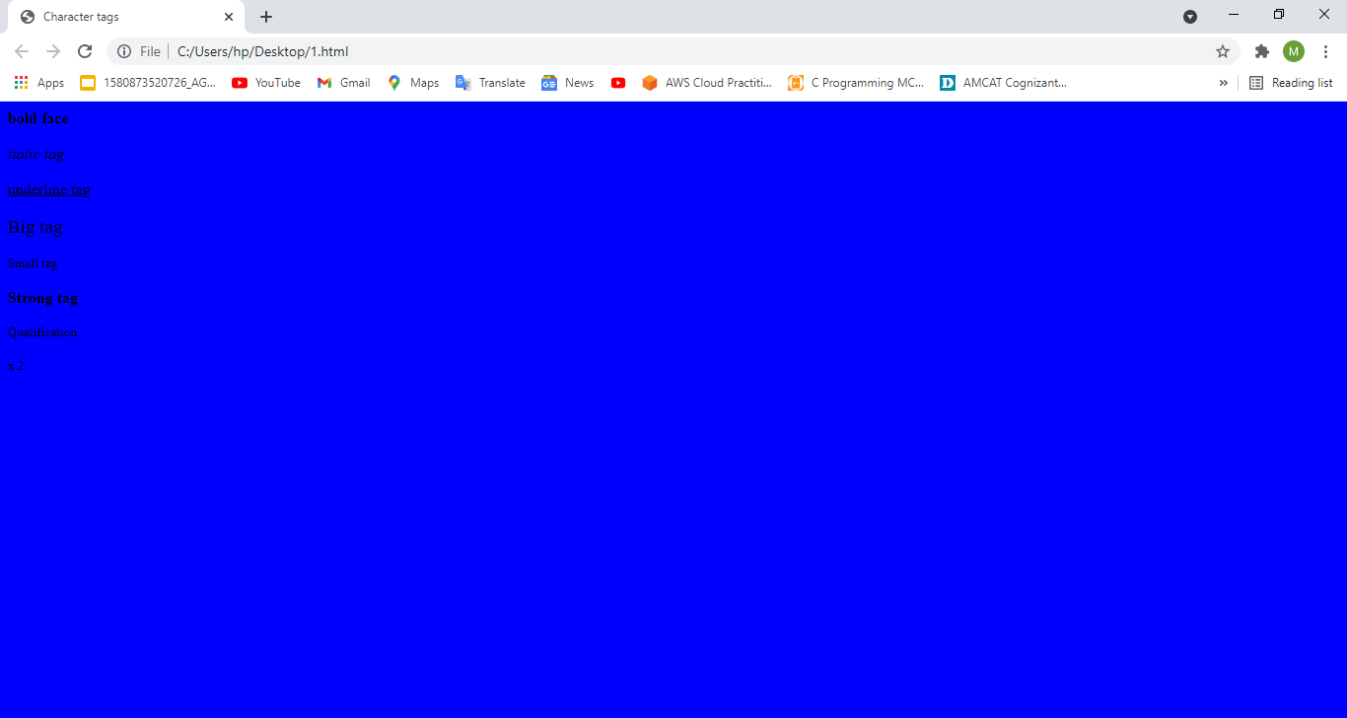

**Block Formatting:**

<html>

<head>

<title>Bold Formatting</title>

</head>

<body bgcolor="blue"><br>

<p align="center">This is formatting</p>

<h1 align="left">This is h1</h1>

<h2 align="right">This is h2</h2>

<h3 align="center">This is h3</h3>

<h4>This is h4</h4>

<h5>This is h5</h5>

<h6 align="left">This is h6</h6>

<p>this is hr</p>

<hr align="center" size="10"/>

<basefont size="50">this is web</basefont>

<tt>Mounika</tt><br>

<PRE>this is aditya</PRE>

<marquee align="right">hi Challa</marquee>

<font face="Blackadder ITC" size="20" color="pink">This is wt lab</font>

</body>

</html>

**Output:**

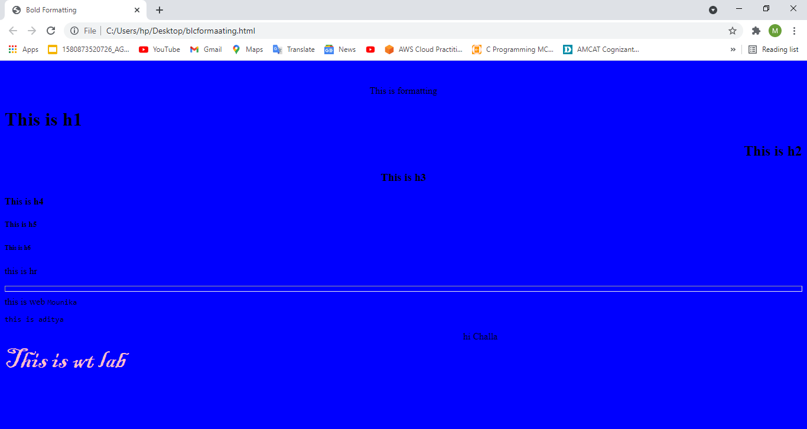

**Lists:**

**Ordered list:**

<html>

<head>

<title>Ordered lists</title>

</head>

<body>

<h4>Microsoft packages</h4>

<ol type="1">

<li>Wordpad

<li>PowerPoint

<li>Ms-Excel

</ol>

<h4>Lists</h4>

<ol type="A" start=25>

<li>ordered list

<li>unordered list

<li>nested list

</ol>

<h4>Scripting language</h4>

<ol type="I" start=4>

<li>java Script

<li>jscript

</ol>

<h4>Database application</h4>

<ol type="i" start=5>

<li>SQL

<li>Mysql

<li>Oracle

</ol>

</body>

</html>

**Output:**

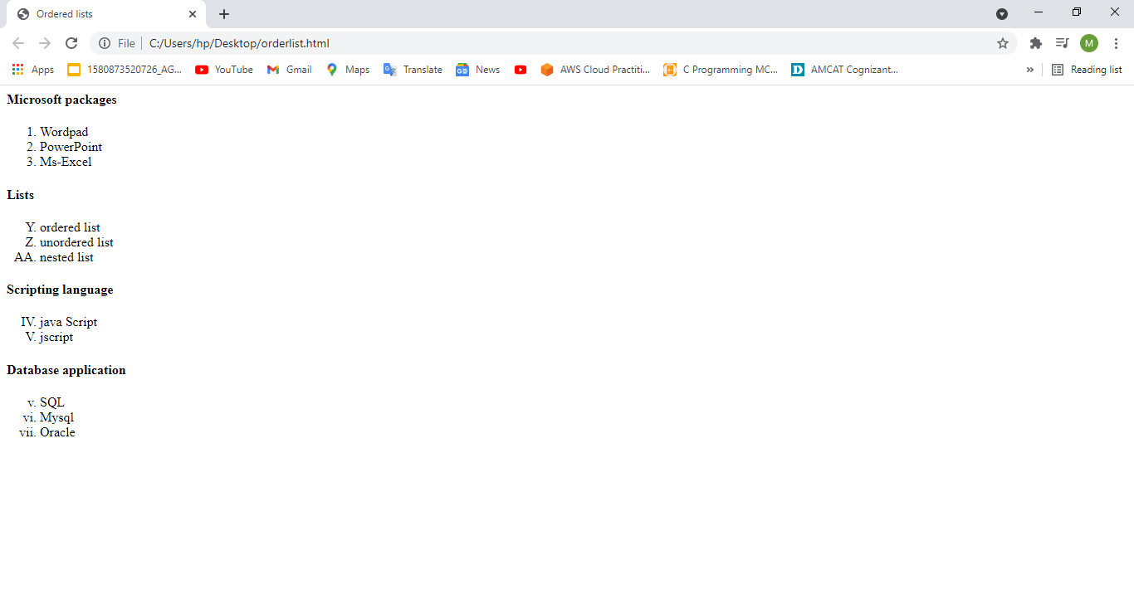

**Unordered List:**

<html>

<head>

<title>UnOrdered lists</title>

</head>

<body>

<h4>Microsoft packages</h4>

<ul>

<li>Wordpad

<li>PowerPoint

<li>Ms-Excel

</ul>

<h4>Lists</h4>

<ul type="square">

<li>ordered list

<li>unordered list

<li>nested list

</ul>

<h4>Scripting language</h4>

<ul type="disc">

<li>java Script

<li>jscript

</ul>

<h4>Database application</h4>

<ul type="circle">

<li>SQL

<li>Mysql

<li>Oracel

</ul>

</body>

</html>

**Output:**

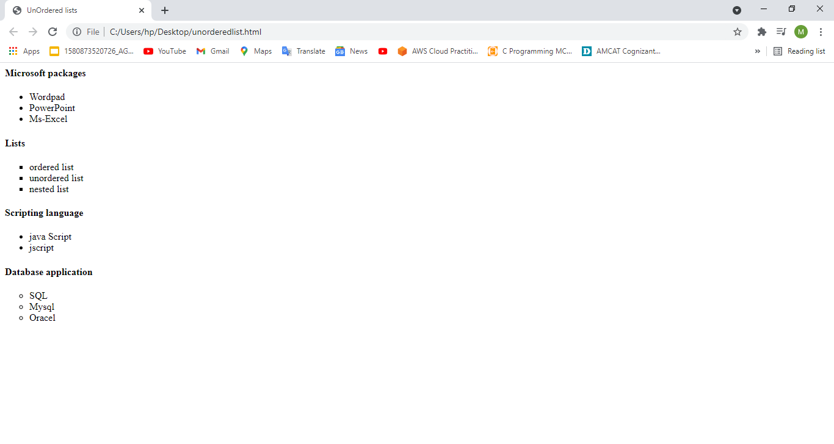

**Image:**

<html>

<head>

<title>Bold Formatting</title>

</head>

<body bgcolor="pink"><br>

<p align="center">This is formatting</p>

<h1 align="left">This is h1</h1>

<h2 align="right">This is h2</h2>

<h3 align="center">This is h3</h3>

<h4>This is h4</h4>

<h5>This is h5</h5>

<h6 align="left">This is h6</h6>

<p>this is hr</p>

<hr align="center" size="10"/>

<basefont size="5">this is web</basefont>

<tt>Mounika</tt><br>

<PRE>this is aditya</PRE>

<marquee align="right">hi challa</marquee>

<font face="Blackadder ITC" size="5" color="Green">This is wt lab</font>

<center><img src="C:\Users\hp\Desktop\btsimage.jpg" border=5 alt="Welcome" height=150 width=150>

</center></body>

</html>

**Output:**

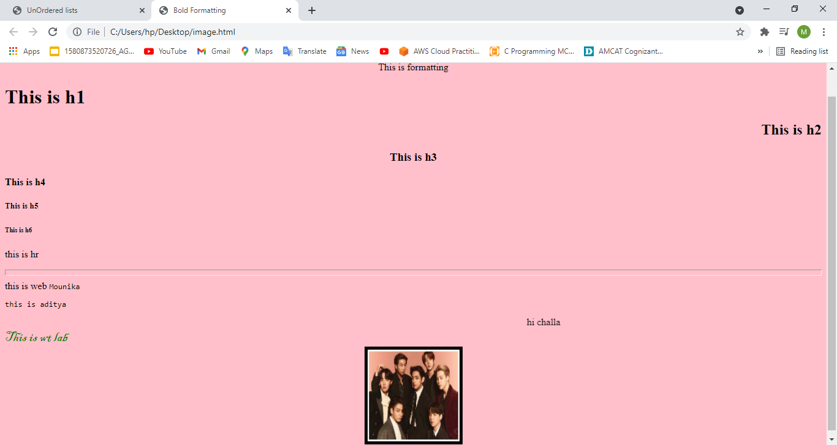

**Table:**

<html>

<head>

<title>table page</title>

</head>

<body bgcolor="pink">

<table align="left" cellpadding="2" cellspacing="2" border="3" bgcolor="cyan"> <tr>

<th colspan="4">Sample Table</th>

</tr>

<tr>

<th>HEAD1</th>

<td rowspan="3">CELL2</td>

<th>HEAD3</th>

<th>HEAD4</th>

<tr>

<td>CELL1</td>

<td>CELL3</td><td>CELL4</td>

</tr>

<tr>

<td>CELL5</td>

<td colspan="2" align="center">CELL6</td>

</tr>

</table>

</body>

</html>

**Output:**

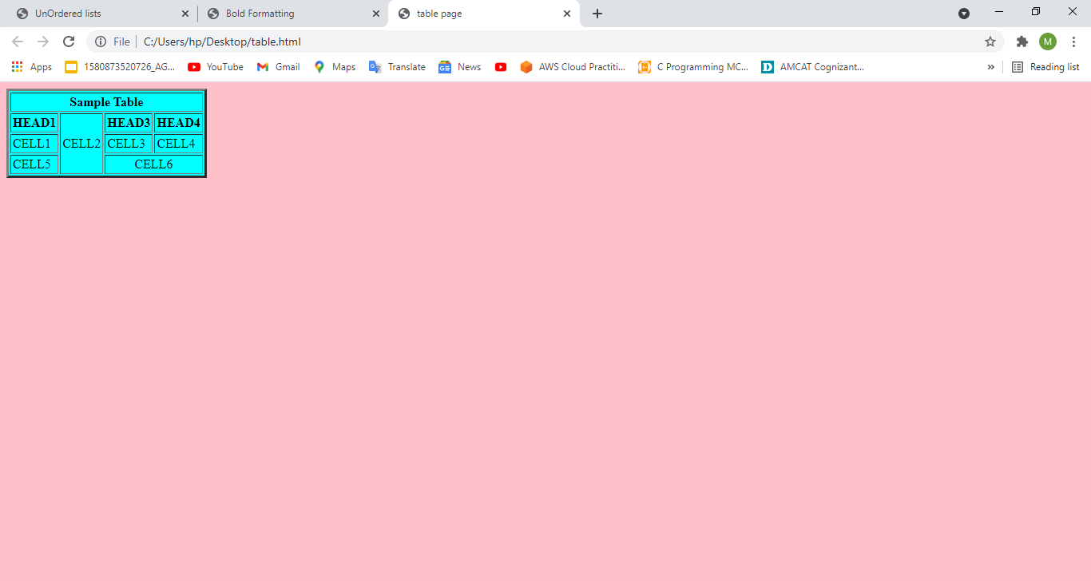

**Frame:**

**First.html**

<html>

<body bgcolor="pink">

<font size=5> <p>This is first frame</p> </font>

</body>

</html>

**Second.html**

<html>

<body bgcolor="pink">

<font size=5> <p>This is second frame</p> </font>

</body>

</html>

**Frame.html**

<frameset cols="45%,55%">

<frame name="fr1" src="first.html" noresize scrolling="yes">

<frame name="fr2" src="second.html" noresize scrolling="yes">

</frameset>

**Output:**

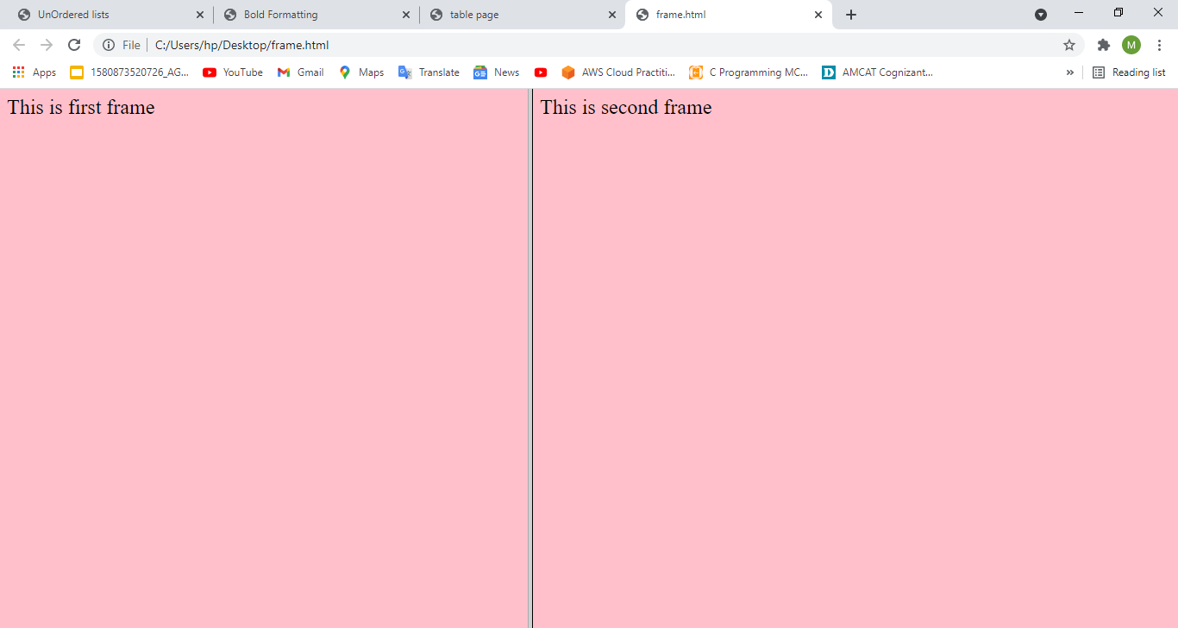

**2)First.html**

<html>

<body bgcolor="pink">

<font size=5> <p>This is first frame</p> </font>

</body>

</html>

**Second.html**

<html>

<body bgcolor="pink">

<font size=5> <p>This is second frame</p> </font>

</body>

</html>

**Third.html**

<html>

<body bgcolor="pink">

<font size=5> <p>This is third frame</p> </font>

</body>

</html>

**Link.html**

<html>

<body bgcolor="cyan">

<font size=5 color="green">

<a href="first.html" target="first">first frame</a></br>

<a href="second.html" target="second">second frame</a></br>

<a href="third.html" target="third">third frame</a>

</font></body></html>

**Frame.html**

<frameset cols="45%,*">

 <frame name="fr1" src="link.html" noresize>

<frameset rows=25%,45%,*>

 <frame name="first" noresize>

 <frame name="second" noresize>

 <frame name="third" noresize>

</frameset>

</frameset>

**Output:**

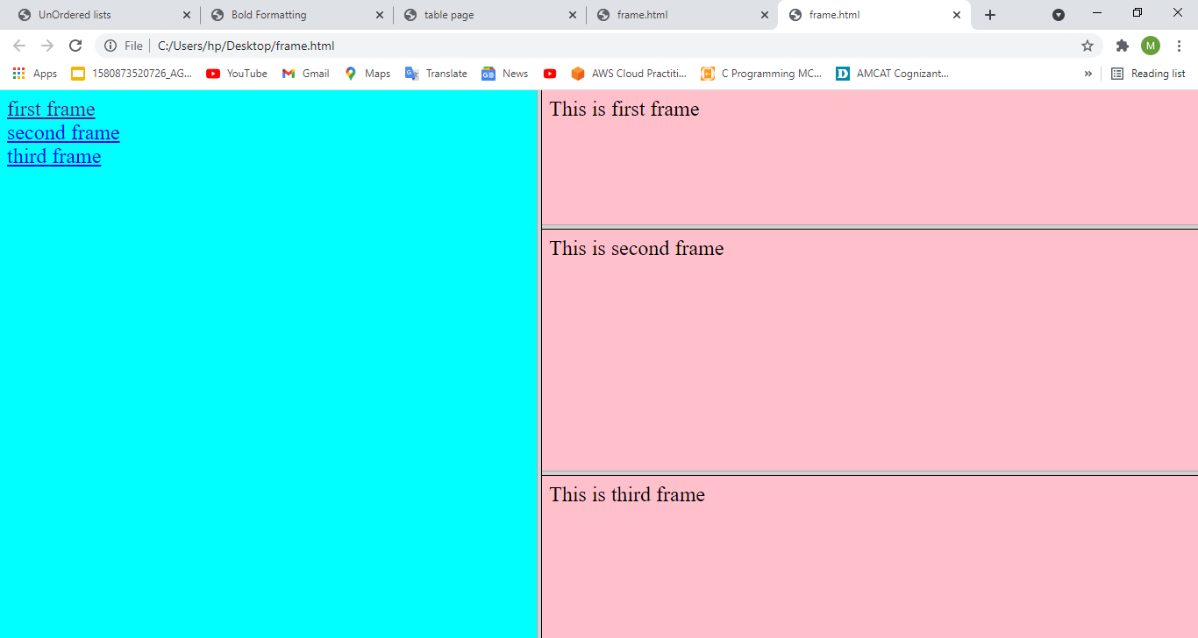

**2) Using Form Tags**

**2.1)Create a Login form**

<html>

<head><title>Login Page</title>

</head>

<body bgcolor="pink">

<form action="validate.php" method="post">

<table align="center">

<tr><td>Login</td><td><input type="text" name="login" size="20" maxlength="20"  value=""></td></tr>

<tr><td>Password</td><td><input type="password"name="pwd" size="20"  maxlength="20"></td></tr>

<tr valign="middle"><td><input type="submit" value="submit"></td>

<td><input type="reset"></td></tr>

</table>

</form>

</body>

</html>

**Output:**

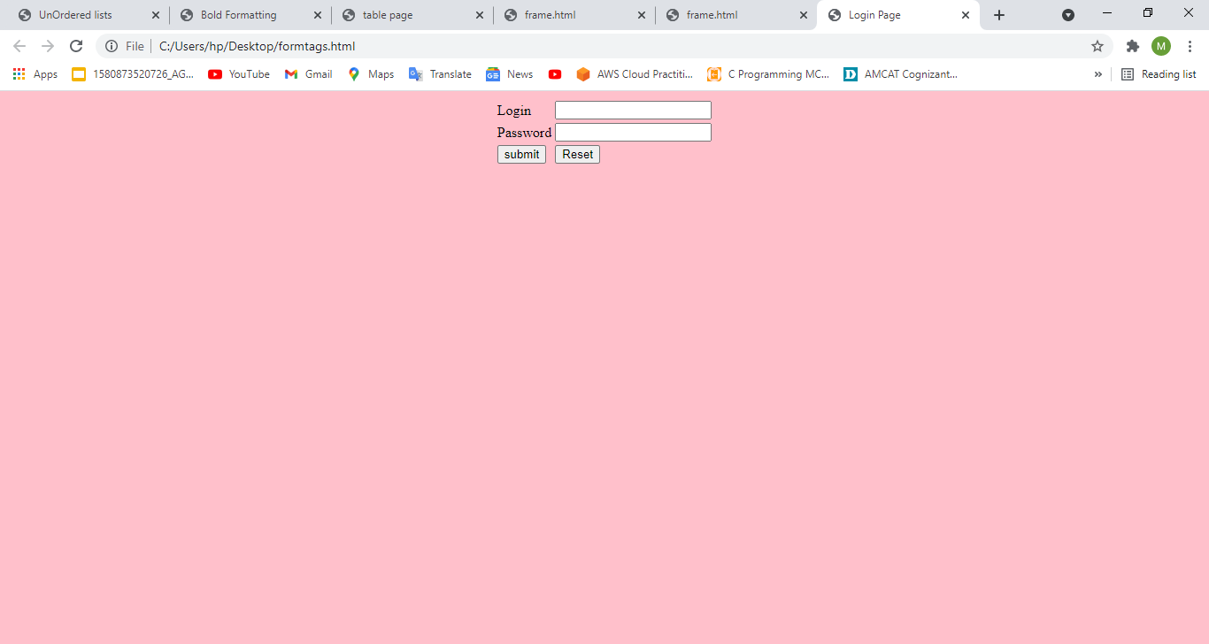

**2..2)Create a “registration form” with the following fields**

**a) Name (Text field) ;b) Password (password field); c) E-mail id (text field); d) Phone number (text field) ;e) Sex (radio button); f) Date of birth (3 select boxes); g) Languages known (check boxes – English, Telugu, Hindi, Tamil) ;h) Address (text area)**

<html>

<head><title>Registration Page</title>

</head>

<body bgcolor="pink">

<center>

<h3 align="center"><u>Registration Form</u></h3>

<table border="3">

<tr>

<td><form name="f1" action="" method="post" onsubmit="">

<table cellspacing="10" cellpadding="5">

<tr><td>Name</td><td><input type="text" name="Name" size="20" maxlength="20" value=""></td></tr>

<tr><td>Password</td><td><input type="password" name="pwd" size="20" maxlength="20"></td></tr>

<tr><td>Email id</td><td><input type="text" name="mail id" size="20" maxlength="20" value=""></td></tr>

<tr><td>Phone Number</td><td><input type="text" name="no" size="20" maxlength="20" value=""></td></tr>

<tr><td>Sex</td><td><input type="radio" name="Gender" value="male">Male <input type="radio" name="Gender" value="female">Female</td></tr> <tr><td>Date of birth</td><td><select>

<option>DD<option>01<option>02<option>03<option>04<option>05<option>06 <option>07<option>08<option>09<option>10<option>11<option>12<option>13 <option>14<option>15<option>16<option>17<option>18<option>19<option>20 <option>21<option>22<option>23<option>24<option>25<option>26<option>27 <option>28<option>29<option>30<option>31</select>

<select>

<option>MM<option>01<option>02<option>03<option>04<option>05<option>06 <option>07<option>08<option>09<option>10<option>11<option>12 </select> <select>

<option>YYYY<option>1999<option>2000<option>2001<option>2003<option>2004 <option>2005 <option>2006<option>2007<option>2008<option>2009<option>2010 <option>2011<option>2012<option>2013<option>2014<option>2015<option>2016

<option>2017 <option>2018<option>2019 <option>2020 <option>2021 </select> <tr><td>Languages Known</td><td><input type="checkbox" name="Language" value="English">English

<input type="checkbox" name="Language" value="Telugu">Telugu <input type="checkbox" name="Language" value="Hindi">Hindi <input type="checkbox" name="Language" value="Tamil">Tamil</td></tr> <tr><td>Address</td><td><textarea name="Address" rows="5" cols=25"></textarea> <tr valign="middle"><td><input type="submit" value="submit"></td>

<td><input type="reset"></td></tr>

</tr>

</table>

</center>

</table>

</form>

</body>

</html>

**Output:**

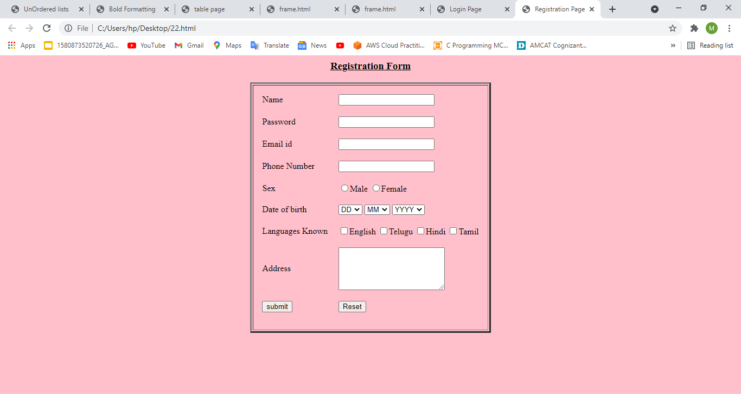

**3) CSS & Java Script**

**3.1) Design a web page using CSS (Cascading Style Sheets) which includes the following: 3.1.1) Use different font, styles: In the style definition you define how each selector should work (font, color etc). Then, in the body of your pages, you refer to these selectors to activate the styles.**

**Style.css**

h1

{

color:red;

font-family:caStellar;font-size:22pt;

text-decoration:underline;

}

h2

{

color:blue;

font-family:Chiller;font-size:18pt;

text-decoration:overline;

}

p

{

color:magenta;

font-family:Trebuchet MS;font-size:14pt;

font-style:italic;

}

**31.html:**

<html>

<head>

<title>Usage of different font,styles and colors</title>

<link rel="stylesheet" type="text/css" href="style.css"/>

</head>

<body>

<h1>This header is in red</h1>

<h2>This header is in blue</h2>

<p>This is normal text</p>

</body>

</html>

**Output:**

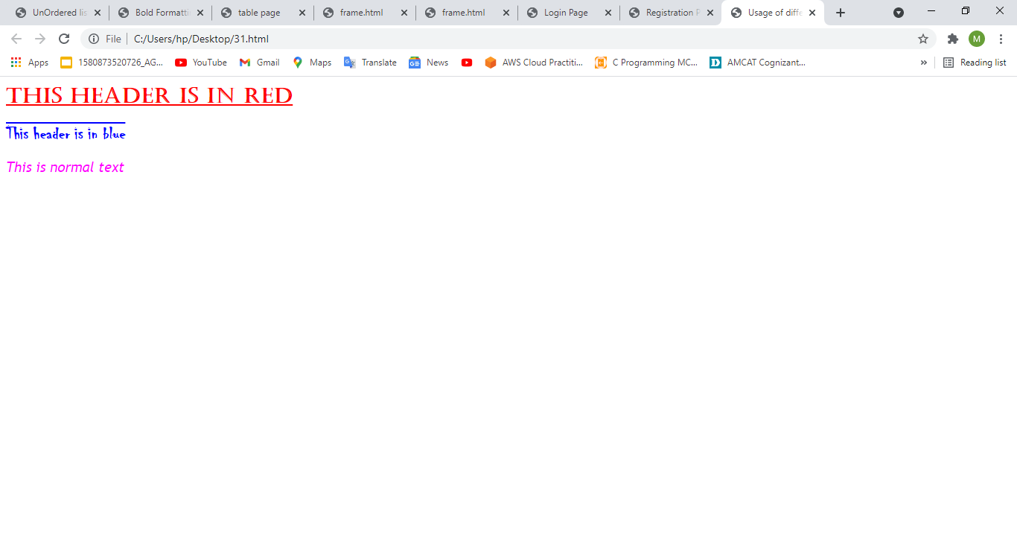

**3.1.2) Set a background image for the web page and control the repetition of the image with the  background-repeat property**

<html>

<head>

<title>Controlling background image</title>

<style type="text/css">

body

{

background-image:url("life.jpg");

background-repeat:no-repeat

}

</style>

</head>

<body text="#fe78a2">

<h1>Life is beautiful!!!</h1>

</body>

</html>

**Output:**

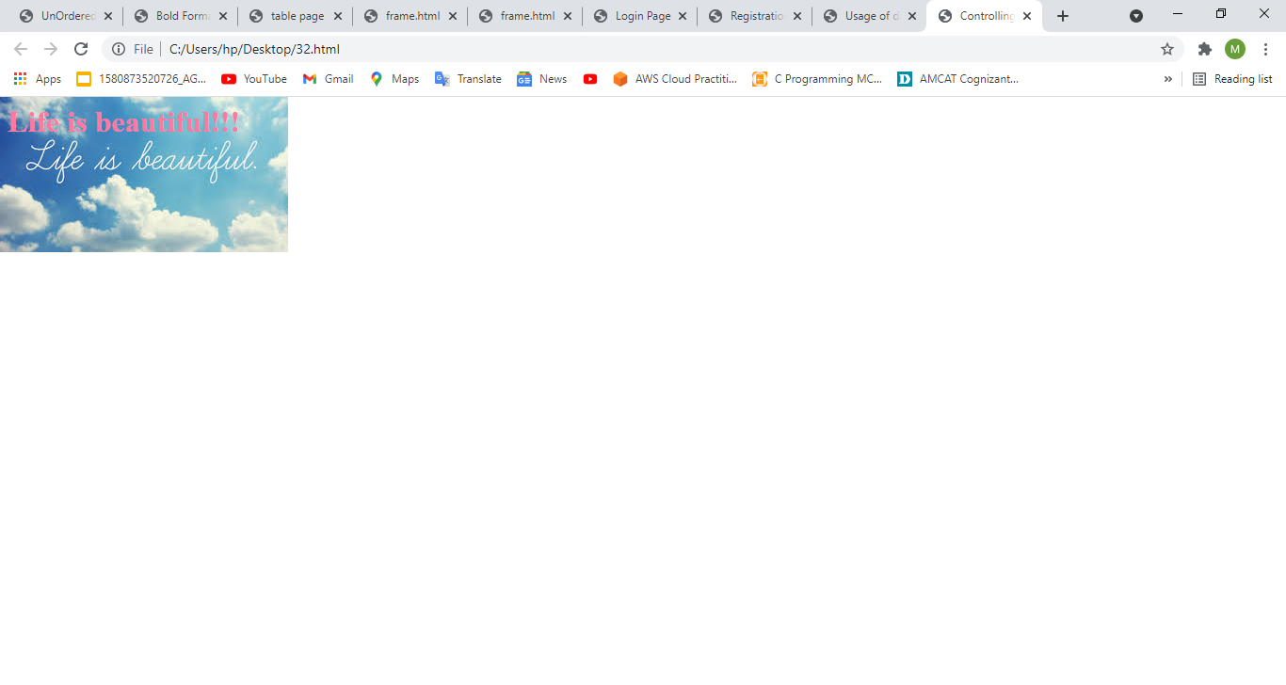

**3.1.3) Define styles for link as visited, active, hover & link.**

<html>

<head><h1 align="center">Web Page using CSS</h1>

<style type="text/css">

body{background-image:url(btsimage.jpg);background-repeat:repeat-y;}

p{color:yellow;font-size:20pt;font-family:chiller;background-image:url(life.jpg);} a:link{font-size:20pt;background-color:white;}

a:hover{font-size:20pt;background-color:pink;cursor:crosshair;}

a:active{font-size:20pt;background-color:cyan;cursor:help;}

a:visited{font-size:20pt;background-color:tan;}

</style></head>

<title>CSS Webpage!!!</title>

<body><br>

<p>Welcome to Web page using CSS where CSS means Cascading Style Sheets! Using CSS we can apply the common styles to different tags and

also different styles to same tag ie repeated more than once in the html file</p> <a href="registration.html"><center>Register</center></a>

<br><br><br><br><br><br><br><br><br>

</body></html>

**Output:**

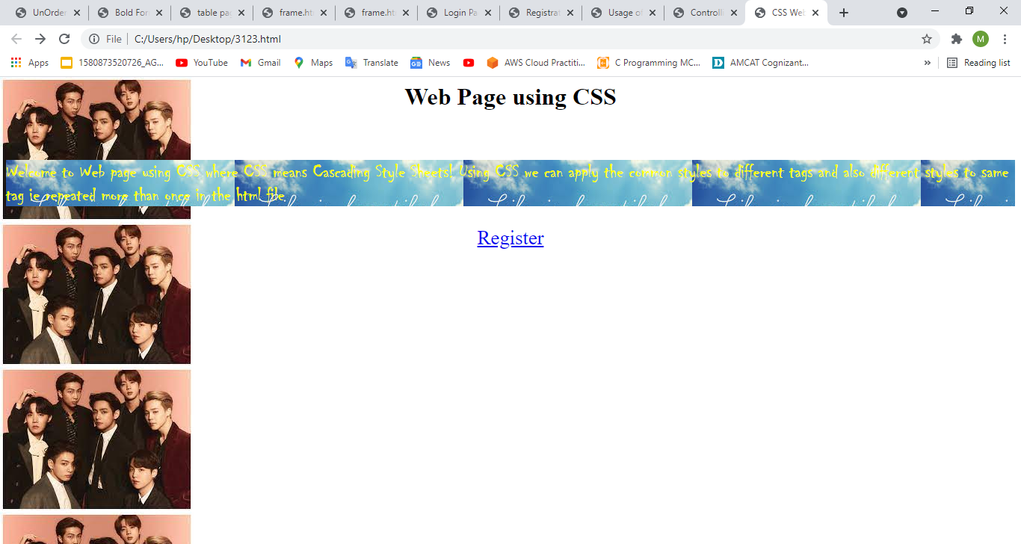

**3.2) Write a JavaScript that takes a number from one text field in the range of 0-999 and display it  in other text field in words. If the number is out of range, it should show “out of range” and if it is not  a number, it should show “not a number” message in the result box.**

<script language="javascript">

function convert_number_to_words(number)

{

hyphen='-';

conjunction='and';

separator='.';

dictionary={0:'zero',1:'one',2:'two',3:'three',4:'four',5:'five',6:'six',7:'seven',8:'eight', 9:'nine',10:'ten',11:'eleven',12:'twelve',13:'thirteen',14:'fourteen',15:'fifteen',16:'sixteen', 17:'seventeen',18:'eighteen',19:'nineteen',20:'twenty',30:'thirty',40:'fourty',50:'fifty', 60:'sixty',70:'seventy',80:'eighty',90:'ninety',100:'hundred',};

if(number<0 || number>999)

{

alert("enter a number range between 0 and 999");

return "";

}

switch(true)

{

case(number<21):

string=dictionary[number];

break;

case(number<100):

tens=parseInt(number/10)*10;

units=number%10;

string=dictionary[tens];

if(units){

string+=hyphen+dictionary[units];

}

break;

case(number<1000):

hundreds=parseInt(number/100);

remainder=number%100;

string=dictionary[hundreds]+ ' ' +dictionary[100];

if(remainder){

string+=conjunction+convert_number_to_words(remainder);

}

break;

default:

break;

}

return string;

}

a=prompt("Enter a number");

num=parseInt(a);

document.write(convert_number_to_words(num));

</script>

**Output:**

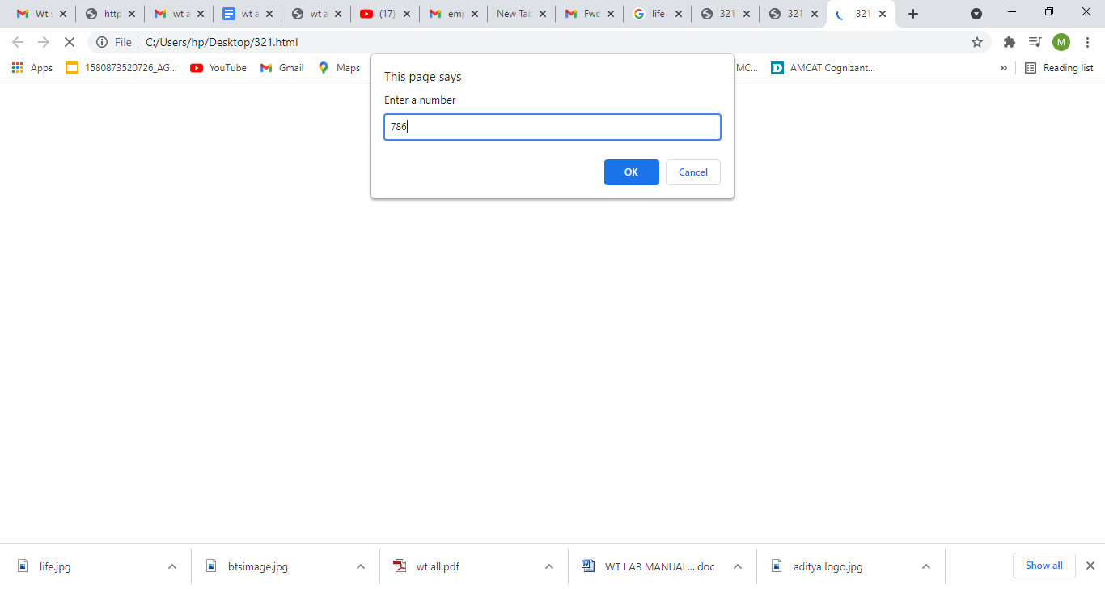

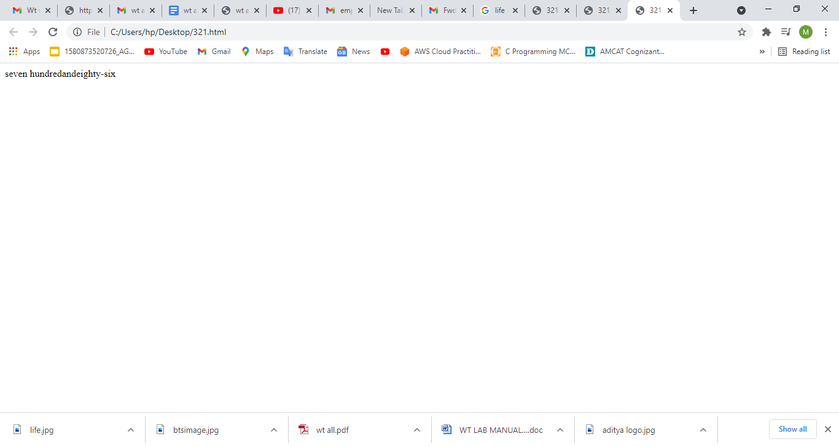

**4) Java Script & XML**

**4.1) Write a JavaScript to validate the following fields in a registration page created in week 2**

**a. Name (start with alphabet and followed by alphanumeric and the lengthshould not be less  than 6 characters)**

**b. Password (it allows alphanumeric, special symbols and should not be less than 6 characters) c. E-mail (should not contain invalid email addresses)**

<html>

<head><h1 align=center>Welcome to Validation

Checking</h1><hr width=50%>

<script language="javascript">

function validation()

{

var x=f.un.value;var len=x.length;

var val=x.charCodeAt(0); var p=f.pw.value;

var c=f.cpw.value;var a=f.email.value;

var atpos=a.indexOf("@");var dotpos=a.lastIndexOf(".");

if(len<6||x==""||x==null)

{

alert("check your username! must be minimum 6 characters");

}

else if(val<65 || val>90&&val<97 || val>122)

{

alert("username must be begin with an alphabet");

return fasle;

}

else if(p==" || c==" || p.length<6 || c.length<6 || p!=c)

{

alert("password and confirm password should be same and greater than 6 characters!"); return false;

}

else if(atpos<6 || dotpos<atpos+6 || dotpos+2>=a.length)

{

alert("Not a Valid email id");

return false;

}

else

alert("Congratulations!you have submitted successfully");

}

</script>

</head>

<body>

<table align=center border=I>

<form name="f" action="success.html" onsubmit="return validation();" method="post"> <tr><td>User Name:</td>

<td><input type="text" name="un"/></td></tr>

<tr><td>Password:</td>

<td><input type="password" name="pw"/></td></tr>

<tr><td>Confirm Password:</td>

<td><input type="password" name="cpw"/></td></tr>

<tr><td>E-mail ID:</td>

<td><input type="text" name="email"/></td></tr>

<tr><td></td>

<td><input type="Submit" name="Submit"/></td></tr>

</form></table></body></html>

**Output:**

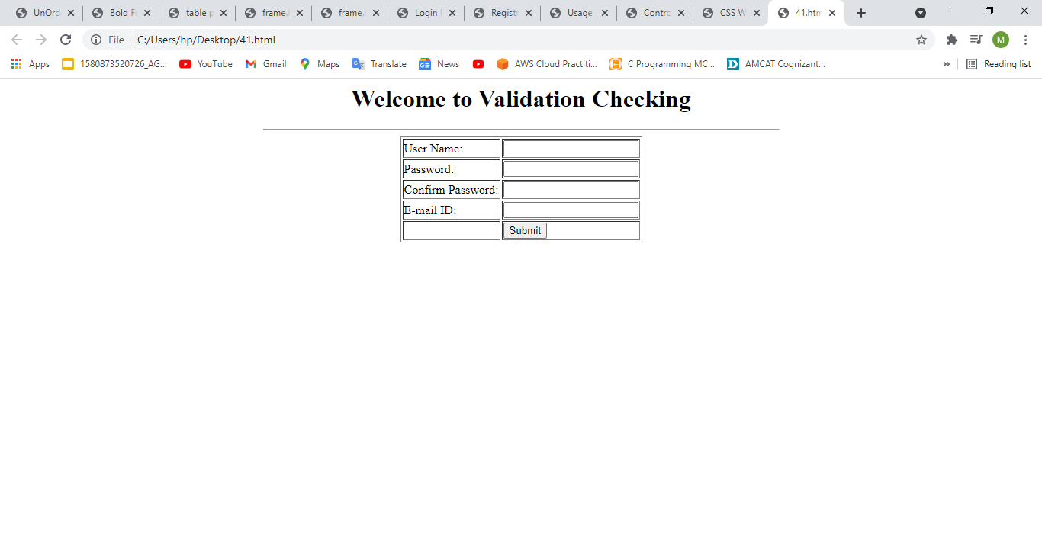

**4.2) Write an XML file which will display the Book information which includes the following:  a) Title of the book ;b) Author Name ;c) ISBN number ;d) Publisher name  e) Edition ;f) Price**

**Write a Document Type Definition (DTD) to validate the above XML file and display the details in  a table (to do this use XSL).**

**Book.dtd:**

<!ELEMENT bookdetails(books+)>

<!ELEMENT books(title,author,isbn,publisher,edition,price)>

<!ELEMENT title(#PCDATA)>

<!ELEMENT author(#PCDATA)>

<!ELEMENT isbn(#PCDATA)>

<!ELEMENT publisher(#PCDATA)>

<!ELEMENT edition(#PCDATA)>

<!ELEMENT price(#PCDATA)>

**Book.xml:**

<?xml version="1.0"?>

<!DOCTYPE bookdetails SYSTEM "book.dtd">

<?xml-stylesheet type="text/xsl" href="book.xsl"?>

<bookdetails>

<books>

<title>C</title>

<author>Balaguruswamy</author>

<isbn>123456</isbn>

<publisher>Oxford</publisher>

<edition>Edition-II</edition>

<price>$30.00</price>

</books>

<books>

<title>C++</title>

<author>yaswanth kanethkar</author>

<isbn>654321</isbn>

<publisher>Tata McHill</publisher>

<edition>Edition-I</edition>

<price>$35.00</price>

</books>

<books>

<title>JAVA</title>

<author>Herbert Schildt</author>

<isbn>789456</isbn>

<publisher>Cenage</publisher>

<edition>Edition-IV</edition>

<price>$50.00</price>

</books></bookdetails>

**Book.xsl:**

<?xml version="1.0"?>

<xsl:stylesheetversion="2.0"xmlns:xsl="http://www.w3.org/1999/XSL/transform"> <xsl:template match="/">

<html>

<head><center>Book Details</center></head>

<body>

<hr width="50%"/>

<table border="1" align="center">

<tr>

<th>TITLE</th>

<th>AUTHOR</th>

<th>ISBN</th>

<th>PUBLISHER</th>

<th>EDITION</th>

<th>PRICE</th>

</tr>

<xsl:for-each select="bookdetails/books">

<tr>

<td><xsl:value-of select="title"/></td>

<td><xsl:value-of select="author"/></td>

<td><xsl:value-of select="isbn"/></td>

<td><xsl:value-of select="publisher"/></td>

<td><xsl:value-of select="edition"/></td>

<td><xsl:value-of select="price"/></td>

</tr>

</xsl:for-each>

</table></body></html></xsl:template>

</xsl:stylesheet>

**Output:**

