**Q3. Implement AdaBoost algorithm using python to answer any specific classification problem.**

***Solution:***

What AdaBoost algorithm does is that it builds a model and gives equal weights to all the data points. It then assigns higher weights to points that are wrongly classified. Now all the points with higher weights are given more importance in the next model. It will keep training models until and unless a lower error is received.

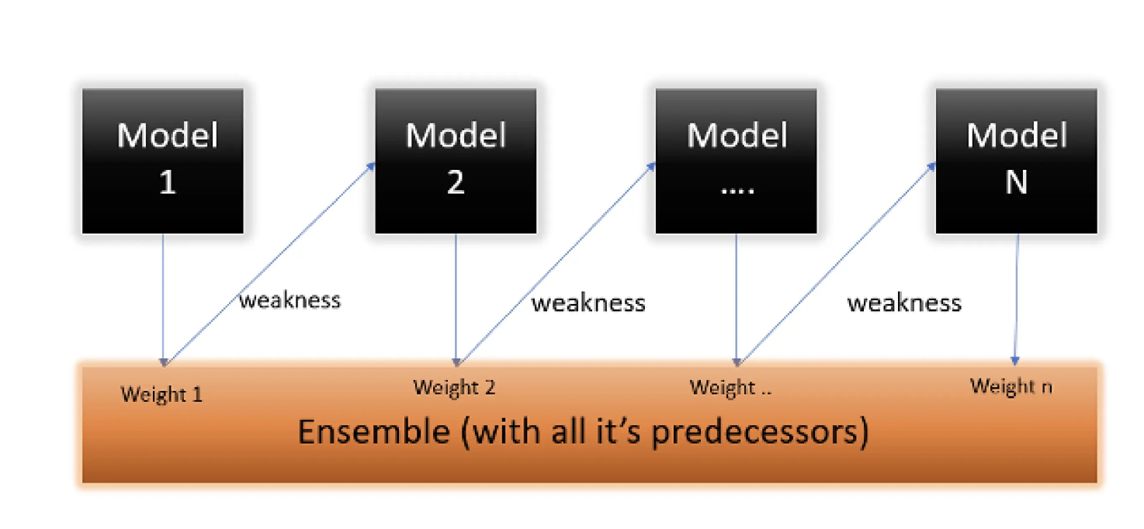

After implementing the AdaBoost the performance of the base classifier (ex : Decision Tree) such as Accuracy etc, will be improved.