STM32 With Simulink Model

Project of Smart Traffic Control  
1. To start with STM32 you need to Install the STM32 Simulink support packages

Name of : - Embedded Coder Support Package for STMicroelectronics STM32 Processors

&& **Simulink Coder Support Package for STMicroelectronics Nucleo Boards**

**Note:-(While installing see the version what they recommended and install it that one only)**

**2 . Once done with the installation choose creat a Simulink mode what you wan to do   
 2.1 select the input output ports and replace with it stm32 package blocks**

**Example :**

**Outputs of the Simulink model**

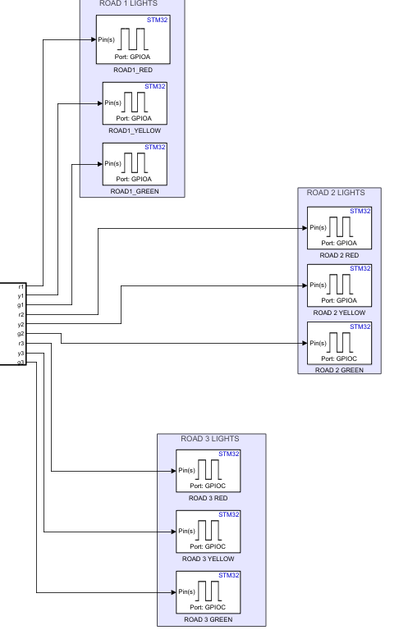

Inputs of the Simulink model

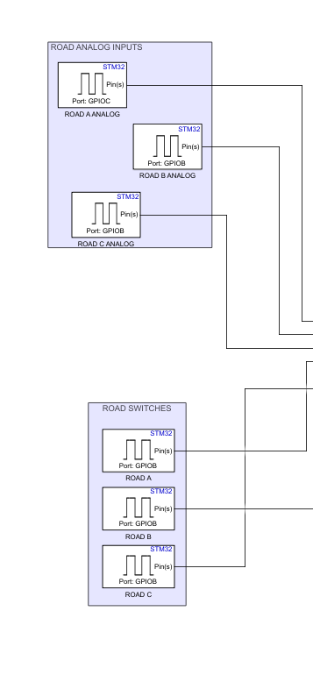

3. OPEN the Configuration Parameters

3.1 Select the Board   
 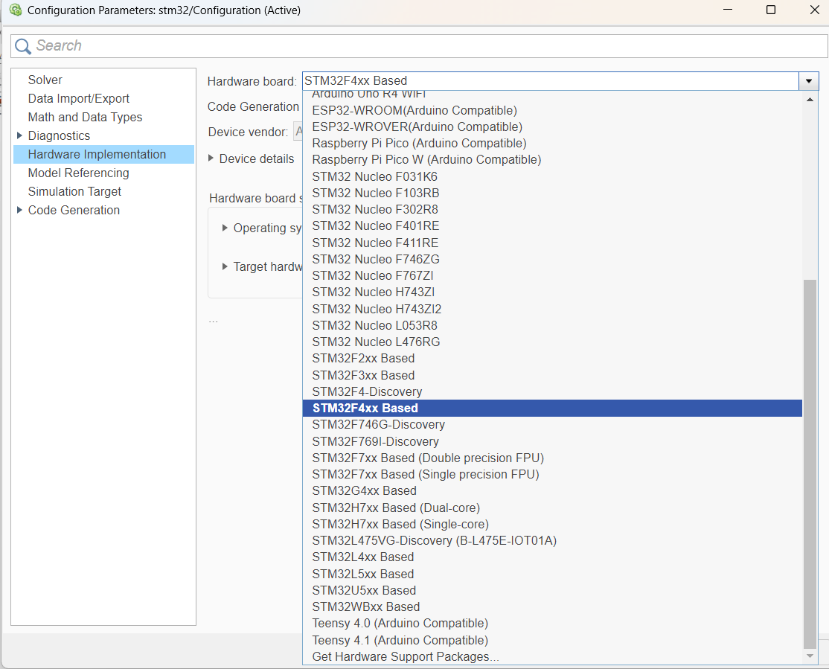

3.2 Go to the Target Hardware resources  
 In that under the Build options , create the project and select the exact board what you have

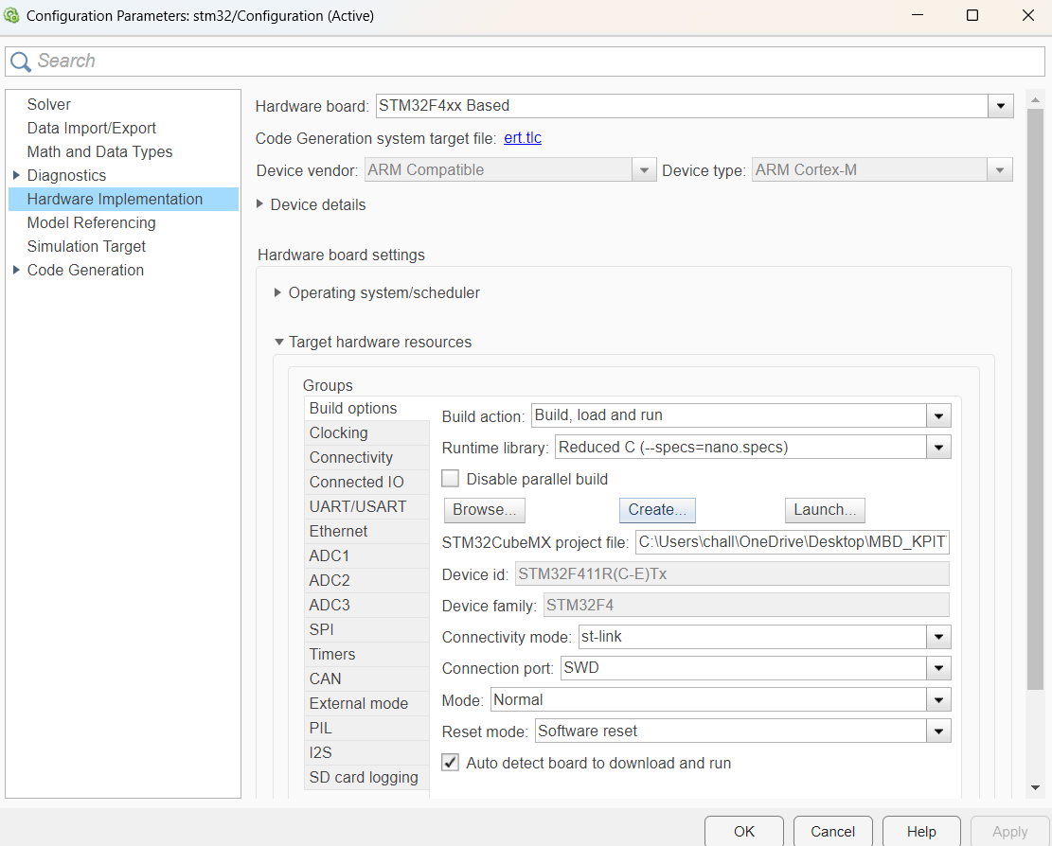

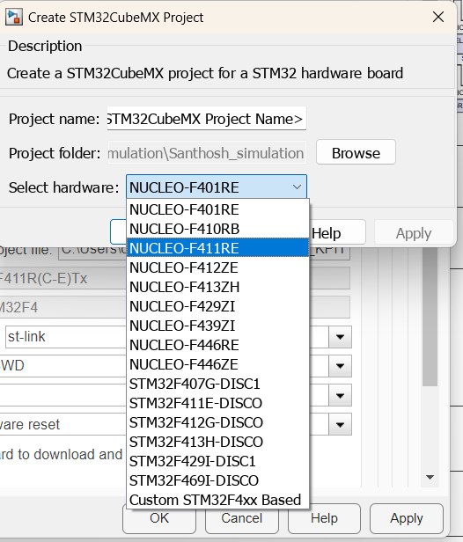

Setting up the stm32 cubemx for deployment of the developed Simulink model

Requirements:

3 digital input ports

9 digital output ports

3 analog input ports

Procedure for setting up the ports:

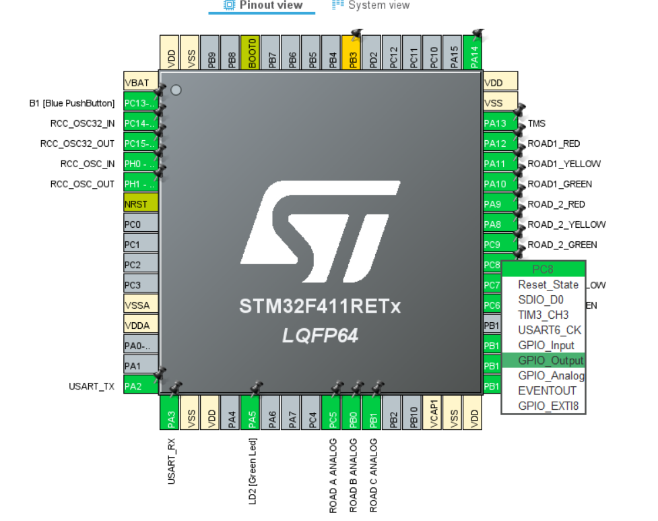

Figure STM32 PIN ASSIGN LAYOUT

* Step 1: Select the desired pin to assign the port
* Step 2: Select the desired function of the pin i.e GPIO_Output or GPIO_Input as shown in the image above

Once all the desired pins are established, move on to the Simulink model that you have created.

Select the output ports of the stm32 embedded programmer library and configure the output ports according to the assigned pins in the STM32 Cube programmer

Take the Image 1 as a reference and assign the ports in the Simulink model as follows

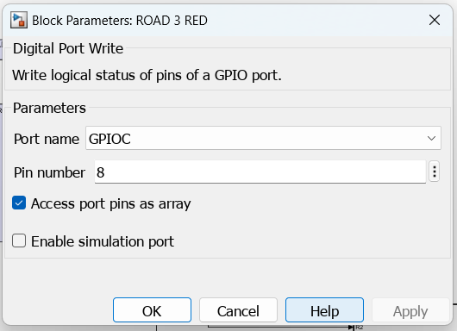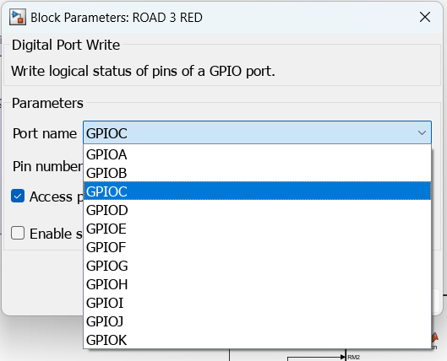

Figure Port parameters

The naming scheme of the port name and the pin number is very important and incorrect assignment will lead to errors

The Correct method of naming the pins is to refer to the port name and assign the name and number of the pins accordingly

For example:

If the pin is PC8 as in Image 1

The Port name in Figure 2 would be GPIOC, so select the relevant group based on the pin assigned for the function.

The group name is GPIOC since the pin is P”C” and the pin number is 8.

After all the pins are assigned, Open project manager in STM32CubeMX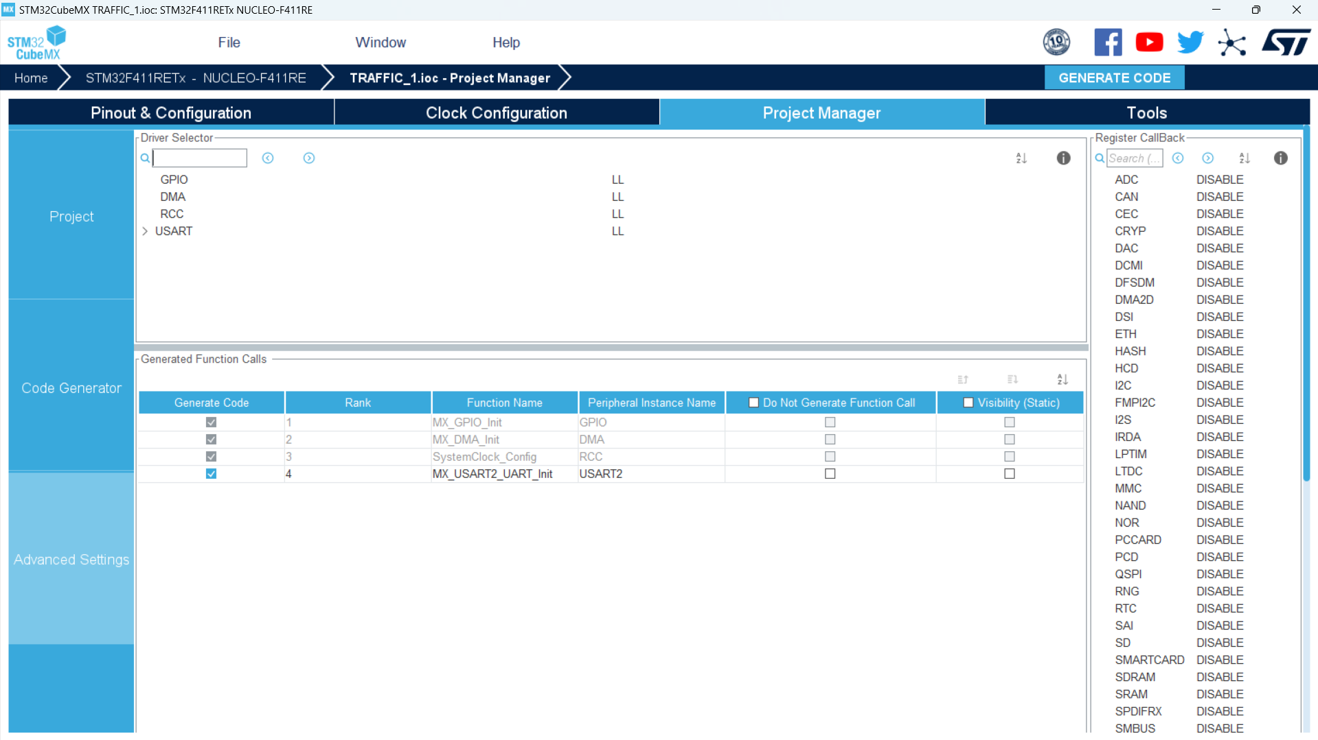

Figure STM32CubeMX

Navigate to advanced settings and make sure the “Visibility (Static)” and “do not generate function call” of all the components is disabled.

Confirm that USART in Device Selector is in LL mode.

Now move to Simulink model and open the Hardware block in the tool ribbon.

Now select the Build,Deploy & Start option.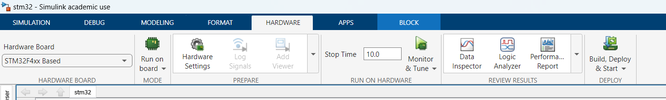

Figure Tool Ribbon

The Simulink model will generate the code and deploy it on the Selected STM32 hardware.

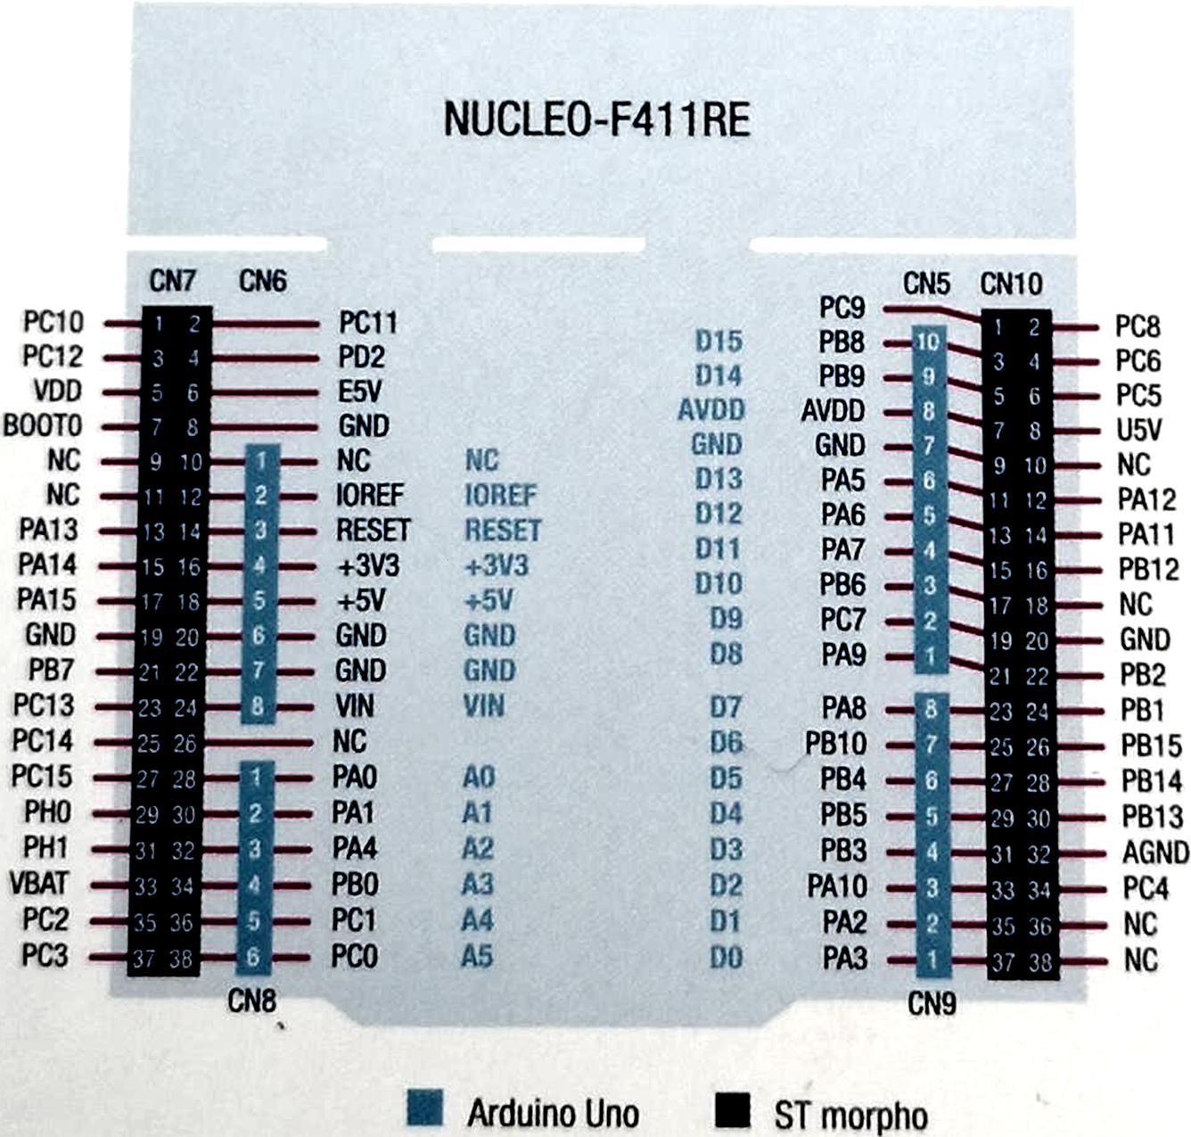

The above shown image is the pinout diagram of the STM32f411re board, this is the board upon which this run was conducted.

The layout of all the components such as the input switches, analog inputs i.e Potentiometers and the output leds have been connected accordingly.

References:

https://in.mathworks.com/help/ecoder/stmicroelectronicsstm32f4discovery/ug/Getting-started-stm32cubemx.html