
Program :B.tech(CSE)
Specialization :AIML
Course Title :AI Assisted Coding
Course Code :24CS002PC215
Semester :3rd semester
Academic Session :2025-2026
Name of Student :Challa Sravya
Enrollment No. :2403A52033
Batch No. :02
Date :28/10/2025
LAB ASSIGNMENT-14.2
TASK DESCRIPTION-1: AI-generated HTML Page
Task: Ask AI to generate a simple HTML homepage for a "Student Info
Portal" with a header, navigation menu, and footer.
Prompt:-
Code:-
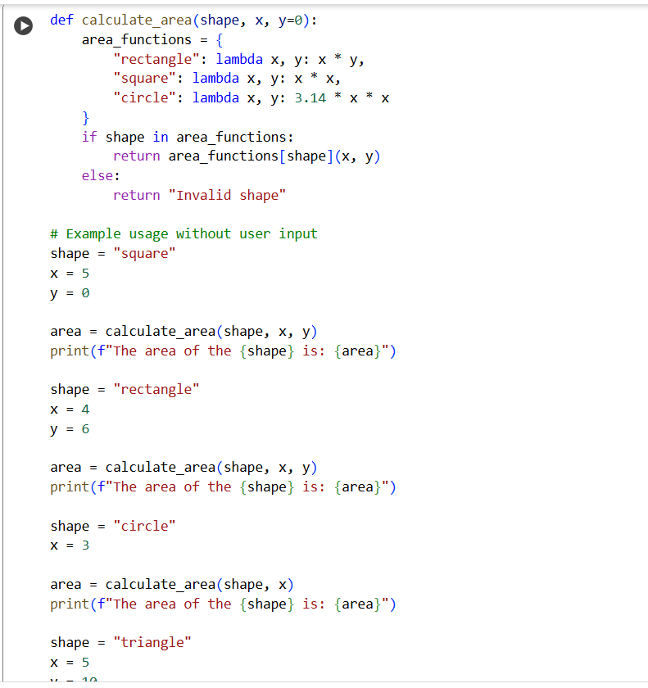
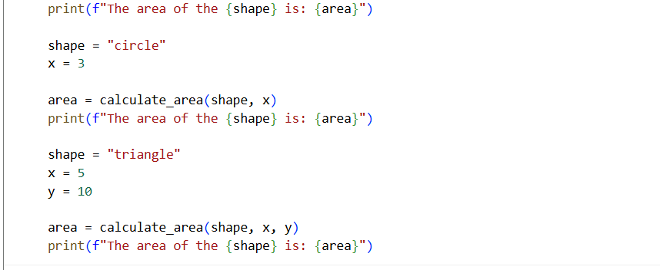
Output:-
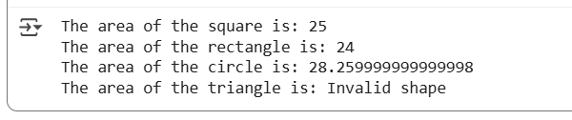
TASK DESCRIPTION-2: Error Handling in Legacy Code
Task: Legacy function without proper error handling
Python Code
def read_file(filename):
f = open(filename, "r")
data = f.read()
f.close()
return data
Prompt: Refactor the following legacy function to include proper error handling and modern Python practices. def read_file(filename): f = open(filename, "r") data = f.read() f.close() return data
Code:
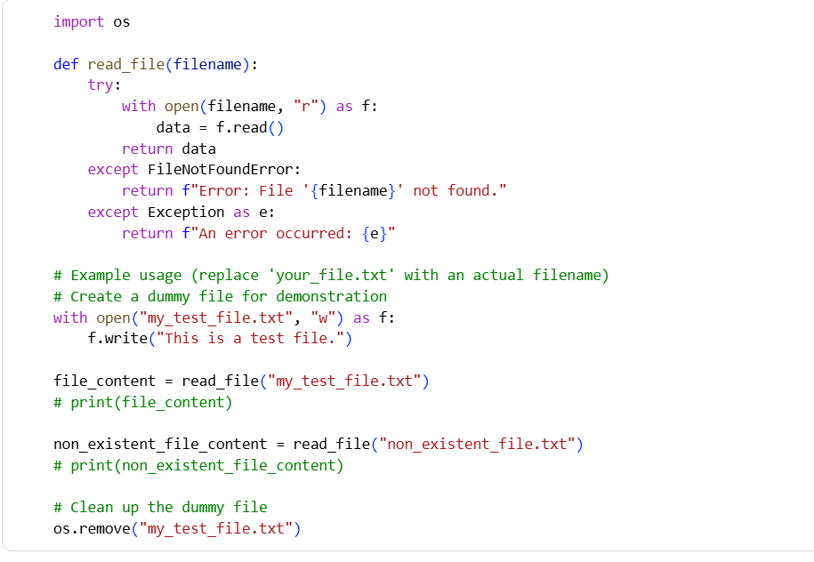
TASK DESCRIPTION-3: Complex Refactoring
Task: Provide this legacy class to AI for readability and modularity
improvements:
Python Code
class Student:
def __init__(self, n, a, m1, m2, m3):
self.n = n
self.a = a
self.m1 = m1
self.m2 = m2
self.m3 = m3
def details(self):
print("Name:", self.n, "Age:", self.a)
def total(self):
return self.m1+self.m2+self.m3
Prompt: Improve this legacy class for better readability, naming, and structure. class Student: def __init__(self, n, a, m1, m2, m3): self.n = n self.a = a self.m1 = m1 self.m2 = m2 self.m3 = m3 def details(self): print("Name:", self.n, "Age:", self.a) def total(self): return self.m1+self.m2+self.m3
Code: 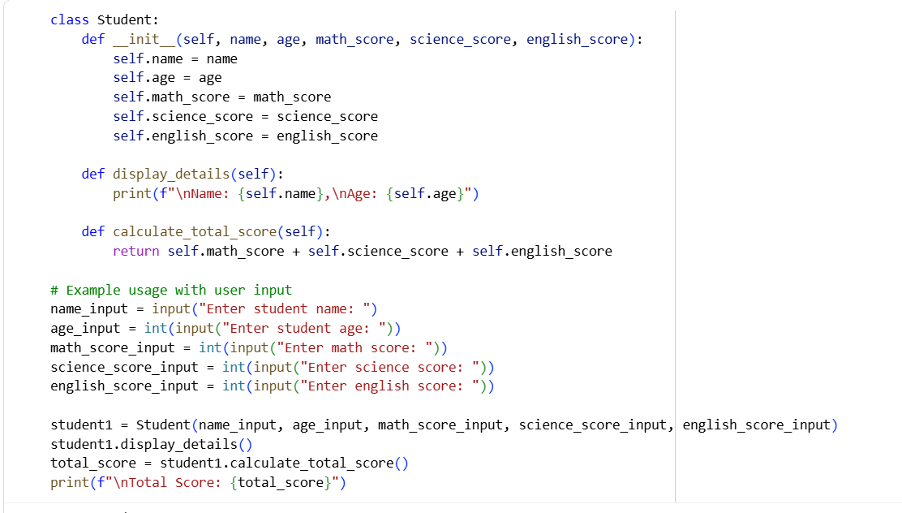
Output:
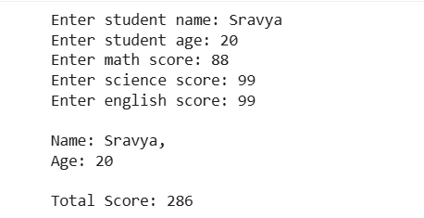
TASK DESCRIPTION-4: Inefficient Loop Refactoring
Task: Refactor this inefficient loop with AI help
Python Code
nums = [1,2,3,4,5,6,7,8,9,10]
squares = []
for i in nums:
squares.append(i * i)
Prompt: Refactor this inefficient loop into a more Pythonic approach. nums = [1,2,3,4,5,6,7,8,9,10] squares = [] for i in nums: squares.append(i * i)
Code:
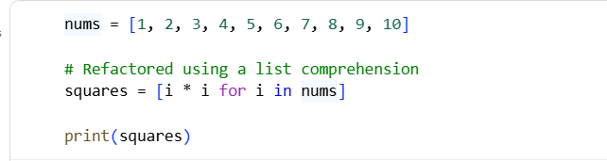
Output:
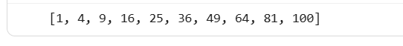
THANK YOU

