
Program :B.tech(CSE)
Specialization :AIML
Course Title :AI Assisted Coding
Course Code :24CS002PC215
Semester :3rd semester
Academic Session :2025-2026
Name of Student :Challa Sravya
Enrollment No. :2403A52033
Batch No. :02
Date :22/10/2025
LAB ASSIGNMENT-12.3
TASK DESCRIPTION-1: Linear Search implementation
Task: Write python code for linear_search() function to search a value
in a list and extract it’s index
Prompt:- Give me a python code for linear_search() function to search a value in a list and extract it’s index. With user input
Code:-
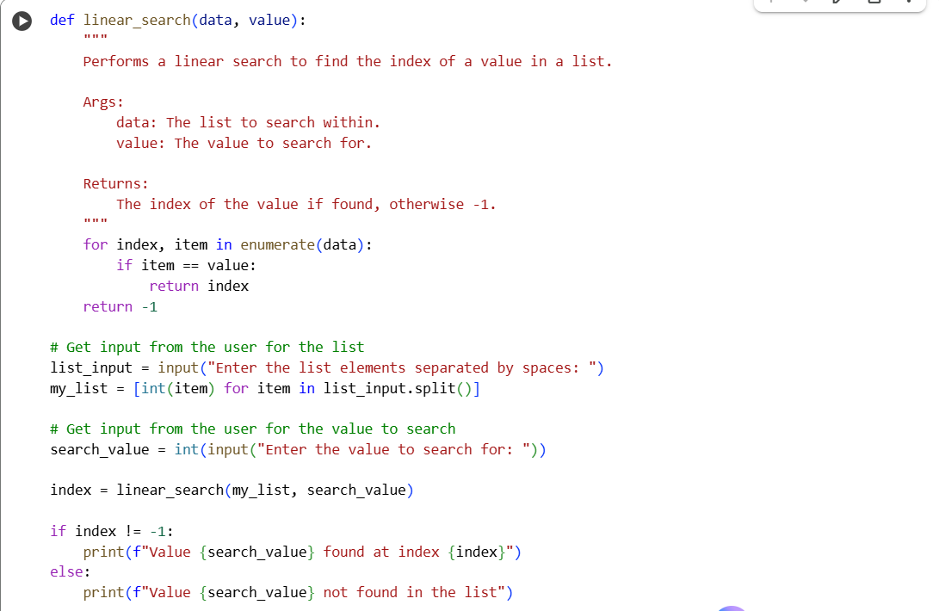
Output:-
TASK DESCRIPTION-2: Sorting Algorithms
Task: Ask AI to implement Bubble Sort and check sorted output
Prompt: Give me a python code that implement Bubble Sort and check sorted output with user input
Code:
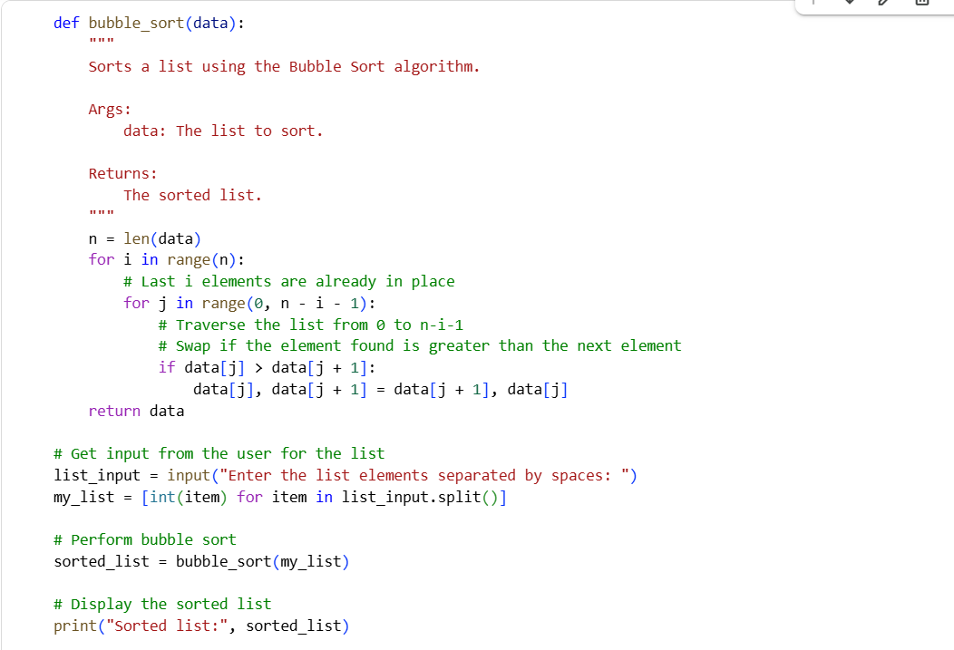
Output:
TASK DESCRIPTION-3: Optimization
Task: Write python code to solve below case study using linear
optimization
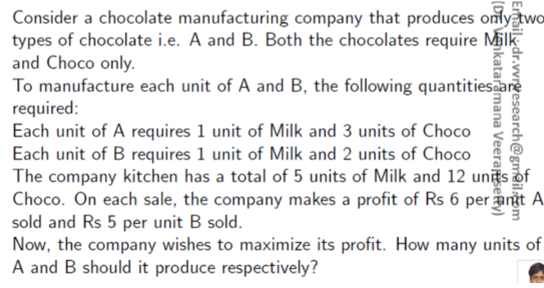

Prompt: write Python code using linear optimization for this case? A chocolate company makes two types of chocolates – A and B. Each A needs 1 unit of Milk and 3 units of Choco. Each B needs 1 unit of Milk and 2 units of Choco. We have only 5 units of Milk and 12 units of Choco available. Profit is Rs 6 per A and Rs 5 per B. Give me a direct Python code without installing anything that calculates how many A and B the company should produce to get the maximum profit. Also show the maximum profit value clearly with user input.
Code: 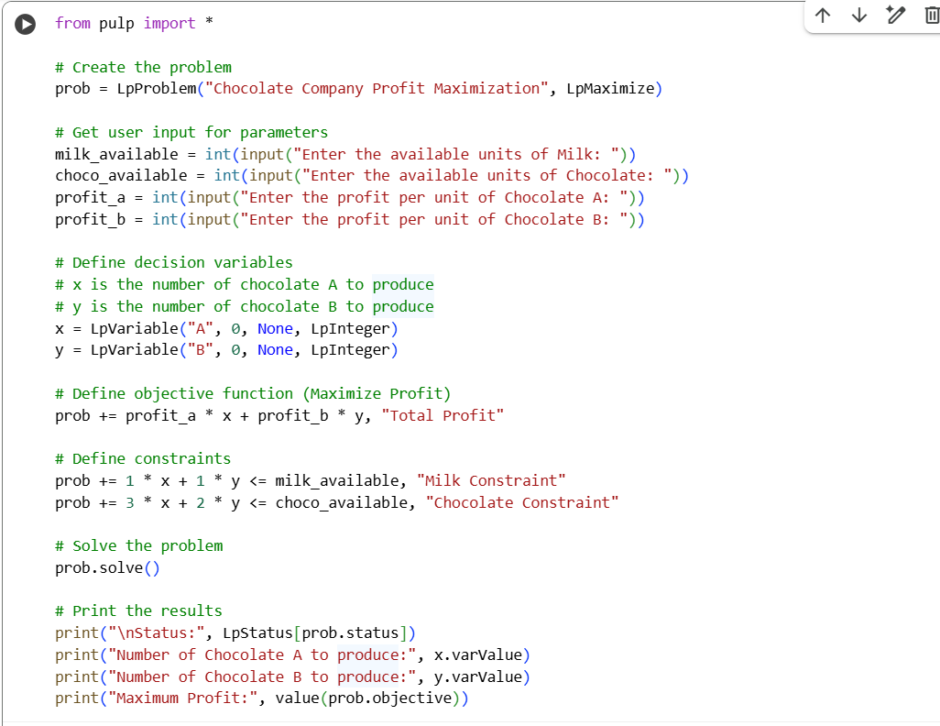
Output:
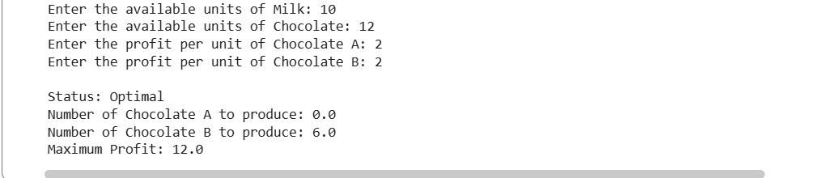
TASK DESCRIPTION-4: Gradient Descent Optimization
Task: Write python code to find value of x at which the function
f(x)=2X3+4x+5 will be minimum
Prompt: write Python code to find the value of x where the function
f(x) = 2x^3 + 4x + 5 becomes minimum using Gradient Descent.and Define the function f(x) and its derivative.Use a learning rate and iteration loop.Show how the value of x updates in each step.Finally, print the x value where the function is minimum and the corresponding f(x)
Code: 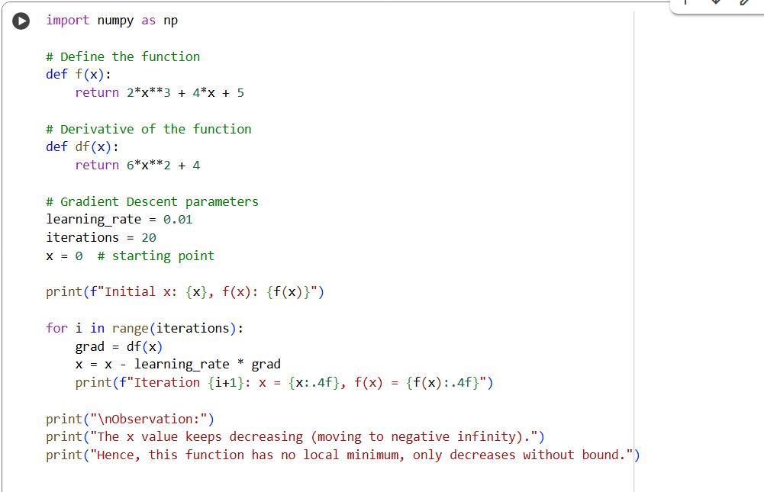
Output:
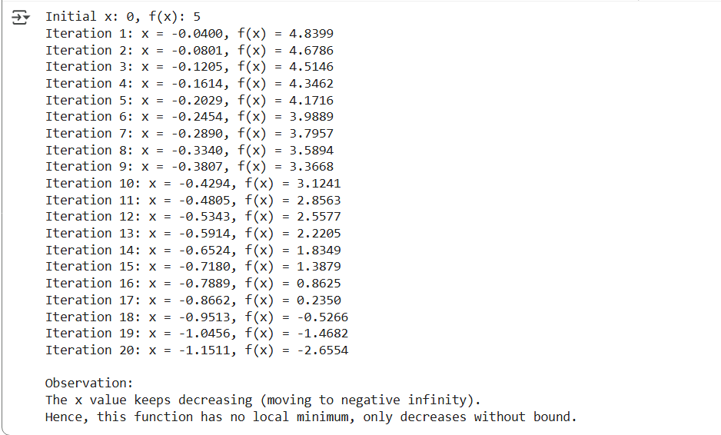
THANK YOU

