
Program :B.tech(CSE)
Specialization :AIML
Course Title :AI Assisted Coding
Course Code :24CS002PC215
Semester :3rd semester
Academic Session :2025-2026
Name of Student :Challa Sravya
Enrollment No. :2403A52033
Batch No. :02
Date :28/10/2025
#LAB ASSIGNMENT-14.3
#TASK DESCRIPTION-1:
AI-generated HTML Page:
Task: Ask AI to generate a simple HTML homepage for a "Student Info
Portal" with a header, navigation menu, and footer.
#PROMPT:
Create a simple HTML homepage for a "Student Info Portal" that includes a header, a navigation menu, and a footer.
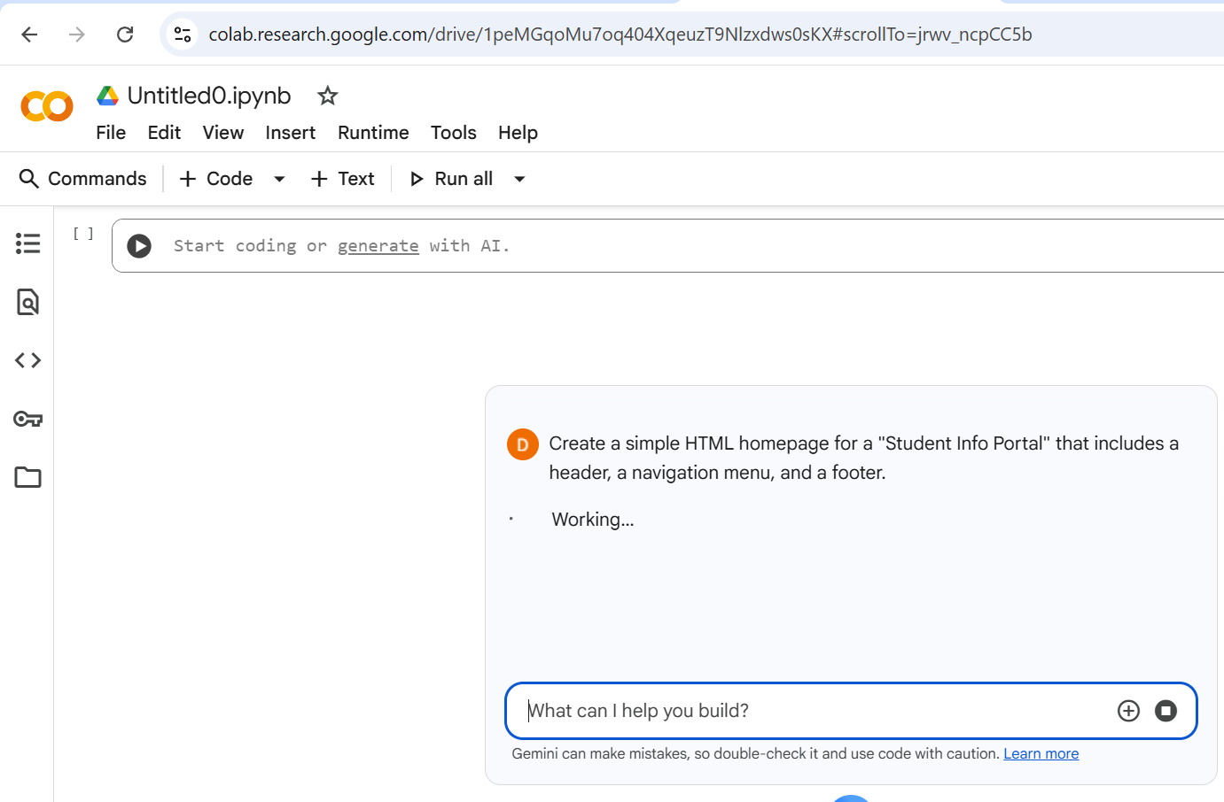
#CODE:
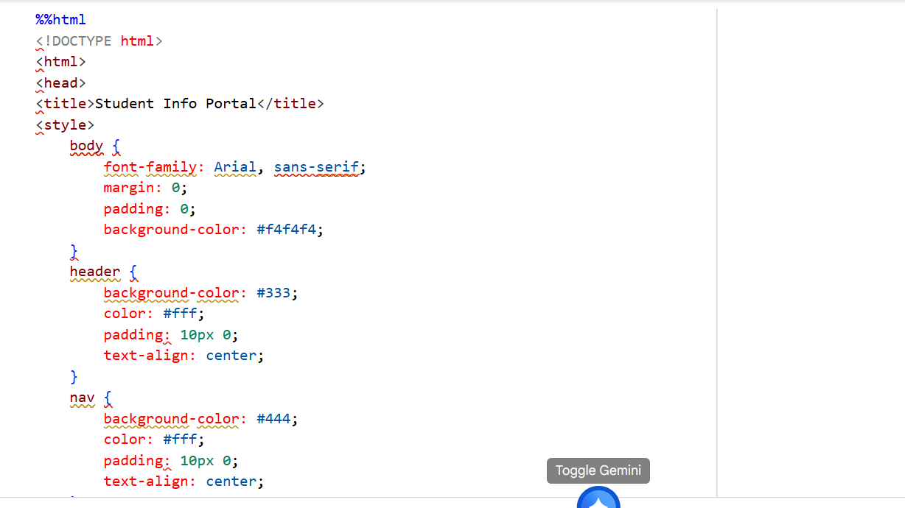
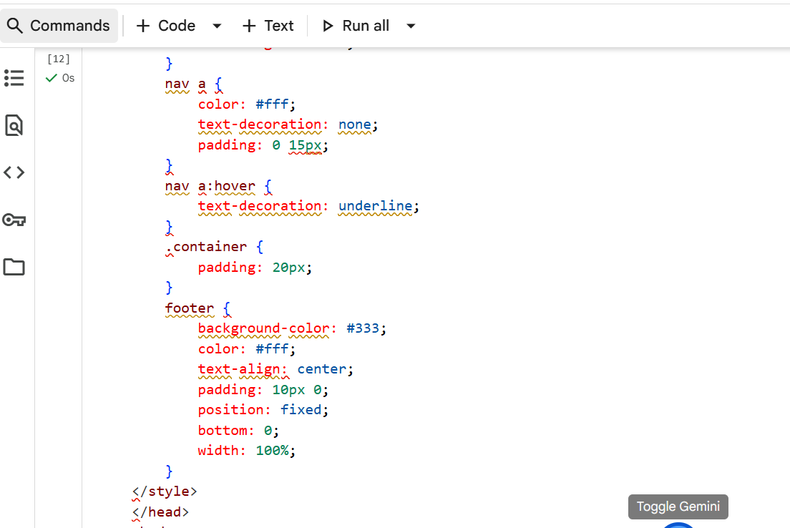
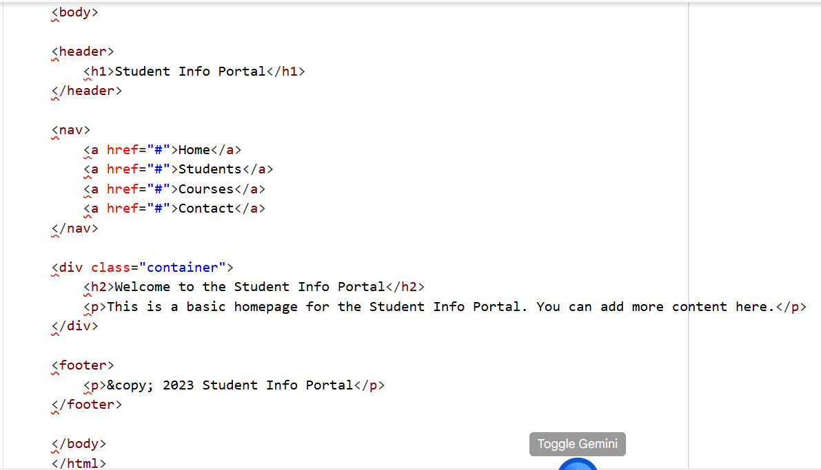
# OUTPUT:
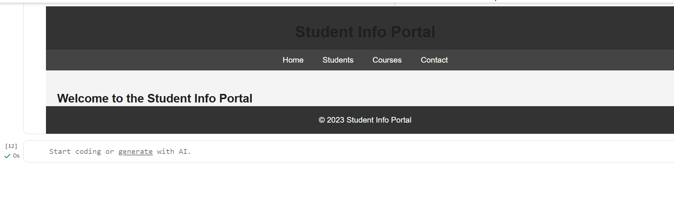
#TASK DESCRIPTION-2:
CSS Styling:
Use AI to add CSS styling to Task #1 homepage for:
• Responsive navigation bar.
• Centered content section.
• Footer with light gray background
#PROMPT:
Add CSS styling to the "Student Info Portal" homepage to include:
- A responsive navigation bar
- A centered content section
- A footer with a light gray background
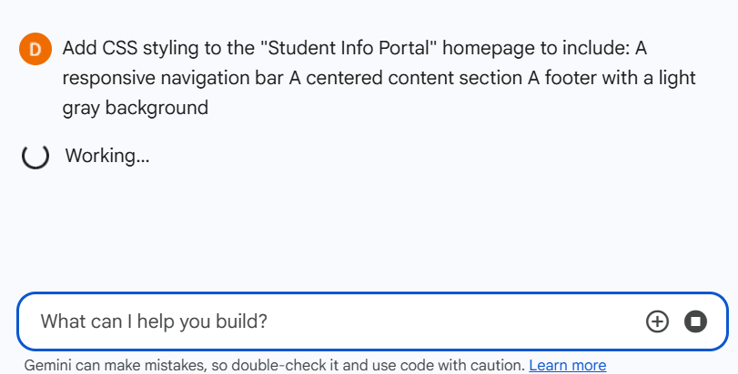

#CODE:
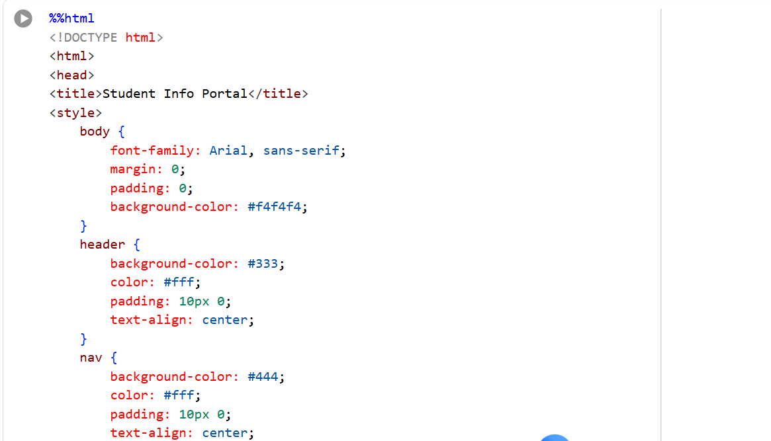
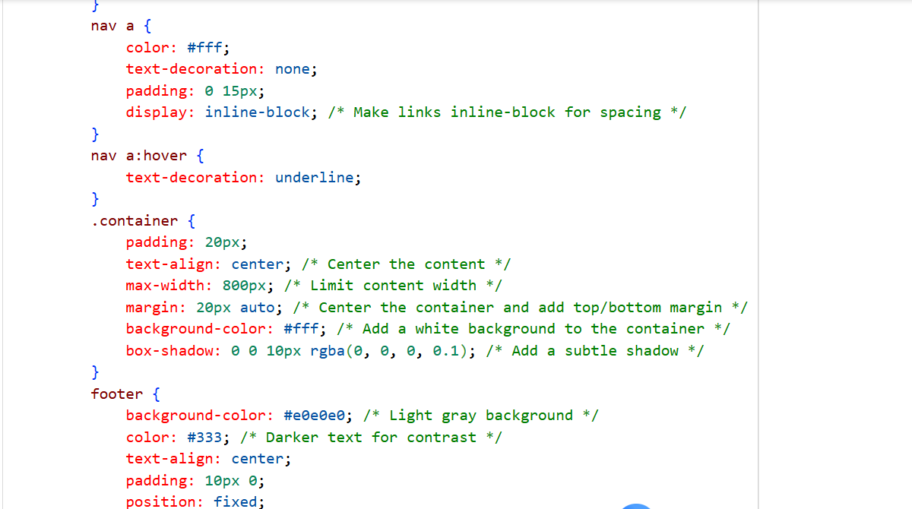
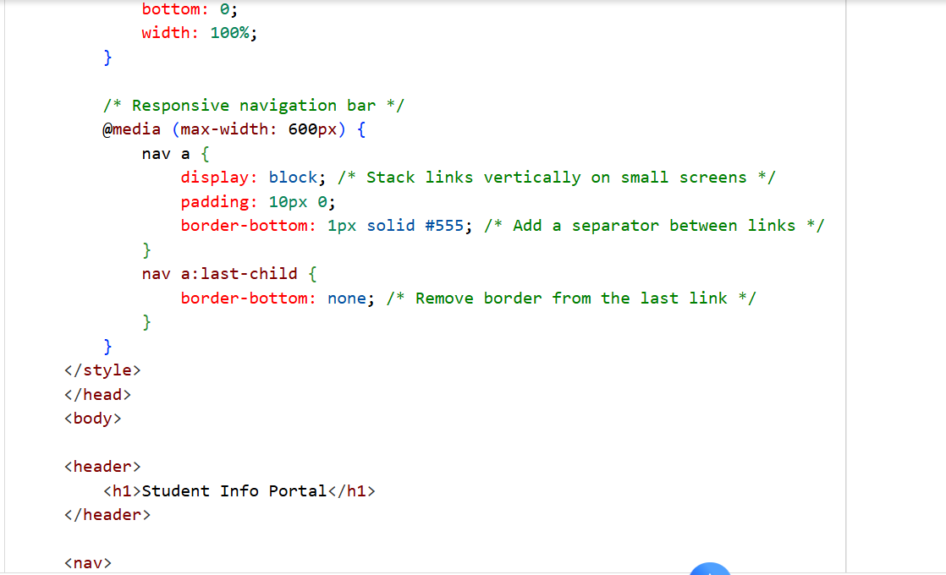
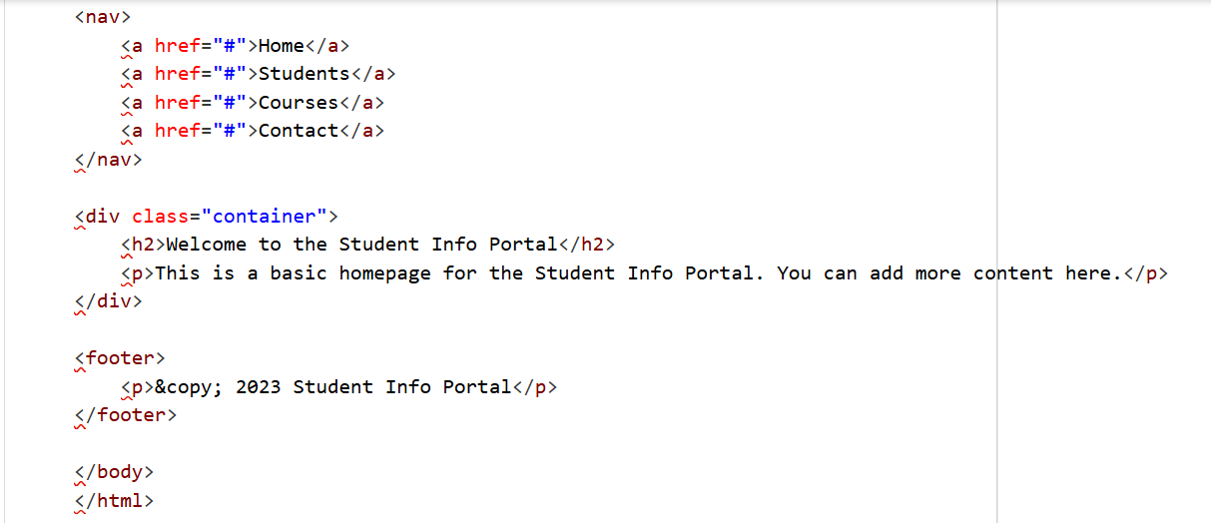
#OUTPUT:
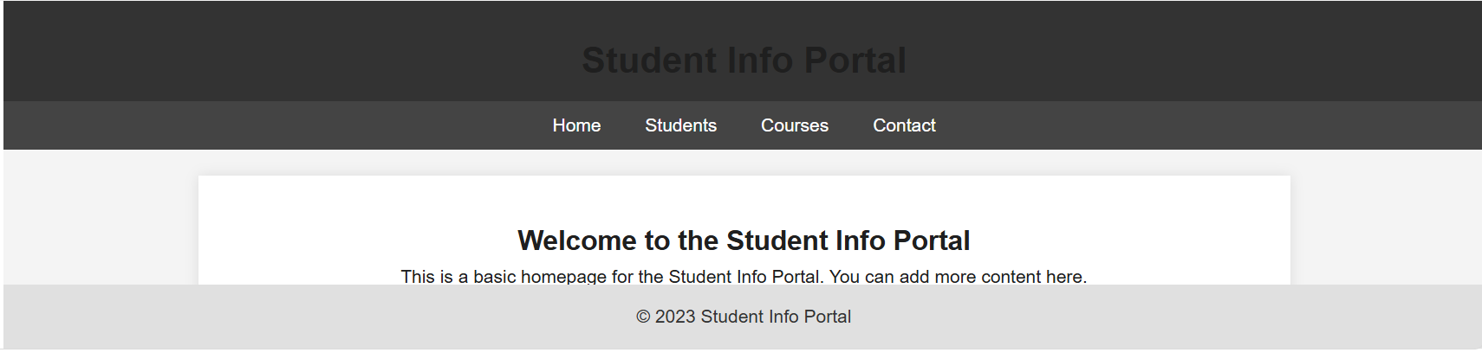
#TASK DESCRIPTION-3:
JavaScript Interactivity:
Task: Prompt AI to generate a JS script that validates a simple login
form (non-empty username/password).
#PROMPT:
Write a JavaScript script that validates a simple login form to ensure the username and password fields are not empty before submission.
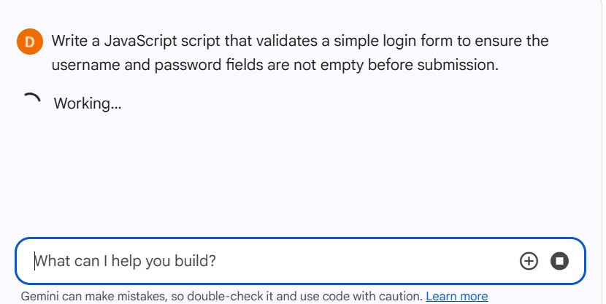
#CODE:
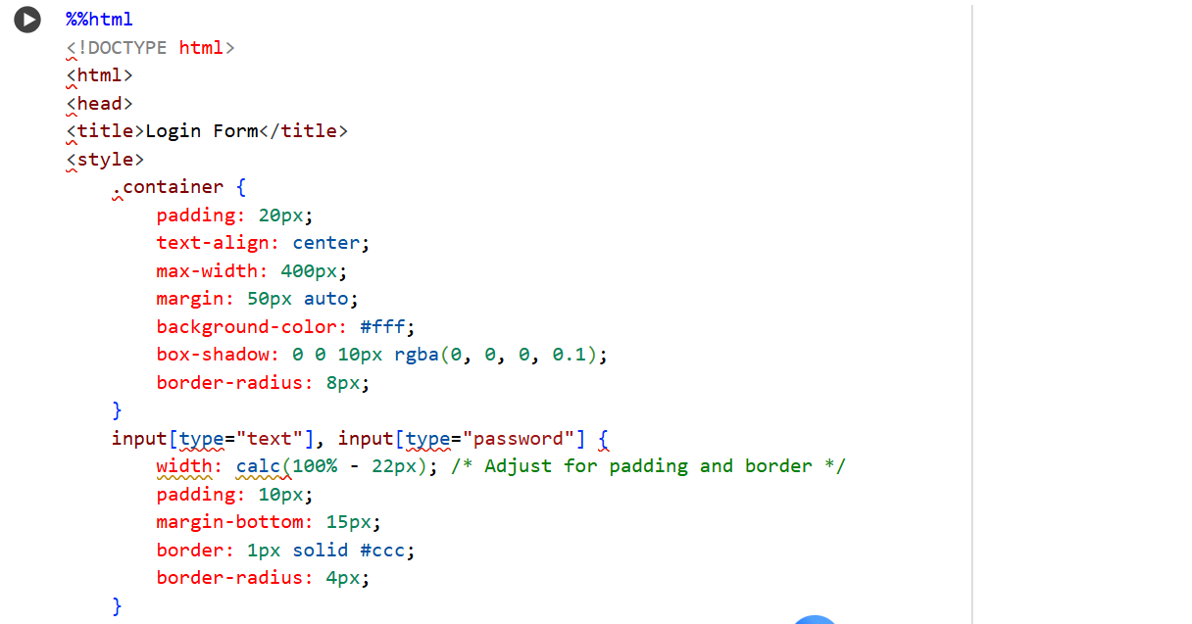
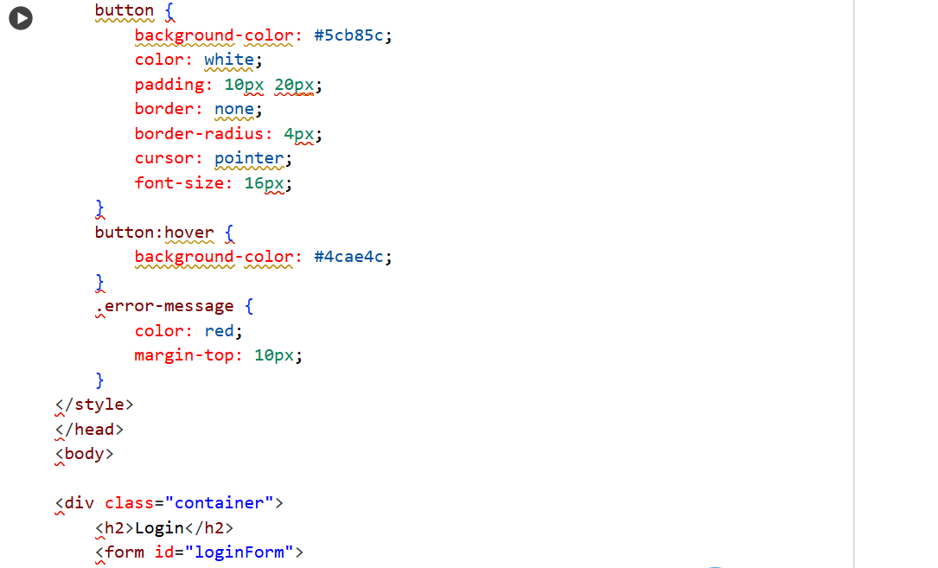
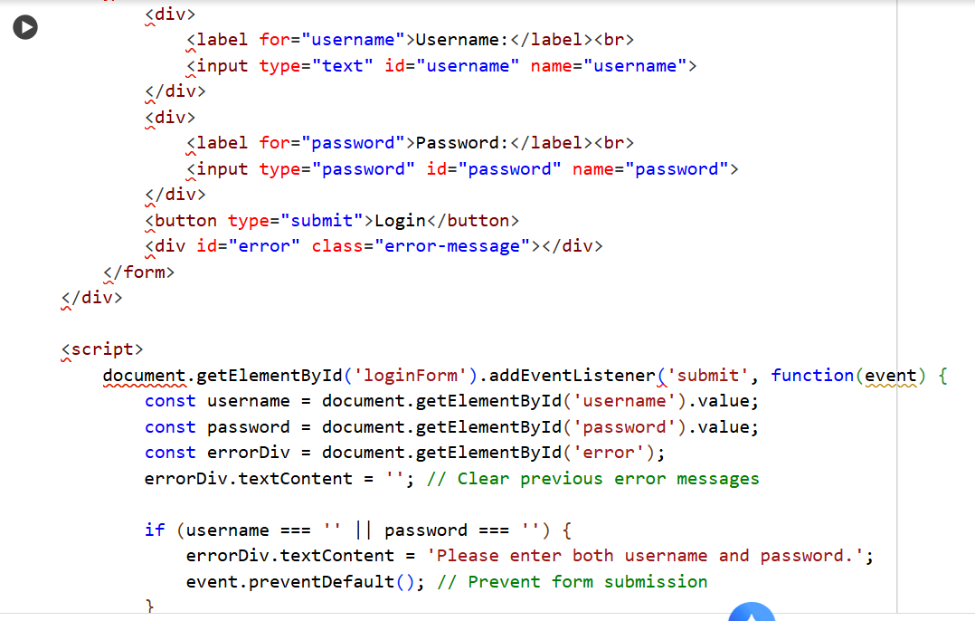
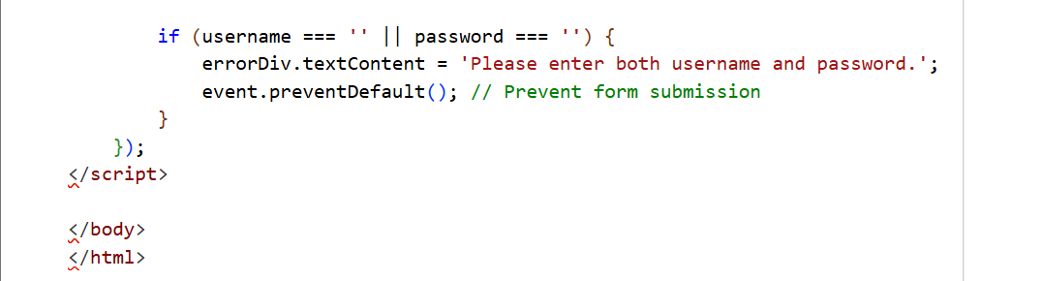
#OUTPUT:
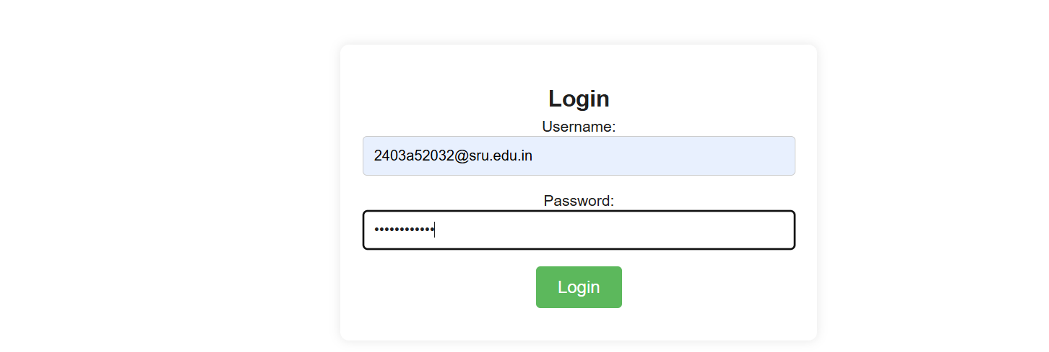
# TASK DISCRIPTION-4:
Python Backend Integration
Task: Ask AI to generate a Flask app that serves the HTML form (Task
#3) and prints the username on successful login
#PROMPT:
Generate a complete and executable Python Flask app that serves a simple HTML login form and, upon successful login, displays the entered username on a new page.
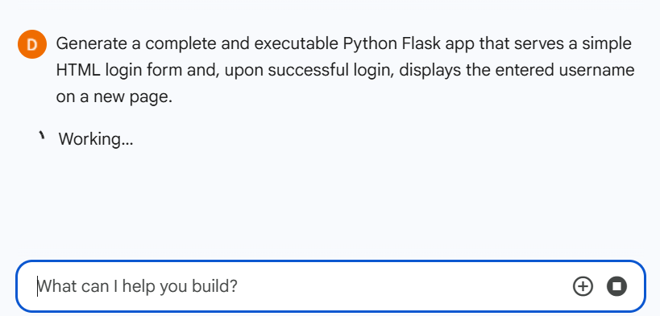
#CODE:
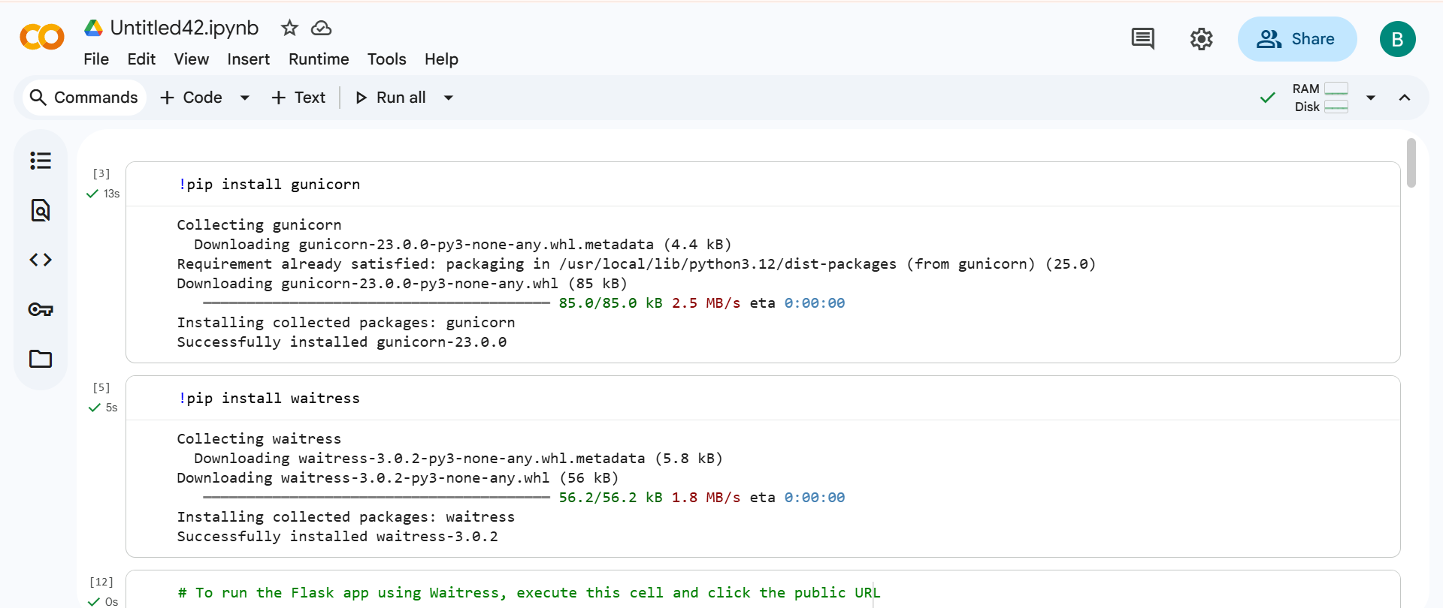
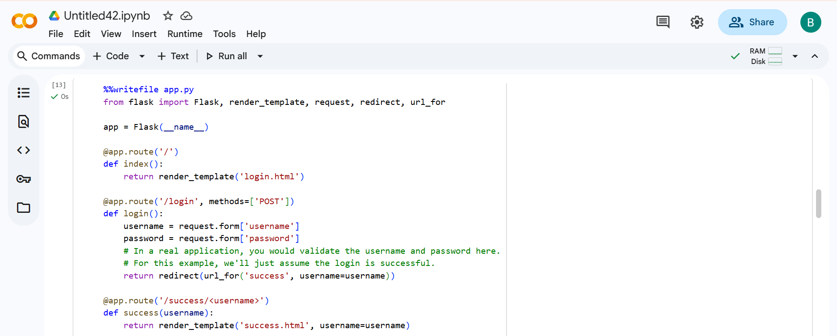
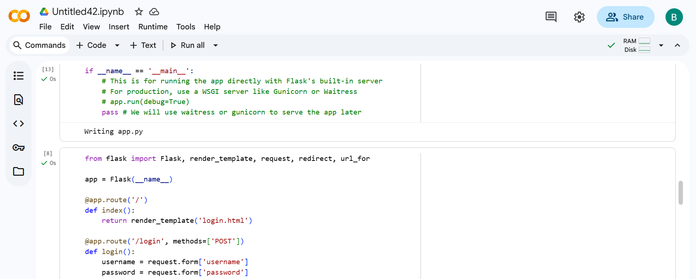
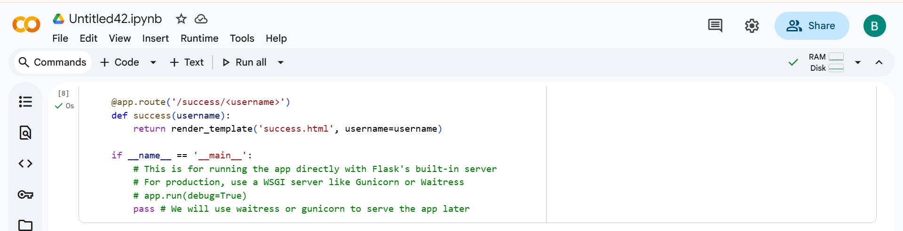
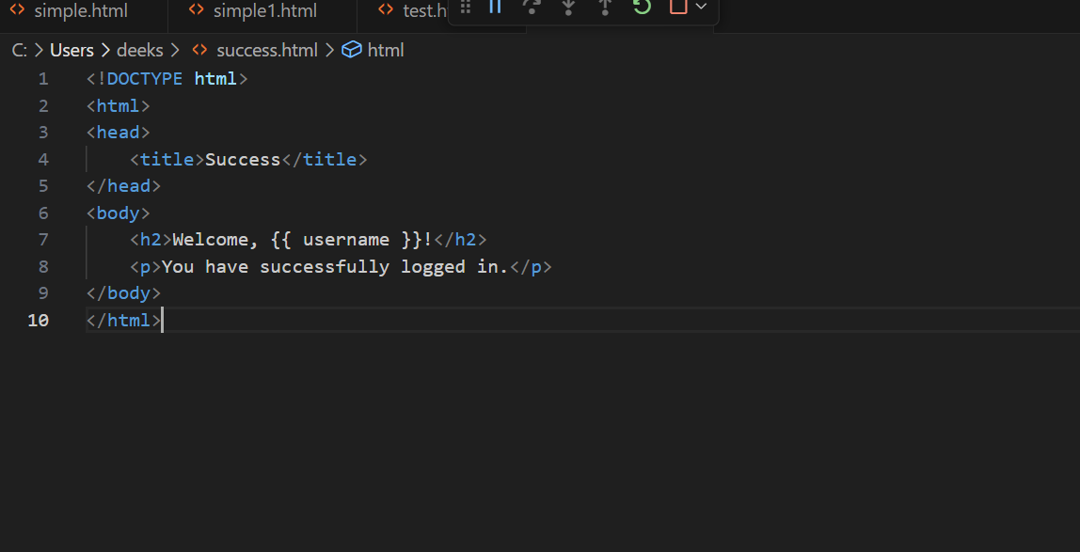
#OUTPUT:

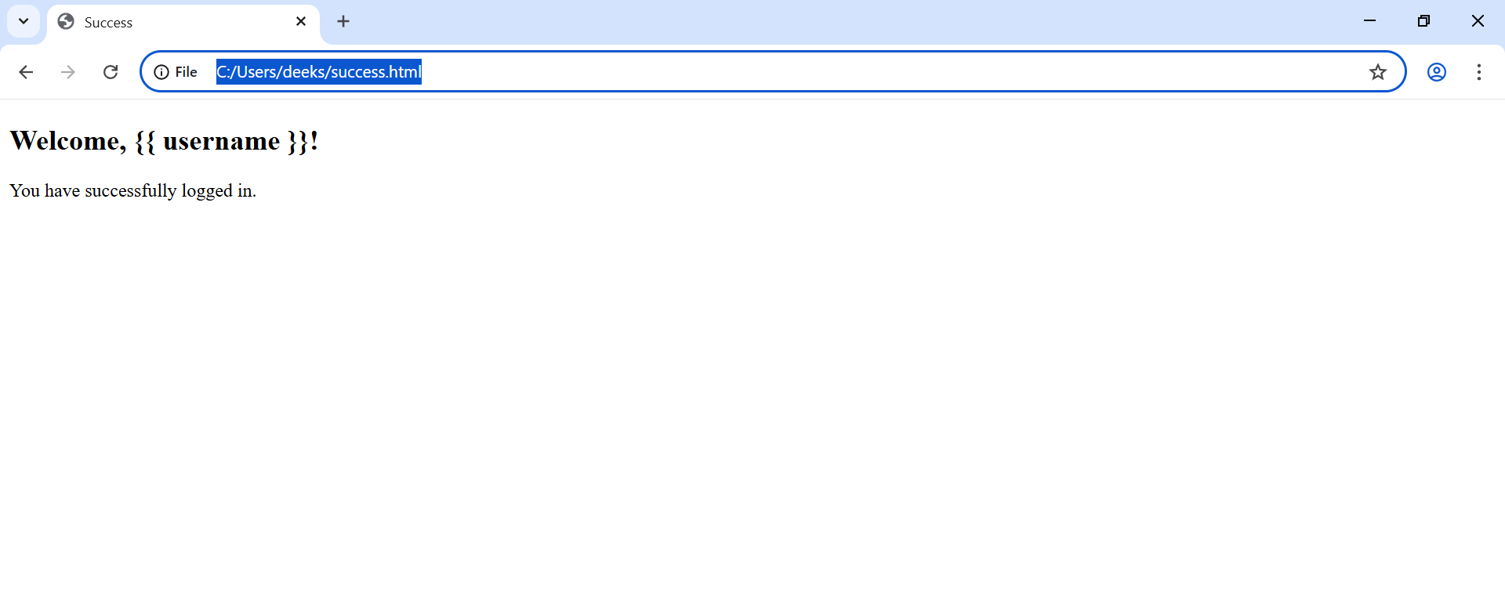

Thank You

