
Program :B.tech(CSE)
Specialization :AIML
Course Title :AI Assisted Coding
Course Code :24CS002PC215
Semester :3rd semester
Academic Session :2025-2026
Name of Student :Challa Sravya
Enrollment No. :2403A52033
Batch No. :02
Date :22/10/2025
#LAB ASSIGNMENT-18.2
#TASK DESCRIPTION-1:
Movie Database API
Task: Connect to a Movie Database API (e.g., OMDb or TMDB) to
fetch details of a movie.
Instructions:
Prompt AI to generate Python code to query the API by movie title.
Handle errors like invalid movie name, missing/expired API key, and
timeout.
Display title, release year, genre, IMDb rating, and director.

#PROMPT:
Write a Python program that connects to the OMDb API to fetch movie details by title. The program should ask the user for a movie name, call the API, and display the movie’s title, release year, genre, IMDb rating, and director. Handle errors for invalid movie titles, missing or expired API keys, and request timeouts. Keep the code simple and well-commented.
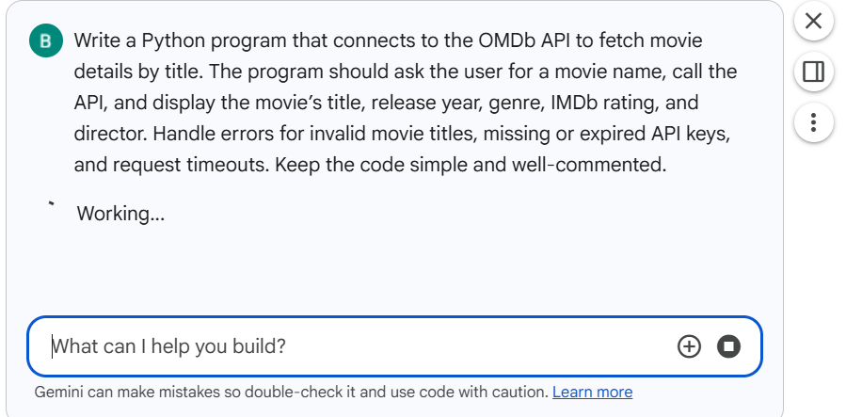
#CODE:
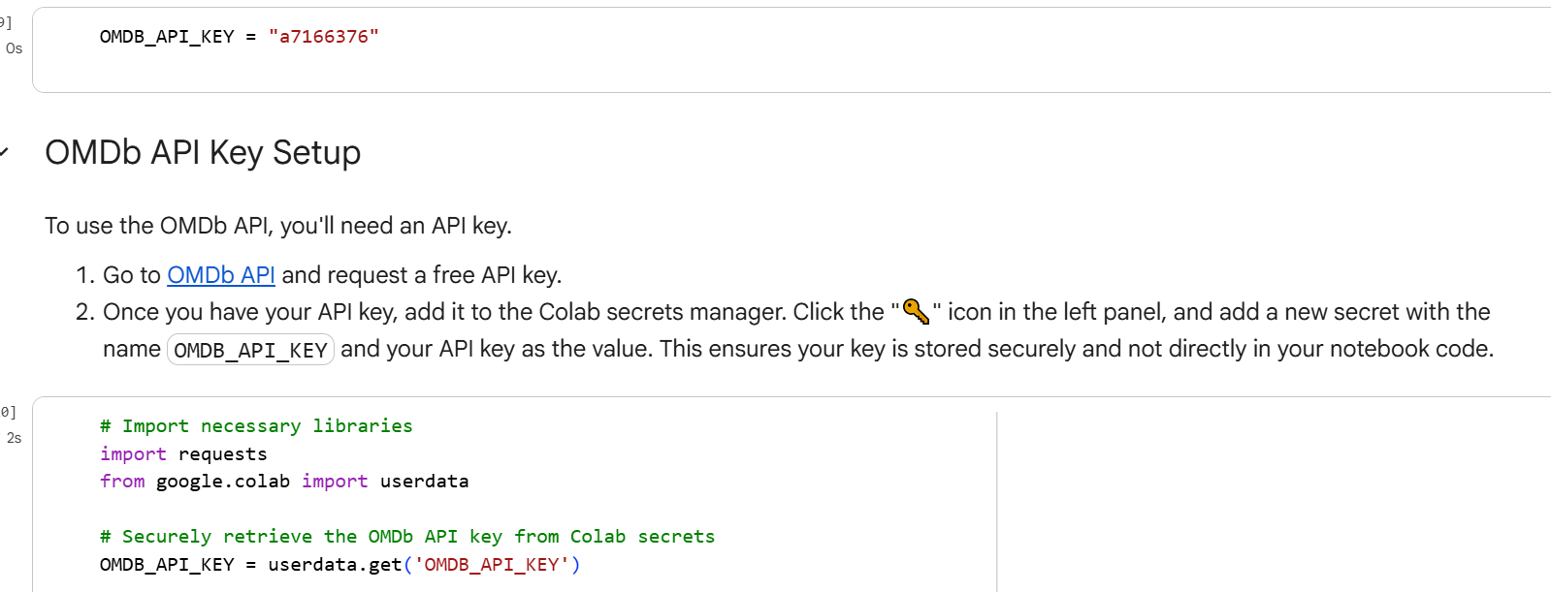
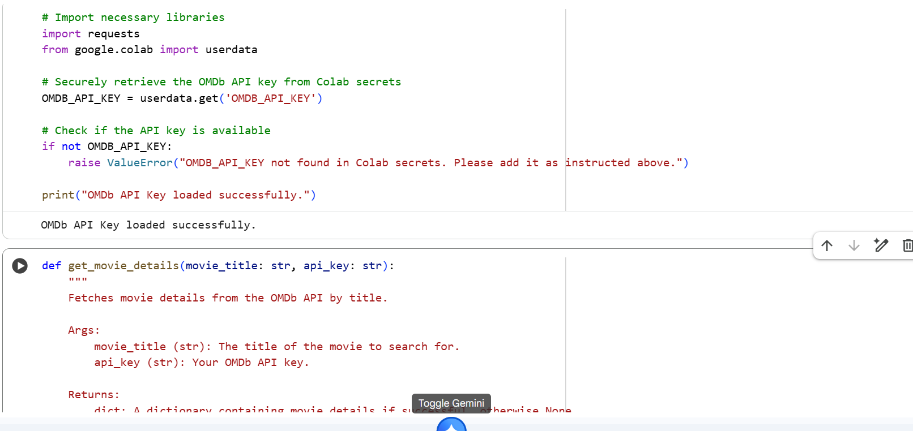
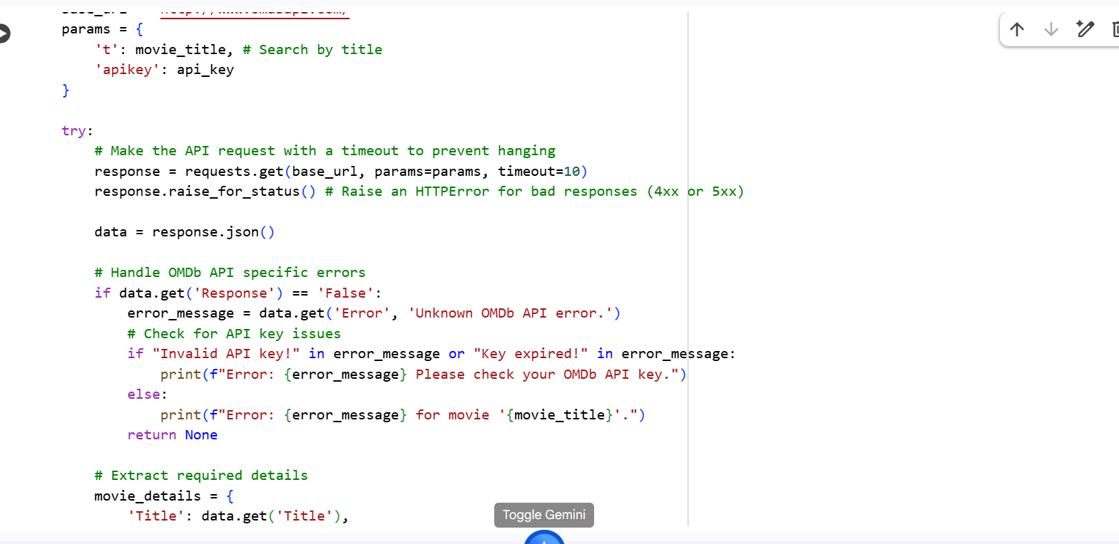
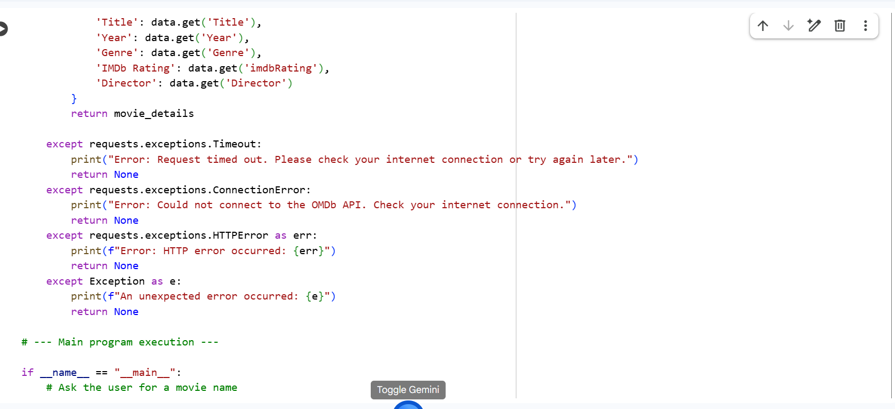
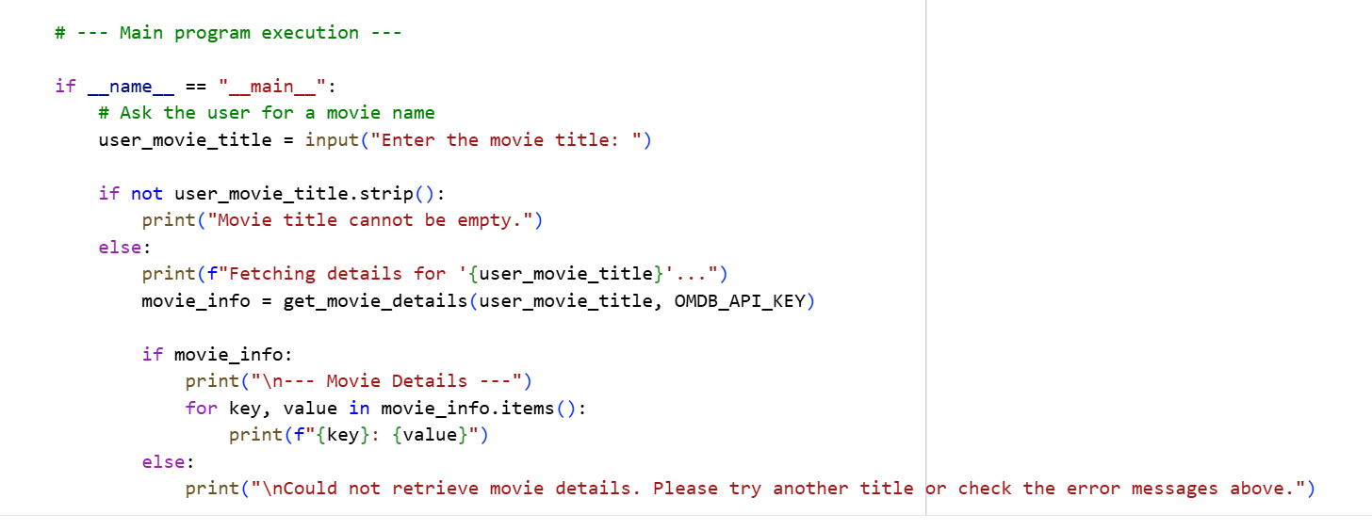
# OUTPUT:
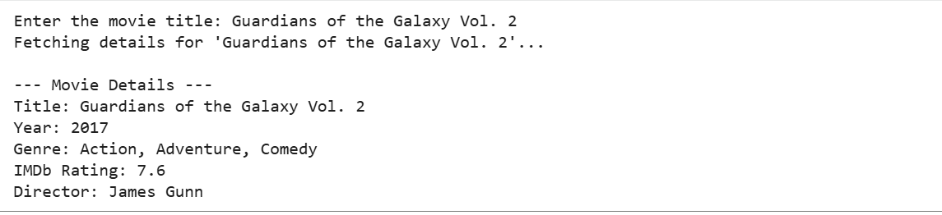

#TASK DESCRIPTION-2:
Public Transport API
Task: Use a Public Transport API (e.g., city bus/train API or mock
data) to fetch live arrival times.
Instructions:
• Fetch the next 5 arrivals for a given stop/station ID.
• Handle invalid station codes, unavailable service, and malformed
responses.
• Display results in a readable table with route number, destination,
and arrival time
#PROMPT:
Write a Python program that connects to a Public Transport API (or uses mock data) to fetch the next 5 arrivals for a given stop or station ID. The program should handle errors such as invalid station codes, unavailable services, and malformed API responses. Display the results in a clean, readable table showing the route number, destination, and arrival time. Keep the code simple, well-commented, and beginner-friendly.
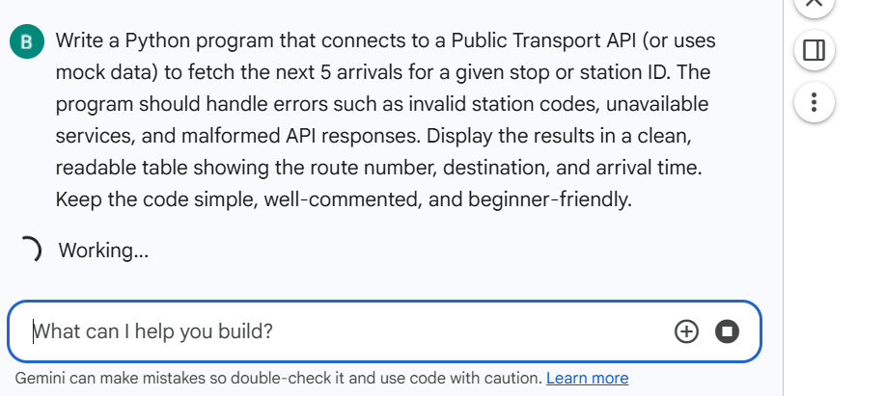

#CODE:
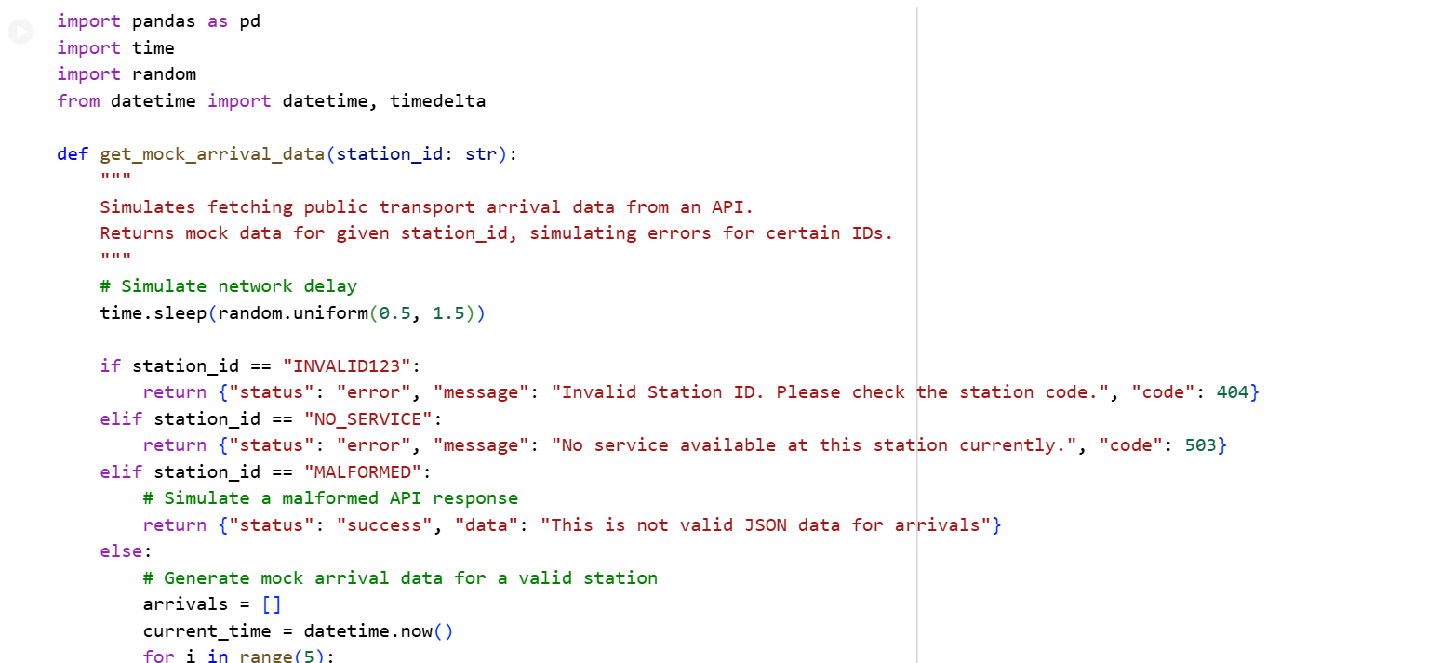
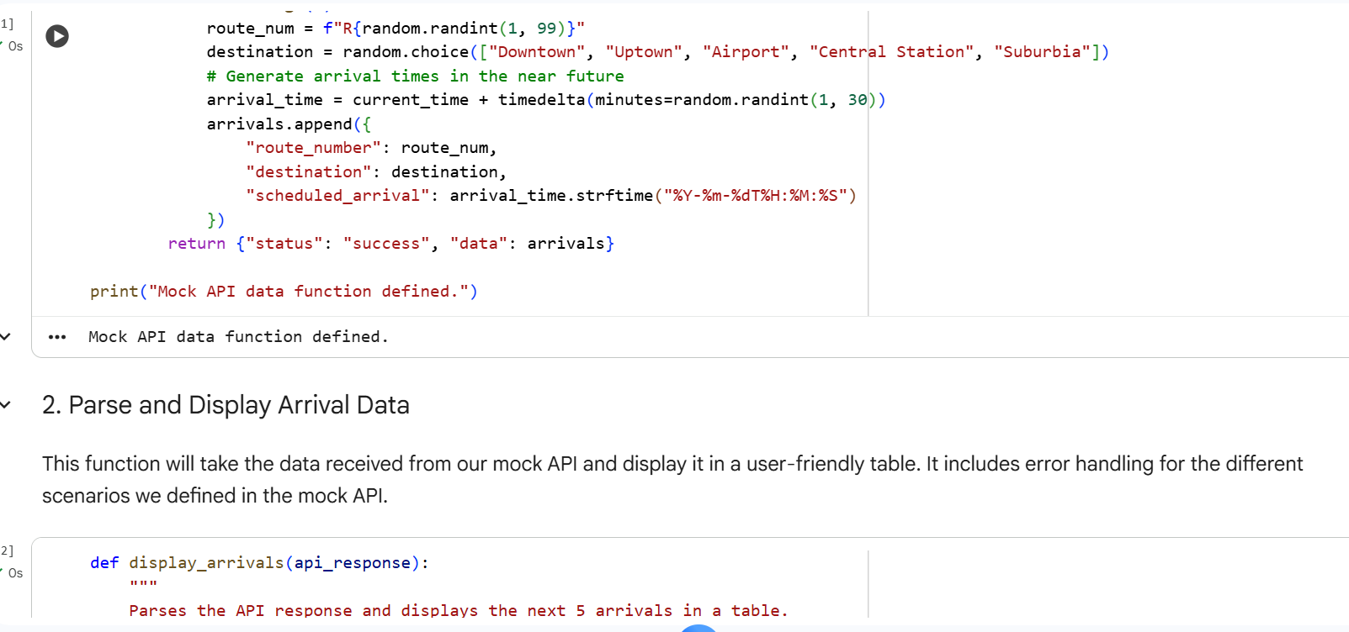
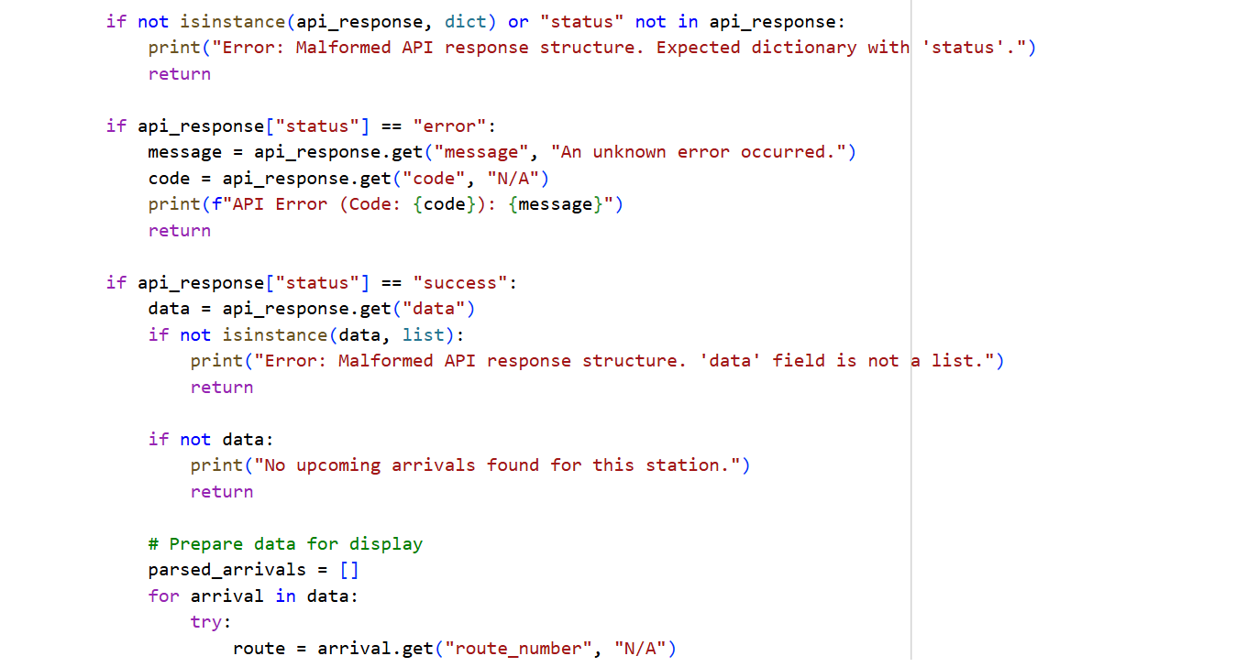
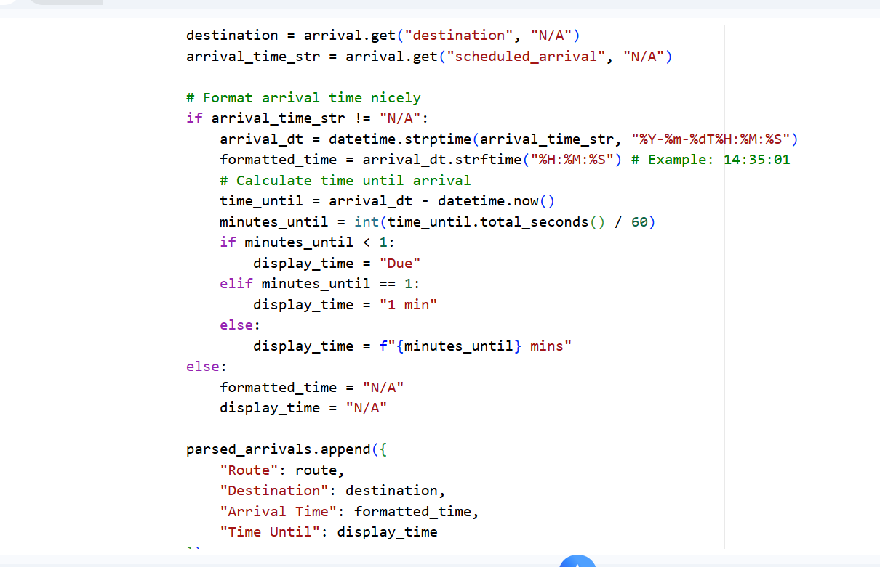
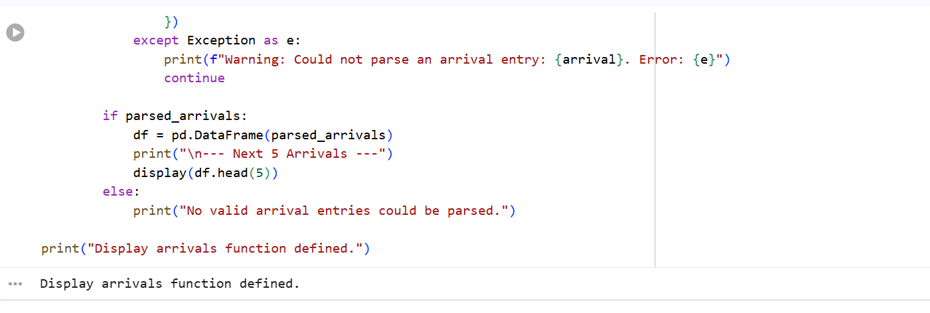
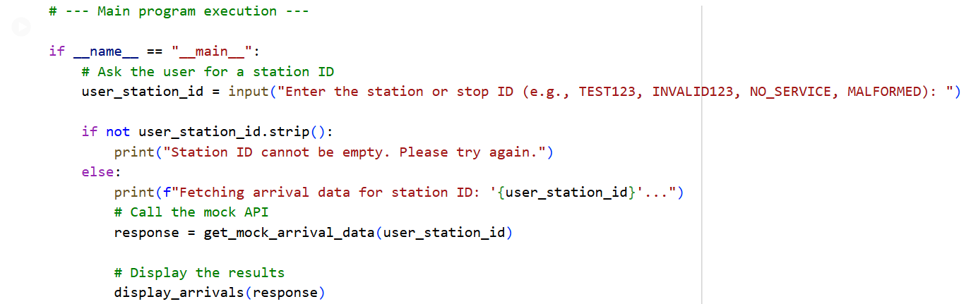#OUTPUT:
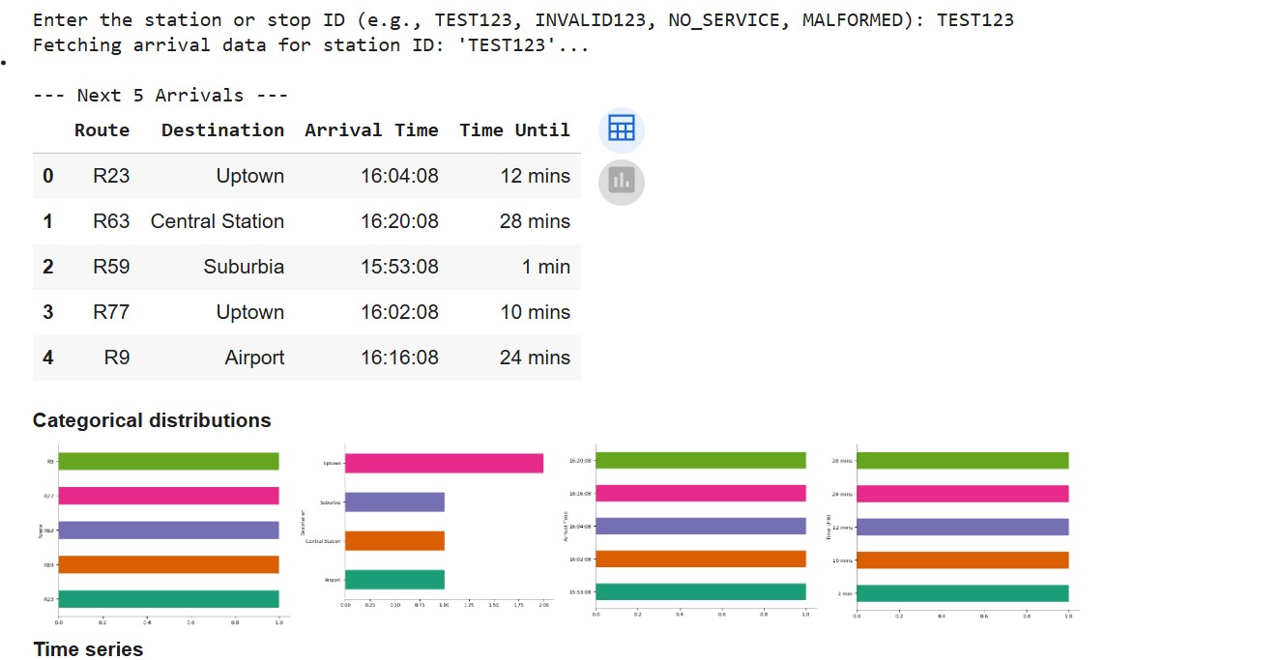
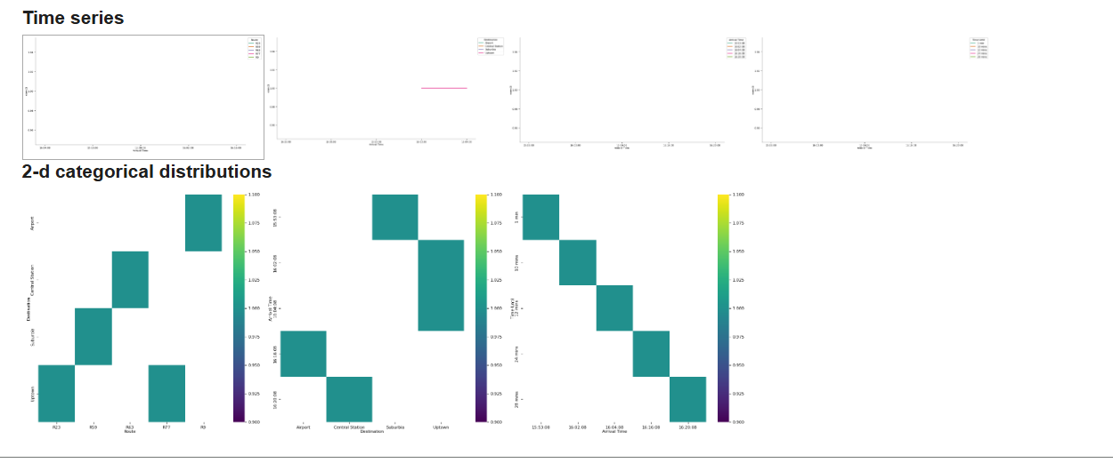
#TASK DESCRIPTION-3:
Stock Market/Financial Data API
Task: Connect to a stock data API (e.g., Alpha Vantage, Yahoo
Finance) to fetch daily stock prices.
Instructions:
Prompt AI to generate Python function to query stock data by ticker
symbol.
Handle API call limits, invalid ticker symbols, and null responses.
Display opening price, closing price, high, low, and trading volume. Give me perfect and simple prompt for the question
#PROMPT:
Write a Python program that connects to a Stock Market API (such as Alpha Vantage or Yahoo Finance) to fetch daily stock prices by ticker symbol. The program should handle errors like invalid ticker symbols, API call limits, and null responses. Display the stock’s opening price, closing price, highest price, lowest price, and trading volume in a clear and simple format. Keep the code clean, well-commented, and easy to understand.
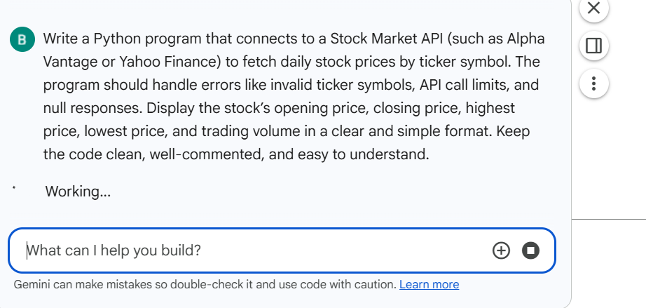
#CODE:
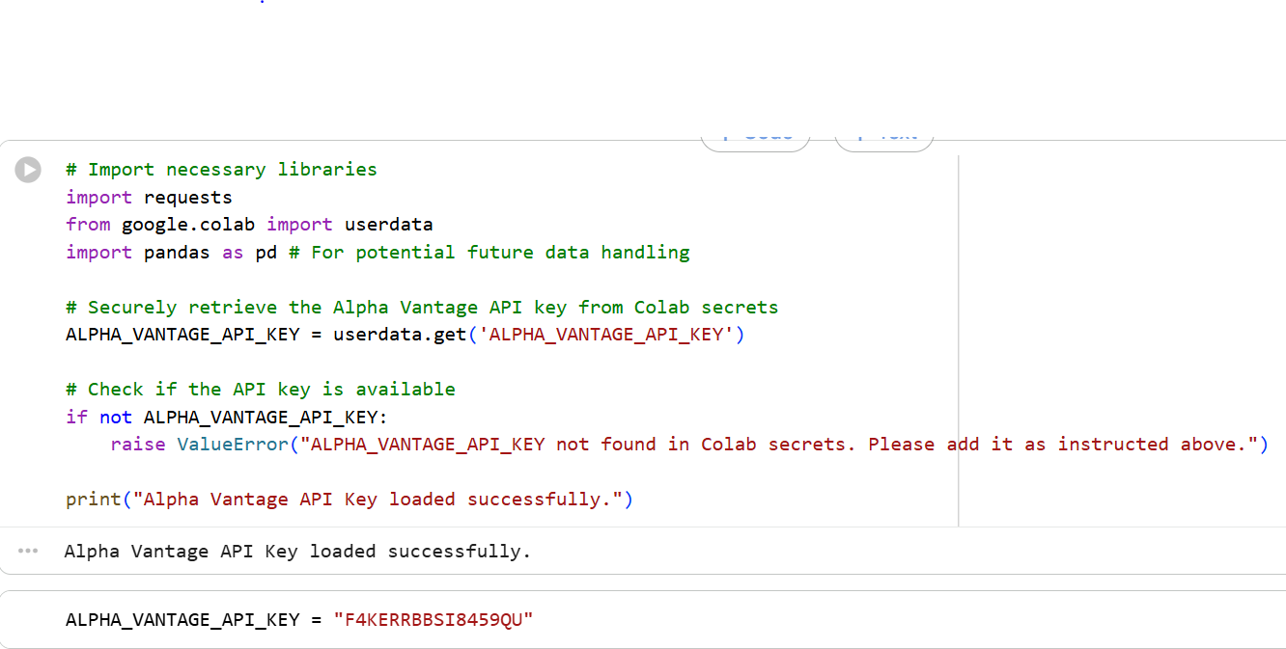
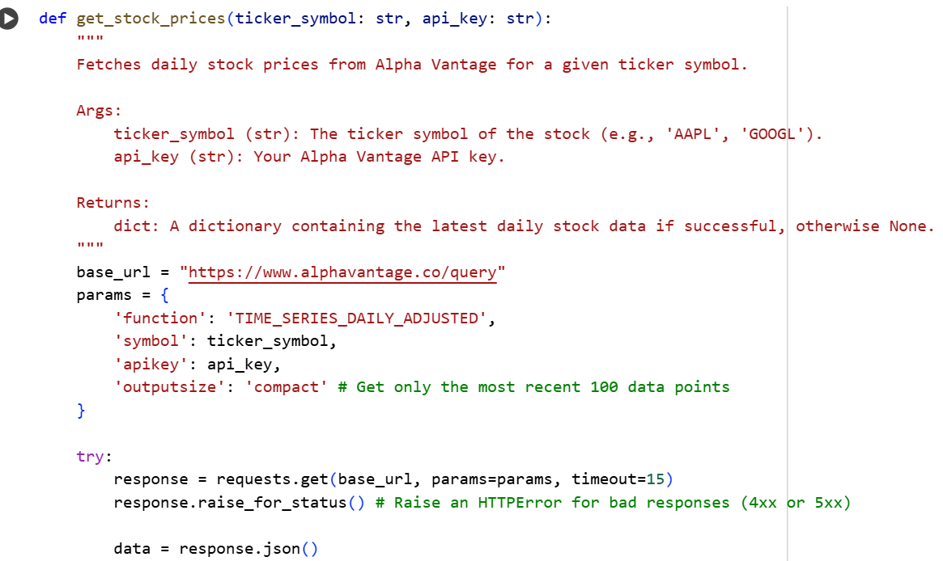
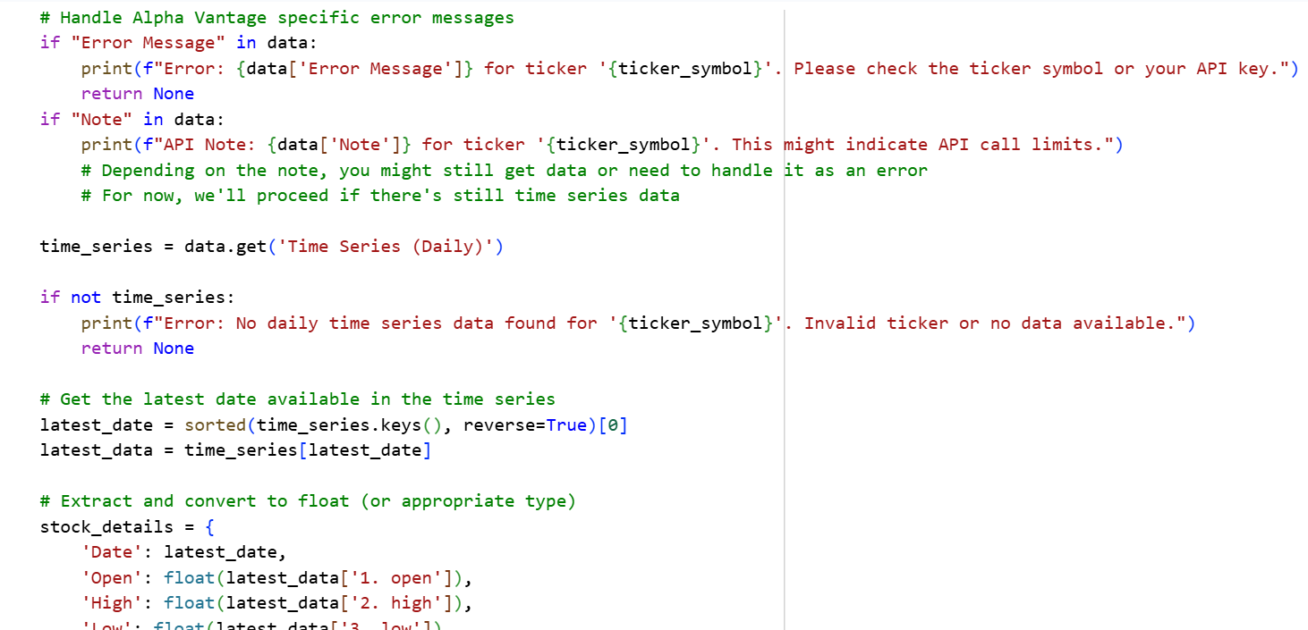
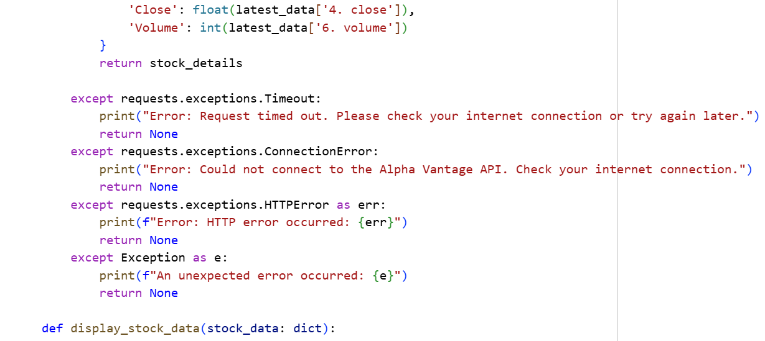
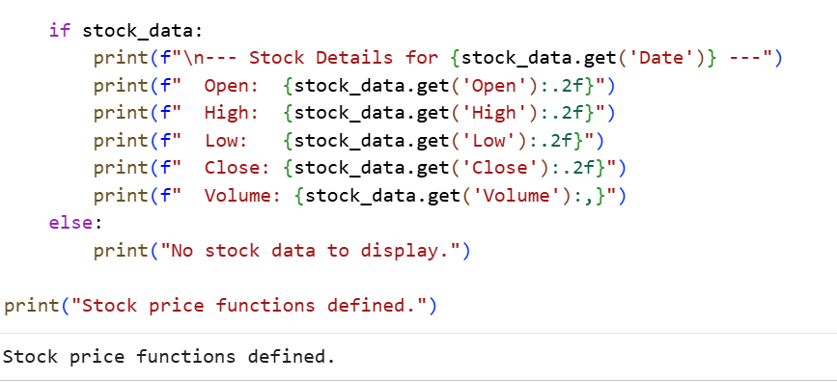
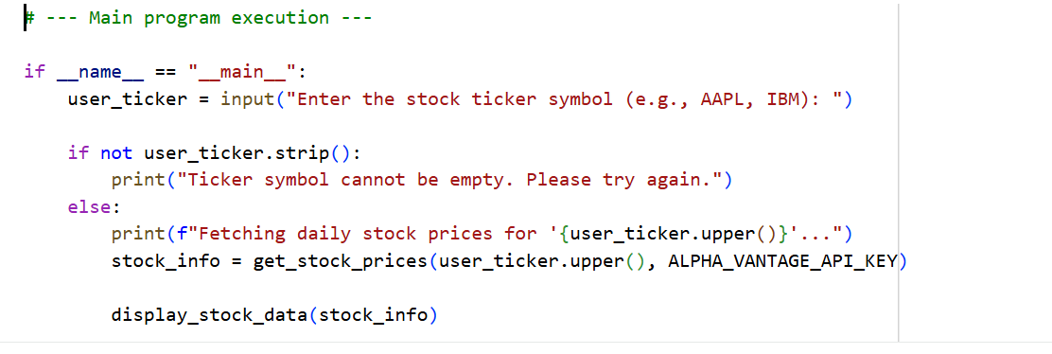
#OUTPUT:
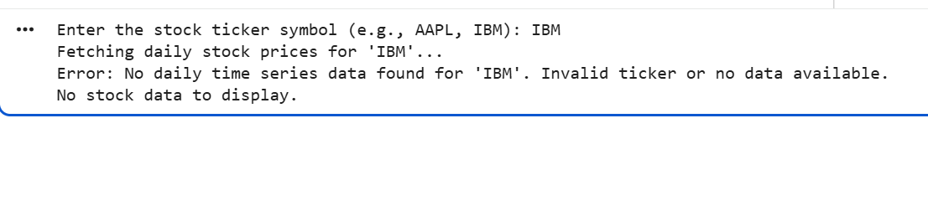

# TASK DISCRIPTION-4:
Real-Time Application: Translation API
Scenario: Build a translator using a free Translation API (e.g.,
Libre Translate, Google Translate).
Requirements:
Accept input text and target language from the user.
Handle invalid language codes, API quota exceeded, and empty text
input.
Display original and translated text clearly.
Implement a retry mechanism if the API fails on the first attempt.
#PROMPT:
Write a Python program that uses a free Translation API (like Libre Translate or Google Translate) to build a simple translator. The program should take text and a target language from the user, then display both the original and translated text clearly. Handle errors such as invalid language codes, empty input, and API quota exceeded. Include a retry mechanism to attempt the translation again if the API request fails the first time. Keep the code clean, well-commented, and easy to understand.
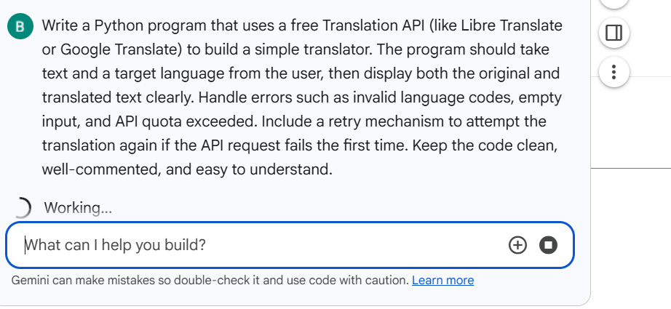
#CODE:
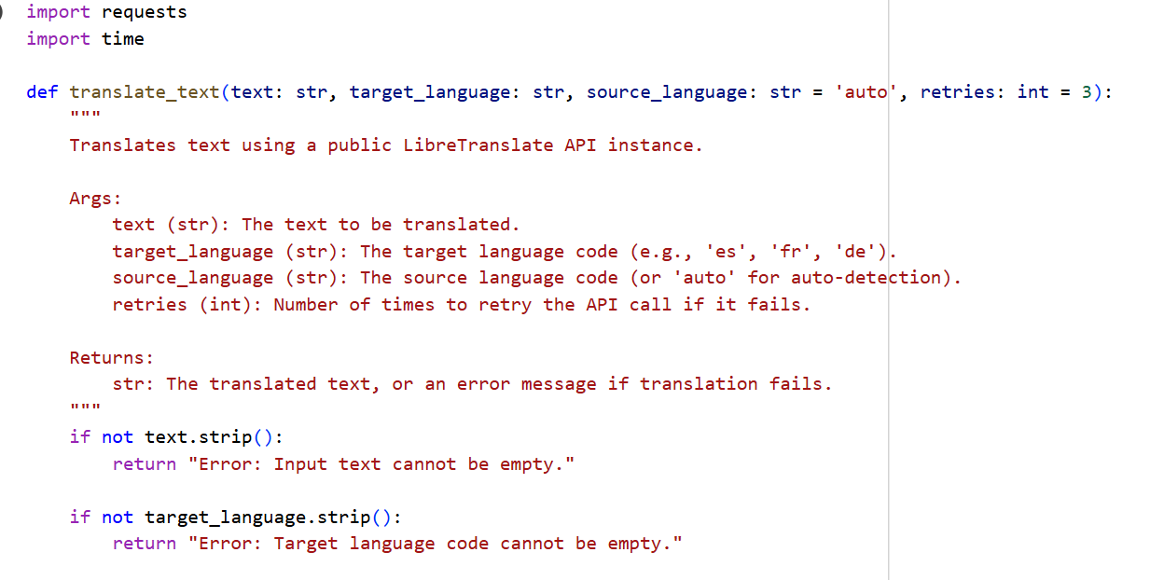
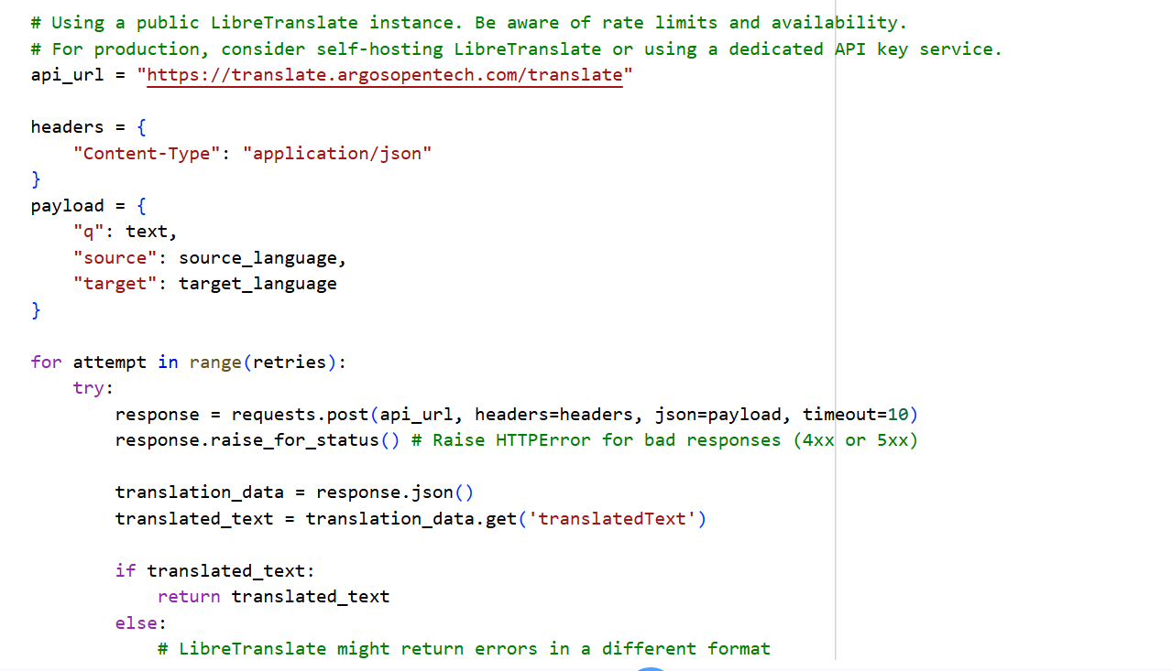
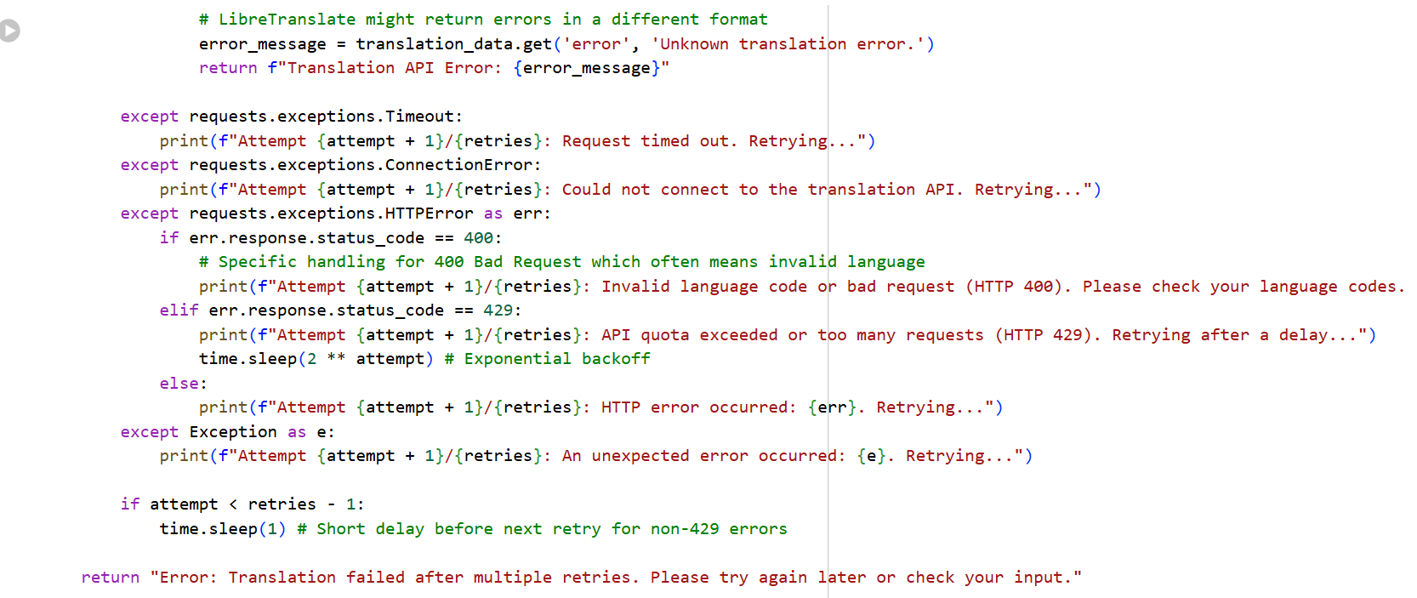
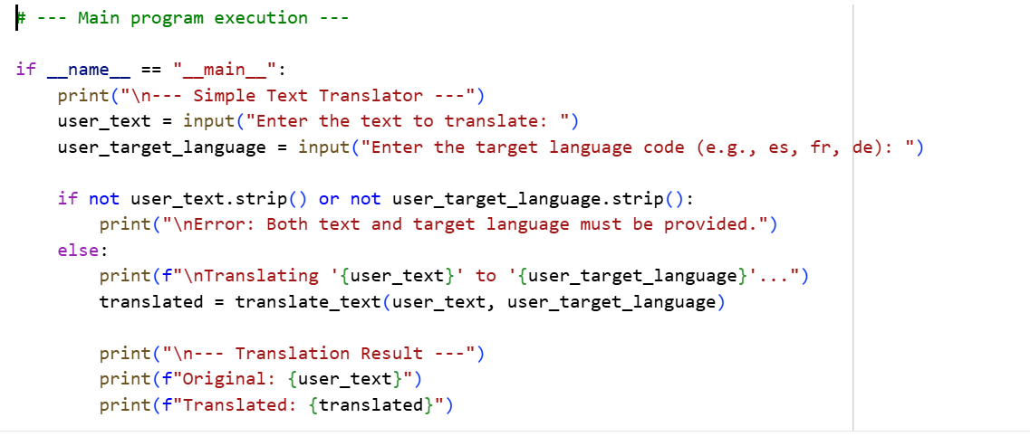
#OUTPUT:
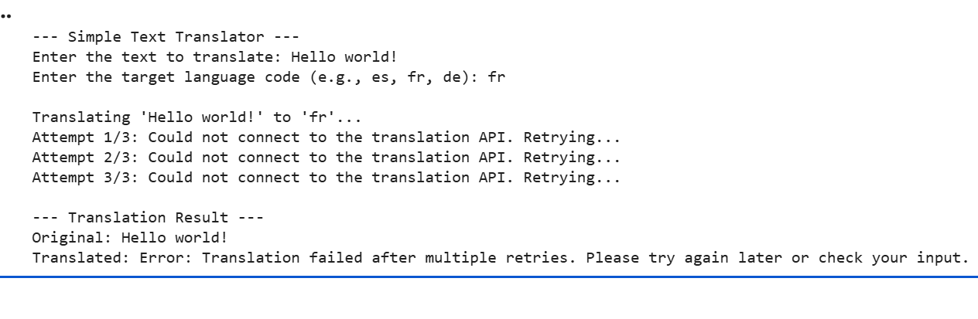

-------- Thank You-------

