By Sri Pranathi Challagolla

**2x1 Mux**: A 2x1 multiplexer selects one of two inputs based on selection line.

out = sel·i1 + sel'·i0

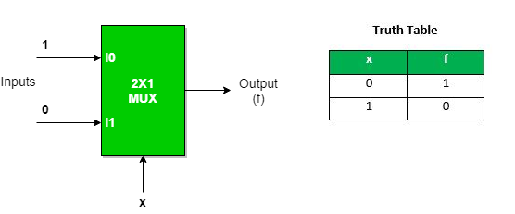

Implementation of 2x1 mux in different modelling styles:

1.Gate level modelling:

2.Data flow modelling:

Test bench for 2x1 mux:

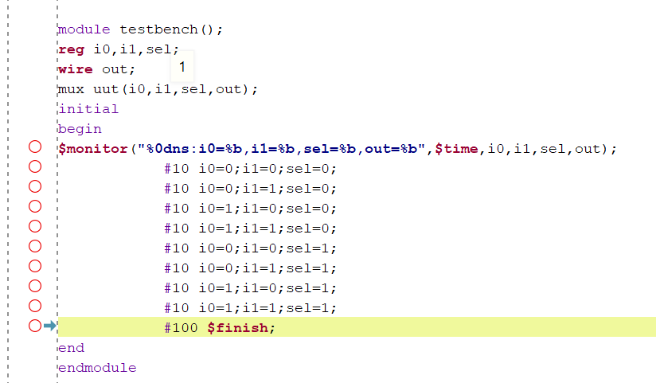

3.Behavioral modelling:

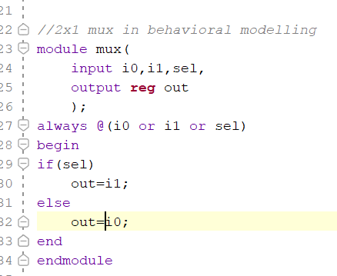

**4x1 mux:** A 4x1 multiplexer selects one of four inputs based on two select lines:  
 **out = s1·s0·i3 + s1·s0'·i2 + s1'·s0·i1 + s1'·s0'·i0.**

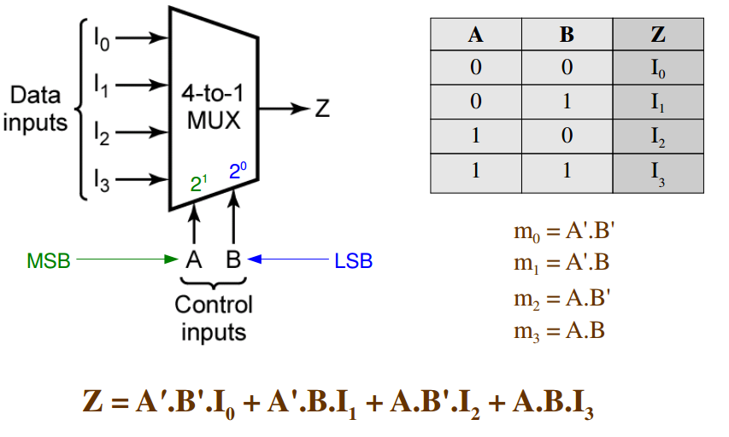

2.Data flow modelling:

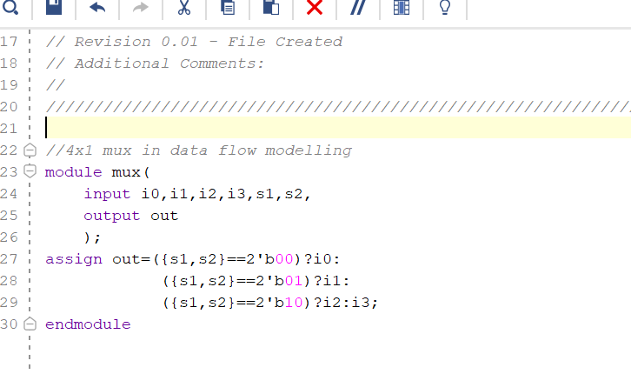

Implementation of 4x1 mux in different modelling styles:

1.Gate level modelling:

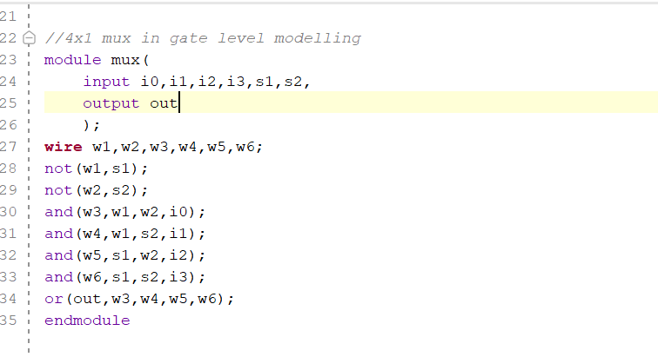

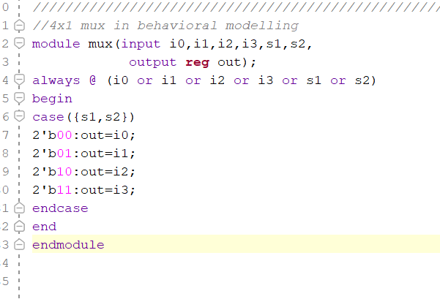

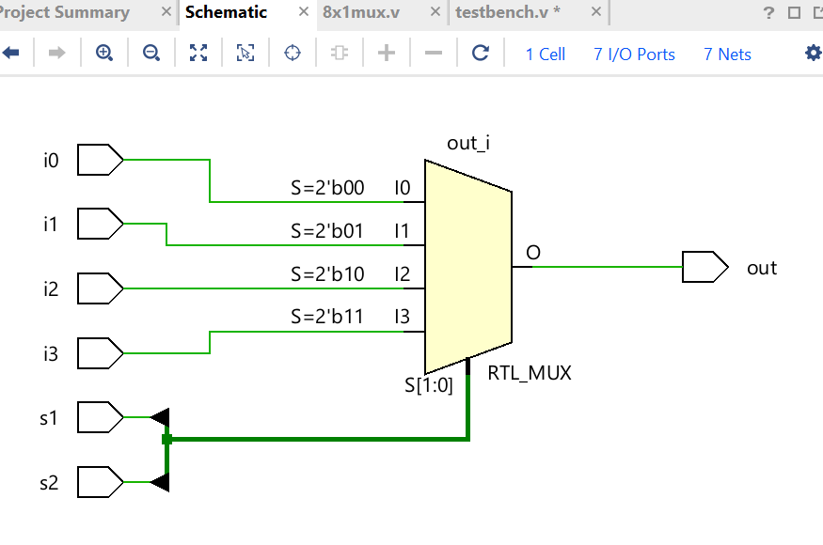

3.Behavioral modelling:

Test bench for 4x1 mux:

8x1 mux using 2x1 mux:

In an 8x1 MUX, there are 8 inputs, 3 select lines, and 1 output.

* The select lines determine which input is passed to the output.
* It can be built using seven 2x1 multiplexers in a hierarchical structure:
* First level: 4 muxes select between pairs of inputs.
* Second level: 2 muxes select between outputs of the first level.
* Third level: 1 mux selects between outputs of the second level.
* Boolean Expression:

**out = s2·s1·s0·i7 + s2·s1·s0'·i6 + s2·s1'·s0·i5 + s2·s1'·s0'·i4 + s2'·s1·s0·i3 + s2'·s1·s0'·i2 + s2'·s1'·s0·i1 + s2'·s1'·s0'·i0**

Implementation of 8x1 mux using 2x1 mux:

By Sri Pranathi Challagolla

Test bench for 8x1mux:



