CNC Digital Twin: How to Run It
A quick guide for running the MTConnect digital twin on your own laptop. It takes about five minutes.

What it is
A web page that reads live data from the Metalogi MTConnect demo agent and moves a 3D model of the machine to match. It works out the axes from the machine’s own description, so the same page runs both machines on the agent (Mazak and OKUMA).

What you need
- Python 3 (any recent version). No extra packages.
- Chrome or another modern browser.
- Internet access, to reach the Metalogi agent and to load the 3D library.
- The project folder with these files kept together: index.html, twin_simple.html, proxy.py.

Steps
- Download or unzip the project folder somewhere easy to find, such as your Desktop.
- Open a terminal in that folder. In VS Code: File → Open Folder, then Terminal → New Terminal.
- Check that proxy.py is in the folder you are in. On Windows, type dir. On Mac, type ls. If you only see another folder with the same name, cd into it.
- Start the proxy:
python proxy.py
On a Mac, use python3 proxy.py. You should see two lines starting with “Twin:” and “Agent:”. The terminal then looks stuck. That is normal: leave it open.
- Open this address in Chrome:
http://localhost:8000/index.html?device=Mazak
- Wait about 20 seconds. The status line turns green and the parts start to move.
- To see the other machine, pick it from the Device dropdown.
- When you are done, click in the terminal and press Ctrl + C to stop the proxy.

What you should see
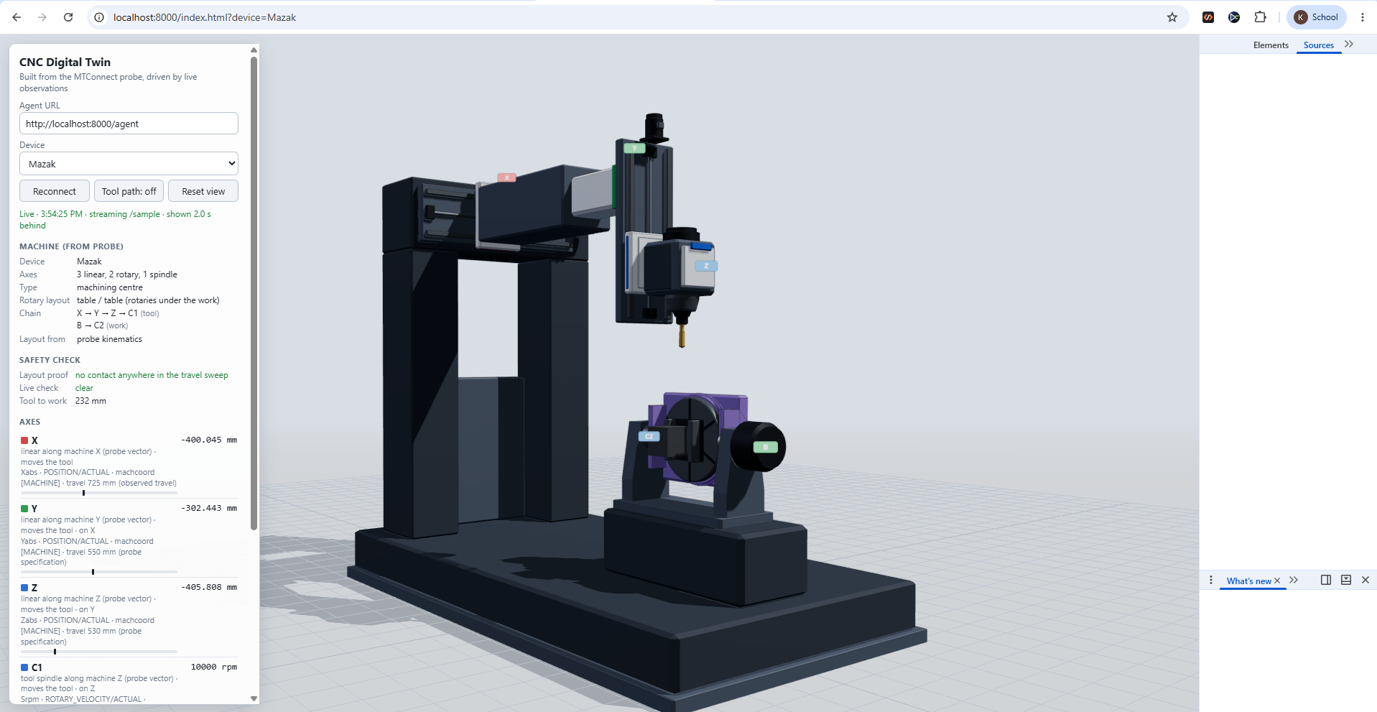
- Status line: green, saying “Live · streaming /sample”.
- Machine: the axes it found and how they are chained together.
- Safety check: both lines should be green.
- Axes: the live value of every axis. These are the numbers that drive the model.
Drag to rotate the view, scroll to zoom, and right-drag to pan.

The two versions
File | Address | What it is
index.html | localhost:8000/index.html | Full version: detailed parts, true-scale motion, collision check, tool path.
twin_simple.html | localhost:8000/twin_simple.html | Simple version: plain boxes, about 280 lines. Easier to read.
Add ?device=Mazak or ?device=OKUMA to either address.

If something goes wrong
What you see | What to do
“can’t open file proxy.py” | You are in the wrong folder. Find the folder that contains proxy.py and cd into it.
The page will not load at all | The proxy is not running. Start it again with python proxy.py.
Red “Agent not reachable” | Check your internet. The Metalogi demo site may also be down: try opening demo.metalogi.io.
Blank grey page, no model | The 3D library did not load. Check your internet and refresh.
Nothing is moving | Look at the numbers in the Axes list. If they are not changing, the machine is idle. OKUMA sits still for minutes at a time, so try Mazak.
The page looks like an old version | Press Ctrl + Shift + R to force a full refresh.
“Address already in use” | A proxy is already running in another terminal. Use that one, or close it first.
The model only moves while proxy.py is running on your own laptop, so each person needs to run it themselves.

