FRONTEND

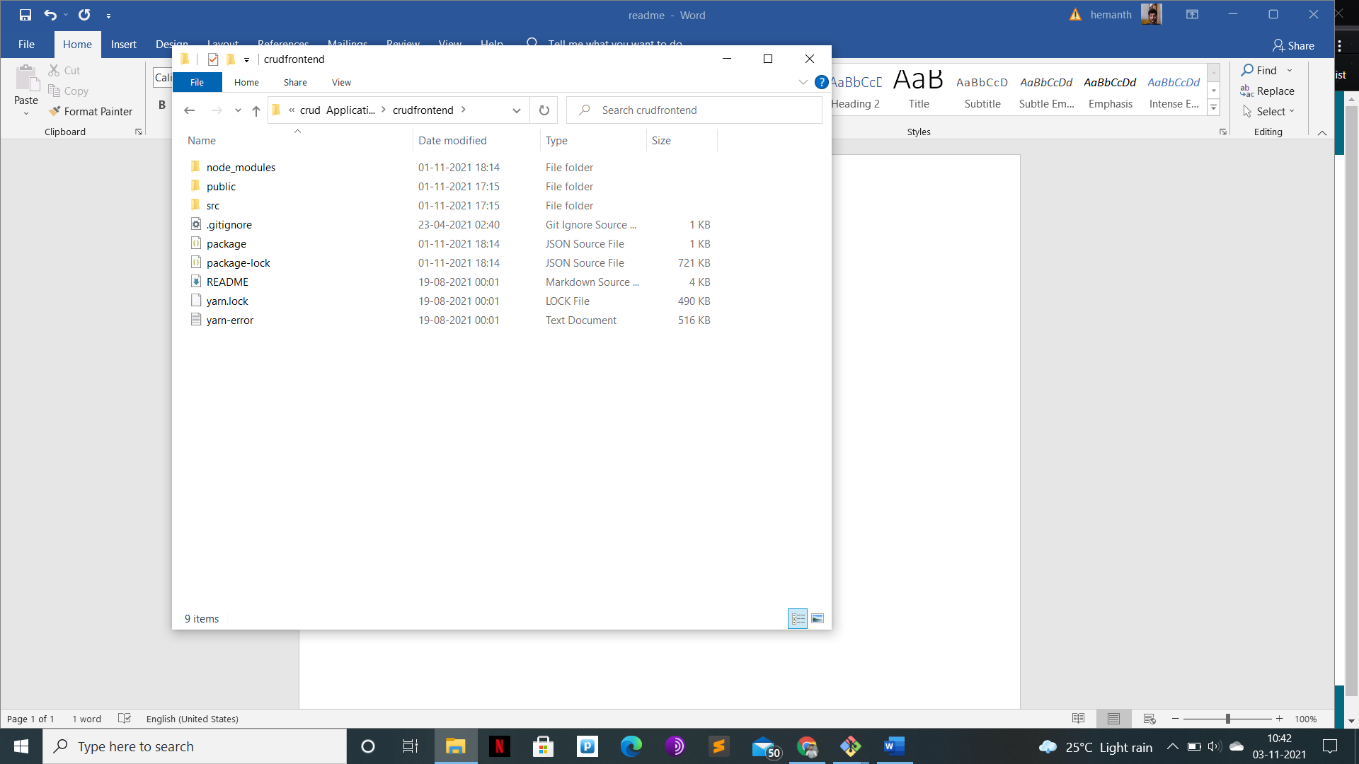

Open Git bash in the above folder

And run npm install

To install necessary modules

And then run npm start

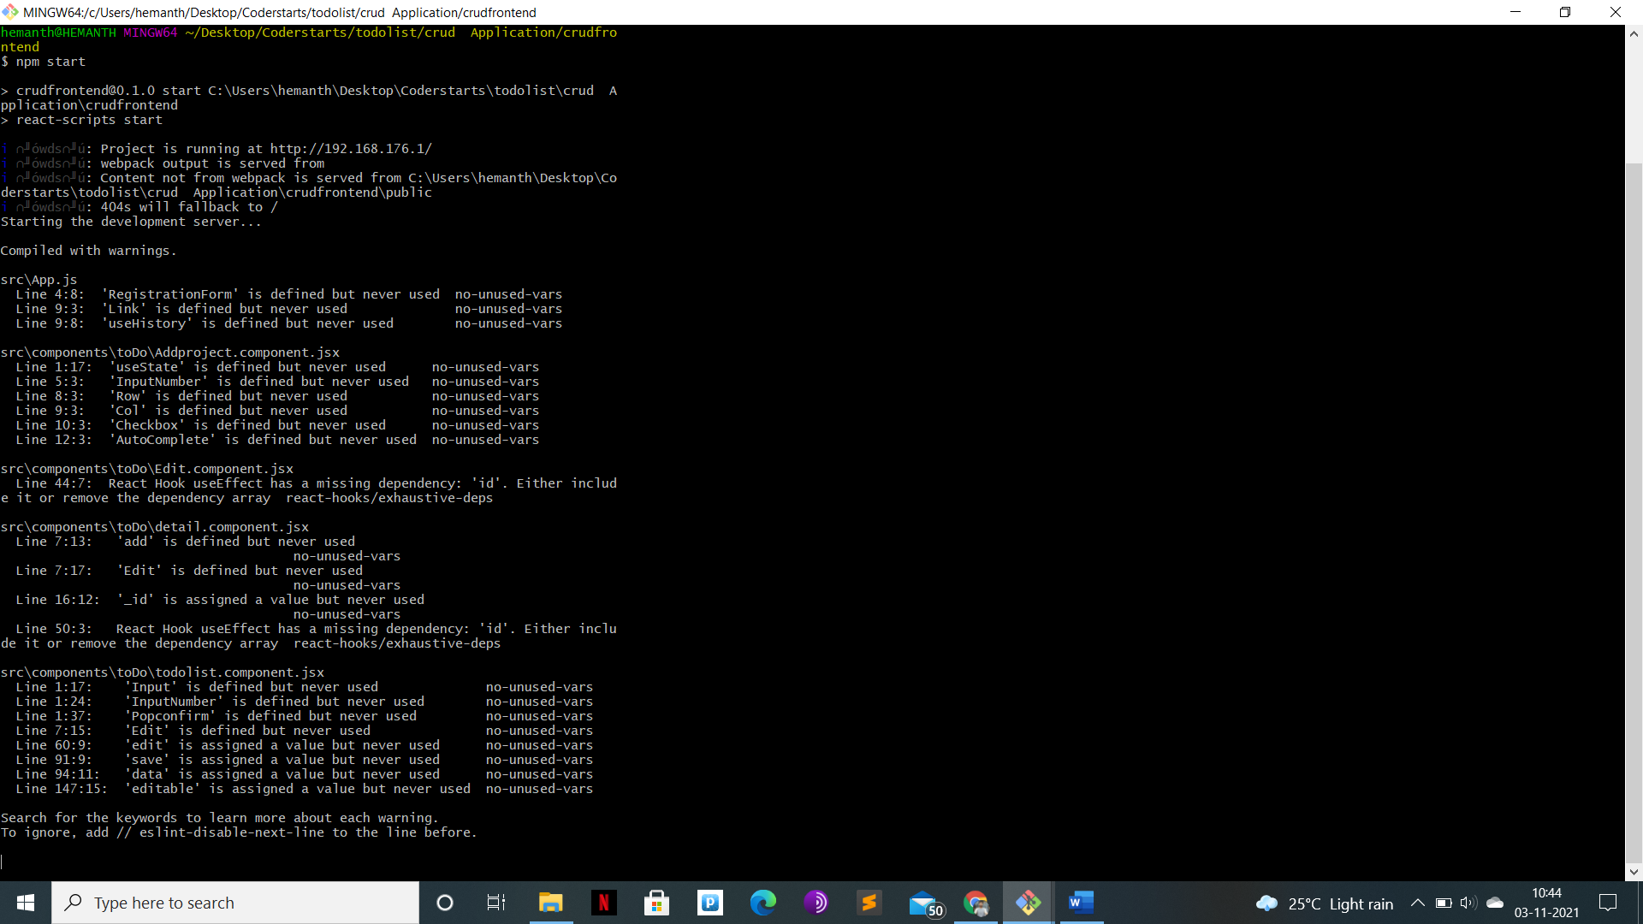

**BACKEND**

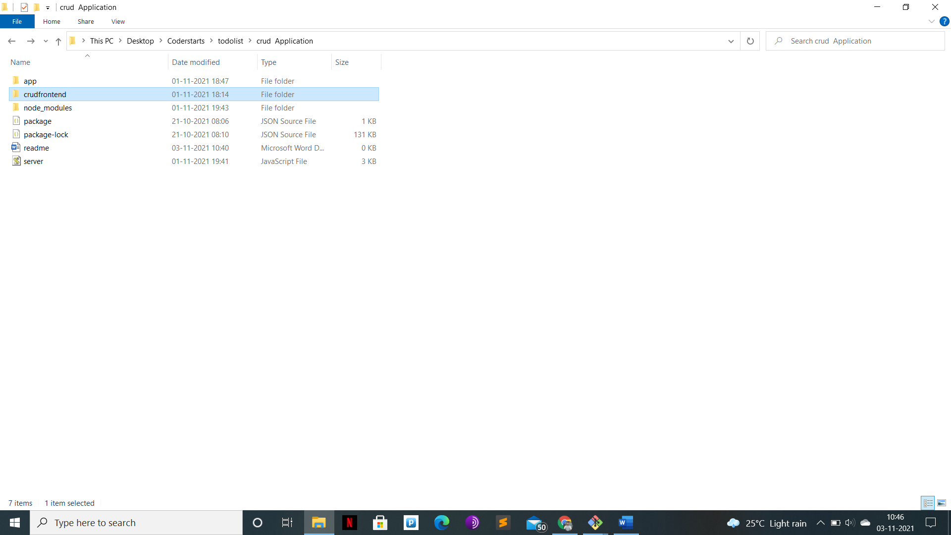

Open git bash and run npm install

And run npm start

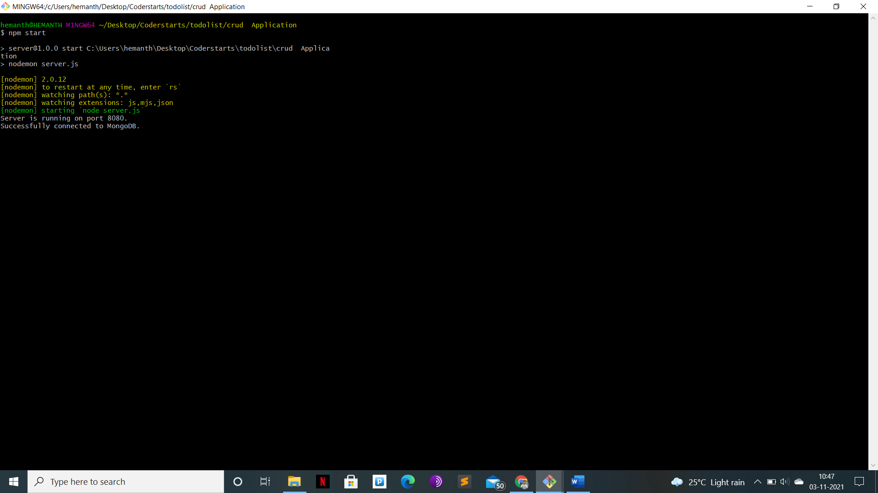

**DATABASE**

Install mongodb command line