**چمران معینی**

**شماره دانشجویی: ۹۹۳۱۰۵۳**

**سوالات اصلی**

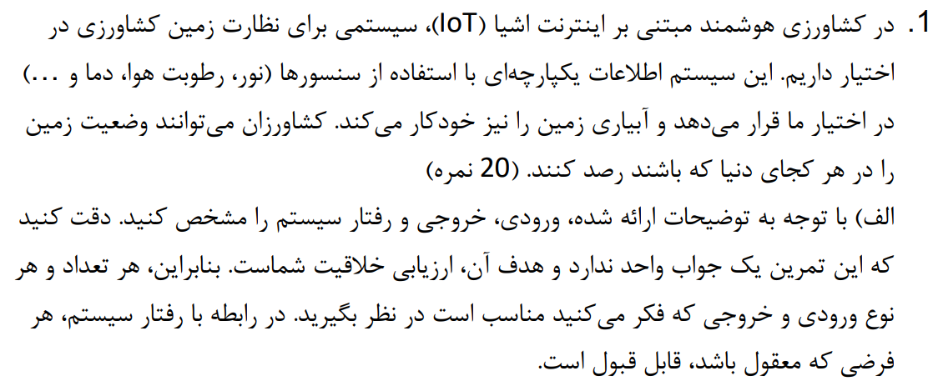

۱. الف)

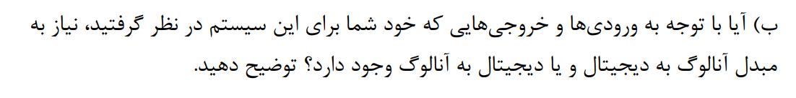

۱. ب)

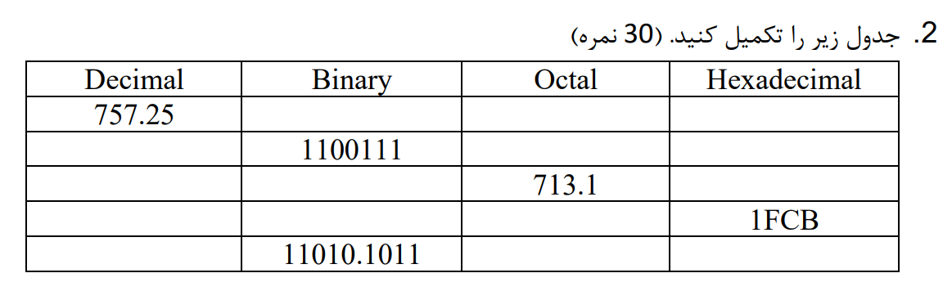

|  |  |  |  |
| --- | --- | --- | --- |
| Hexadecimal | Octal | Binary | Decimal |
| 2D5.4 | 1325.2 | 1011010101.01 | 757.25 |
| 67 | 147 | 1100111 | 103 |
| 1CB.2 | 713.1 | 111001011.001 | 459.125 |
| 1FCB | 17713 | 1111111001011 | 8139 |
| 1A.B | 32.54 | 11010.1011 | 26.6875 |

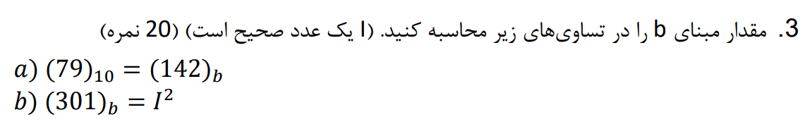

$${\left(79\right)}_{10}={\left(142\right)}_{b}→2{\left(b\right)}^{0}+4{\left(b\right)}^{1}+1{\left(b\right)}^{2}={\left(79\right)}_{10}→b^{2}+4b-77=0→\left(b-7\right)\left(b+11\right)$$

$$→b=7$$

$${\left(301\right)}_{b}=I^{2}→3b^{2}+1=I^{2}→b^{2}=\frac{I^{2}-1}{3}=\frac{\left(I-1\right)\left(I+1\right)}{3}=\frac{\left(I-1\right)}{3}\left(I+1\right)\underset{→}{I=7}b^{2}=16→b=4$$

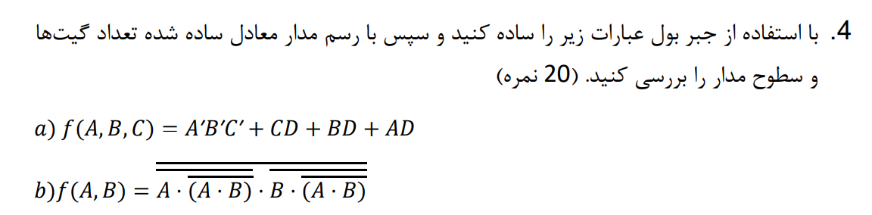

$$a) f\left(A,B,C\right)=A^{'}B^{'}C^{'}+CD+BD+AD→Factoring→A^{'}B^{'}C^{'}+\left(A+B+C\right)D→DeMorgan’s Law→\overline{\left(A+B+C\right)}+\left(A+B+C\right)D→Absorption Property →\overline{\left(A+B+C\right)}+D$$

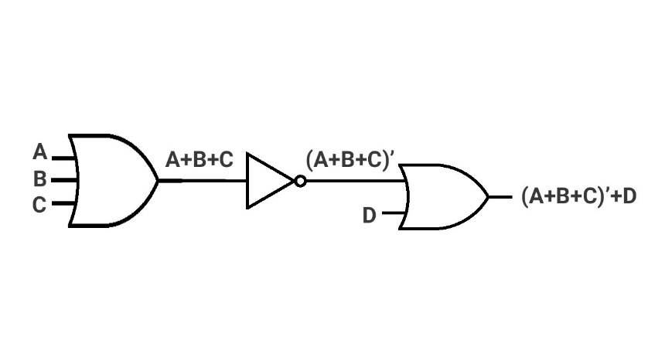

$b) f$ 𝐴,𝐵= $\text{A.}\text{A.B}$.𝐵.(𝐴.𝐵)→**𝑫𝒆𝑴𝒐𝒓𝒈𝒂𝒏**’**𝒔** **𝑳𝒂𝒘**→𝐴. $\text{A.B}$ +𝐵. $\text{A.B}$ →**𝑭𝒂𝒄𝒕𝒐𝒓𝒊𝒏𝒈**→ $\text{A.B}$ 𝐴+𝐵→**𝑫𝒆𝑴𝒐𝒓𝒈𝒂𝒏**’**𝒔** **𝑳𝒂𝒘**→ $\text{A}$′+𝐵′𝐴+𝐵→**𝑴𝒖𝒍𝒕𝒊𝒑𝒍𝒚𝒊𝒏𝒈 𝑶𝒖𝒕**→𝐴𝐵′+𝐵𝐴′



AC’ + BC + AB’ = X

B’C’ + A’B + AC = Y

|  |  |  |  |  |  |  |  |  |  |  |
| --- | --- | --- | --- | --- | --- | --- | --- | --- | --- | --- |
| **Y** | AC | A’B | B’C’ | **X** | AB’ | BC | AC’ | C | B | A |
| **1** | 1 | 0 | 0 | **1** | 0 | 1 | 0 | 1 | 1 | 1 |
| **1** | 1 | 0 | 0 | **1** | 0 | 0 | 1 | 0 | 1 | 1 |
| **0** | 0 | 0 | 0 | **1** | 1 | 0 | 0 | 1 | 0 | 1 |
| **1** | 0 | 0 | 1 | **1** | 1 | 0 | 1 | 0 | 0 | 1 |
| **1** | 0 | 1 | 0 | **1** | 0 | 1 | 0 | 1 | 1 | 0 |
| **1** | 0 | 1 | 0 | **0** | 0 | 0 | 0 | 0 | 1 | 0 |
| **0** | 0 | 0 | 0 | **0** | 0 | 0 | 0 | 1 | 0 | 0 |
| **1** | 0 | 0 | 1 | **0** | 0 | 0 | 0 | 0 | 0 | 0 |

همان‌طور که مشاهده می‌کنیم، در سه حالت تساوی بالا برقرار نیست، پس نادرست است.



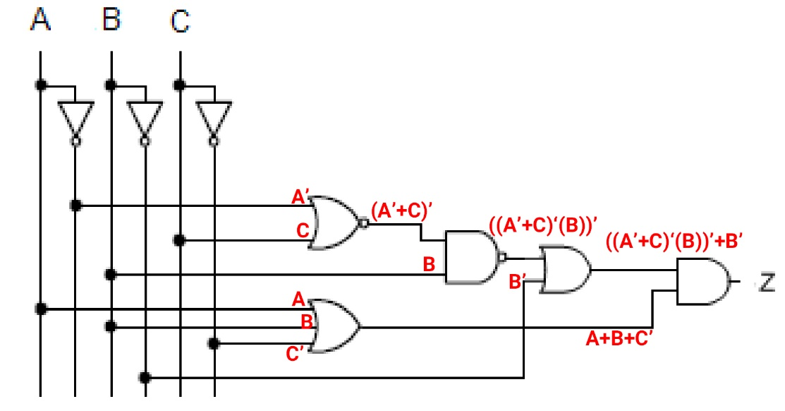

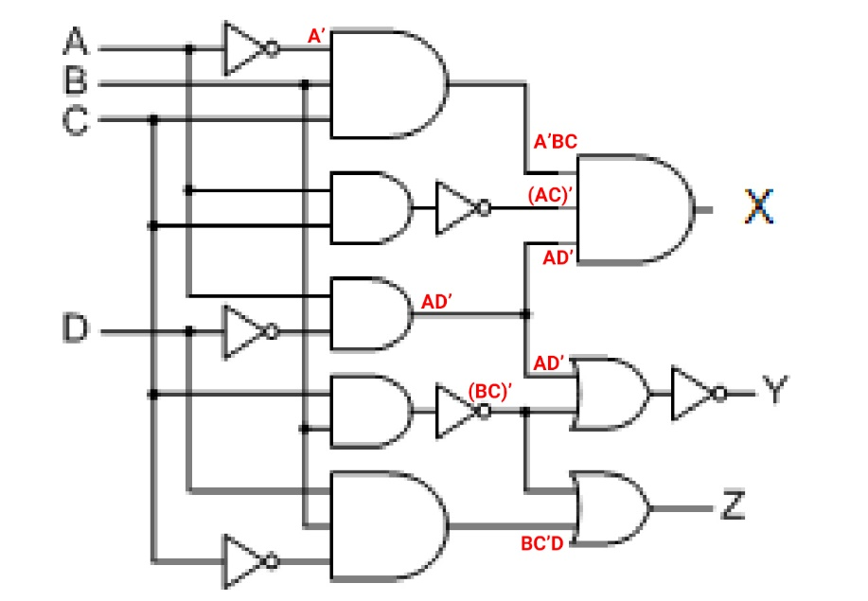

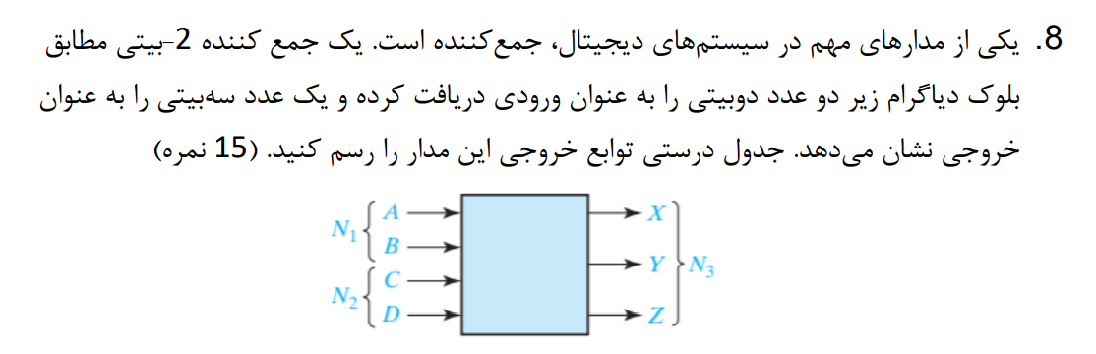

|  |  |  |  |  |  |  |  |  |  |
| --- | --- | --- | --- | --- | --- | --- | --- | --- | --- |
| A | B | N(1) | C | D | N(2) | X | Y | Z | N(3) |
| 0 | 0 | 0 | 0 | 0 | 0 | 0 | 0 | 0 | 0 |
| 0 | 0 | 0 | 0 | 1 | 1 | 0 | 0 | 1 | 1 |
| 0 | 0 | 0 | 1 | 0 | 2 | 0 | 1 | 0 | 2 |
| 0 | 0 | 0 | 1 | 1 | 3 | 0 | 1 | 1 | 3 |
| 0 | 1 | 1 | 0 | 0 | 0 | 0 | 0 | 1 | 1 |
| 0 | 1 | 1 | 0 | 1 | 1 | 0 | 1 | 0 | 2 |
| 0 | 1 | 1 | 1 | 0 | 2 | 0 | 1 | 1 | 3 |
| 0 | 1 | 1 | 1 | 1 | 3 | 1 | 0 | 0 | 4 |
| 1 | 0 | 2 | 0 | 0 | 0 | 0 | 1 | 0 | 2 |
| 1 | 0 | 2 | 0 | 1 | 1 | 0 | 1 | 1 | 3 |
| 1 | 0 | 2 | 1 | 0 | 2 | 1 | 0 | 0 | 4 |
| 1 | 0 | 2 | 1 | 1 | 3 | 1 | 0 | 1 | 5 |
| 1 | 1 | 3 | 0 | 0 | 0 | 0 | 1 | 1 | 3 |
| 1 | 1 | 3 | 0 | 1 | 1 | 1 | 0 | 0 | 4 |
| 1 | 1 | 3 | 1 | 0 | 2 | 1 | 0 | 1 | 5 |
| 1 | 1 | 3 | 1 | 1 | 3 | 1 | 1 | 0 | 6 |

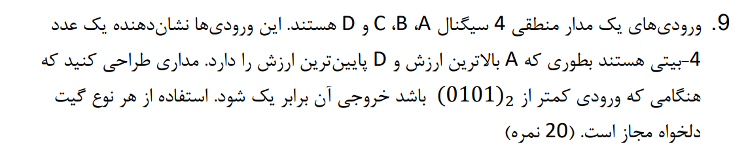

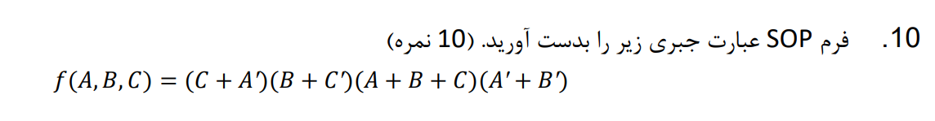

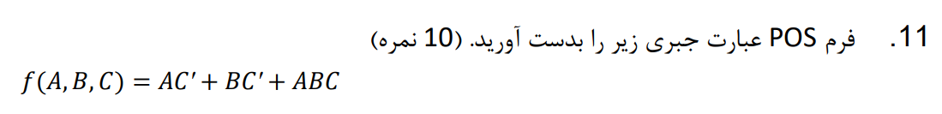

$$f\left(A,B,C\right)=AC^{'}+BC^{'}+ABC→FACTOR→A\left(C^{'}+BC\right)+BC$$

