

Executive Summary
GlobalMart dashboard uses four worksheets to analyze 9,426 e-commerce transactions. Due to discounts in Technology western region shows 4.9% profit-margin regardless of high sales. Regional inefficiencies, suggested discount controls, optimized shipping and prioritization of corporate segment (From 19.75 % has 45.89% profit) revealed by coordinated-filtering.
Table of Contents
Executive Summary 1
Question-1:Which geographic regions drive profitability? 1
Question-2:How do product categories perform over time? 2
Question-3:How do discount rates affect profitability? 3
Question-4:Which shipping modes optimize delivery? 5
Question-5:How do customer segments differ? 6
Scenario of Usage 7
Research Background 9
Reflection 9
Conclusions and recommendations 10
Reference 11

Question-1:Which geographic regions drive profitability?
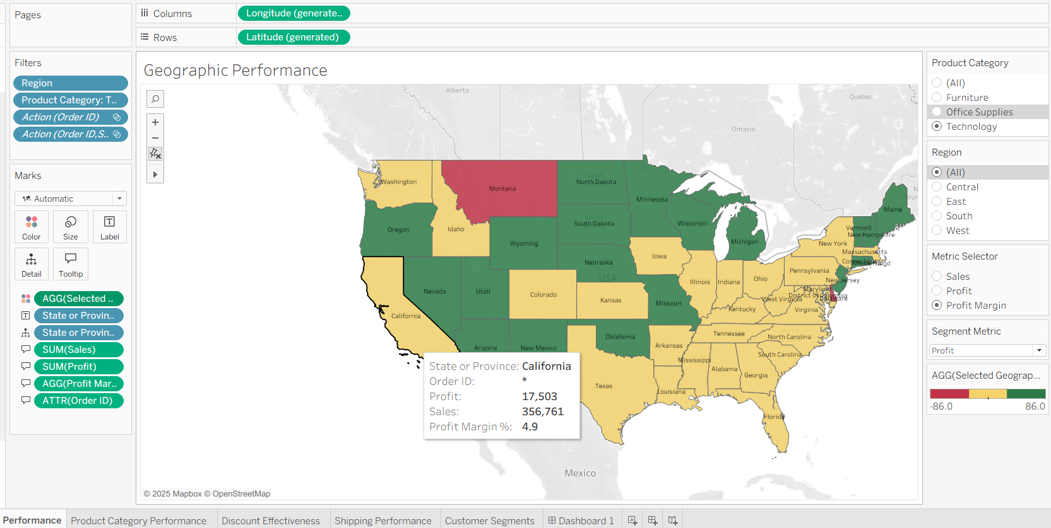
Visualization Type :Filled Geographic Map.
Uses diverging red-green-gold for geographic performance and Profit Margin % comparison of scale -independent.
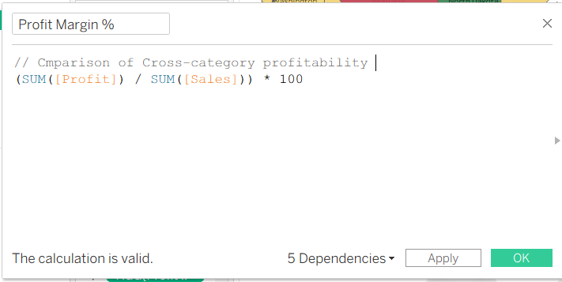

Visual-Encoding:
- Red = negative margins
- Yellow = break-even
- Green = profitability
- Change scale to ensure real-time map updates.
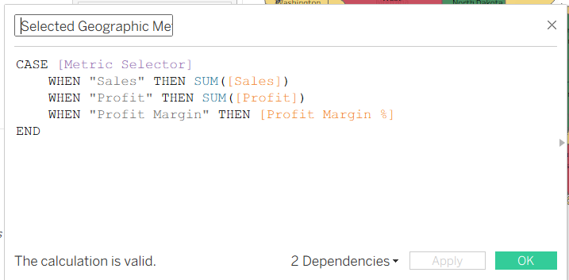

Design-Appropriateness: Distributing data on the map is quite natural, people are programmed to read geography. Color saturation enables to gaze at the 50 states simultaneously.
Answer: The Western region margin is 4.9, Montana was negative. Technological discounting only makes it worse (loss of approximately 25 568). The central-eastern regions are solid and remain more than 10 percent in margins.

Question-2:How do product categories perform over time?

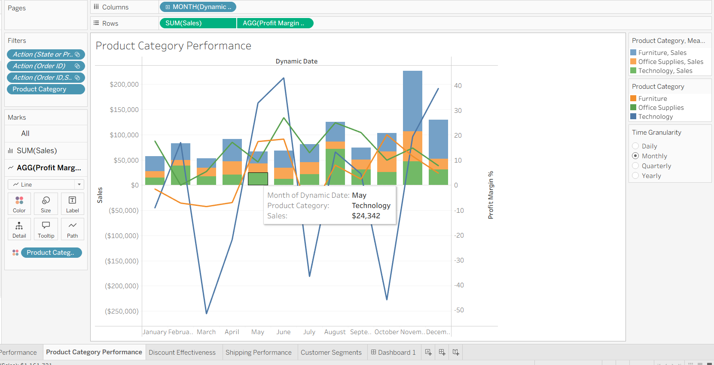
Visualization Type: Dual-Axis Combination Chart.
Place bars of sales on the first axis and plot margins on the second axis- is honest with both measures.
Visual Encoding: Length of bars, Position of lines, Colors remain the same: Technology(blue),Office(green),Furniture(orange).Drag dates to any granularity.
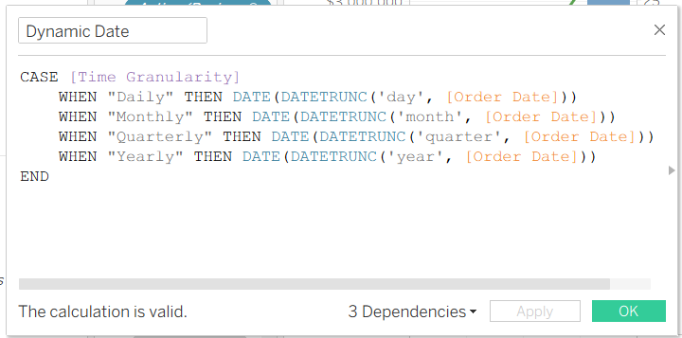
Design-Appropriateness: A two-axis display of the volume/rate interaction will loss data with one axis, which would have been opaque.
Answer: Technology has the volume but its margins are negative in the months of February, April and September. The maximum trims are in May of $24,342 and August of $72,171. Office has a range of 10-15% whereas Furniture has the highest margin.

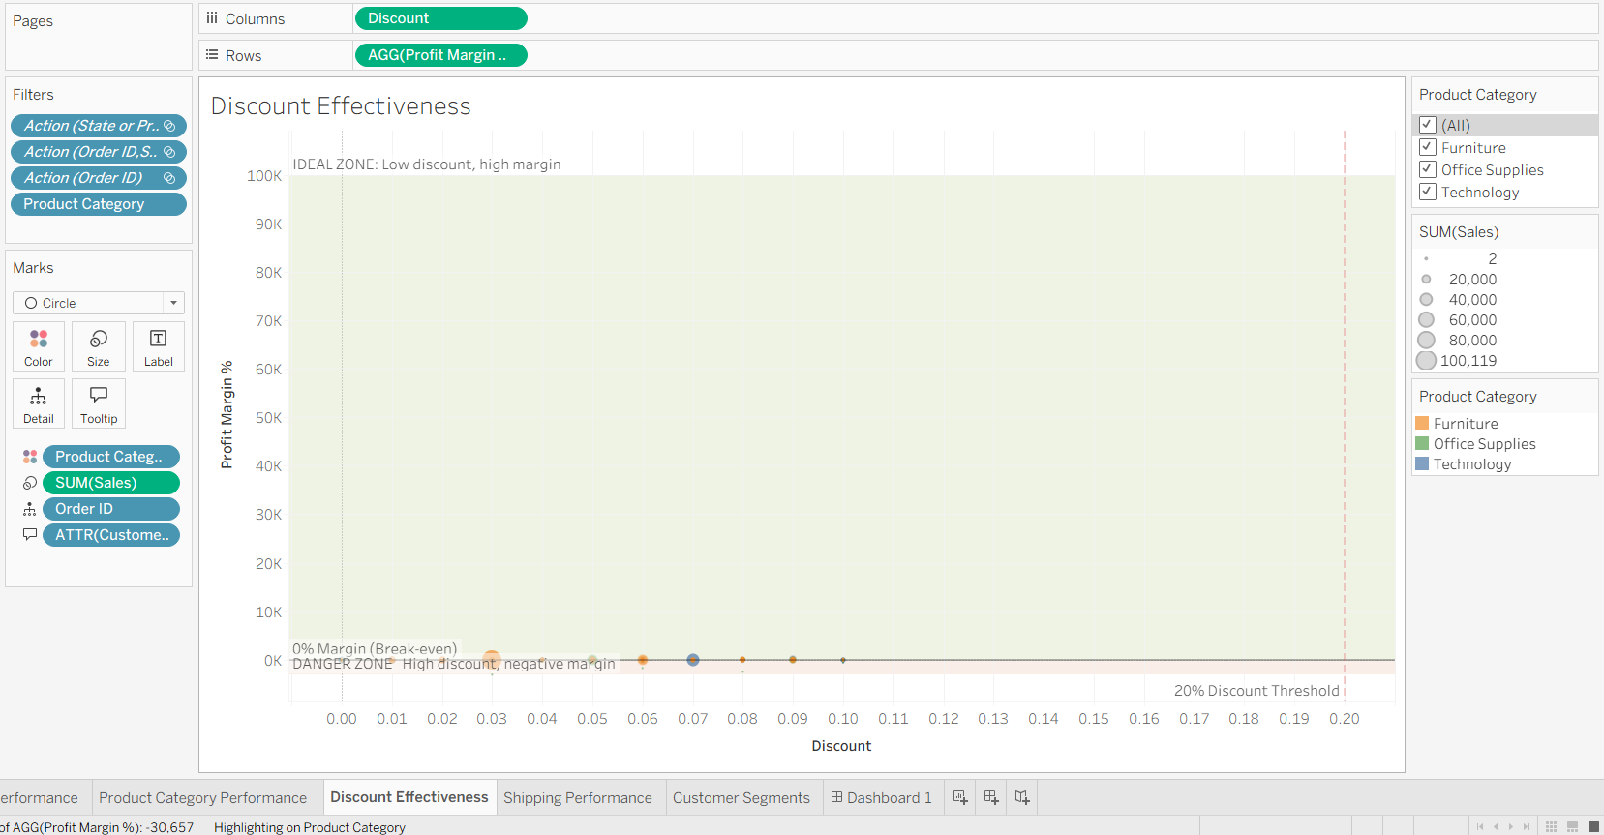
Question-3:How do discount rates affect profitability?

Visualization Type: Scatter Plot with Reference Zones
Plot discount on X, margin on Y, and have value of bubble in the form of value.
The zones serve: green “IDEAL ZONE” vs red “DANGER ZONE”.
Visual-Encoding: Position encoding exploits the perceptual superiority; the discount bands assist sectioning of data. Lasso also allows to point out a cluster.
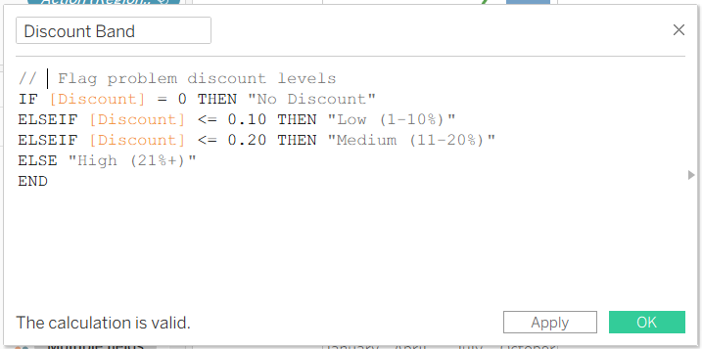
Design-Appropriateness: Scatter plots are excellent in identifying correlation. Downward trend = less ,discount = less margin.
Response: Negative correlation is evident. Order #2433 (9% margin, 7% discount, sales of 43,046) is in danger zone. Technology is mostly present here. Filtering the West only becomes the density even more intensified. The sweet spot is 5‑15% discount.

Question-4:Which shipping modes optimize delivery?
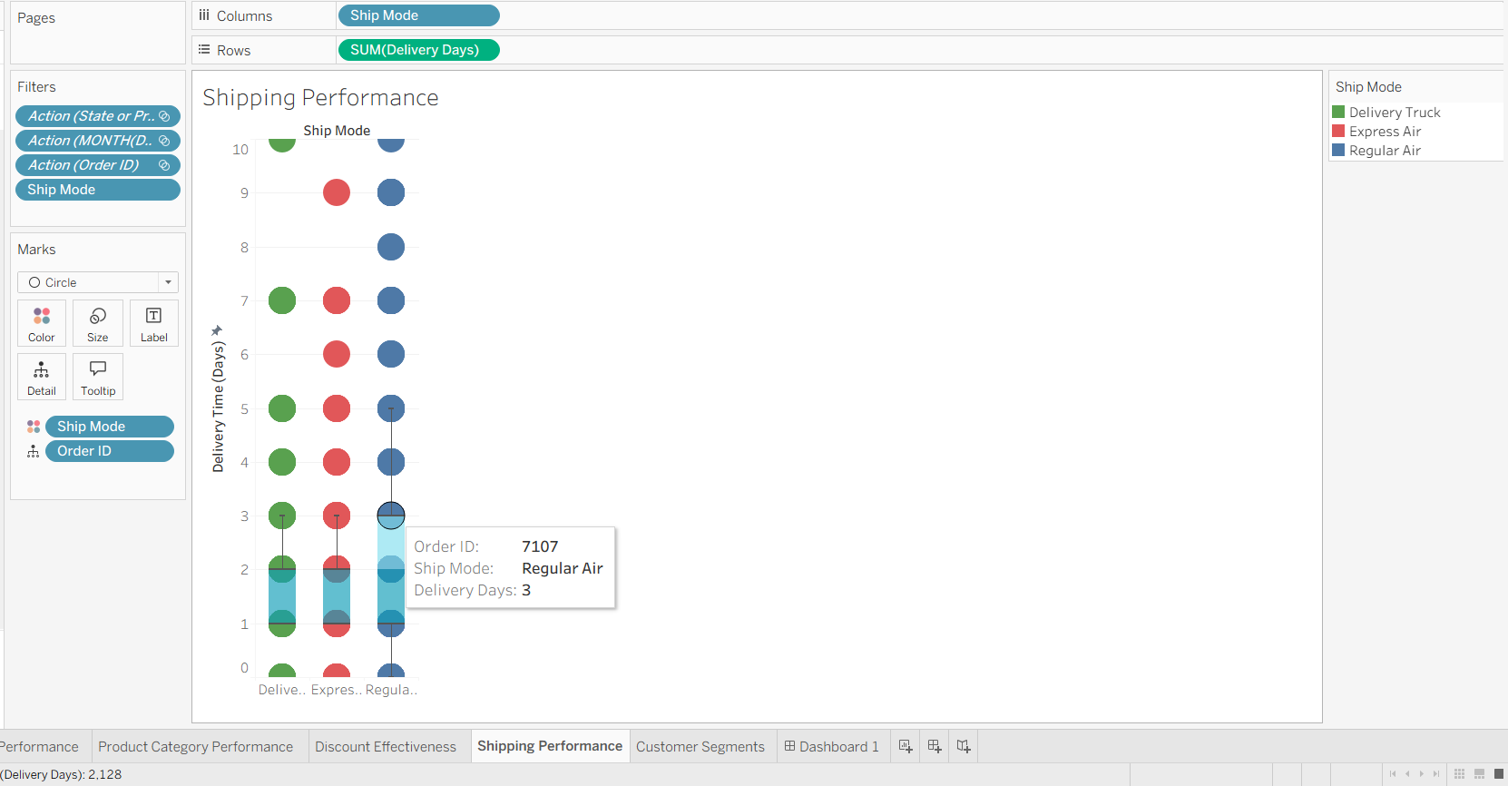
Visualization type: Box Plot Distribution.
Box plots represent min, Q1, median, Q3, max.
Colors: the green of a Delivery Truck, red of the Express Air, blue of the regular air. The Delivery Days given below:
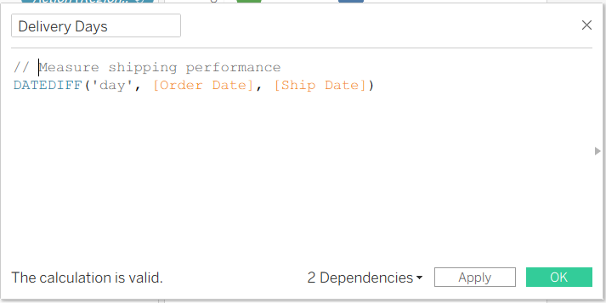
Visual-Encoding: Box plots allows to view the spread, outliers and medians by looking at the plot.
Design-Appropriateness: It is important to identify consistency and outliers in the design since the quality of the delivery influences the satisfaction.
Answer: Regular Air: 2–4-day median, small IQR. Order #7107 rocks at 3 days. Delivery Truck has the wildest spread (2-8 days) and it has enough outliers. Express Air also 24 but it does not appear to be worth the premium.

Question-5:How do customer segments differ?
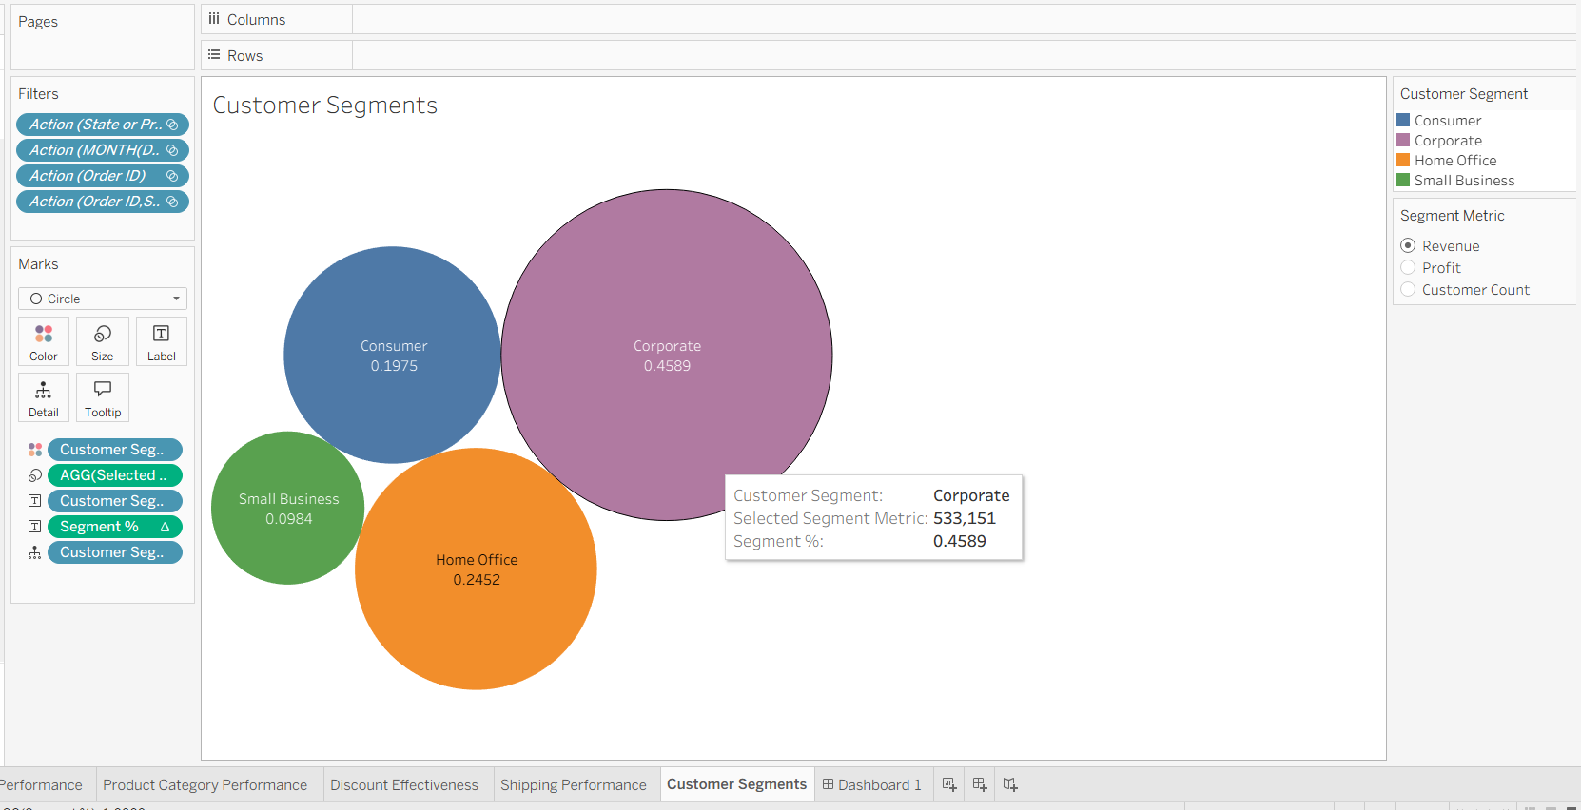
Visualization Type: Bubble Chart, packed.
Contribution = size of the bubble, Corporate purple, Home Office orange, Small Business green, Consumer blue. The segment measure can alternate.
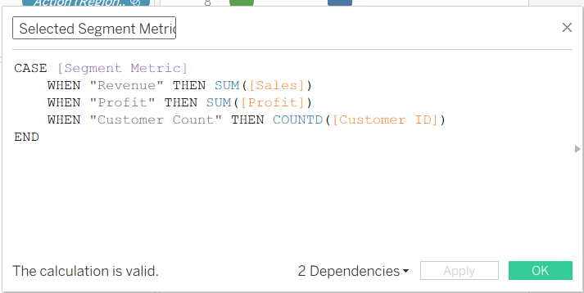

Percentage labels:
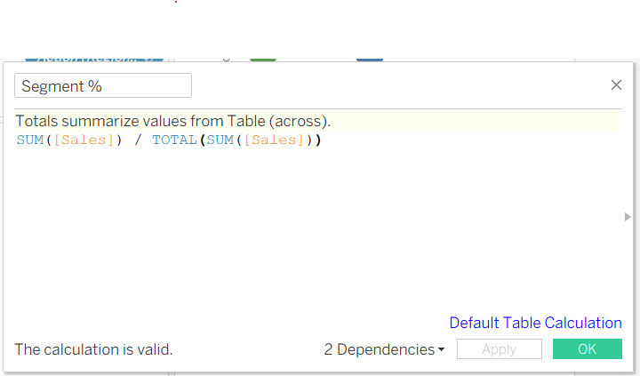
Visual Encoding: Part to whole. It is possible to view revenue, profit or count with a good parameter in one view.
Design Appropriateness: Has a hierarchy to it and provides us with many lenses of the information.
Response: Consumer is the largest (19.75%) according to revenue, but Corporate leads (45.89% and earns a profit of $62,311) according to profit. Small Business (9.84) appears to be an opportunity in growth.

Scenario of Usage
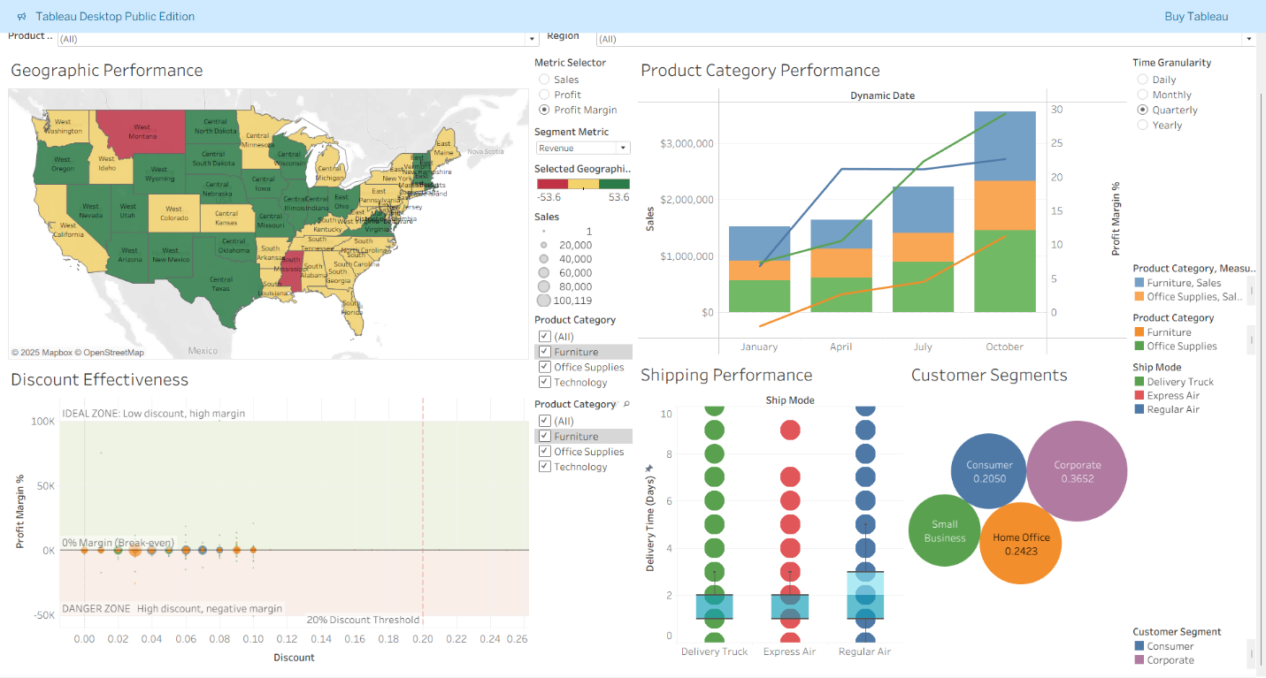

Step 1: Manager opens dashboard. Pops up map: Western is yellow/red, Eastern green.
Step 2: Clicks California. Filter updates: profit $17,503, total sales of 356,761, margin 4.9%.
Step 3: Picks Technology. The combined filter indicates $25,568 losses ,negative February -September margins.
Step 4: Lasso chooses the danger zone. All is fresher: the segments prove that Consumer receives more discounts than Corporate.
Lasso activate :
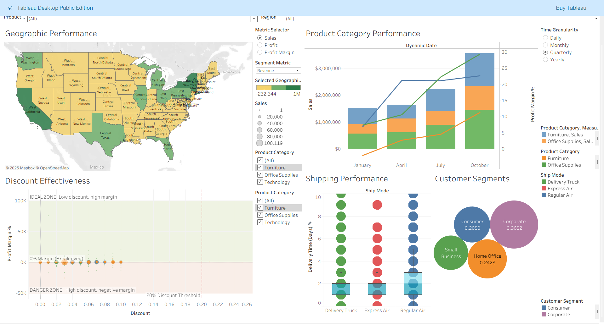
Calculated Fields
- Profit margin to compare percent
- Delivery days to quantify shipping
- Discount band to analyze
- Dynamic date to aggregate
- Selected geographic to switch
- Selected segment to views
- Segment percent to contribute
- Revenue category to tier
Parameters
- Metric Selector -keep focus on map.
- Time Granularity -provides us with scale
- Segment Metric -displays three different depths.

Encoding Hierarchy
The rank based on effectiveness:
- Position
- Length
- Diverging color of margins
- Area of bubbles categorical of categories.
Constant mapping Technology is never brown and see then and there.
Appropriateness
All of this is equivalent to the query: map in geography, dual-axis in volume-rate, scatter in correlation, box in distributions, packed bubbles in hierarchies.

Research Background
Position, length, area and color are rankings by perception psychology by Cleveland and McGill (1984), position has the highest accuracy (+-3%), length (+-5%), area (+-15%) and color (+-20%). Dashboard design is based on Few (2013), which incorporates quantitative clarity in design rather than decoration. The framework presented by Munzner (2014) is used to make systematic decisions on visualization, the story-driven structure made by Segel and Heer (2010), and the interaction-based structure based on the perceptual principles introduced by Ware (2020), the organization of visualization.

Reflection
Preliminary plan vs. actual implementation: Stakeholders desire additional perspective changes and include additional calculated logic.
Scatter plot repositioning: The actual negative correlation was margin vs. discount, whereas discount vs. sales had been used in the old design.
Coordinated filtering: Began with simple, and then full propagation.
Lasso selection: added to allow users to view transactions in detail.
Lessons learned:
- Interactivity is crucial.
- Filters reveal concealed problems.
- Parameters shorten clutter.
- Uniformity on design accelerates the cognition.
- The data is usable using the calculated fields.
Strengths: Inclusivity of all angles with geography, time, correlation, distribution and mixed interactivity. Visual perception due to regular encoding. Actionable insights are presented in a gradual manner.
Weaknesses: Box plots is difficult; the dashboard is built based on the U.S. and further expansion internationally would require effort and size is 1920-1080 not effective on phones. Lasso takes time with 9,426 records.
Difficulties: How to correct incorrect Profit margin per cent calculations, dynamic date control, robust filter settings, color availability with a vivid red-green palette.

Conclusions and recommendations
Key Findings
- Geographic Disparity: The Western margins are low (4.9 in California), and Central-Eastern margins maintains 10%+.
- Discount-Profitability: The correlation is very negative and tech is at a risk zone. West demonstrates excessiveness in discounting, keep it at 5-15.
- Category Volatility: Technology has the biggest volume (24,342 May; 72,171 August) but negative margins in the month of February , April, September. Office is stable and Furniture is at the lead.
- Segment Disparity: The corporate makes 45.89% profit out of only 19.75% of revenue.
Strategic Recommendations
- Western Recovery: Have managers accept technology discounts of more than 15, currently 34 per-cent exceed 25.
- Discount Optimization: Optimize tiered 5-15 percent plan and hike only with huge acquisitions.
- Shipping Rebalancing: Cut Express Air to orders more than 1000 (should be dropped to 25%), push Regular to 60, and re-verify the Delivery Truck option.
- Segment Targeting: Launch Corporate bundles, loyalty programs, management; implement Consumer self-service portals reducing costs 30%.

Reference

Cleveland, W. S., & McGill, R. (1984). Graphical perception: Theory, experimentation, and application to the development of graphical methods. Journal of the American Statistical Association, 79(387), 531–554. https://doi.org/10.1080/01621459.1984.10478080

Few, S. (2013). Information dashboard design: Displaying data for at-a-glance monitoring (2nd ed.). Analytics Press. https://www.academia.edu/39421755/Dashboard_Design_for_at_a_glance_monitoring

Munzner, T. (2014). Visualization analysis and design. CRC Press. https://doi.org/10.1201/b17511

Segel, E., & Heer, J. (2010). Narrative visualization: Telling stories with data. IEEE Transactions on Visualization and Computer Graphics, 16(6), 1139–1148. https://doi.org/10.1109/TVCG.2010.179

Shneiderman, B. (1996). The eyes have it: A task by data type taxonomy for information visualizations. Proceedings of the 1996 IEEE Symposium on Visual Languages, 336–343. https://doi.org/10.1109/VL.1996.545307

Tableau Software. (2024). Tableau Desktop user guide.
https://community.tableau.com/s/question/0D54T00000C5qIhSAJ/tableau-desktop-manual-download

Ware, C. (2020). Information visualization: Perception for design (4th ed.). Morgan Kaufmann. https://doi.org/10.1016/C2009-0-62432-6

