5 Step-by-Step Instructions to run first basic Selenium Program

- Install Java and Set Java Home Path in System variables
- Install Eclipse and Create new Maven Project with Selenium Dependencies
- Understand creation of WebDriver object and its related classes
- Run the First Selenium WebDriver Program with Browser Invocation
- Different ways of setting Browser Driver executable files.

What can Kind of Interview Questions I can expect from above Concepts?

1. What is Interface in Java?
An interface is a group of related methods with empty bodies.
Its class responsibility to implement the methods declared in the Interface
When class agreed to implement the interface, they must need to provide implementation/bodies to all the defined methods in Interface
In simple terms, Interface enforces the Contract to class to follow.

2. WebDriver is an Interface which provides Set of Browser Automation methods with empty bodies (Abstract methods)

Classes like ChromeDriver, FirefoxDriver, MicrosoftEdgeDriver , SafariDriver etc implement the WebDriver Interface
and provide their own implementation to the WebDriver methods

3. We need to create the object of the class to access the methods present in the class.

ChromeDriver driver = new ChromeDriver ();
driver object here has access to all the methods of Chrome driver

WebDriver driver = new ChromeDriver ();
driver object here has access to the methods of Chrome driver which are defined in web Driver Interface
Selenium Web Driver Locators

- As part of Automation, Selenium Performs actions (such as click, typing) on the Page HTML Elements.

- The Locators are the way to identify an HTML element on a web page.
Selenium WebDriver uses any of the below locators to identify the element on the page and performs the Action

ID
Xpath
CSS Selector
name
Class Name
Tag Name
Link Text
Partial Link Text

<input type="text" placeholder="Username" id= “inputUsername” value=" ">

My Element Selector-
<input type="text" placeholder="Username" id="inputUsername" value="">

Input -> tag name
Red-> attribute
Green-> attribute associated value.

Css Selector-

- Class name -> tagname.classname -> button.signInBtn -> .error

- Id -> tagname#id -> input#inputUsername

- Tagname[attribute=’value’]

<input type="text" placeholder="Username” value=" ">

Input [placeholder=’ Username’]

- //Tagname[@attribute=’value’]:nth-child(index). - Child items
- Parenttagname childtagname
- input[type*='pass'] – CSS
- tagname
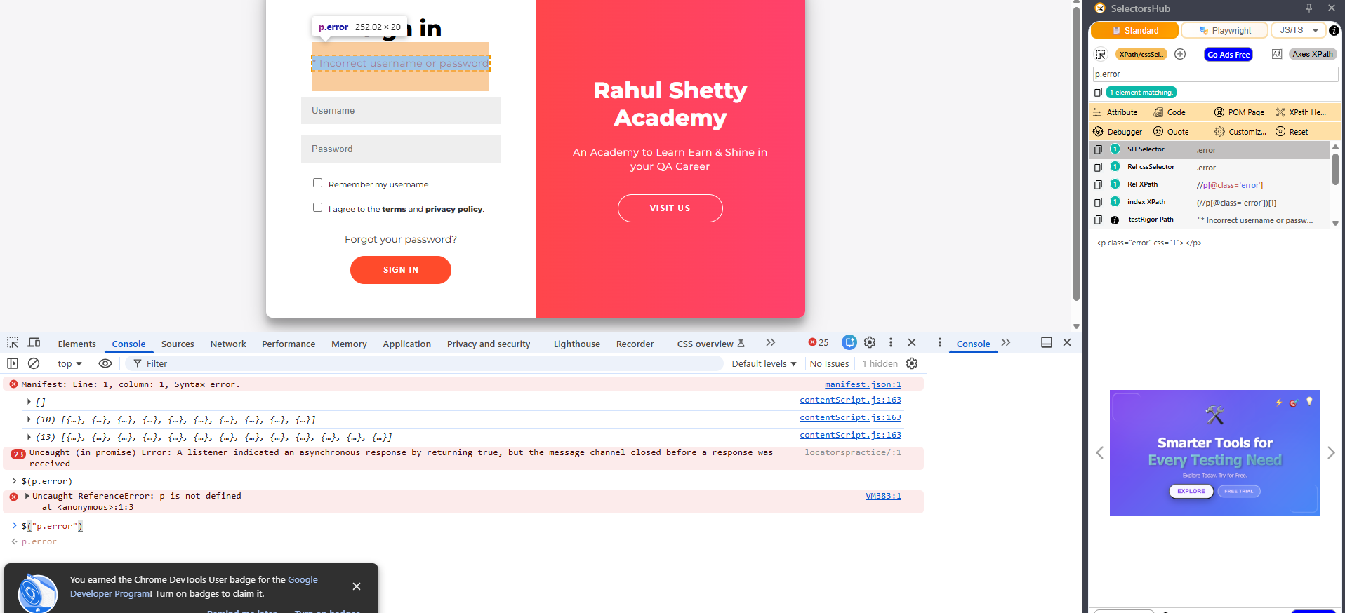

Xpath –

- //Tagname[@attribute=’value’]
//input[@placeholder=’ Username’’]

<input type="text" placeholder="Name">
//input[@placeholder=’ Name’]

- //Tagname[@attribute=’value’][index]
(index numbers are start in the 1st 2nd 3rd like that)
//input[@type=’text’][2]

- //parentTagname/childTagname
- //button[contains(@class,'submit')]. – Regular expression
- //tagname
- //header/div/button[1]/following-sibling::button[1]
- //header/div/button[1]/parent::div

Interview Question -

Core Java Basics needed to Get started with Automation –

- Variables & Data types in Java
- Working with Arrays
- Loops & Conditions
- Strings and its functions
- Importance of Array Lists
- Array list operations and conversion of Array to List
- Declaring Methods
- Accessing Methods in class & Static keyword

Note: Rest all topics are present in the last 2 sections of this course.

