Version 1.0

Wensong Jing, Julian Rayan, Shakwat Hossain Limon, Dasun Tharaka Kodikara Munasinghe, Ruwanganath Ramanayake, Surpreet Singh, Chenyu Kong, Xinyu Ji, Lachlan Exton, Nabil Francis

Software Requirements Specification

Chameleon Website Project

Table of Contents

Table of Contents i

Revision History ii

1. Introduction 1

1.1 Purpose 1

1.2 Document Conventions 1

1.3 Intended Audience and Reading Suggestions 1

1.4 Product Scope 2

1.5 References 2

2. Overall Description 3

2.1 Product Perspective 3

2.2 Product Functions 4

2.3 User Classes and Characteristics 4

2.4 Operating Environment 5

2.5 Design and Implementation Constraints 5

2.6 User Documentation 5

2.7 Assumptions and Dependencies 6

3. External Interface Requirements 6

3.1 User Interfaces 6

3.2 Hardware Interfaces 13

3.3 Software Interfaces 13

3.4 Communications Interfaces 13

4. System Features 14

4.1 Main Navigation Bar 14

4.2 Landing Page 14

4.3 Login Feature 15

4.4 Announcement feature 16

4.5 User Review and Testimonials 16

4.6 Review Form 16

4.7 Footer 17

4.8 Portfolio 18

4.9 Services Card 18

4.10 Circular Progress Bar 19

4.11 Event Calendar 19

4.12 FAQ 20

5. Other Nonfunctional Requirements 20

5.1 Performance Requirements 20

5.2 Safety Requirements 20

5.3 Security Requirements 20

5.4 Software Quality Attributes 21

5.5 Business Rules 21

6. Other Requirements 21

Appendix A: Glossary 21

Appendix B: Analysis Models 21

Appendix C: To Be Determined List 22

Revision History

|  |  |  |  |
| --- | --- | --- | --- |
| Name | Date | Reason For Changes | Version |
| Chameleon Website Project | 21st May 2022 | Initial issue | 1.0 |

# Introduction

## Purpose

The main purpose of this document is to provide a detailed overview of the Chameleon website/ web system, its parameters, and its goals. This document describes the Chameleon website project’s stakeholders, target audience, UX/UI designs, hardware interfaces, software interfaces, communication interfaces, software requirements, and every other requirement from the software development aspect.

The Chameleon Company is a brand-new company so the website will be set up from scratch. Only the basic features will be implemented into the website. The intention of the website is to promote Chameleon’s projects, products and the services it provides. Additional features such as blogs and events will be implemented in the future.

## Document Conventions

The SRS document is using the IEEE standard. Titles within this SRS have been allocated the “Times” typeface. Chapters will have a font size of 18 while subtitles will have a font size of 14. The text within this SRS will be aligned to the left and general text will be font size 11 with “Arial”. typeface.

|  |  |
| --- | --- |
| Abbreviation | Text |
| SRS | Software Requirement Specification |
| IEEE | Institute of Electrical and Electronic Engineers |
| CEO | Chief Executive Offices |
| HTML | Hypertext Markup Language |
| CSS | Cascading Style Sheets |
| FAQ | Frequently Asked Question |
| CPU | CPU Central Processing Unit |
| HTTPS | HTTPS Hypertext Transfer Protocol |
| SSL | SSL secure sockets layer |

Table1. Document conventions

## Intended Audience and Reading Suggestions

The company’s main focus is to use the website to attract clients, highlight their work, and manage internal affairs. Therefore it is intended for their stakeholders, general public, developers who wish to improve their technology within the company. When it comes to stakeholders, stakeholders include clients, academics, CEO’s, company leaders, project managers, team leaders and other management parties and the company staff. When it comes to developers, developers include UX/UI designers, software engineers, testers, and DevOps engineers.

Additionally, the purpose of the SRS is to document everything related to the website, including the scope the tech stack and the functional and non-functional requirements. This SRS is a domain specific document and recommend for readers who are educators to use as a learning material and who are UX/UI designers, testers, programmers and DevOps engineers to enhance this website in to the next level.

## Product Scope

The chameleon company is a tech company established in 2022 as part of the Deakin University Australia. Their focus is to research, develop, test, document, and deploy IoT-based solutions to enhance life through building smarter cities, transportation, homes, and energy management systems. The presence of a dedicated website/ web system for a company can make an enormous impact when it comes to its success from many aspects. In today’s world most clients visit company or business websites to extract information as much as possible before they contact the actual business. Therefore, having a dedicated company website for the chameleon is one of the major advances to attract clients, highlight their work, and manage internal affairs.

The initial stage of the Chameleon website development is fully focused on setting up the foundation of the website, attracting clients to the business, present company information, and showcase projects to the outside world. Expanding the website into a web system will be coming in the next stages accordingly to handle company operations such as user management, maintaining a blog, and so on.

## References

* **IEEE Template for System Requirement Specification Document**

Link to the online resource - <https://ieeexplore.ieee.org/document/278253>

Access Date – 30.04.2022

* **VueJs Official Documentation**

*Link to the online resource -* <https://vuejs.org/guide/introduction.html>

Access Date – 30.04.2022

* **Bootstrap Official Documentation**

*Link to the online resource -* <https://getbootstrap.com/docs/4.1/getting-started/introduction/>

Access Date – 30.04.2022

* **NodeJS Official Documentation**

*Link to the online resource -* <https://nodejs.org/en/docs/>

Access Date – 30.04.2022

* **Express Official Documentation**

*Link to the online resource -* <https://expressjs.com/>

Access Date – 30.04.2022

* **MongoDB Official Documentation**

*Link to the online resource -* <https://www.mongodb.com/docs/>

Access Date – 30.04.2022

* **Google Cloud Official Documentation**

*Link to the online resource -* <https://cloud.google.com/docs>

Access Date – 30.04.2022

* **Trello Official Documentation**

*Link to the online resource -* <https://developer.atlassian.com/cloud/trello/>

Access Date – 30.04.2022

* **Airbnb Coding style guides**

*Link to the online resource -* <https://github.com/airbnb/javascript>

Access Date – 30.04.2022

# Overall Description

## Product Perspective

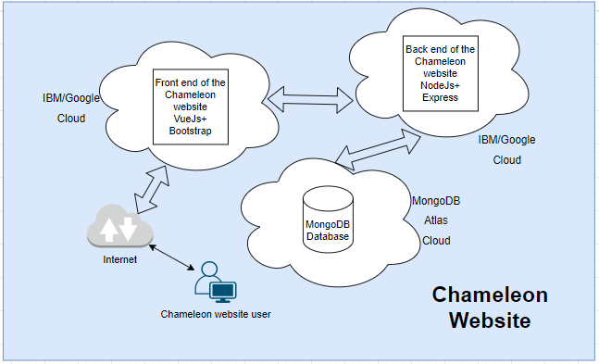This is a new product that is being created by the Chameleon team. This will be a website to showcase our current and future projects along with displaying some information about our company. The website consists of a front end, a back end and a database to store data.

Fig1. Website architecture diagram

The initial design of the Chameleon website is mainly focused on the front or the top level pages and intending to add more inner pages in the second stage of the development process. In general the anatomy of the website contains a header, a main navigation bar, page contents and a footer section. The following pages have been included in the initial design and development.

* Home page
  + The home page will include our featured projects along with any news and announcements that the company will have to make and the testimonials from our clients about the quality and type of work that we do. Also, it includes a login feature, subscribe feature for a newsletter, send us a review section and a footer including quick links to the entire site and connection to social media links.
* Portfolio
  + The portfolio will include all of the projects that we have worked on or we are currently working on and the clients that these projects are for. (Provided the clients are okay with this information being made public)
* Our services
  + In this section of the website there will be a list of the different range of products and services we offer. This will also include more detailed reviews from our clients than the testimonials section of the home page.
* Resources
  + The resources section will have frequently asked questions, a calendar displaying the events that we are currently undertaking.
* About us
  + This section will cover the basics of any website that include the terms of use, any legal notices, privacy notices and a About us section with contact information.

## Product Functions

* Home page
  + Includes a main banner and a logo
  + Includes a signup or login button to login and signup
  + Includes a navigation menu
  + Includes the mission statement
  + Includes the testimonials
  + Includes a send us review section
  + Includes an announcement button to click and view announcements
  + Include a subscribe button to receive a news letter
  + Includes a footer for quick links to the entire site including privacy policy, terms and conditions and connect to social media
* Login page
  + Email and password, remember me feature, forgot password and link to the signup page
* Registration page
  + Requires a first name, last name, email address, password and the confirmed password
  + Includes agreement to the terms of use and link to the login
* Portfolio page
  + Includes the read more button
* About us page
* Our services page
  + Includes the types of services the company provides.
* Resource page
  + Includes a calendar and the FAQs section

## User Classes and Characteristics

There are three main user classes that will use the Chameleon website. The public who are looking to find out more about Chameleon’s projects, products, and services. It will also be used by featured clients and existing clients that have worked with Chameleon who want to access the websites information including blogs, events calendar, and the clients’ area. Lastly the stakeholders of the Chameleon team, which is made up of the company board, company leadership team, developer team, and design team. The Chameleon team will provide updates, improvements, and maintenances for website.

## Operating Environment

The operating environment for the Chameleon website is listed below.

Software

* Google App Engine or Cloud foundry in IBM Cloud for hosting
* Google Cloudbuild or IBM Cloud Toolchain for DevOps
* MongoDB is the database and MongoDB compass for development
* Vue JS – JavaScript framework (Front end)
* Bootstrap – UI CSS framework (Front end)
* NodeJS – Back JavaScript runtime
* Express – Server Management for backend APIs
* In most Windows versions, Linux versions, Mac OS or OS X edition as operating systems

Web browsers supported

* Chrome
* Safari
* Opera
* Firefox
* Microsoft Edge
* Most modern browsers which supports HTML/JS.CSS

Hardware

* A computer system capable of running any major web application
* An internet connection to allow the client access to the website

## Design and Implementation Constraints

* Chameleon website is developed in Java (Vue framework), HTML, CSS(Bootstrap framework), Mongodb (Database) and Google cloud/IBM Cloud for deployment. GitHub is used as the code hosting platform for collaborations amongst the developers.
* Throughout the application development process, program code should be uniform, straightforward, and, where necessary, documented. It will be beneficial for developers in the event of any changes or future improvements.
* The client's current business strategy and brand presence serve as an important constraint, dictating the visual style of the building website.
* The system must adhere to all relevant accessibility, web design, and security protocols. There may be legal constraints on activities, which should be clarified by the appropriate authorities.
* Disruptions in the internet service might cause the program to stop functioning.

## User Documentation

* A FAQ will be included as a help section (Resources page), additionally, a walk-through tutorial might be provided that demonstrates on how to utilize the website.
* The SRS document will be delivered to necessary parties such as stakeholders, developers and educators as a guide to the development process of the website.
* The handover document will be de delivered as a guide and a product sign off sheet to the members who are taking over the development process in the future.

## Assumptions and Dependencies

* Using an up-to-date internet browser (latest versions) could be considered as an assumption.
* There may be instances when the program does not run as expected if the computer's back-end cannot handle the demands of the Chameleon and assume necessary hosting providers support load balancing required.
* Consumers must have a sufficiently speed internet connection in order to access the website without experiencing any disruptions and must have the necessary tools installed on their devices.
* The service will be completely functioning independent of the recipient's geo location and when it comes to safety and security, it will conduct all essential activities without the participation of anybody other than approved third parties.
* To access some features of the website, user should be registered and the website assumes the user is registered when try to access such features.

# External Interface Requirements

## User Interfaces

1. **Home page -** The Chameleon website has a default home page that all users land on for the first time when the page starts.
   1. **Home page -** When users swipe down with the scroll wheel on the home page, they can see the mission and testimonials of our chameleon website.

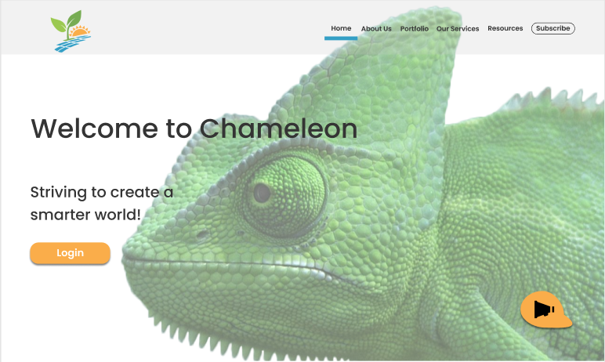

Fig2. Landing page initial screen

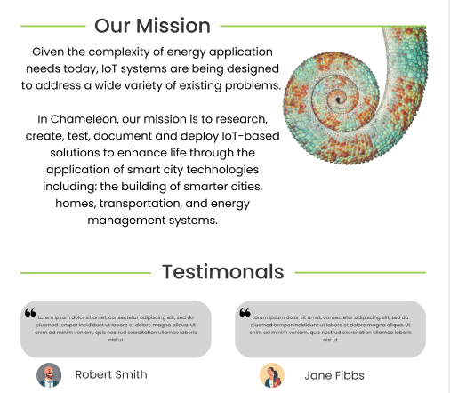

Fig3. Landing page mission and testimonial sections

* 1. **Home page -** Scroll down again, if the user has any questions, they can fill in here, the user's name, email address and the question they want to ask and click send.

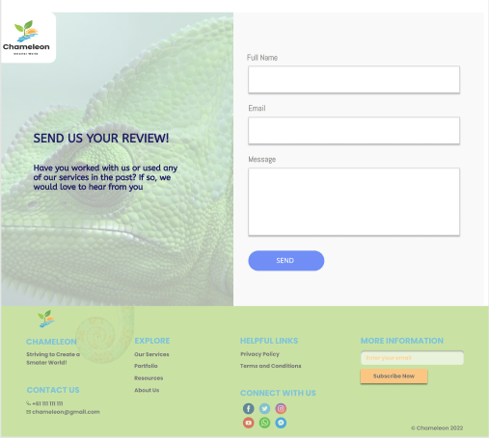

Fig3. Landing page mission and testimonial sections

* 1. **Home page -** Scroll down again, The footer section with quick links, social media links, privacy policy and terms and conditions links and the subscribe feature button.



Fig4. The footer section of the website

1. **Login page -** On the login interface of the Chameleon website, users need to enter their email and password to log in. If the user does not want to enter again next time, they can click "Please remember me" and click to log in; if the user forgets the password, they can click “forgot password"; for new users, they need to click the register button.

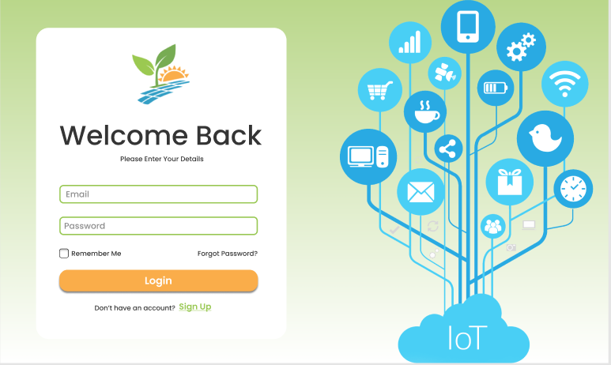

Fig5. The login page

1. **Signup page -** On the registration page of the Chameleon website, the user needs to fill in their first and last name, then fill in the email address, password and re-confirm the password, and click to complete the registration after reading and agreeing to the Terms of Service and Privacy Policy.

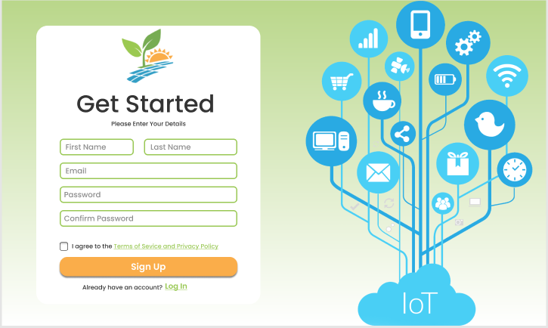

Fig6. The signup page

1. **About Us page -** Users can learn about the purpose of our Chameleon website on the About Us page

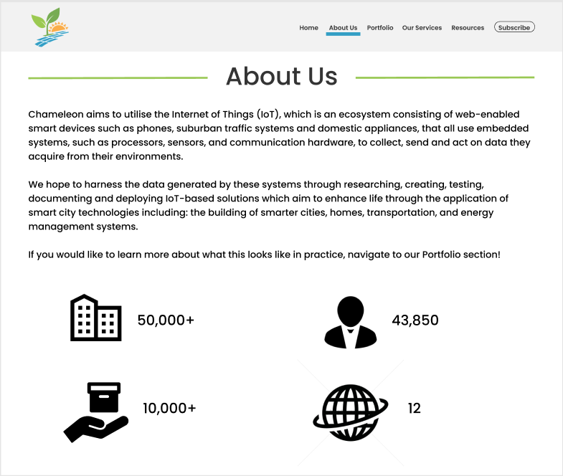

Fig7. The about us page

1. 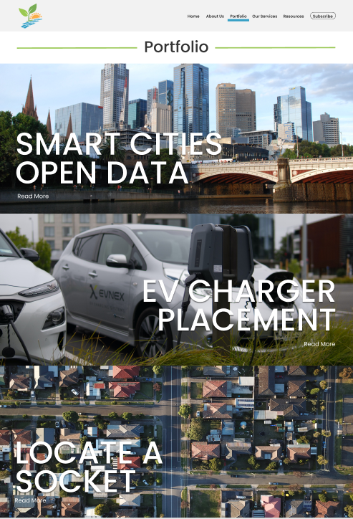**Portfolio Page -** On this page are three types of data provided by our website, including energy city data and electric vehicle data. If users want to know more, they can click "read more".

Fig8. The portfolio page

1. 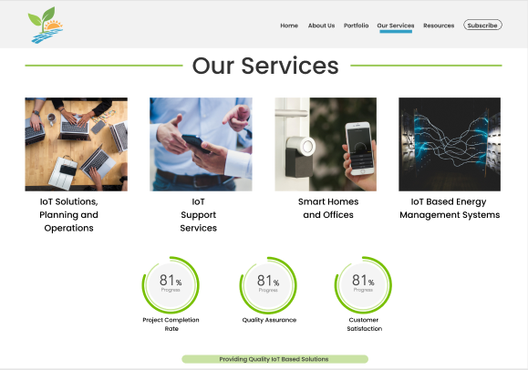**Our Service Page -** On this page users can find out what services and programs we have supported, as well as our benefits, program efficiency, and customer satisfaction with us.

Fig9. The our services page

1. **Resource Page - O**n this page, users can see that we have exemplified some common questions of users. If you want more detailed answers, users need to click on the common questions and then there will be a series of answers to the questions.

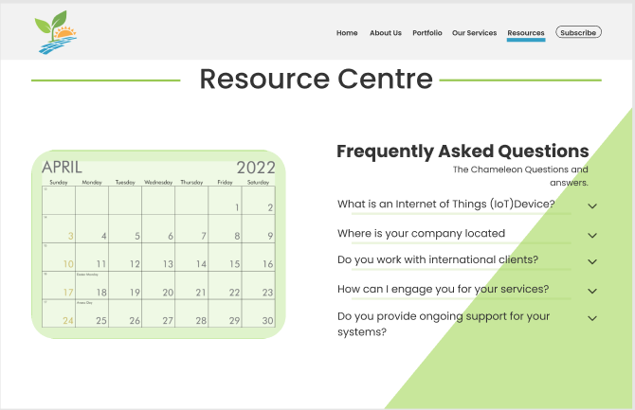

Fig10. The our services page

## Hardware Interfaces

The Chameleon website and its database are placed on a web server, and users can connect to the Chameleon website by searching on the web from any device connected to the Internet, such as: smartphones, computers, and iPads.

## Software Interfaces

* The Tech stack
* Front end: HTML, CSS (Bootstrap), Vue.js
* Back end: NodeJs, (Express.js) – (version: 4.16.4)
* Database: Mongo dB - (Version: 5.4.0)
* Hosting: Google Cloud/ IBM Cloud
* DevOps: CD/CI Pipeline (Google App engine + Cloud build/ IBM Cloud foundry +Toolchain)
* Source Control: GitHub
* Integration and Service
* Jwt token: Authentication of the login feature
* Trello Board: Issue and project tracking

## Communications Interfaces

* HTTPS will be used for the communication between the server, users and database server (For accessing the website through browser).
* SMTP - Simple Mail Transfer Protocol will be used to handle email functionality of the website.
* SSL Certificate will be used for data Encryption (To keep the credentials safe while logging on to the website).

# System Features

## Main Navigation Bar



Fig11. The navbar

Nav bar consists of button that can be clicked by the user to navigate to the other pages in the website. When the user desires to explore the website and navigate to a different page the user can click on the name of the page in the navbar and it will redirect the user to that page.

There is also a subscribe button placed in the navbar and upon clicking the subscribe button a Modal box will render on the screen allowing the user to provide their email address to subscribe to the latest news and information, as shown below

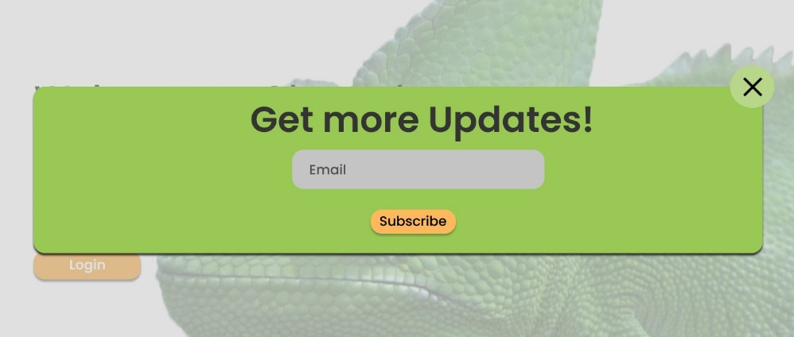

Fig12. The subscribe feature

The navbar uses the Vue router to redirect to the different routes that are responsible for each page. The modal box is a Vue component that is rendered when the subscribe button is pressed by the user.

TBD : The email newsletter or subscription feature for the users is yet to be decided but services like MailChimp, HubSpot or other services can be used for this feature.

## Landing Page

The landing page provides the user with a quick overview of the company and there are Components that allow the users to interact with the webpage.

The login button allows the user to redirect to the login page through the Vue Router and the modal Box that shows the latest announcement of the company is a Vue component that is rendered when the user presses on the floating announcement button.

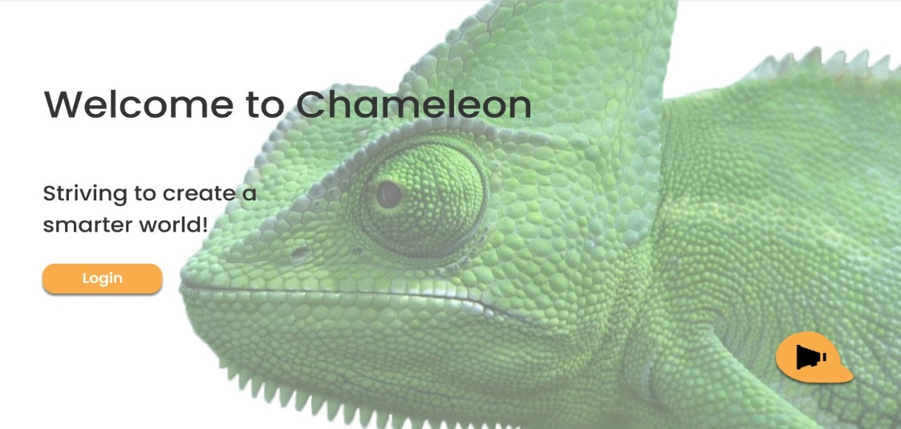

Floating Announcement Button

Login Button

*Fig13. The lading page login and announcement buttons*

## Login Feature

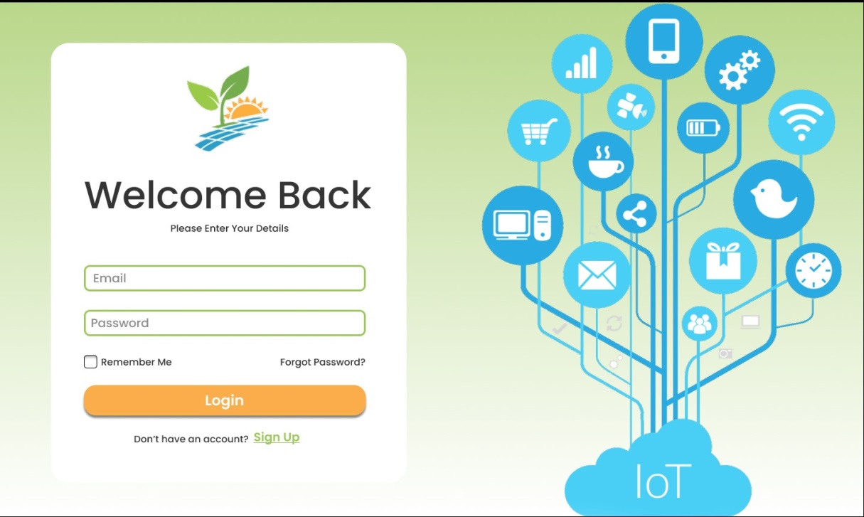The landing page consist of a hero image that resembles the company and there is a button “Login” that redirects the user to the Login page as shown below

*Fig14. The login page which appears when user click on the login button*

The user can provide their login credential and get redirected to a member profile page. User can click on forgot password to recover the password, If the user forgot the password. Remember me checkbox allow the system to remember user password until the browser session is over.

TBD: member profile page and functionality is yet to be discussed and finalized.

## Announcement feature

There is a floating button on the right corner of the landing page. Upon clicking on the floating button a Modal Box is rendered that contains the new announces made by the company. As shown below.



*Fig15. The Announcement modal box which appears when user click on the floating Announcement button*

## User Review and Testimonials

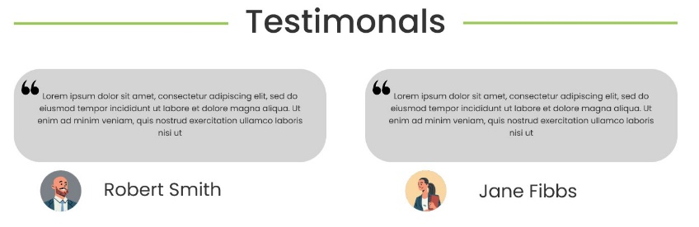

*Fig15. The testimonial section of the landing page which renders testimonials from the database*

The testimonial section renders the reviews of the customer that which is stored in the database and retrieved through axios and rendered as individual components.

## Review Form

In this section it consist of a HTML form that posts the review to the server after the form is being completed by the user and the send button is pressed.

The reviews are stored in a database that through the server and is later retrieved and rendered in the testimonial section of the landing page. Also, it will send as an email to the Chameleon administration to review.

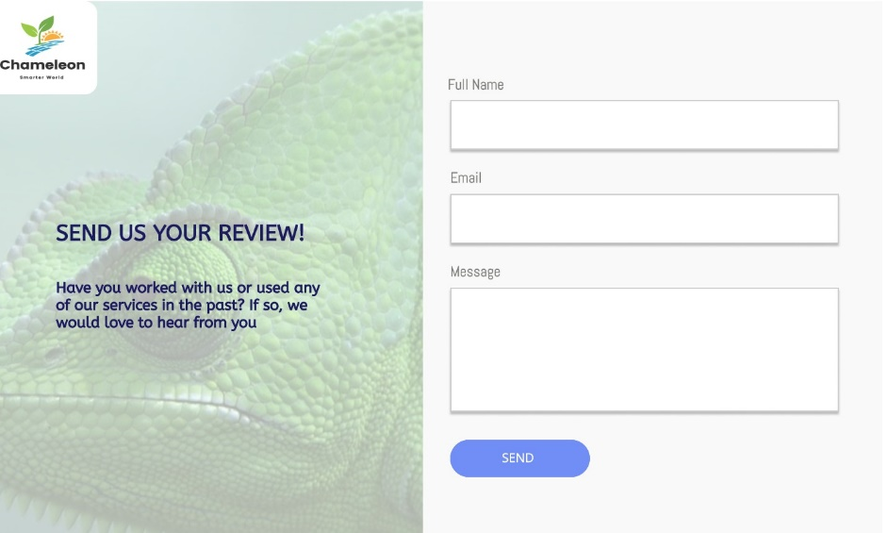The review section is as shown below.

*Fig16. The send us a review section which sends an email and store the message in the database.*

## Footer

This is the footer of the landing page that allows the user to connect with the company and find relevant and summarized information about the website.

There are icons of all the social media profile of the company that the user can interact by clicking on it and it will redirect the user to that specific social media site. There is also an option for the user to provide their email and subscribe to the company newsletter.



*Fig17. The footer contains quick links for the site, privacy and terms of use pages and to the subscribe feature to receive a newsletter.*

## Portfolio

This component contains a div with a hero image relate to the project and above the image there is a title of the project and beneath the project there are option for the user to click a button “Read More” which renders the relevant information in a paragraph into that div.



Project title

Read more link to project information

*Fig18. Read more link in the portfolio page, which redirects to project information*

The information about the project is retrieved through the server using the axios method and rendered through a Vue Component.

## Services Card

Relevant service image

Description relevant to the service

*Fig19. Component for various services in the services page*

The cards are located in the service page that displays the number of services that the company provides. There is an image placed in the card and a description underneath the image. When clicked on the card it will redirect the user to another page where there will be a detailed description of the services provided by the company.

## Circular Progress Bar

There is a circular progress bar in the services page that provides information about the progress of a project that the company is working on.

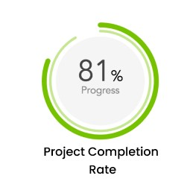The progress bar can display the progress by retrieving data about the progress from the database that will be rendered through Vue.

*Fig19. Company services progress ratios display in the services page*

## Event Calendar

The event calendar widget allows the user to view all the upcoming event of the company the user can click on particular date displaying with the event and it will render further information about the event.

TBD this component can render google calendar or other third-party services to render the information.

*Fig20. Interactive calendar widget in the resources page*

## FAQ

This component displays all the FAQ and the answers in a Accordion dropdown this is built using a vue as a component and displayed to the user. Clicking on the dropdown button answers of the FAQ will be rendered to the screen as shown below.

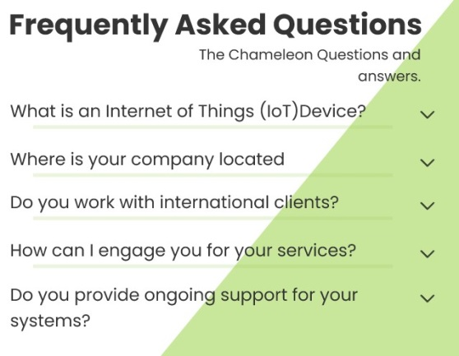

*Fig21. FAQ section in the resources page, user can expand to see answers*

# Other Nonfunctional Requirements

## Performance Requirements

* After the user submits different requests, the response time to the request cannot exceed 5 seconds, within which the request will be completed and a confirmation message will be returned.

## Safety Requirements

The Chameleon company website is a sole property of the Chameleon company and all information in the website cannot be used for any illegal purposes. Every user of the Chameleon website is bound by the company privacy policy and terms of use.

## Security Requirements

* Access Control - According to different user roles, set corresponding permissions. Important operations of users are logged for future reference.
* Log - The system should be able to record all errors that occur while the system is running, including native errors and network errors. These error logs make it easy to find the cause of the error. Logs also record key operations.
* The Data Backup - Periodically backup and restore data to compensate for data damage and loss.
* Critical Data Encryption - This system encrypts some important data according to certain algorithms, such as user password, important parameters and so on.

## Software Quality Attributes

Chameleon provides the user with many features. The page design throughout the site is simple and easy to understand, so it can be used by both experts and typical users. Chameleon is a simple, efficient, accountable and responsive website.

## Business Rules

Any user can access certain pages of the website without any registration and in order to use some specific features user must be registered. Every user who registers with the website becomes a guest user by default. The company administration can access reviews sent by users and chose reviews for testimonials.

# Other Requirements

Appendix A: Glossary

|  |  |
| --- | --- |
| Term | Description |
| Protocol | The official procedure or system of rules  governing affairs of state or diplomatic  occasions. |
| HTTPS | Hypertext Transfer Protocol Secure (https) is  a combination of the Hypertext Transfer  Protocol (HTTP) with the Secure Socket  Layer (SSL)/Transport Layer Security (TLS)  protocol. |
| SSL certificates | An SSL certificate is a type of  digital certificate that provides authentication  for a website and enables an encrypted  connection. |
| Responsiveness | A web development approach that creates  dynamic changes to the appearance of  a website, depending on the screen size and  orientation of the device being used to view it |
| DevOps | DevOps is a set of practices, tools, and a cultural philosophy that automate and integrate the processes between software development and IT teams. |
| FAQ | Frequently asked questions |
| SMTP | Simple mail transfer protocol which used for sending emails. |

Appendix B: Analysis Models

Currently not available

Appendix C: To Be Determined List

* The email newsletter or subscription feature for the users is yet to be decided but services like MailChimp, HubSpot or other services can be used for this feature.
* Member profile page and functionality is yet to be discussed and finalized.
* The calendar component can render Google calendar or other third-party services to render the information.
* User reviews to be stored in the database and retrieve for testimonials is yet to be decided.
* Necessary database schemas yet to be decided.