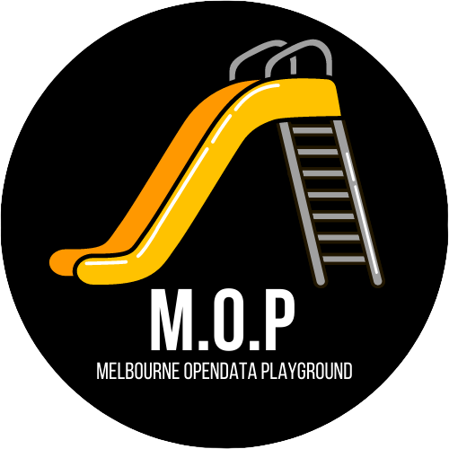

City   
Of   
Melbourne



Branding Style Guide

May 2022

Contents

01 Introduction 3

02 The brand 5

What is a brand? 6

04 Logo 7

City of Melbourne logo 8

City of Melbourne 3 colour logo 9

City of Melbourne logo reversed 10

City of Melbourne logo mono 11

Logo variants 12

Logo exclusion zone 13

Logo minimum size 14

Incorrect logo usage 15

05 Brand elements 16

Brand symbol 17

Primary colour palette 18

City of Melbourne branding style guide | 2

LOGO

01 Introduction

City of Melbourne branding style guide | 3

01 Introduction

The City of Melbourne brand is an important asset to the organisation. It contributes to growth and development and helps to cement a visual presence for Data Playground in Australia.

"Brand" is much more than just a logo - it encapsulates commitments, expresses vision and values, and represents the City of Melbourne mission and experience. It stands for who we are, what we do, and symbolises our identity both internally and out in the community.

This guide establishes a set of reference points for use   
by City of Melbourne employees and

sub-contractors, and provides the tools that support the brand, including usage of the logo, colour palette, fonts, graphic

elements, images and editorial conventions.

It is important that these guidelines be followed to optimise the effectiveness and integrity of the City of Melbourne brand.

About us

Text

.

City of Melbourne branding style guide | 4

LOGO

02 The brand

City of Melbourne branding style guide | 5

02 The brand

What is a brand?

A brand is more than a name or a logo.

A brand encapsulates an organisation’s vision and values and represents the mission, experience and reputation that is behind the organisation.

Brand symbolises who we are, what we do, and our identity

Building an enduring brand is essential to creating a distinct and recognisable identity, both for within the City of Melbourne organisation and out in the community. Key to the brand’s success is the consistency of its use.

A consistent approach towards managing the brand will enable City of Melbourne to boost awareness about objectives and services to meet our long term goals.

What is the City of Melbourne brand?

The brand has been developed to provide City of Melbourne with a visual identity that supports its work within the sector.

The brand consists of a new logo, unique graphic elements and colours.

The brand is based on clean, strong design elements that are easy to use   
and communicate to the City of Melbourne audience   
and community. All of these elements can be used either individually or   
together to represent City of Melbourne’s work and

create a strong and consistent visual communication.

About this guide

This City of Melbourne branding style guide establishes a set of reference points for use by anyone using the brand, including

employees and sub-contractors.

The guide provides the tools that support the brand’s consistent use, such as the brand and logo management and colours usage.

It is important that everyone who uses the brand follows these guidelines to optimise the effectiveness and integrity of the City of Melbourne brand identity.

City of Melbourne branding style guide | 6

LOGO

03 Logo

City of Melbourne branding style guide | 7

03 Logo

City of Melbourne primary logo

The primary colour versions of the City of Melbourne logo (below) should only be used on a white background.

Primary logo with strapline Primary logo

City of Melbourne branding style guide | 8

03 Logo

City of Melbourne 3 colour logo

The 3 colour version of the City of Melbourne logo (below) should only be used when printing with pms colours, on a white background.

3 colour logo with strapline. 3 colour primary logo.

City of Melbourne branding style guide | 9

03 Logo

City of Melbourne logo reversed

The City of Melbourne reversed out logo must be used   
whenever the background contains an image or the background colour   
is not white.

Logo reversed with strapline Logo reversed

Reversed out logo can be placed over images or flat colour. Reversed out logo can be placed over images or flat colour.

City of Melbourne branding style guide | 10

03 Logo

City of Melbourne logo mono

Use the mono version of the City of Melbourne logo for   
all mono and black and white communications. Always place on a white   
background.

Logo mono with strapline Logo mono

Mono and black and white communications. Mono and black and white communications.

Use on a white background. Use on a white background.

City of Melbourne branding style guide | 11

03 Logo

Logo variants

The City of Melbourne logo variants have been developed for use on social media platforms to maximise brand clarity in the smaller image areas.

Facebook page screenshot w/ logo

Social media symbol/Avatar

For social media communication only. Use on a white background.

City of Melbourne branding style guide | 12



03 Logo

Logo exclusion zone

The external dotted line (below) defines a boundary equivalent to the

height of two stacked letter ‘C’s’ around the logo. This boundary indicates   
the minimum area of clearspace that must surround the logo in all   
communications. No other elements should intrude into this boundary area.

Logo with strapline Logo

Cx2 = minimum area of clearspace required around logo Cx2 = minimum area of clearspace required around logo

where ‘C’ is equal to the ‘C’ in the logo. where ‘C’ is equal to the ‘C’ in the logo.

City of Melbourne branding style guide | 13



03 Logo

Logo minimum size

When using the City of Melbourne logo please note that   
the minimum allowable widths specified below. The maximum size for the

logo is unlimited.

Minimum size for print use

Minimum size for logo with strapline   
48mm x 18mm (not including clearspace).

Minimum size for logo   
25mm x 9mm (not including clearspace).

Minimum size for digital use

Minimum size for logo with strapline   
180px x 70px (not including clearspace).

Minimum size for logo

112px x 40px (not including clearspace).

City of Melbourne branding style guide | 14



03 Logo

Incorrect logo usage

The City of Melbourne brand has been designed to work   
across a variety of different media. The key to keeping the brand consistent   
is to always present the logo in its original and correct format. The logo   
should never be altered, distorted or changed. Particular attention should   
be paid when inserting graphics into Word and PowerPoint documents. The   
x and y ratios must always be proportional. Below are some examples of   
what NOT to do with the logo.

Do not distort the logo horizontally.

City of Melbourne branding style guide | 15



04 Brand elements

City of Melbourne branding style guide | 16

05 Brand elements

Brand symbol

The City of Melbourne brand symbol is a key piece of the brands visual language. The symbol can be used in multiple ways and will become a common link across all materials.

Symbol, colour.

The City of Melbourne brand pattern can only be applied over flat colour.

Symbol, reversed.

City of Melbourne branding style guide | 17

05 Brand elements

Primary colour palette

The City of Melbourne primary colour palette consists   
of orange, grey and burnt orange. These colours should not be altered.

Colours should always be copied from the formula breakdown specifications below. All colour formulas derive from the   
Pantone Colour Bridge System.

Orange

Print

Pantone: 137 C

C: 0.0000

M: 0.3608

Y: 1.0000

K: 0.0000

Digital

R: 255

G: 152

B: 0

HTML:

#ff9800

Grey

Print

Pantone: 7537 C

C: 0.0291

M: 0.0000

Y: 0.0581

K: 0.3255

Digital

R: 160

G: 160

B:160

HTML:

#a0a0a0

Black

Print

Pantone: N/A

C:

M:

Y:

K:

Digital

R: 0

G: 0

B: 0

HTML:

#000000

Yellow

Print

Pantone: 7406C

C: 0.0000

M: 0.1867

Y: 1.0000

K: 0.0549

Digital

R: 255

G: 152

B: 0

HTML:

#ff9800

Digital

R: 255

G: 152

B: 0

HTML:

#ff9800

Digital

R: 255

G: 152

B: 0

HTML:

#ff9800

Digital

R: 255

G: 194

B: 0

HTML:

#ffc200

City of Melbourne branding style guide | 18