## Design / Styling Framework

The page layouts and design elements must be consistent throughout a site to ensure the user that they are still on the same site.

**Testing:**

|  |  |  |
| --- | --- | --- |
|  | Comments |  |
| Consistent design & style elements | **No clear design consistency. Elements such as the box size vary.** |  |
| Appropriate Color Theme | **The color palate matches well and is consistent throughout the website.** |  |
| Text / Font easy to read and understand | **Text is easy to read but font size is too big & text alignments are not applied.** |  |
| Visual hierarchy optimization | **The visual hierarchy is a bit disturbed. Lack of alignment and correct font sizes creates a less appealing user centered design.** |  |
| Conventionality | **Only a few changes need to be made. All outlined in this document.** |  |
| Accessibility | **Elements of accessibility are there, but more functionalities may be required in the future.** |  |

**Highlighted Problems**

1. **Home Page**

* The information boxes are not of same sizes that is why there is inconsistency in the alignments. These should be fixed.
* On each download, information there should be some graphics or images so that it is more readable to the users.These boxes need the same, consistent size throughout. If the content is too much there should a read more button or link to expand it and read it. Icon additions would be recommended here. So, user can get an easier and clearer picture of what is it about. In addition, some boxes do not have shadows. The logo is barely visible, which means that the company’s image is compromised, meaning that the user could end up having a bias and have it further affected their experience. The complexity of the logo also reflects the user’s first impression. Since it’s small, dark and unproportionate to the structure of the page, the user may be discouraged from navigating, which deteriorates their experience.

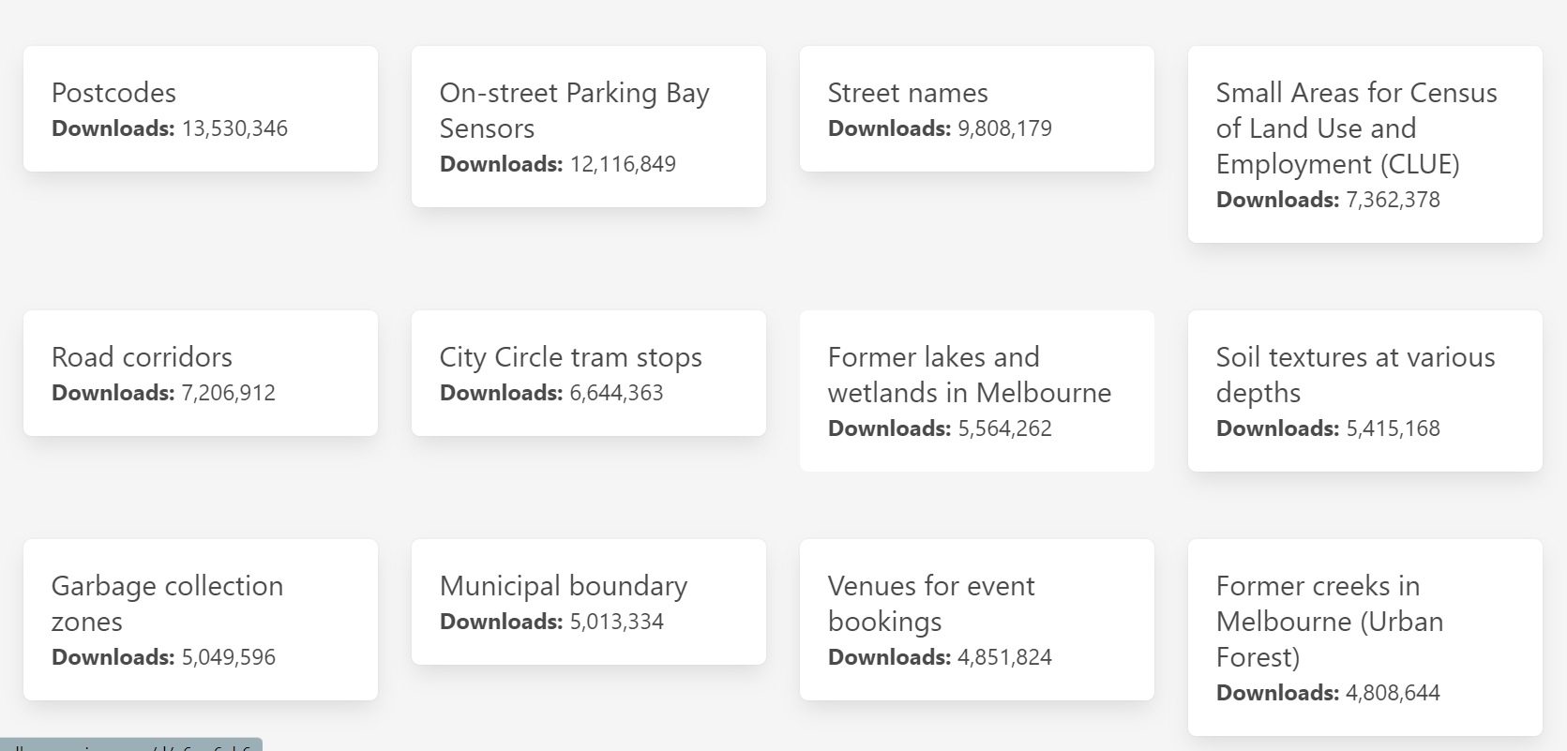

1. **About**

* The information on about Page is not aligned and well managed.
* This need to be in paragraph and it should align as justified.

1. **Contact Us**

The contact us page should provide emails or contacts and address. Clear idea to be contacted. Aligned the content as justified.

1. **FAQ (Optional)**

* The questions text size is too big and bold that need to be reduced.
* It should have an option that allow the users to ask questions after that if they want, they can see FAQs.

SUGGESTIONS

Datasets and Use Cases could have been displayed on individual pages, to bring consistency to the home page. Considering the datasets there should be a clear indication that upon being clicked, the user will be re-directed to another webpage. Instead of boxes, the names and number of downloads should be displayed in a tabular format. Separated data types will give the user reduced cognitive strain, improving their overall experience.

Adding a Dark Mode Theme to enhances visual ergonomics by reducing eye strain & give the user the option to toggle between both themes.

