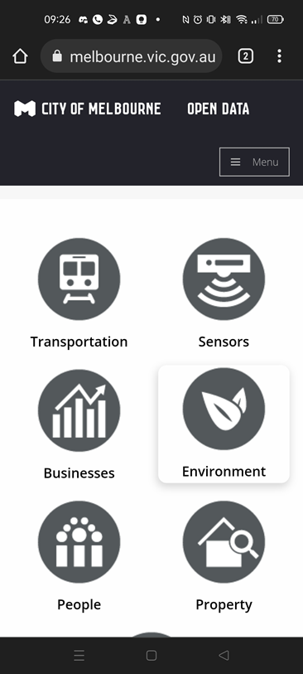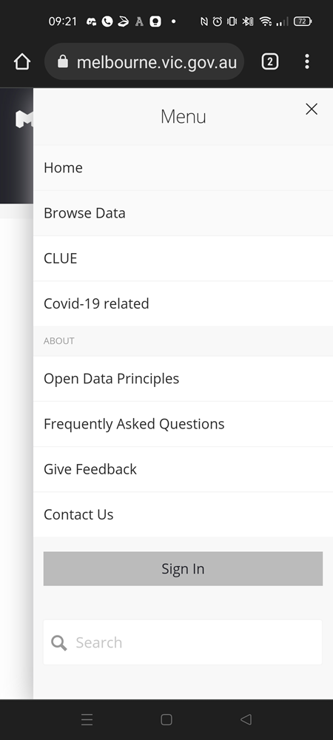

1

3

2

5

4

7

6

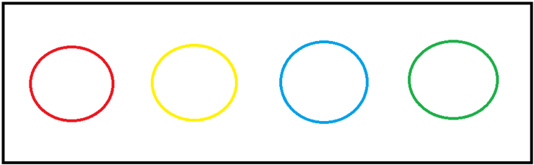

* Search bar is secluded at the bottom of the page
* Set above Home
* “City of Melbourne” takes too much header space
* “Menu” is too small and blends in with the dark header on mobile.
* Icons are much too large, taking up unnecessary screen space.

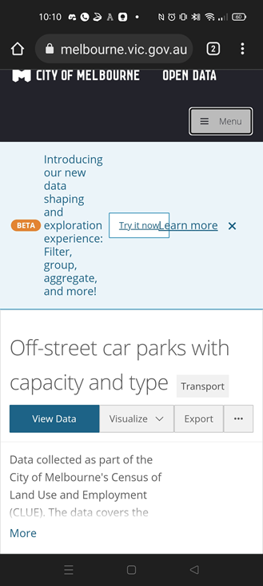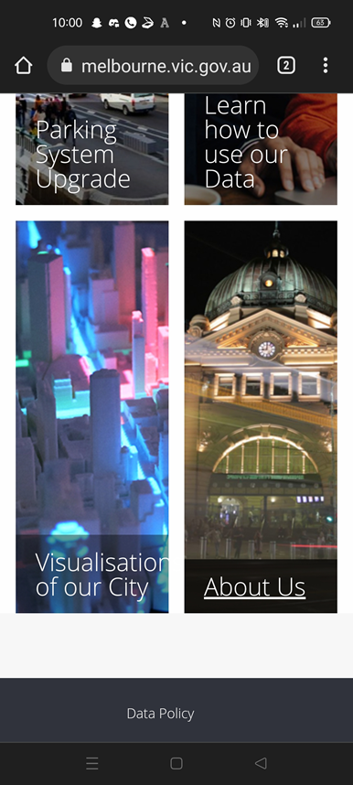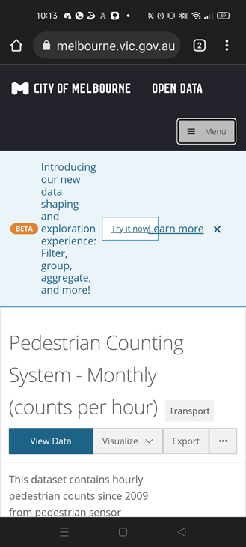

11

10

9

* “About us” is too far down on mobile
* Sub-header under main header is clumped up with information.

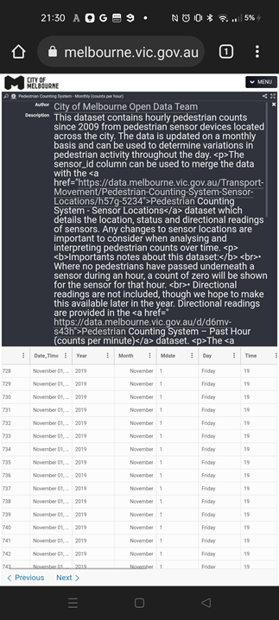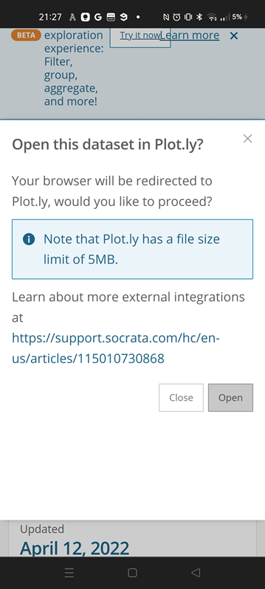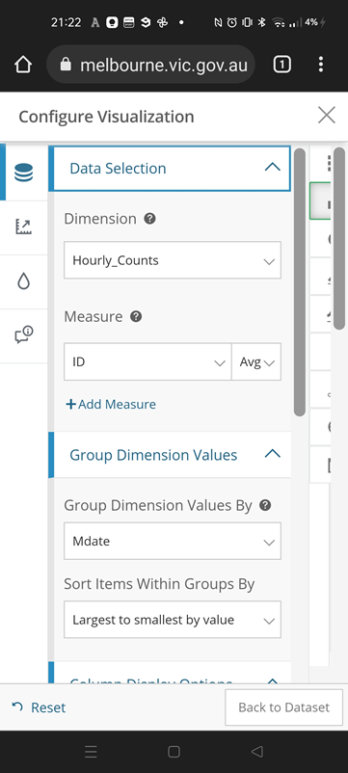

14

13

12

* Lack of input feedback
* Difficult to understand
* Link does not function
* Open code on comment page
* Lack of clear instruction

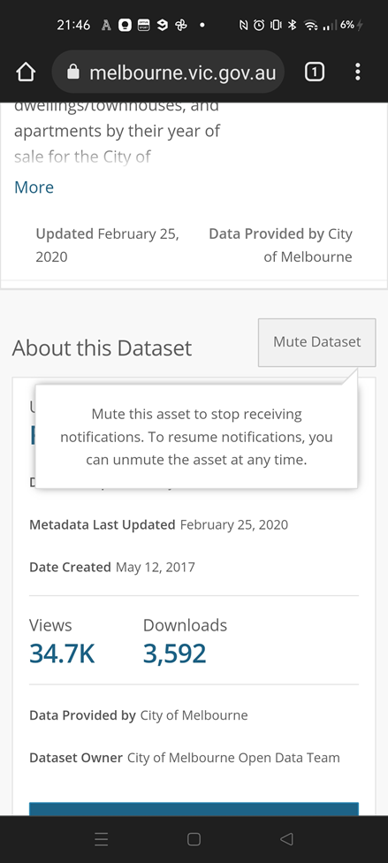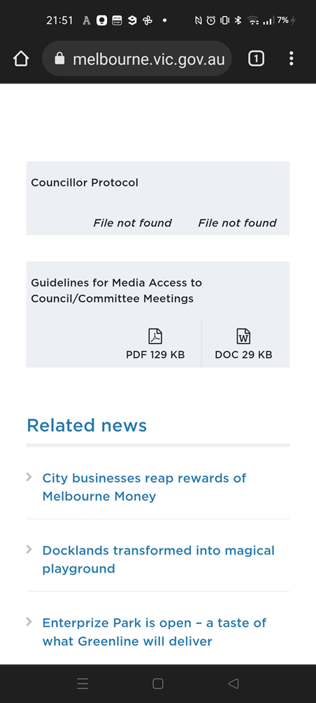

16

15

* Lack of visual feedback
* Lack of sufficient data

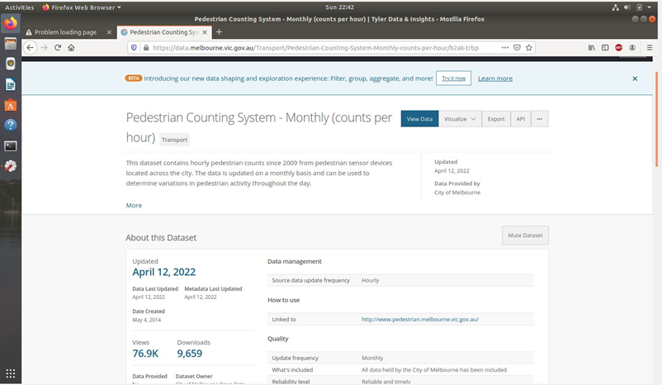

* Lack of visual feedback
* Link not functioning (Ubuntu)

17

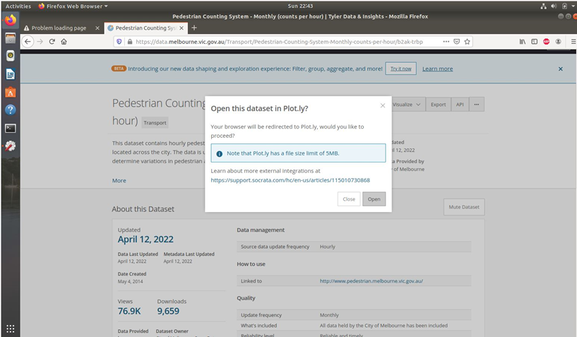

18