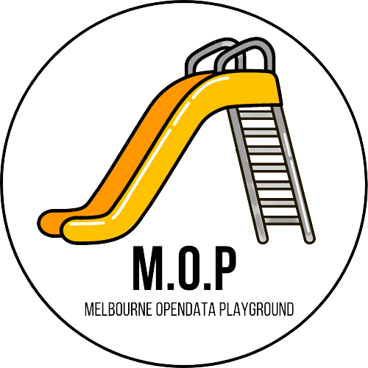

Project Handover Document

City of Melbourne Open Data Playground

Trimester 1, 2022

Table of Contents

1. Project Information 4

1.1. Client/Product Owner/s 4

1.2. Academic Mentor/Supervisor 4

1.3. Project Team 5

2. Project Overview 6

3. Public GitHub Repository 9

4. Completed Deliverables 10

4.1. User Story 1: Bicycle Route Network and Accidents (Bree and Anugra) 10

4.2. User Story 2: Green Walls (Julian and Ryan) 10

4.3. User Story 3: Event Disruption (Brendan, Mark and Alex) 11

4.4. Functionality (Harrison) 11

4.5. Design/Styling (Kishen) 11

4.6. Usability (Imani) 12

4.7. Cyber Security (Bradie) 12

4.8. Migration to Google Cloud Platform (Sammy, Shlomi, Michael) 13

4.8.1. Creating the GCP Plan (Sammy, Shlomi, Michael) 13

4.8.2. Creating GCP Test Environment 13

4.8.2.1. Implementing GCP CI/CD Pipeline and Pushing to Production 14

4.9. Use Case Fixes (Sammy, Eric) 14

4.10. Tutorial for Development Environment (Sammy) 14

4.11. Use Case Not Appearing In Development Environment (Shlomi) 15

4.12. GitHub Migration (Steven) 15

4.13. Chameleon Handover Documents GitHub Repository (Mollie) 18

5. Roadmap 19

5.1. Progress in 2022 19

5.2. Future Direction 19

6. Open Issues 22

7. Lessons Learnt, Challenges & Recommendations 23

7.1. Project Team Size 23

7.2. GitHub Knowledge Gap 23

7.3. Onboarding Team Leads 24

8. Product Architecture 25

8.1. Technology Stack 25

8.1.1. DATASCI Team 25

8.1.2. DESIGN Team 25

8.1.3. WEBDEV Team 26

9. Project Links 27

# Project Information

## Client/Product Owner/s

Mr Remi Cattier Mr. Will McIntosh

Data Hub Lead Senior Advisor to the CEO

[remi.cattier@melbourne.vic.gov.au](mailto:remi.cattier@melbourne.vic.gov.au) [will.mcintosh@melbourne.vic.gov.au](mailto:will.mcintosh@melbourne.vic.gov.au)

## Academic Mentor/Supervisor

Dr Valeh Moghaddam

Lecturer, Internet of Things

[valeh.moghaddam@deakin.edu.au](mailto:f.ansarizadeh@deakin.edu.au)

## Project Team

City of Melbourne Open Data Playground

|  |  |  |  |  |  |
| --- | --- | --- | --- | --- | --- |
| Student ID | Full Name | Junior/ Senior | UG/PG | Team Group/Role | Project/ Team Lead |
| 220541733 | **Steven James Tuften** | **Senior** | **Postgrad** | **Project Leader** | **Y** |
| 217285498 | **Mollie Fernandez** | **Junior** | **Undergrad** | **Assistant Project Leader** | **Y** |
| 217495571 | **Alex V.A. Vuong** | **Senior** | **Postgrad** | **Data Science & Engineering** | **Y** |
| 220616385 | **Brendan Patrick Richards** | **Junior** | **Postgrad** | **Data Science & Engineering** | **Co-Lead** |
| 220532657 | **Julian Cape** | **Junior** | **Postgrad** | **Data Science & Engineering** | **Co-Lead** |
| 400150369 | **Bree Margaret McLennan** | **Junior** | **Postgrad** | **Data Science & Engineering** | **Co-Lead** |
| 220563849 | Mark Brooksby | Senior | Postgrad | Data Science & Engineering |  |
| 221047172 | Nitish Kumar Neelala Harish | Junior | Postgrad | Data Science & Engineering |  |
| 221153273 | Anugra Sara Thomas | Senior | Postgrad | Data Science & Engineering |  |
| 215127684 | Ryan Daniel Waites | Junior | Undergrad | Data Science & Engineering |  |
| 221308586 | Pramodya Senanayaka | Junior | Postgrad | Data Science & Engineering |  |
| 217284769 | **Anthony Todaro** | **Senior** | **Undergrad** | **Design** | **Y** |
| 214335826 | **Bradie Robinson** | **Senior** | **Postgrad** | **Design** | **Co-Lead** |
| 218271294 | Jacob Djaelani | Junior | Undergrad | Design |  |
| 218673691 | Imani Maina | Junior | Undergrad | Design |  |
| 218268634 | Harrison Corin Padraic Murphy | Junior | Undergrad | Design |  |
| 219362178 | Bansi Baiju Patel | Junior | Undergrad | Design |  |
| 217587577 | Kishen Makanji Patel | Senior | Undergrad | Design |  |
| 218296596 | **Michael John Leen** | **Junior** | **Undergrad** | **Web & App Development** | **Y** |
| 219302799 | Janitha Thushara Nilaweera Patabandige | Junior | Postgrad | Web & App Development |  |
| 221023977 | Muhammad Sohaib Bin Kashif | Junior | Postgrad | Web & App Development |  |
| 219365506 | Lakshmi Meghana Kethiri | Senior | Postgrad | Web & App Development |  |
| 218341765 | Shlomi Moreh | Junior | Postgrad | Web & App Development |  |
| 219273805 | Yi Yang (Eric) Yu | Junior | Undergrad | Web & App Development |  |
| 221070031 | Tianqi Zhou | Junior | Postgrad | Web & App Development |  |
| 220236048 | Matthew Hall | Junior | Undergrad | Web & App Development |  |

# Project Overview

In trimester 2 2021 the project’s scope was redefined by the client. This introduced the current problem statement:

*The City of Melbourne has been an Australian leader in Open Data since 2014. The latest research and local user engagement have identified a gap where users would like access to Open Data example tools so that our users can re-use these tools in their apps and city solutions.*

In trimester 3 2021, the client identified two key benefits that this re-definition of the scope would deliver for this project:

* The toolkit examples created will be developed to maximise efficiency and time saving for the council’s staff. This will save council time through the reduction of calls and emails relating to questions of how to use council’s Open Data platform API.
* The use cases lists are the most common customer requests for assistance in creating a data solution using City of Melbourne’s open data/API.

In Trimester 1 2022 this project continues to deliver a proof-of-concept example of how calls to Open Data API can be made to deliver a solution. Figure 2.1 illustrates the major components of the Melbourne Open Data Playground platform.

Building on the foundation of work completed in the previous trimesters, our project focussed on delivering three key outputs:

1. Migrating from the current AWS platform to the Google Cloud Platform (GCP).
2. Creating and implementing 3 new use cases.
3. Testing and updating all functionality, usability and design/styling elements of the site.

A major result of this focus has been the development of style guide templates (Design Team), development environment setup guides (Web Development Team) and upskilling guides for each team (Project Team). This will provide new students checklists and guidance during the onboarding and upskilling process.

Figure 2.1: Melbourne Open Data Platform High Level Architecture

This trimester saw the data science and engineering team create three new use cases: Melbourne Bicycle Network Routes and Road Safety: Part 1 & 2, Event Disruption and Green Walls. These use cases explored and analysed a variety of datasets available from Melbourne Open Data. Utilising python libraries such as Selenium, folium, Plotly, and mapbox, our data science team was able to deliver highly stylized, interactive tools to help in developing business insights using the City of Melbourne’s Open Data API.

The web development team focussed on migrating the platform from Amazon Web Services (AWS) to the Google Cloud Platform (CGP). This also included the creation of the GCP pipeline which was a time-consuming process to figure out. Improvements were made in conjunction with the Design team, fixing links and updating functionality and usability. The team also worked on documentation which will assist the new trimesters students in setting up their development environments.

The design team was centred around three main deliverables; improved functionality, enhances usability and creating a design/style guide. These deliverables included comprehensive testing of the site and all of its links. Then working with the web development team to implement these changes.

The work completed this trimester leaves the project and the students coming onto the project next trimester in a great place to continue with the project. This will allow next trimesters team to fast track the implementation of new use cases, implement site updates and further the project.

# Public GitHub Repository

In addition to the Melbourne Open Data playground, the project has also curated a public-facing GitHub. In this environment we showcase python code that supports and extends the use cases integrated onto the web portal.

The Jupyter notebooks are shared for the benefit of those who may be more technically motivated to explore and build upon our examples.

Readme pages help users to navigate to and explore these works. This was created to aid in building a community around the playground and Melbourne Open Data more generally. Figure 4.1 below illustrates the home page of the GitHub site.

Figure 3.1: Public-facing GitHub repository

# Completed Deliverables

In this section we describe the key deliverables as well as the main teams and contributors responsible.

## User Story 1: Bicycle Route Network and Accidents (Bree and Anugra)

As a cyclist, I want a safe transport journey in the city of Melbourne. Which roads are safest to cycle on? As a council, we seek to invest in road safety initiatives which reduce the occurrences of accidents resulting in serious injuries of citizens using our road network. Where are accident hotspots for cyclists occurring?

Trello: <https://trello.com/c/zMV2kzYg/13-1-user-story-bicycle-route-network-and-accidents>

GitHub: <https://github.com/Chameleon-company/MOP-Code/tree/master/datascience/usecases>

The accidents ‘crash stats’ dataset forms a key dependency to support the exploratory data analysis python notebooks for this use case. The dataset is built from the VicRoads Open Data Traffic Accident Dataset. The python notebook which prepares and pre-processes this data is listed below.

GitHub: <https://github.com/Chameleon-company/MOP-Code/blob/master/datascience/dataanalysis/Other%20EDA/MOP_BicycleNetwork_AccidentData_DataLoadPreprocessing.ipynb>

GitHub: <https://github.com/Chameleon-company/MOP-Code/blob/master/datascience/usecases/interactive_dependencies/Accidents_Bicyclists_Melbourne_2017to2020.csv>

## User Story 2: Green Walls (Julian and Ryan)

A green wall is a vertically built structure intentionally covered in vegetation. They have ecological, environmental and cultural benefits, helping the city meet its liveability goals. As a town planner, how do I know the best locations for their installation?

Trello: <https://trello.com/c/PXo0nXbS/14-2-user-story-green-walls>

GitHub: <https://github.com/Chameleon-company/MOP-Code/blob/master/datascience/usecases/usecase-GreenWallLocationIDRevA.ipynb>

This user story analyses tree canopy, airborne particulate matter and insect density datasets to calculate the areas that would benefit most from the installation of a green wall. These locations are mapped using Folium and visualised using Google Street View.

## User Story 3: Event Disruption (Brendan, Mark and Alex)

My business is dependent on walk-in customers. I need to understand what events or factors can influence pedestrian numbers so I can plan accordingly, from staff numbers to supply needs – even to working out what times are most profitable.

This use case is built around the pedestrian sensor network data provided by the City of Melbourne, and enriched with other relevant datasets.

Trello: <https://trello.com/c/CnsTIgi8/23-3-user-story-event-disruption>

GitHub: <https://github.com/Chameleon-company/MOP-Code/blob/Brendan-R-Branch/datascience/dataanalysis/Other%20EDA/use_case_event_disruption_v2.ipynb>

## Functionality (Harrison)

The functionality of the website was tested by assessing all of the links within webpages, the database connections, any forms used for submitting or getting information from the user in the web page worked. A number of dead links were identified and with the web development team the appropriate changes were pushed through.

Trello: <https://trello.com/c/4vYduLy3/23-functionality>

GitHub: <https://github.com/Chameleon-company/Chameleon-Handover-Documents/blob/main/2022-T1/cityofmelbourne/designteam/Functionality_Framework.docx>

GitHub: <https://github.com/Chameleon-company/Chameleon-Handover-Documents/blob/main/2022-T1/cityofmelbourne/designteam/reports-t12022/Functionality-External_Links_Testing_Report_T12022.xlsx>

## Design/Styling (Kishen)

The site page layouts and design elements were all evaluated. Some inconsistency issues were found throughout the site. These were identified through our Design and Styling framework report. Recommendations for fixes were made and the design team worked in conjunction with the web development team in implementing these fixes.

Trello: <https://trello.com/c/w3IzNLB9/21-design-styling>

GitHub: <https://github.com/Chameleon-company/Chameleon-Handover-Documents/blob/main/2022-T1/cityofmelbourne/designteam/Design-Styling_Framework.docx>

GitHub: <https://github.com/Chameleon-company/Chameleon-Handover-Documents/blob/main/2022-T1/cityofmelbourne/designteam/reports-t12022/City_of_Melbourne_Brand_Style_Guide.docx>

## Usability (Imani)

The design team tested multiple usability functions of the website and recorded how they felt to a user. Ease of navigation, general appearance and the ability to use the site were all things that were assessed. The report measured the strengths and weaknesses of the site and identified areas for correction.

Trello: <https://trello.com/c/F7r3hK5d/22-usability>

GitHub: <https://github.com/Chameleon-company/Chameleon-Handover-Documents/blob/main/2022-T1/cityofmelbourne/designteam/Usability_Framework.docx>

GitHub: <https://github.com/Chameleon-company/Chameleon-Handover-Documents/blob/main/2022-T1/cityofmelbourne/designteam/reports-t12022/Usability_Testing_Report_T12022.docx>

## Cyber Security (Bradie)

The design team created a comprehensive Cyber Security document which discusses the AWS instance of the live site and its security functions and the current GCP implementation and the current security scheme for the Melbourne Open Data Playground.

Trello: <https://trello.com/c/5EeoPhUo/20-cyber>

GitHub: <https://github.com/Chameleon-company/Chameleon-Handover-Documents/blob/main/2022-T1/cityofmelbourne/designteam/reports-t12022/AWS-GCP_Security_Scheme_for_Chameleon_MOP.pdf>

## Migration to Google Cloud Platform (Sammy, Shlomi, Michael)

The team was tasked with Migrating the previously implemented cloud architecture that was on AWS (Amazon Web Services), and migrating it over to GCP (Google Cloud Platform), The goal was also to mirror the current implementation, however, some areas of the project needed considerable re-factoring, and major improvements to development implementations and integration have been improved upon, such as the CI/CD Pipeline that was implemented in the second sprint of T1 2022

Trello GCP Plan: <https://trello.com/c/LZGyRh7L/60-plan-for-gcp-migration>

Trello Test Environment: <https://trello.com/c/q3Y1z3ut/25-create-gcp-test-environment>

Trello Pipeline:<https://trello.com/c/JQef0SlW/48-implement-github-integration-pipeline>

GitHub to Current Project: <https://github.com/Chameleon-company/MOP-Code>

### Creating the GCP Plan (Sammy, Shlomi, Michael)

At the beginning of the trimester, Sammy, Shlomi and Michael were tasked with assessing the current implementation of the AWS architecture and aiming to replicate and migrate to Google Cloud Platform. The Plan was split into 3 parts:

AWS Lambda → GCP Cloud Run

AWS Container Registry → GCP Artefact Registry

AWS API Gateway → GCP API Gateway

The goal of the documents that were created were to outline, What the current service provides, if the mirror service acts the same, and how it can be implemented with the other services as above.

Trello: <https://trello.com/c/LZGyRh7L/60-plan-for-gcp-migration>

### Creating GCP Test Environment

After the team had created the GCP plan, in order to further our knowledge with GCP, we created a test web-app, first using an app that would display a simple heading, finally a the end of sprint 1, the team created a test environment with the current AWS deployed web-app.

Trello: <https://trello.com/c/q3Y1z3ut/25-create-gcp-test-environment>

GitHub: <https://github.com/Chameleon-company/MOP-Code/tree/master/google_cloud_test>

### Implementing GCP CI/CD Pipeline and Pushing to Production

Finally, in the second sprint of Trimester 1 2022, the team wanted to complete the AWS to GCP migration by fully implementing a CI/CD Pipeline, using GCP Cloud Build, the team created a trigger on any merge to the master branch. Following and trigger that happens it will run the cloudbuild.yaml file and will re-deploy a web-app with the latest repo changes. Following this addition, it was suitable to for the team to push this through as the production web-app.

Trello: <https://trello.com/c/JQef0SlW/48-implement-github-integration-pipeline>

GitHub: <https://github.com/Chameleon-company/MOP-Code/blob/master/webapp/cloudbuild.yaml>

## Use Case Fixes (Sammy, Eric)

There were many broken links and generally small issues that were outlined at the beginning

of the trimester, and further down the line in a more comprehensive and thorough document

from the design team. One of the smaller tasks this trimester was to fix majority of the broken

links and headings throughout the use cases.

Trello: <https://trello.com/c/ag65KOM7/41-use-case-fixes-new-business-location>

GitHub: <https://github.com/Chameleon-company/MOP-Code/pull/16>

## Tutorial for Development Environment (Sammy)

At the beginning of the trimester the team had wasted a large amount of time setting up the

development environments in order to begin working on adding changes and fixes into the

web-app. Sammy had a great idea to great a tutorial like document that would act as a guide

for new and current team members to get it up and running quick, as well as various “known

issues” to help along the way.

Trello: <https://trello.com/c/ftYSwIFP/30-tutorial-for-installing-development-environment>

GitHub: <https://github.com/Chameleon-company/Chameleon-Handover-Documents/blob/main/2022-T1/cityofmelbourne/webdevteam/upskilling.md>

## Use Case Not Appearing In Development Environment (Shlomi)

At the beginning of the trimester we had many team members who were unable to see use case

article tiles appearing in their development environment. Shlomi had found a potential fix for

some of us, however a “workaround” was later found if this issue could not be fixed.

Trello: <https://trello.com/c/EHWCQZso/26-use-case-not-appearing-in-development-environment>

## GitHub Migration (Steven)

At the end of 2021, Bitbucket was used as the primary source code repository for this project. GitHub was used as the Melbourne Open Data Playground GitHub public Repository for Jupyter notebooks associated with the site.

This trimester (2022 T1), the project team migrated the contents of the old Bitbucket repository to a newly established private repository i.e.. MOP-Code, located in the D2I-Melbourne GitHub Account. All source code for the project was managed through this repository including any data analysis and draft artefacts developed by the Data Science team. The MOP repository, located in the D2I-Melbourne GitHub Account, was still a public repository containing Jupyter notebooks associated with the Melbourne Open Data Playground site. This trimester we standardised on GitHub Desktop instead of SourceTree as our primary UI desktop tool for using git.

**Towards the end of the first half of trimester, the DISC team sought to standardise the management of code repositories across all Companies and setup a GitHub account for the Chameleon company into which each of the Chameleon Projects should store their artefacts.**

As a result, we needed to migrate the existing repositories into this new Chameleon company account. To preserve the existing functioning website on AWS, and its links to its public Github repository, we retained the MOP repository but did not accept any more changes into it after Saturday 7th May. The MOP-Code and MOP repositories had their ownership transferred to the new Chameleon company account on this date.

**Figures 4.11.1 and 4.11.2 illustrate the GitHub configurations prior to and immediately after the migration respectively.**

At the end of trimester, both the existing AWS environment and the original GitHub account will be de-commissioned leaving an environment configured as shown in figure 4.11.3.

*Figure 4.11.1: State (pre-migration) GitHub configuration* as of start of T1 2022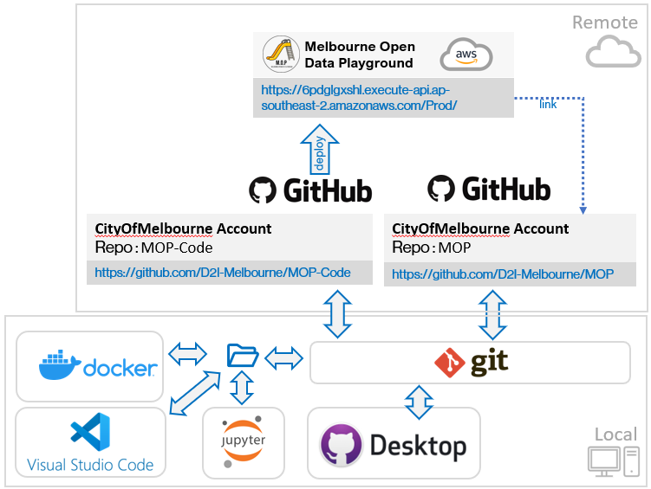

*Figure 4.11.2: GitHub configuration after completion of the migration*

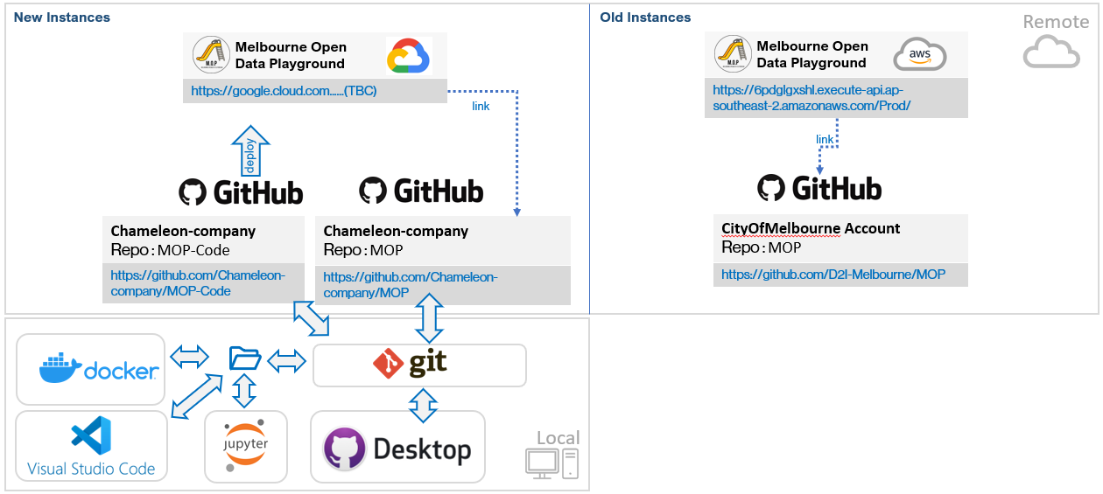

*Figure 4.11.3: GitHub configuration at end of T3 2022*

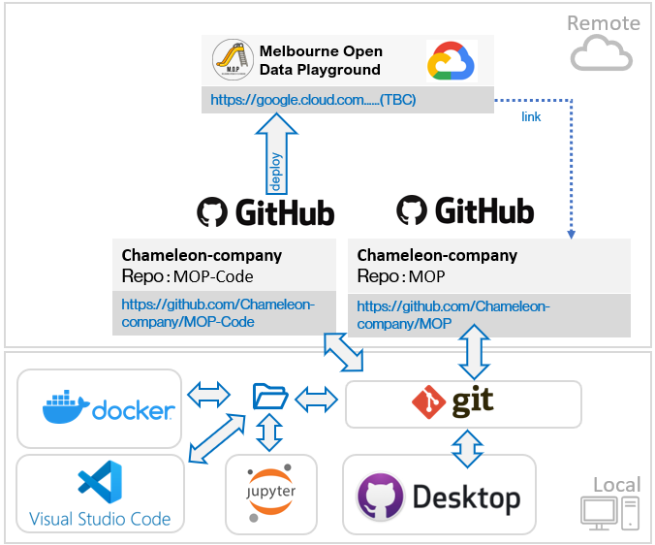

Trello: <https://trello.com/c/Vk6MUQ2v>

GitHub: <https://github.com/Chameleon-company/>

## Chameleon Handover Documents GitHub Repository (Mollie)

As the assignment requirements changed and there was no requirement to produce a handover document for each project, the idea was formed instead to create a GitHub repository for the whole company which combines templates, set-up documents, upskilling checklists and handover information. This can all be used by new students on the project who can use these resources to understand how the project works and know what they need to upskill in in order to be successful within this unit.

Trello: <https://trello.com/c/gaa8OF1k/45-handover-documents-github>

GitHub: <https://github.com/Chameleon-company/Chameleon-Handover-Documents>

This repository was further broken down into smaller section for each of the Chameleon Company’s projects; chameleonwebsite, evadoptiontools and cityofmelbourne. This initiative allowed each of the projects and their teams to have one place to put all of their separate handover documents but also allow students from each of the projects to see what the other projects are doing.

GitHub: <https://github.com/Chameleon-company/Chameleon-Handover-Documents/tree/main/2022-T1/cityofmelbourne>

# Roadmap

## Progress in 2022

The Melbourne Open Data Playground is the result of three years of development and industry collaboration with the City of Melbourne to support greater community and industry use of its published open data sets. The current implementation of the Melbourne Open Data Playground web application (site) and its associated GitHub repository came to fruition in Trimester 2 of 2021 and has experienced significant enhancements this trimester (T1 2022). T1 2022 saw three new use cases added in addition to increased usability, functionality and design and the migration of the platform from AWS to Google Cloud Platform.

## Future Direction

Having established a process for converting Jupyter notebooks into web application use cases, the platform is now well positioned to realise rapid implementation of future use cases. Future new use cases for implementation will be decided on and created in each new trimester and delivered iteratively over multiple sprints across the remainder of each trimester**.**

#### Design Team

1. Complete the Design Guide

* Finalise the Design Guide and add to handover documentation
* Provide to client for feedback and assessment

1. Conduct Functionality, Usability, Testing of the Site after new Use Cases are added to ensure all functionality works as intended.

* Utilize framework report templates created during sprint 1 T1 2022
* Mobile device testing
* Using a virtual machine to test different operating systems and browsers

1. Penetration testing of the new GCP deployment of the live site
   * Focus on Python Vulnerabilities
2. Run stress testing on the new GCP deployment of the live site

* Focus on Python Vulnerabilities

#### Web Development Team

1. Implementation of Use cases created in T1 2022
2. .
3. .

#### Data Science and Engineering Team

1. Continue to develop use case 1: Bicycle Route Network and Traffic Analysis
   * Finalise the creation of the second Jupyter notebook
2. Continue to develop use case 2: Green Walls
   * Explore more potential relevant data sets in order to devise novel location mentrics
3. Continue to develop use case 3: Event Disruption
   * Exploring additional data sets
   * Extend the analysis of the public transport data against pedestrian data
   * Improve the regression models through feature selection/engineering
4. Migration of Open Data from SOCRATA to another open data platform provider
5. Migration of flat file data sources into a relational database for improved performance of the search function

It should be noted that all scope shown for 2022 has been proposed by the City of Melbourne Open Data Project team but has not yet been ratified by the City of Melbourne. This roadmap will serve as a starting point for discussion and agreement of scope with the City of Melbourne. Figure 6.1 below illustrates the most significant deliverables completed and anticipated across T1 2022 and into T2 & T3 2022.

Figure 6.1: Roadmap for T1 2022-T2 & T3 2022

# Open Issues

Induction Processes for Style and Integration Templates

The trimester 3 2021 team developed style and integration frameworks. This means consistency in style across use cases and ease of integration of use cases onto the web portal.

This team has made excellent progress in creating notebook templates and examples to follow as well as a step-by-step guide for web integration. That said, the process of web integration requires manual and tactful work by a skilled squad of members. Further, the libraries and content used in the notebooks, which serve as the foundation of the use cases, contribute to the complexity of this task.

Good standardisation of tasks, better induction of the processes of new members, and limiting the use of new libraries or content help make this process even more efficient. Retaining, building upon, and transferring these skills to future squads is a benefit of this standardisation work.

Interactivity Concerns in Notebooks

The spot parking problem use case utilises a third-party service (Binder) to initialise interactivity. The time for initialisation ranges from a few seconds up to a minute. The delay has a negative impact on the user experience and is antithetical to the streamlined product that the tribe is hoping to develop. Future squads may wish to explore alternative techniques to enable this level of interactivity including cloud service hosting of notebooks or other possible solutions. Trimester 1 2022 project team decided that this use case should be retired.

# Lessons Learnt, Challenges & Recommendations

## Project Team Size

The projects biggest challenge for the trimester was the sheer size of the team we had. Having 27 students within the project meant we needed to create a new team to accommodate the extra students, which was the design team. Along with this issue 25 of the students were new and had never worked on the project before, this meant that the two senior students needed to pull the weight a little bit at the beginning when the rest of the project was upskilling.

This led to the project and its teams having a bit of trouble getting off its feet, as we did have the full 11/12 week's we were slow to begin with a lot of teams struggling to gain traction. This mean that sprint 0 was slow and there was a lot of late students added to the project and it took time for them to upskill and understand what the project was all about.

**It is recommended that teams be no larger than 8-10 students including the team leads and that the project organisation structure adopted in T1 2022 be continued.**

## GitHub Knowledge Gap

Although many students had some exposure to GitHub as a source code repository tool, it appeared an equal number of students had never used it in their courses or had limited knowledge on how it is used in a commercial development environment.

During the setup of users and subsequent migration of the GitHub repositories to the Chameleon company, it became clear that few understand how branches and the pull request process worked to ensure source code peer review.

**It is recommended that in future trimesters, all students complete the following two LinkedIn courses as part of their upskilling in Weeks 1 and 2:**

[**GitHub Essential Training**](https://www.linkedin.com/learning-login/share?account=2104084&forceAccount=false&redirect=https%3A%2F%2Fwww.linkedin.com%2Flearning%2Fgithub-essential-training%3Ftrk%3Dshare_ent_url%26shareId%3DxP0CT7iYTKqKOKUK2W%252FmPA%253D%253D)

[**Learning GitHub**](https://www.linkedin.com/learning-login/share?account=2104084&forceAccount=false&redirect=https%3A%2F%2Fwww.linkedin.com%2Flearning%2Flearning-github%3Ftrk%3Dshare_ent_url%26shareId%3D%252Fjs1HoKbRNuo2%252F9IzZw4hw%253D%253D)

## Onboarding Team Leads

Although care was taken in T1 2022 to select team leads, it became clear a few weeks into the semester that many students had no practical experience of managing or leading teams and that care had to be taken to pick those with a reasonable level of emotional maturity as well as those with good verbal communication and people skills. It was also apparent that with many more people in a team compared to prior capstone trimesters, a single team lead shouldered a disproportionally higher workload than their team members.

To counter this, co-leads were identified and appointed by week 5 to assist the initially selected team leads.

**It is recommended that in future trimesters, all team leads be interviewed by at least 2 senior chameleon leaders and co-leads be appointed concurrently.**

# Product Architecture

## Technology Stack

The two teams have different workflows and goals along with different technologies and tools. Some common technologies, such as Python and HTML, help with the integration of Data Science team generated use cases into the web application by the WEB Team.

The technologies used by each team are listed below.

### DATASCI Team

* **General - Python, SodaPy, Pandas, NumPy**: The DS Team works with the powerful, open-source Python language and its well-known utility libraries such as NumPy and Pandas. SodaPy is also used to access Melbourne Open Data through the Socrata API.
* **NLP Libraries - PyLDAvis, NLTK, Spacy, Genism:** Some Natural Language processing libraries may be used for future work in the backlog.
* **Geospatial Libraries - GeoPy, Shapely, GeoPandas, Folium, Mapbox & Plotly:** These libraries are used for the various mapping tools and visualisations used in our use-cases.
* **IDE - Jupyter Notebooks:** Jupyter Notebooks are the tool of choice for data scientists working with Python, allowing us to create and share documents that integrate live code, equations, computational output, visualizations, and other multimedia, along with explanatory text in a single document. Notebooks are created by the DS Team for each use-case, which can be converted to HTML by the WEB Team to display on the site.

### DESIGN Team

* **Front end - JavaScript, HTML, CSS:** The website content, styling, and functionality such as navbar, search input, and clickable buttons are all coded using these ubiquitous tools.
* **Back end - Python, Flask:** In the backend, the webapp runs on Flask, a micro web framework written in Python. It is classified as a microframework because it does not require particular tools or libraries. It has no database abstraction layer, form validation, or other components where pre-existing third-party libraries provide these functions.
* **Security - Flask-Talisman:** Talisman is a small Flask extension that handles setting HTTP headers that can help protect against a few common web application security issues.  
  **NMAP, SQLMap, Nikito**: Penetration testing tools used with Kali Linux to test the security of the website.   
  **GCP Cyber Security Features:** The use to several in-built GCP features; API gateway, Cloud Build, Web app, Google Risk Protection Program and container registry.

### WEBDEV Team

* **Frontend - JavaScript, HTML, CSS:** The website content, styling, and functionality such as navbar, search input, and clickable buttons are all coded using these ubiquitous tools.
* **Backend - Python, Flask:** In the backend, the webapp runs on Flask, a micro web framework written in Python. It is classified as a microframework because it does not require particular tools or libraries. It has no database abstraction layer, form validation, or other components where pre-existing third-party libraries provide these functions.
* **Security - Flask-Talisman:** Talisman is a small Flask extension that handles setting HTTP headers that can help protect against a few common web application security issues.
* **Deployments - Docker, AWS, Google Cloud Platform (GCP):** Docker is the most popular solution for creating and working with containers. Currently the team employees the use of GCP and their *Cloud Run* service. There are many other services available in these Cloud Providers that we can use as we expand the project.
* **IDE - Visual Studio Code:** Visual Studio Code is a lightweight code editor which the WEB Team uses for coding in the webapp. It allows for running the Flask server in a local development environment so we can see changes live in a browser, and it also has several useful extensions for working with Git, debugging, etc.

# Project Links

**[1] Link to City of Melbourne MS Teams Channels Files**

[Chameleon-CityOfMelbourne](https://deakin365.sharepoint.com/:f:/r/sites/Chameleon2-Chameleon-CityOfMelbourne/Shared%20Documents/Chameleon-CityOfMelbourne?csf=1&web=1&e=jwCJOT)

**[2] Link to the team’s pitch video**

[**https://video.deakin.edu.au/media/t/1_tu93x3dv**](https://video.deakin.edu.au/media/t/1_tu93x3dv)

**[3] Link to our Trello board (T1/2022)**

[Melbourne City | Trello](https://trello.com/b/ln6GEN45/melbourne-city)

**[6] Link to the live website (T1/2022)**

<https://master-mop-busaytgm.ts.gateway.dev/>

**[7] Link to GitHub Accounts and Repositories**

**Chameleon Company** account: <https://github.com/Chameleon-company>

**MOP Community** repository: <https://github.com/Chameleon-company/MOP>

**MOP Code** repository: <https://github.com/Chameleon-company/MOP-Code>

**Chameleon Handover Documentation** repository:

<https://github.com/Chameleon-company/Chameleon-Handover-Documents>