Chameleon

**Company Handover**

Task 11.1P

Company Structure

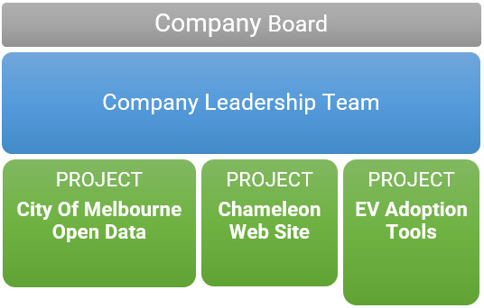

T1 2022 Objectives

* Establish a website presence for Chameleon
* Research, design and develop minimum viable products (MVP) for commercially viable EV Adoption Tools
* Enhance the Melbourne Open Data Playground to support City of Melbourne's smart cities goals and aspirations

Executive Summary

OUR MISSION

"Given the complexity of energy application needs today, IoT systems are being designed to address a wide variety of existing problems.

In Chameleon, our mission is to research, create, test, document and deploy IoT-based solutions to enhance life through the application of smart city technologies including: the building of smarter cities, homes, transportation, and energy management systems."

There are 3 divisions within the company, focusing on the 3 key areas of strategic importance:

* City of Melbourne Open Data
* Chameleon Website
* Electric Vehicle (EV) Adoption Tools

Both the open data project and the EV adoption tools leverage data sets that are created using IoT-based sensors and as such, fit into the goals of the company. The Chameleon website articulates the goals of the company and provides a visible presence.

The goals of the City of Melbourne Open Playground are to create a toolset to assist non-technical users in understanding some of the challenges that open data in the City of Melbourne can help to solve, along with useful, step by step examples.

The EV adoption tools division will be focusing on 3 projects. These projects will all related to building out tools to help drive EV adoption and/ or solve challenges associated with building out EV infrastructure.

____________________

Valeh Moghaddam

Director

Table of Contents

Leadership Team 1

Trimester Goals and Objectives 1

Week 6 Progress Update Summary 1

Week 11 Progress Update Summary 1

Company Structure and Projects Overview 2

Project 1: City of Melbourne Open Data 3

Overview, Goals, and Objectives 3

Aims for Trimester 3

Deliverables 3

Week 6 (Mid-Trimester) Progress Update 3

Week 11 Final Project Status 3

Project Members 5

Project 2: Chameleon Website 6

Overview, Goals, and Objectives 6

Aims for Trimester 6

Deliverables 6

Week 6 (Mid-Trimester) Progress Update 6

Week 11 Final Project Status 7

Key Achievements and Member contributions 7

Next steps for the project 8

Location of project resources 8

Project Members 8

Project 3: EV Adoption Tools 9

Overview, Goals, and Objectives 9

Aims for Trimester 9

Deliverables 9

Project Members 9

Sub-Project/Deliverable 1: Locate a Socket 10

Week 6 (Mid-Trimester) Progress Update 10

Week 11 Final Project Status 11

Sub-Project/Deliverable 2: Identify Best EV Locations based on Big Data 13

Week 6 (Mid-Trimester) Progress Update 13

Week 11 Final Project Status 13

**SHOWCASE VIDEO…………………………………………………………………………………………………….14**

# Leadership Team

The company board consists of the following key personnel:

* Valeh Moghaddam
* Chathu Ranaweera
* Seng Loke

Valeh Moghaddam is the acting director and key point of contact for the leadership team on a day-to-day basis.

The leadership team consists of the following students, of which three additional students were added in Week 4 being Mollie Fernandez, Haley Holloway and Nykolai Garcia McHerron.

|  |  |  |  |  |  |  |
| --- | --- | --- | --- | --- | --- | --- |
| **Student ID** | **Full Name** | **Junior/Senior** | **UG/PG** | **Team Group/Role** | **Project/Team Lead?** | **Project** |
| **221310579** | **Angela Corriero** | **Junior** | **Postgrad** | **Leadership Support** |  | **Chameleon** |
| **220622865** | **Van Tri Nguyen** | **Senior** | **Undergrad** | **Leadership Support** |  | **Chameleon** |
| **220544661** | **Glenn Richmond** | **Senior** | **Postgrad** | **Project Leader** | **Y** | **EV Adoption Tools** |
| **216095588** | **Haley Holloway** | **Senior** | **Undergrad** | **Data Science & Engineering Team Lead** | **Y** | **EV Adoption Tools** |
| **220618314** | **Nabil Francis** | **Senior** | **Postgrad** | **Project Leader** | **Y** | **Chameleon Website** |
| **217072092** | **Nykolai Garcia McHerron** | **Junior** | **Undergrad** | **Assistant Project Leader** | **Y** | **Chameleon Website** |
| **220541733** | **Steven James Tuften** | **Senior** | **Postgrad** | **Project Leader** | **Y** | **City Of Melbourne Open Data** |
| **217285498** | **Mollie Fernandez** | **Junior** | **Undergrad** | **Assistant Project Leader** | **Y** | **City Of Melbourne Open Data** |

# Trimester Goals and Objectives

* Create an initial version of the Chameleon company website
* Implement additional use cases and perform a cloud platform migration for City of Melbourne Open Data Project
* Establish the framework, development processes, DevOps and possibly an early MVP for the mobile app
* Provide an initial MVP for the EV business case portal
* Perform initial research and create an early MVP for the EV location recommendation engine

# Week 6 Progress Update Summary

All project teams are progressing well towards their defined goals and objectives. Foundations have been made which will set up Chameleon for success during this trimester and beyond. A forecast of deliverables is outlined in the proceeding report. Stand out achievements so far: The City of Melbourne Open Data project met with their client in Week 5 to present the project’s direction and deliverables. The client was very satisfied and approved the deliverables. The Chameleon Website team have identified their web development and infrastructure technology stack as well as an initial design of the main website pages. Finally, the EV Adoption tools team have commenced several research tasks which will form the basis for a recommendation engine that can be used to predict future requirements for charging stations.

# Week 11 Progress Update Summary

Key deliverables have been successfully completed by all teams as outlined in this report. Of most significance, the groundwork, structure, and documentation for the next trimester cohort has been established. This will ensure Chameleon can gain rigor at pace moving forward.

# Company Structure and Projects Overview

In our first trimester, Chameleon will be running the following three concurrent projects that, together, support the mission and objectives of the company.

* City of Melbourne Open Data – Promoting smart cities open data adoption
* Chameleon Web Site – A platform for showcasing and promoting Chameleon's activities
* EV Adoption Tools – A variety of tools to support the adoption of EV adoption by the Australian community

Chameleon is run by a Company leadership team comprising one Board Director and a student leadership team. This team coordinates whole of company initiatives and ensures projects are delivering on the company mission and objectives. The Company Leadership team reports to the Board of Directors.

Some members of the Student Leadership team are allocated as leaders of each of the projects with the remaining student leaders providing vitally important administrative and executive support functions for the company.

Figure 1 illustrates the company structure at a high level with members of each team listed in subsequent sections of this document and Figure 2 illustrates the typical structure of a project team its relationship to the Leadership team.

Each project may be comprised of multiple teams providing a different set of skills in support of the project's deliverables. Each team will have a designated team leader accountable for that teams' deliverables.

The project leader will be supported by an assistant project leader who can assist with project management, team communications and meeting facilitation. Assistant project leaders and team leaders are also candidates for future leadership roles in the subsequent trimester.

*Figure 1: Chameleon Company Structure Figure 2: Chameleon Project Team Structure*

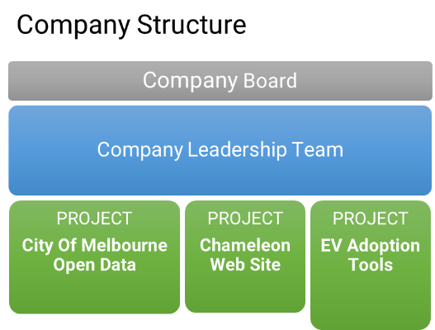

# Project 1: City of Melbourne Open Data

## Overview, Goals, and Objectives

The City of Melbourne has been an Australian leader in Open Data since 2014. The City of Melbourne initiated this project with Deakin to support greater use of their Open Data by businesses, researchers, and software developers. Open Data is a component of their smart cities' strategy.

This project delivers an education portal which demonstrates how to leverage Open Data using real world scenarios that may be of interest to industry, government, and researchers. Its long-term goal is to increase the usage of City of Melbourne Open Datasets and drive increased investment across the City of Melbourne council area.

## Aims for Trimester

This semester the project will aim to become integrated into the Chameleon project by re-focusing its deliverables on Smart Cities Open Data while delivering additional use cases of value to City of Melbourne businesses and residents.

## Deliverables

The short term (trimester) deliverables were:

* Add additional data science use cases to the Melbourne Open Data Playground portal and GitHub Repo.
* Migrate the Melbourne Open Data Playground portal from AWS to Google Cloud Platform (GCP)
* Ensure the Melbourne Open Data Playground portal can run on mobile devices
* Make Minor cosmetic improvements to the Melbourne Open Data Playground portal

Longer term goals included:

* Preparing the Melbourne Open Data Playground portal and GitHub repository for use by the public
* Migrating the Pedestrian data use cases and Jupyter notebooks to support a new data provider
* Migrating the Open Data access API from SOCRATA to a new platform

## Week 6 (Mid-Trimester) Progress Update

The City of Melbourne Open Data Project is in full swing with the first three-week sprint beginning in week 6. With a very successful client meeting in week 5 outlining the goals and direction of the project, City of Melbourne was very happy with our ideas and plans for the project and gave the green light to implement the proposed changes.

### Forecast of likely state of deliverables at end of trimester

* Three additional data science use cases added to the Melbourne Open Data Playground portal and GitHub Repo.
* The Melbourne Open Data Playground portal migrated from AWS to Google Cloud Platform (GCP)
* Developed Melbourne Open Data Playground portal to be able to run on mobile devices
* Functionality, design and usability improvements to the Melbourne Open Data Playground portal

## Week 11 Final Project Status

The city of Melbourne Open Data Project has completed the following deliverables:

#### Project Team

* Migration of the GitHub repository to a companywide repository
* Handover Document Development
* Production of project specific showcase video
* Creation of the Chameleon Handover Documents Repository

#### Data Science & Engineering Team

* Completion of 3 new use case Jupyter Notebooks
* Implementation of 1 use cases to the live site.
* Creation of a ‘how to’ document for transformation and implementation of use cases.

#### Web Development Team

* Migration from AWS to the Google Cloud Platform
* Creation of a ‘how to’ document for setting up local environments
* Decommissioning of the AWS platform
* Implementation of a working CI/CD pipeline

#### Design Team

* Comprehensive Design/Styling Guide
* Implementation of fixes to issues identified during testing
* Functionality, design, and usability improvements to the Melbourne Open Data Playground portal
* Development of Cyber Security Documentation

### Progress made since the Week 6 (Mid-Trimester) update

Since the week 6 update, the City of Melbourne Open Data Project has completed their two sprints (3 weeks each). Majority of the deliverables outlined at the beginning of the trimester were achieved and any not fully achieved will be prioritised in trimester 2. We scheduled a second client update meeting with Remi Cattier from the City of Melbourne after sprint 1 (week 9) to provide him an update on the project progress. The completion of sprint 2 was also a success with all major deliverables completed including multiple handover documents created for the trimester 2 2022 City of Melbourne Project Team.

### Key Achievements and Member contributions

#### GCP migration: Michael John Leen, Shlomi Moreh and Mohammad Kashif (Sammy)

The GCP migration from the AWS platform was the Web Development teams primary objective for this trimester and was successfully completed before the end of sprint 2 with significant contributions from Michael Leen, as team leader for this project, and from Shlomi and Sammy for assisting in troubleshooting.

#### Data Science Use Case 1 (Bike traffic analysis): Bree McLennan and Anugra Thomas

The Bike Traffic analysis headed up by Bree was the first use case to be completed and implemented onto the live site. Special mention should be made of Bree and Anugra for their exemplary data science work including additional work on a second Jupyter notebook to accompany this use case.

#### Data Science Use Case 2 (Green walls): Julian Cape and Ryan Waites

The Green walls use case was an original idea from Julian who, alongside Ryan, worked to create some very comprehensive interactive maps which can be used to find ideal locations for green walls around the city of Melbourne.

#### Data Science Use Case 3 (Event Disruption): Brendan Richards, Mark Brooksby and Alex Vuong

The Event disruption was Brendan’s idea. He led the team in analysing how different events could disrupt pedestrian traffic, trains and local businesses. Brendan, Mark and Alex did some great work on this use case producing comprehensive maps and visualisations for event disruptions.

#### Handover Documentation and Showcase Videos: Steven Tuften, Mollie Fernandez

Creating a handover GitHub repository being Steven's idea, Mollie created the repository at a company level for all of Chameleon to use for their handover documentation. Special mention to Steven for all of his work on creating the script and being the MC for the company showcase video as well as doing all of the editing and creating the PowerPoint presentation for the City of Melbourne Showcase Video and Mollie for being the face for the project.

### Next steps for the project

Next trimester we plan to focus on the following deliverables:

* Implement the remaining use cases designed in 2022 trimester 1 into the live site
* Create new data science use cases
* Implement design changes suggested in trimester 1
* Migration Open Data from SOCRATA to another open data platform provider
* Migration from flat file data sources to a relational database for improved search functions

### Location of project resources

* [Melbourne Open Data Playground website](https://master-mop-busaytgm.ts.gateway.dev/)
* [Melbourne Open Data Playground GitHub Repository](https://github.com/Chameleon-company/MOP)
* [City of Melbourne MS Teams Channels Files](https://deakin365.sharepoint.com/:f:/r/sites/Chameleon2-Chameleon-CityOfMelbourne/Shared%20Documents/Chameleon-CityOfMelbourne?csf=1&web=1&e=jwCJOT)
* [Melbourne Open Data Playground Code GitHub Repository](https://github.com/Chameleon-company/MOP-Code)
* [Chameleon Handover Documentation GitHub Repository](https://github.com/Chameleon-company/Chameleon-Handover-Documents)
* [City of Melbourne Trello Board](https://trello.com/b/ln6GEN45/melbourne-city)
* [City of Melbourne Project Showcase Video](https://video.deakin.edu.au/media/t/1_tu93x3dv)

## Project Members

| **Student ID** | **Full Name** | **Junior/Senior** | **UG/PG** | **Team Group/Role** | **Project/Team Lead?** |
| --- | --- | --- | --- | --- | --- |
| **220541733** | **Steven James Tuften** | **Senior** | **Postgrad** | **Project Leader** | **Y** |
| **217285498** | **Mollie Fernandez** | **Junior** | **Undergrad** | **Assistant Project Leader** | **Y** |
| **217495571** | **Alex V.A. Vuong** | **Senior** | **Postgrad** | **Data Science & Engineering** | **Y** |
| **220616385** | **Brendan Patrick Richards** | **Junior** | **Postgrad** | **Data Science & Engineering** | **Co-Lead** |
| **220532657** | **Julian Cape** | **Junior** | **Postgrad** | **Data Science & Engineering** | **Co-Lead** |
| **400150369** | **Bree Margaret McLennan** | **Junior** | **Postgrad** | **Data Science & Engineering** | **Co-Lead** |
| 220563849 | Mark Brooksby | Senior | Postgrad | Data Science & Engineering |  |
| 221047172 | Nitish Kumar Neelala Harish | Junior | Postgrad | Data Science & Engineering |  |
| 221153273 | Anugra Sara Thomas | Senior | Postgrad | Data Science & Engineering |  |
| 215127684 | Ryan Daniel Waites | Junior | Undergrad | Data Science & Engineering |  |
| 221308586 | Pramodya Senanayaka | Junior | Postgrad | Data Science & Engineering |  |
| **217284769** | **Anthony Todaro** | **Senior** | **Undergrad** | **Design** | **Y** |
| **214335826** | **Bradie Robinson** | **Senior** | **Postgrad** | **Design** | **Co-Lead** |
| 218271294 | Jacob Djaelani | Junior | Undergrad | Design |  |
| 218673691 | Imani Maina | Junior | Undergrad | Design |  |
| 218268634 | Harrison Corin Padraic Murphy | Junior | Undergrad | Design |  |
| 219362178 | Bansi Baiju Patel | Junior | Undergrad | Design |  |
| 217587577 | Kishen Makanji Patel | Senior | Undergrad | Design |  |
| **218296596** | **Michael John Leen** | **Junior** | **Undergrad** | **Web & App Development** | **Y** |
| 219302799 | Janitha Thushara Nilaweera Patabandige | Junior | Postgrad | Web & App Development |  |
| 221023977 | Muhammad Sohaib Bin Kashif | Junior | Postgrad | Web & App Development |  |
| 219365506 | Lakshmi Meghana Kethiri | Senior | Postgrad | Web & App Development |  |
| 218341765 | Shlomi Moreh | Junior | Postgrad | Web & App Development |  |
| 219273805 | Yi Yang (Eric) Yu | Junior | Undergrad | Web & App Development |  |
| 221070031 | Tianqi Zhou | Junior | Postgrad | Web & App Development |  |
| 220236048 | Matthew Hall | Junior | Undergrad | Web & App Development |  |

# Project 2: Chameleon Website

## Overview, Goals, and Objectives

Like any other company, the Chameleon company requires a website to be its digital public facing space. The main goal of the website is to promote Chameleon’s projects, products, and the services that it provides. As the project implementation progresses additional features and functionalities will be added such as blogs, events calendar, and a clients’ area.

## Aims for Trimester

Being a new project that is being built from scratch, the project team aims to deliver the infrastructure (Hosting environment, code repositories, deployment pipelines), the web development framework (SDLC process, Dev tools) and the handover document to be used in the future trimesters.

## Deliverables

This trimester's short-term deliverables include:

* Identify the hosting infrastructure and set up the DevOps pipelines
* Identify the web development tools and SDLC processes to follow
* Propose an initial website layout and style
* Include an initial list of standard pages (including links to other Chameleon projects) and start working on their contents
* The website pages will be static where the content is hardcoded not database driven
* A very basic subscribe and login feature

The future trimesters long term deliverables include:

* Finalise the list of pages
* Create a backend to serve dynamic pages from a database
* Implement a SEO strategy to rank the website higher in the web search engines
* Implement a web tracking mechanism and a web traffic analysis
* Add a blogging engine
* Add an events calendar
* Add a clients’ area for project collaboration with various levels of user access. This is an extension of the basic subscription/login feature.

## Week 6 (Mid-Trimester) Progress Update

The team has already identified the Web development and infrastructure stack as well as an initial design of the main website pages. We have finished Sprint 1 (3 weeks in duration). Sprint 2 will commence after the mid trimester break. The second and third sprints are both two weeks in duration and will take us to the end of the trimester.

Jack Hagen from the design team asked to be moved to the Web development team to be able to meet his Learning outcome. He will be working on a login functionality which wasn’t part of our original deliveries.

### Forecast of predicted state of deliverables at end of trimester

By the end of the trimester, we aim to have:

* Working public website with draft content of the following pages:
* Landing
* Portfolio
* Services
* Resources
* About us
* The website deployed automatically using a GCP pipeline for efficiency of deployment and updates.

## Week 11 Final Project Status

The Chameleon Website team has delivered the following tasks:

#### Project Team

* Provided several document templates to be used across the teams
* Participated in the creation of the handover Github repository content and the Chameleon website section
* Added the Handover Documentation as a Markdown page for better collaboration
* Produced a website showcase video as well as a company showcase video
* Provided a shared email address to be used by future trimesters

#### Web Development Team

* Provided a Full SRS document of the Website the audience, standard software design requirements, constraints, guidelines, operating environments, tools, and techniques
* Identified the technical stack to be adopted and used
* Created the proper infrastructure (Github repositories, MongoDB, IBM Cloud Build pipelines)
* Developed a first version of the static website pages
* Implemented a Subscribe and Login feature paving the way for a more comprehensive members area

#### Design Team

* Provided a style guide for the Website layout
* Proposed a website structure based on the ideation workshop and the feedback from the team members
* Created the website theme and provided a layout for the main website pages and a few inner pages

### Progress made since the Week 6 (Mid-Trimester) update

As we have wrapped Sprints 2 and 3, the team has completed all their planned tasks. The website now deploys automatically once a new approved code check in is committed. This is due to the IBM Cloud pipeline. We couldn’t build this on GCP so this would be a priority for T2 2022.

The main website pages have been implemented and filled with the proper contents as well as details from the other projects sitting in their own inner pages. The projects showcase videos can now be served from the website as well.

The subscribe and login pages have been completed laying the ground for a more comprehensive members area as a future priority.

## Key Achievements and Member contributions

Although most of the team has worked very hard to meet their deliveries there are a few achievements that stand out and are worth highlighting

### Web Dev Team

* + Proper repository structure and technical stack selection (Ruwanganath Ramanayake, Wensong Jing and Shakwat Hossein Limon)
  + IBM build pipeline (Ruwanganath Ramanayake )
  + SRS documentation (Web Development team)
  + Web site development – Client side (Web Development team)
  + Web site development – Server side (Ruwanganath Ramanayake, Jack Hagen, Wensong Jing)
  + Database management and development (Ruwanganath Ramanayake)

### Design Team

* + Deciding of Colour Pallette and Design of Login Page and Home Page ( ejal Girish Ranade)
  + Final Prototype (Ayushi Alujjage)

## Next steps for the project

T2 2022 Trimester and beyond can start working on the following:

* Provide a static domain name
* Move the Build pipeline from IBM cloud to GCP
* Make the website pages dynamic served from a database
* Add Web Analytics and Tracking to the various pages
* Apply SEO to the website pages
* Enhance the Newsletter functionality
* Enhance the Members area
* Add a blog functionality
* Review the current pages layout and produce an enhanced version

## Location of project resources

The resources are spread in a few different locations:

* [The Chameleon Website](https://chameleon-client.mybluemix.net)
* [The Chameleon Website Project MS Teams channel](https://deakin365.sharepoint.com/sites/Chameleon2-Chameleon-Website/Shared%20Documents/Forms/All%20items.aspx?RootFolder=%2Fsites%2FChameleon2%2DChameleon%2DWebsite%2FShared%20Documents%2FChameleon%2DWebsite&FolderCTID=0x0120004FE98DEF20507045961D15A063046024)
* [The Project Github Handover repository](https://github.com/Chameleon-company/Chameleon-Handover-Documents/tree/main/2022-T1/chameleonwebsite)
* [The Project Trello Board](https://trello.com/b/wbieC0bc/chameleon-website)
* [The Project Backend Github repository](https://github.com/Chameleon-company/chameleon-website-webdev-server)
* [The Project Frontend Github repository](https://github.com/Chameleon-company/chameleon-website-webdev-client)
* [The Chameleon Website showcase video](https://chameleon-client.mybluemix.net/#/web/portfolioP3)

## Project Members

|  |  |  |  |  |  |
| --- | --- | --- | --- | --- | --- |
| **Student ID** | **Full Name** | **JuniorSenior** | **UG/PG** | **Team Group/Role** | **Project/Team Leader?** |
| **220618314** | **Nabil Francis** | **Senior** | **Postgrad** | **Project Leader** | **Y** |
| **217072092** | **Nykolai Garcia McHerron** | **Junior** | **Undergrad** | **Assistant Project Leader** | **Y** |
| **220077269** | **Ayushi Natalie Alujjage** | **Junior** | **Undergrad** | **Design** | **Y** |
| 221337514 | Nathan Cahill | Junior | PostGrad | Design |  |
| 220490637 | Sangjun Kim | Junior | Undergrad | Design |  |
| 220102998 | Nikhil Nikhil | Junior | Undergrad | Design |  |
| 219204947 | Tejal Girish Ranade | Junior | Undergrad | Design |  |
| 218430879 | Paulina Katarzyna Wesolowska | Junior | Undergrad | Design |  |
| 220457523 | Zhenyu Ye | Junior | Undergrad | Design |  |
| 219449118 | Yinfei Zhou | Senior | Undergrad | Design |  |
| 220068066 | Uchechukwu Ajoku | Junior | Postgrad | Design |  |
| 216258809 | Karanbir Singh Bhatti | Senior | Undergrad | Design |  |
| **220599451** | **Ramanayake Arachchige Don Ruwanganath Ramanayake** | **Senior** | **Postgrad** | **Web & App Development** | **Y** |
| 219222529 | Lachlan James Exton | Junior | Undergrad | Web & App Development |  |
| 220460399 | Xinyu Ji | Junior | Undergrad | Web & App Development |  |
| 221418332 | Wensong Jing | Senior | Postgrad | Web & App Development |  |
| 219352504 | Bhavishya Pun | Junior | Undergrad | Web & App Development |  |
| 220381653 | Jack Hagen | Junior | Undergrad | Web & App Development |  |
| 220240516 | Julian Ryan | Junior | Undergrad | Web & App Development |  |
| 220462328 | Kong Chenyu | Junior | Undergrad | Web & App Development |  |
| 217438109 | Dasun Kodikara M | Junior | Undergrad | Web & App Development |  |
| 218663803 | Surpeet Singh | Junior | Undergrad | Web & App Development |  |
| 218429514 | Shakwat Hossein Limon | Junior | Undergrad | Web & App Development |  |

# Project 3: EV Adoption Tools

## Overview, Goals, and Objectives

The EV Adoption Tools project aims to drive increased adoption of Electric Vehicles (EVs) in Australia.

This will help drive reduced dependence on fossil fuels, lower greenhouse gas emissions and have a positive impact on the environment and global weather events.

EV adoption tools will help EV owners better plan their trips by identifying optimal EV charging stations as waypoints on their journey.

The **Identify Best EV Locations based on Big Data** sub-project will support enterprises looking to establish charging stations in the optimal location based on user demand, traffic, EV owner density and many other data points sourced from government and industry.

## Aims for Trimester

The goals for this trimester will be:

* Set up the framework, development processes, DevOps, and an early MVP, for the mobile app platform
* To provide an initial MVP for the EV Locate a Socket app
* To perform initial research and create an early MVP for the EV location recommendation engine

## Deliverables

This project has two deliverables running as sub-projects:

* Sub-Project/Deliverable 1: Locate a Socket
* Sub-Project/Deliverable 2: Identify Best EV Locations based on Big Data
* All projects will require research, planning and design activities to be continued on this trimester with finalisation of each carried out in subsequent trimesters.

## Project Members

| **Student ID** | **Full Name** | **JuniorSenior** | **UG/PG** | **Team Group/Role** | **Project/Team Lead?** |
| --- | --- | --- | --- | --- | --- |
| **220544661** | **Glenn Richmond** | **Senior** | **Postgrad** | **Project Leader** | **Y** |
| **222084667** | **Mohamed Dallol** | **Junior** | **Postgrad** | **Assistant Project Leader** | **Y** |
| **216095588** | **Haley Holloway** | **Senior** | **Undergrad** | **Data Science & Engineering** | **Y** |
| 220267679 | Billie Jack Hancock | Junior | Undergrad | Data Science & Engineering |  |
| 219213881 | Matthew Robert Iredale | Junior | Undergrad | Data Science & Engineering |  |
| 221045868 | Rahul Kumar | Senior | Postgrad | Data Science & Engineering |  |
| 221430794 | Mei Liu | Junior | Postgrad | Data Science & Engineering |  |
| 218637524 | Disha Mann | Senior | Undergrad | Data Science & Engineering |  |
| 219605515 | Truong Giang Nguyen | Junior | PostGrad | Data Science & Engineering |  |
| 221459705 | Nidhi Tapankumar Patel | Junior | Postgrad | Data Science & Engineering |  |
| 600022742 | Sarah Bullen | Senior | Postgrad | Data Science & Engineering |  |
| **219285112** | **Sarishti Sarishti** | **Senior** | **Undergrad** | **Design** | **Y** |
| 221212001 | Richard Adams | Junior | Undergrad | Design |  |
| 220252511 | Yuvraj Kapoor | Junior | Undergrad | Design |  |
| 220421563 | Nihaal Sachdev | Junior | Undergrad | Design |  |
| 218292859 | Samuel James Spice | Junior | Undergrad | Design |  |
| **219020285** | **Harleen Kaur** | **Senior** | **Undergrad** | **Web & App Development** | **Y** |
| 222057256 | Kussay Al-Zubaidi | Junior | PostGrad | Web & App Development |  |
| 219051815 | Muhammad Ahmed Arif | Junior | Postgrad | Web & App Development |  |
| 220462328 | Chenyu Kong | Junior | Undergrad | Web & App Development |  |
| 219179817 | Hamish Glover | Junior | Undergrad | Web & App Development |  |
| 218062706 | Muhammad Rehan Qureshi | Junior | Undergrad | Web & App Development |  |
| 219314678 | Abhiishekh Avula | Senior | Undergrad | Web & App Development |  |

## Sub-Project/Deliverable 1: Locate a Socket

### Summary

The goal of this project is to be able to design and implement a mobile app (Android and iOS) to help consumers identify a nearby charging location. While there are existing apps on the market that offer this functionality (i.e., Chargefox), we believe that we can offer an app that differentiates itself from those apps by designing features that add value beyond just finding the charging station.

A few examples of what the app may offer in addition to the core function of locating a stock include:

* Providing additional information and filtering of stations based on type (EV vs hydrogen, for example), information on the source of the power (direct solar, grid powered, gas, diesel etc)
* Providing a full journey planner for longer trips that optimizes for reducing charge time, cost, and environmental impact along the route
* Ability to incorporate your usage data with current fuel prices, cost of maintenance etc and provide an indication of real savings for running the vehicle

Note that Chargefox does also offer the ability to pay for charging via the app, so this may be something to consider in the architecture of the platform.

### Aims for Trimester

The goal for this trimester will be:

* To create branding and user experience for the mobile app
* To create the process for capturing and processing updated EV location data
* To create an MVP mobile app that helps end users to identify nearby EV locations
* To be able to deploy this app on Android at a minimum
* To create the back-end framework to capture the EV location data

## Week 6 (Mid-Trimester) Progress Update

The team have been focusing and have delivered the following outcomes:

* The user stories for the initial app have been defined and translated into requirements for the project
* The project architecture and framework have been defined, with the team selecting react native as the platform (via the expo engine).
* The UX designs have been completed by a number of team members (sample below).
* An initial (basic) app build has been completed and this has been set up in the Google Play store for Android release.
* The source code repository has been set up with Github and a Github actions pipeline has been set up to automatically build the app and deploy to the app store (via the expo framework).

The next steps in the project are to get the mapping component to work with live EV charging station information and to get the app to work with the Google Firestore back-end database. In addition, we need to automate the population of the firestore database to capture the EV charger locations.

### Forecast of predicted state of deliverables at end of trimester

The team is aiming to have a working app that performs the following functions:

* Shows nearby charging stations
* Allows users to filter and search based on features (dining, restrooms etc)
* We may also be able to implement the user signup and authentication, but this is yet to be started and so may take more time.

A sample of some of these designs are below.

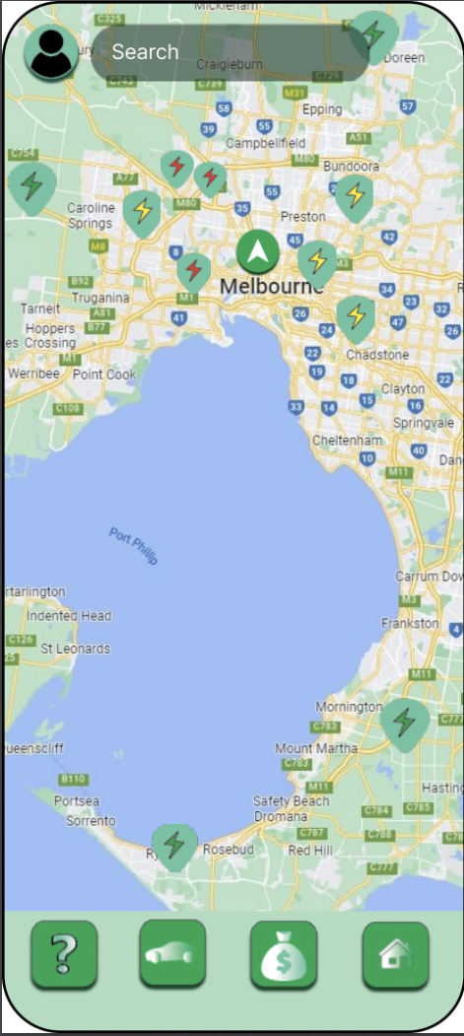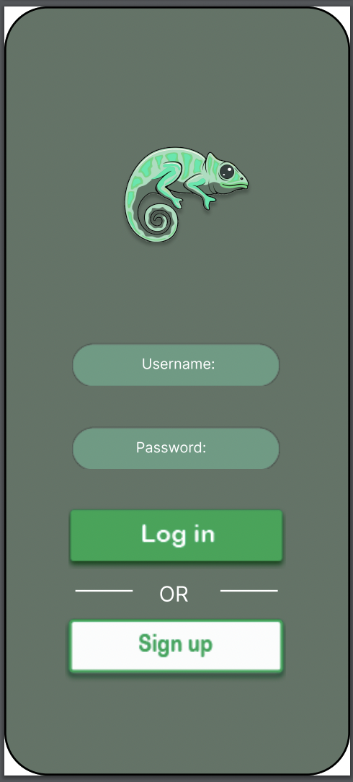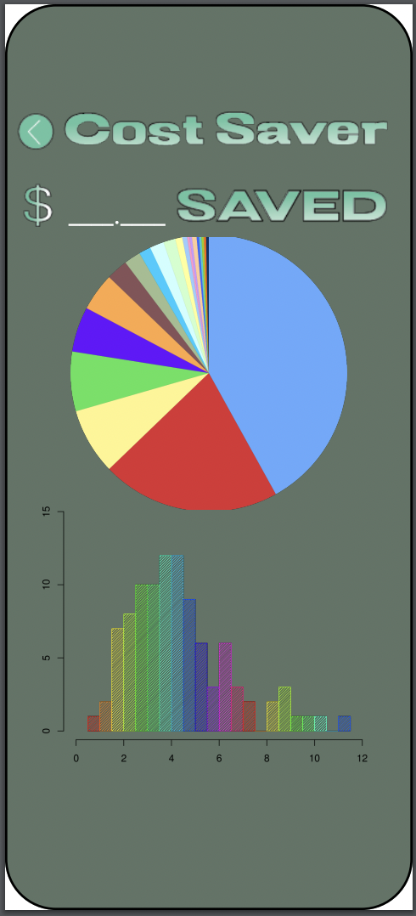

## Week 11 Final Project Status

The EV adoption tools team has completed the following deliverables:

#### Mobile App Team

* Selection of the React Native framework for development
* Design of user interfaces for desired user flows
* Creation of basic app that includes a map, form for submitting a new charger station (although no back end yet exists for this) and the ability to sign into / register an account.
* Creation of a DevOps pipeline using GitHub actions that automatically builds and submits the app to the play store

#### Data Science & Engineering Team

* Identification and population of EV charger locations within Australia
* Creation of several data science investigations to understand what can be done with the data
* Creation of initial API to return EV charger locations to mobile app

### Progress made since the Week 6 (Mid-Trimester) update

Since the 6.2 update the EV Adoption Tools team has completed two sprints focused primarily on building out the actual mobile app and adding functionality to achieve an MVP. This proved challenging as we hit several technical challenges around getting the proposed menu designs to work well with the mapping engine. This was due to incompatibilities between the libraries and the latest Android SDKs, but we were eventually able to solve this and now have a working app with simple mapping, navigation, and a form to submit a new EV location. In addition, we have the working automated build processes, pipelines and play store listing working well. Overall, we would have liked to have a more complete MVP, but we were able to achieve a functioning app that will form a basis for future development.

### Key Achievements & Member contributions

#### User Story Creation: Harleen, Yuvi Kapoor

To proceed with the design of the mobile app interface, we needed to establish what the user stories are required for the app. This was defined in consultation with the rest of the team and documented to provide this to the design team.

#### Design of Mobile App Screens & Workflows: Karanbir Bhatti, Yuvi Kapoor, Harleen

For the development team to start the app build, we needed to have the screens for the app designed so that we have a consistent user interface throughout the app.

#### Creation of Github & React Native Build Pipelines: Glenn Richmond, Van Nguyen, Hamish Glover

To ensure that testing and deployment of the app is a consistent and streamlined process, we created automated pipelines that build the app and automatically deploy the app to the play store for testing on each main branch store. This also makes it easy to identify when developers introduce errors in the app since the build immediately fails and allows the developer to fix the issues before it impacts other developers.

#### Creation of Mobile App MVP: Glenn Richmond, Van Nguyen, MUHAMMAD AHMED ARIF

This piece of the project involved creating the Android app and making it available for testing. In the end, we were able to get the navigation, live google map and an EV submission form working together.

### Next steps for the project

The next steps for this project are to continue to enhance the mobile app and add the following:

* Add real EV location display to the Google map along with the ability to filter those EV chargers (requires new APIs (application programming interfaces) from the data science team).
* Add improved user interface to the layout and form submission.
* Improve the branding of the app to incorporate the Evoleon app branding.
* Add registered user functionality to the app such as the ability to log and track my EV charging usage.

### Location of project resources

* [Evoleon App play store listing](https://play.google.com/console/u/1/developers/8755112969725174772/app/4972461749874318628/app-dashboard?timespan=thirtyDays) (use [evoleonapp@gmail.com](mailto:evoleonapp@gmail.com) to access as admin)
* [Github Repository](https://github.com/grdeakin/evoleonapp)
* [Github Build Pipelines](https://github.com/grdeakin/evoleonapp/actions)
* [Evoleon Expo Project](https://expo.dev/accounts/chamelonorg/projects/evoleon) (React Native Build Pipeline & submission to play store)
* [Trello Board](https://trello.com/b/wA8EhPD2/mobile-app-development)

## Sub-Project/Deliverable 2: Identify Best EV Locations based on Big Data

### Summary

The goal of this sub-project is to use community data (population, traffic, transit etc) to predict where would be the most mutually beneficial place to install new charging stations so that:

* Stations are well located in relation to other charging stations
* People have other reasons to stop there (landmark or facility that people spend time at)
* Residents benefit from the installation (business see increased foot traffic & residents are spared extra traffic)
* Existing or planned infrastructure can accommodate the stations (power requirements)

This project will primarily be a data science project that will include:

* Identifying data sets that can support this decision-making process. This will include a research process that will determine whether the required data sets are available
* The outcomes here will be creating a dashboard and an application or machine learning model that provides these recommendations

## Week 6 (Mid-Trimester) Progress Update

This team has now been named the “EV Charger Forecasting and Location Optimisation project team”. They have been hard at work getting everything organised to ensure that this project has a stable foundation that will ensure the current team as well as future teams have everything they need to work effectively. This included setting up team channels, repositories, Trello boards and documentation. We have also started collecting and assessing data for our project and have commenced several data research tasks aimed at exploring the relationship between community data and EV charging locations. The findings from these research tasks are intended to form the basis for a recommendation engine that may be used to predict future requirements for charging stations within a community and the optimal places to build them (this is a long-term deliverable for future trimesters)

Forecast of predicted state of deliverables at end of trimester

* Project infrastructure established including process documentation.
* Comprehensive onboarding/handover process documented.
* A database established to record Existing EV charging locations. This database may also serve to assist the Mobile application development team in future trimesters.
* A webpage with 2 key features
* A map displaying EV locations on a google map (This is the first step in our recommendation application which will in future trimesters be able to plot the recommended locations alongside the existing charger locations)
* A section that will serve as catalogue to display the findings of current and future research tasks associated with EV Charger Forecasting and Location Optimisation.

## Week 11 Final Project Status

The EV charger Forecasting, and Location Optimisation team have completed the following deliverables:

* Established project infrastructure and associated documentation
* Created Existing EV Charger location database and have started to populate this with confirmed locations
* Set up the API to access DB and display coordinates on Google map
* Design of the website UI (User Interface)
* Created a functional test site to display EV location map and research findings
* Completed research tasks to explore the relationship between community data and EV charging locations

### Progress made since the Week 6 (Mid-Trimester) update

Since the Week 6 update, the EV charger forecasting, and location optimisation team has completed two sprints. The first of these focused mainly on continued exploration of community data via various research tasks. The second has focus on wrapping up tasks for this trimester and preparing for project handover.

### Key Achievements & Member contributions

#### Creation of project infrastructure: Leigh Rowell

Leigh setup a NoSQL database for storing EV charger locations, built a web server allowing web and mobile applications to retrieve charger station locations from the database using a REST API, and finally built a basic front-end application to present the teams data analysis reports and demonstrate how we can interact with the web server.

#### Project direction and documentation: Haley Holloway

Haley was responsible for the leadership and administration of the project including project direction and documentation as well as contributions to the group tasks on behalf of the EVCLFO team.

#### Data collection: Haley Holloway, Rahul Kumar, Merry Liu, Sarah Bullen

Collection of confirmed co-ordinates of existing charger locations and associated data for contribution to the EV charge station database that will be utilized by the mobile app team.

#### Research task – Site locations: Rahul Kumar

Creation of customized data & analysis for Australian EV Charging stations & Research on EV charge station Usage:  
Rahul built a customized Data Dictionary, Dataset & performed Exploratory Data Analysis (EDA), Visualizations & used Google Maps API service to fetch nearby EV charging stations & buildings utilizing customized Australian EV Charging Stations Dataset (for Queensland & Melbourne).

#### Research task – Infrastructure Trends: Rahul Kumar

EV charging infrastructure trends across US & EV charge station usage for Australia which incorporates future plans for adoption of EV in Australia & selecting sites for implementation.

#### Research task – Predicted Energy Consumption: Merry Liu, Sarah Bullen & Matthew Iredale

Merry initiated a research proposal on supplier payback periods, based on multiple national charging point datasets she collected; encouraged two other team members to work together on the data analysis and visualisation, and then built two models to generate predictions of energy consumption.

#### Research task – Distribution of Registered EV’s: Matthew Iredale

Explored the possibility of predicting EV charge station requirements based on electric vehicle registration across Australia by state, America by state and globally by country.

#### Research task – EV Sales Data: Sarah Bullen

Explored the viability of using EV sales data to predict future EV adoption in a given area.

### Next steps for the project

The focus for next trimester will be the following:

* Continued research into community data and the potential insights we can gain from it.
* Add functionality to API to enable database searching.
* Improve the website user interface.

The long-term goal of developing a predictive and forecasting model that will enable a user to receive recommendations for optimal EV charging installation locations is ongoing and dependant on the viability of the data and insights provided by the research tasks undertaken by the team.

### Location of project resources

[Test Site](https://storage.googleapis.com/evcflo_static_frontend/index.html)

[Trello Board](https://trello.com/b/mDtE9aF8/ev-charger-forecasting-location)

[Teams Channel](https://deakin365.sharepoint.com/:f:/r/sites/Chameleon2-EVChargerForecastingandOptimisation/Shared%20Documents/EV%20Charger%20Forecasting%20and%20Optimisation?csf=1&web=1&e=vKAgI9)

[Github Repository](https://github.com/Chameleon-company/EVCFLO)

# Showcase Videos

**Company wide Showcase**: <https://chameleon-client.mybluemix.net/#/web/about-us>

**Team Showcases:**

The City of Melbourne: <https://chameleon-client.mybluemix.net/#/web/portfolioP1>

Website: <https://chameleon-client.mybluemix.net/#/web/portfolioP3>

EV Adoption Tools: <https://chameleon-client.mybluemix.net/#/web/portfolioP2>