# Trimester 2 of 2022 - Figma Wireframe Transfer Document – City Of Melbourne Open Data Project

* The purpose of this document is to guide future endeavours in the development, monitoring, basis, and transfer to live servers as it details how to download the wireframes file and use Figma in a collaborative setting with the initial individual setting the Figma file up, acting as the host.

***Hot Tool Tip: Zoom into any screenshots on word with [CTRL] +Mouse Scroll Up***

* **IF A HOST** – Download the Figma wireframe file from either the Deakin Service:
* <https://deakin365-my.sharepoint.com/:u:/r/personal/sjspice_deakin_edu_au/Documents/Website%20Wireframe%20Creation%20(1).fig?csf=1&web=1&e=p70alT>
* Or the Google Drive Service:
* <https://drive.google.com/file/d/1xM7nNLM9vy-aZFfvBJVwaIrbUPVFnAnw/view?usp=sharing>
* **IF GUEST OR EDITOR** – Follow the steps below and use the link provided by your host.

# Steps

1. Initially, open the Figma website.
2. Then click the blue ‘Get started’ button in the corner.

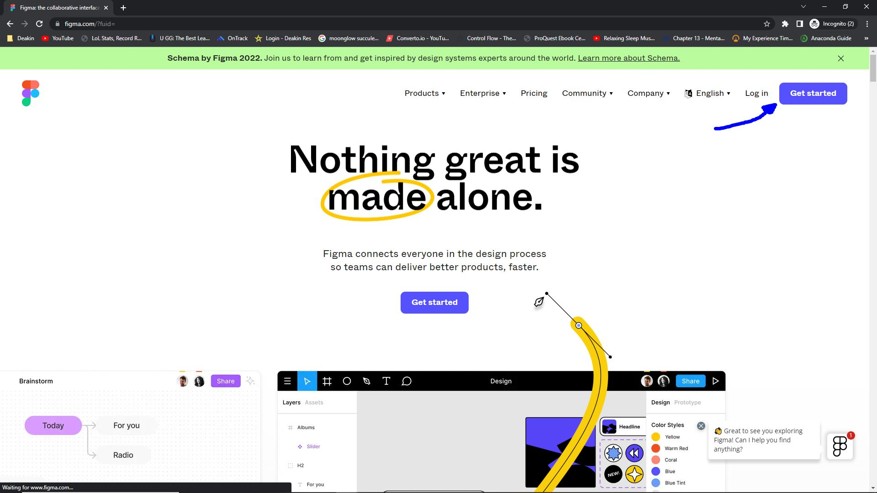

1. Enter an email and password, then click the black ‘Create account’ button.

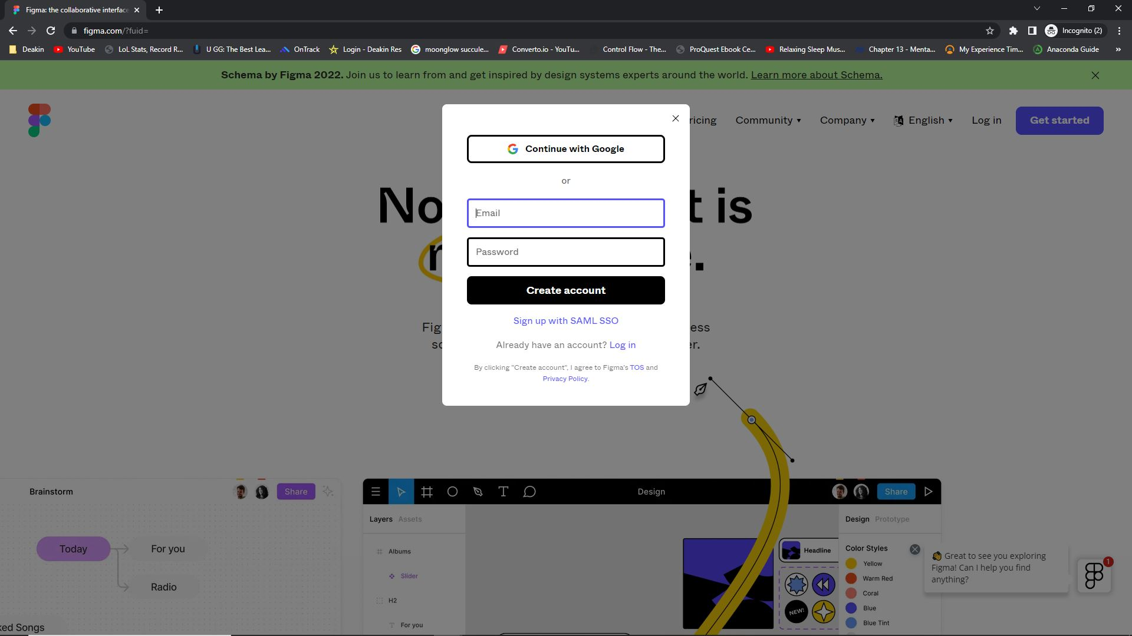

1. [This may then take you across a tour, use and browse as you wish at your own benefit]. After clicking about the tours, and closing some pop-ups we are lead to the main Figma screen, which details all of the current files in creation and development. You are then going to want to click ‘Import file’ for hosting a Figma file, otherwise, use the link provided both your host or hostess and skip to step 7.

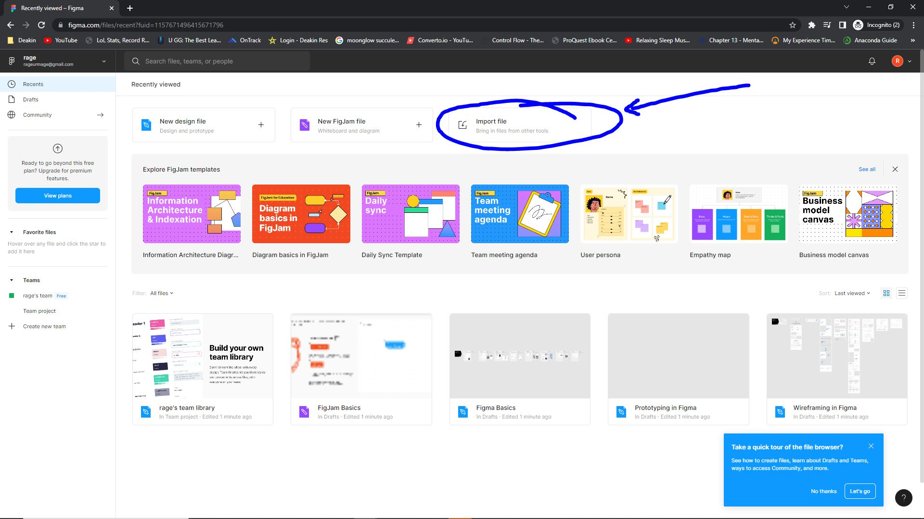

1. You should then be brought to a file directory, which you may want to redirect to your downloads, select the intended Figma File as highlighted below, and click ‘Open’.

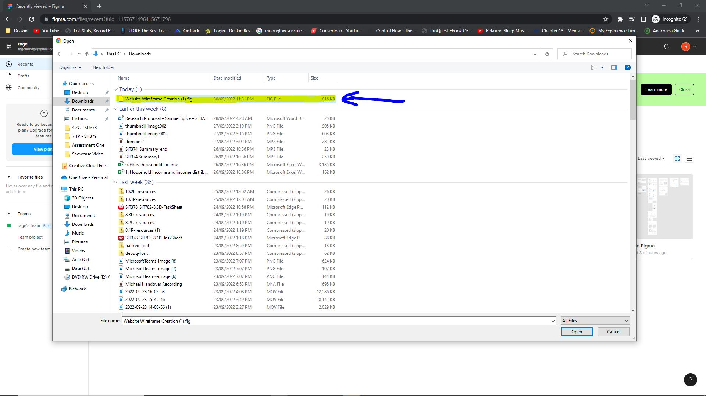

1. It will take a few moments but this should lead you to pop-up with the finalisation of the file occurring with your account and importing the file successfully.

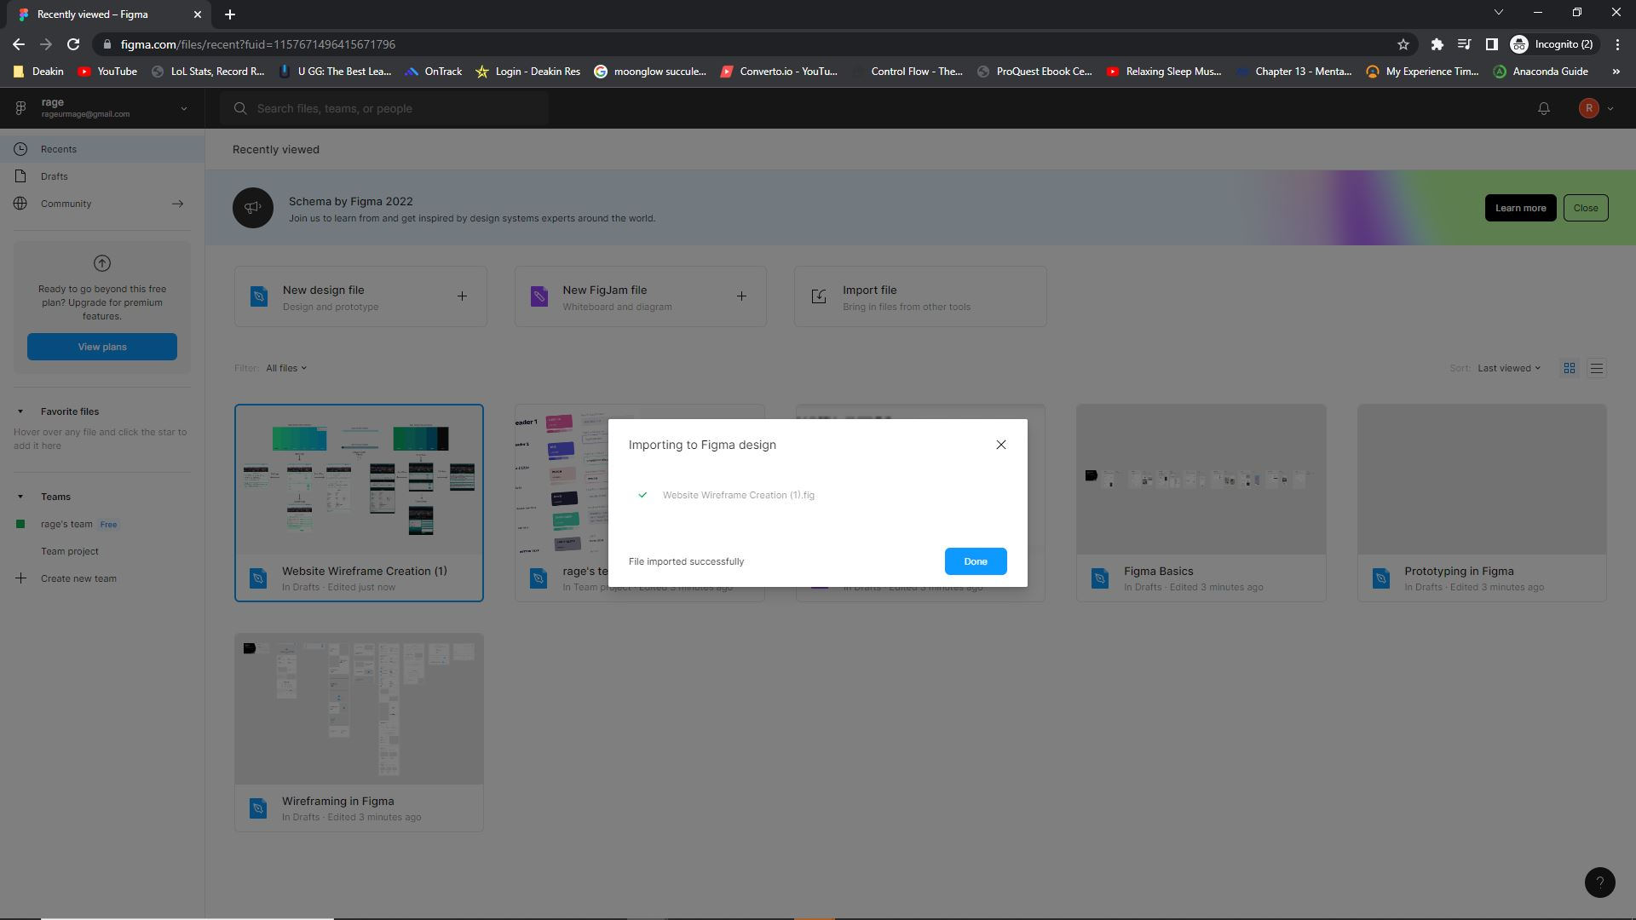

1. Depending on whether you used the link or imported the file, you may have the screenshot displayed below, in which you will want to double click on the Figma File as labelled [‘Website Wireframe Creation (1)’] which will lead you to the step 8 screenshot or you may already start on the step 8 screenshot.

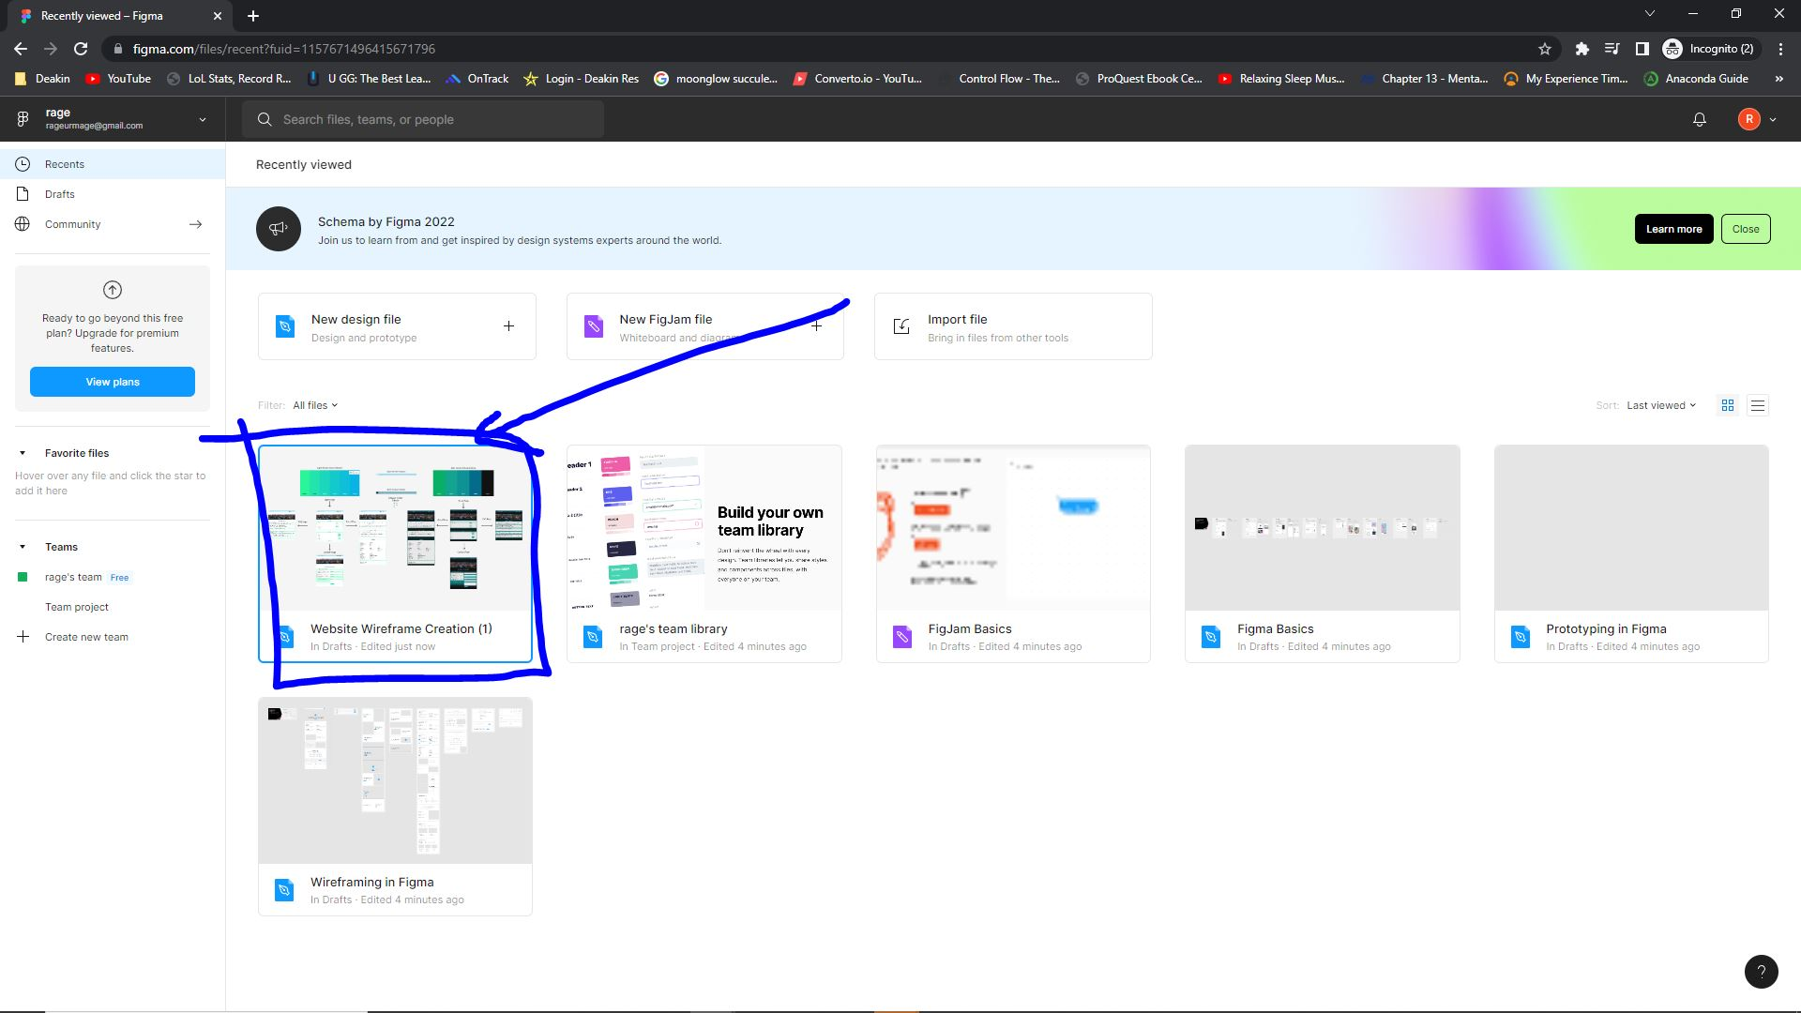

1. This is the main screen containing the wireframes, here we can edit and view the wireframes depending on our permissions and accessing individual frames as symbolised by the lock, which can be clicked to unlock a frame and edit its contents. The red arrow indicates different pages people can work on, using them as a desktop space before they can be compiled together in a main section currently listed as ‘Overview’. The left black arrow indicates the pane in which the editing and designing can occur, where edits can be made to shapes, colours, and images in required. Alternately the top black bar holds a couple of elements, such as the creation of shapes, textboxes, cropping, moving and more, which should be explored to an extent for knowledge purposes.

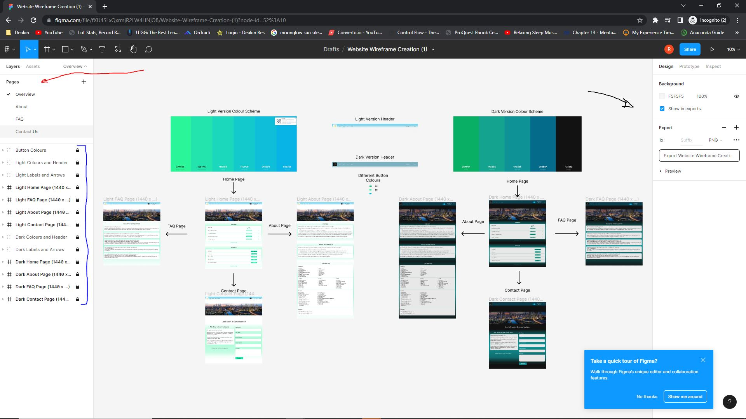

1. To share such a document, simply click the blue ‘Share’ button in the top right corner, here you can invite specific emails however, it is easier to click the ‘Copy link’ button and share the link with others. *Remember, you must change the permissions when sharing the document for adequate editing and viewing permissions as highlighted.*

