Chameleon

**Company Objectives and Structure**

Task 5.1P

Company Structure

T2 2022 Objectives

* Continue to develop the Chameleon Website capabilities to be optimised for mobile access and create a staff portal for Chameleon staff to make blog post and manage website user accounts.
* Research, design and develop minimum viable products (MVP) for commercially viable EV Adoption Tools.
* Enhance the Melbourne Open Data Playground to support City of Melbourne's smart cities goals and aspirations.

Executive Summary

**OUR MISSION**

"Given the complexity of energy application needs today, IoT systems are being designed to address a wide variety of existing problems.

In Chameleon, our mission is to research, create, test, document and deploy IoT-based solutions to enhance life through the application of smart city technologies including: the building of smarter cities, homes, transportation, and energy management systems."

There are 3 divisions within the company, focusing on the 3 key areas of strategic importance:

* City of Melbourne Open Data
* Chameleon Website
* Electric Vehicle (EV) Adoption Tools

Both the open data project and the EV adoption tools leverage data sets that are created using IoT-based sensors and as such, fit into the goals of the company. The Chameleon website articulates the goals of the company and provides a visible presence.

The goals of the City of Melbourne Open Playground are to create a toolset to assist non-technical users in understanding some of the challenges that open data in the City of Melbourne can help to solve, along with useful, step by step examples.

The EV adoption tools division will be focusing on 3 projects. These projects will all related to building out tools to help drive EV adoption and/ or solve challenges associated with building out EV infrastructure.

____________________

Seng Loke

Director

Table of Contents

Leadership Team 1

Trimester Goals and Objectives 1

Company Structure and Projects Overview 1

Project 1: City of Melbourne Open Data 3

Overview, Goals, and Objectives 3

Aims for Trimester 3

Deliverables 3

Project Members 4

Project 2: Chameleon Website 5

Overview, Goals, and Objectives 5

Aims for Trimester 5

Deliverables 5

Location of project resources 5

Project Members 6

Project 3: EV Adoption Tools 7

Overview, Goals, and Objectives 7

Aims for Trimester 7

Deliverables 7

Project Members 7

Sub-Project/Deliverable 1: Locate a Socket 8

Sub-Project/Deliverable 2: Identify Best EV Locations based on Big Data 9

# Leadership Team

The company board consists of the following key personnel:

* Seng Loke
* Valeh Moghaddam

Seng Loke is the acting director and key point of contact for the leadership team on a day-to-day basis.

The leadership team consists of the following students:

|  |  |  |  |  |  |
| --- | --- | --- | --- | --- | --- |
| **Student ID** | **Full Name** | **Junior/Senior** | **UG/PG** | **Project** | **Project/Team Lead?** |
| 217072092 | Nykolai Mcherron | Senior | Undergrad | Chameleon Website | Project Lead |
| 219425396 | Kinshuk Jain | Junior | Undergrad | Chameleon Website | Assistant Project Lead |
| 220077269 | Ayushi Natalie Alujjage | Senior | Undergrad | Chameleon Website | Team Lead |
| 218429514 | Shakwat Hossain Limon | Senior | Undergrad | Chameleon Website | Team Lead |
| 217285498 | Mollie Fernandez | Senior | Undergrad | City of Melbourne | Project Lead |
| 220005641 | Bose Alli | Junior | Postgrad | City of Melbourne | Assistant Project Lead |
| 218296596 | Michael John Leen | Senior | Undergrad | City of Melbourne | Team Lead |
| 400150369 | Bree Margaret McLennan | Senior | Postgrad | City of Melbourne | Team Lead |
| 220532657 | Julian Cape | Senior | Postgrad | City of Melbourne | Co-Team Lead |
| 219179817 | Hamish Finnley Glover | Senior | Undergrad | EV Adoption Tools | Evoleon Project Lead |
| 214490138 | Leda Scott | Junior | Undergrad | EV Adoption Tools | Evoleon Assistant Project Lead |
| 219213881 | Matthew Robert Iredale | Senior | Undergrad | EV Adoption Tools | Best EV Locations Project Lead |

# Trimester Goals and Objectives

* Continue to develop the Chameleon company website
* Implement additional use cases and rebranding for the City of Melbourne Open Data Project
* Begin to build and create the base for the Evoleon mobile app
* Provide an initial MVP for the EV business case portal
* Create an early MVP for the EV location recommendation engine

# Company Structure and Projects Overview

In trimester 2 2022, Chameleon will be running the following three concurrent projects that, together, support the mission and objectives of the company.

* City of Melbourne Open Data – Promoting smart cities open data adoption
* Chameleon Web Site – A platform for showcasing and promoting Chameleon's activities
* EV Adoption Tools – A variety of tools to support the adoption of EV adoption by the Australian community.

Chameleon is run by a Company leadership team comprising one Board Director and a student leadership team. This team coordinates whole of company initiatives and ensures projects are delivering on the company mission and objectives. The Company Leadership team reports to the Board of Directors.

Some members of the Student Leadership team are allocated as leaders of each of the projects with the remaining student leaders providing vitally important administrative and executive support functions for the company.

Figure 1 illustrates the company structure at a high level with members of each team listed in subsequent sections of this document and Figure 2 illustrates the typical structure of a project team its relationship to the Leadership team.

Each project may be comprised of multiple teams providing a different set of skills in support of the project's deliverables. Each team will have a designated team leader accountable for that teams' deliverables.

The project leader will be supported by an assistant project leader who can assist with project management, team communications and meeting facilitation. Assistant project leaders and team leaders are also candidates for future leadership roles in the subsequent trimester.

*Figure 1: Chameleon Company Structure,* *Figure 2: Chameleon Project Team Structure*

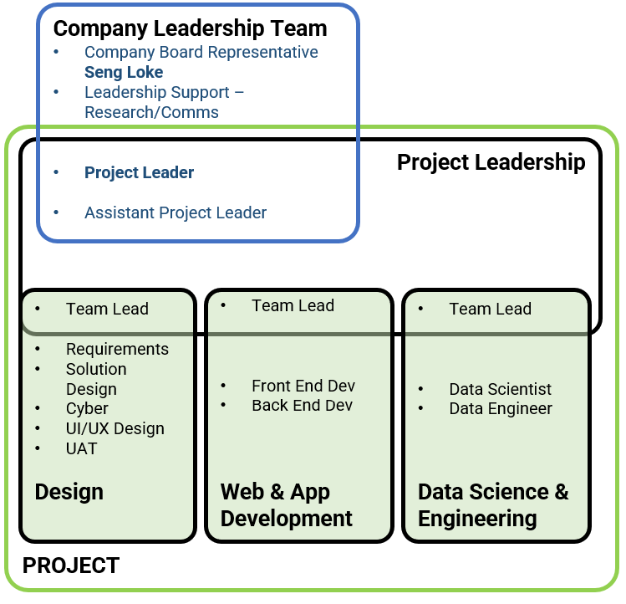

# Project 1: City of Melbourne Open Data

## Overview, Goals, and Objectives

The City of Melbourne has been an Australian leader in Open Data since 2014. The City of Melbourne initiated this project with Deakin to support greater use of their Open Data by businesses, researchers, and software developers. Open Data is a component of their smart cities' strategy.

This project delivers an education portal which demonstrates how to leverage Open Data using real world scenarios that may be of interest to industry, government, and researchers. Its long-term goal is to increase the usage of City of Melbourne Open Datasets and drive increased investment across the City of Melbourne council area.

## Aims for Trimester

This semester the project will aim to become integrated into the Chameleon company by re-focusing its deliverables on Smart Cities Open Data while delivering additional use cases of value to City of Melbourne businesses and residents.

## Deliverables

The short term (trimester) deliverables were:

* Create additional data science use cases to the Melbourne Open Data Playground portal and GitHub Repository.
* Ensure the Melbourne Open Data Playground portal can run on mobile devices
* Make Minor cosmetic improvements to the Melbourne Open Data Playground portal
* Implement the remaining use cases designed in 2022 trimester 1 into the live site
* Implement design changes suggested in trimester 1
* Researching & Rebranding the Open Data resources for easier recognition and accessibility
* Migration from flat file data sources to a relational database for improved search functions
* Implement Staging Pipeline & Web-application for more streamlined Development and Integration

Longer term goals included:

* Preparing the Melbourne Open Data Playground portal and GitHub repository for use by the public
* Migrating the Pedestrian data use cases and Jupyter notebooks to support a new data provider
* Migrating the Open Data access API from SOCRATA to a new platform
* Implementation and Integration of updated designs and features

## 5.1P update

### Project Progress Update

The City of Melbourne Project is full steam ahead, with our first client meeting on Friday the 5th of August (end of week 4) which outlined our goals and expected deliverables for the trimester. The client was impressed with the proposed deliverables and updates to the Melbourne open Playground site giving feedback. We have now begun our first three-week sprint at the beginning of week 5.

#### Web App Development team

At this point in the project the web development team have made great headway getting all their new members upskilled and development environments setup. Moving into sprint 1 the focus is on documenting and creating tutorial videos for implementing use cases onto the Melbourne Open Playground. Secondary focus for sprint 1 is to implement a staging pipeline to assist with development and future changes to the web application.

#### Design Team

With a rebranding in mind the design team have hit the ground running. The team begun with a research phase, looking into colour pallets and design elements to enhance the functionality and usability of the site. The end of sprint 0 saw the collation all this research into creating documentation which will solidify the direction of a solid idea of the new look and feel of the site. Sprint 1 will focus on redesigning the new aspects of the site and creating mock-ups. Also, the team will be working with the data science team to implement standardized colour pallets whilst the web development team implement these changes.

#### Data Science and Engineering team

As of week 5, the data science team have now commenced technical development work on the use cases which were endorsed by the client. All team members have been allocated use cases to work on and all have clearly stated their engagement and commitment to their assigned tasks. The technical work has been categorised into 3 domains, ‘safety and wellbeing’, ‘environment and sustainability’ and ‘business and activity’. The team have also commenced work on a 4th domain which focuses on building internal value to the team, project and company through the development of documentation and work practices.

### Forecasted likely state of project deliverables at the end of the trimester

* Addition of 3+ data science use cases to the Melbourne Open Playground
* Creation of multiple use cases within the three domain streams to be added to the Melbourne Open Playground
* Ensuring the Melbourne Open Data Playground portal can run on mobile devices
* Make minor cosmetic improvements to the Melbourne Open Data Playground
* Implement design changes suggested in trimester 1
* Researching & Rebranding the Open Data resources for easier recognition and accessibility
* Implement Staging Pipeline & Web-application for more streamlined Development and Integration

### Changes to plans for the project

No changes have been made.

### Location of project resources

* [Melbourne Open Data Playground website](https://master-mop-busaytgm.ts.gateway.dev/)
* [Melbourne Open Data Playground GitHub Repository](https://github.com/Chameleon-company/MOP)
* [City of Melbourne MS Teams Channels Files](https://deakin365.sharepoint.com/:f:/r/sites/Chameleon2-Chameleon-CityOfMelbourne/Shared%20Documents/Chameleon-CityOfMelbourne?csf=1&web=1&e=jwCJOT)
* [Melbourne Open Data Playground Code GitHub Repository](https://github.com/Chameleon-company/MOP-Code)
* [Chameleon Handover Documentation GitHub Repository](https://github.com/Chameleon-company/Chameleon-Handover-Documents)
* [City of Melbourne Trello Board](https://trello.com/b/ln6GEN45/melbourne-city)
* [City of Melbourne T1 2022 Project Showcase Video](https://video.deakin.edu.au/media/t/1_tu93x3dv)

## Project Members

| **Student ID** | **Full Name** | **Junior/Senior** | **UG/PG** | **Team Group/Role** |
| --- | --- | --- | --- | --- |
| **217285498** | **Mollie Fernandez** | **Senior** | **Undergrad** | **Project Leader** |
| **220005641** | **Abosede Alli** | **Junior** | **Postgrad** | **Assistant Project Leader** |
| **400150369** | **Bree Margaret McLennan** | **Senior** | **Postgrad** | **Data Science & Engineering Team Leader** |
| **220532657** | **Julian Cape** | **Senior** | **Postgrad** | **Data Science & Engineering Co Leader** |
| 216019732 | Hannah Smith | Junior | Postgrad | Data Science & Engineering |
| 221377945 | Jack Pham | Junior | Undergrad | Data Science & Engineering |
| 215127684 | Ryan Daniel Waites | Senior | Undergrad | Data Science & Engineering |
| 220616385 | Brendan Patrick Richards | Senior | Postgrad | Data Science & Engineering |
| 220554762 | Andrew Tilling | Junior | Postgrad | Data Science & Engineering |
| 220410831 | Barkha Javed | Junior | Postgrad | Data Science & Engineering |
| 221308817 | Weiren Kong | Senior | Postgrad | Data Science & Engineering |
| **218292859** | **Samuel Spice** | **Senior** | **Undergrad** | **Design Team Co Leader** |
| **220580602** | **Stephen Brackenridge** | **Junior** | **Undergrad** | **Design Team Co Leader** |
| 218271294 | Jacob Djaelani | **Senior** | Undergrad | Design |
| 219595935 | Muhammad Hassan Peerzada | **Junior** | Postgrad | Design |
| 218673691 | Imani Maina | Senior | Undergrad | Design |
| 218268634 | Harrison Corin Padraic Murphy | Senior | Undergrad | Design |
| 219362178 | Bansi Baiju Patel | Senior | Undergrad | Design |
| **218296596** | **Michael John Leen** | **Senior** | **Undergrad** | **Web & App Development Team Leader** |
| **221023977** | **Muhammad Sohaib Bin Kashif (Sammy)** | **Senior** | **Postgrad** | **Web & App Development Co Leader** |
| 219297735 | Caleb Webb | Junior | Undergrad | Web & App Development |
| 218341765 | Shlomi Moreh | Senior | Postgrad | Web & App Development |
| 221070031 | Tianqi Zhou | Senior | Postgrad | Web & App Development |
| 219273805 | Yi Yang Yu (Eric) | Senior | Undergrad | Web & App Development |
| 222296654 | Marcel Gebara | Junior | Undergrad | Web & App Development |

# Project 2: Chameleon Website

## Overview, Goals, and Objectives

Like any other company, the Chameleon company requires a website to be its digital public facing space. The main goal of the website is to promote Chameleon’s projects, products, and the services that it provides. As the project implementation progresses, additional features and functionalities will be added such as blogs, events calendar, and a clients’ area.

## Aims for Trimester

After the foundations for the website were built in Trimester 1, in this trimester we aim to optimise the website for mobile access, create a blog section and begin laying the foundations for a Chameleon Staff Portal, which will allow members of the Chameleon Company to make and manage blog posts, calendar events and manage client's user accounts.

## Deliverables

This trimester's short-term deliverables include:

* Optimise website for mobile access
* Build a blogging section
* Create the front end for staff portal
* If time allows, begin creating back end for staff portal

The future trimesters long term deliverables include:

* Chameleon Staff Portal features
  + Set up staff accounts
  + Manage client's user accounts
  + Create client area that allows them to view Chameleons project progress, updates and other services
  + Allow Chameleon staff to edit the website pages text content, making them dynamic
  + Manage blog, client reviews & calendar
* Implement a SEO strategy to rank the website higher in the web search engines
* Implement a web tracking mechanism and a web traffic analysis

## 5.1P update

### Project Progress Update

Weeks 1-4 of the project saw the onboarding and briefing of new students, establishment our short and long term goals, organisation of weekly meetings, and creating and assigning the tasks required to achieve them. As of week 5, the Chameleon Website project is on schedule to implement mobile optimisation by week 7, a static blog by week 8, and if time allows in the remaining trimesters begin development for the Staff and Client Portal.

#### Design Team Update

The new additions to the design team have been added to Figma and taught how to use it and mobile optimisation design templates have been created.

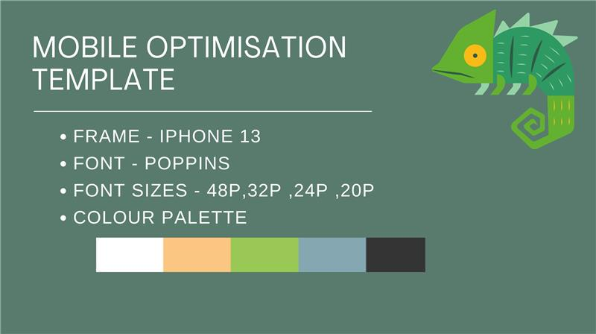

Almost all the lo-fi wireframes for mobile optimisation have been completed in week 5 with some designs pending completion by week 6. Work will begin on the blog wireframes in week 6, the Staff and Client Portal wireframes will begin from week 8 onwards.

Logo 
Our Miss 
Logo 
estimonal 
Welco me to 
Chameleon 
SEM no o 
Logo 
Send Us 
Your Review 
Logo 

#### Web & App Development Team

There were quite a few late additions to the Web & App Development team, the latest being in week 4. Despite this, all the team members have been briefed, granted access to GitHub, and new developers have been buddied with more experienced project members. The responsiveness of the website should be finished by week 6 and all these updates will be included in the SRS document to help future students familiarise themselves with our systems. We have plans to begin development for the Staff & Login Portal from week 8 if time permits.

### Forecasted likely state of project deliverables at the end of the trimester

We have planned to finish the mobile optimisation and blogging section before the end of the trimester in week 8. Aiming to finish these deliverables earlier in the trimester gives us time should we fall behind but if we meet our deadlines, it also gives us the opportunity to begin developing the Client & Staff Portal, which will help the next trimester begin development earlier.

### Changes to plans for the project

At the start of the trimester, we decided to deprioritise the Client & Staff portal to focus on accessibility and engagement deliverables. So far, we have kept up with our trimester deadlines, so there are no major changes to our plans for this trimester.

The design team did however provide some wireframes that are designed similarly to a mobile app. But, since these drafted designs were proposed in week 5, it was too late to implement them across the website. However, we have considered implementing them into the Staff & Client Portal and potentially the blog section, as these are more interactive and have yet to begin development, making it more feasible to implement them within this trimester.

**Left:** original design  
**Right:** updated app style design

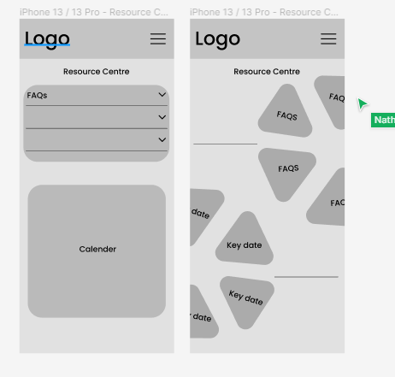

## Location of project resources

The resources are spread in a few different locations:

* [The Chameleon Website](https://chameleon-client.mybluemix.net)
* [The Chameleon Website Project MS Teams channel](https://deakin365.sharepoint.com/sites/Chameleon2-Chameleon-Website/Shared%20Documents/Forms/All%20items.aspx?RootFolder=%2Fsites%2FChameleon2%2DChameleon%2DWebsite%2FShared%20Documents%2FChameleon%2DWebsite&FolderCTID=0x0120004FE98DEF20507045961D15A063046024)
* [The Project Github Handover repository](https://github.com/Chameleon-company/Chameleon-Handover-Documents/tree/main/2022-T1/chameleonwebsite)
* [The Project Trello Board](https://trello.com/b/wbieC0bc/chameleon-website)
* [The Project Backend Github repository](https://github.com/Chameleon-company/chameleon-website-webdev-server)
* [The Project Frontend Github repository](https://github.com/Chameleon-company/chameleon-website-webdev-client)
* [The Chameleon T1 2022 Website showcase video](https://chameleon-client.mybluemix.net/#/web/portfolioP3)

## Project Members

|  |  |  |  |  |
| --- | --- | --- | --- | --- |
| Student ID | Full Name | Junior/Senior | UG/PG | Team Group/Role |
| 217072092 | **Nykolai Garcia McHerron** | **Senior** | **Undergrad** | **Project Leader** |
| 219425396 | **Kinshuk Jain** | **Junior** | **Undergrad** | **Assistant Project Leader** |
| 220077269 | **Ayushi Natalie Alujjage** | **Senior** | **Undergrad** | **Design Team Leader** |
| 218429514 | **Shakwat Hossain Limon** | **Senior** | **Undergrad** | **Web & App Development Team Leader** |
| 221337514 | Nathan Cahill | Senior | PostGrad | Design |
| 220102998 | Nikhil Nikhil | Senior | Undergrad | Design |
| 220490637 | Sangjun/Samual Kim | Senior | Undergrad | Design |
| 219204947 | Tejal Girish Ranade | Senior | Undergrad | Design |
| 218360746 | Muhammed Haris Saeed | Junior | Undergrad | Design |
| 220079655 | Pratham | Junior | Undergrad | Design |
| 220462239 | Aye Moh Moh Shwe | Junior | Undergrad | Design |
| 220068066 | Uche Ajoku | Senior | Postgrad | Design |
| 220381653 | Jack Hagen | Senior | Undergrad | Web & App Development |
| 220271708 | Mathew Ho | Junior | Undergrad | Web & App Development |
| 220240516 | Julian Ryan | Senior | Undergrad | Web & App Development |
| 219222529 | Lachlan James Exton | Senior | Undergrad | Web & App Development |
| 220460399 | Xinyu Ji | Senior | Undergrad | Web & App Development |
| 217438019 | Dasun Tharaka Kodikara Munasinghege | Senior | Undergrad | Web & App Development |
| 218663803 | Surpreet Singh | Senior | Undergrad | Web & App Development |
| 220457523 | Zhenyu Ye | Senior | Undergrad | Web & App Development |
| 218595157 | VINEETH KARUPPIAH | Senior | PostGrad | Web & App Development |
| 218086716 | Gideon Kiptugen | Junior | Undergrad | Web & App Development |
| 219220123 | Jason Hu | Junior | Undergrad | Web & App Development |
| 218517597 | ChenXuan Hao | Junior | Undergrad | Web & App Development |
| 221200347 | Jiayi Wei | Junior | Undergrad | Web & App Development |

# Project 3: EV Adoption Tools

## Overview, Goals, and Objectives

The EV Adoption Tools project aims to drive increased adoption of Electric Vehicles (EVs) in Australia.

This will help drive reduced dependence on fossil fuels, lower greenhouse gas emissions and have a positive impact on the environment and global weather events.

EV adoption tools will help EV owners better plan their trips by identifying optimal EV charging stations as waypoints on their journey.

The **Identify Best EV Locations based on Big Data** sub-project will support enterprises looking to establish charging stations in the optimal location based on user demand, traffic, EV owner density and many other data points sourced from government and industry.

## Aims for Trimester

The goals for this trimester will be:

* To expand on the mobile app MVP, implementing features designed in the previous trimester (T1 2022)
* To perform initial research and create an early MVP for the EV location recommendation engine

## Deliverables

This project has two deliverables running as sub-projects:

* Sub-Project/Deliverable 1: Locate a Socket
* Sub-Project/Deliverable 2: Identify Best EV Locations based on Big Data
* All projects will require research, planning and design activities to be continued on this trimester with finalisation of each carried out in subsequent trimesters.

## Project Members

|  |  |  |  |  |
| --- | --- | --- | --- | --- |
| **Student ID** | **Full Name** | **Junior/Senior** | **UG/PG** | **Team Group/Role** |
| **219179817** | **Hamish Glover** | **Senior** | **Undergrad** | **Evoleon Project Leader** |
| **214490138** | **Leda Scott** | **Junior** | **Undergrad** | **Evoleon Assistant Project Leader** |
| 218062706 | Muhammad Qureshi | Junior | Undergrad | Evoleon Design |
| 221071029 | Jasdeep Singh | Junior | Undergrad | Evoleon Design |
| 218556009 | Shafiq Jahangir | Junior | Undergrad | Evoleon Design |
| 220421563 | Nihaal Sachdev | Senior | Undergrad | Evoleon Design |
| 220252511 | Yuvraj Kapoor | Senior | Undergrad | Evoleon Design |
| 220267679 | Billie Jack Hancock | Senior | Undergrad | Evoleon Data Science |
| 221459705 | Nidhi Tapankumar Patel | Senior | Postgrad | Evoleon Data Science |
| 220224202 | Abraham Awonusi | Junior | Undergrad | Evoleon Web Application Development |
| 219051815 | Muhammad Ahmed Arif | Senior | Postgrad | Evoleon Web Application Development |
| 220462328 | Chenyu Kong | Senior | Undergrad | Evoleon Web Application Development |
| 219302799 | Janitha Patabandige | Senior | PostGrad | Evoleon Web Application Development |
| 218673691 | Virg Mania | Senior | Undergrad | Evoleon Web Application Development |
| **219213881** | **Matthew Robert Iredale** | **Senior** | **Undergrad** | **Best EV Locations Project Lead** |
| **219309149** | **Leigh Rowell** | **Senior** | **Undergrad** | **Best EV Locations Team Co Lead** |
| **221430794** | **Mei Liu** | **Senior** | **Postgrad** | **Best EV Locations Team Co Lead** |
| 219223276 | Kale Petruisic | Senior | Undergrad | Best EV Locations Team |
| 220559183 | Onawaree Rattanathon | Junior | Postgrad | Best EV Locations Team |
| 219272783 | Ezekiel Griffin | Junior | Undergrad | Best EV Locations Team |
| 221302256 | Nevil Sukhadiya | Junior | Postgrad | Best EV Locations Team |

## Sub-Project/Deliverable 1: Locate a Socket

### Summary

The goal of this project is to be able to design and implement a mobile app (Android and iOS) to help consumers identify a nearby charging location. While there are existing apps on the market that offer this functionality (i.e., Chargefox), we believe that we can offer an application that differentiates itself from those apps by designing features that add value beyond just finding the charging station.

A few examples of what the app may offer in addition to the core function of locating a socket include:

* Providing additional information and filtering of stations based on type (EV vs hydrogen, for example), information on the source of the power (direct solar, grid powered, gas, diesel etc)
* Providing a full journey planner for longer trips that optimizes for reducing charge time, cost, and environmental impact along the route
* Ability to incorporate your usage data with current fuel prices, cost of maintenance etc and provide an indication of real savings for running the vehicle.

Note that Chargefox does also offer the ability to pay for charging via the app, so this may be something to consider in the architecture of the platform.

### Aims for Trimester

The goal for this trimester will be:

* Add page switching functionality to app navigation menu
* Implement clickable charging location icons onto the EV charging station map, with details such as charge speed and available/total vehicle capacity to assist the end user’s in choosing an appropriate station.
* Arrange charge station data (from a variety of sources) in a consistent format that is readable by the application.
* Design new features, or expand on previous designs, to inform future development

## 5.1P update

### Project Progress Update

Changes to our project’s team structure were made in the first few weeks and communicated with all members, then we began breaking down our project deliverables into smaller tasks on our Trello board. Most of the tasks have been assigned to one or more team members.

Our Design team’s work is well underway, with App Development following at a slower pace due to development prerequisites (i.e., setting up individual environments and training new developers) and some difficulty contacting all members of the App Dev team. The Data Science branch – working primarily with the App Dev team this trimester – is working towards producing a consistent format to store the EV charging station data that will be used by the Evoleon app and populating it with some data for demonstration and testing.

### Forecasted state of project deliverables at the end of the trimester

### App’s basic navigation functionality implemented (ability to switch between pages)

* Locations of charging stations overlayed on map (using dummy or demo data)
* Charging station location icons made clickable to reveal more details about the station
* User sign-up and authentication methods implemented
* Multiple app screens redesigned to ensure consistency and improve user experience
* Some data will be represented in a consistent format that is readable by the app, demonstrating this capability that can be expanded with further data in future trimesters

### Changes to plans for the project

At this stage, our objectives remain unchanged.

### Location of project resources

* [Evoleon App play store listing](https://play.google.com/console/u/1/developers/8755112969725174772/app/4972461749874318628/app-dashboard?timespan=thirtyDays) (use [evoleonapp@gmail.com](mailto:evoleonapp@gmail.com) to access as admin)
* [Github Repository](https://github.com/grdeakin/evoleonapp)
* [Github Build Pipelines](https://github.com/grdeakin/evoleonapp/actions)
* [Evoleon Expo Project](https://expo.dev/accounts/chamelonorg/projects/evoleon) (React Native Build Pipeline & submission to play store)
* [Trello Board](https://trello.com/b/nZWqrgXy/evoleon)

## Sub-Project/Deliverable 2: Identify Best EV Locations based on Big Data

### Summary

Continuing from T1 2022 the goal of this sub-project remains the same, utilizing community data specifically; political, economic, commercial, and traffic (pedestrian/vehicle) to predict where the most mutually beneficial place to install new charging stations so that:

* Stations are well located in relation to other charging stations to avoid competition.
* People are enticed to stop to charge rather than forced, nearby entertainment (landmarks/restaurants)
* Local economy benefits, new station installation attracts more visitors thus more customers for nearby businesses
* Strategically placed stations to encourage EV users to take different routes and minimise traffic congestion
* Existing or planned infrastructure can accommodate the stations (power and land requirements)

#### This project primarily involves Data Science, secondarily Web Development:

* Identifying community datasets that can support the previously mentioned dot-points in the decision-making process. This is ensured via data dictionaries to uphold relevance to the project’s goal.
* Analysing said datasets to generate visualisations that effectively demonstrate trends and/or outliers, proving or disproving factors that impact predictions on new charging station locations.
* Dataset snapshots, coding and visualisations from analysis will be added to our pre-existing test site.

### Aims for Trimester

* Continue building our data-pool from the foundation constructed in T1 2022 by collating more community datasets
* Detect trends and/or outliers through data analysis, thus ever-increasing the accuracy for predicting new charging station locations
* Expanding on Google API datasets to include more existing stations within Australia and begin to incorporate international locations.

## 5.1P update

### Project Progress Update

#### Web Development Team:

* Setup and introduction of the existing GitHub Repositories, website, and Google API has been conducted and achieved with any new members that have joined in T2 2022 given access permission.
* Using google maps and coordinate script searching methodology, the team has been finding existing EV charging locations around Australia with the primary focus localised to Melbourne.
* These locations are then recorded into a database and implemented into the Google API via plotting for user’s to visibly see and plan trips accordingly.
* Alternative approach of plotting EV charging stations has been suggested and currently investigated...
* The theory is EVCS locations from pre-existing databases will be read into a program where the coordinates are distinguished and plotted onto the Google API automatically.

#### Data Analysts Team:

* Process of finding, cleaning and analysing raw datasets regarding the usage of EV charging stations has been introduced to new members and refreshed for continuing members from T1 2022.
* New methods of documentation have been provided with a dataset dictionary to record datasets the team has currently found and still need to in the future.
* Summary of the file directories and its structure for current and future team members to easily discern where pre-existing work can be found and new work to be added.
* Divide and conquer approach established for data scientists, each member has been delegated a region to work on to cover a wider footprint across the globe.

### Forecasted likely state of project deliverables at the end of the trimester

* Australia’s existing EV charging station locations will be fully integrated into the Google API for EV Adoption Tools mobile app team to implement and provide for its users
* Database for locations and usage of EV charging stations continuing to expand, this will provide accurate information for the project’s end-goal of an AI prediction system for advising new locations to install EV charging stations
* Discovery of new external factors that are proven/disproven to impact the usage of EVs, further information found to prove/disprove known factors.

### Changes to plans for the project

* Divide and conquer approach is now the standard procedure for delegating dataset collection/cleaning/analysis (using regions as the divider of tasks)
* **Potential** new method of plotting existing locations via dataset scanning (as opposed to map scanning)

### Location of project resources

[Test Site](https://storage.googleapis.com/evcflo_static_frontend/index.html)

[Trello Board](https://trello.com/b/10idYvBh/evcflo-t2-2022)

[Teams Channel](https://deakin365.sharepoint.com/:f:/r/sites/Chameleon2-EVChargerForecastingandOptimisation/Shared%20Documents/EV%20Charger%20Forecasting%20and%20Optimisation?csf=1&web=1&e=vKAgI9)

[Github Repository](https://github.com/Chameleon-company/EVCFLO)