Rainfall Dataset

Datasets inspect

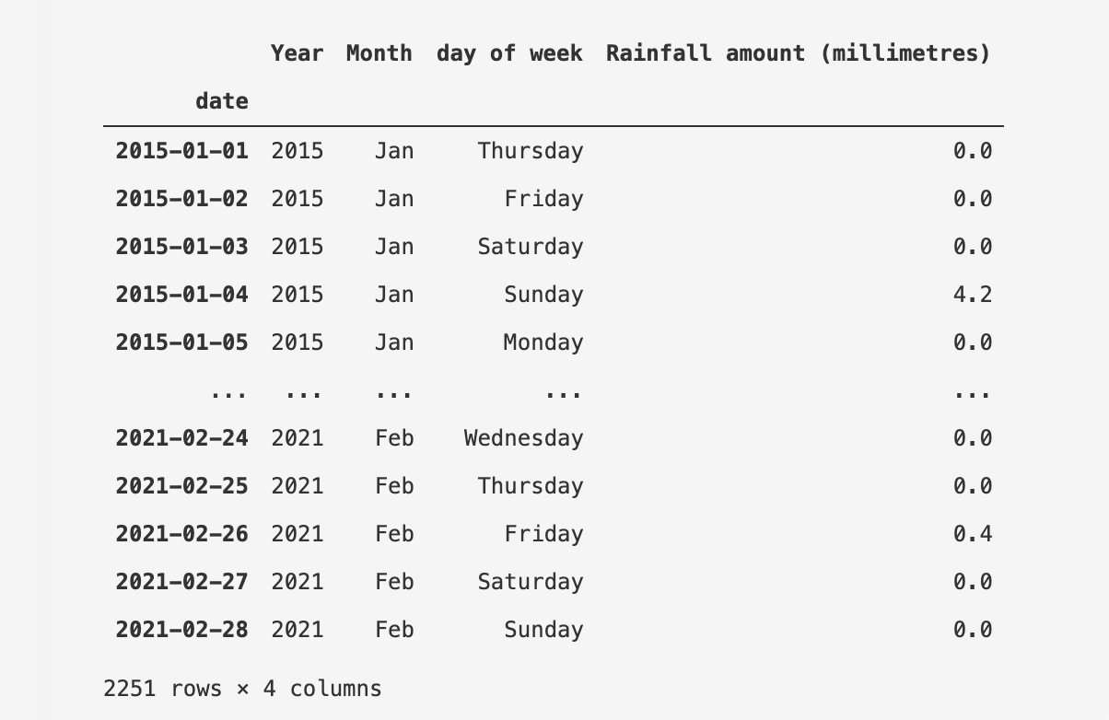
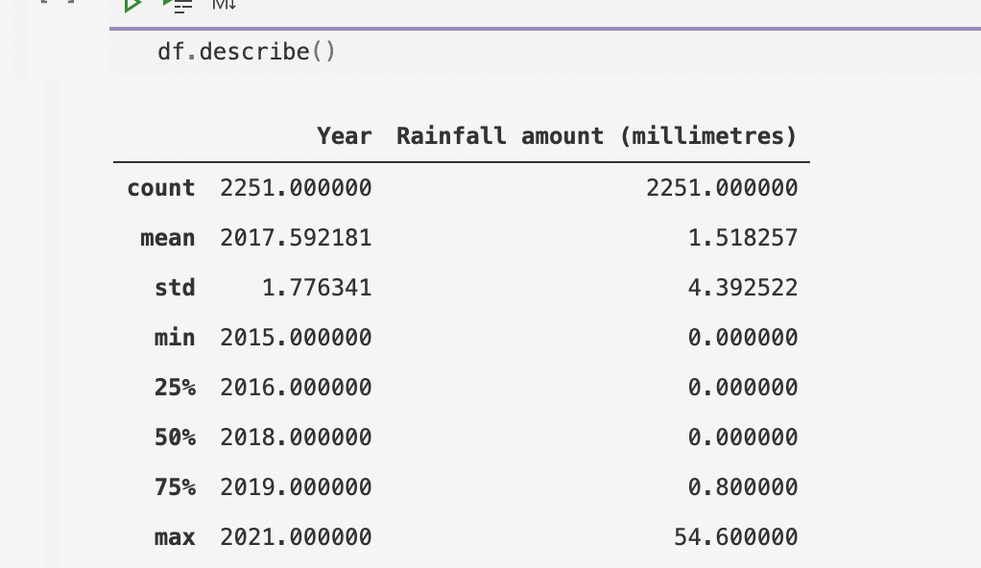

- The rainfall dataset date is range from 2015-01-01 to 2021-02-28

- The rainfall amount with mean 1.51 millimetres. The rainfall amount is range from 54 to 0 (max and min)

- The median is less than mean, the dataset is skewed to the right, most of data spread on the right side.

Rainfall dataset Association

Day of week
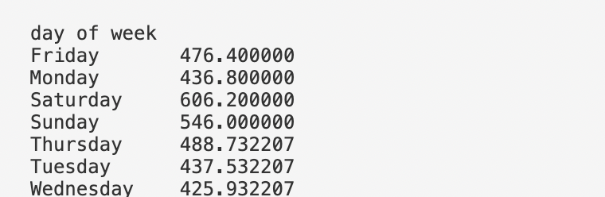

- The total of rainfall amount on Saturday is largest, while rainfall amount on Wednesday is lowest.

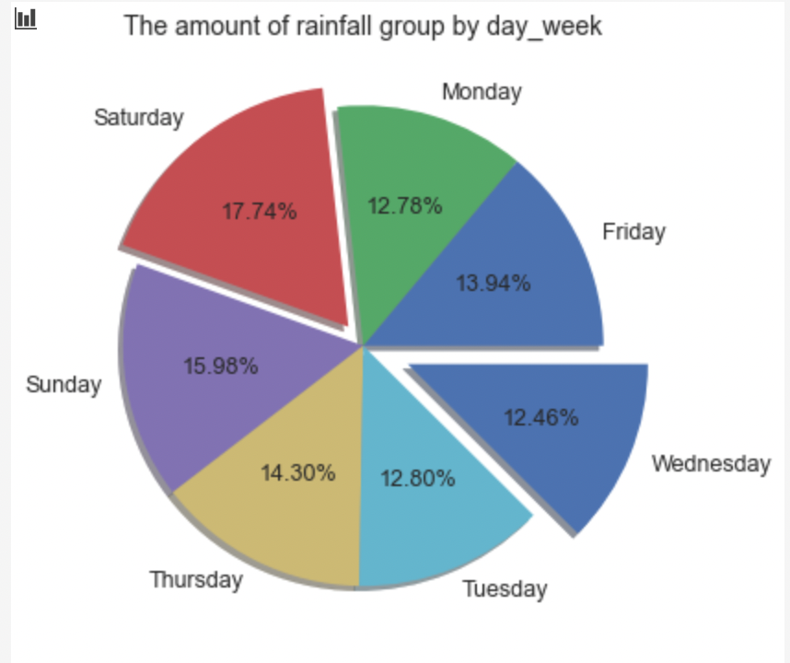

Error bar:
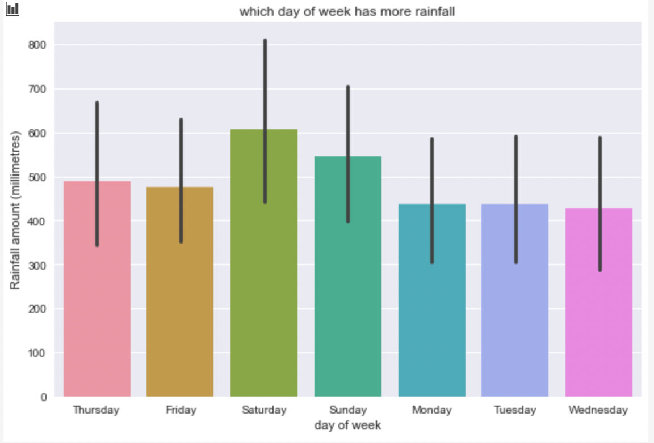
- If check the error, the difference between Saturday and other day of week is significant.
- The days of week (except Saturday) are not significant.

Month index

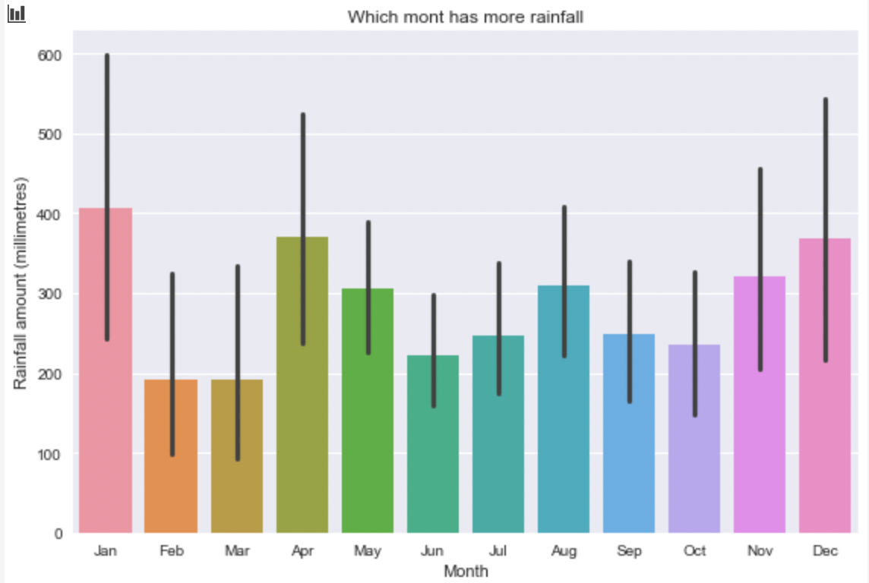
- The Feb and Mar are significant from rest of month.

Year index
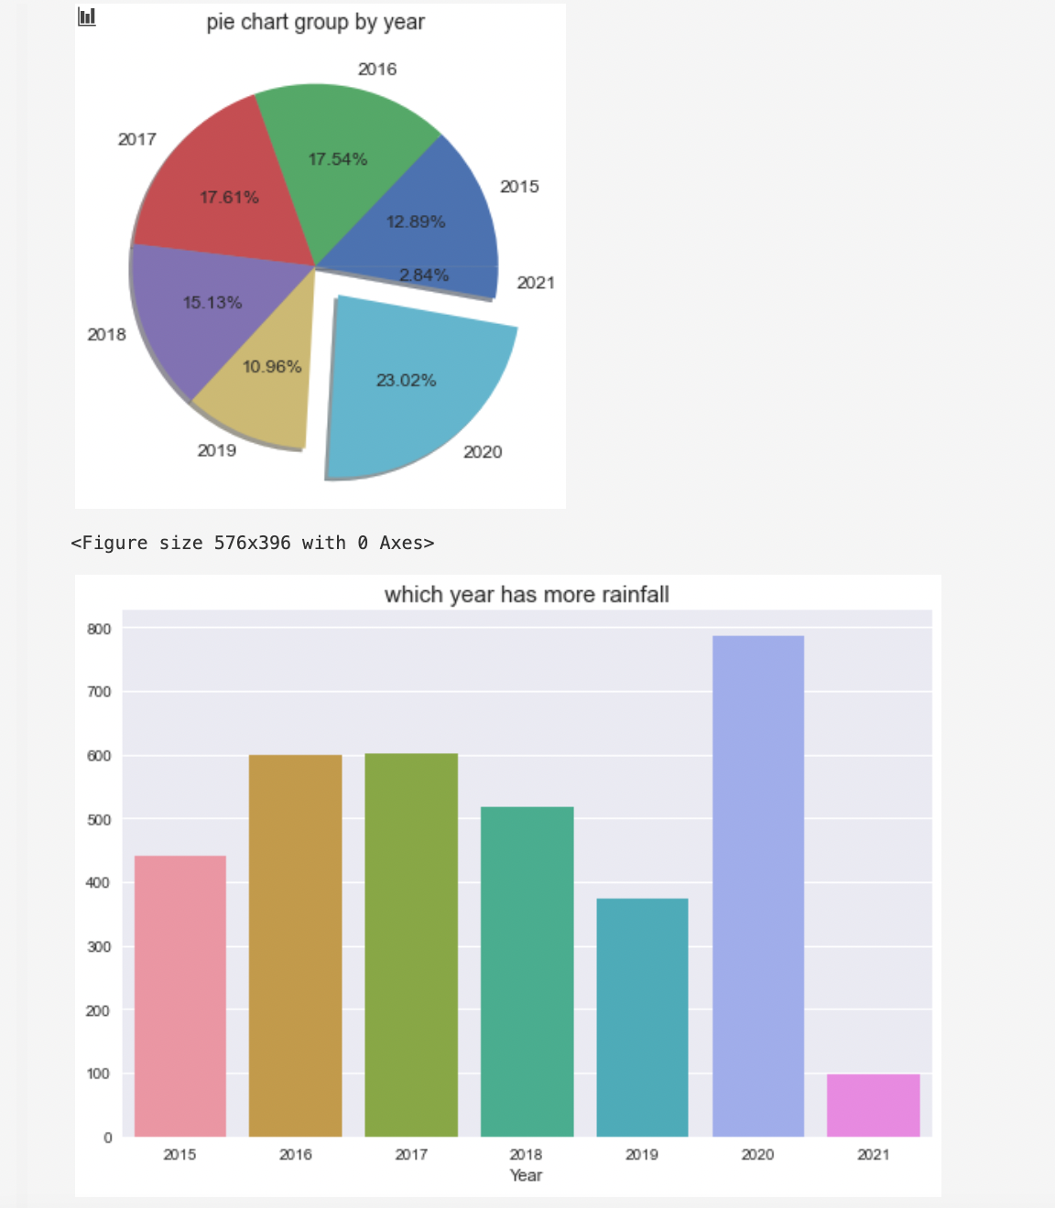

- Rainfall in 2020 was above average across Greater Melbourne.
- To be specific, check each month in 2020

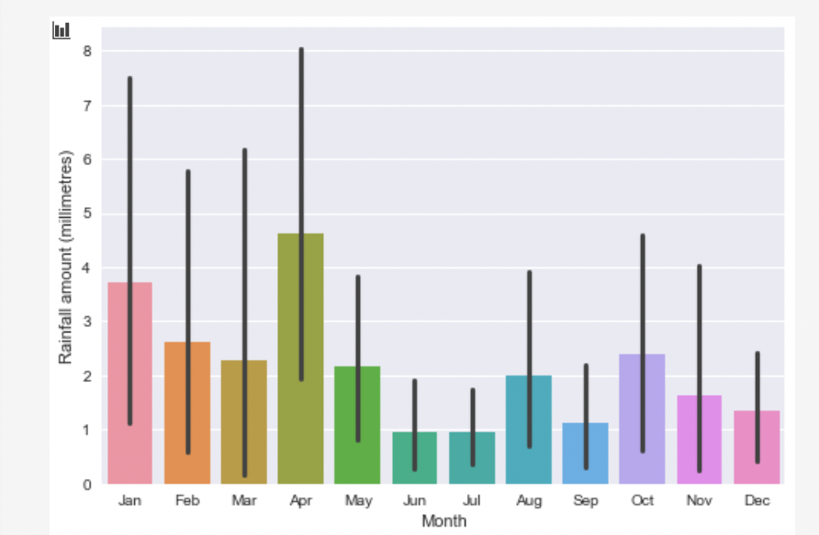

- It was particularly wet in April; averaged across all reporting sites in Greater Melbourne, it was the wettest April since 1974.

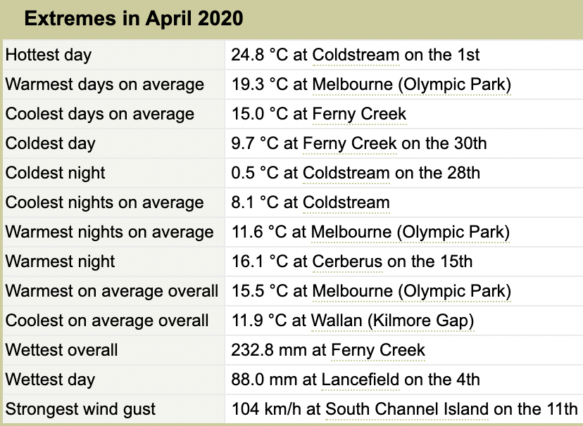

Rainfall values analyse
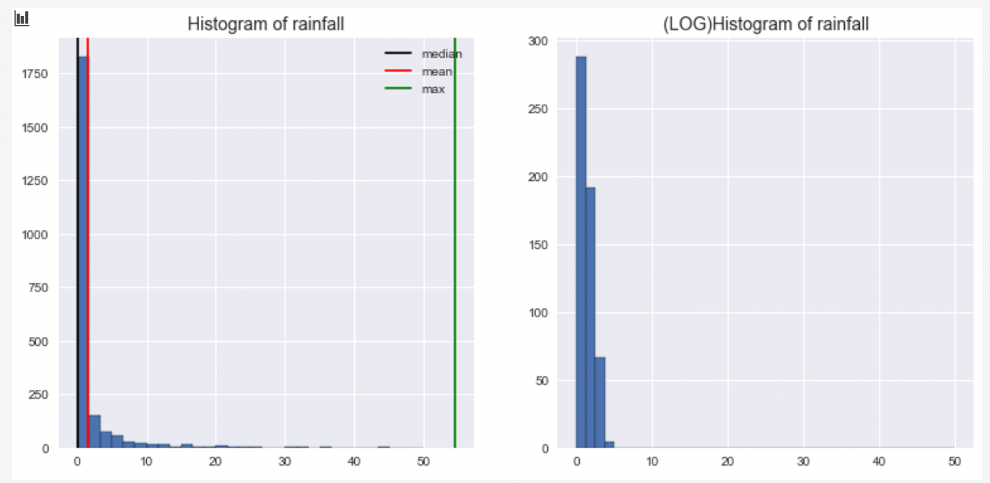
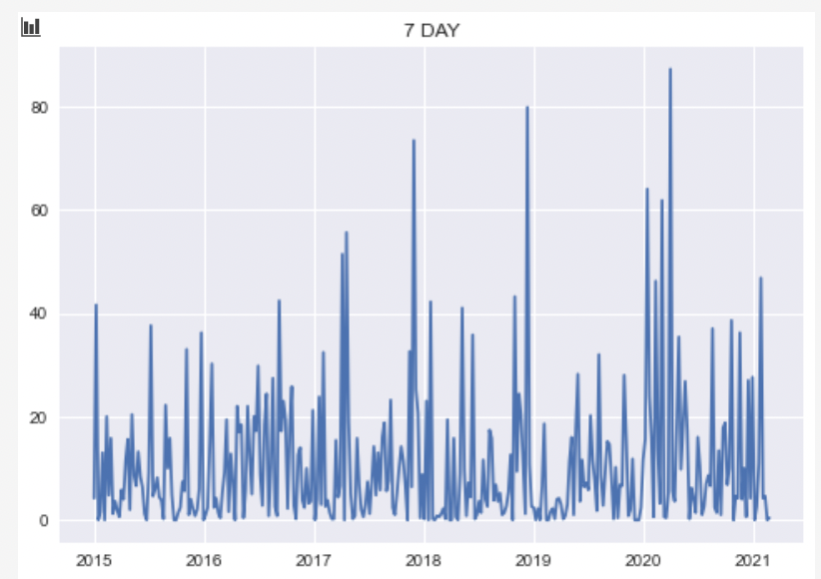

- The data has extremely outliers
- Most of days in Melbourne are dry.
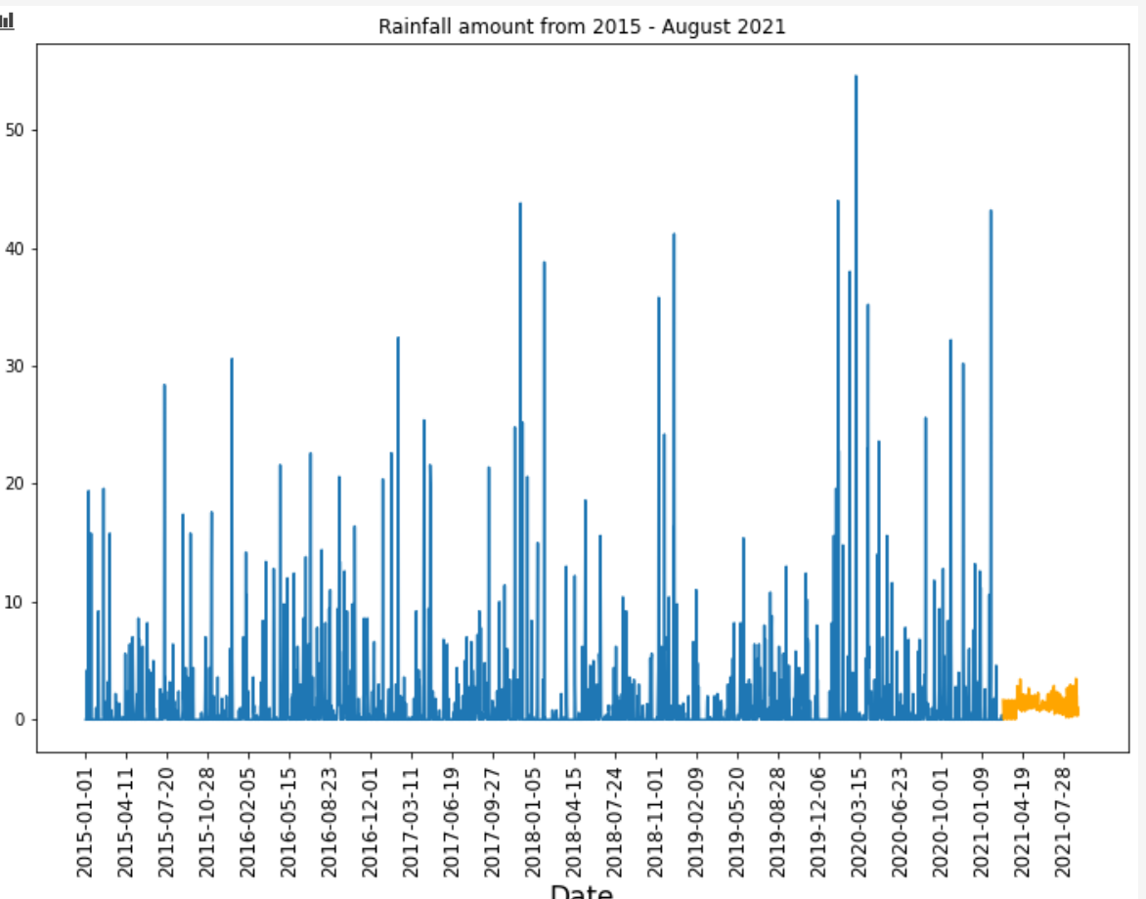

- There are a lot of outliers in rainfall dataset, resulting in missing fit the rainfall trend.
- The R square is relatively low. The KNN fit rainfall best among these five models

Pedestrians Prediction in Southern Cross Station and VIC point station

Datasets inspect

