Sri Lanka Institute of Information Technology


IT1040 - Fundamentals of Computing
Year 1, Semester 1 - 2024
Automated Healthcare Monitoring System
Proposal Document
Group P6-8

IT Number | Name
IT24102687 | Jayathilake Y. M. C. S.
IT24101838 | Prameesha M. L. I.
IT24100538 | Ishan G. T.
IT24102360 | Dankoluge C. P.
IT24100505 | Jathusha V.
IT24100104 | Kinukshan K.



TABLE OF CONTENTS

Introduction
Background and Context 2
Problem and Motivation
Problem 3
Motivation 4
Solution 5
Aim and Objective
Aim 5
Objective 6
System Diagram 7
Methodology 8
Evaluation Method 11
Gantt Chart 12
References 12

INTRODUCTION
Background and Context
A healthcare monitoring system is a holistic, technological solution to track and manage the health status of individuals or populations. These systems contain mixes of hardware, software, and data analytics to provide real-time insights into healthcare practices and offer improvement in patient care and the general efficiency of the delivery of healthcare. Systems like these could be useful in monitoring a wide array of health parameters, such as body temperature, heart rate, blood oxygen saturation, and so forth, or equally well in performing some other task that would help and enhance efficiency.
Today, in the modern world, healthcare monitoring systems use wireless connections and devices to maintain the accuracy of the results and those results can be sent to a doctor or a hospital via software. Some apps can even send information to family or legal guardians. Automated healthcare monitoring systems can help patients, families, and medical staff in several ways including; saving time and effort for doctors, freeing up hospital beds, helping patients recover at home, and reducing healthcare expenditure for the elderly. The monitoring devices include Bluetooth which can transmit health data via the Internet to the guardians or the healthcare team, wearable devices like watches, embedded biosensors, surveillance monitors, handheld medical devices, and even mobiles with specific applications.

PROBLEM & MOTIVATION
PROBLEM
The issues related to the health care system can only be managed effectively if the efficiency of the medical staff in administering medicine and in time management is improved.
Poor time management and performance of health care professionals get reflected in medication errors, delays in treatment, and poor patient care.
Some of the critical issues that need to be worked on in improving the system have to do with inefficiencies in the administration of medication by the medical staff and poor time management.
Challenges are more intense when care involves the elderly and the disabled; they more often need intensive care and frequent medication intake.
These challenges are particularly pronounced when dealing with elderly and disabled patients, who often require more care and frequent medication management.
Administering medication to elderly and disabled patients present unique challenges, primarily due to their treatment regimens. Major problems are, of course, forgetting to give the medications on time, a lot of the time through no fault of the caregivers, whether they are health workers or family members. This can sometimes result from poor communication, lack of documentation, or the heavy burden of many tasks that caregivers have to handle.
Additionally, elderly patients often require multiple medications at specific times increasing the risk of missed doses or incorrectly administrated doses.
To mitigate these problems, it's essential to implement a system for tracking and reminding caregivers of the medication schedule
MOTIVATION
There are several potential advantages for society from the creation of an automated healthcare monitoring system and a robot drug dispenser, especially when it comes to tackling common issues in healthcare management.
- Personalized Care: -
By gathering and evaluating large volumes of patient data, these systems can provide more effective management and more individualized treatment regimens.
- Accessibility: -
Patients who live in remote or underdeveloped locations can obtain healthcare through remote monitoring, ensuring they receive quality treatment without having to frequently visit medical institutions.

- Data-Driven Insights: -
Ongoing data collecting facilitates improved health trend analysis and research, which advances medical knowledge and procedures.

- Cost Reduction: -
By lowering the need for frequent hospital visits, emergency room visits, and extended hospital Stays, automated monitoring can lower healthcare expenses.

- Efficiency: -
Healthcare workers may concentrate on more difficult responsibilities, by using automation to expedite data gathering and analysis which increases total healthcare delivery.

SOLUTION
As our proposal depicts, a movable trolley will be made with proper line navigation and control systems for automatic medication transportation to patients. The trolley will be assigned to follow specific routes within the healthcare facility. This system simply moves to the patients, and patients will manually retrieve their medicines. The trolley will be fitted with safety features such as obstacle detection and line detection that allow it to move around safely within busy hospital environments. A movable trolley enables smart design and automation, making the medicine delivery process easier, less burdensome to the health staff, more punctual and accurate for the patient, and enhancing quality and efficiency in healthcare services.

AIM & OBJECTIVES
AIM
This healthcare monitoring system project is to design a new movable trolley, which will help in the distribution of medications easily to patients. It will provide a reliable system for efficient functioning that ensures timely and proper delivery of medicines within healthcare facilities. So, it computerizes medication delivery to patients in the hospital, reducing workload from the healthcare staff and risks of human error and increasing efficiency towards better healthcare service delivery that impacts positively on patient care and satisfaction.

OBJECTIVES
An automated healthcare monitoring system aims to enhance patient care and streamline health management through technology. Key objectives for such a system typically include.
- Remote Monitoring
- Patient Engagement
- Cost Reduction
- Enhanced Efficiency
- Improved Outcomes
- User-Friendly Interface
- Mobility Support
- Emergency Response
- Personalized Care

These objectives help ensure that automated healthcare monitoring systems contribute to better patient outcomes, more efficient healthcare delivery, and overall improved health management

SYSTEM DIAGRAM
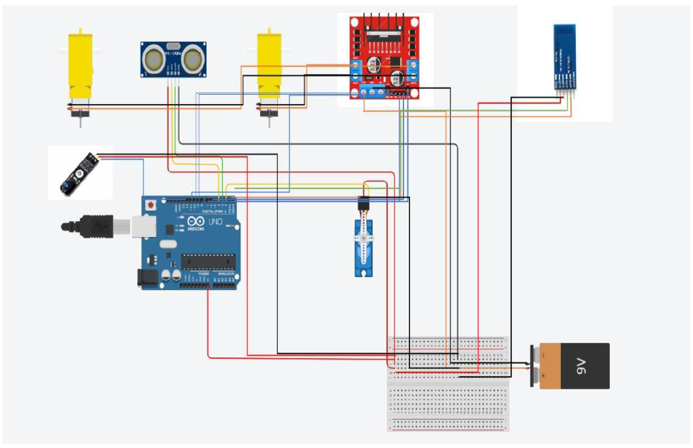

Methodology
1. Introduction: -
The project deals with the design and development of a medicine dispenser robot that shall move autonomously to the patient like a trolley and dispense the medication. To do so, it equips an Arduino programmable microcontroller, line sensors, and ultrasonic sensors together with Bluetooth communication to navigate properly to deliver medicine on time and with accuracy. Also, it requires software development, which is to be used by medical staff in programming when the robot is to dispense medications.

2. System Design
- Hardware Components:
- Arduino Microcontroller:
It acts as a central control unit, and it is programmed to manage sensor data and thus control movement actions of the robot and medicine dispensing process.
- Line Sensors:
These are installed on the robot to detect and follow a path that is designated, thus making sure it reaches its destination correctly.
- Ultrasonic Sensors:
This will be applied in the detection of obstacles that may be on your way and avoid them to not cause a collision and navigate safely.

- Bluetooth Module:
This module shall provide the robot with wireless communication between the robot and the software application to be able to send real-time instructions from the application to the robot.

3. Software Components:
- Robot Control Software & User Application:
This shall be programmed on the Arduino, responsible for reading the sensor data, executing navigation, and controlling medicine dispensing based on the received instructions. Also, it is developed for medical staff to provide them with an interface to schedule medicine dispensing time and provide instructions to the robot via Bluetooth.

4. Data Collection and Communication
- Sensor Data:
Line sensors track continuously to determine the position of the robot concerning the traced path. Ultrasonic sensors detect obstacles in their way and provide real-time feedback to the Arduino for navigation adjustments.

- Bluetooth Communication:
The software application sends instructions to the robot via Bluetooth regarding when and where to dispense the medicine. In turn, the robot communicates back to the application its status updates, hence ensuring that delivery follows through or raises an alert in case of malfunction.

5. Data Analysis and Control Algorithms
- Path Following Algorithm:
The line sensor data is then processed in Arduino, which keeps the robot aligned to the path by modulating the speed of the wheels
- Obstacle Avoidance:
The ultrasonic sensor data feeds into an obstacle avoidance algorithm that stops or reroutes the robot temporarily in case of obstacle detection.
- Medicine Dispensing Logic:
Processing the commands from the application through the Arduino to dispense medicines at the correct timings and places according to the patient's schedule.
6. Software Application Development
- User Interface Designing:
Designing a user-friendly interface for the application to feed in instructions and monitor the activity of the robot by medical staff.
- Scheduling Functionality:
It has features for setting medicine delivery time settings. These are then sent to the robot as Bluetooth commands.
- Feedback Mechanism:
The application receives data back from the robot, including real-time updates of the robot's status and problems met during its operation.

7. Testing and Validation
Tested the robot against a simulated environment imitating a hospital setting to make sure that sensors, Bluetooth communication, and dispensing mechanisms work well. Conducted user testing with medical staff to guarantee that the application would meet their needs, and implemented feedback to further develop the interface and functionalities of the tool.
8. Conclusion
This methodology describes the steps to develop systematically a medicine dispenser robot along with its related software application. This assures an effective and safe medicine distribution to patients by integrating sensor and Bluetooth communication capabilities into a user-friendly application.

EVALUATION METHOD
1. Evaluation Criteria:
- Accuracy & Response Time:
To assess how accurate a robot follows programmed paths and delivers correct medicines at right time. The duration it takes for a robot to receive instructions from software before executing them.
- User Satisfaction & Connectivity Stability:
Conducting surveys or interviews to find out whether medical personnel are satisfied with user interface, ease of use, and reliability of these software programs. Examining stability as well as range concerning Bluetooth connectivity within healthcare facility under different conditions and distance.
2. Methods of Evaluation:
- Field Testing & User Testing :
Deploying the robot in controlled health care settings simulating real life situations in order to observe its performance. Medical personnel who should use this program in various situations involving interaction with robots will provide feedback through questionnaires or interviews.
- Performance monitoring:
Analyze data logs on movements, sensor readings, commands issued by related algorithms running on computers controlling executive elements collected through various embedded sensors located all over body parts used during performing task .
- Error Analysis:
Record all errors that occurred during the period of evaluation as well as how they were resolved.
4. Expected Outcomes:
Clear understanding of system’s strengths and weaknesses, List of necessary adjustments or improvements Performance documentation for a system in real-life scenarios, Suggestions by medical practitioners on how it can better serve them, Final Report which may guide future development efforts.

Gantt Chart
 | July |  |  | August |  |  |  |  |  | September
 | 3 | 4 |  | 1 | 2 |  | 3 |  | 4 | 1 | 2 |  | 3 |  | 4
Finding a project idea and preparing the project proposal
Requirements gathering
Feasibility study
Writing the proposal
System analysis and Software design
Coding
Testing
Integration and Implementation
Operations and maintenance
Report writing and presentations

REFERENCES
- “Arduino: A Technical Reference” by J.H. Hsu
- “Arduino Cookbook” by Micheal Margolis (O’Reilly Media)
- IEEE Xplore Digital Library
- Google Scholar
- The Journal of Open Hardware
- “Programming Arduino: Getting Started with Sketches” by Simon Monk

